Week 2: Supervised Machine Learning Models
YuvaIntern – AI Pioneers Machine Learning Internship

1. Introduction
This project demonstrates supervised machine learning using the Student Performance dataset from the UCI Machine Learning Repository. The aim was to train regression and classification models with Scikit-learn, evaluate their performance on test data, and compare the results using appropriate metrics.

2. Dataset and preparation
The project uses student-mat.csv, which contains 395 student records and 33 columns. The final grade column, G3, was used as the regression target. For classification, a pass was defined as G3 greater than or equal to 10 out of 20, while a grade below 10 was treated as a fail. G3 was excluded from the input features. Numerical features were scaled and categorical features were one-hot encoded. Preprocessing was included in Scikit-learn pipelines so it was fitted on training data rather than test data.

3. Models and evaluation metrics
Two regression models were trained: Linear Regression and Random Forest Regressor. Their performance was measured using Mean Absolute Error (MAE) and Root Mean Squared Error (RMSE); lower values indicate smaller prediction errors. Two classification models were trained: Logistic Regression and Decision Tree. Their performance was measured using accuracy, precision, recall, and F1-score; higher values generally indicate better performance.

4. Regression results
Linear Regression: MAE = 1.647, RMSE = 2.378. Random Forest Regressor: MAE = 1.201, RMSE = 2.015. The Random Forest Regressor performed better on this test split because it achieved lower MAE and RMSE.

5. Classification results
Logistic Regression: accuracy = 0.873, precision = 0.957, recall = 0.849, F1-score = 0.900. Decision Tree: accuracy = 0.886, precision = 0.978, recall = 0.849, F1-score = 0.909. The Decision Tree achieved higher accuracy and F1-score, while both models had the same recall. Precision, recall, and F1-score describe performance for the positive class, defined here as students who pass.

6. Visualizations and output files
The Python script generated week2_regression_comparison.png and week2_classification_comparison.png to visualize the model comparisons. It also saved results in week2_regression_comparison.csv and week2_classification_comparison.csv. Insert both PNG charts into this report before submission, either in this section or in an appendix.
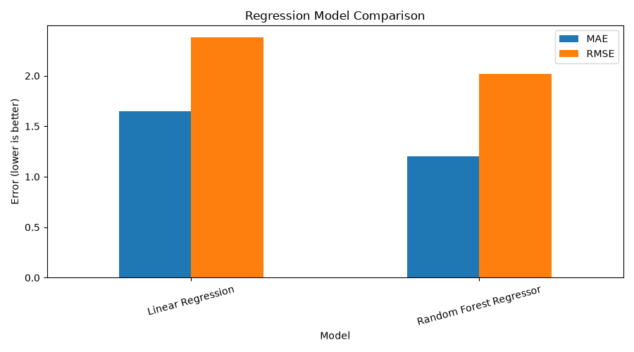

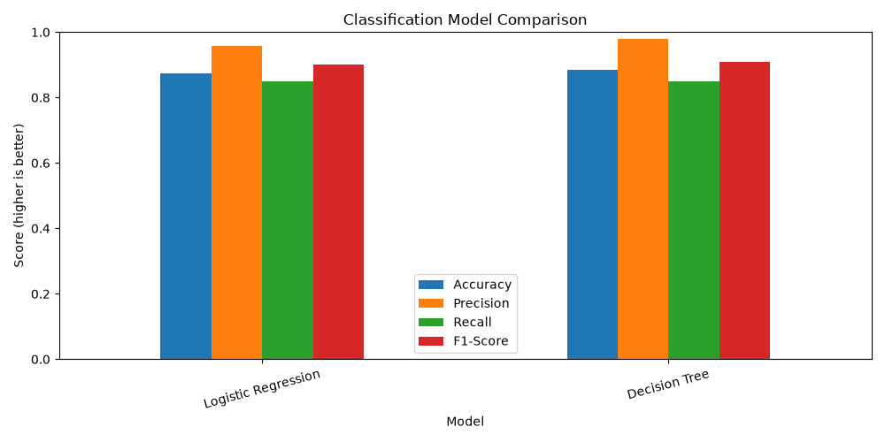

7. Conclusion
This task provided practical experience with supervised learning, train/test splitting, preprocessing pipelines, model training, prediction, and evaluation. The Random Forest Regressor produced lower regression errors than Linear Regression, and the Decision Tree produced slightly higher classification accuracy and F1-score than Logistic Regression on the current test split. These findings are specific to this split and would need further validation, such as cross-validation, before making broader claims. The project meets the objective of training and comparing multiple supervised machine learning models.

8. Tools used
Python, Pandas, NumPy, Matplotlib, and Scikit-learn.

