WEEK 1 INTERNSHIP REPORT
Python for Machine Learning & Data Preprocessing
Internship: AI Pioneers Internship – Machine Learning
Platform: YuvaIntern
Student: Athilakshmi Anil
Dataset: Student Performance (Mathematics) – UCI Machine Learning Repository
Dataset source: https://archive.ics.uci.edu/dataset/320/student+performance

1. Introduction
The objective of this task was to practise Python fundamentals for machine learning, inspect a real dataset, perform data preprocessing, and conduct exploratory data analysis (EDA). The Student Performance dataset from the UCI Machine Learning Repository was used. It contains student-related demographic, family, school, study, attendance and grade attributes.

2. Tools and Libraries
Python was used in Visual Studio Code. The project used Pandas for data loading and manipulation, scikit-learn for MinMaxScaler, and Matplotlib for data visualization.

3. Dataset Loading and Initial Inspection
The Mathematics dataset was loaded with Pandas using a semicolon delimiter (sep=';'), because the source CSV uses semicolons to separate values. The initial inspection reported 395 records and 33 columns. The first five rows, column data types, missing-value counts, duplicate-row count and descriptive statistics were examined.

4. Data Cleaning
The initial inspection showed zero missing values in every column and zero duplicate rows. Therefore, no records needed to be removed or imputed. The code includes conditional handling for missing values if any are present, and removes duplicate rows only when duplicates exist. The original dataset was retained unchanged by creating a working copy for preprocessing.

5. Categorical Encoding
Categorical columns were identified using Pandas and transformed into numeric indicator columns with pandas.get_dummies(), using drop_first=True. This converts categories into a numerical representation suitable for many machine-learning workflows. The encoded output shown during execution contained 39 columns.

6. Numerical Feature Normalization
MinMaxScaler from scikit-learn was used to scale numerical input features to a range from 0 to 1. The grade columns G1, G2 and G3 were excluded from scaling so the original grade values remain available for interpretation. For a predictive model, the scaler should be fitted on training data only and then applied to validation/test data to avoid data leakage.

7. Exploratory Data Analysis
Two visualizations were created. The histogram, 'Distribution of Final Student Grades', displays the distribution of the final grade (G3). The bar chart, 'Average Final Grade by Study Time', compares the mean G3 grade across study-time categories. In this dataset, categories 3 and 4 show higher average grades than categories 1 and 2. This is a descriptive association and does not establish that study time alone causes higher grades.
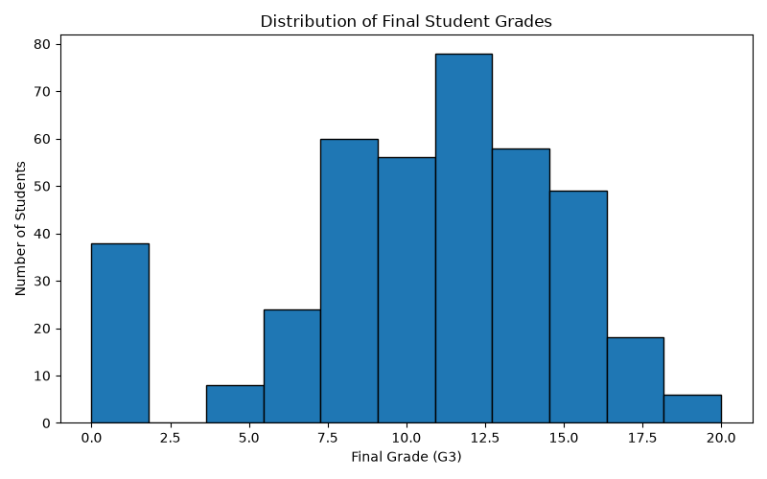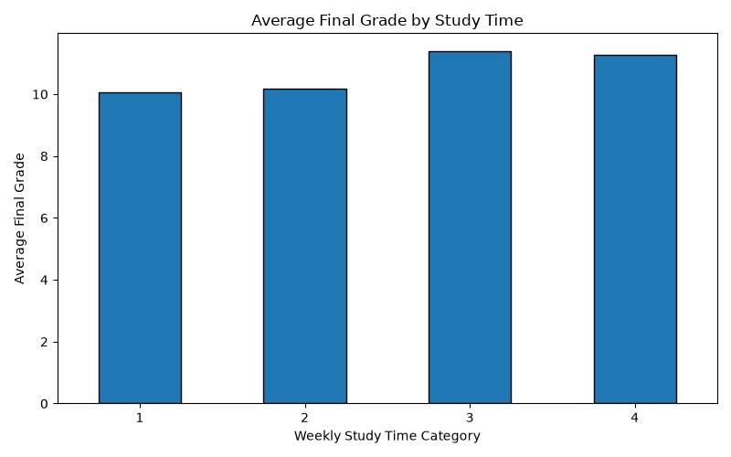

8. Output and Deliverables
The script saves a preprocessed CSV file named student_performance_preprocessed.csv and saves the charts as final_grade_distribution.png and average_grade_by_studytime.png.

9. Conclusion
This task provided practical experience in loading and inspecting a real dataset, checking data quality, encoding categorical variables, normalizing numerical features and visualizing patterns with Python. The work establishes a foundation for the next internship tasks involving supervised and unsupervised machine-learning models.

10. References
Cortez, P. (2008). Student Performance [Dataset]. UCI Machine Learning Repository. https://doi.org/10.24432/C5TG7T

