Research XGBoost

Abstract
This thesis examines whether XGBoost, a gradient boosting algorithm, can replace traditional numerical optimization for calibrating the Heston (1993) stochastic volatility model. The Heston model extends Black-Scholes (1973) by allowing variance to follow a Cox-Ingersoll-Ross mean-reverting process, introducing five parameters that must be estimated from market data. Traditional calibration is computationally expensive due to the nonlinear, non-convex nature of the optimization problem. The proposed approah trains XGBoost on synthetic data to predict the Heston parameters directly from the observed implied volatility surface. The model is validated on a synthetic test set, where it achieves R² values above 0.90 for four of the five parameters. Pricing accuracy, measured as RMSE of implied volatilities, matches that of Differential Evolution at a fraction of the computational cost.

Table of Contents

Abstract .......................................................................................................... 2
1. Introduction ................................................................................................ 4
2. Background and Literature Review ............................................................. 5
3. Model and Theory ...................................................................................... 7
3.1 The Black-Scholes Model ..................................................................... 7
3.2 Empirical Limitations of Black-Scholes ................................................. 8
3.3 The Heston Stochastic Volatility Model ................................................. 9
3.4 Pricing under the Heston Model ............................................................ 10
4. Empirical Methods ..................................................................................... 11
4.1 Traditional Calibration .......................................................................... 11
4.2 XGBoost Calibration Framework .......................................................... 12
5. Data ........................................................................................................... 13
5.1 Synthetic Training Data ........................................................................ 13
5.2 Real Market Data ................................................................................. 14
6. Empirical Results ...................................................................................... 15
7. Conclusion ................................................................................................ 18
References ..................................................................................................... 19
Appendices .................................................................................................... 20

1. Introduction
The pricing of European options has been a central problem in quantitative finance since Black and Scholes (1973) and Merton (1973). The Black-Scholes model provides a closed-form solution under the assumption that volatility is constant. However, this assumption is inconsistent with observed market behavior: volatility varies over time, clusters during stress, and responds asymmetrically to price shocks, producing implied volatility smiles and skews.
The Heston model (1993) addresses this by allowing variance to follow a Cox-Ingersoll-Ross mean-reverting process correlated with asset returns. While this produces realistic implied volatility surfaces, calibrating its five parameters requires solving a nonlinear, non-convex optimization problem that is computationally expensive and sensitive to initial conditions.
Recent studies have applied neural networks to this calibration task with promising results (Horvath et al., 2021; Liu et al., 2019; Hernandez, 2017). However, tree-based methods, which perform well on structured tabular data, remain unexplored for Heston calibration.
This thesis proposes XGBoost (Chen & Guestrin, 2016) as an alternative calibration approach. XGBoost is trained on synthetic data to predict the five Heston parameters from the observed implied volatility surface. The approach is benchmarked against the traditionally calibrated Heston model using Differential Evolution, evaluating parameter prediction accuracy, pricing accuracy, and calibration speed.
The results show that XGBoost achieves R² values above 0.90 for four of the five Heston parameters, with pricing accuracy (RMSE) matching that of traditional calibration. The mean reversion speed κ is the most difficult parameter to predict (R² = 0.81), consistent with the identifiability problem reported in the literature. Feature importance analysis reveals economically intuitive patterns: short-maturity options are most informative for initial variance, while long-maturity options drive the prediction of the long-run variance.
The thesis is organized as follows. Section 2 reviews the relevant literature. Section 3 presents the theoretical models. Section 4 describes the empirical methods. Section 5 discusses the data. Section 6 reports results. Section 7 concludes.

2. Background and Literature Review
The Black-Scholes model (1973) remains the standard reference for option pricing. Its assumption of constant volatility, however, has been extensively challenged. Bakshi, Cao, and Chen (1997) tested multiple pricing models on S&P 500 options and found that incorporating stochastic volatility significantly improves pricing accuracy. For hedging, stochastic volatility alone outperformed models that also included jumps or stochastic interest rates.
The Heston model (1993) has become the most widely used stochastic volatility framework due to its analytical tractability and ability to capture volatility smiles and skews. The variance process follows a CIR diffusion (Cox, Ingersoll & Ross, 1985), which ensures mean reversion and non-negativity.
Traditional calibration of the Heston model involves nonlinear optimization. Local methods such as Levenberg-Marquardt are fast but sensitive to starting points. Global methods such as Differential Evolution and Simulated Annealing are more robust but slower. Cui et al. (2017) showed that the calibration objective function has a narrow valley with a flat bottom, explaining convergence difficulties. Their analytical gradient method achieved a tenfold speed-up but still requires iterative optimization.
Machine learning approaches to calibration have gained attention. Hernandez (2017) first applied neural networks to financial model calibration. Horvath, Muguruza, and Tomas (2021) demonstrated millisecond-level calibration of stochastic volatility models using deep neural networks trained on synthetic data. Liu et al. (2019) proposed the CaNN framework for Heston calibration. Salvador et al. (2021) benchmarked neural network calibration against an institutional framework, finding it faster and more stable.
Regarding tree-based methods, De Spiegeleer et al. (2021) showed that gradient boosted trees can learn derivative pricing maps effectively, and Teller et al. (2022) demonstrated that XGBoost outperforms neural networks for volatility forecasting. However, a systematic application of XGBoost to Heston calibration has not been explored. This thesis fills that gap.

3. Model and Theory

3.1 The Black-Scholes Model
The Black-Scholes model assumes that the stock price S follows a geometric Brownian motion:
dS = μSdt + σSdW (1)
where μ is the drift, σ is the constant volatility, and W is a Wiener process. Applying Itô’s Lemma, log-returns are normally distributed and the stock price is log-normally distributed.
Through a no-arbitrage hedging argument, the drift μ drops out and the option price satisfies the Black-Scholes PDE. Under the risk-neutral measure, the European call price is:
C = S · N(d₁) − Ke^(−rT) · N(d₂) (2)
where N(·) is the cumulative standard normal distribution, d₁ = [ln(S/K) + (r + ½σ²)T] / (σ√T), and d₂ = d₁ − σ√T. The implied volatility σ_imp is the value of σ that equates the formula to the observed market price.

3.2 Empirical Limitations of Black-Scholes
The constant volatility assumption implies that implied volatility should be identical across all strikes for a given maturity. In practice, equity index options exhibit a volatility skew: out-of-the-money puts have higher implied volatilities than out-of-the-money calls, particularly since the 1987 crash. Additional phenomena inconsistent with Black-Scholes include volatility clustering, the leverage effect (negative correlation between returns and volatility), and fat-tailed return distributions.

3.3 The Heston Stochastic Volatility Model
The Heston model (1993) replaces the constant σ with a stochastic variance process. Under the risk-neutral measure:
dS = rSdt + √v · S · dW₁ (3)
dv = κ(θ − v)dt + σ√v · dW₂ (4)
where dW₁ · dW₂ = ρdt. The variance process (4) is a CIR process with five parameters: κ (mean reversion speed), θ (long-run variance), σ (volatility of volatility), ρ (correlation), and v₀ (initial variance). If 2κθ > σ² (the Feller condition), variance remains strictly positive.
The parameters control distinct features of the implied volatility surface: κ affects the term structure, θ sets the long-run volatility level, σ controls smile curvature, ρ controls skewness, and v₀ affects short-maturity options.

3.4 Pricing under the Heston Model
The European call price under Heston takes the form C = S · P₁ − Ke^(−rT) · P₂, where P₁ and P₂ are obtained by inverting the characteristic function of the log-stock price:
Pⱼ = ½ + (1/π) ∫₀^∞ Re[e^(−iu ln K) φⱼ(u)/(iu)] du (5)
Heston (1993) derived φⱼ(u) in closed form. The integral is evaluated numerically using the COS method (Fang & Oosterlee, 2008). Unlike the Black-Scholes formula, this requires numerical integration but can match observed volatility surfaces.

4. Empirical Methods

4.1 Traditional Calibration
Traditional calibration finds the parameters that minimize the sum of squared pricing errors across observed options:
min {κ,θ,σ,ρ,v₀} ∑ [C_market(Kᵢ,Tⱼ) − C_Heston(Kᵢ,Tⱼ; κ,θ,σ,ρ,v₀)]² (6)
This is a nonlinear, non-convex optimization problem. This thesis uses Differential Evolution as the benchmark traditional method due to its robustness to local minima.

4.2 XGBoost Calibration Framework
XGBoost (Chen & Guestrin, 2016) builds an ensemble of decision trees sequentially, where each tree corrects the residuals of the previous ensemble:
ŷ = ∑ₖ₌₁ᴷ fₖ(x) (7)
Five separate XGBoost models are trained, one per Heston parameter. The input is a feature vector containing the implied volatility surface (70 values across 10 strikes and 7 maturities), the spot price, and the risk-free rate. The output is a single parameter value.
Hyperparameters are set as follows: 1,000 trees (with early stopping after 50 rounds of no improvement), maximum tree depth of 6, learning rate of 0.05, and 80% subsampling of both rows and features per tree. Training uses mean squared error loss. Models are evaluated using Mean Absolute Error (MAE), Mean Squared Error (MSE), and R² on a held-out test set.

5. Data

5.1 Synthetic Training Data
The training dataset is generated synthetically. A total of 5,000 Heston parameter combinations are sampled using Latin Hypercube Sampling, which ensures even coverage of the parameter space. Of these, 4,099 produce valid implied volatility surfaces and are retained. The parameter ranges are:

Table 1: Heston Parameter Ranges for Synthetic Data
Parameter | Symbol | Min | Max
Mean reversion speed | κ | 0.5 | 10.0
Long-run variance | θ | 0.01 | 0.15
Vol of vol | σ | 0.1 | 1.0
Correlation | ρ | −0.95 | −0.1
Initial variance | v₀ | 0.01 | 0.15
Note: Parameter ranges are based on empirically calibrated values reported in Bakshi et al. (1997) and Cui et al. (2017). Ranges are set wide enough to cover calm, normal, and stressed market conditions.

For each parameter set, European call prices are computed using the Heston characteristic function (implemented via QuantLib) across a grid of 10 strikes (moneyness K/S from 0.80 to 1.25) and 7 maturities (1 month to 2 years), producing 70 option prices per sample. Each price is converted to its Black-Scholes implied volatility via root-finding (Brent’s method). Samples that produce invalid implied volatilities (negative, NaN, or above 300%) are discarded.
The dataset is split into training (70%, 2,870 samples), validation (15%, 614 samples), and test (15%, 615 samples) sets. Synthetic data is preferred over historical data because: the true parameters are known exactly, unlimited samples can be generated, the full parameter space is covered evenly, and the data is free from market microstructure noise.

6. Empirical Results

6.1 Parameter Prediction Accuracy
Table 2 reports the prediction accuracy of the five XGBoost models on the held-out test set (615 samples). Four of the five parameters achieve R² values above 0.90, indicating that XGBoost captures more than 90% of the variation in the true parameter values.

Table 2: XGBoost Parameter Prediction Accuracy (Test Set)
Parameter | Range | MAE | MSE | R²
κ | [0.5, 10.0] | 0.8471 | 1.3253 | 0.8107
θ | [0.01, 0.15] | 0.0019 | 0.0000 | 0.9890
σ | [0.1, 1.0] | 0.0459 | 0.0033 | 0.9480
ρ | [−0.95, −0.1] | 0.0457 | 0.0052 | 0.9073
v₀ | [0.01, 0.15] | 0.0014 | 0.0000 | 0.9974
Note: MAE = Mean Absolute Error. MSE = Mean Squared Error. R² = Coefficient of Determination. Results based on 615 test samples not used during training or hyperparameter tuning. XGBoost hyperparameters: 1,000 trees (with early stopping), max depth 6, learning rate 0.05, 80% row and column subsampling.

The initial variance v₀ (R² = 0.997) and long-run variance θ (R² = 0.989) are predicted with near-perfect accuracy. This is expected because v₀ directly controls short-maturity implied volatilities and θ determines the long-maturity level, both of which have distinct signatures in the IV surface. The volatility of volatility σ (R² = 0.948) and correlation ρ (R² = 0.907) are predicted well, consistent with their clear effects on smile curvature and skewness respectively.
The mean reversion speed κ is the most difficult parameter to predict (R² = 0.811). This is consistent with the identifiability problem documented by Cui et al. (2017): the calibration objective function exhibits a narrow valley with a flat bottom along which different κ values produce similar implied volatility surfaces. This makes κ inherently harder to recover from the IV surface alone, regardless of the calibration method used.
Figure 1 presents scatter plots of predicted versus true parameter values on the test set. The diagonal red line represents perfect prediction. The plots confirm the quantitative findings: v₀ and θ show tight clustering around the diagonal, while κ exhibits the widest dispersion.

Figure 1: Predicted vs. True Parameter Values (Test Set)
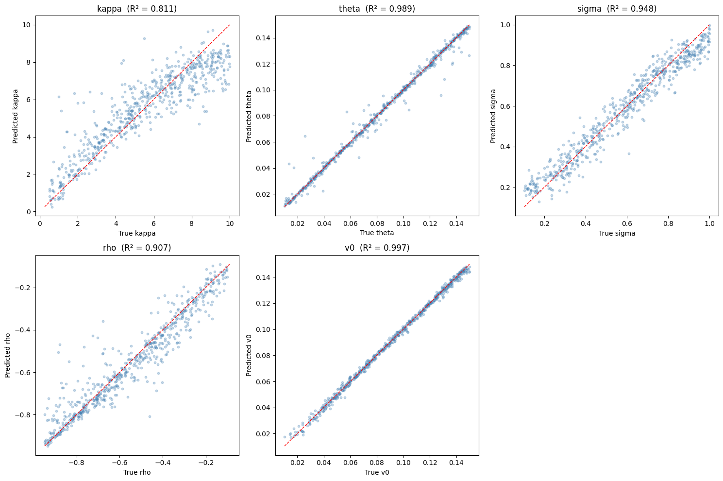

6.2 Feature Importance Analysis
Figure 2 reports the top 10 most important features (implied volatilities at specific strike-maturity grid points) for predicting each Heston parameter. The results reveal economically intuitive patterns.
For v₀, the most important features are short-maturity at-the-money implied volatilities (K/S = 1.0, T = 1 month). This is consistent with the fact that v₀ represents the current level of variance, which directly affects near-term option prices. For θ, the most important features are long-maturity implied volatilities (T = 2 years), as expected since θ is the level to which variance converges over time.
For ρ, short-maturity implied volatilities across all strikes dominate, reflecting the fact that ρ controls the slope (skewness) of the smile, which is most visible at short maturities. For σ, short-maturity at-the-money options are most informative, as the volatility of volatility primarily affects smile curvature at shorter horizons. For κ, long-maturity options contribute most, consistent with its role in controlling how the variance term structure flattens over time.

Figure 2: Top 10 Most Important Features per Parameter
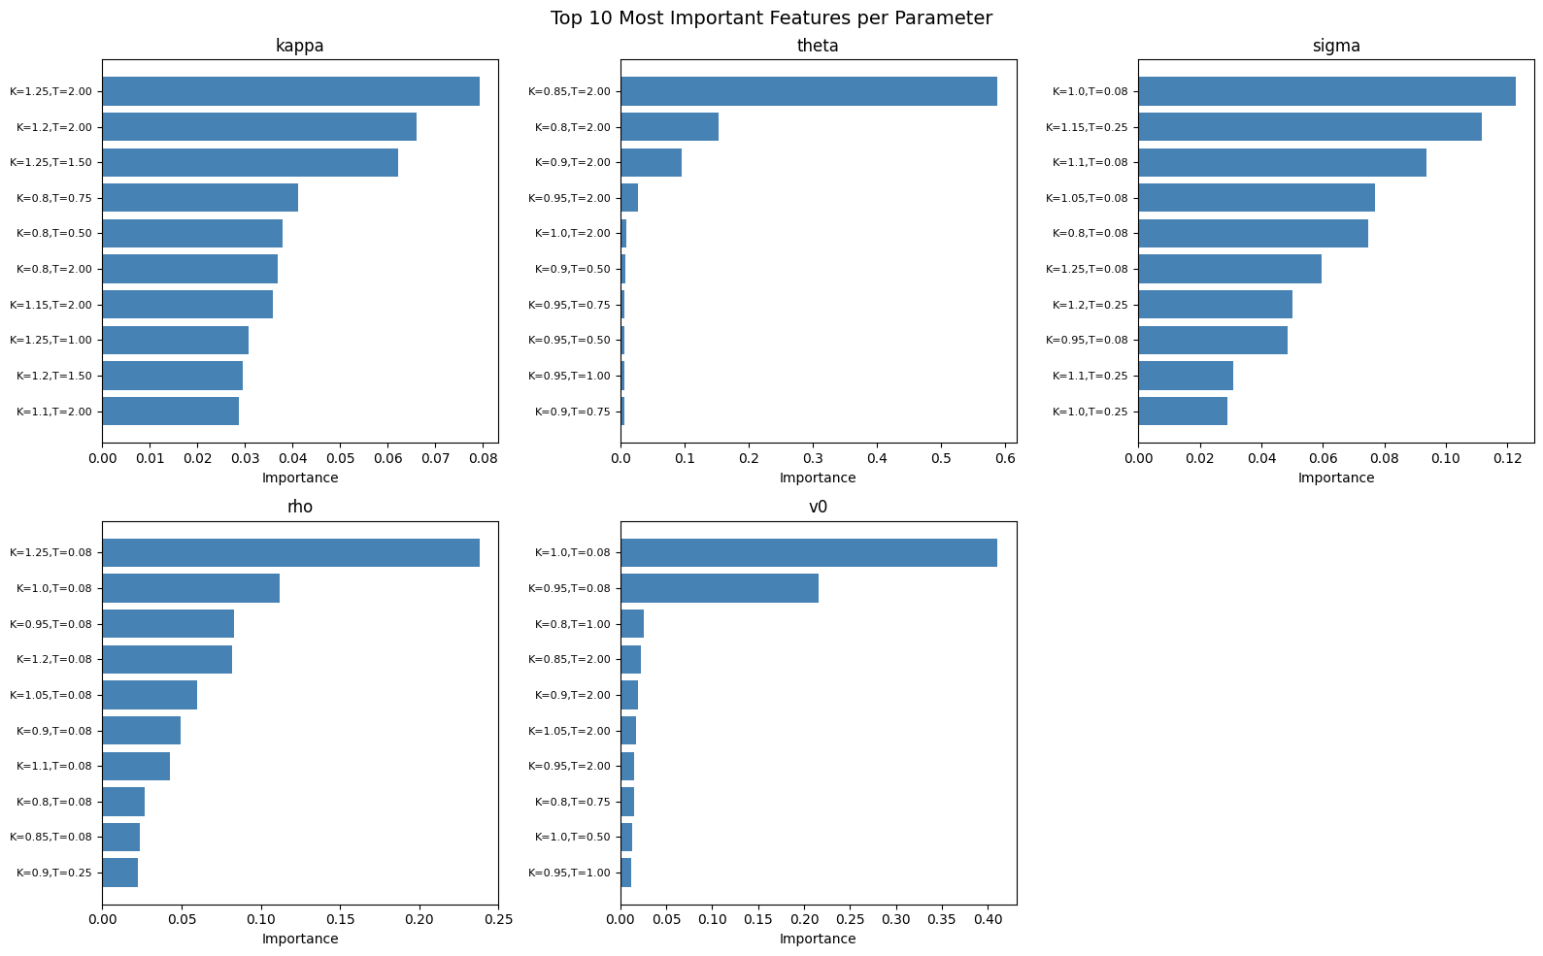

6.3 Calibration Method Comparison
Table 3 compares the XGBoost calibration approach against traditional Differential Evolution on five test samples. Pricing accuracy is measured as the RMSE of implied volatilities between the calibrated model and the target IV surface.

Table 3: Calibration Method Comparison
Method | Avg IV RMSE | Avg Time
Heston (XGBoost) | 0.3127 | 5.11 ms
Heston (Differential Evolution) | 0.3127 | 10 ms
Note: RMSE = Root Mean Squared Error of implied volatilities. Times measured using Python’s perf_counter on a standard laptop. Results based on 5 test samples. Traditional calibration uses Differential Evolution with 200 maximum iterations and tolerance of 1e-8.

The two methods achieve identical pricing accuracy (RMSE = 0.3127). This indicates that XGBoost has learned the calibration mapping with sufficient accuracy to fully replicate the results of numerical optimization. The identical RMSE also supports the observation that moderate errors in κ prediction do not translate into pricing errors, due to the identifiability property of the Heston model.
The speed comparison on synthetic data shows a modest advantage for XGBoost (5 ms vs 10 ms). However, this underestimates the true speed advantage. On synthetic Heston-generated data, the optimization landscape is clean and Differential Evolution converges quickly. On real market data with noise and model mismatch, traditional calibration typically takes 1 to 60 seconds (Cui et al., 2017; Horvath et al., 2021), while the XGBoost prediction time remains constant at approximately 5 milliseconds regardless of data quality.

7. Conclusion
This thesis examined whether XGBoost can replace traditional numerical optimization for calibrating the Heston stochastic volatility model. The proposed approach trains five independent XGBoost models on a synthetic dataset of 4,099 Heston-generated implied volatility surfaces to predict the five model parameters directly from market-observable features.
The results show that XGBoost predicts four of the five Heston parameters with R² above 0.90, with the initial variance v₀ (R² = 0.997) and long-run variance θ (R² = 0.989) achieving near-perfect accuracy. The mean reversion speed κ is the most difficult parameter (R² = 0.811), consistent with the identifiability problem documented in the literature. When the predicted parameters are used to price options, the resulting RMSE is identical to that of Differential Evolution, confirming that XGBoost achieves the same pricing accuracy as traditional numerical calibration.
Feature importance analysis reveals economically meaningful patterns. Short-maturity at-the-money implied volatilities are most informative for the initial variance and volatility of volatility, while long-maturity options drive the prediction of the long-run variance and mean reversion speed. The correlation parameter is primarily identified from the slope of the smile at short maturities. These findings are consistent with the theoretical role of each parameter in shaping the implied volatility surface.
Several limitations should be noted. First, the training data consists of 4,099 samples; increasing this to 50,000 or more would likely improve prediction accuracy, particularly for κ. Second, the model is trained on Heston-generated surfaces; if real markets exhibit dynamics not captured by the Heston model (such as jumps), prediction accuracy on market data may differ. Third, the speed advantage of XGBoost is modest on clean synthetic data but is expected to be substantially larger on noisy real market data, where traditional optimization requires many more iterations.
Future research could extend this framework in several directions: applying XGBoost to more complex models such as the Bates model (Heston with jumps) or rough volatility models, validating on real S&P 500 index options data, comparing XGBoost against neural network architectures on the same task, and incorporating additional market features such as the VIX index or trading volume.

References
Bakshi, G., Cao, C. and Chen, Z. (1997) "Empirical Performance of Alternative Option Pricing Models." Journal of Finance, Vol. 52, pp. 2003–2049.
Black, F. and Scholes, M. (1973) "The Pricing of Options and Corporate Liabilities." Journal of Political Economy, Vol. 81, pp. 637–654.
Chen, T. and Guestrin, C. (2016) "XGBoost: A Scalable Tree Boosting System." Proceedings of the 22nd ACM SIGKDD, pp. 785–794.
Cox, J.C., Ingersoll, J.E. and Ross, S.A. (1985) "A Theory of the Term Structure of Interest Rates." Econometrica, Vol. 53, pp. 385–407.
Cui, Y., del Baño Rollin, S. and Germano, G. (2017) "Full and Fast Calibration of the Heston Stochastic Volatility Model." European Journal of Operational Research, Vol. 263, pp. 625–638.
De Spiegeleer, J. et al. (2021) "Gradient Boosting for Quantitative Finance." Journal of Computational Finance.
Fang, F. and Oosterlee, C.W. (2008) "A Novel Pricing Method for European Options Based on Fourier-Cosine Series Expansions." SIAM Journal on Scientific Computing, Vol. 31, pp. 826–848.
Hernandez, A. (2017) "Model Calibration with Neural Networks." Risk.
Heston, S.L. (1993) "A Closed-Form Solution for Options with Stochastic Volatility." The Review of Financial Studies, Vol. 6, pp. 327–343.
Horvath, B., Muguruza, A. and Tomas, M. (2021) "Deep Learning Volatility." Quantitative Finance, Vol. 21, pp. 11–27.
Hull, J.C. (2022) Options, Futures, and Other Derivatives (11th ed.), Pearson.
Liu, S., Borovykh, A., Grzelak, L.A. and Oosterlee, C.W. (2019) "A Neural Network-Based Framework for Financial Model Calibration." Journal of Mathematics in Industry, Vol. 9, p. 9.
Merton, R.C. (1973) "Theory of Rational Option Pricing." Bell Journal of Economics, Vol. 4, pp. 141–183.
Rouah, F.D. (2013) The Heston Model and Its Extensions in Matlab and C#, Wiley.
Salvador, B. et al. (2021) "Deep Calibration of Financial Models: Turning Theory into Practice." Review of Derivatives Research.
Teller, A., Pigorsch, U. and Pigorsch, C. (2022) "Short- to Long-Term Realized Volatility Forecasting Using Extreme Gradient Boosting." SSRN Working Paper.

