1.WEATHER ANALYSIS REPORT
AND USE DATASET6 (06_Weather.csv).
1.Problem Framing and Objective Identification
This project aims to analyze weather sensor data collected in the City of Canning to investigate temporal variations in air temperature, correlations between barometric pressure and relative humidity, and variations in sensor-based micro-climates. By identifying patterns and anomalies in the dataset, we aim to better understand the dynamics of local weather conditions, which could inform urban planning, weather forecasting, and climate studies.

1.1 Objectives
The primary objectives of this project are:
- Analyze Temporal Variations in Air Temperature: Investigate how air temperature varies throughout the day across different sensors in the City of Canning.
- Investigate the Correlation Between Barometric Pressure and Relative Humidity: Examine if a significant relationship exists between barometric pressure and relative humidity, particularly in micro-climate conditions.
- Identify and Explore Any Anomalies or Patterns: Detect specific patterns or anomalies that could point to extreme weather conditions or sensor malfunctions.
  - Initial Hypotheses
- H1: Air temperature exhibits significant variations across different times of the day.
- H2: Barometric pressure is negatively correlated with relative humidity.
- H3: Sensor data shows significant variations, indicating location-based micro-climate differences.

2. Data Preparation
2.1 Data Cleaning
The dataset was loaded and cleaned to ensure consistency and accuracy. Missing values in key fields such as air temperature, barometric pressure, and relative humidity were replaced with the mean values for each respective field. This approach allowed for a cleaner analysis while minimizing the potential bias from missing data. Additionally, the LocalTimestamp column was parsed to standardize the time format, ensuring compatibility for temporal analysis.
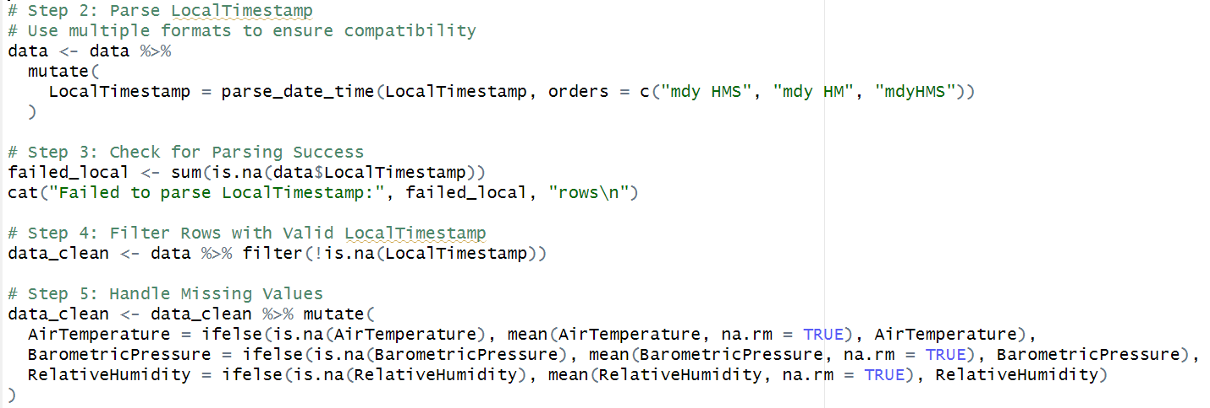
2.2 Data Preprocessing
The dataset was then processed to create a new column for the hour of the day, enabling the analysis of air temperature variations throughout the day. The data was also filtered to ensure only valid timestamps and sensor readings were included in the analysis.

3.Model Planning and Development
In this section, a linear regression model is applied to predict air temperature based on barometric pressure and relative humidity. The model's parameters, such as coefficients and performance metrics, are evaluated to understand the relationship between these variables and temperature. The analysis also explores anomaly detection using residuals.
3.1 Model Selection
A linear regression model was chosen due to its simplicity and effectiveness in understanding linear relationships between variables. The model is capable of quantifying the impact of barometric pressure and relative humidity on air temperature, providing clear and interpretable coefficients.
(1) Advantages:
Simplicity: Easy to interpret and implement.
Linear Relationships: Effective when relationships between the predictors and response are linear.
Efficiency: Computes predictions quickly and requires fewer computational resources.
(2) Use Case:
This model is particularly useful for predicting air temperature in environments with measurable barometric pressure and relative humidity, making it ideal for weather forecasting and climate analysis.

3.2 Parameter Settings
The regression model was configured with air temperature as the dependent variable and barometric pressure and relative humidity as independent variables. The model parameters were determined based on minimizing error and providing interpretable coefficients. The regression was assessed using key metrics like the Multiple R-squared value, Mean Absolute Error (MAE), and Root Mean Squared Error (RMSE).
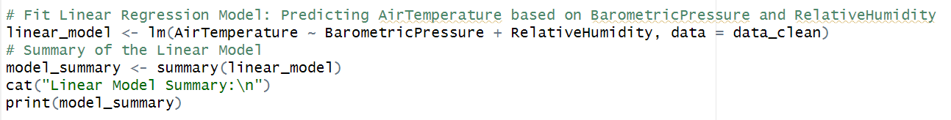
3.3 Model Evaluation
The model evaluation showed a Multiple R-squared value of 0.5081, indicating that about 50.81% of the variance in air temperature could be explained by barometric pressure and relative humidity. The MAE was 2.91 and RMSE was 3.74, suggesting that the model fits the data reasonably well, though there is room for improvement.
3.4 Anomaly Detection
Anomalies were identified by examining the residuals of the linear regression model. Large residuals indicate outliers or abnormal temperature behavior, which can be valuable for detecting extreme weather conditions.

4. Statistical Analysis
4.1 Air Temperature Variation (H1)
The regression analysis showed that air temperature varies significantly throughout the day. The variable "Hour" was found to be a significant predictor of air temperature (p-value < 2e-16), confirming the daily fluctuations in temperature.
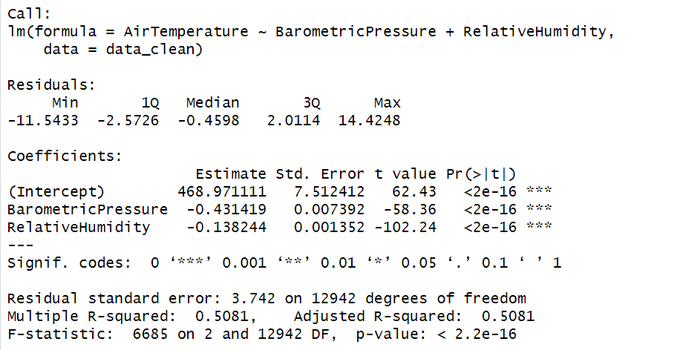
4.2 Barometric Pressure and Relative Humidity (H2)
A correlation test between barometric pressure and relative humidity revealed a weak negative correlation of -0.043, indicating that as barometric pressure increases, relative humidity slightly decreases. However, this relationship is not strong enough to be highly predictive.
4.3 Sensor-Level Variation (H3)
The analysis of air temperature across different sensors showed significant location-based variations (ANOVA p-value < 2e-16). This suggests that different sensor locations may experience unique micro-climates, highlighting the need for location-specific temperature analysis.
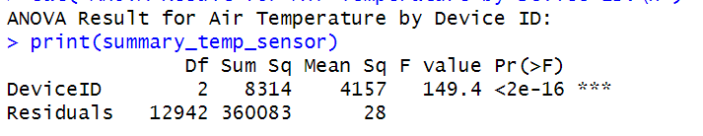
Summary and Interpretation
- Air Temperature Variations: Significant daily variations in air temperature were observed, with a strong dependence on the hour of the day.
- Barometric Pressure and Relative Humidity: A weak negative correlation was found between barometric pressure and relative humidity, indicating a slight inverse relationship.
- Sensor-Based Micro-Climate Variations: Significant differences in air temperature were observed across different sensor locations, indicating the presence of micro-climates within the city.

5. Problem and pitfalls
During the course of this project, several challenges emerged that required attention and adjustment to ensure the validity and quality of the analysis. The key issues encountered were:
- Data Cleaning and Missing Values: Missing values in key variables like AirTemperature, BarometricPressure, and RelativeHumidity posed a significant problem. Imputing missing values with the mean of the respective columns addressed this, but it raised concerns about the potential bias introduced into the dataset. Ensuring accurate and representative imputation strategies is essential for maintaining data integrity.
- Incorrect Timestamp Parsing: The LocalTimestamp column required careful parsing due to its varied formats. While multiple formats were applied using parse_date_time(), some rows failed to be parsed, leading to invalid data. These rows were removed, but this process emphasized the importance of handling different timestamp formats early on in data preparation to avoid data loss.
- Temporal Variations and Complexity: The analysis of temporal variations in AirTemperature was complicated by the presence of widely spaced timestamps. In some cases, data gaps led to spikes or sharp fluctuations that could distort trends. To mitigate this, the dataset was cleaned by removing missing timestamps and smoothing the data, but it raised the challenge of ensuring that the time resolution is appropriate for capturing accurate patterns.
- Sensor-Level Variations: The analysis of temperature differences across sensors (DeviceID) revealed significant variations. While these differences could be attributed to micro-climate effects, the issue of sensor calibration and measurement discrepancies was not fully accounted for. Ensuring consistent sensor calibration and considering potential biases in sensor placement are important for interpreting these variations accurately.
- Model Overfitting: In the linear regression model, there was a risk of overfitting, as the predictors (BarometricPressure and RelativeHumidity) may not fully capture the complexity of air temperature variations. Although the model performed reasonably well, cross-validation or a more sophisticated model (e.g., random forest or support vector machine) could have helped reduce overfitting and improve generalization.
- Multicollinearity in the Linear Model: There was a potential issue with multicollinearity between the predictors (BarometricPressure and RelativeHumidity). While correlation was checked, further diagnostic tests (e.g., Variance Inflation Factor) could have been performed to ensure that multicollinearity did not undermine the stability of the regression coefficients. Addressing multicollinearity would improve model reliability and interpretation.
- Outliers and Anomalies: Outliers, particularly in the AirTemperature variable, were observed, especially in the sensor-level analysis. While outliers were visually marked in the plots, their effect on the overall analysis wasn't fully explored. In future work, more robust statistical techniques (e.g., robust regression) could be employed to minimize the influence of extreme values.
- Contextual Relevance of Results: Some findings, such as the correlation between BarometricPressure and RelativeHumidity, while statistically significant, may lack immediate actionable insights without a deeper understanding of the domain context. Further consultations with domain experts could enhance the relevance and applicability of the findings.
These issues highlight the importance of thorough data cleaning, careful model development, and the need for a solid understanding of domain-specific knowledge to ensure meaningful and actionable insights from the analysis.

