**CPT113 REPORT**

**Name: Anjumanara Athina**

**Matric: 155142**

**Specification of Requirements**

**Input:**

1. Programs is a menu driven where users can choose among the options given below

* Enter personal information
* Name
* Passport Number
* Age
* Gender

1. User details need to be entered on the terminal itself.

* Where name should be a single word as a string
* Gender should be M or F
* Age should be int
* Passport no should be long int

1. Doses details have to be filled in where the system asks to choose option to get the type of vaccine and date of taking it in int format.
2. Other information a user can choose

* Add a new person
* Update Vaccination information
* Search each individual vaccination information status via passport no
* list of unvaccinated persons
* list of individuals who received certain vaccine such as Pfizer, Sinovac or AstraZeneca
* Statistical Information

1. Option to get Statistical information where different options are

* Total number of individuals who received vaccine under Pfizer
* Total number of individuals who received vaccine under Sinovac
* Total number of individuals who received vaccine under AstraZeneca
* Total number of individuals fully vaccinated
* Total number of individuals partially vaccinated
* Total number of individuals has not vaccinated yet

**Output:**

Programs is a menu drive where output is displayed on the terminal itself.

1. After choosing the first option User details such as name, age, gender and passport number are entered.
2. After entering the user details System prompts the user to enter dose information.
3. When a user shares the dose information it asks for the number of doses the user has been vaccinated for.
4. Then it asks for the Type of vaccine user has been vaccinated. If the user has mentioned that he/she has been twicely vaccinated then it asks details two times.
5. It displays user to update vaccination date.
6. After updating date, it will ask user to choose other optional informations about vaccination if he/she wants.

**UML diagram:**

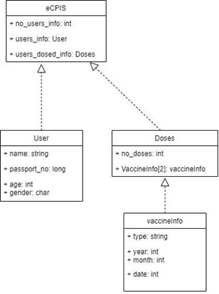

**Sample input output:**

**Step-1:** User Information

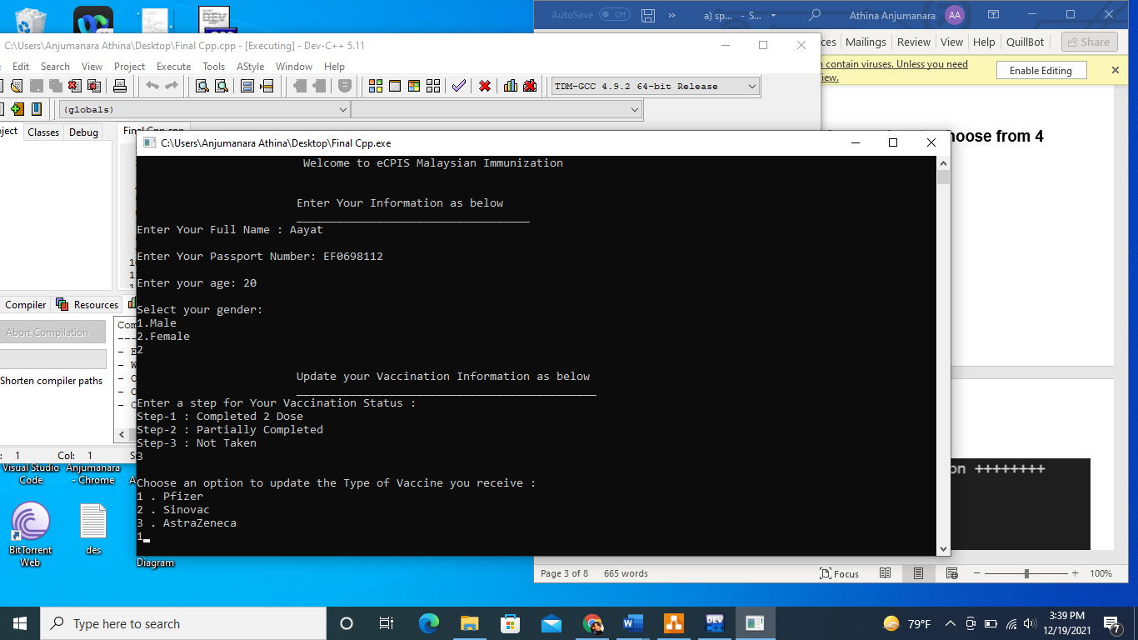

**Step-2**: Enter a step from given three step



**Step-3:**

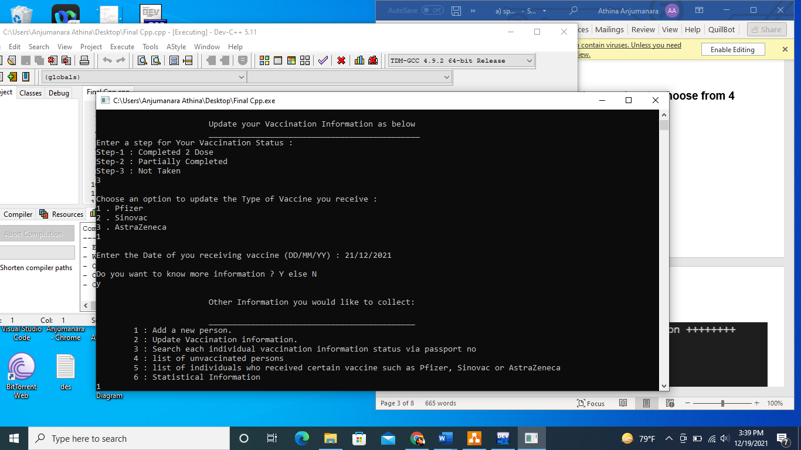

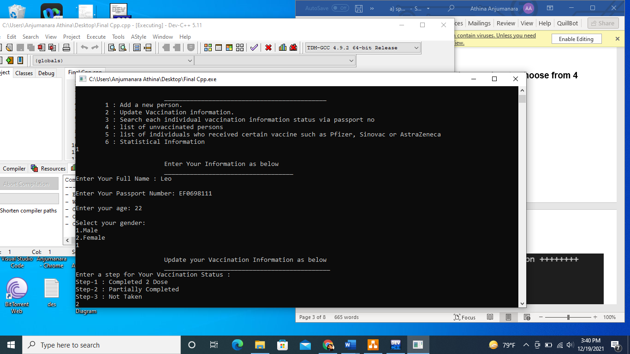

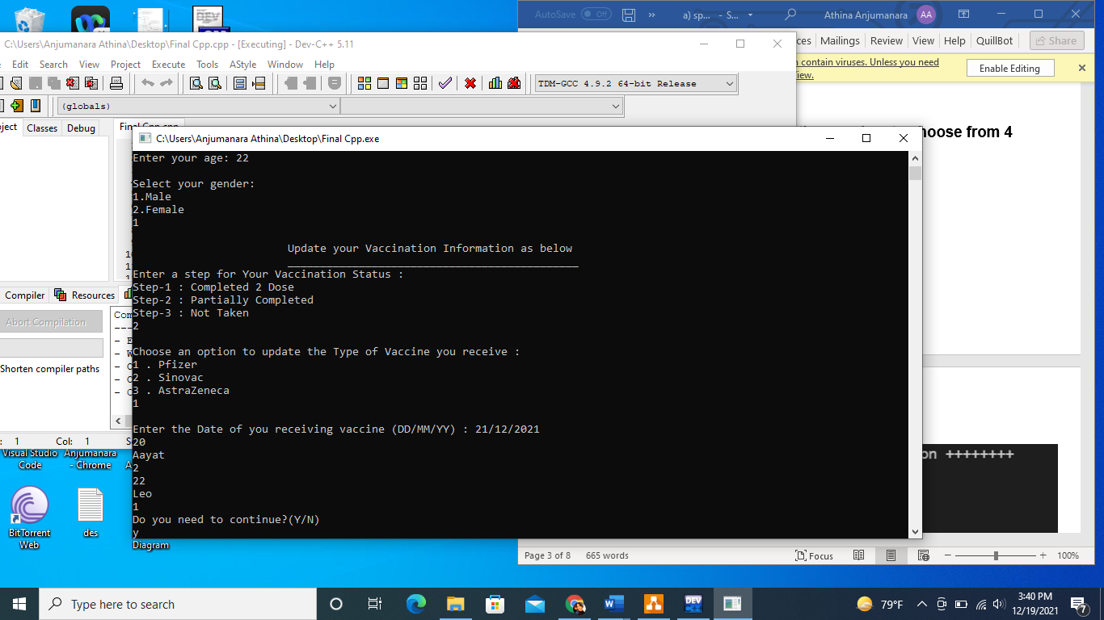

**Step-4:**

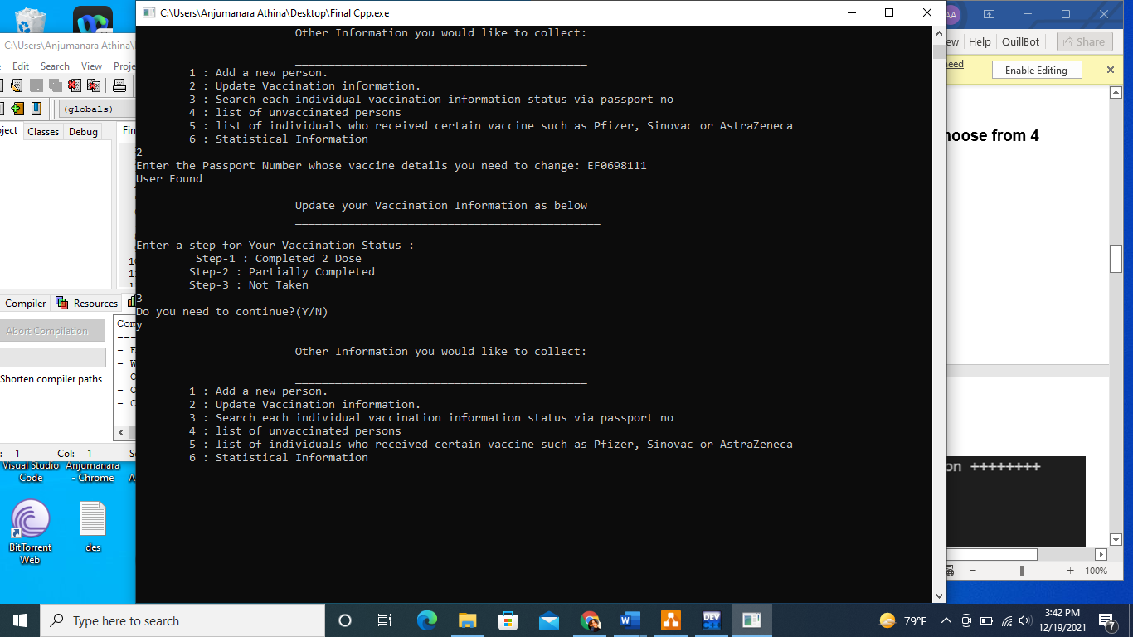

**Step-5:**

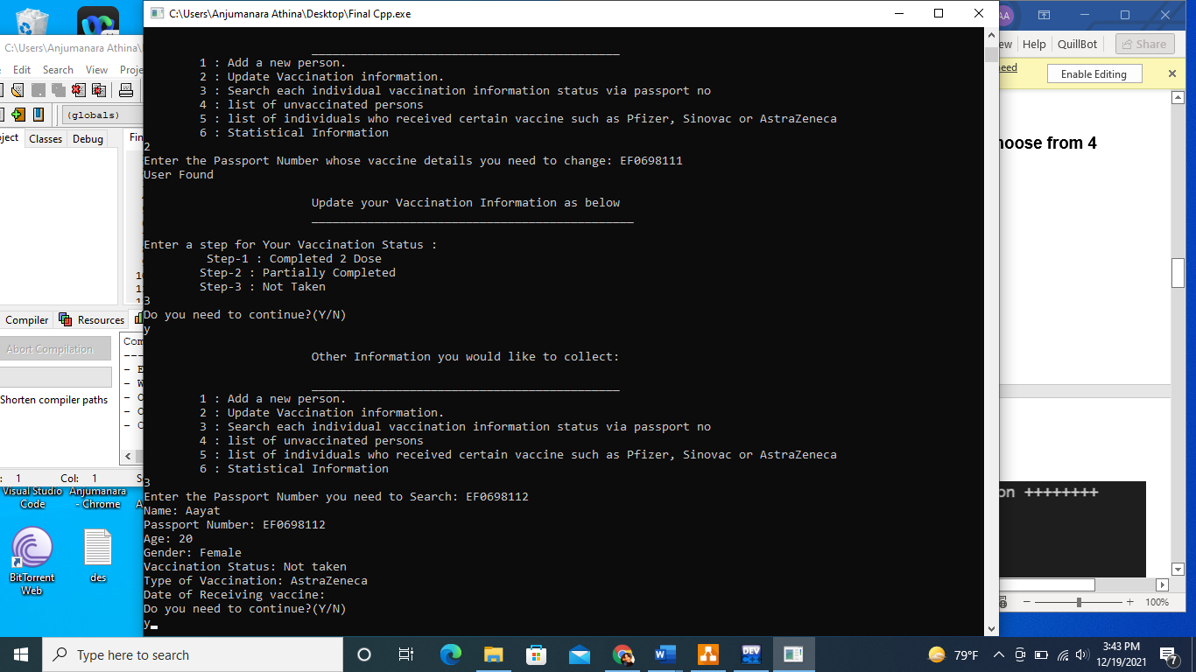

**Step-6:**

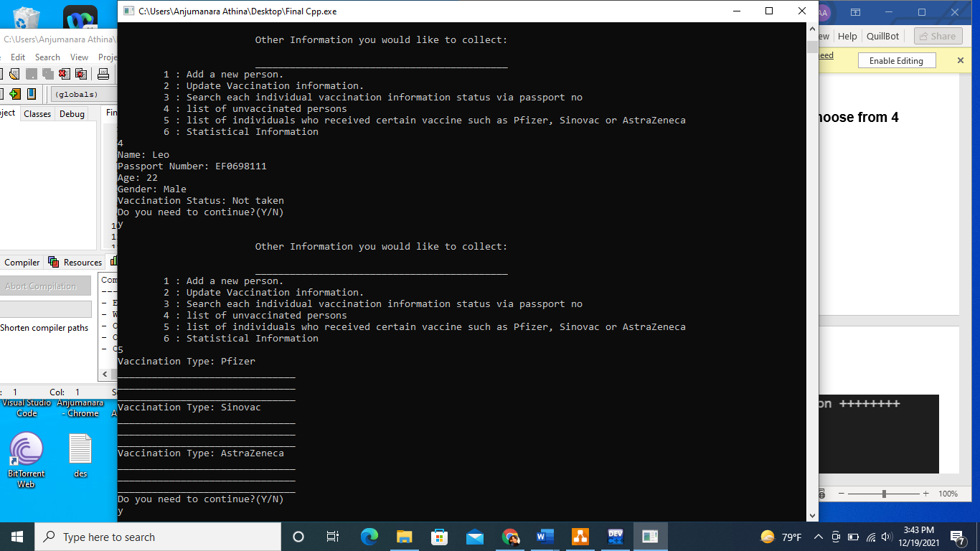

**Step-7:**



**Step-8:**

