BookFlow Database Project Report
MySQL Relational Database Management System Implementation & Constraint Validation
Developer / Author: | Arun Tej (2520030472)
Database Name: | bookflow_db

1. Project Overview
The BookFlow database project is a robust relational database management system designed to streamline library operations, manage book inventories, and track active library members. Built on MySQL Server 8.0, the system enforces strict relational integrity, domain constraints, and entity uniqueness to ensure reliable data management.
2. Database Schema & Architecture
The database bookflow_db consists of two primary normalized tables: books and members. These tables establish clear entity relationships and leverage MySQL constraints to maintain data quality.
A. Books Table Structure
The books table stores comprehensive details about every publication available in the system inventory.
- book_id: INT, Auto-Increment, Primary Key uniquely identifying each book entry.
- title: VARCHAR(255), Not Null ensuring every book has a registered title.
- isbn: VARCHAR(13), Not Null and Unique, representing the International Standard Book Number.
- published_year: INT, validated via a custom check constraint.
B. Members Table Structure
The members table tracks registered library participants.
- member_id: INT, Auto-Increment, Primary Key uniquely identifying each member.
- full_name: VARCHAR(100), Not Null recording the member's full name.
- email: VARCHAR(150), Not Null and Unique, used for user communication and identification.
3. Implementation & Data Insertion
Database creation and table definitions were successfully executed in the MySQL monitor environment. Initial seed data was populated to verify operational readiness:
- Initial Books Seeded: 'The Alchemist' (1988), 'Clean Code' (2008), and 'Atomic Habits' (2018).
- Initial Members Seeded: Arun Tej (arun.tej@gmail.com), Sai Shashank (sai.shashank@gmail.com), and Manish (manish@gmail.com).
4. Constraint Validation & Error Handling
To test the resilience and integrity enforcement of bookflow_db, several edge cases and constraint violation tests were executed. The database successfully intercepted and rejected invalid transactions:
- Duplicate ISBN Violation (Error 1062): Attempting to insert a book with an existing ISBN ('9780061122415' from The Alchemist) triggered a duplicate entry error on the unique isbn key.
- Null Title Violation (Error 1048): Inserting a record with a NULL title and ISBN '9999999999999' was blocked because the title column is constrained as NOT NULL.
- Check Constraint Violation (Error 3819): Attempting to add a book published in the future ('Time Traveler' with published_year = 2030) was rejected by the table check constraint (chk_published_year: published_year < 2027).
- Duplicate Email Violation (Error 1062): Registering a member clone ('Arun Clone') with an existing email ('arun.tej@gmail.com') was blocked by the unique email constraint.
5. Conclusion
The BookFlow database implementation successfully demonstrates professional database design principles in MySQL. By incorporating auto-incrementing primary keys, unique constraints, not-null filters, and custom check constraints, the system effectively safeguards against anomalous data entry, ensuring high integrity for academic and real-world library applications.

6. Screenshots

Database Tables (SHOW TABLES)
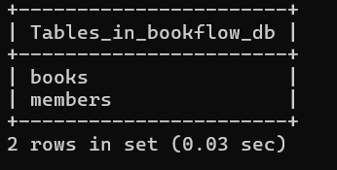

Books Table Structure (DESCRIBE BOOKS)
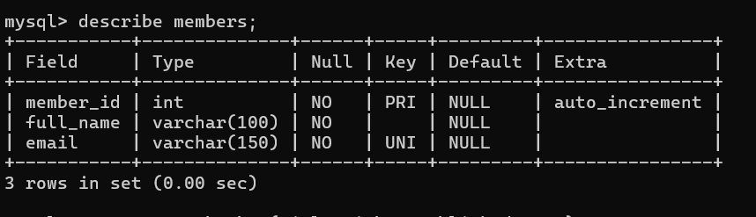

Members Table Structure (DESCRIBE MEMBERS)
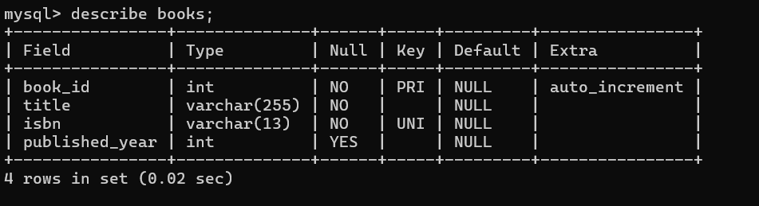

Books Table Data (SELECT * FROM BOOKS)
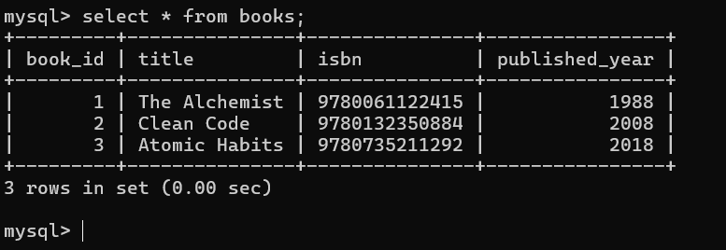

Members Table Data (SELECT * FROM MEMBERS)
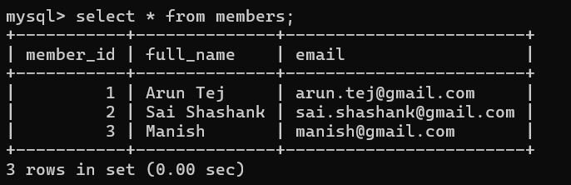

Books Table Data (Alternate Screenshot)
