BookFlow Database Project Report
MySQL Relational Database Management System Implementation, Schema Validation & Screenshots
Developer / Author: | Arun Tej (2520030472)
Database Name: | bookflow_db2

1. Project Overview
The BookFlow database project (bookflow_db2) is a relational database management system designed to streamline library operations, manage book inventories, track active library members, handle loan circulations, and record book donations.
2. Database Creation & Schema Architecture
The database bookflow_db2 was created in MySQL, establishing normalized tables with primary keys, unique constraints, check constraints, and foreign key relationships.
A. Books Table Structure & Seed Data
- book_id: INT, Primary Key uniquely identifying each book entry.
- title: VARCHAR(100), Not Null ensuring every book has a registered title.
- isbn: VARCHAR(20), Unique International Standard Book Number.
- published_year: INT, validated via check constraint (published_year < 2027).
Initial books populated: The Great Gatsby (1925), To Kill a Mockingbird (1960), and 1984 (1949).
B. Members Table Structure & Seed Data
- member_id: INT, Primary Key uniquely identifying each member.
- full_name: VARCHAR(100), recording the member's full name.
- email: VARCHAR(100), Unique email for member communication.
Initial members populated: John Smith, Emma Wilson, and Michael Brown.
C. Loans Table Structure & Foreign Key Relationships
- loan_id: INT, Primary Key.
- member_id: INT, Foreign Key referencing Members(member_id).
- book_id: INT, Foreign Key referencing Books(book_id).
- loan_date: DATE, recording the transaction date.
10 active loan circulation records successfully inserted and verified spanning January to April 2025.
3. System Tables & Schema Verification
Comprehensive table descriptions and schema structures were verified across all database relations, including books, donation_history, loans, and members.
4. Conclusion
The BookFlow database implementation successfully demonstrates professional relational database design principles in MySQL, incorporating foreign key integrity, check constraints, and multi-table operations for effective library management.

Additional Database Screenshots

Database Creation, Books Table & Data
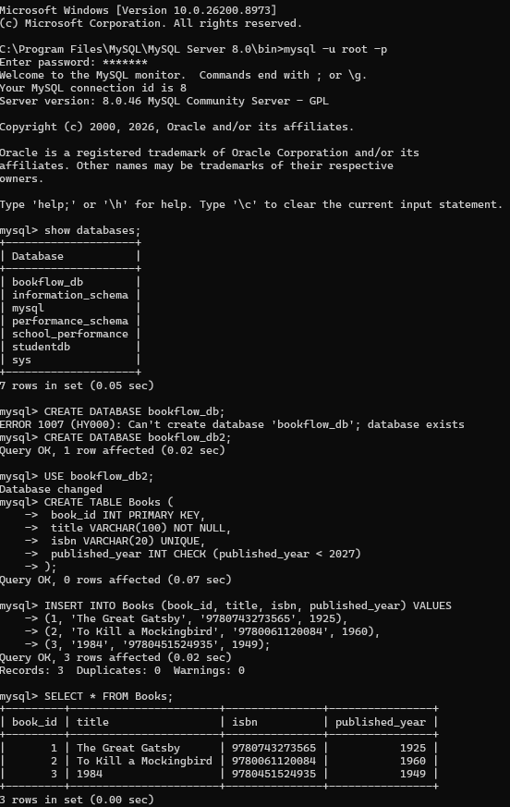

Members, Loans Table & Data
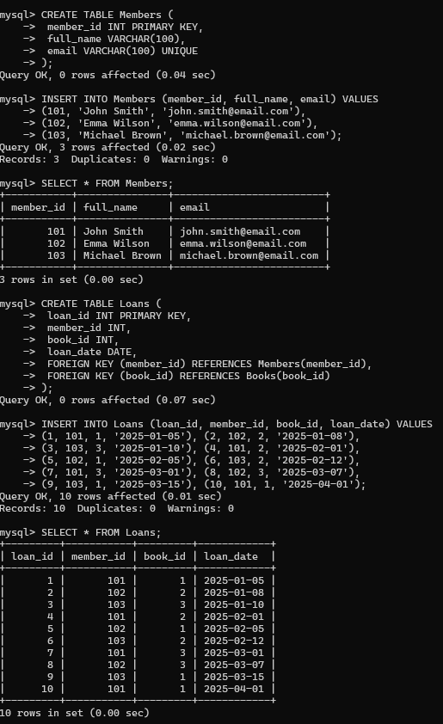

Donation History, SHOW TABLES & DESCRIBE
