Typing Bassa on Linux Computers
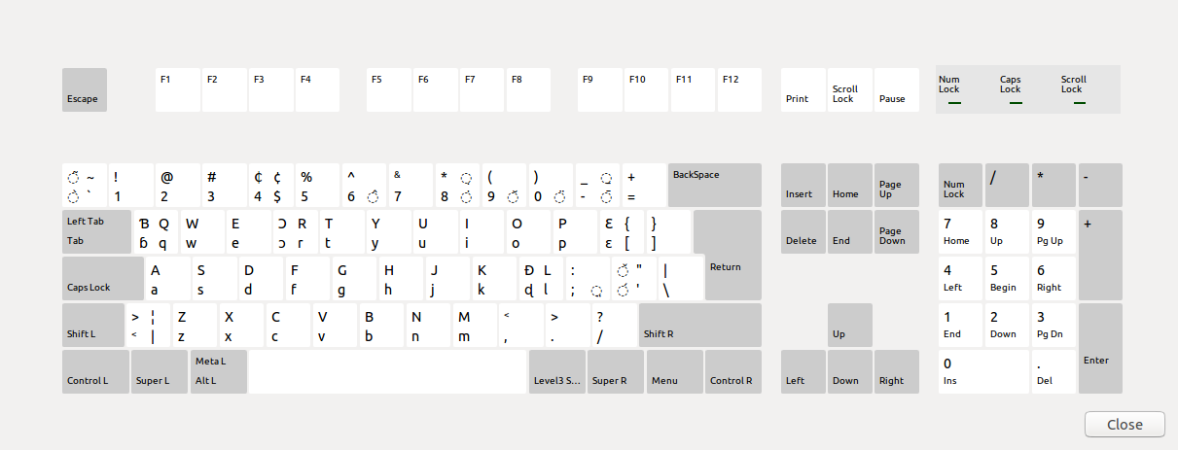
The diagram above shows the location of the keys. You can view this layout at any time. Right-click on the keyboard switcher (US/Lb) button on the tool panel at the top of the screen, and click Keyboard Layout Chart. The layout is based on a normal QWERTY keyboard but a few non-used keys are replaced. The keys: Q, R, L, and [ have been replaced with Ɓ, Ɔ, Đ, and Ɛ. Combining characters are used for typing diacritic marks.
To change from the US English keyboard to Bassa, click US on the tool panel at the top of the screen. When you click this button it changes the keyboard from US to Bassa. The button now says Lb. Click it again to switch back to US English.
The following table shows the key sequence to produce the extended characters for Bassa, and replaced characters
Character | Key Sequence
Ɓ | Q
Ɔ | R
Ɛ | [
Đ | L
Q | RAlt + SHIFT + Q
R | Ralt + SHIFT + X
[ | RAlt + [
L | RAlt + SHIFT + [
q | RAlt + Q
r | Ralt + R
l | RAlt + L

To type Đ, simply press L. To type L, which is has been replaced because it’s not used in Bassa, press RAlt + L together. RAlt is the Alt key next to the Space bar on the right side. In the diagram at the beginning of this document it is shown as ISO_Le...
The follow combining characters are defined for typing diacritic marks:
Name | Tone | Mark | Access Key
Combining Grave Accent | Low | ò | RAlt + TILDE
Combining Acute Accent | High | ó | RAlt + APOSTROPHE
Combining Circumflex Accent | High-Low | ā | RAlt + Minus
Combining Macron | High-Low | â (option) | RAlt + 6
Combining Breve | Low-Rise | ǎ | RAlt + 10
Combining Tilde | Nasalization | ã | RAlt + Shift + TILDE

To type a diacritic mark, first type the base character you want to add a diacritic mark to and then type the key sequence for the combining key from the above table.
Placing tone marks above upper case (capital) letters requires that you install the correct fonts. These can be downloaded from SIL fonts library. I like Andika, Charis, Doulos, and Gentium.
You can use the Bassa keyboard for the LibreOffice Writer (which is similar to Microsoft Word) and the LibreOffice Calc (similar to Microsoft Excel). It also works for web applications, such as email, and for the simple text editor (gedit) in Linux, although Bassa characters are somewhat wonky. This editor is handy for writing short notes.
Please contact me for suggestions and preferences. We can make changes, and I will be looking into ways to make those changes.
Tim Slager
Grand Rapids, MI
October 2008
Update: March 2014, October 2014

Technical Stuff
The following information came from Chris Manu, who helped with the files for writing Bassa. It describes a variety of ways for altering a keyboard so that it will type Bassa. To get a Windows computer to type Bassa, I suggest that you contact William Boen or one of the others at LIBTRALO and ask them for help in configuring the computer to type Bassa. I have written these instructions for writing Bassa with Linux computers, such as the laptop(s) shipped in November of 2008.
Microsoft Keyboard Layout Creator
This format provides a keyboard layout for Microsoft Windows environment. The layout is as described above except there are no limitations on the number of diacritic marks that can be added to a base character. This limitation is due to the fact that there are no context information provided by the Microsoft keyboard layout creator. This solution is applicable to users who cannot afford to purchase Tavultesoft keyman to use the keyman solution below.
Linux Xkb
This format is used by linux X windows keyboard extension to provide a native keyboard support for Bassa. Like the Microsoft keyboard layout, context information are not available to provide diacritic marking constraints. In addition, deadkey key sequences are not available.
Tavultesoft Keyman
This provides a complete solution in terms of restricting the number of diacritic marks: limited to two. The layout is as described above. Both RAlt and dead key sequence are available.
Under Linux, the KMFL + SCIM engine does not have the CAPS key behavior currently implemented and therefore press CAPS key does not provide the expected behavior as is on Windows version of Tavultesoft keyman. As a workaround, Shift key should be used to type upper case letters.
Compilation and Installation
Microsoft Keyboard Layout Create:
- Go to http://www.microsoft.com/globaldev/tools/msklc.mspx to obtain the MKLC tool.
- Install the MKLC tool by following instructions provided by Microsoft.
- Lunch the MKLC tool from the Programs menu
- From the file menu, select the “Load Source File…” and use the File Open dialog box to locate and open the klc keyboard definition files in the windows folder.
- The selected keyboard layout is displayed. From the Project menu, select Validate menu. Windows may return with warning message. These are safe to ignore. If it fails, review the error log it provides you for a clue to resolving the problem. Eg. You cannot build a keyboard package that is currently installed on your computer. Contact kasahorow for assistance if you encounter any difficulties.
- Again, from the Project menu select “Build DLL and Setup Package”
- A setup package is created in your current working folder, which is “My Documents” by default.
- From windows explorer, navigate to your working folder and lunch the double click on the setup.exe file for your system architecture to launch the installation wizard. Follow the on-screen instructions to complete the installation.
- To select the installed keyboard for testing, navigate to the Control Panel and launch the “Regional and Language options” component.
- The Regional and Language Options window opens. Click the “Languages” tab, and click the “Details” button.
- The Text Services and Input Language window opens. Click the Add button to open the Add Input Language window.
- All the keyboards are currently assigned to English language for testing purposes, as not languages have locale support under windows.
- Select the “Keyboard Layout/IME” checkbox to activate installed keyboards drop down list.
- From the drop down list, select the keyboard you’ve just installed and click OK.
- Click OK again, to close the Text Services and Input Language window.
- A small keyboard icon will appear on windows task bar. Use this icon to switch between installed keyboards.
Linux Xkb
NOTE: This is the process I used for typing Bassa on Linux computers.
For testing purposes, all the proposed keyboard layouts are being distributed as a single file. This will appear under linux as one keyboard layout with many variants. After going to testing and acceptance, the keyboard definitions will be grouped by country and language with the respective currency symbol defined.
To install the African keyboards for linux, perform the following steps:
1. Copy the Africa X keyboard definition file “bassa” file to /etc/X11/xkb/symbols
2. Create a backup copy of your existing xorg.xml file in /etc/X11/xkb/rules/xorg.xml
3. Copy the “xorg.xml” file to /etc/X11/xkb/rules/xorg.xml
4. Use the keyboard switcher to choose test the Bassa Keyboard
Update (2014-3):
I have installed these a couple of times since this. I am now installing fonts on a Xubuntu machine that I am getting ready to send to Liberia. I thought I had updated this file with my latest, but the location is now different and file names are different.
The keyboard definition file is lr (stands for Liberia) and the rules file is evdev.xml. The place to find these directories is/usr/share/X11/xkb/
To start, copy the custom evdev.xml file and the lr file to the desktop of your computer.
I haven't explained how to copy, move, and rename files. I have to re-figure this out every time. You have to use the Terminal (in Xubuntu, Terminal emulator). You'll need to find this in your menu or dashboard. In Linux 12.04, go to the Dashboard and type Terminal.
When you start Terminal, you have to find the usr directory. By default you will probably be in the home or your own user directory. To back up, type:
cd ..
<ENTER>
Then type:
ls
<ENTER>
Do this until, when you type ls you see the usr directory. Then type:
cd usr
<ENTER>
cd share
<ENTER>
cd X11
<ENTER>
cd xkb
<ENTER>
cd rules
<ENTER>
sudo mv evdev.xml evdev.BACK.xml
<ENTER>
This renames the current evdev.xml file to a backup copy. Next you need to copy the custom evdev.xml file from your desktop to the same rules folder. You can back up all the way to the root File System directory by repeatedly typing cd .. or by typing cd /home, or you can start a new instance of Terminal. Xubuntu has a very nice feature in that you can use the File Manager to navigate to a location, right-click, and then click Open Terminal Here.
I'm going to assume that you have Xubuntu and have navigated to the Desktop in File Manager, or you can figure out how to get to the folder in Terminal. So right-click in the Desktop folder and open the Terminal.
Type:
sudo cp evdev.xml /usr/share/X11/xkb/rules
<ENTER>
sudo cp lr /usr/share/X11/xkb/symbols
<ENTER>
In Ubuntu, use the gnome/KDE keyboard switcher to choose the Bassa Keyboard. In Xubuntu:
- Click the blue menu button in the top left corner.
- Click Settings.
- Click Lxkeymap.
- In the left pane, scroll to and click Liberia.
- In the right pane, click Bassa.
- Click Apply.
- Close the Lxkeymap window.
You can also add an indicator on the top panel to show which language you are using. To do this:
- Right click on the panel at the top of the screen.
- Click Panel.
- Click Add New Items.
- Scroll to and select Keyboard Layouts.
- Click Add.
When you are typing US English, a small, rectangular US flag is on the right side of the panel. When you switch to Bassa, the rectangular flag is replaced with a round flag with a lone star.
Linux lr File
This keyboard mapping file is added to this folder:
/usr/share/X11/xkb/symbols
Eventually, this file should include mappings for all Liberian languages, although one might make a case for having a separate file for Vai. Still, I'd rather have them all together.
partial default alphanumeric_keys
xkb_symbols "basic" {

include "us"

name[Group1]= "Liberia";

key <AE04> { [ 4, dollar, cent, 0x010020B5 ] };
key <AC10> { [ semicolon, colon, 0x01000324 ] }; //COMBINING DIAERESIS BELOW
key <AC11> { [ apostrophe, quotedbl, 0x01000301, 0x0100030c ] }; //COMBINING ACUTE ACCENT, COMBINING CARON
key <TLDE> { [ grave, asciitilde, 0x01000300, 0x01000303 ] }; //COMBINING GRAVE ACCENT, COMBINING TILDE
key <AE06> { [ 6, asciicircum, 6, 0x01000302 ] }; //COMBINING CIRCUMFLEX ACCENT
key <AE08> { [ 8, asterisk, 0x01000307, 0x01000323 ] }; //COMBINING DOT ABOVE, COMBINING DOT BELOW
key <AE09> { [ 9, parenleft, 0x01000306 ] }; //COMBINING BREVE
key <AE10> { [ 0, parenright, 0x01000308 ] }; //COMBINING DIAERESIS
key <AE11> { [ minus, underscore, 0x01000331, 0x01000304 ] }; //COMBINING MACRON,COMBINING MACRON BELOW

include "level3(ralt_switch)"
};

partial default alphanumeric_keys
xkb_symbols "bassa" {

include "lr(basic)"

name[Group1]= "Liberia - Bassa";

key <AD11> { [ 0x0100025B, 0x01000190, bracketleft, braceleft ] }; //LATIN LETTER OPEN E
key <AD01> { [ 0x01000253, 0x01000181, q, Q ] }; //LATIN LETTER B WITH HOOK
key <AC09> { [ 0x01000256, 0x01000110, l, L ] }; //LATIN LETTER SOFT D
key <AD04> { [ 0x01000254, 0x01000186, r, R ] }; //LATIN LETTER OPEN O
key <TLDE> { [ 0x01000300, 0x01000303, grave, asciitilde ] }; //COMBINING GRAVE ACCENT, COMBINING TILDE
key <AE06> { [ 6, 0x01000302, 6, asciicircum ] }; //COMBINING CIRCUMFLEX ACCENT
key <AE11> { [ minus, 0x01000331, underscore, 0x01000304 ] }; //COMBINING MACRON,COMBINING MACRON BELOW

};

partial alphanumeric_keys
xkb_symbols "vah" {

include "lr(basic)"

name[Group1]= "Liberia - BassaVah";

key <AB01> { [ 0x01016ADC, 0x01016ADC, z, Z ] }; //VAH LETTER Zɔ
key <AB02> { [ 0x01016ADA, 0x01016ADA, x, X ] }; //VAH LETTER XWA
key <AB03> { [ 0x01016ADF, 0x01016ADF, c, C ] }; //VAH LETTER CE
key <AB04> { [ 0x01016AE3, 0x01016AE3, v, V ] }; //VAH LETTER VU
key <AB05> { [ 0x01016AE2, 0x01016AE2, b, B ] }; //VAH LETTER BHA (FORTIS B)
key <AB06> { [ 0x01016AD0, 0x01016AD0, n, N ] }; //VAH LETTER ENNI
key <AB07> { [ 0x01016AD4, 0x01016AD4, m, M ] }; //VAH LETTER MƐ
key <AB08> { [ 0x01016AF5, 0x01000273, comma, less ] }; //VAH COMMA
key <AB09> { [ 0x01016AF6, 0x0100019D, period, greater ] }; //VAH PERIOD
key <AB10> { [ slash, question, 0x01000294, 0x01000295 ] }; //NO VAH CHARACTER

key <AC01> { [ 0x01016AE7, 0x01016AE7, a, A ] }; //VAH LETTER A
key <AC02> { [ 0x01016AD2, 0x01016AD2, s, S ] }; //VAH LETTER SE
key <AC03> { [ 0x01016AD7, 0x01016AD7, d, D ] }; //VAH LETTER DHI (FORTIS D)
key <AC04> { [ 0x01016AD3, 0x01016AD3, f, F ] }; //VAH LETTER FA
key <AC05> { [ 0x01016AD6, 0x01016ADD, g, G ] }; //VAH LETTER GA, LETTER GBU
key <AC06> { [ 0x01016AE4, 0x01016AE4, h, H ] }; //VAH LETTER HIĨ
key <AC07> { [ 0x01016AD9, 0x01016AD9, j, J ] }; //VAH LETTER JƆ
key <AC08> { [ 0x01016AD1, 0x01016AD8, k, K ] }; //VAH LETTER KA, LETTER KPA
key <AC09> { [ 0x01016ADE, 0x01016ADE, l, L ] }; //VAH LETTER DƆ (LENIS D)
key <AC10> { [ 0x01016AF2, 0x01016AF4, semicolon, colon ] }; //COMBINING VAH MID TONE, HIGH-LOW TONE
key <AC11> { [ 0x01016AF0, 0x01016AF3, apostrophe, quotedbl ] }; //COMBINING VAH HIGH TONE, LOW-MID TONE

key <AD01> { [ 0x01016AE6, 0x01016AE6, q, Q ] }; //VAH LETTER BADA (LENIS B)
key <AD02> { [ 0x01016ADB, 0x01016ADB, w, W ] }; //VAH LETTER WA
key <AD03> { [ 0x01016AEB, 0x01016AEB, e, E ] }; //VAH LETTER E
key <AD04> { [ 0x01016AE8, 0x01016AE8, r, R ] }; //VAH LETTER Ɔ
key <AD05> { [ 0x01016AE1, 0x01016AE1, t, T ] }; //VAH LETTER TO
key <AD06> { [ 0x01016AD5, 0x01016AD5, y, Y ] }; //VAH LETTER DYI
key <AD07> { [ 0x01016AEA, 0x01016AEA, u, U ] }; //VAH LETTER U
key <AD08> { [ 0x01016AED, 0x01016AED, i, I ] }; //VAH LETTER I
key <AD09> { [ 0x01016AE9, 0x01016AE9, o, O ] }; //VAH LETTER O
key <AD10> { [ 0x01016AE5, 0x01016AE5, p, P ] }; //VAH LETTER PA
key <AD11> { [ 0x01016AEC, 0x01016AEC, bracketleft, braceleft ] }; //VAH LETTER ɛ
key <BKSL> { [ backslash, bar, 0x010001C1, 0x010001C0 ] }; //NO VAH CHARACTER

key <TLDE> { [ 0x01016AF1, 0x01016AF1, grave, asciitilde ] }; //COMBINING VAH LOW TONE
key <AE01> { [ 1, exclam, exclamdown, onesuperior ] };
key <AE02> { [ 2, at, twosuperior, dead_doubleacute ] };
key <AE03> { [ 3, numbersign, threesuperior, dead_macron ] };
key <AE04> { [ 4, dollar, currency, sterling ] };
key <AE05> { [ 5, percent, EuroSign ] };
key <AE06> { [ 6, 0x01016AF4, onequarter, asciicircum ] }; //COMBINING VAH HIGH-LOW TONE
key <AE07> { [ 7, ampersand, onehalf, dead_horn ] };
key <AE08> { [ 8, asterisk, threequarters, dead_ogonek ] };
key <AE09> { [ 9, parenleft, leftsinglequotemark, dead_breve ] };
key <AE10> { [ 0, parenright, rightsinglequotemark, dead_abovering ] };
key <AE11> { [ 0x01016AF3, 0x01016AF4, minus, underscore ] }; //COMBINING VAH LOW-MID TONE, HIGH-LOW
key <AE12> { [ 0x01016AF5, 0x01016AF6, equal, plus ] }; //VAH COMMA, VAH FULL STOP
};
Linux evdev.xml File
A modified version of the evdev.xml file goes in this folder:
/usr/share/X11/xkb/rules
The file is too long to include here, especially because most of it does not apply to Bassa or Liberian languages. However, the lines in the following image should be included.
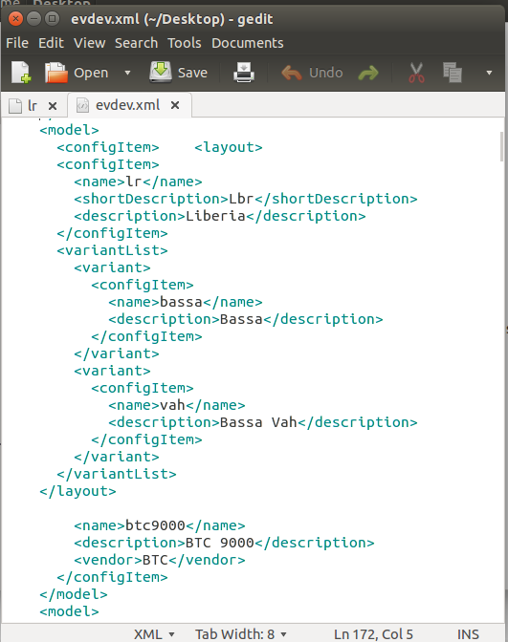
Tavultesoft keyman
Download Tavultesoft keyman Developer version to compile and install the *.kmn file
Detailed instructions are provided on Tavultesoft website

KMFL+SCIM Engine
Install KMF and SCIM engine from http://kmfl.sourceforge.net/
Instructions are provided on their website. Instead of compiling from source, use the rpm file to install KMFL http://downloads.sourceforge.net/kmfl/kmfl-0.9.6-fc8.tar.gz?modtime=1203960629&big_mirror=0
After installation, restart X and use the SCIM applet to install the .kmn file

