SAS-MACRO
Macros take longer to write and debug than standard SAS code, you generally won’t want macros in programs that will be run only a few times. But used properly, macros can make the development and maintenance of production programs much easier.
They do this in several ways.
- With macros you can make one small change in your program and have SAS echo that change throughout your program.
- Macros allow you to write a piece of code once and use it over and over, in the same program or in different programs. You can even store programs in a central location—an auto call library—and share them between programs and between programmers.
- you can make your programs data driven, letting SAS decide what to do based on actual data values.

The two main components of the SAS macro facility are SAS macro variables and SAS macro programs.
SAS Macro Variables: The names of macro variables are prefixed with an ampersand (&) while the names of macros are prefixed with a percent sign (%). A macro variable is like a standard data variable except that, having only a single value, it does not belong to a data set, and its value is always character. This value could be a variable name, a numeral, or any text that you want substituted into your program.
SAS Macro programs: A macro, on the other hand, is a larger piece of a program that may contain complex logic including complete DATA and PROC steps and macro statements such as %DO, %END, and %IF-%THEN/%ELSE.

SCOPE of Macro Variables: Local versus global Macro variables can have two kinds of “scope”⎯either local or global. Generally, a macro variable is local if it is defined inside a macro. A macro variable is generally global if it is defined in “open code” which is everything outside a macro. You can use a global macro variable anywhere in your program, but you can use a local macro variable only inside its own macro.

Turning on the macro processor Before you can use macros you must have the MACRO system option turned on. This option is usually turned on by default, but may be turned off, especially on mainframes, because SAS runs slightly faster when it doesn’t have to bother with checking for macros. If you are not sure whether the MACRO option is on, you can find out by submitting these statements:

PROC OPTIONS OPTION = MACRO;
RUN;
Creating a macro variable :
%LET macro-variable-name = value;
%LET iterations = 10;
%LET country = New Zealand;

240W 02-07-2008 Ginger 120
240W 02-07-2008 Protea 180
356W 02-08-2008 Heliconia 60
356W 02-08-2008 Anthurium 300
188R 02-11-2008 Ginger 24
188R 02-11-2008 Anthurium 24
240W 02-12-2008 Heliconia 48
240W 02-12-2008 Protea 48
356W 02-12-2008 Ginger 240

%LET flowertype = Ginger;

DATA flowersales;
INFILE 'c:\MyRawData\TropicalSales.dat';
INPUT CustomerID $4. @6 SaleDate MMDDYY10. @17 Variety $9. Quantity;
/* IF Variety = "&flowertype"; */ RUN;

* Print the report using a macro variable;
PROC PRINT DATA = flowersales;
WHERE Variety=”&flowertype”;
FORMAT SaleDate WORDDATE18.;
TITLE "Sales of &flowertype"; RUN;

Creating Modular Code with Macros :
%MACRO macro-name;
macro-text
%MEND macro-name;

Invoking a macro:
%macro-name
EX- %MACRO sample;
PROC SORT DATA = flowersales;
BY DESCENDING Quantity; RUN;
PROC PRINT DATA = flowersales (OBS = 5);
FORMAT SaleDate WORDDATE18.; RUN;
%MEND sample;

* Invoke the macro;
%sample

Term Description
input stack Holds a SAS program after it is submitted and before it is processed by the word scanner.
word scanner Scans the text it takes from the input stack and breaks the text into tokens. Determines the destination of the token: DATA step compiler, macro processor, etc.
token Fundamental unit in the SAS language. SAS statements must be broken down into tokens, or tokenized, before the statements can be compiled. Tokens are the actual words in the SAS statements as well as the literal strings, numbers, and symbols.
compiler Checks the syntax of tokens received from the word scanner. After it completes checking the syntax, the compiler translates the tokens into a form for execution.
macro processor Processes macro language references and statements.
macro trigger The symbols & and %, when followed by a letter or underscore, that signal the word scanner to transfer what follows to the macro processor.
macro symbol table The area in memory where macro variables and their associated values are stored.

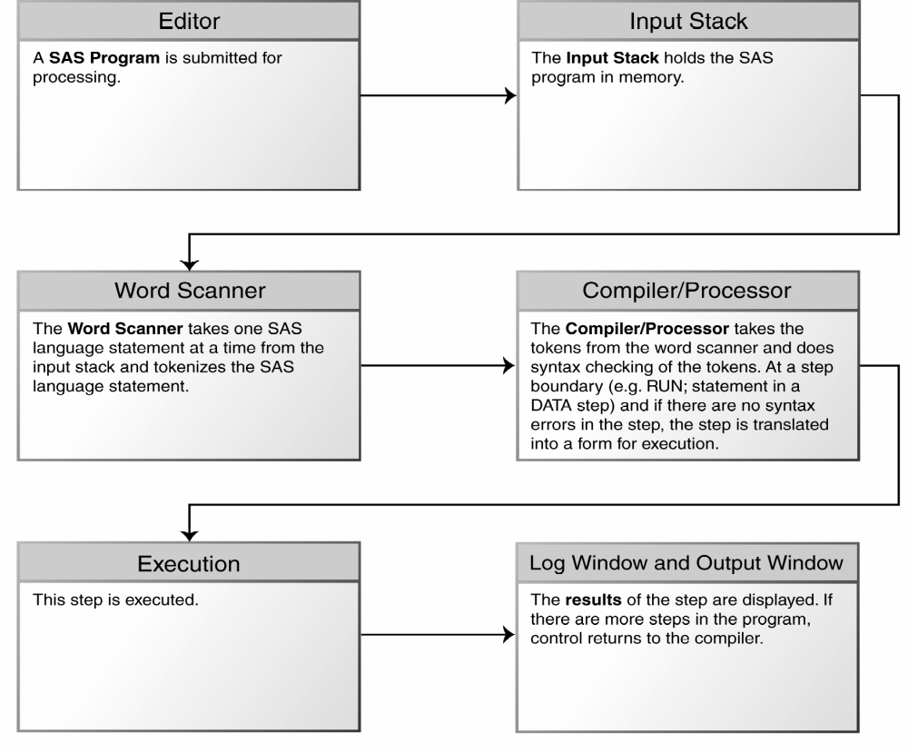

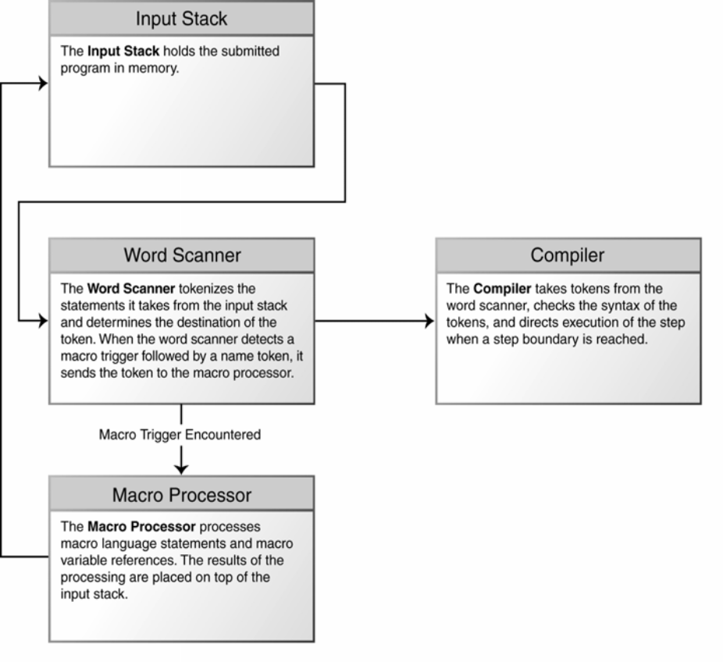

Macro autocall libraries The macros are defined and invoked inside a single program, but you can also store macros in a central location, called an autocall library. Macros in a library can be shared by programs and programmers. Basically you save your macros as files in a directory or as members of a partitioned data set (depending on your operating environment), and use the MAUTOSOURCE and SASAUTOS= system options to tell SAS where to look for macros.
Then you can invoke a macro even though the original macro does not appear in your program. For more information see the SAS Help and Documentation.
Adding Parameters to Macros
Parameters are macro variables whose value you set when you invoke a macro. So, suppose you may want the same report, but for a different data set, or product, or patient. Parameters allow you to do this.
%MACRO macro-name (parameter-1=, parameter-2= . . . parameter-n=);
Macro-text
%MEND macro-name;
Taking the same data once again; suppose the gardener often needs a report showing sales to an individual customer. The following program defines a macro that lets the grower select sales for a single customer and then sorts the results.
* Macro with parameters;
%MACRO select (customer=, sortvar=);
PROC SORT DATA = flowersales OUT = salesout;
BY &sortvar;
WHERE CustomerID = "&customer"; RUN;
PROC PRINT DATA = salesout;
FORMAT SaleDate WORDDATE18. ;
TITLE1 "Orders for Customer Number &customer";
TITLE2 "Sorted by &sortvar"; RUN;
%MEND select;
*Invoke the macro;
%select (customer = 356W, sortvar = Quantity)
%select (customer = 240W, sortvar = Variety)
/*Keyword Parameters*/
%macro sclass(dname= ,dlist1= ,dlist2= );
PROC PRINT DATA = &dname;
VAR &dlist1 &dlist2;
Title "Database Details of &dname"; run;
%mend sclass;
%sclass(dlist2= height, dname= sashelp.class, dlist1=age);
/*POSITIONAL PARAMETERS*/
%macro temp(dname, dlist1, dlist2);
PROC PRINT DATA = &dname;
VAR &dlist1 &dlist2;
Title "Database Details of &dname"; run;
%mend temp;
%temp(sashelp.class, height, age);
Writing Macros with Conditional Logic
Combining macros and macro variables gives you a lot of flexibility, but you can increase that flexibility even more by adding macro statements such as %IF.
%IF condition %THEN action;
%ELSE %IF condition %THEN action;
%ELSE action;
%IF condition %THEN %DO;
SAS statements
%END
These macro statements can be used only inside a macro.
Automatic macro variables Every time you invoke SAS, the macro processor automatically creates certain macro variables. You can use these variables in your programs. The most common automatic macro variables are
Variable name Example
&SYSDATE 28MAY08
&SYSDAY Wednesday
Description: the character value of the date that job or session began the day of the week that job or session began.
Others macro variables are %put &sysdate &sysday &systime &sysver &syslast;
For example, you could combine conditional logic and an automatic variable like this:
%IF &SYSDAY = Tuesday %THEN %LET country = Belgium;
%ELSE %LET country = France;
%IF statements can contain actions that standard IF statements can’t contain, such as complete DATA or PROC steps and even other macro statements. The %IF-%THEN statements don’t appear in the standard SAS code generated by your macro. Remember you are writing a program that writes a program.
%MACRO dailyreports;
%IF &SYSDAY = Monday %THEN %DO;
PROC PRINT DATA = flowersales;
FORMAT SaleDate WORDDATE18.; RUN;
%END;
%ELSE %IF &SYSDAY = Tuesday %THEN %DO;
PROC MEANS DATA = flowersales MEAN MIN MAX;
CLASS Variety;
VAR Quantity; RUN;
%END;
%MEND dailyreports;
Writing Data-Driven Programs with CALL SYMPUT:
When you submit a SAS program containing macros it goes first to the macro processor which generates standard SAS code from the macro references. Then SAS compiles and executes your program. Not until execution—the final stage—does SAS see any actual data values. This is the tricky part of writing data driven programs: SAS doesn’t know the values of your data until the execution phase, and by that time it is ordinarily too late.
CALL SYMPUT takes a value from a DATA step and assigns it to a macro variable. You can then use this macro variable in later steps. To assign a value to a single macro variable, you use CALL SYMPUT with this general form:
CALL SYMPUT ("macro-variable-name”, value);
Where macro-variable-name, enclosed in quotation marks, is the name of a macro variable, and
Value is the value you want to assign to that macro variable. Value can be the name of a variable whose value SAS will use, or it can be a constant value enclosed in quotation marks.
CALL SYMPUT is often used in IF-THEN statements such as this:
IF Age >= 18 THEN CALL SYMPUT ("status", "Adult");
ELSE CALL SYMPUT ("status", "Minor");
These statements create a macro variable named &STATUS and assign to it a value of either Adult or Minor depending on the variable Age.
Caution You cannot create a macro variable with CALL SYMPUT and use it in the same DATA step because SAS does not assign a value to the macro variable until the DATA step executes.
PROC SORT DATA = flowersales;
BY DESCENDING Quantity; RUN;
* Find biggest order and pass the customer id to a macro variable;
DATA biggest_customer;
SET flowersales;
IF _N_ = 1 THEN CALL SYMPUT ("selectedcustomer", CustomerID);
ELSE STOP; RUN;
PROC PRINT DATA = biggest_customer;
WHERE CustomerID = "&selectedcustomer";
FORMAT SaleDate WORDDATE18.;
TITLE "Customer &selectedcustomer Had the Single Largest Order";RUN;

Debugging Macro Errors:
Avoiding macro errors As much as possible develop your program in standard SAS code first. Then, when it is bug-free, add the macro logic one feature at a time. Add your %MACRO and %MEND statements. When that’s working, add your macro variables, one at a time, and so on, until your macro is complete and bug-free.
Quoting problems The macro processor doesn’t resolve macros inside single quotation marks. To get around this, use double quotation marks whenever you refer to a macro or macro variable and you want SAS to resolve it.
System options for debugging macros:
MERROR | NOMERROR when this option is on and SAS has trouble in finding a macro, SAS will print warning message.
SERROR | NOSERROR when this option is on, SAS will issue a warning if you use a macro variable that SAS cannot find.
MLOGIC | NOMLOGIC when this option is on, SAS prints in your log describing the actions of the macro processor
MPRINT | NOMPRINT when this option is on, SAS prints in your log showing the SAS statements generated by your macro.
SYMBOLGEN | NOSYMBOLGEN when this option is on, SAS prints messages in your log showing the value of each macro variable after resolution.
OPTIONS MPRINT NOSYMBOLGEN NOMLOGIC;
SAS/ACCESS
1. LIBNAME
2. SQL PASS THROUGH
3. PROC DBLOAD
LIBNAME TEST2 'E:\karthick\';
LIBNAME abcd ORACLE USER = PASSWORD = PATH = ;
LIBNAME myACC ACCESS 'C:\Documents and Settings\Administrator\My Documents\DB1.MDB';
SQL PASSTHROUGH
PROC SQL;
CONNECT TO ORACLE AS myoracle (USER = PASSWORD = PATH= );
SELECT * FROM CONNECTION TO myoracle
(select * from emp);
DISCONNECT FROM myoracle;
QUIT;
PROC DBLOAD
PROC DBLOAD DBMS = ORACLE DATA = sas-dsn APPEND;
USER = scott;
PASSWORD = tiger;
PATH = ;
TABLE = oracle-table-name;
errlimit = 10;
commit = 50;
LOAD; RUN;

