Real-world Scenario
The goal of this track challenge is to build a multi-agent system that can effectively assist students in their preparation for Microsoft certification exams. The system should be capable of understanding the exam syllabus, generating study plans, providing practice questions, and offering feedback on performance.
Below is a suggested architecture for your multi-agent solution. Feel free to adapt and expand upon this architecture based on your creativity and technical skills.
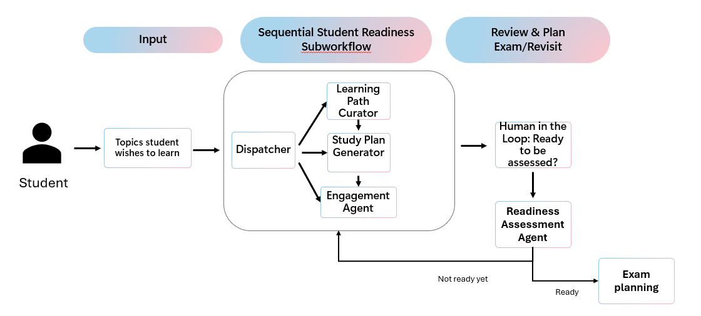
In the above architecture:
- The student inputs to the system the topics they wish to learn. This input is processed, so that the main information are extracted in a pre-defined structure and sent to a subworkflow of 3 sequential agents:
  - A learning path curator agent – suggesting a list of learning paths on Microsoft Learn relevant to the topics provided.
  - A study plan generator agent - converting the curated path into a tangible study plan and generating a timeline with milestones, suggested time allocations, and daily/weekly study sessions.
  - An engagement agent – setting up automated reminders to send to the student email to help them stay up to date with the study plan.
- Once the subworkflow is executed, the system waits for a human input that confirms the student is ready to start an assessment.
- Once the student confirms, the assessment agent generates an assessment to evaluate the student readiness.
- If the student passes the test, then another agent suggests the relevant Microsoft certification to take and plans the exam. Otherwise, the system loops back into the preparation subworkflow.

########################################################################
Here’s the upgraded architecture that maps exactly to the rubric.

A) Core Agents (Role-based specialization)

1. Intake & Structuring Agent (Executor)
- Extracts:
  - target exam (if known)
  - topics, skill level
  - available hours/week
  - target date
  - preferred learning mode
- Output: normalized JSON schema

2. Planner/Orchestrator Agent (Planner)
- Produces a step plan:
  - retrieve syllabus/objectives
  - curate Learn paths
  - generate study plan
  - set reminders
  - generate assessment
  - evaluate results and iterate
- Decides loops and escalations

3. Syllabus Mapper Agent (Executor)
- Grounds on:
  - official skills outline / syllabus
- Builds objective map:
  - objectives → subskills → resources → assessment tags

4. Learning Path Curator Agent (Executor + Tool user)
- Uses external retrieval:
  - Microsoft Learn modules/paths
- Returns ranked list with coverage justification:
  - “covers objective 1.2, 2.1…”

5. Study Plan Generator Agent (Executor)
- Generates:
  - milestones
  - time budget per objective
  - review cadence (spaced repetition)
  - practice schedule

6. Engagement / Reminder Agent (Tool user)
- Integrates with:
  - Graph API (email/calendar/tasks)
- Sends reminders + monitors drift:
  - if behind schedule → alert + replan suggestion

7. Assessment Builder Agent (Executor)
- Generates questions mapped to objectives:
  - tags: objective, difficulty, skill type
- Produces answer key + rationales

8. Critic/Verifier Agent (Verifier)
- Validates:
  - correctness
  - hallucination risk
  - objective coverage
  - style and fairness
- If fail → sends revision request back to builder (reflection loop)

9. Gap Analyzer Agent (Reflection)
- Uses results to:
  - compute readiness score
  - identify weak objectives
  - recommend remediation resources
- Feeds to Planner

10. Certification & Exam Planner Agent (Executor + Tool user)
- If readiness threshold met:
  - recommends certification
  - suggests booking plan
  - optionally adds calendar reminders (with user approval)

🔄 Workflow (demonstrates multi-step reasoning + loops)

Phase 1: Preparation
- Intake Agent → structured learner profile
- Planner → decides next steps
- Syllabus Mapper → objective map
- Curator (tool retrieval) → Learn paths + coverage notes
- Study Plan Generator → schedule + milestones
- Engagement Agent (Graph) → reminders + check-ins

Phase 2: Assessment + Iteration
- Student says “Ready”
- Assessment Builder → assessment
- Critic/Verifier → validate; if low confidence, revise
- Student takes assessment
- Gap Analyzer → readiness + weak areas
- Planner decides:
- If pass → certification planner
- If not → loop to curator + plan regeneration focusing weak objectives
This is exactly what “reasoning and multi-step decision making across agents” looks like.

AI-102 Student Preparation Flow — Step by Step (Bullet Points)

🧑‍🎓 Student Action
- Student searches for “AI-102” and provides availability and target timeline

🔹 1. Intake & Structuring Agent
- Parses the student’s free-text input
- Extracts:
  - Target certification → AI-102
  - Available study time per week
  - Target exam timeline
- Validates input and normalizes it into a structured learner profile

🔹 2. Preparation Orchestrator (Planner)
- Receives the structured learner profile
- Decides the preparation strategy based on:
  - Exam scope
  - Available time
  - Learning constraints
- Orchestrates the four preparation sub-agents

🔹 3. Syllabus Mapper Agent
- Retrieves the official AI-102 exam objectives
- Maps high-level domains such as:
  - Computer Vision
  - NLP
  - Azure OpenAI
  - Search & Knowledge Mining
  - Responsible AI
- Produces an objective-to-skill map to prevent hallucinated topics

🔹 4. Learning Path Curator Agent
- Searches Microsoft Learn for AI-102-relevant content
- Matches learning modules to each exam objective
- Ranks learning paths by relevance and coverage completeness
- Outputs a curated list of official learning resources

🔹 5. Study Plan Generator Agent
- Converts curated learning paths into a time-bound study plan
- Allocates study hours per objective
- Generates:
  - Weekly milestones
  - Review checkpoints
  - Practice windows
- Produces a realistic preparation timeline

🔹 6. Engagement Agent
- Sets up ongoing engagement for the student
- Sends reminders and nudges based on the study plan
- Monitors progress and flags delays or missed milestones
- Runs continuously without blocking other agents

📦 7. Preparation Output Artifact (Explicit Output)
- Combines preparation results into a single artifact:
  - ✅ Study plan
  - ✅ Microsoft Learn resources
  - ✅ Milestones and schedule
- This artifact becomes the input to the assessment decision

🔷 8. Readiness Decision (Human-in-the-Loop)
- Student is asked:
  - “Are you ready to take an AI-102 readiness assessment?”
- Human explicitly confirms readiness
- Decision controls whether assessment begins

🔹 9. Assessment Builder Agent
- Generates AI-102-style assessment questions
- Questions are:
  - Scenario-based
  - Tagged by exam objective
  - Balanced by difficulty
- Produces draft assessment content

🔹 10. Critic / Verifier Agent
- Reviews generated assessment questions
- Validates:
  - Correctness of answers
  - Alignment with AI-102 objectives
  - Difficulty balance
  - Safety and hallucination risks
- Sends content back for revision if issues are detected

🔹 11. Gap Analyzer & Reflection Agent
- Analyzes student assessment results
- Identifies:
  - Strong topics
  - Weak objectives
- Computes an overall readiness signal
- Produces targeted remediation insights

🔷 12. Final Readiness Decision
- System evaluates readiness outcome:
  - ✅ Ready → proceed to certification planning
  - ❌ Not ready → return to preparation with focused remediation

🔁 13. Targeted Re-planning (If Not Ready)
- Planner receives gap insights
- Updates study plan to focus only on weak areas
- Engagement agent resumes reminders
- Student re-enters preparation loop with higher precision

🏁 14. Certification & Exam Planner (When Ready)
- Recommends AI-102 exam formally
- Suggests exam booking timeline
- Prepares exam-day checklist and next steps
- Ends the learning journey

