**PES UNIVERSITY,Bangalore**

**(Established under Karnataka Act No.16 of 2013)**

**UE17CS204- WEBTECHNOLOGIES -I**

**REPORT**

**WEBSITE CREATION FRONTEND USING HTML , CSS AND JAVASCRIPT AND BASIC BACKEND FUNCTIONALITY**

**TEAM MEMBERS:**

**1] NAME : MANEESHA.S.**

**USN : PES1201700024**

**SEMESTER : 3rd SEMESTER**

**SECTION :‘C’SECTION**

**2] NAME : ATHIRA.A.D.**

**USN : PES1201701633**

**SEMESTER : 3rd SEMESTER**

**SECTION :‘C’SECTION**

**3] NAME : NIVEDITHA.C.U.**

**USN : PES1201701640**

**SEMESTER : 3rd SEMESTER**

**SECTION :‘C’SECTION**

**OBJECTIVE**

Our main objective is to provide information about new and upcoming movies and, to book tickets for the same.

**Link to github repository:**

https://github.com/[maneesha1404](https://github.com/maneesha1404/MAN142630)/MAN142630

**TECHNOLOGIES USED:**

**FRONT END:**

**HTML5:** Used to provide structure for the content.

**CSS:** Used to beautify the web page.

**JAVASCRIPT:** Used to provide interaction between website and users.

**BACK END:**

**PHP:** For Sign-in and Sign-up form validation.

**SERVER:**

**XAMPP**

**FRONT END FUNCTIONALITY:**

* **Navigation Bar:** To redirect to the main pages of our web site such as Sign-up, About us and Contact us.
* **Search Bar:** It is located within the navigation bar that redirects to the respective movie location i.e, to the poster which in turn is a link situated in the home page.
* **Slide Show:** Implemented using javaScript for providing attractive information about the offers in our website to the users.
* **Released Movie Pages:** Once you are redirected to the respective movie page the contents found are:
* Movie poster
* Trailer video
* Movie name
* Language
* Certification of the movie
* Release date
* Duration
* Ratings
* Synopsis
* Reviews
* Button to book your tickets.
* **Unreleased Movie Pages:** Once you are redirected to the respective movie page the contents found are:

* Movie poster
* Trailer video
* Movie name
* Language
* Certification of the movie
* Release date
* Duration
* Interest rate(thumbs up)
* Synopsis
* Reviews
* **‘BOOK YOUR TICKETS!’button:** It throws an alert if the user is not a member of our website otherwise redirects to available theaters page.
* **Theatre page:** It contains all the cinema theaters list along with the show timings which on mouse hover shows the ticket cost and on clicking on a particular show timing redirects you seating arrangement page.
* **Seating arrangement page:** Here user can see the seats available and reserved for that show time. On double clicking on available seat(s) the seats are selected, to unselect a seat user has to single click. On clicking on VIEW HERE user can see the total amount that has to be paid. If the user accidentally clicks on PROCEED TO PAYMENT or VIEW HERE button, an alert pops up asking you to select your seats.
* **‘PROCEED TO PAYMENT’ button:** After the successful selection of seats this button redirects to payment page.
* **Payment Page:** It has a list of different modes of payment. On clicking a radio button of a particular mode of payment and clicking on ‘Proceed to checkout’ button it redirects to the respective payment mode and on filling the required details asked in the page and clicking on ‘Proceed to checkout’ button here throws an alert saying ‘YOU HAVE SUCCESSFULLY BOOKED YOUR TICKETS!!’

**BACK END AND FUNCTIONALITY:**

* **PHP:** We used PHP in:
* Sign-in and Sign-up form validation.
* If username given by user already exist, it will throw an error saying username already exists.
* If user is already a member and gives wrong username and password then it will throw an error.

**IMAGES OF WEBSITE**

Sign Up Page Sign in Page

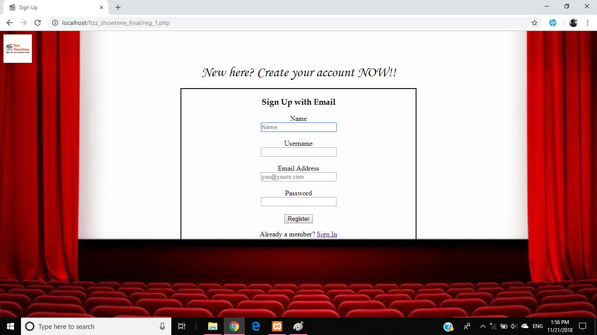 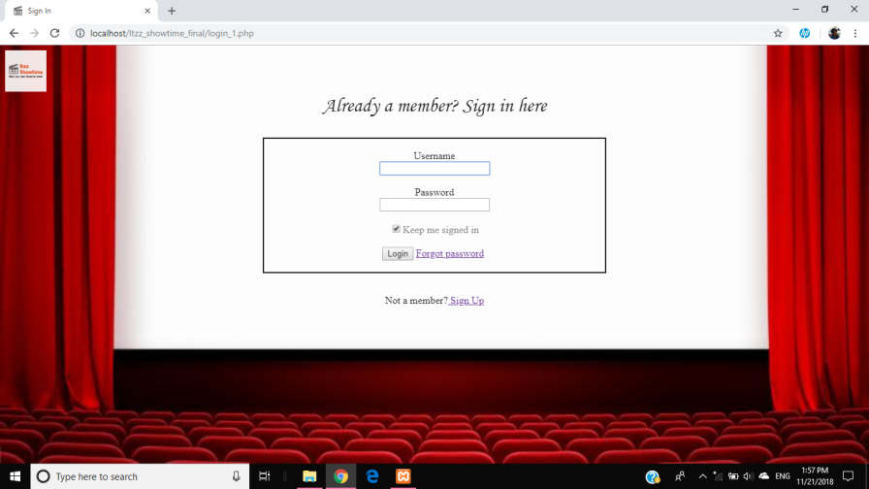

Forgot password Page Home Page

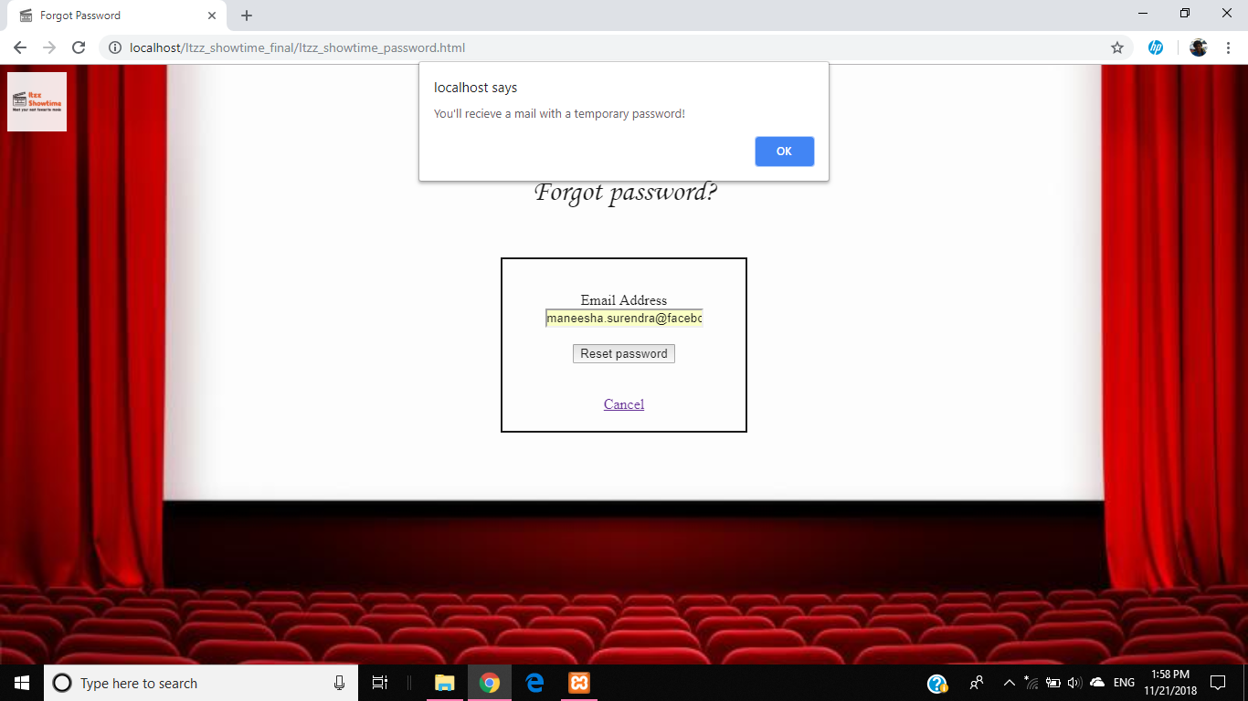 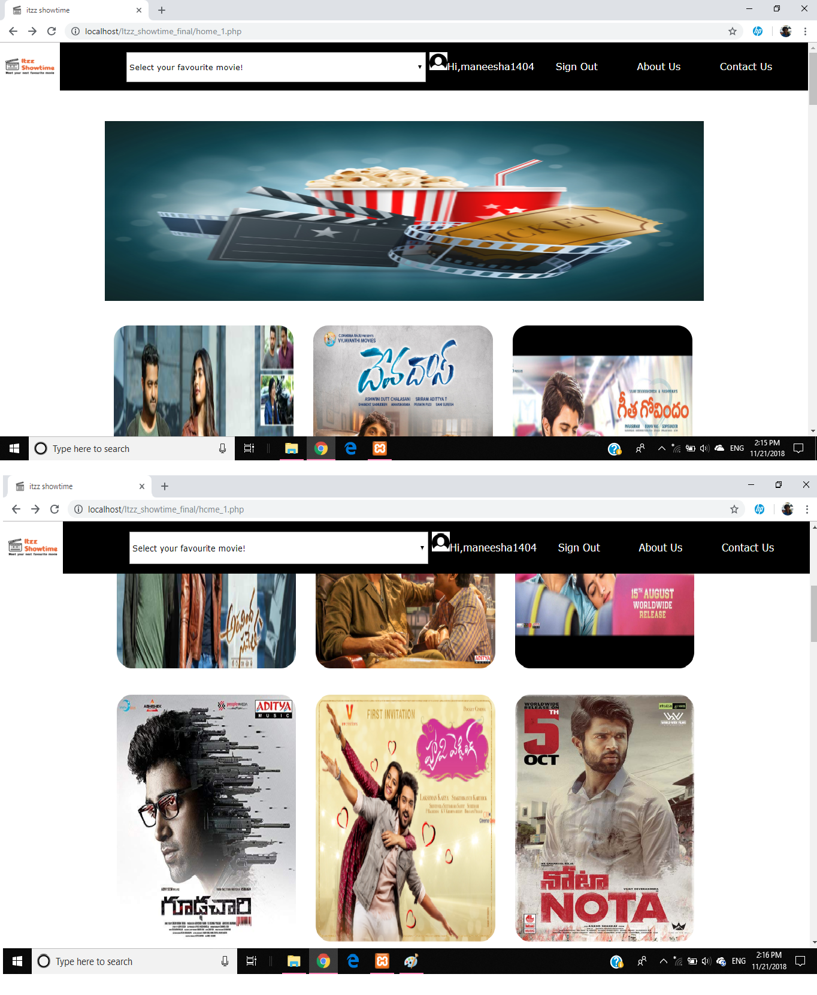

Movie Page Theatre Page

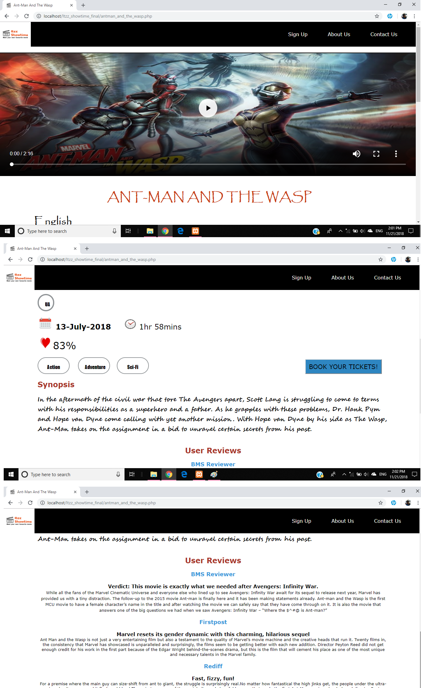 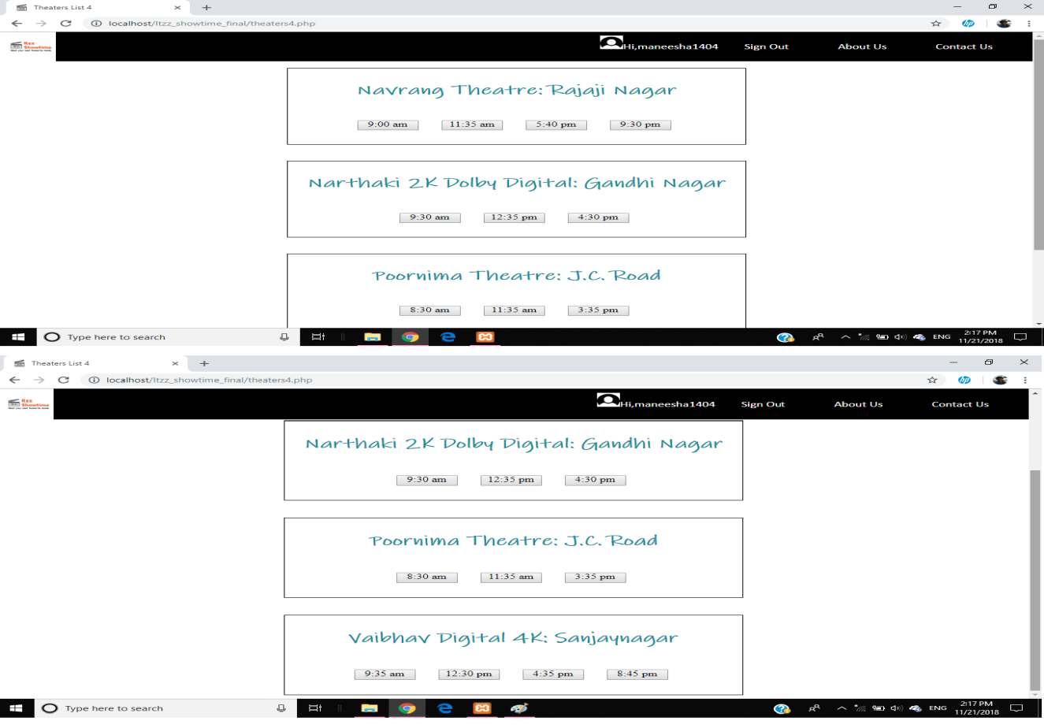

Seating Arrangement Page Payment Pages

