**NETWORKING & SYSTEM ADMINISTRATION LAB** 

**Experiment No.: 1**

**Aim**

Install the latest version of Ubuntu on an Oracle VM VirtualBox.

**Procedure**

Step1:Download the virtual box for windows and install it on computer.

Click the next button.

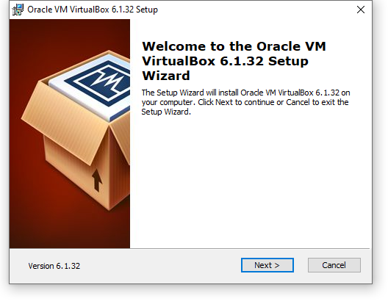

Step2: select the features to be installed

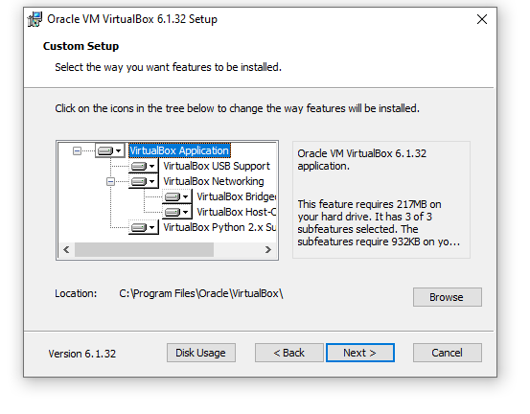

Step 3: set up the featuresand click the next.

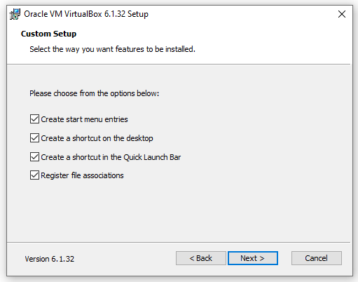

Step 4: click the yes button to proceed the successful

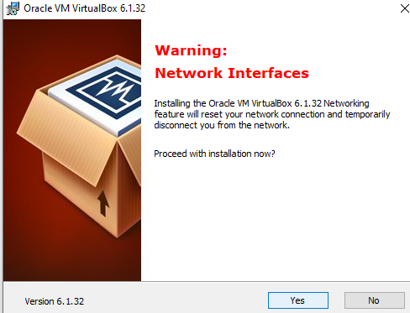

step 5: Click install to begin the installation .if you want to review or change any of your installation setting click back.click cancel to exit wizard.

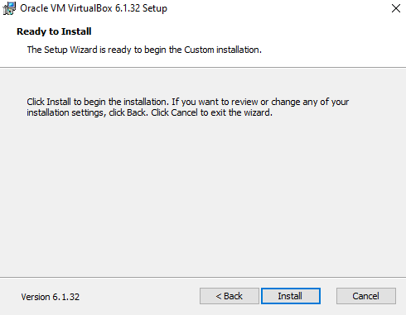

step 6: installing oracle vm

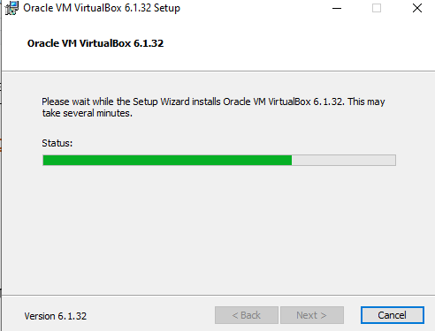

Step 7: Click the finish button to installation complete

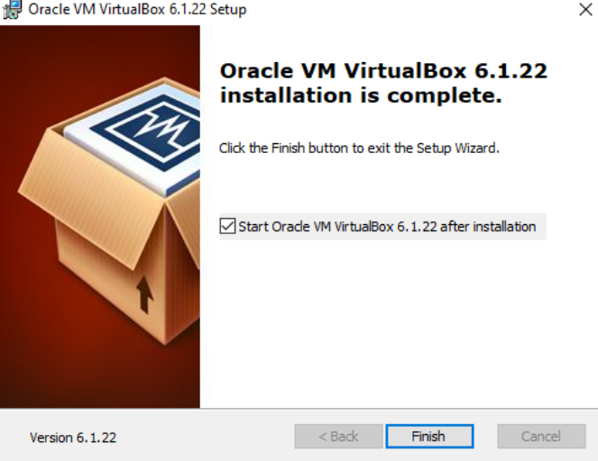

step 8: Open the virtualization box and select new in top taskbar

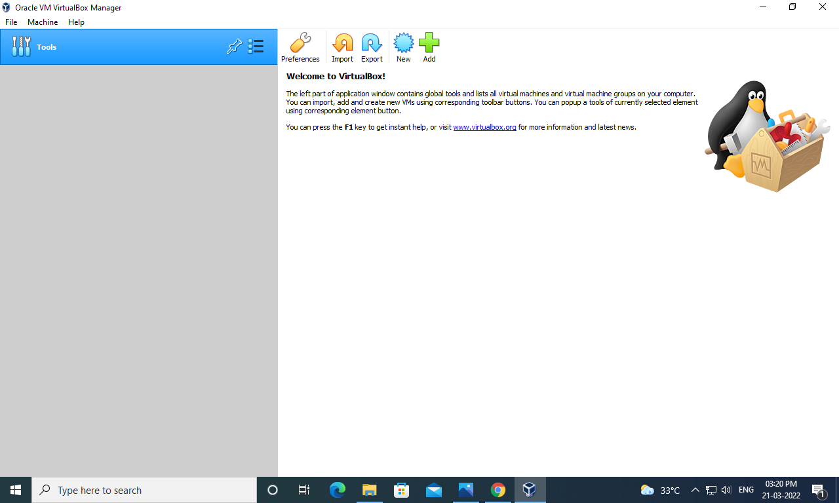

Step 9: give a name for the VM type as linux and version as ubuntu and then select next.

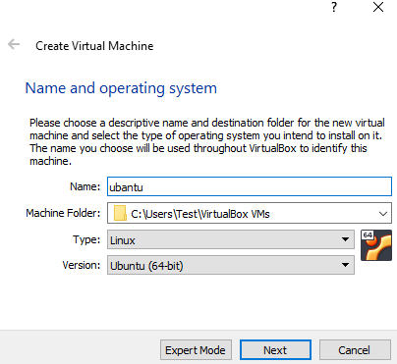

step 10: Allocate the memory size of RAM and select next.

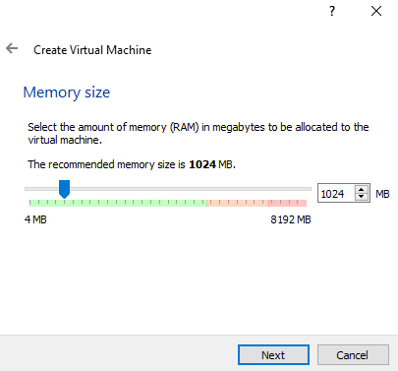

step 11: choose the virtual hard disk now and click create.

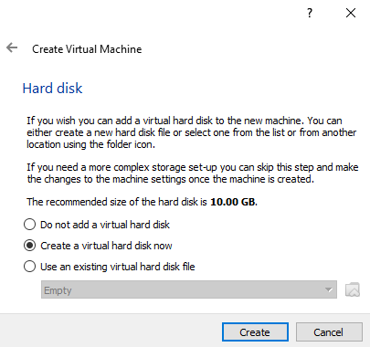

step 12: select VDI and click next.

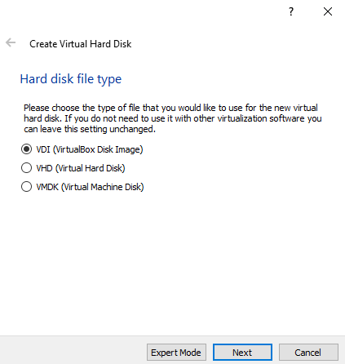

step 12: change the storage type from the default fixed size to dynamically allocated and click next

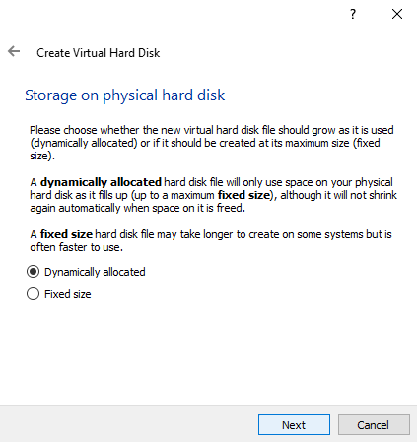

Step 13: select the size of virtual harddisk and click create ubuntu.

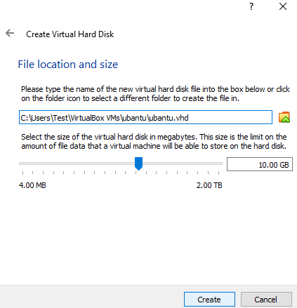

step 14:select your new virtual box and click settings.

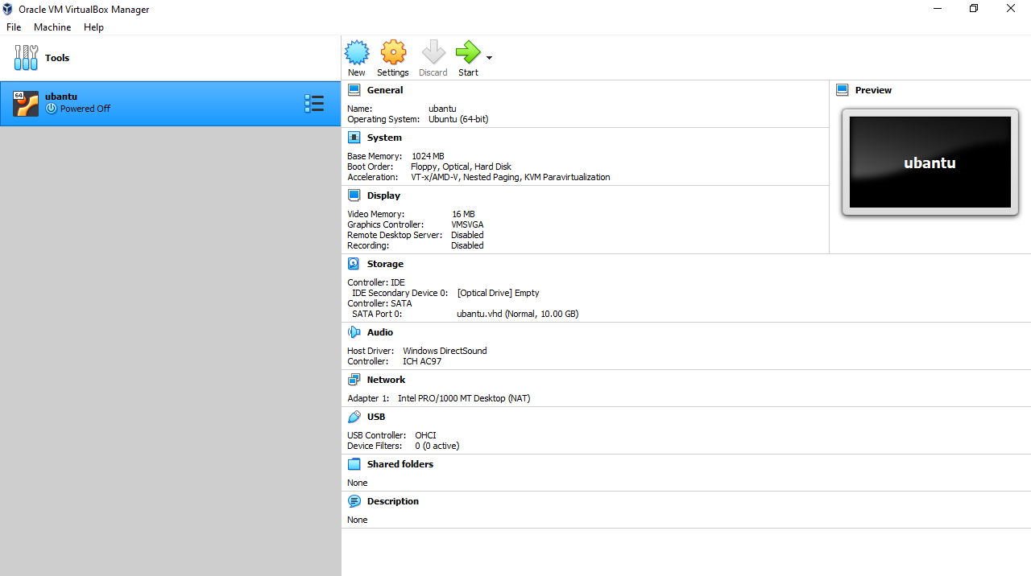

Step 15: click storage and then empty under controller

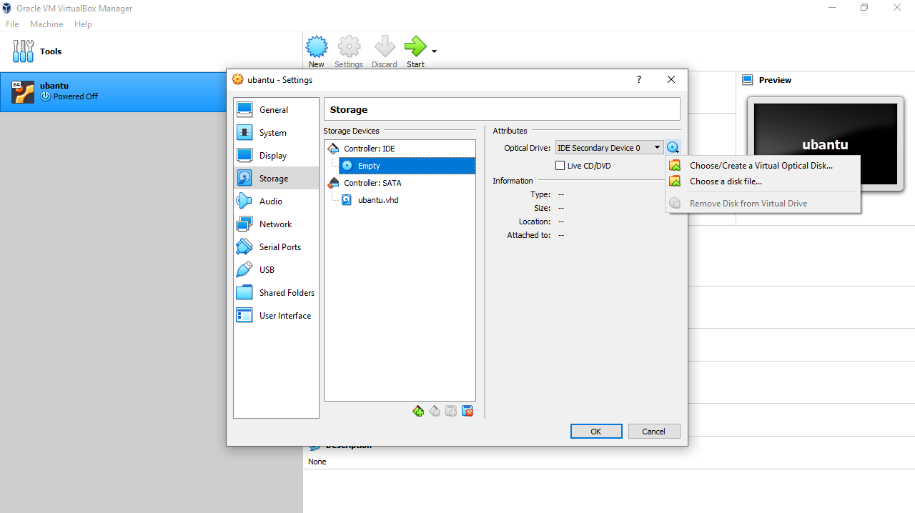

step 16: IDE click select iso file to mount click ok to continue

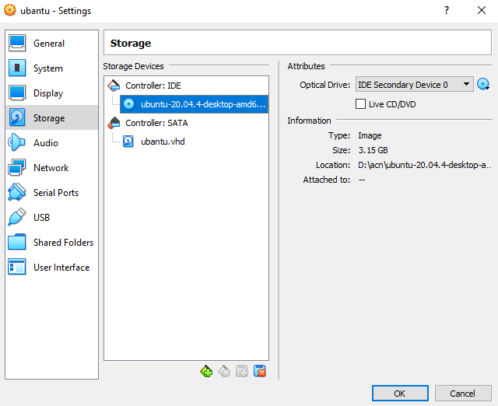

Step 17:back to oracle vm virtual box manager and click on new ubuntu.



step 18: now a welcome screen appears

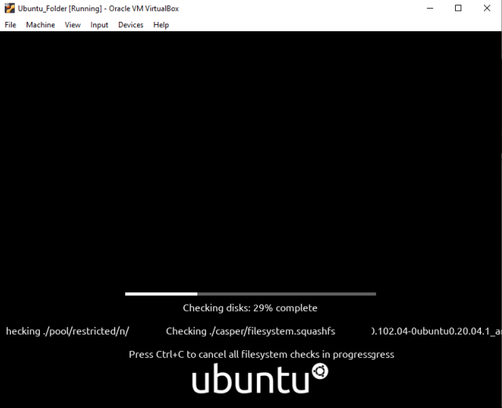

step 19:Click on install ubuntu

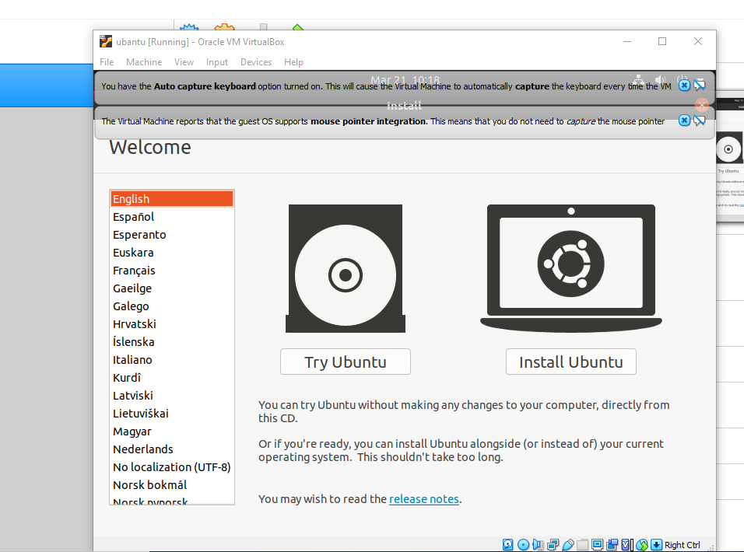

Step 20: Select the keyboard layout.

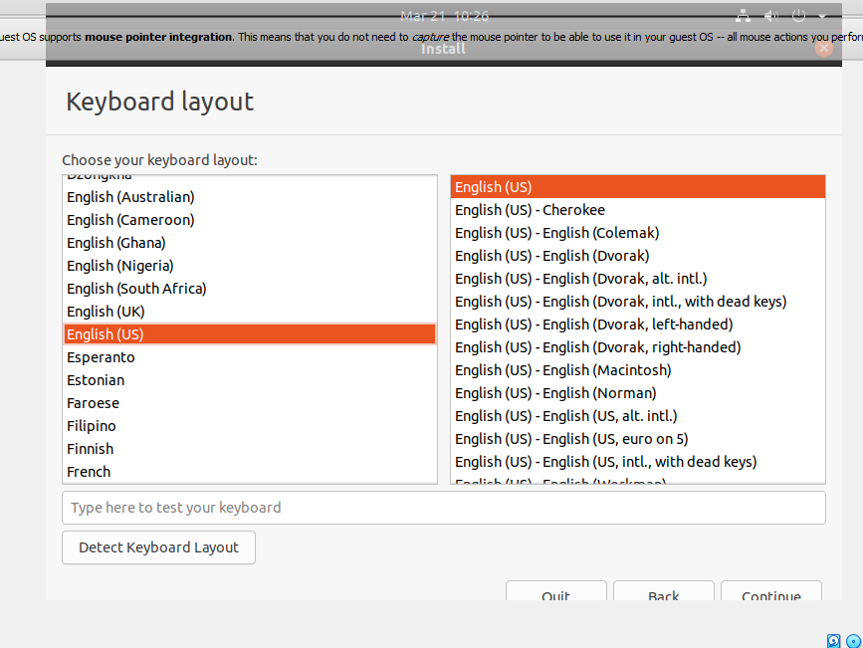

step 21: click continue.

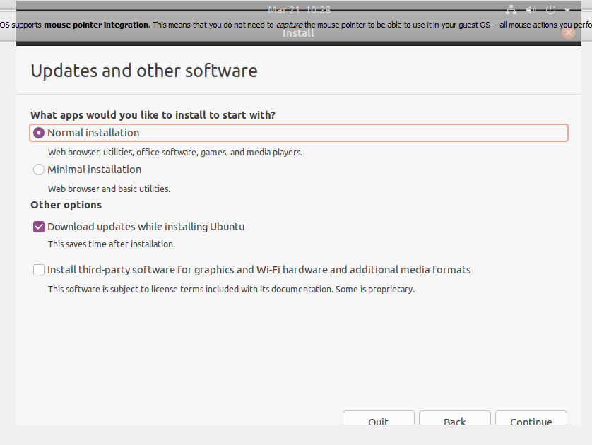

step 22: click continue button to erase disk and install ubuntu.

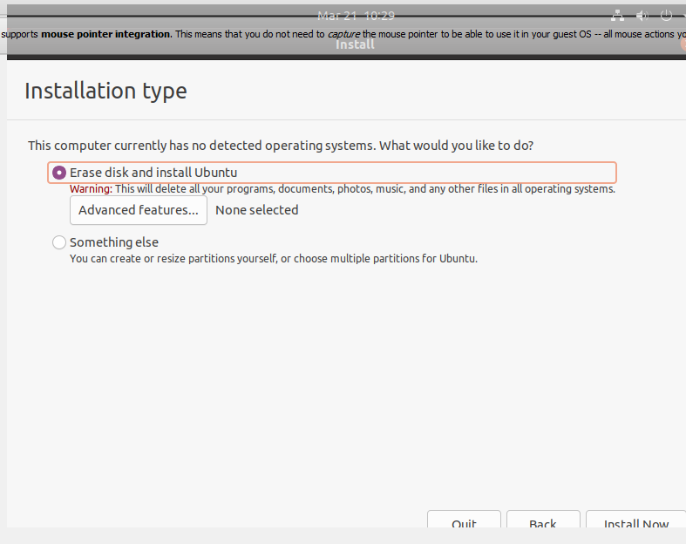

step 23:ubuntu will ask few questions if the default is good click continue.

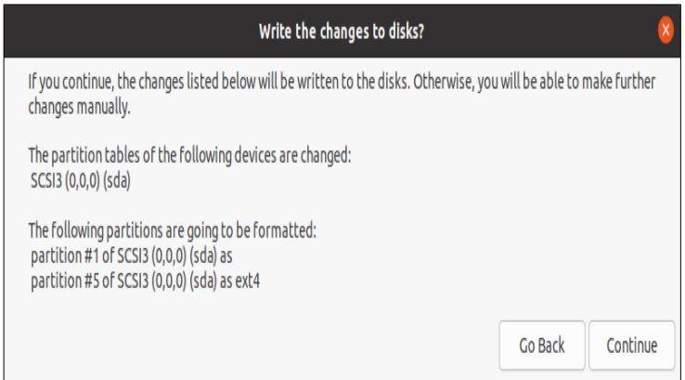

step 23: click continue.

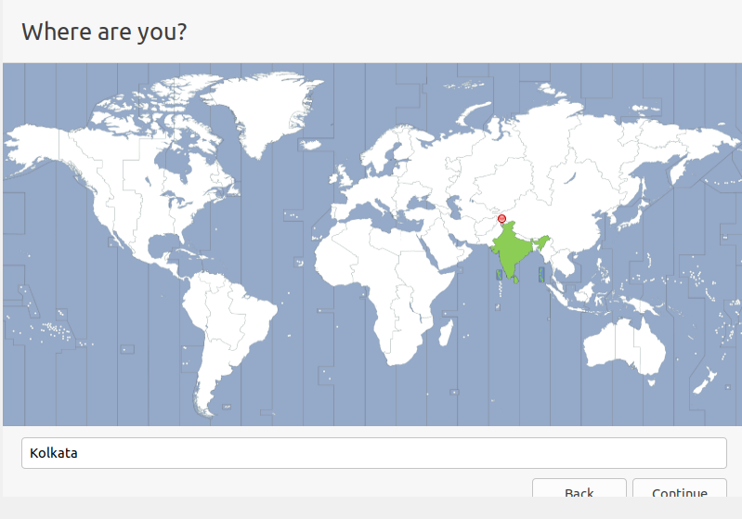

step 24:”who are you dialog” wil open enter preferred name,username,and password click continue.

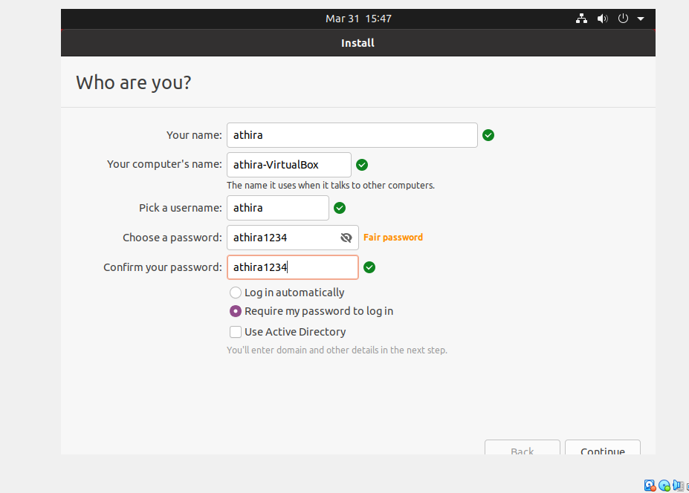

step 25: the installation will continue until it is finished .

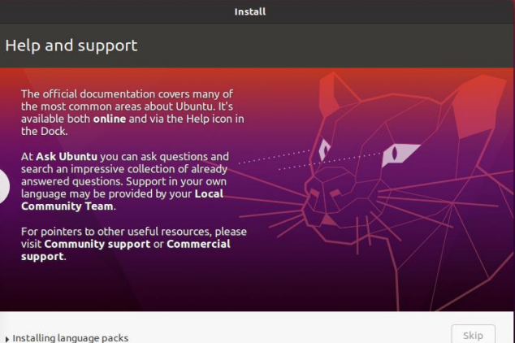

step 26:the ubuntu desktop os is ready

