

**NETWORKING & SYSTEM ADMINISTRATION LAB**

**Experiment No.: 2**

**Aim**

HARDWARE COMPONENTS

**Procedure**

# **1, CPU (Central Processing Unit)**

The central processing unit (CPU) is the computer component that's responsible for interpreting and executing most of the commands from the computer's other [hardware](https://www.lifewire.com/computer-hardware-2625895) and [software](https://www.lifewire.com/what-is-software-4153107).

The CPU [attaches directly to a CPU "socket"](https://www.lifewire.com/tour-inside-a-desktop-pc-2624588) (or sometimes a "slot") on the [motherboard](https://www.lifewire.com/motherboards-system-boards-and-mainboards-2618154). The CPU is inserted into the socket pin-side-down, and a small lever helps to secure the processor.

After running even a short while, modern CPUs can get very hot. To help dissipate this heat, it's almost always necessary to attach a heat sink and a fan directly on top of the CPU. Typically, these come bundled with a CPU purchase. The clock speed of a processor is the number of instructions it can process in any given second, measured in gigahertz (GHz).

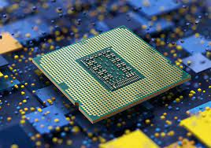

# **2. Solid State Drive (SSD)**

Solid state refers to electronic circuitry that is built entirely of semiconductors. The term was originally used to define those [electronics](https://www.lifewire.com/how-electronics-work-819000), such as a transistor radio that used semiconductors rather than vacuum tubes in its construction.

An SSD is also a type of hard drive, but it doesn’t have any moving parts. It consists of a bank of flash memory that can holda reasonable amount of data.

While SSD’s are increasing in size all the time, they aren’t cost-effective forstoring large amounts of data.

However, the SSD is a high-performance drive. It’s fast and cannot be as easily damaged by dropping it or taking a few knocks.

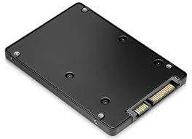

**3. HARD DISK STORAGE DEVICE**

A computer hard disk drive (HDD) is a non-volatile data storage device. Non-volatile refers to storage devices that maintain stored data when turned off. All computers need a storage device, and HDDs are just one example of a type of storage device.

HDDs are usually installed inside desktop computers, mobile devices, consumer electronics and enterprise storage arrays in data centers. They can store operating systems, software programs and other files using magnetic disks.

More specifically, hard disk drives control the reading and writing of the hard disk that provides data storage. HDDs are used either as the primary or [secondary storage](https://www.techtarget.com/searchstorage/definition/secondary-auxiliary-storage) device in a computer. They are commonly found in the drive bay and are connected to the motherboard via an Advanced Technology Attachment (ATA), [Serial ATA](https://www.techtarget.com/searchstorage/definition/Serial-ATA), parallel ATA or Small Computer System Interface (SCSI) cable, among other formats. The HDD is also connected to a power supply unit and can keep stored data while powered down.

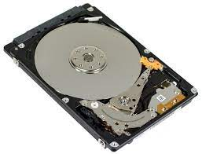

**4. Video card**

The video card is an expansion card that allows the computer to send graphical information to a video display device such as a [monitor](https://www.lifewire.com/what-is-a-monitor-2618155), TV, or projector.

Some other names for a video card include graphics card*,* graphicsadapter*,* display adapter*,* video adapter,video controller*,* and add-in boards (AIBs).

A staggering number of companies manufacture video cards, but almost every one includes a graphics processing unit (GPU) from either NVIDIA Corporation or AMD*.*

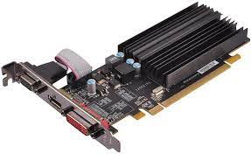

**5. Power Supply Unit**

The power supply unit is the piece of [hardware](https://www.lifewire.com/computer-hardware-2625895) that converts the power provided from the outlet into usable power for the many parts inside the computer [case](https://www.lifewire.com/what-is-a-computer-case-2618149).

It converts the alternating current from your wall outlet into a continuous form of power called direct current that the computer components require. It also regulates overheating by controlling [voltage](https://www.lifewire.com/voltage-definition-3134824), which might change automatically or manually depending on the power supply.

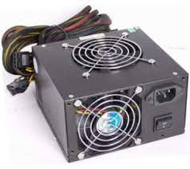

## 6. Motherboard

The motherboard is the piece of computer [hardware](https://www.lifewire.com/computer-hardware-2625895) that can be thought of as the "backbone" of the PC, or more appropriately as the "mother" that holds all the pieces together.

Phones, tablets and other small devices have motherboards, too, but they're often called *logic boards* instead. Their components are usually soldered directly onto the board to save space, which means there aren't [expansion slots](https://www.lifewire.com/expansion-slot-2625870) for upgrades like you see in desktop computers.

The IBM Personal Computer that was released in 1981, is considered to be the very first computer motherboard (it was called a "planar" at the time).

Popular motherboard manufacturers include ASUS, AOpen, Intel, ABIT, MSI, Gigabyte, and Biostar.

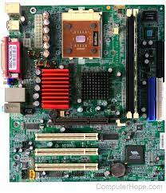

**Parts**

**1. Back Panel Connectors & Ports**

Connectors and ports for connecting the computer to external devices such as display ports, audio ports, USB ports, Ethernet ports, PS/2 ports etc.

**2. PCI Slots**

PCI: Peripheral Component Interconnect Slot for older expansion cards such as sound cards, network cards, connector cards.

**3. PCI Express x1 Slots**

Slot for modern expansion cards such as sound cards, network cards (Wi-Fi, Ethernet, Bluetooth), connector cards (USB, FireWire, eSATA) and certain low end graphics cards.

**4. PCI Express x16 Slot**

Slot for discrete graphic cards and high bandwidth devices such as top-end solid state drives.

**5. Northbridge**

Also known as Memory Controller Hub (MCH). Chipset that allows the CPU to communicate with the RAM and graphics card.

Beginning from Intel Sandy Bridge in 2011, this motherboard component is no longer present as it has been integrated within the CPU itself.

**6. CPU Socket**

Insert CPU here.

**7. ATX 12V Power Connector**

Connects to the 4-pin power cable of a power supply unit which supplies power to the CPU.

**8. Front Panel USB 2.0 Connectors**

Connects to USB 2.0 ports at the front or top of a computer case.

**9. Front Panel Connectors**

Connects to the power switch, reset switch, power LED, hard drive LED and front audio ports of a computer case.

**10. IDE Connector**

Connects to older hard drive disks and optical drives for data transfer.

**11.CMOS Battery**

Supplies power to store BIOS settings and keep the real-time clock running.

**12.Southbridge**

Also known as the Input/Output Controller Hub (ICH). Chipset that allows the CPU to communicate with PCI slots, PCI-Express x 1 slots (expansion cards), SATA connectors (hard drives, optical drives), USB ports (USB devices), Ethernet ports and on-board audio.

**13.SATA Connectors**

Connects to modern hard disk drives, solid state drives and optical drives for data transfer.

**14. Fan Headers**

Supplies power to the CPU heat sink fan and computer case fans.

**15.RAM Slots**

Insert RAM here.

**16. ATX Power Connector**

Connects to the 24-pin ATX power cable of a power supply unit which supplies power to the motherboard.

**17.mSATA Connector**

Connects to a mSATA solid state drive. In most cases, this SSD is used as cache to speed up hard disk drives, but it's possible to re-purpose it as a regular hard drive.

**18.Front Panel USB 3.0 Connector**

Connects to USB 3.0 ports at the front or top of the computer case.

**19.Power & Reset Button**

Onboard button to turn on, turn off and reboot the computer. This motherboard component is more common among high end boards.

## 

## 

## 6. Monitor

The monitor is a hardware device that displays the video and graphics information generated by the computer via the video card. Monitors can also be called video display units, video display terminals, or simply as screens.

Older monitors were bulky and built using cathode ray tubes, but nowadays they normally use LCD technology and are lighter and thinner.

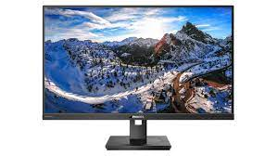

**7. Speakers**

Computer speakers are a common output device and are used for listening to music, movies, and other audio. They are available in a range of different qualities and prices, the more sophisticated versions having an additional subwoofer to provide enhanced bass output.

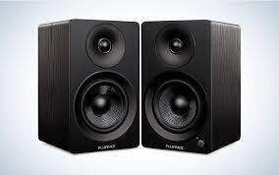

## 

## 

## 8. USB Flash Drive

A USB flash drive is a portable data storage device. Unlike optical drives, flash drives have no moving parts, making them more durable. A USB flash drive has an integrated USB interface and connects to the computer via a USB port.

This content is accurate and true to the best of the author’s knowledge and is not meant to substitute for formal and individualized advice from a qualified professional.

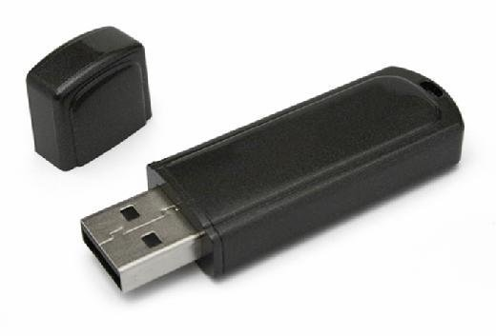

## 9. Printer

Printers are output devices that generate hard copies of electronic data stored on the computer, usually in the form of text or images on paper. The most common types of modern printer use inkjet or laser technology, and connect to the computer either via the computer's USB port, or via WI-FI.

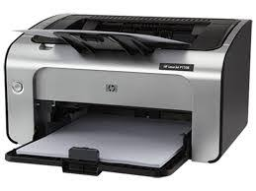

**10. Scanner**

Computer scanners are devices that convert images into digital or computerized information.The first scanners were large and expensive, but today they’re affordable and compact enough to fit on a desktop.

A scanner allows you to copy anything from a picture to a receipt as well as images from magazines, newspapers, and books as long as it’s black and white.Scanners can be used for many purposes such as archiving family photos or creating an electronic form of your child’s artwork.

