CMT1124/CMTJ1124 Mathematics II

Tutorial 1

Topic (Lecture 1): Angles, Trigonometric Ratios and Functions

Q1 Find the radian measure of the angle with the given degree measure.
(a) $72^{o}$ (b) $-300^{o}$

Q2 Find the degree measure of the angle with the given radian measure.
(a) $\frac{7π}{6}$ (b) $\frac{-2π}{15}$

Q3 The measure of an angle in standard position is given below. Find two positive and two negative angles that are coterminal with the given angle.
(a) $50^{o}$ (b) $\frac{3π}{4}$

(c) $\frac{-π}{4}$

Q4 Find the length of an arc that subtends a central angle of $45^{o}$ in a circle of radius 10m.

Q5 Find the area of the sector shown in each figure.
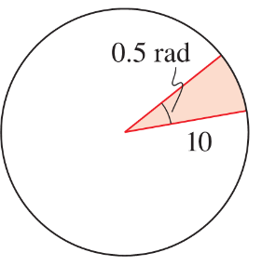
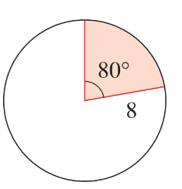
- (b)

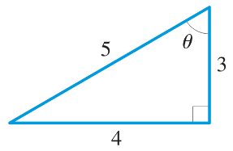
Q6 Find the exact values of the six trigonometric ratios of the angle $θ$ in the triangle.
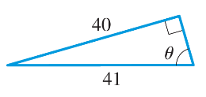
- (b) b)

Q7 Express the length x in terms of the trigonometric ratios of $θ$
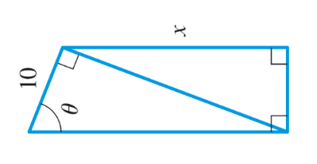

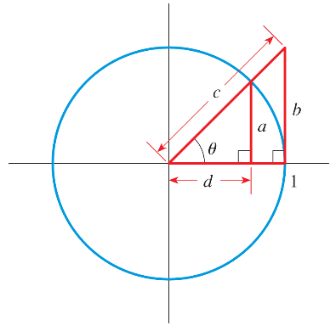
Q8 Express the length a, b, c, and d in the figure below in terms of the trigonometric ratios of $θ$

Q9 When the moon is seen at its zenith at a point A on the earth, it is observed to be at the horizon from point B. Point A and B are 6155 mi apart, and the radius of the earth is 3960 mi.
- Find the angle $θ$ in radian
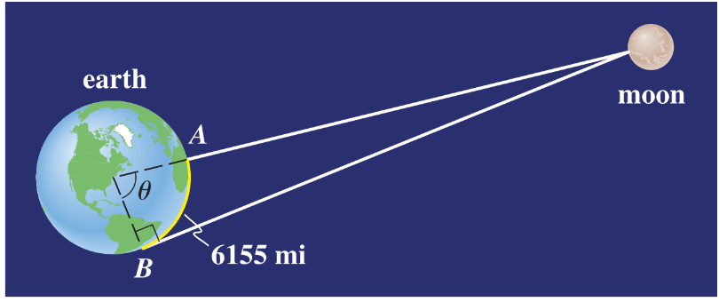
(b) Estimate the distance from point A to the moon

Q10 For each of the following angles, graph the angle in an xy-plane to determine the corresponding reference angle $\overline{θ}$.
(a) 99º (b) 225º

(c) -150º

(d) $\frac{11π}{4}$ (e) 2.3

(f) $-1.4π$

Q11 For each of the following angles, graph the angle in an xy-plane to determine at which quadrant the angle lies and its reference angle value. Then use these to find the trigonometric function values without calculator.
(a) $\sin{150^{o}}$ (b) $\sec{(}300^{o})$

(c) $\tan{750^{o}}$

(d) $\csc\left(\frac{17π}{3}\right)$ (e) $\cos\left(-\frac{7π}{3}\right)$

(f) $\cot\left(-\frac{π}{4}\right)$

Q12 For each of the following angles, with the given information, graph the angle $θ$ in an xy-plane. Then use it to find the values of trigonometric functions.
(a) $\sin{θ}=\frac{3}{5}$, $θ$ in Quadrant II

(b) $\tan{θ}=-\frac{3}{4}$, $\cos{θ}>0$

(c) $\cos{θ}=-\frac{2}{7}$, $\tan{θ}<0$

(d) $\csc{θ}=2$, $θ$ in Quadrant I

