Student Enrollment & Course Management System (SECMS)
Salesforce Developer Edition — Implementation Documentation
Prepared by Sri Athirai R

1. Project Overview
SECMS is a Salesforce-based academic project built entirely with declarative tools (custom objects, flows, validation rules, and approval processes — no Apex code) in a Salesforce Developer Edition org. It manages student enrollment, course offerings, instructor assignment, approvals, and reporting for an educational institute.

2. Milestone Status Summary
Milestone | Description | Status
1 | Developer Edition org created and verified | Complete
2 | Custom objects: Student__c, Course__c, Instructor__c, Enrollment__c | Complete
3 | Custom fields added to all four objects per spec | Complete
4 | Lookup relationships on Enrollment (Student, Course, Instructor) | Complete
5 | Validation rules (Student email domain; Enrollment fees-before-approval) | Complete
6 | Approval Process “Approval Enrollment Request” on Enrollment | Complete
7 | Custom tabs for all four objects | Complete
8 | Lightning App “Student Enrollment System” | Complete
9 | Record Types and Page Layouts on Enrollment; related lists on parent objects | Complete
10 | Automation with Flow — Activity 1 & 2 | In Progress
11 | Reports | Not Started
12 | Dashboards | Not Started
13 | Security Setup | Not Started

3. Data Model

3.1 Custom Objects
Four custom objects form the core data model: Student__c, Course__c, Instructor__c, and Enrollment__c.
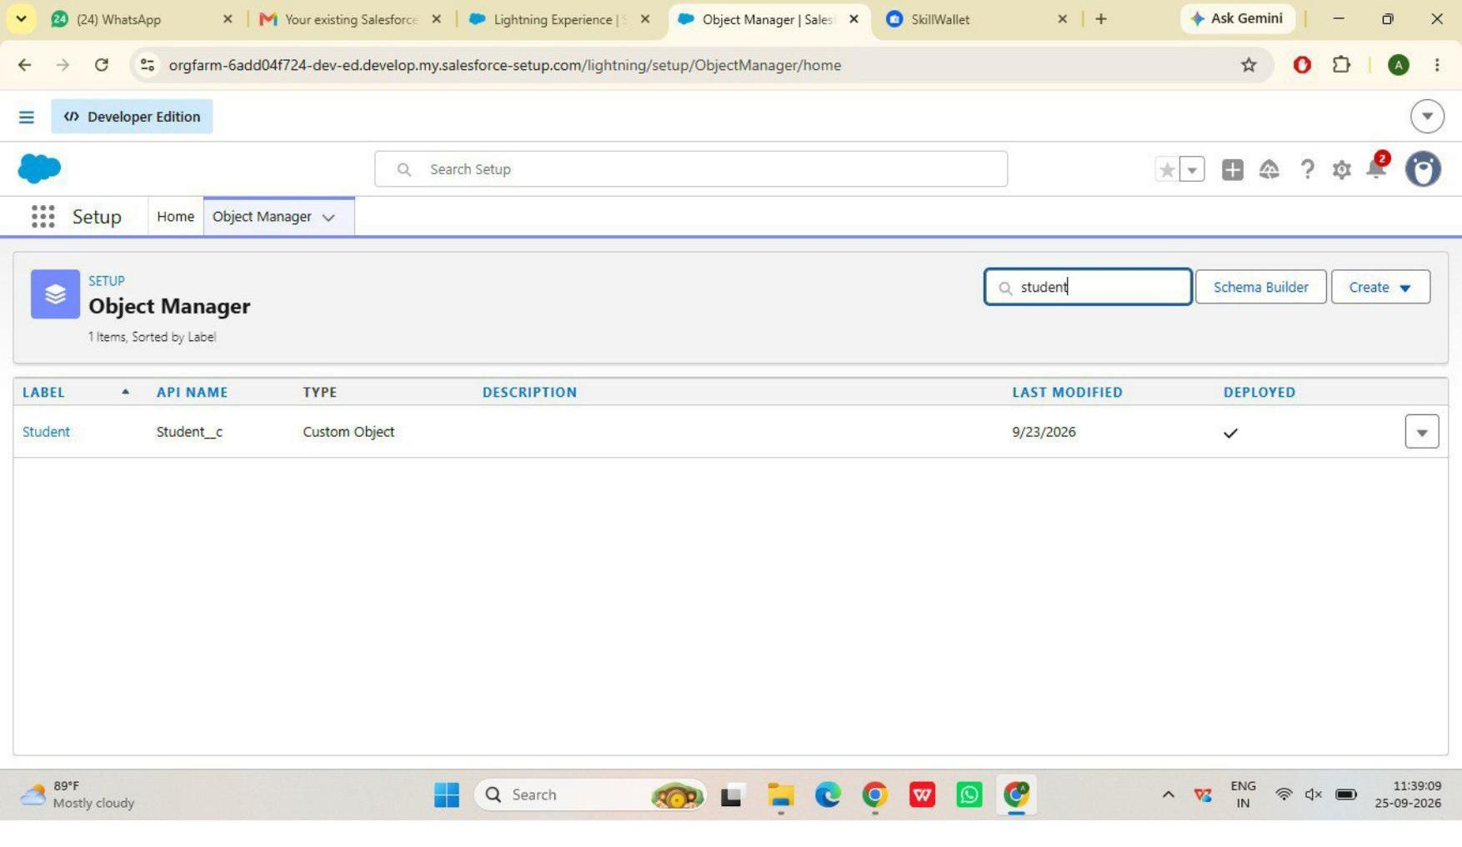
Figure 1 — Student custom object (Object Manager)
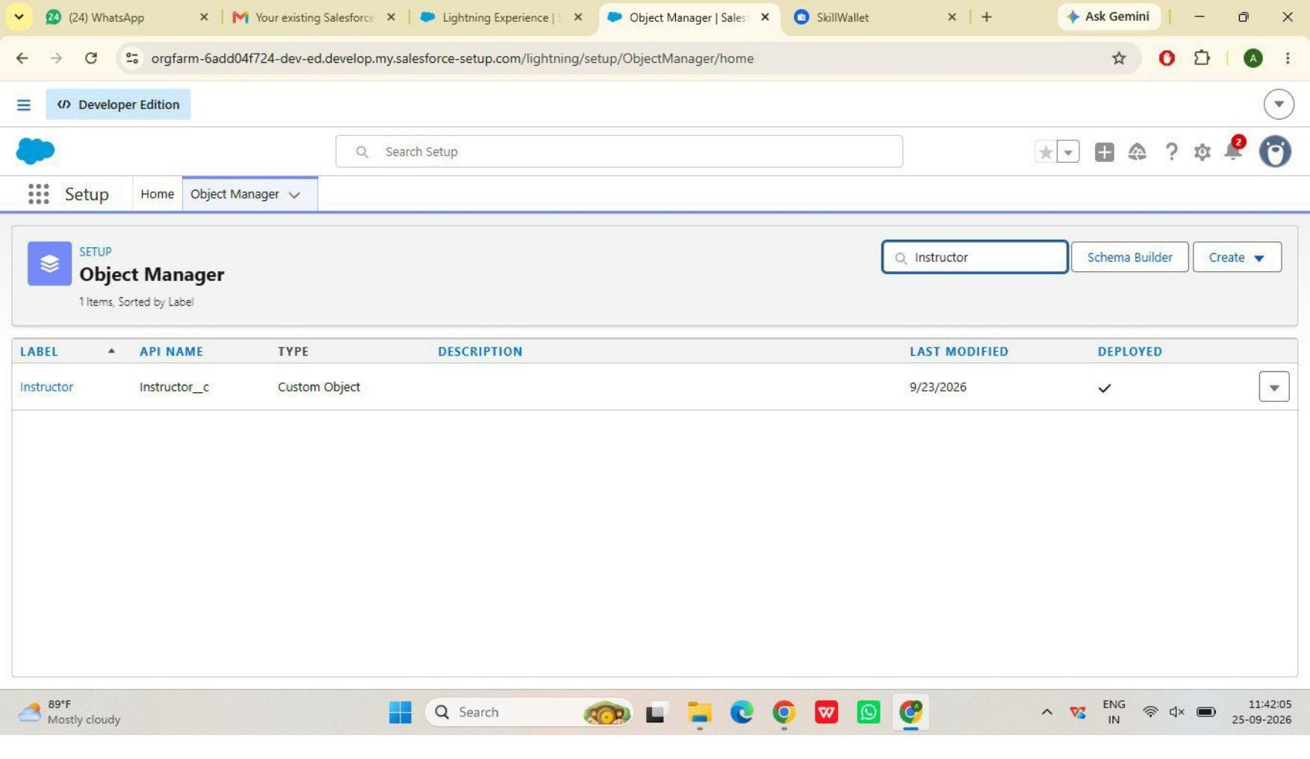
Figure 2 — Instructor custom object (Object Manager)

3.2 Fields & Relationships
Enrollment__c holds lookup relationships to Student, Course, and Instructor, linking the four objects together.
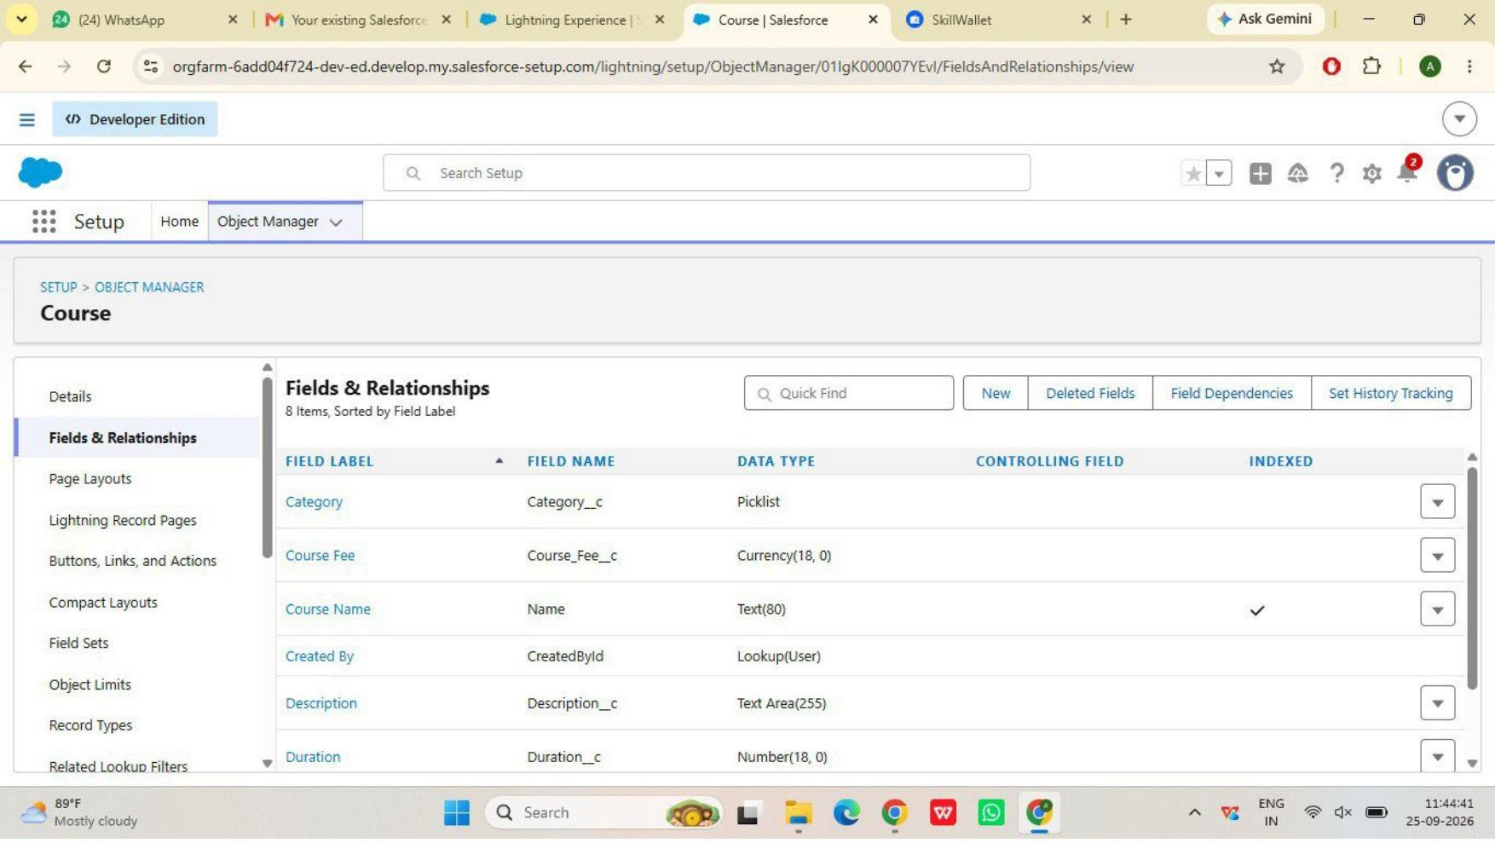
Figure 3 — Course fields (Category, Course Fee, Duration, Description)
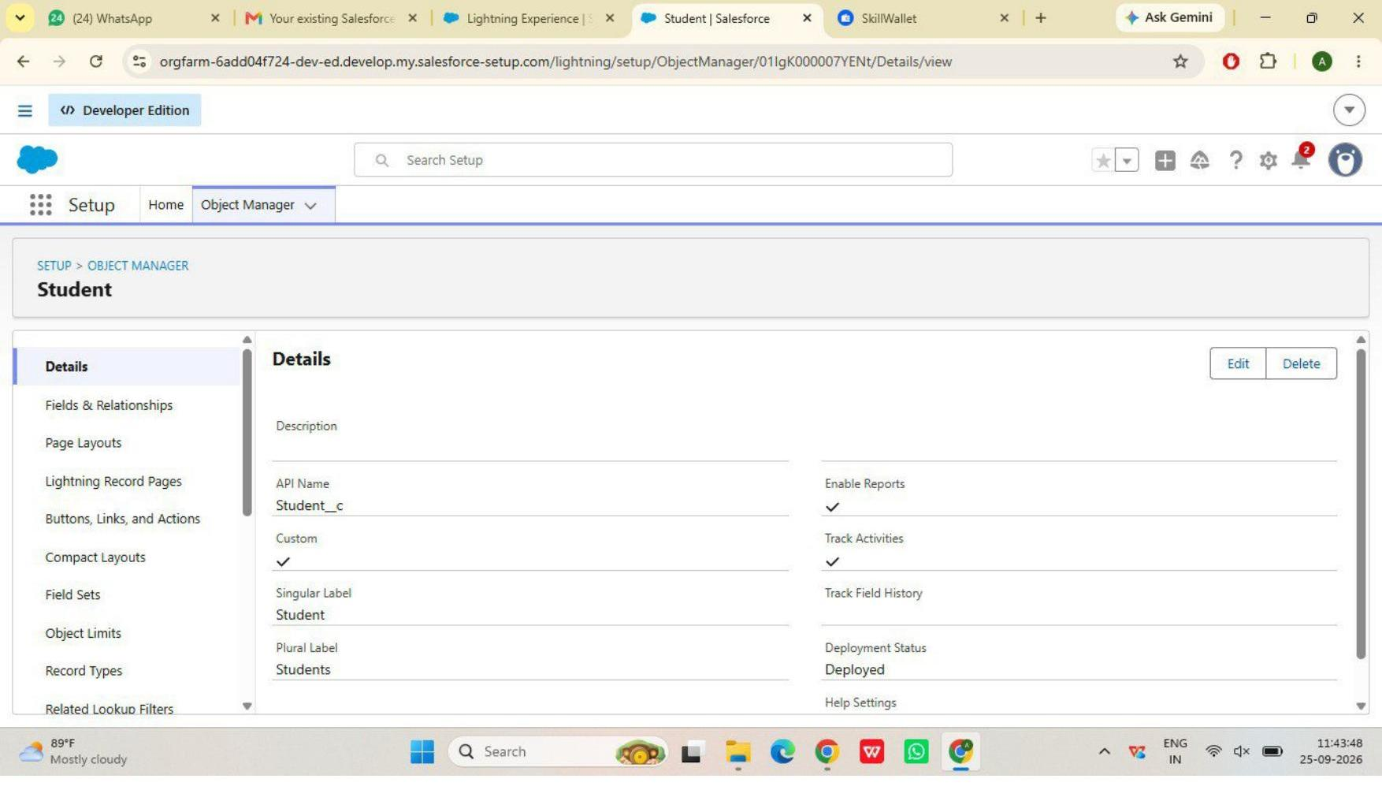
Figure 4 — Student object detail
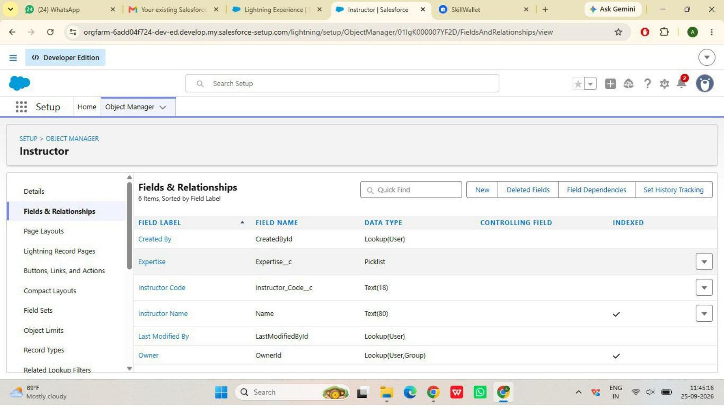
Figure 5 — Instructor fields (Expertise, Instructor Code, Email)
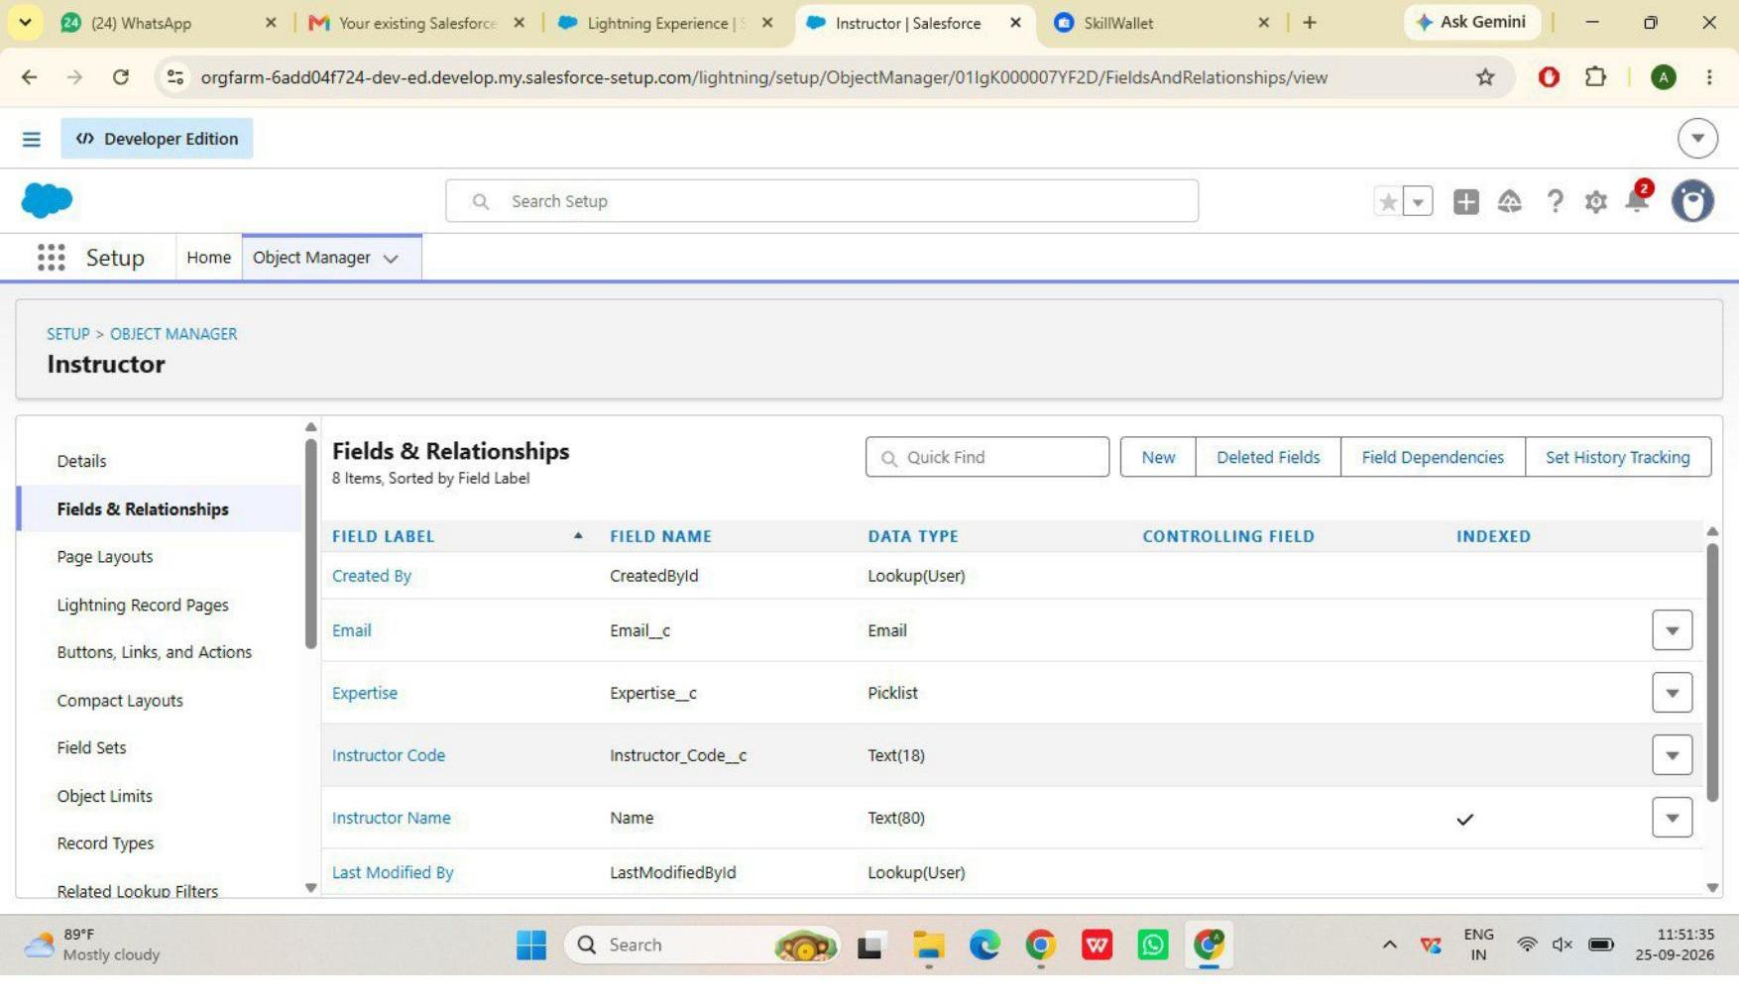
Figure 6 — Instructor fields, continued

4. Validation Rules
Two validation rules enforce data integrity: an email-domain check on Student, and a fees-paid check that blocks Enrollment approval until fees are settled.
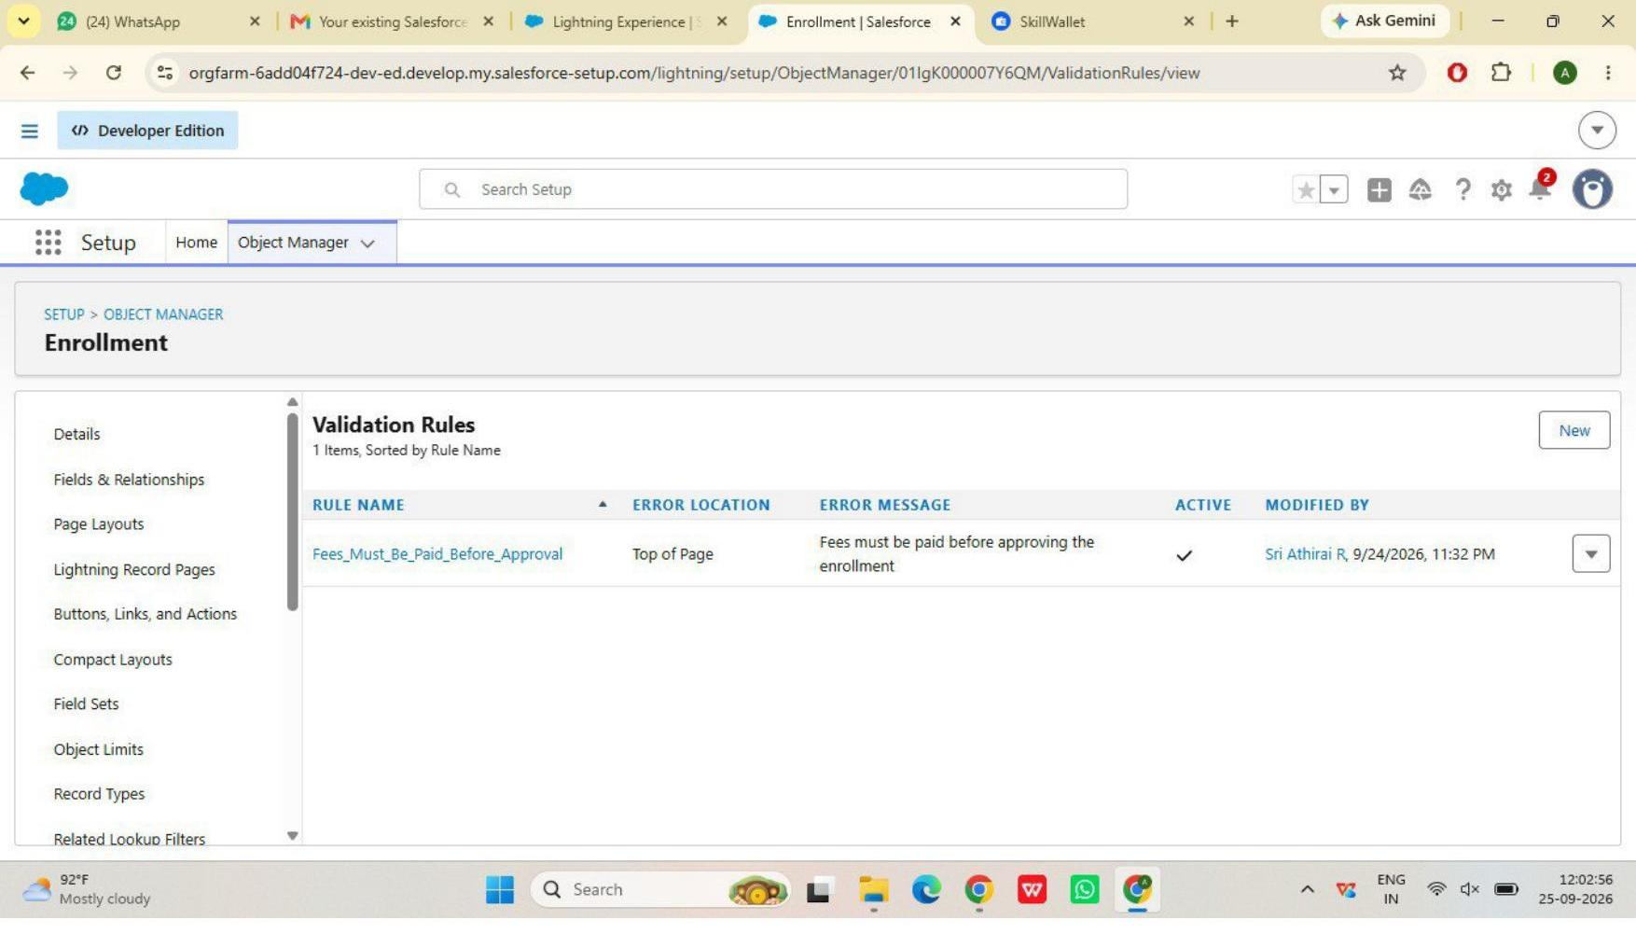
Figure 7 — Enrollment validation rule: Fees_Must_Be_Paid_Before_Approval
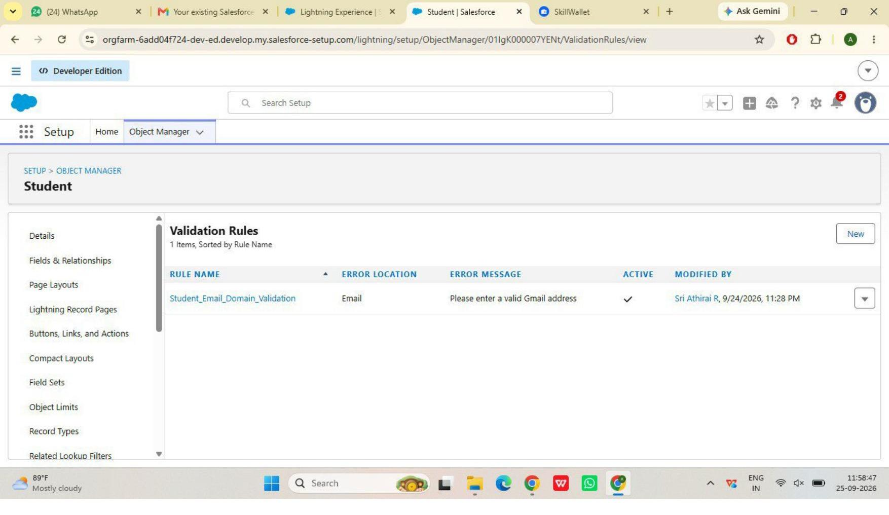
Figure 8 — Student validation rule: Student_Email_Domain_Validation

5. Approval Process
The “Approval Enrollment Request” process routes Enrollment records with Status = Requested to an approver (Training Manager). Approval sets Status to Approved; rejection sets it to Rejected.
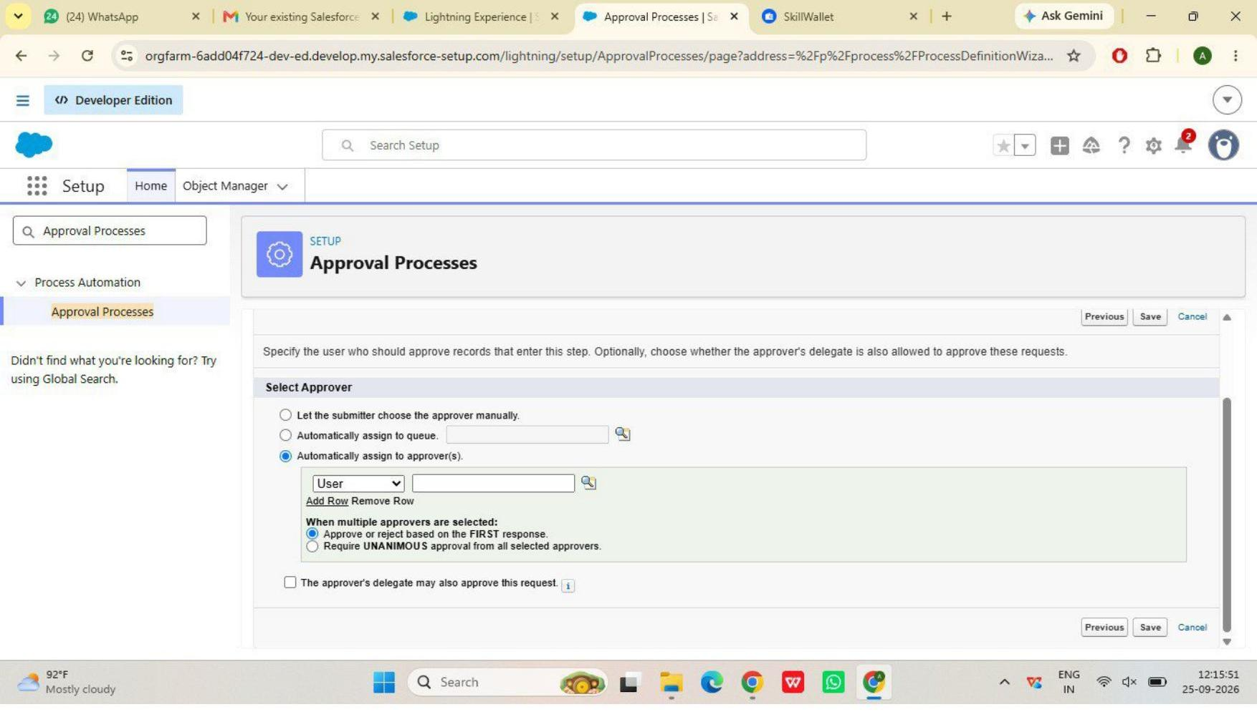
Figure 9 — Approval process approver configuration
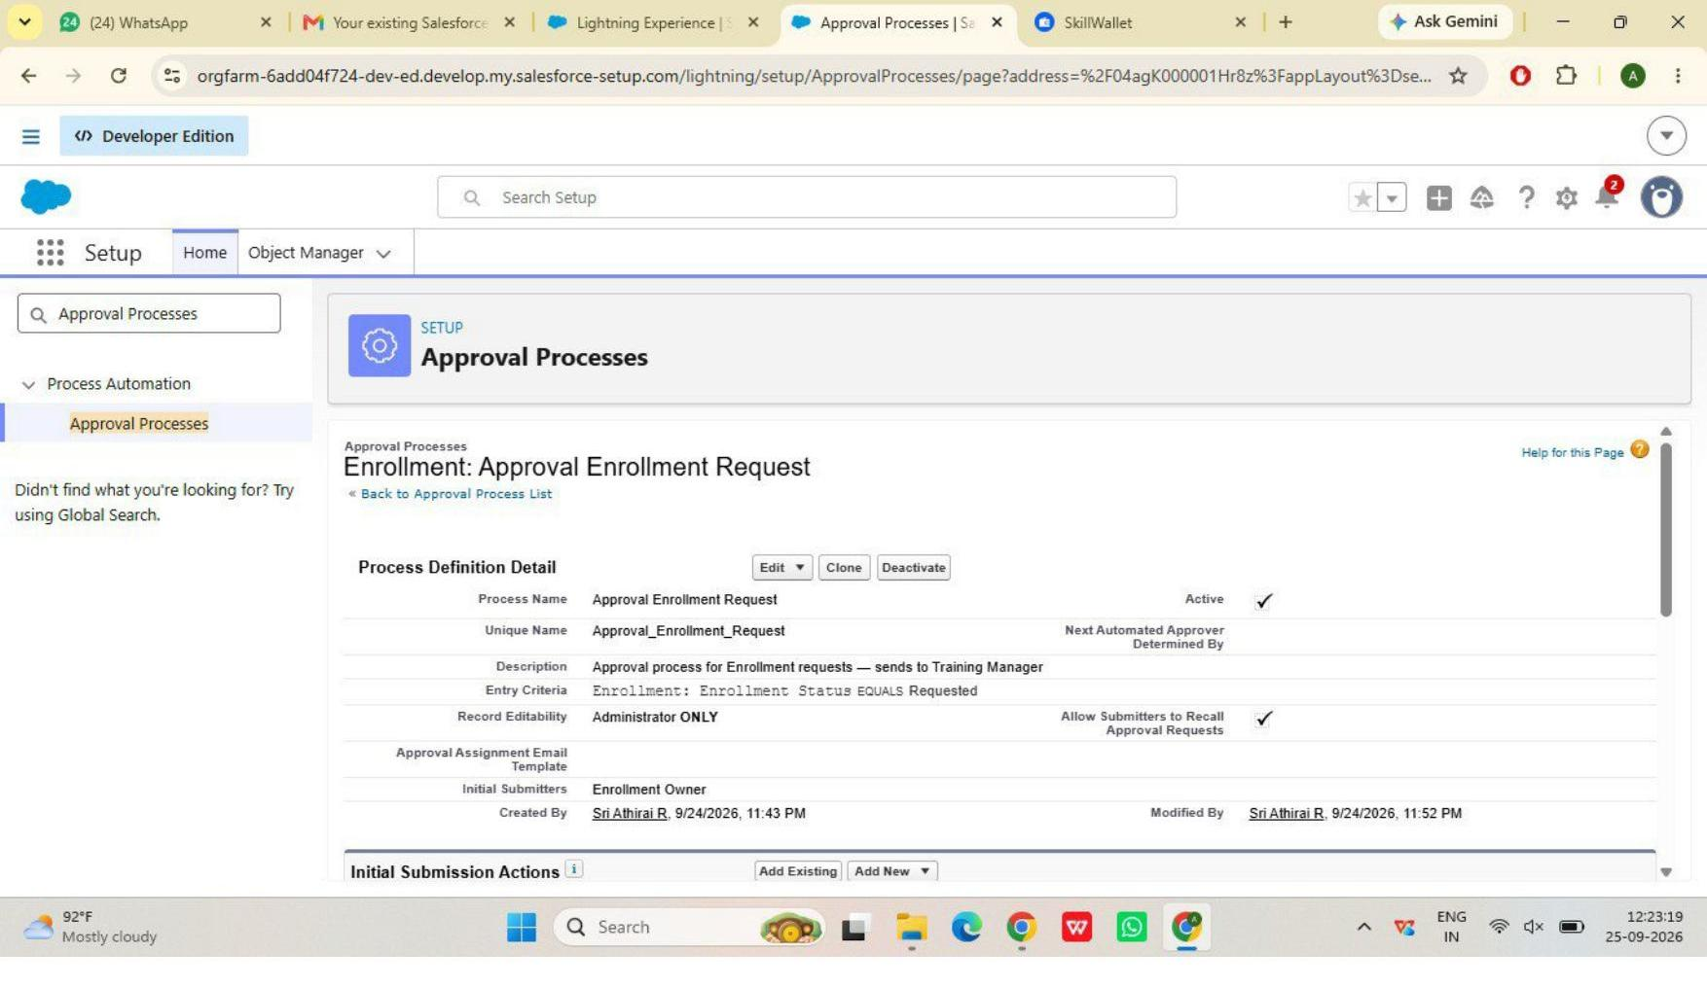
Figure 10 — Approval process detail, Active
End-to-end test: a Test Enrollment record was submitted for approval and approved; Enrollment Status updated automatically and Approval History logged both steps.
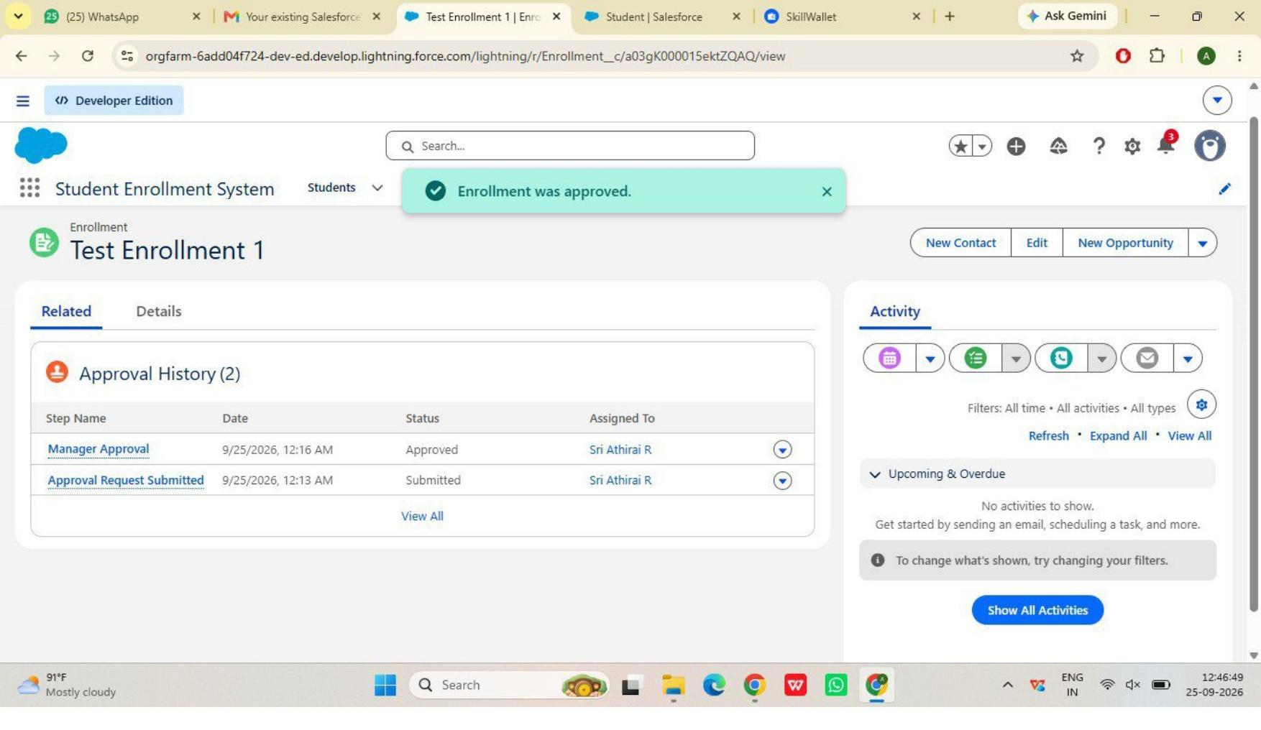
Figure 11 — Approval History showing a completed approval

6. Tabs, App, and Page Layouts
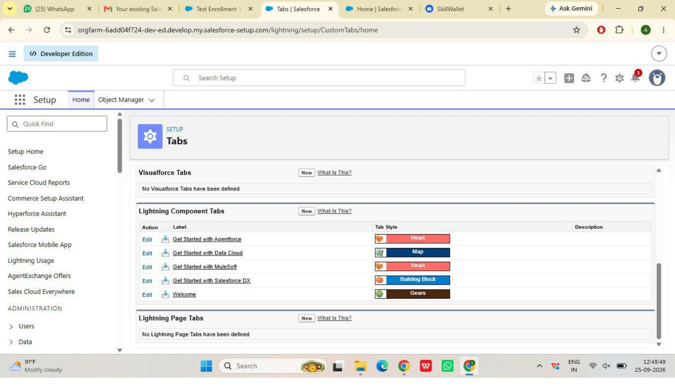
Figure 12 — Custom object tabs (Students, Courses, Instructors, Enrollments)
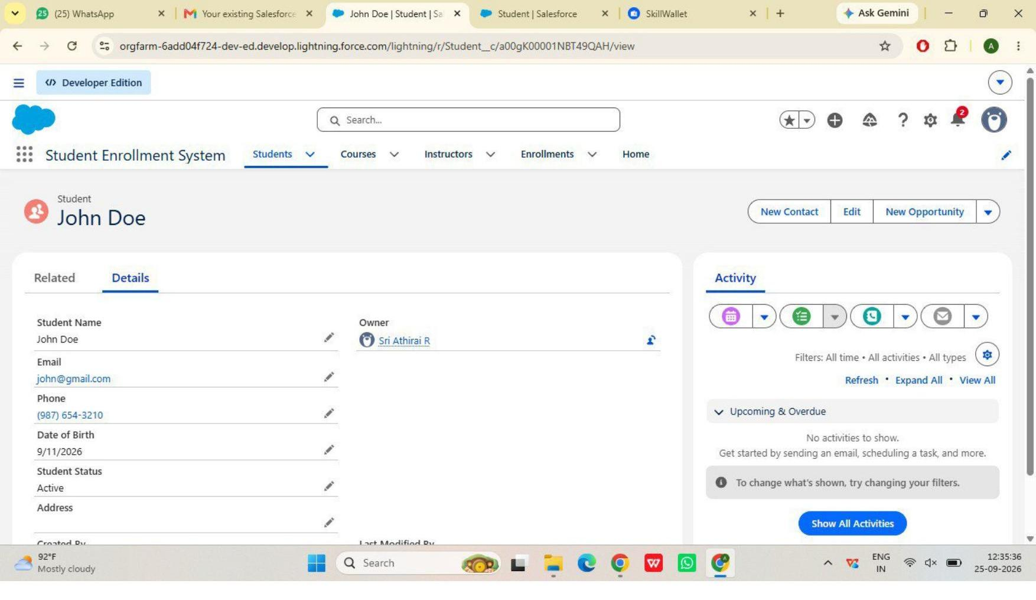
Figure 13 — “Student Enrollment System” Lightning App navigation
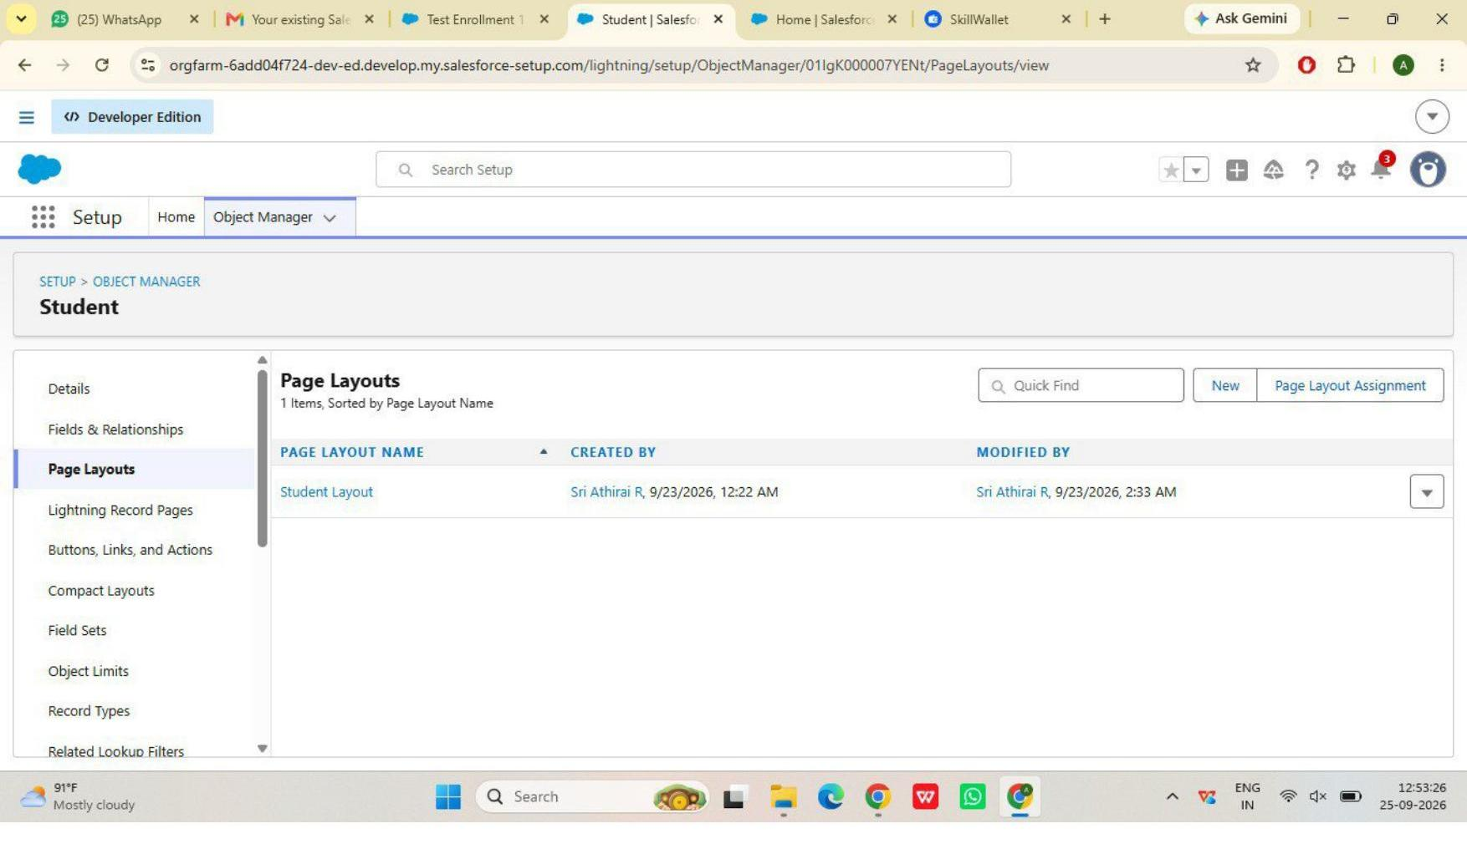
Figure 14 — Enrollment Record Types (New Enrollment / Re-Enrollment)
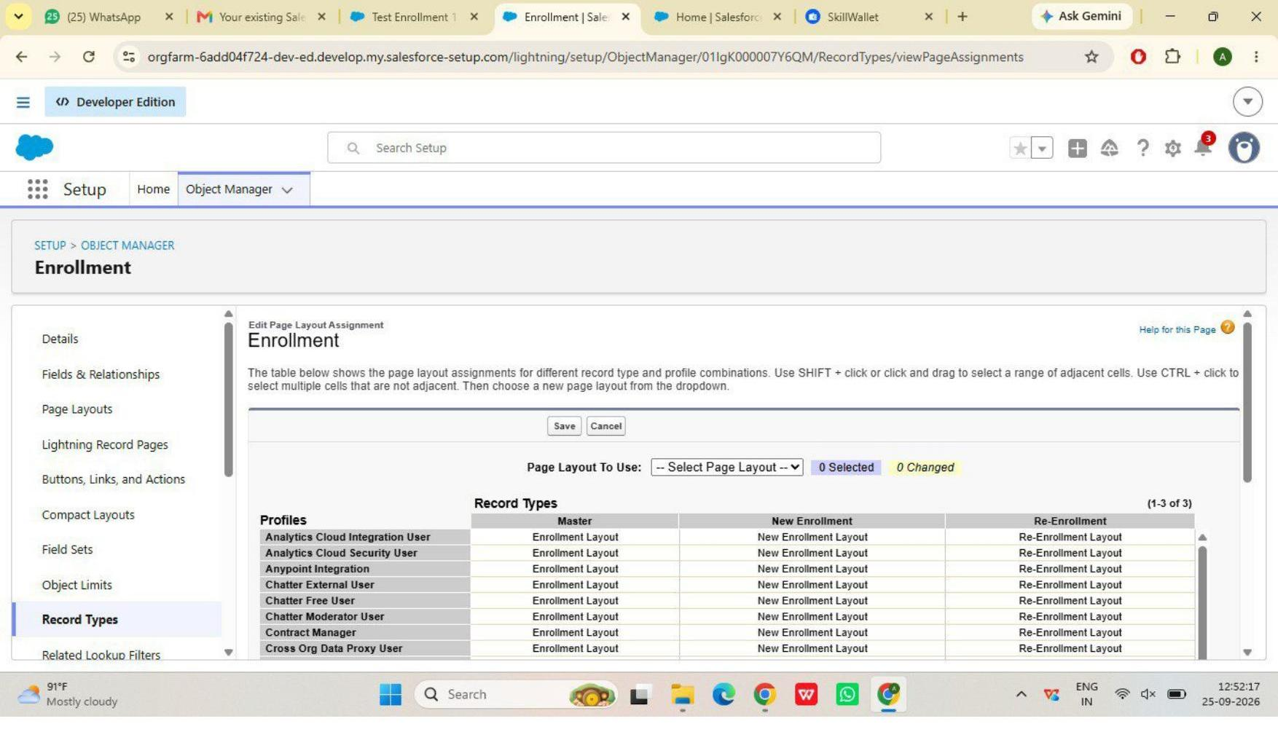
Figure 15 — Student page layout
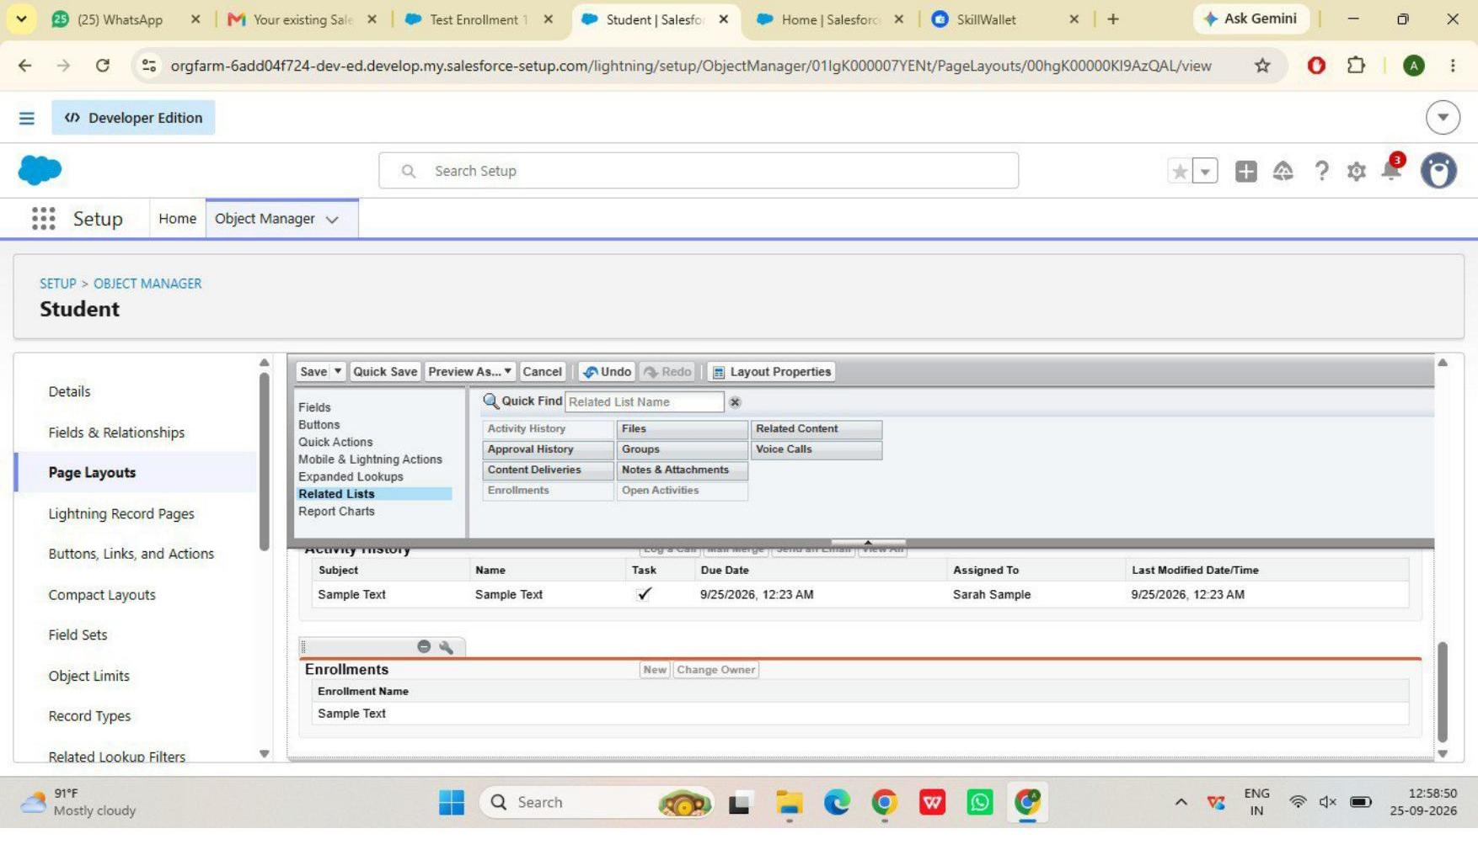
Figure 16 — Student layout with Enrollments related list
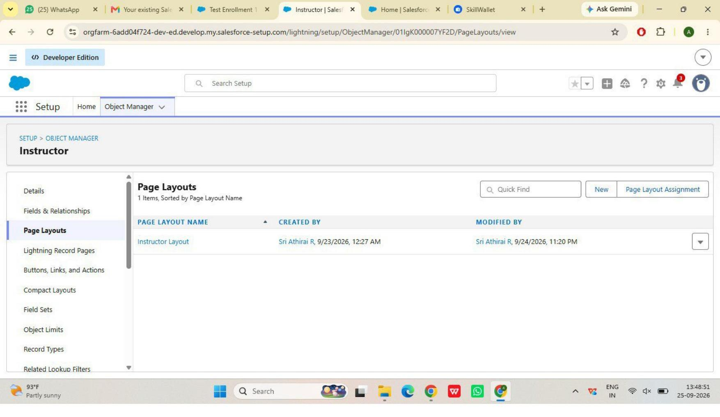
Figure 17 — Instructor page layout

7. Milestone 10 — Automation with Flow

7.1 Activity 1 — Auto-Populate Enrollment Date
A Record-Triggered Flow on Enrollment (trigger: record created) automatically sets Enrollment_Date__c to today's date using a Date-typed formula resource. Active and tested.
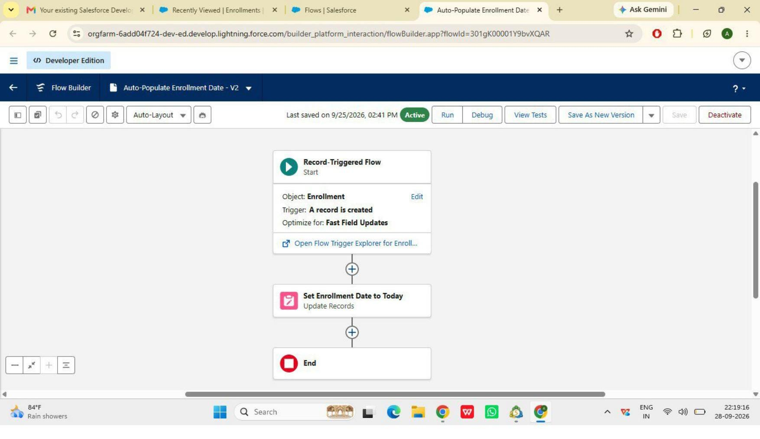
Figure 18 — Auto-Populate Enrollment Date flow, Active
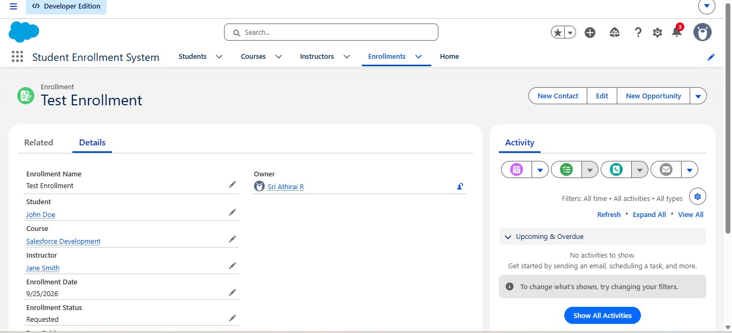
Figure 19 — Test record confirming Enrollment Date auto-populated

7.2 Activity 2 — Send Approval Outcome Email
A Record-Triggered Flow on Enrollment (trigger: record updated, Enrollment Status Is Changed) retrieves the related Student record and sends an outcome email to the student when Status changes to Approved or Rejected.
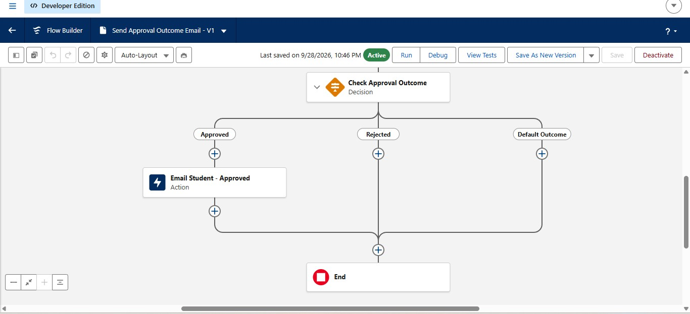
Figure 20 — Send Approval Outcome Email flow, Active, both branches configured
Both branches were built, activated, and tested end-to-end: the Approved outcome email was confirmed delivered to a real inbox after correcting an initial placeholder test address.

8. Remaining Work
- Milestone 10, Activities 3–4: auto-assign instructor by course category; auto-create follow-up task
- Milestone 11: Reports
- Milestone 12: Dashboards
- Milestone 13: Security Setup

