STUDENT ENROLLMENT & COURSE MANAGEMENT SYSTEM
(SECMS)
Salesforce Project Documentation
Prepared by Sri Athirai R
Salesforce Developer Edition
Complete project, user stories, implementation record, testing evidence and screenshots

Document Item | Details
Project | Student Enrollment & Course Management System (SECMS)
Platform | Salesforce Developer Edition
Implementation approach | Declarative Salesforce configuration
Core areas | Students, Courses, Instructors, Enrollments, Approvals, Automation, Reports, Dashboards, Security
Source material | Provided SECMS project specification and implementation documentation

1. Project Overview
The Student Enrollment & Course Management System (SECMS) is a Salesforce application designed to streamline academic enrollment operations. The project centralizes student, course, instructor, and enrollment information and supports validation, approval, automation, reporting, and dashboard-based monitoring.
The implementation document states that the completed build uses Salesforce declarative capabilities including custom objects, flows, validation rules, approval processes, tabs, a Lightning app, record types, page layouts, and related lists, with no Apex code in the documented implementation.

1.1 Purpose
The primary purpose is to replace manual and fragmented enrollment processes with a scalable, automated, and secure Salesforce solution supporting accurate student data management, structured enrollment workflows, automated approvals and validations, and transparent reporting and monitoring.

1.2 Functional Requirements
FR No. | Epic | Description
FR-1 | Student Management | Manage student records
FR-2 | Course Management | Create and manage courses
FR-3 | Enrollment Processing | Request, approve, reject enrollments
FR-4 | Instructor Assignment | Auto-assign instructors
FR-5 | Reporting | Dashboards and reports

1.3 Non-Functional Requirements
Requirement | Source requirement
NFR-1: Usability | Simple, intuitive and user-friendly interface; clearly labeled tabs, dashboards and forms.
NFR-2: Security | Confidentiality, integrity, authentication, authorization and access controls.
NFR-3: Reliability | Consistent processing of enrollments, approvals and reporting without incorrect or duplicate records.
NFR-4: Performance | Fast response times, including dashboard refresh, student search and bulk operations.
NFR-5: Scalability | Support growth in students, courses, departments and users and allow future modules.
NFR-6: Availability | Continuous accessibility during institutional working hours with minimized downtime.

2. Ideation & Requirements Analysis

2.1 Problem Statement
Problem Statement | Customer | Need | Problem | Effect
PS-1 | Enrollment Officer | manage student enrollments efficiently | enrollment data is scattered; systems are manual and unintegrated | frustrated and error-prone
PS-2 | Administrator | track enrollments and revenue | reporting is delayed; data is not centralized | uncertain in decision-making

2.2 Empathy Map Canvas
- Think & Feel: Concerned about double bookings and revenue loss
- Hear: Complaints from students and management
- See: Multiple spreadsheets and emails
- Say & Do: Rechecks data, follows up manually
- Pain: Duplicate entries, approval bottlenecks
- Gain: Automation, dashboards, faster processing

2.3 Customer Journey
- Awareness & Registration
- Course Selection
- Enrollment Request
- Fee Payment
- Approval
- Instructor Assignment
- Reporting & Completion

3. Product Backlog — Exact User Stories
The following 13 user stories are reproduced from the supplied project specification. The user-story IDs, sprint/epic labels, wording, story points, priority, and team-member fields are retained as provided.
Sprint | Functional Requirement (Epic) | User Story Number | User Story / Task Story | Points | Priority | Team Members
Sprint-1 | Developer Setup | USN-1 | As a system administrator, I want to create a Salesforce developer account so that I can configure and deploy the Student Enrollment system.. | 1 | High | Member1
Sprint-1 | Data Modeling | USN-2 | As an admin, I want to create custom objects for Student, Course, Enrollment, and Instructor so that academic data can be stored and managed efficiently. | 3 | High | Member2
Sprint-2 | Data Modeling | USN-3 | As a user, I want dedicated tabs for each object so that I can easily navigate between students, courses, enrollments, and instructors. | 3 | High | Member3
Sprint-2 | Data Modeling | USN-4 | As an admin, I want to create relevant fields such as student details, course information, and enrollment status so that complete records can be captured accurately. | 5 | High | Member4
Sprint-2 | Data Modeling | USN-5 | As an enrollment officer, I want a centralized Lightning App so that I can access all academic operations from one interface. | 3 | High | Member4
Sprint-2 | Data Modeling | USN-6 | As an admin, I want to define relationships between students, courses, and enrollments so that the system can logically link and track academic activities. | 5 | Medium | Member1
Sprint-2 | Data Modeling | USN-7 | As a user, I want customized page layouts so that only relevant information is displayed, improving clarity and ease of data entry. | 5 | High | Member2
Sprint-3 | Automation | USN-8 | As a system, I want to validate input data such as mandatory fields and enrollment limits so that incorrect or incomplete records are prevented. | 3 | High | Member4
Sprint-3 | Automation | USN-9 | As a system, I want automated flows to handle enrollment processing and notifications so that manual effort is reduced and processes become faster. | 3 | High | Member4
Sprint-3 | Automation | USN-10 | As an administrator, I want an approval process for enrollment requests so that registrations are verified before confirmation. | 5 | High | Member1
Sprint-4 | Security | USN-11 | As an admin, I want to configure role-based security so that users can only access data relevant to their responsibilities. | 5 | High | Member2
Sprint-5 | Reports | USN-12 | As a manager, I want reports on student enrollments, course registrations, and instructor assignments so that I can monitor academic operations. | 4 | High | Member3
Sprint-6 | Dashboards | USN-13 | As a manager, I want visual dashboards showing enrollment statistics and trends so that I can quickly analyze system performance. | 4 | Medium | Member4

3.1 Source Screenshot — Exact User Story Table
The following screenshots are taken directly from the supplied project PDF pages containing the original backlog.
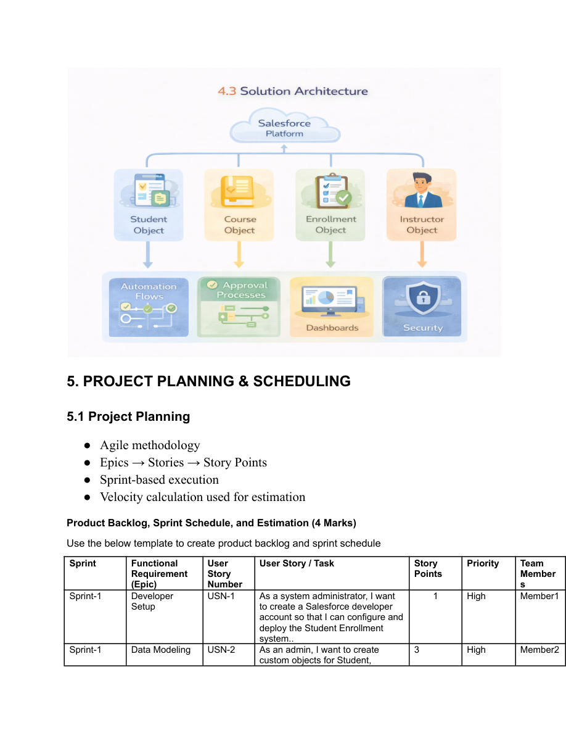
Source screenshot — Product backlog/user stories, page 12 of supplied PDF
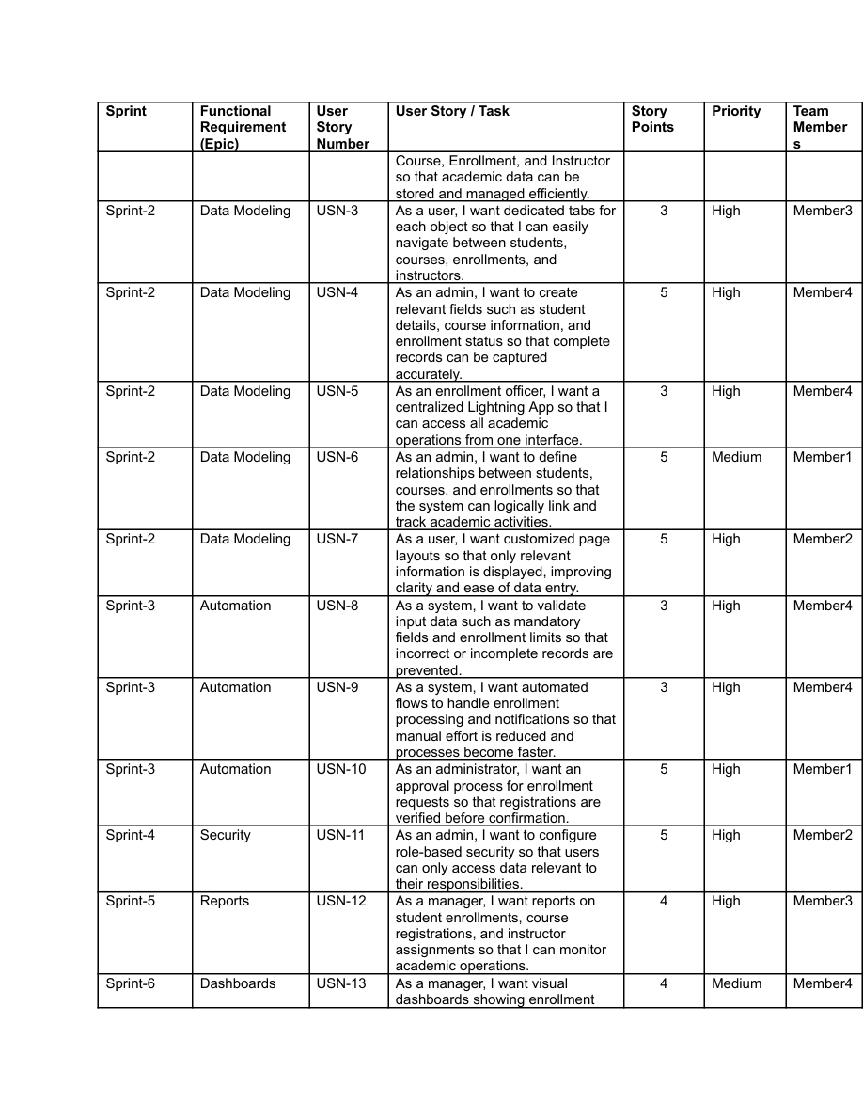
Source screenshot — Product backlog/user stories, page 13 of supplied PDF
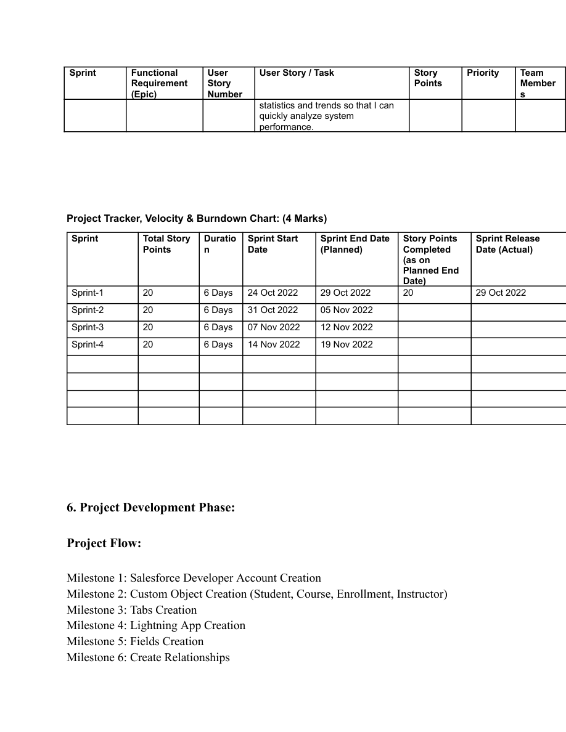
Source screenshot — Product backlog/user stories, page 14 of supplied PDF

4. Project Planning & Scheduling

4.1 Project Planning
- Agile methodology
- Epics → Stories → Story Points
- Sprint-based execution
- Velocity calculation used for estimation
Sprint | Total Story Points | Duration | Sprint Start Date | Sprint End Date (Planned) | Story Points Completed | Sprint Release Date (Actual)
Sprint-1 | 20 | 6 Days | 24 Oct 2022 | 29 Oct 2022 | 20 | 29 Oct 2022
Sprint-2 | 20 | 6 Days | 31 Oct 2022 | 05 Nov 2022
Sprint-3 | 20 | 6 Days | 07 Nov 2022 | 12 Nov 2022
Sprint-4 | 20 | 6 Days | 14 Nov 2022 | 19 Nov 2022

4.2 Project Flow
- Milestone 1: Salesforce Developer Account Creation
- Milestone 2: Custom Object Creation (Student, Course, Enrollment, Instructor)
- Milestone 3: Tabs Creation
- Milestone 4: Lightning App Creation
- Milestone 5: Fields Creation
- Milestone 6: Create Relationships
- Milestone 7: Page Layout Customization
- Milestone 8: Validation Rules
- Milestone 9: Flows (Automation)
- Milestone 10: Approval Process
- Milestone 11: Reports
- Milestone 12: Dashboards
- Milestone 13: Security Setup
- Milestone 14: Conclusion

5. Detailed Implementation Documentation
The implementation section follows the supplied project specification and the supplied implementation record.

5.1 Milestone 2 – Objects

Activity 1: Creating Student Object:
Purpose: To store and manage information about students such as their personal details, contact information, and enrollment status.
Object | Label / Configuration
Student | Student
Plural Label | Students
Object Name | Student
Record Name | Student Name
Data Type | Text
Optional Features | Allow Reports; Allow Activities (optional but recommended); Track Field History (optional)
Search Status | Allow Search
In the same way Create Courses, Instructors, and Enrolments objects

5.2 Milestone 3 - Fields
Object | Field | Data Type
Student | Student Name | Text (Standard)
Student | Email | Email
Student | Phone | Phone
Student | Date of Birth | Date
Student | Student Status | Picklist
Student | Address | Text Area
Course | Course Name | Text (Standard)
Course | Category | Picklist
Course | Duration | Number/Text
Course | Course Fee | Currency
Course | Description | Text Area
Instructor | Instructor Name | Text (Standard)
Instructor | Instructor Code | Text
Instructor | Expertise | Picklist
Instructor | Phone | Phone
Instructor | Email | Email
Enrollment | Student | Lookup (Student)
Enrollment | Course | Lookup (Course)
Enrollment | Instructor | Lookup (Instructor)
Enrollment | Enrollment Date | Date
Enrollment | Enrollment Status | Picklist
Enrollment | Fees Paid | Checkbox
Enrollment | Total Amount | Currency
Enrollment | Comments | Text Area

5.3 Milestone 4 – Create Relationships

1. Activity 1: Create Lookup from Enrollment to Student:
Purpose: Link Enrollment to Student.
- Go to Setup → click Object Manager.
- Type Enrollment in Quick Find → click Enrollment__c object.
- Click Fields & Relationships → click New.
- Select Lookup Relationship → click Next.
- For Related To, select Student__c → click Next.
- Enter Field Label: Student (API Name: Student__c).
- Complete visibility/layout options and click Save.

Activity 2: Create Lookup from Enrollment to Course
Purpose: To link each Enrollment to a Course.
- Go to Setup → Object Manager → Enrollment__c.
- Click Fields & Relationships → New.
- Select Lookup Relationship → Next.
- Related To: select Course__c → click Next.
- Field Label: Course (API Name: Course__c).
- Set visibility/layout → Save.

Activity 3: Create Lookup from Enrollment to Instructor:
Purpose: To store which Instructor is assigned to a particular Enrollment.
- Go to Setup → Object Manager → Enrollment__c.
- Click Fields & Relationships → New.
- Choose Lookup Relationship → Next.
- Related To: select Instructor__c → Next.
- Field Label: Instructor (API Name: Instructor__c).
- Complete Field-Level Security and Page Layout options → Save.

5.4 Milestone 5 – Validation Rules:

Activity 1: Student Email Domain Validation
Purpose: To ensure students use only allowed institutional email addresses.
Rule Name: Student_Email_Domain_Validation
Error Condition Formula: NOT(CONTAINS(Email__c, "@student.edu"))
Error Message: Email must be a valid student institutional email.
Error Location: Field → Email__c.

Activity 2: Fees Must Be Paid Before Approval
Purpose: Prevent Enrollment from being approved until fees are paid.
Rule Name: Fees_Must_Be_Paid_Before_Approval
Error Condition Formula: AND( ISPICKVAL(Enrollment_Status__c, "Approved"), Fees_Paid__c = FALSE )
Error Message: Fees must be paid before approving an enrollment.
Error Location: Top of Page (or field as needed).

5.5 Milestone 6 – Approval Process

Activity 1: Create Approval Process for Enrollment Requests
Purpose: Route Enrollment requests to Training Manager for approval or rejection.
- Go to Setup → Approval Processes → select Enrollment__c.
- Click Create New Approval Process → Use Standard Setup.
- Process Name: Approval_Enrollment_Request.
- Entry Criteria: Enrollment_Status__c = "Requested".
- Save and configure steps.
- Add Approval Step: Approver: specific Training Manager user.
- Under Final Approval Actions: Add Field Update to set Enrollment_Status__c = Approved.
- Under Final Rejection Actions: Add Field Update to set Enrollment_Status__c = Rejected.
- Add Email Alert to send rejection email to student.
- Activate the approval process.

5.6 Milestone 7- Tabs

Activity 1: Creating a Tab for the Student Object:
- Go to Setup.
- In the Quick Find box, type Tabs.
- Under Custom Object Tabs, click New.
- Select Student from the object list.
- Choose a tab style (icon).
- Click Next, assign it to all profiles, and then click Save.

Activity 2: Creating Remaining Tabs
Now create the Tabs for the remaining Objects, they are “Courses, Instructors, Enrollment”. Follow the same steps as mentioned in Activity -1

5.7 Milestone 8 - The Lightning App

Activity 1: Creating the Lightning Application for the Project
App Name: Student Enrollment & Course Management
Navigation Style: Choose Standard Navigation
Assign the app to specific profiles (e.g., Admin, Enrollment Officer, Instructor).
Items included: Student, Course, Instructor, Enrollment, Reports, Dashboards, Home, Tasks.

5.8 Milestone 9 – Page Layouts and Record:

Activity 1: Create Record Types for Enrollment:
Purpose: To separate New Enrollment vs Re-Enrollment processes.
Record Type | Configuration
New Enrollment | Existing Record Type: Master; Record Type Label: New Enrollment; Enable for Admin, Enrollment Officer; default Page Layout
Re-Enrollment | Record Type Label: Re-Enrollment; enable for same profiles; default Page Layout

Activity 2: Separate Page Layo Createuts for Each Enrollment Record Type
Purpose: To show different fields for New Enrollment vs Re-Enrollment.
New Enrollment Layout: keep Student, Course, Instructor, Enrollment Date, Status, Fees, etc.; remove unnecessary re-enrollment fields if any.
Re-Enrollment Layout: include previous Enrollment reference (if any), Re-Enrollment Reason, Status, Fees, etc.

Activity 3: Enrollment R Addelated Lists to Parent Objects:
Purpose: To see all Enrollments from Student, Course, and Instructor records.
- Student → Enrollment Related List
- Course → Enrollment Related List
- Instructor → Enrollment Related List

5.9 Milestone 10 – Automation with Flow

Activity 1: Auto-Populate Enrollment Date (Record-Triggered Flow)
Purpose: Set Enrollment_Date__c to today when Enrollment is created.
- Go to Setup → Flows → New Flow.
- Select Record-Triggered Flow → Create.
- Object: Enrollment__c.
- Trigger: A record is created.
- Optimize for Actions and Related Records → Done.
- Add Update Records element: Label: Set Enrollment Date.
- Use record that triggered the flow.
- Field: Enrollment_Date__c → Value: $Flow.CurrentDate.
- Save as SetEnrollmentDate → Activate.

Activity 2: Send Email When Enrollment Approved
Purpose: When Enrollment_Status__c = Approved, send email, alert admin, and set Student to Active.
- Create Email Template and Email Alert for student notification.
- Go to Flows → New → Record-Triggered Flow.
- Object: Enrollment__c, Trigger on update.
- Condition: Enrollment_Status__c Equals "Approved".
- Add Get Records to fetch related Student__c.
- Add Action (Email Alert) to send email to student.
- Add Action to notify Admin if needed.
- Add Update Records to set Student__c.Status__c = Active.
- Save as Enrollment Approved Action → Activate.

Activity 3: Auto-Assign Instructor Based on Course Category
Purpose: Assign Instructor automatically based on Course category.
Course Category | Instructor
Technical | Instructor A
Language | Instructor B
Non-Technical | Instructor C
- Prepare Instructor__c records with codes (e.g., INSTR_A, INSTR_B, INSTR_C).
- Create Record-Triggered Flow on Enrollment__c (created/updated).
- Add Get Records to fetch related Course__c.
- Add Decision element on Course__r.Category__c.
- Technical / Language / Non-Technical outcomes.
- For each outcome, get Instructor record (A/B/C) based on code or name.
- Update Records: set Instructor__c = Get_Instructor_X.Id.
- Save as AutoAssign_Instructor → Activate.

Activity 4: Auto-Create Task for Follow-Up
Purpose: When Enrollment is “Requested”, create a follow-up task for Admin.
- Create Record-Triggered Flow on Enrollment__c.
- Trigger: Record created or updated; condition Enrollment_Status__c = "Requested".
- Add Get Records to fetch Admin user (by Username / Profile).
- Add Formula (Date): TODAY() + 2 for due date.
- Add Create Records for Task.
- Subject: Follow up on enrollment request.
- OwnerId: Admin user Id.
- WhatId: Enrollment Id.
- ActivityDate: formula Today + 2.
- Save as Create_Followup_Task → Activate.

5.10 Milestone 11 – Reports:
Activity | Report Type | Configuration | Save As
Activity 1: Create “Students by Status” Report | Students | Group rows by Status__c | Students by Status
Activity 2: Create “Enrollments by Course” Report | Enrollments | Group rows by Course__r.Name; show record count per course | Enrollments by Course
Activity 3: Create “Pending Enrollment Approvals” Report | Enrollments | Filter Enrollment_Status__c = Requested; columns Student, Course, Owner, Created Date | Pending Enrollment Approvals
Activity 4: Create “Revenue Report (Fees Paid)” Report | Enrollments | Filter Fees_Paid__c = TRUE; group by Course__r.Name; summarize fee field | Revenue Report – Fees Paid

5.11 Milestone 12 – Dashboards:

Activity 1: Create “Student Managemet Dnashboard”
Dashboard name: Student Management Dashboard
- Donut Chart → using Students by Status report.
- Bar Chart → using Enrollments by Course report.
- Gauge → using Revenue Report – Fees Paid (sum of revenue field).
- Table → using Pending Enrollment Approvals report.
- Arrange components on canvas. Click Save → Done.

5.12 Milestone 13 – Security Setup

Activity 1: Configure Profiles
Profile | Required access
Admin | Full access.
Enrollment Officer | Create/Update Enrollments.
Instructor | Read-only access to assigned Enrollments.

Activity 2: Create Permission Sets
- Create Custom Object Access (additional access to project objects if needed).
- Create Dashboard Editor (Create/Customize Reports & Dashboards permissions).
- Assign to relevant users.

Activity 3: Configure Sharing & OWD
Object | OWD
Students (Student__c) | Public Read/Write
Courses (Course__c) | Public Read/Write
Enrollments (Enrollment__c) | Private

6. Implementation Status
Milestone | Description | Status
1 | Developer Edition org created and verified | Complete
2 | Custom objects: Student__c, Course__c, Instructor__c, Enrollment__c | Complete
3 | Custom fields added to all four objects per spec | Complete
4 | Lookup relationships on Enrollment (Student, Course, Instructor) | Complete
5 | Validation rules (Student email domain; Enrollment fees-before-approval) | Complete
6 | Approval Process “Approval Enrollment Request” on Enrollment | Complete
7 | Custom tabs for all four objects | Complete
8 | Lightning App “Student Enrollment System” | Complete
9 | Record Types and Page Layouts on Enrollment; related lists on parent objects | Complete
10 | Automation with Flow — Activity 1 & 2 | In Progress
11 | Reports | Not Started
12 | Dashboards | Not Started
13 | Security Setup | Not Started

6.1 Documented Completed Automation
Activity 1 — Auto-Populate Enrollment Date: a Record-Triggered Flow on Enrollment sets Enrollment_Date__c to today's date using a Date-typed formula resource. The implementation record states that it is Active and tested.
Activity 2 — Send Approval Outcome Email: a Record-Triggered Flow on Enrollment update retrieves the related Student and sends an outcome email when status changes to Approved or Rejected. The implementation record states both branches were activated and tested end-to-end.

7. Functional & Performance Testing
The supplied project document states that screenshots were captured during testing to verify student, course, instructor, and enrollment record creation; validation checks; record-type behavior; flow execution; reports; dashboards; and other project behavior. The implementation document additionally records an end-to-end approval test in which a Test Enrollment was submitted, approved, and logged in Approval History.
Test Area | Documented evidence
Student / Course / Instructor / Enrollment setup | Salesforce UI screenshots in source materials
Validation rules | Student email domain and fees-before-approval rules
Approval process | Test Enrollment approved; status updated; Approval History logged
Enrollment Date flow | Test record confirms Enrollment Date auto-populated
Approval outcome email flow | Approved/Rejected branches built and tested; approved email delivered to real inbox
Reports / Dashboards / Security | Listed in project specification; implementation status document marks these as remaining/not started at the documented checkpoint

8. Screenshot Evidence
Screenshots below are extracted from the supplied implementation document. Captions retain the figure titles from that document.
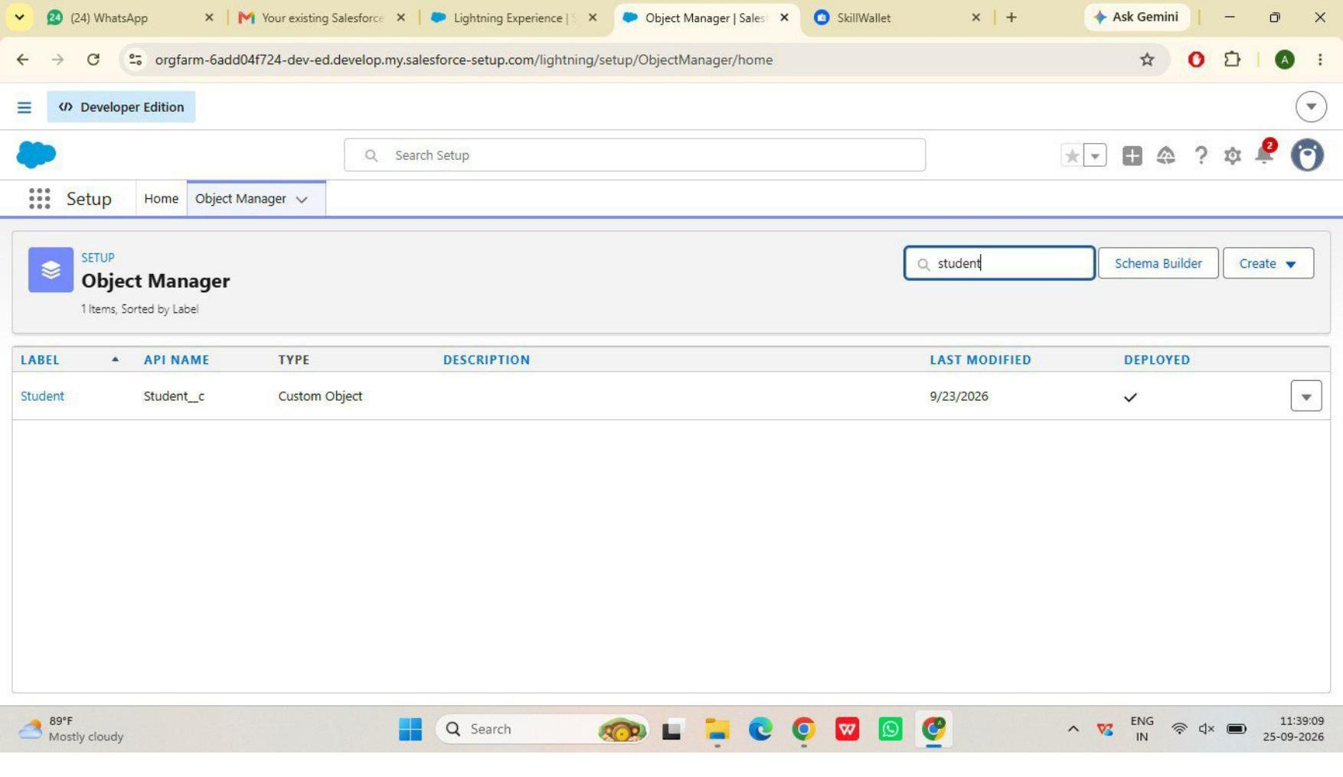
Figure 1 — Student custom object (Object Manager)
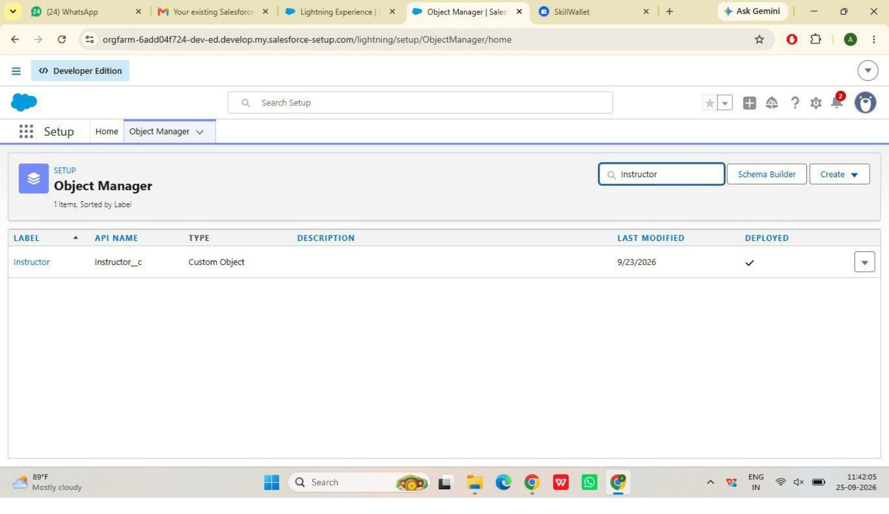
Figure 2 — Instructor custom object (Object Manager)
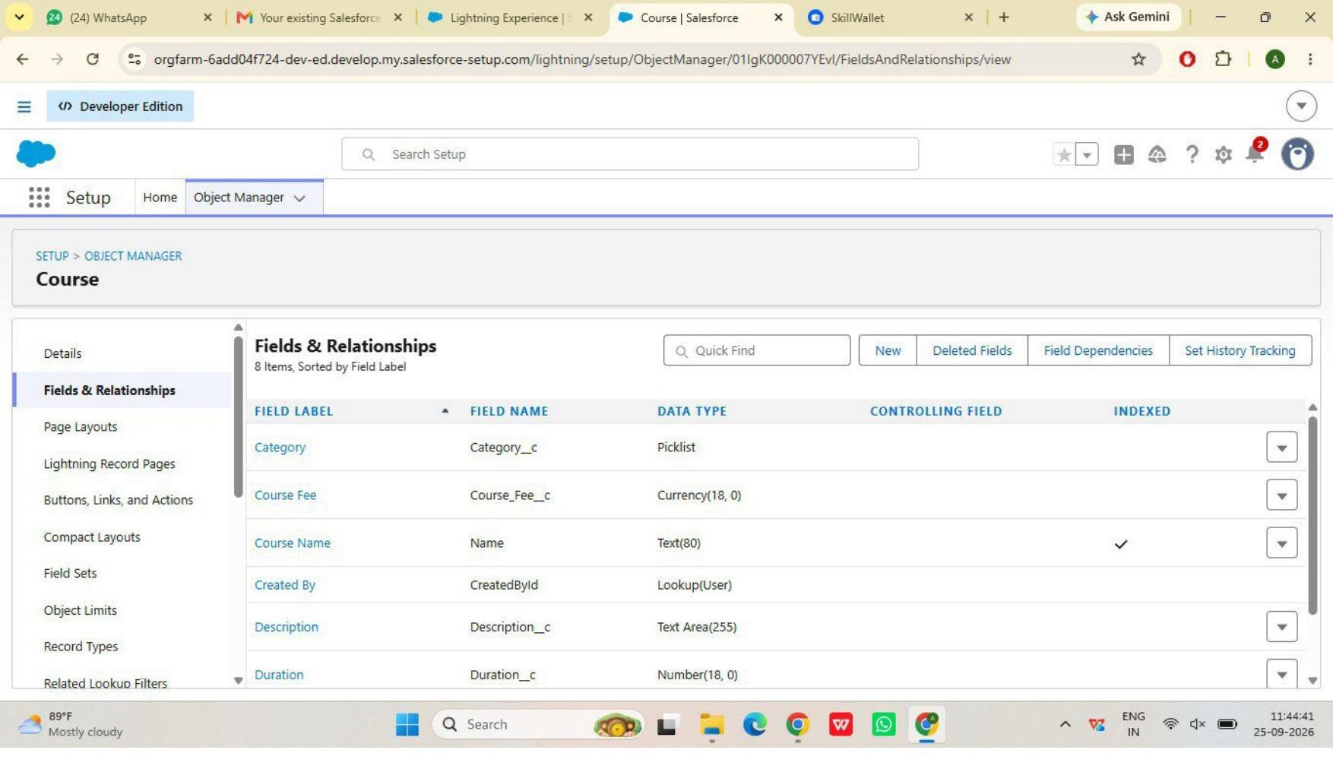
Figure 3 — Course fields (Category, Course Fee, Duration, Description)
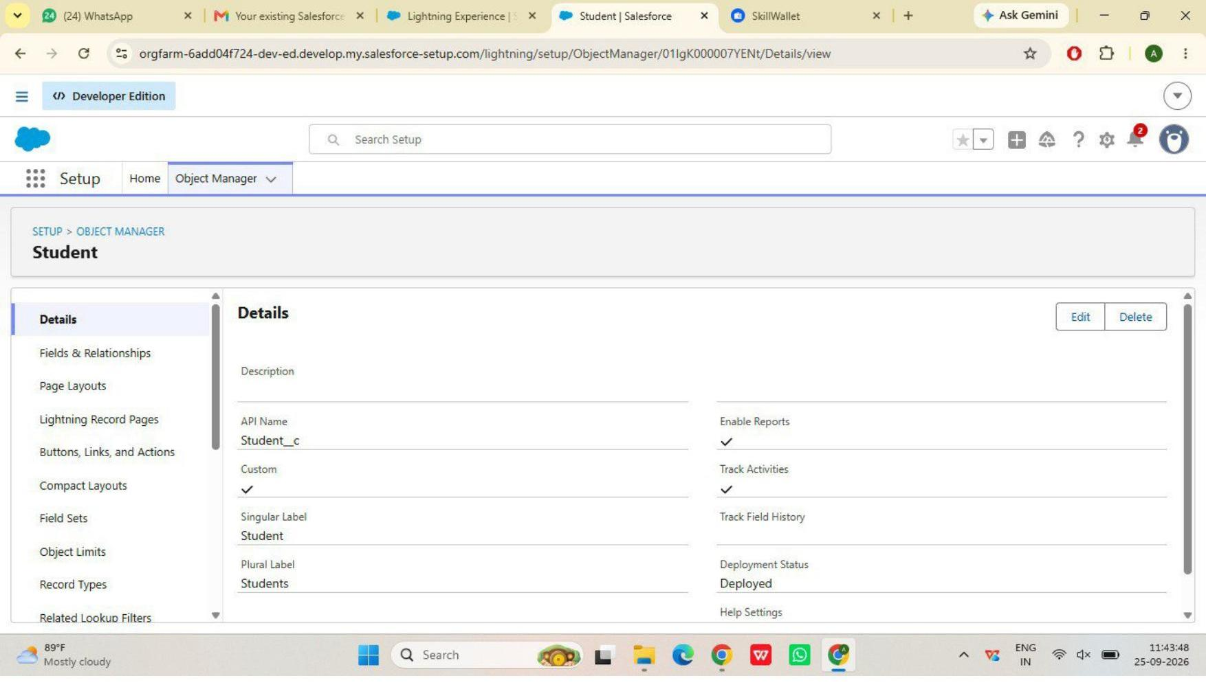
Figure 4 — Student object detail
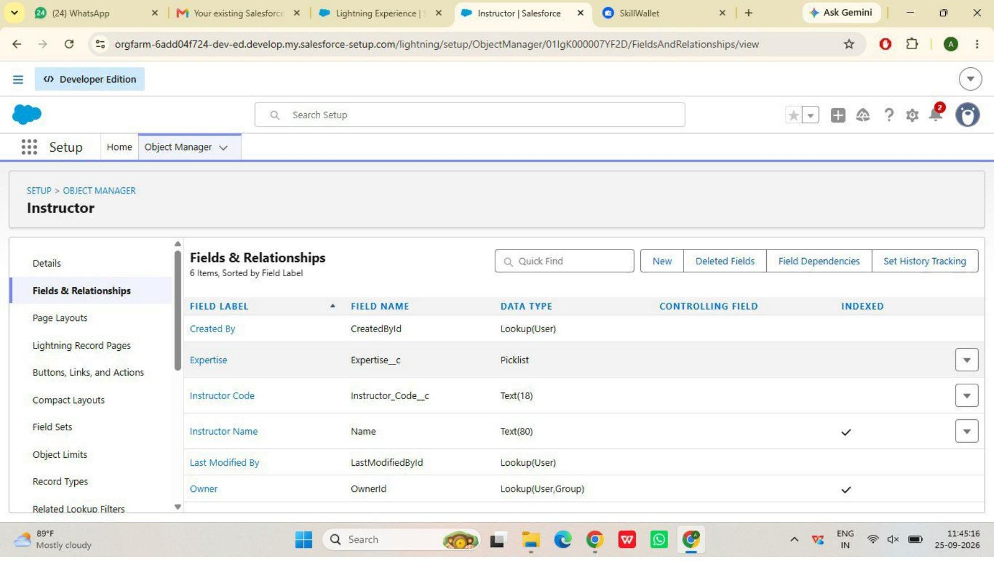
Figure 5 — Instructor fields (Expertise, Instructor Code, Email)
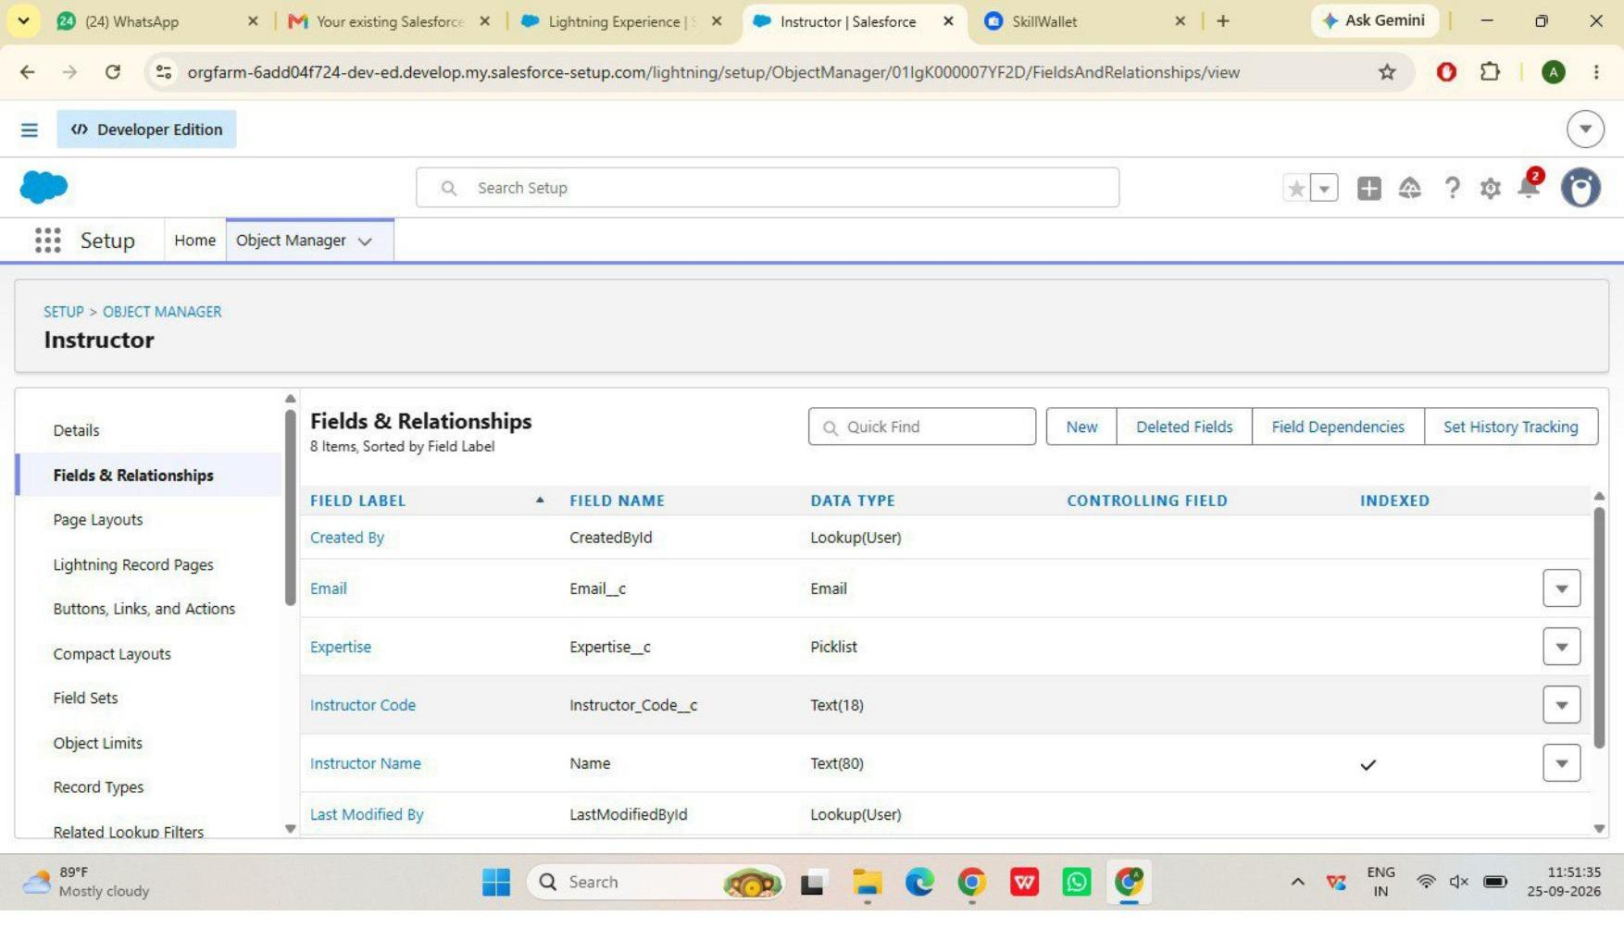
Figure 6 — Instructor fields, continued
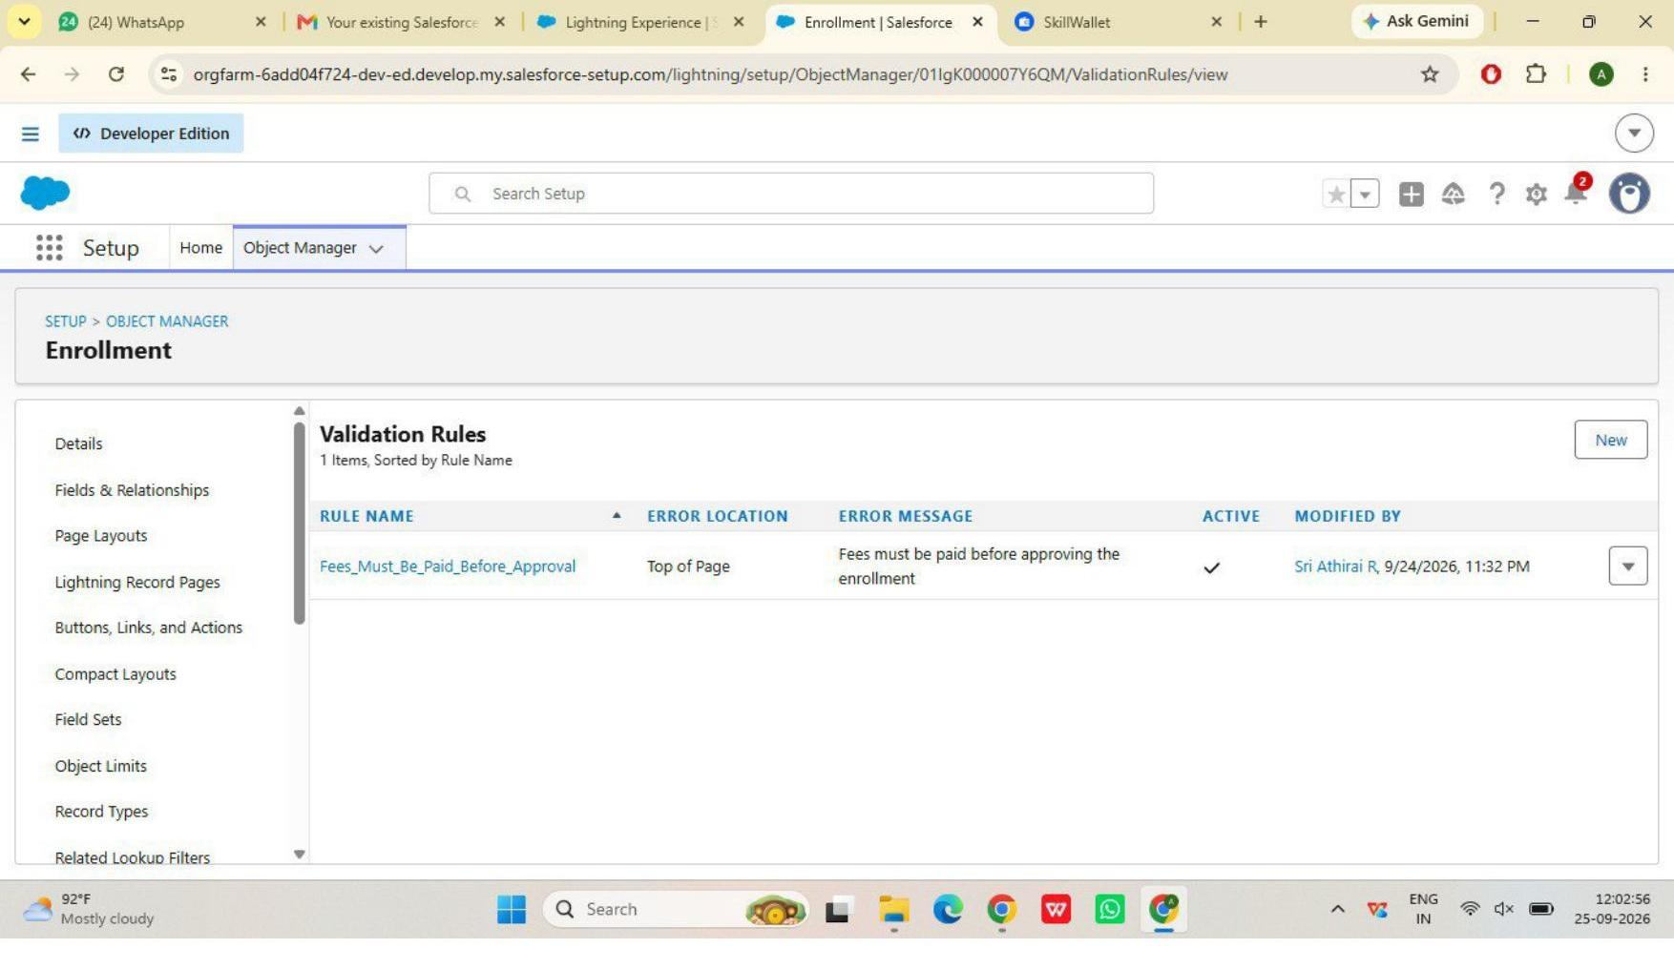
Figure 7 — Enrollment validation rule: Fees_Must_Be_Paid_Before_Approval
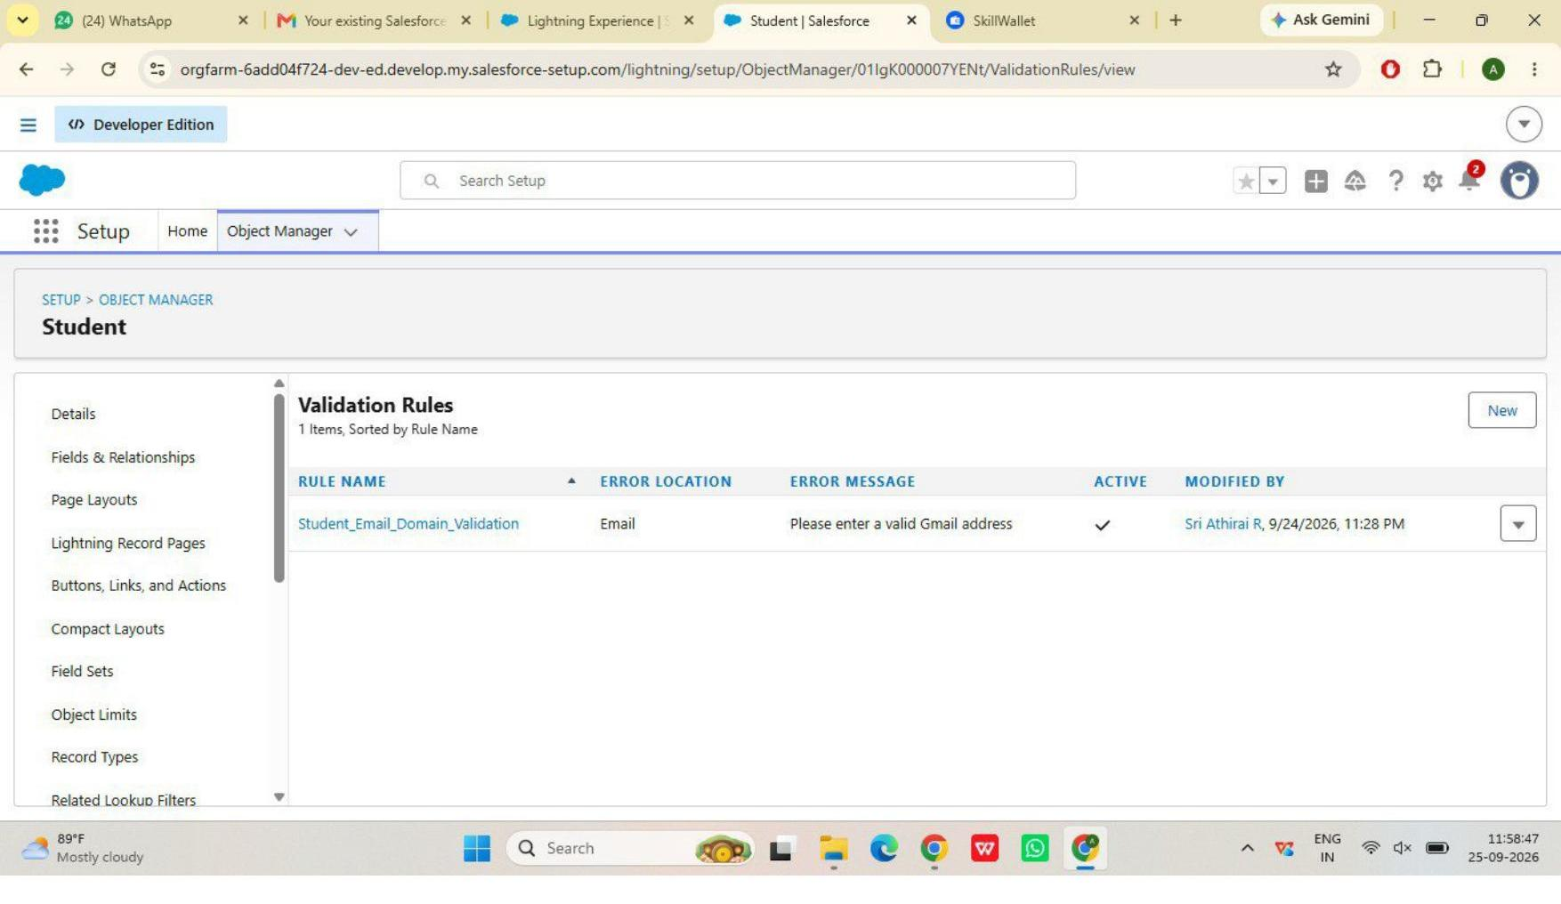
Figure 8 — Student validation rule: Student_Email_Domain_Validation
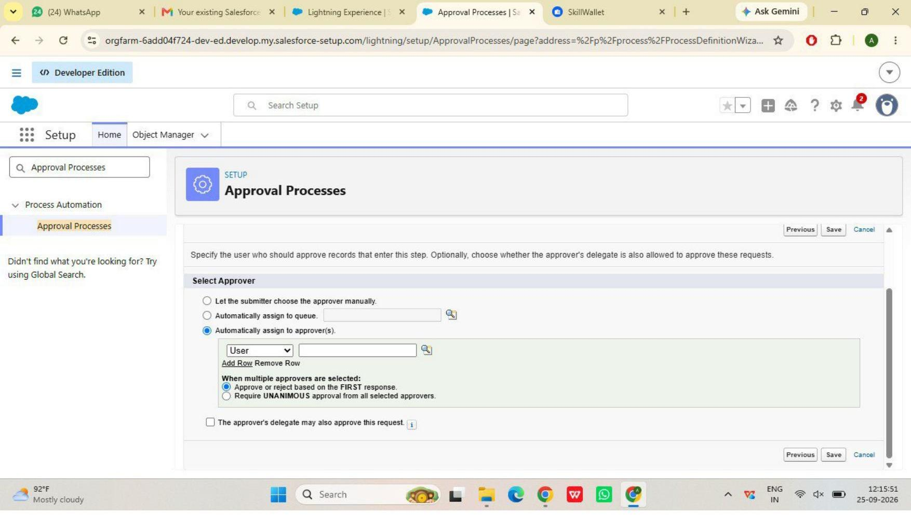
Figure 9 — Approval process approver configuration
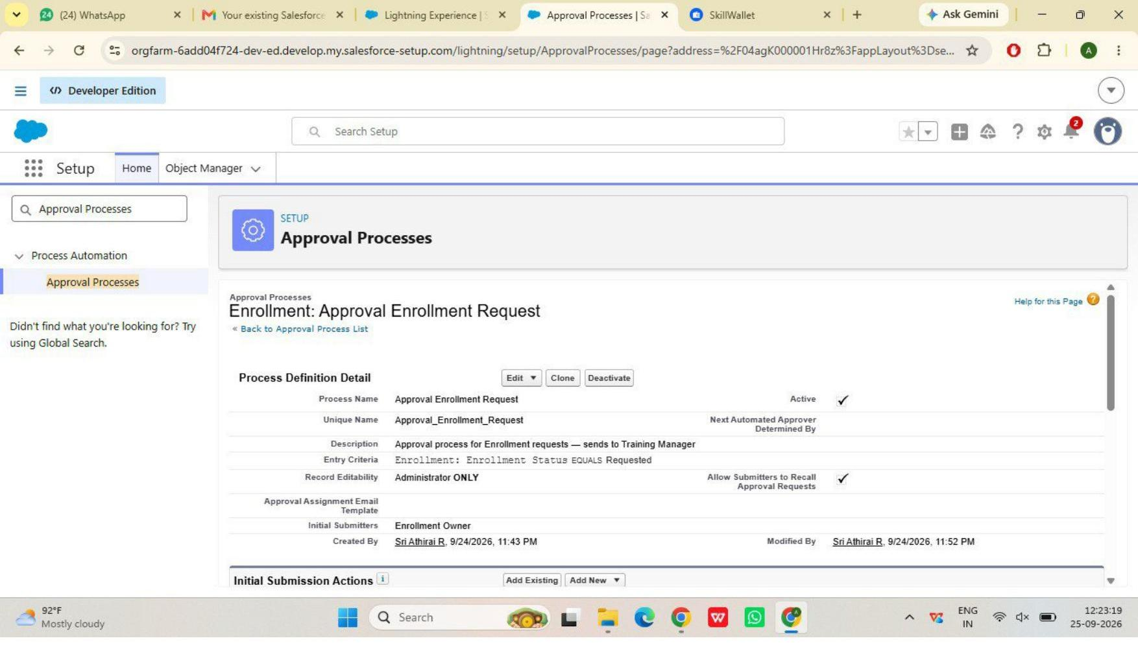
Figure 10 — Approval process detail, Active
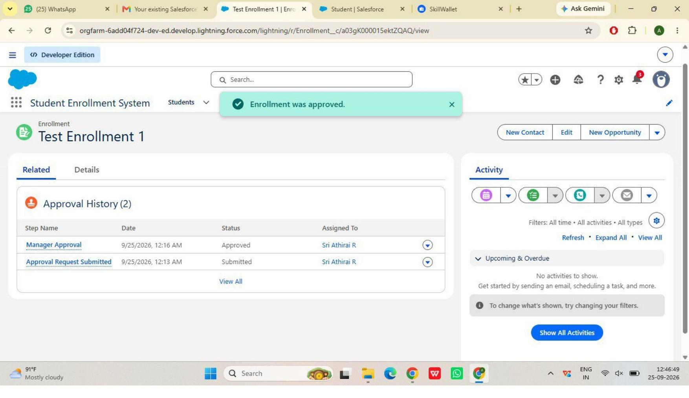
Figure 11 — Approval History showing a completed approval
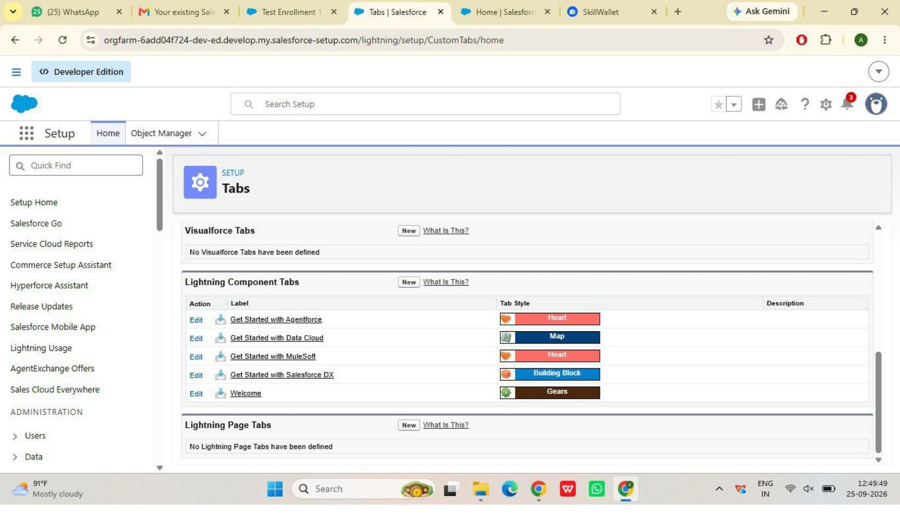
Figure 12 — Custom object tabs (Students, Courses, Instructors, Enrollments)
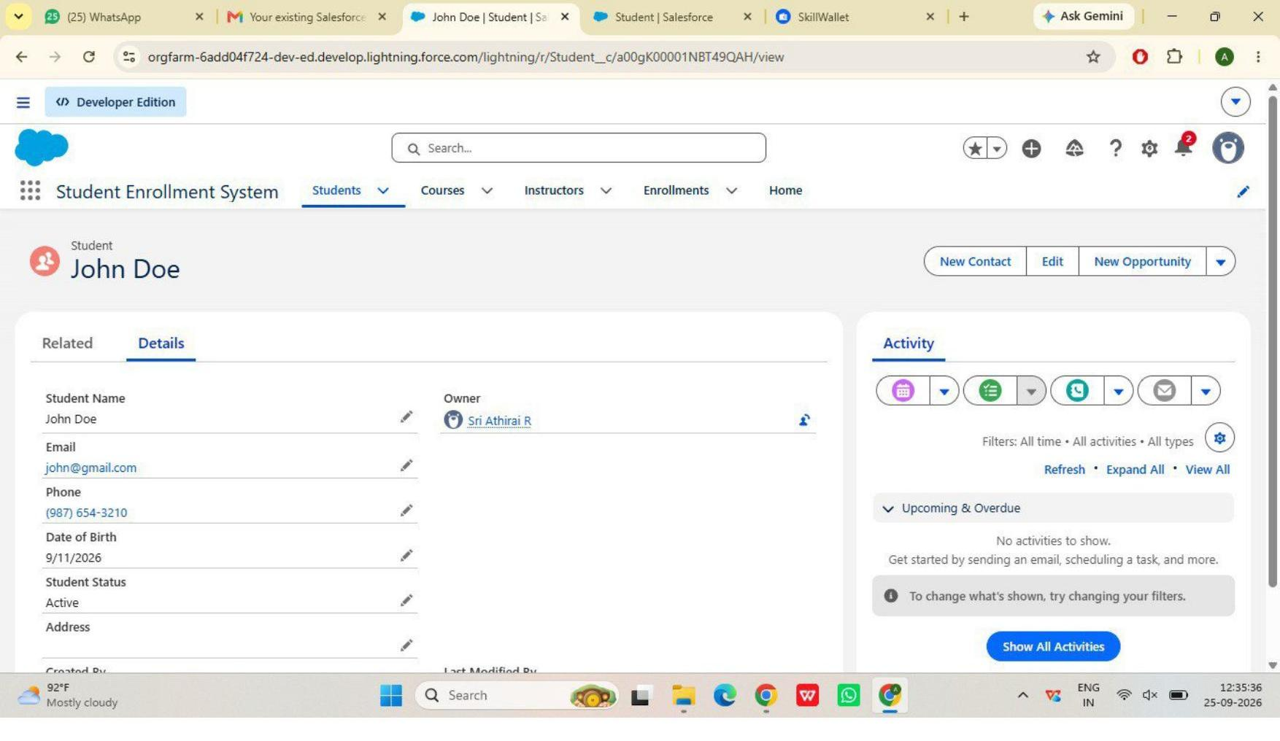
Figure 13 — “Student Enrollment System” Lightning App navigation
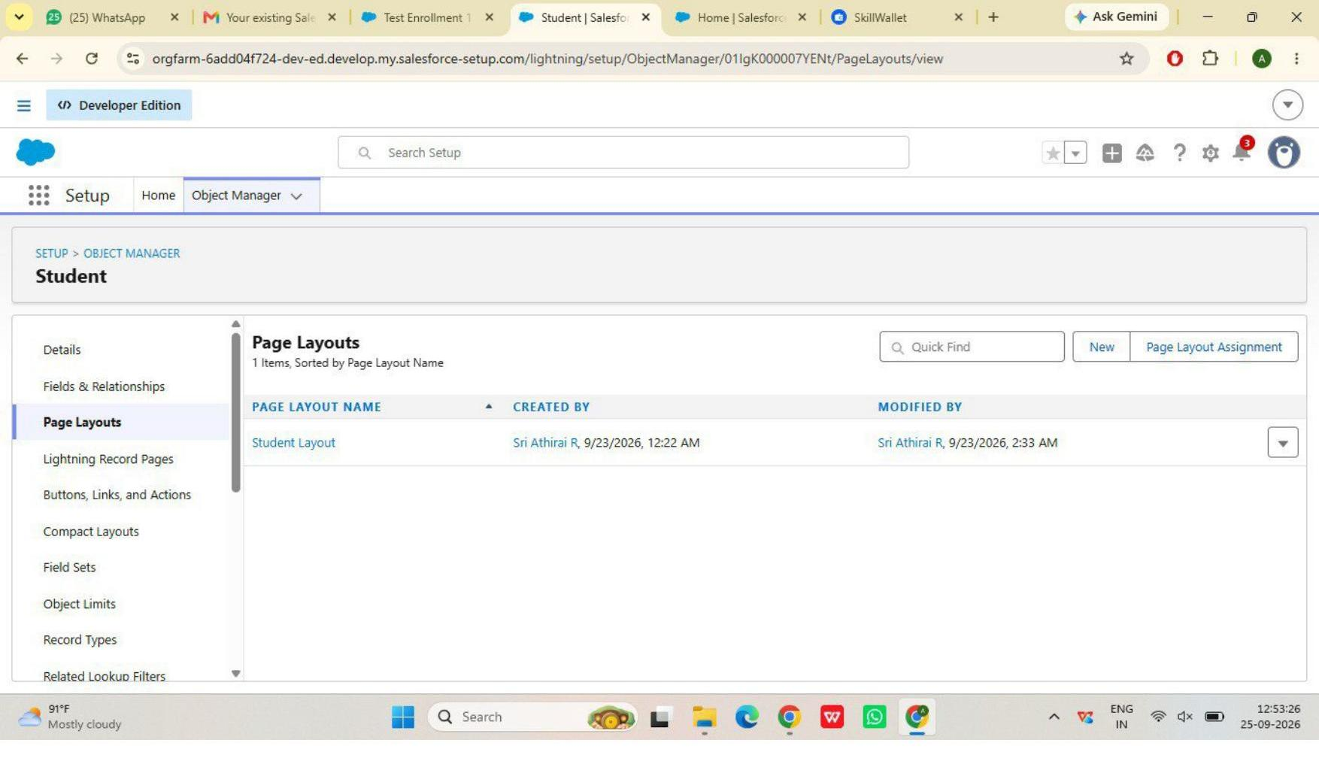
Figure 14 — Enrollment Record Types (New Enrollment / Re-Enrollment)
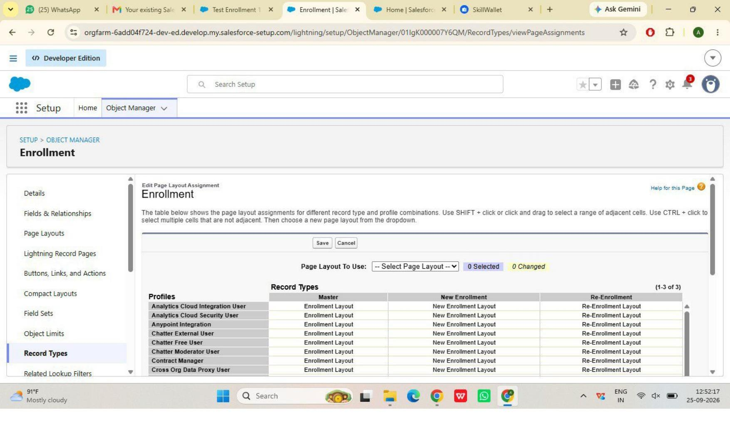
Figure 15 — Student page layout
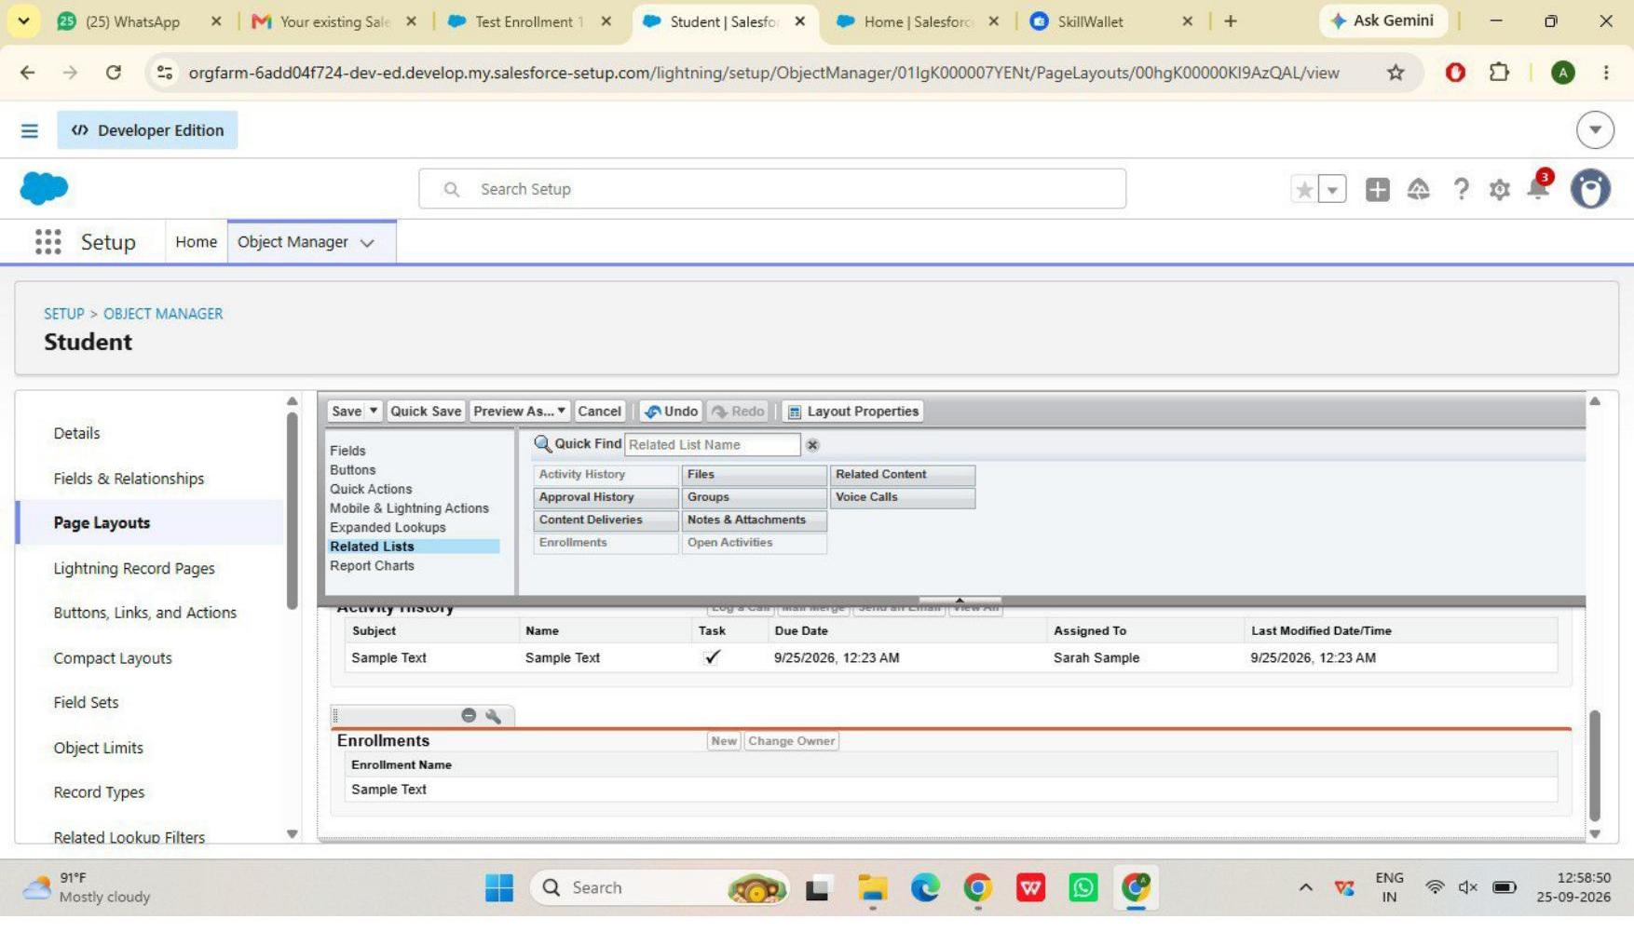
Figure 16 — Student layout with Enrollments related list
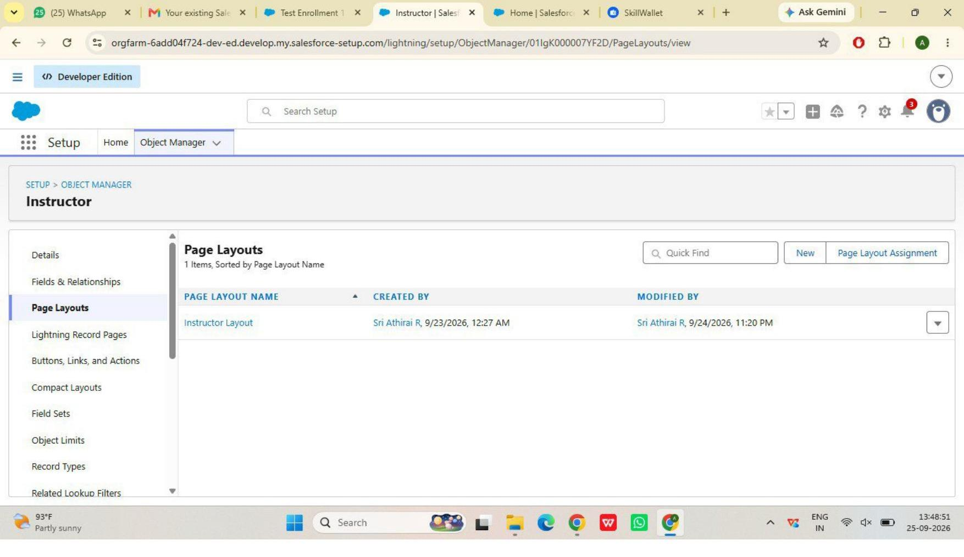
Figure 17 — Instructor page layout
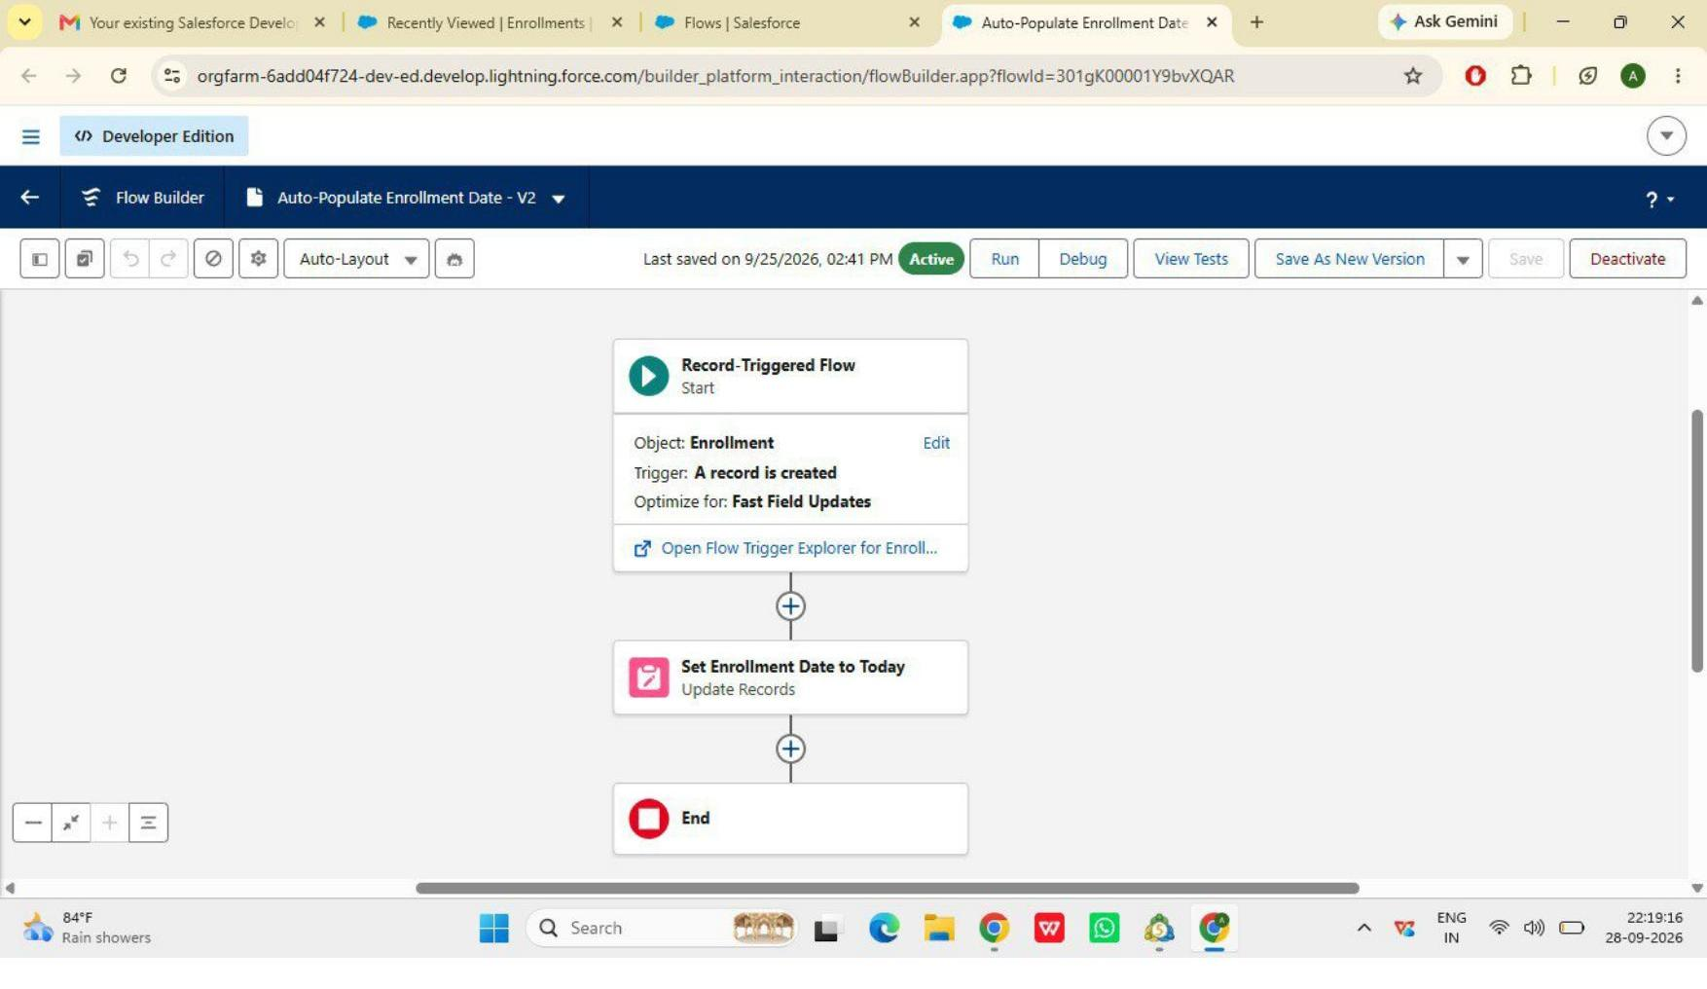
Figure 18 — Auto-Populate Enrollment Date flow, Active
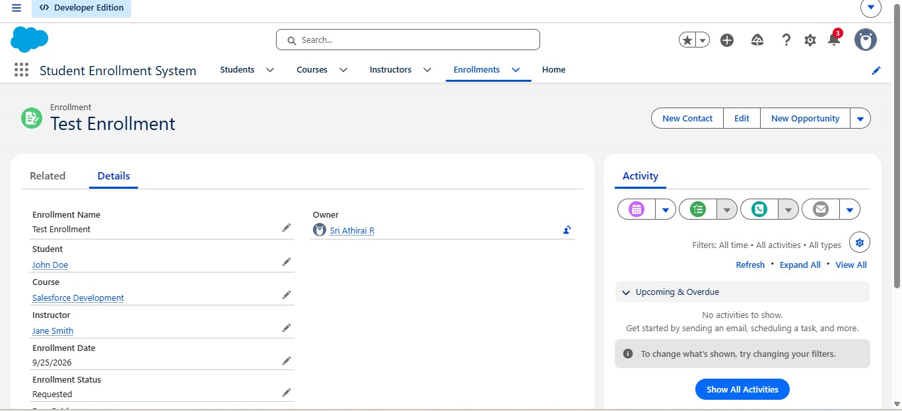
Figure 19 — Test record confirming Enrollment Date auto-populated
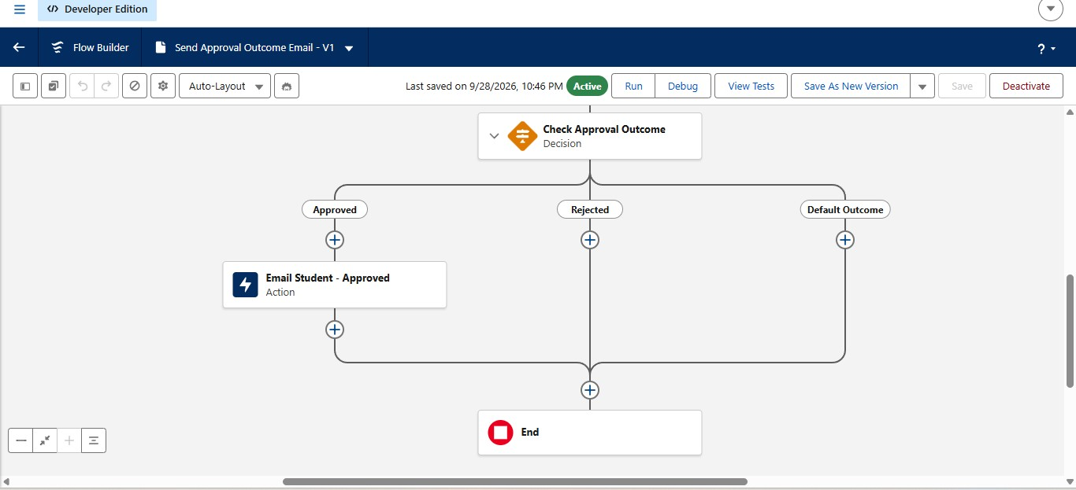
Figure 20 — Send Approval Outcome Email flow, Active, both branches configured

- Milestone 10, Activities 3–4: auto-assign instructor by course category; auto-create follow-up task
- Milestone 11: Reports
- Milestone 12: Dashboards
- Milestone 13: Security Setup

10. Advantages & Disadvantages

Advantages
- Centralized data
- Automated workflows
- Real-time reporting

Disadvantages
- Salesforce dependency
- Requires initial configuration effort

11. Future Scope
- Payment gateway integration
- Student self-service portal
- Analytics-driven insights
- Mobile access support

12. Conclusion
The Salesforce Student Enrollment & Course Management System is designed to streamline the student academic lifecycle from registration and course creation through enrollment management, instructor assignment, approvals, revenue tracking, and reporting. The supplied implementation evidence documents the Salesforce configuration, validation, approval process, page layouts, and completed automation activities at the stated project checkpoint.

13. Appendix — Source & Evidence Notes
Source 1: Supplied SECMS project specification PDF (58 pages), used for the exact user stories, milestone/activity subtitles, requirements, planning, and project flow.
Source 2: Supplied SECMS implementation DOCX (11 pages), used for the implementation status, Salesforce configuration evidence, and screenshots.
Where the implementation document reports a feature as not started or in progress, this documentation preserves that status rather than presenting it as completed.

Source Evidence – Project Backlog and User Stories
The following screenshots are taken directly from the supplied project specification PDF and preserve the original Project Backlog, User Stories, sprint information, and Project Flow.
Figure 21: Source PDF screenshot – Project specification page 12
Figure 22: Source PDF screenshot – Project specification page 13
Figure 23: Source PDF screenshot – Project specification page 14

