[NextWork.org](https://community.nextwork.org/c/i-have-a-question?automatic_login=true)

**Build a**

**Chatbot with**

**Amazon Lex**



**krathira**

**009**

**@**

**gmail**

**.**

**com**

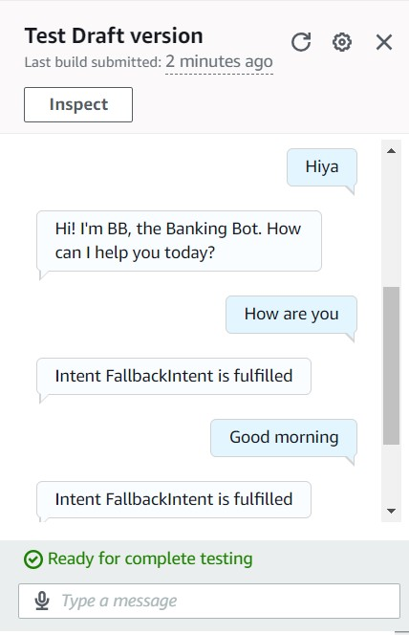

**Introducing Today's Project!**

**What is Amazon Lex?**

Amazon Lex is an AWS service for building conservational interfaces for applications using voice and text. We can build bots to increase contact center productivity, automate simple tasks and drive operational efficiencies across the enterprise.

**How I used Amazon Lex in this project**

Amazon Lex was used to create chatbot, BankerBot, that can help the imaginary bank's customers check their account balance and transfer money between accounts

**One thing I didn't expect in this project was...**

The thing I didn't expect is that one thing is obviously the time taken to create the account and finish this project and the responses they gave for the utterance we gave as input.

**This project took me...**

I completed this project less than an hour including the documentation.

# Setting up a Lex chatbot

I created my chatbot from scratch with Amazon Lex. Setting it up took me 5 minutes following the procedure.

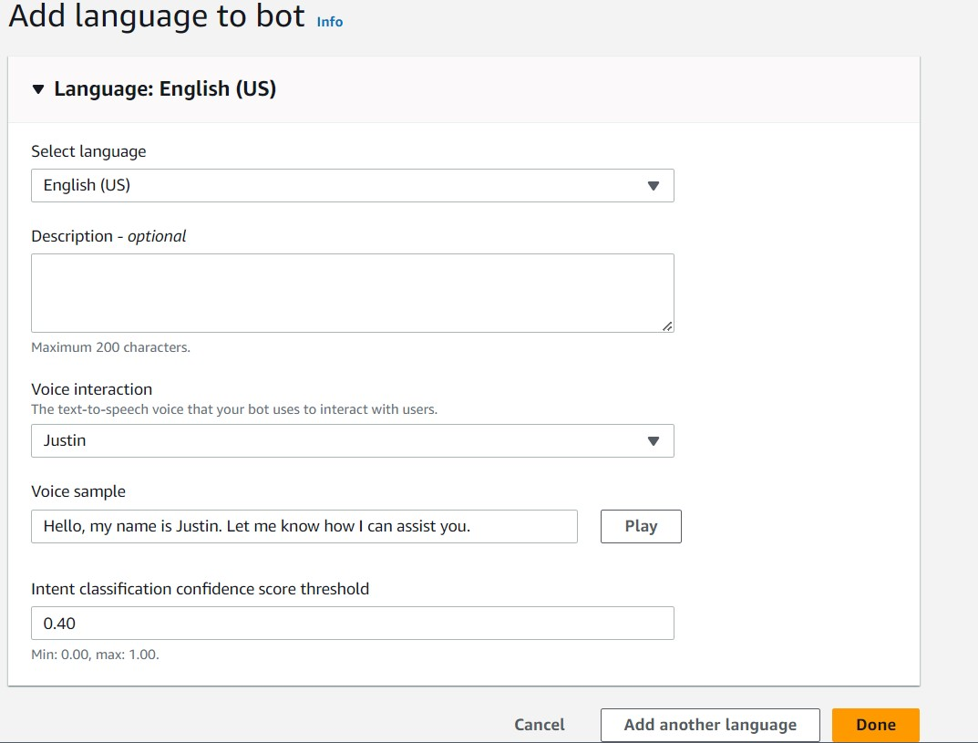

While creating my chatbot, I also created a role with basic permissions because to call other AWS services like Lambda which will be used in this series of project.

In terms of the intent classification confidence score, I kept the default value of 0.40. This means the chatbot needs to be at least 40% confident that it understands what the user is asking to be able to give a response.

# Intents

Intents represents users' purposes for using the chatbot. Here a chatbot is defined by the intents that will supports this chatbot.

I created my first intent, WelcomeIntent, to greet the user when they say hello.



# FallbackIntent

I launched and tested my chatbot, which could respond successfully if I enter utterances like Hello!, Help me and Hiya...

My chatbot returned the error message `Intent FallbackIntent is fulfilled` when I entered 'Good morning, How are you'. This error message occurred because Amazon Lex didn't recognize the utterance mentioned above.



# Configuring FallbackIntent

FallbackIntent is a default intent in every chatbot that gets triggered when the chatbot doesn't understand the users' input.

I wanted to configure FallbackIntent because the default closing response to the user is not easily understandable.

# Variations

To configure FallbackIntent, I had to create my own response in the intent's setup page.

I also added variations! What this means for an end user is they get to see different forms of my chatbot's closing response.

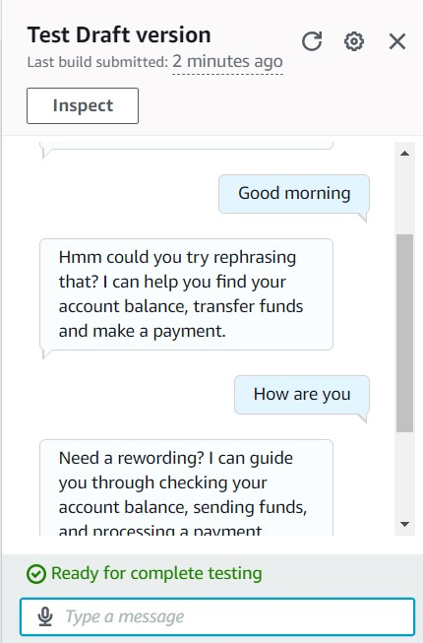

[NextWork.org](https://community.nextwork.org/c/i-have-a-question?automatic_login=true)

**Everyone should be in a job they love.**

Check out nextwork.org for more projects

