select * from job_history;

select * from EMPLOYE1;

select * from JOB1;

select * from DEPARTMENTS;

select * from LOCATIONS;

select * from COUNTRIES;

select * from Regions;

1)select * from job1 where min_salary>10000;



2)select first_name,hire_date from EMPLOYE1 where (extract(year from hire_date)) between 1987 and 1989;



3)select first_name,hire_date from employe1 where job_id='IT_PROG' OR JOB_ID='SA_MAN';

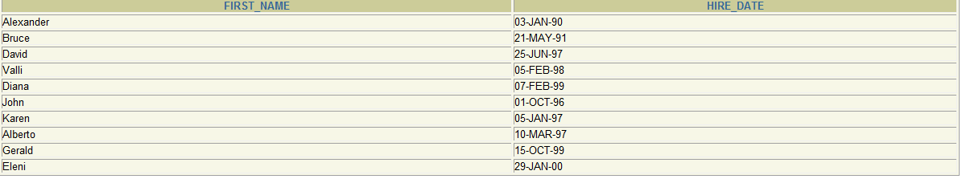

4)select first_name from employe1 where hire_date >'01-jan-2000';

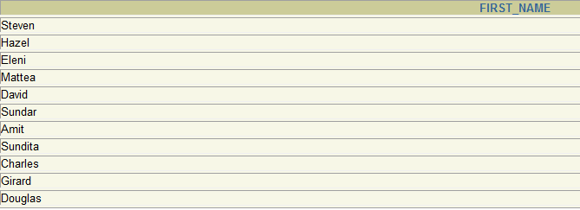

5)select * from employe1 where employee_id between 150 and 160;

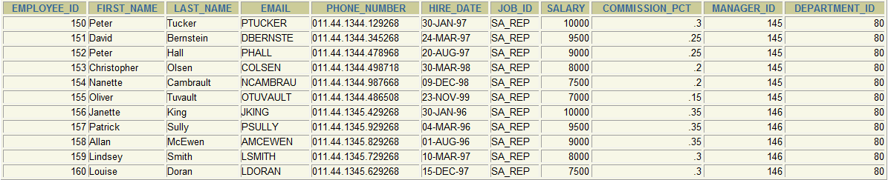

6) select first_name , salary,commission_pct,hire_date from employe1 where salary<3000;

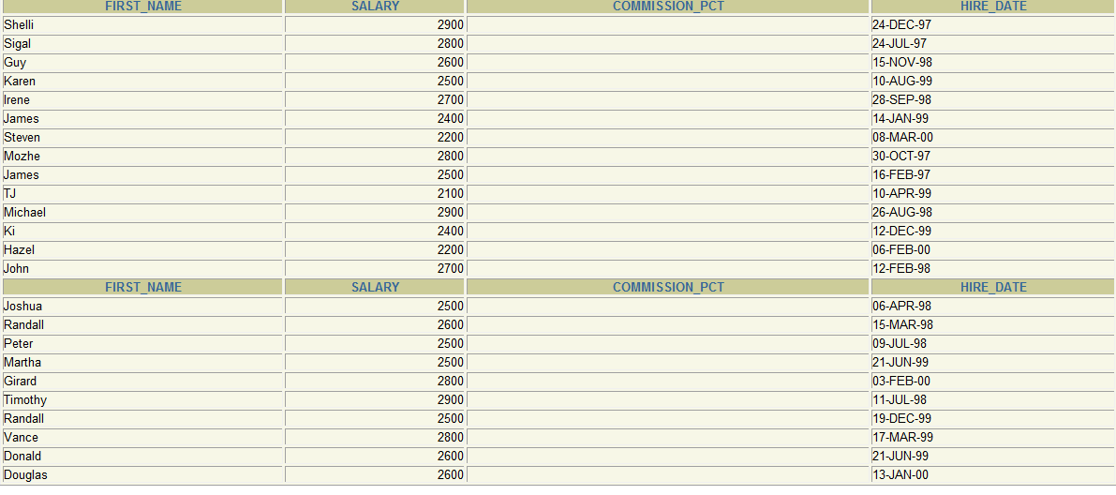

7) select job_title,max_salary-min_salary from job1 where max_salary between 10000 and 20000;

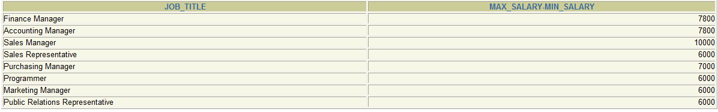

8) update employe1 set salary=16723 where employee_id=104,101;

update employe1 set salary=2968.25 where employee_id=115;

select first_name,salary,round(salary-3) from employe1;

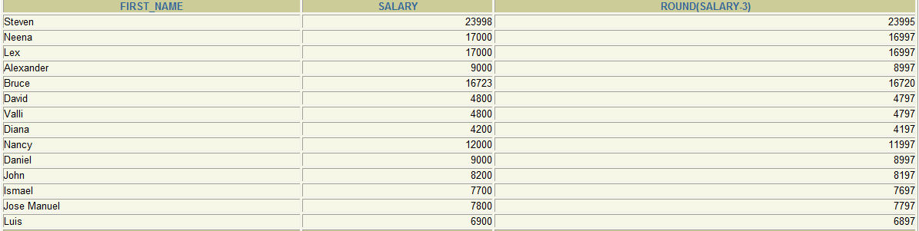

9) select job_title from job1 order by job_title desc;

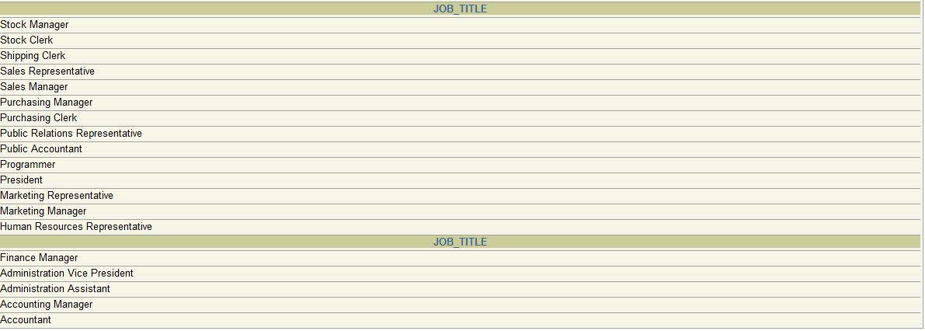

10) select first_name,last_name from EMPLOYE1

where first_name like 'S%' or last_name LIKE 'S%';

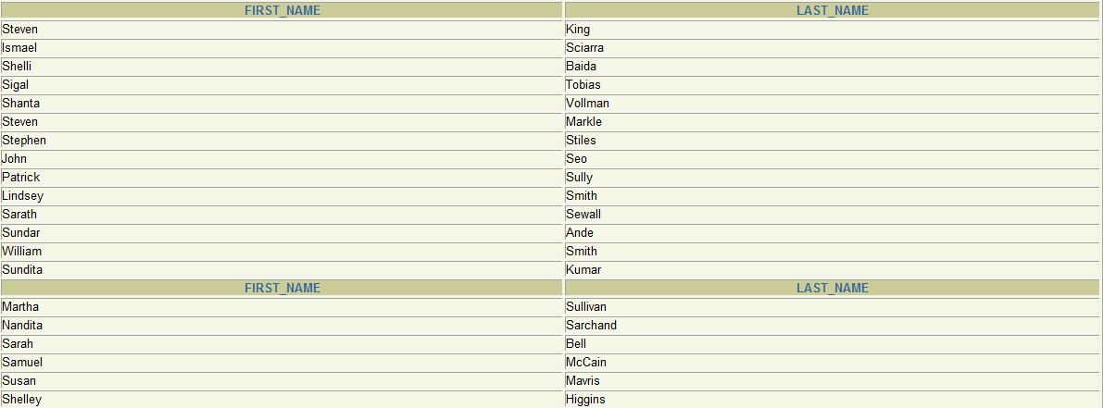

11) select * from EMPLOYE1 where (extract(month from hire_date))='05';

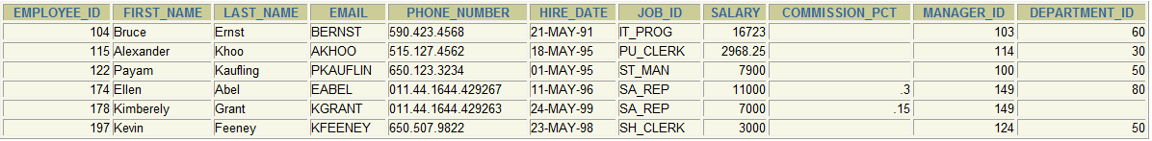

12) select * from employe1 where ((commission_pct is null and salary between 5000 and 10000)and department_id='100') ;

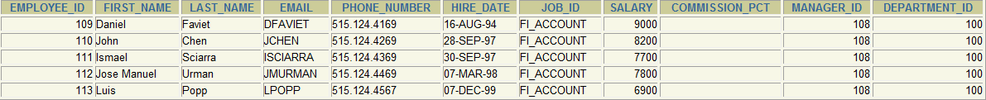

13)