**REFRIGERATION & AIR CONDITIONING LAB REPORT**

**Submitted by**

***NAME: Rajat Choudhary***

***ROLL NO.: 11ME30031***

**Experiment: 2**

***Studies on vapour compression refrigeration test-rig***

**Objective:**

To carry-out steady-state measurements on the **test-rig of a** **vapor compression refrigeration system** in order to determine:

1. Carnot COP, Cycle COP and Actual COP of the refrigeration system
2. Overall heat transfer coefficients for the evaporator and the condenser
3. Overall volumetric efficiency of the compressor

**Components in the test-rig of a vapour compression refrigeration system:**

➢ Hermetic compressor

➢ Air cooled condenser

➢ Capillary tube / Thermostatic expansion valve

➢ Water cooled evaporator

➢ Shut-off valves

➢ Sight glass

➢ Drier

➢ Filter

➢ Solenoid valve

➢ Pressure gauges

➢ Thermometric wells

➢ Rota meter

Refrigerant used: R-12

**Observations:**

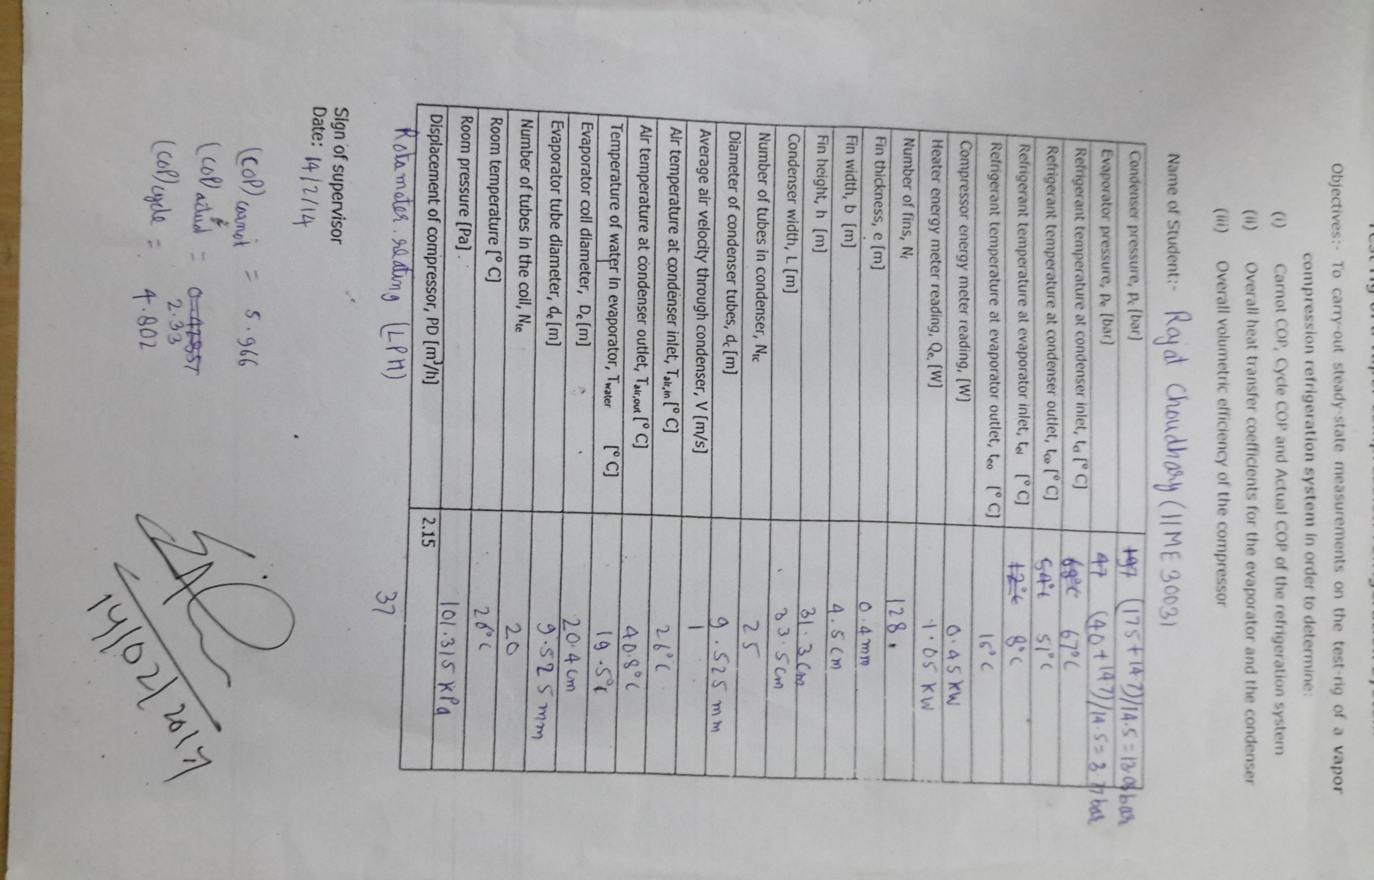

**Calculation:**

1. **Carnot COP, Cycle COP and Actual COP of the refrigeration system**

(i) **Carnot CoP:**

*CoP = T*evp */ (T*cond *– T*evp*)*

= (273+6.223)/ (53.03-6.223)

= 5.966

Here, Tevp and Tcond are the saturation temperatures corresponding to evaporator pressure and condenser pressure.

(ii) **Cycle CoP:**

CoP = (h1 – h3) / (h2– h1)

Where

h1 = enthalpy of refrigerant vapor at evaporator outlet = 196.1 kJ/kg

h2 = enthalpy of refrigerant vapor at compressor outlet = 220.5 kJ/kg

h3 = enthalpy of refrigerant liquid at condenser outlet = 83.96 kJ/kg

CoP = 4.802

(iii) **Actual CoP:**

CoP = actual refrigerant effect / actual energy input to compress

= energy meter reading of heater/ energy meter reading of compressor

= 1.05/0.45

= 2.33

1. **Overall heat transfer coefficients of evaporator and condenser (Uevp, Ucond) :**

For the evaporator:-

**Uevp =**

Where, Acoil is the area of the evaporator coil (to be obtained from the

evaporator tube diameter, coil diameter and number of coils immersed

in water)

Twater & Te are the water and refrigerant temperatures in the evaporator.

Te = (8+15)/2 = 11.5 oC

Twater = 19.5 oC

Acoil = (pi*de )*(pi*De*Nte)

= 0.384 m2

Actual refrigeration effect = 1050 KJ

**Uevp = 341.8 KJ/m2-K**

For the condenser,

**Ucond =**

Condenser heat rejection rate = (m * Cp)*( Tair,out – Tair,in)

Cp,air =1000 J/Kg-K

mair = air velocity*area*density

= 1*(L*h – Nf*e*h) *density

= 1*1.225*(335*313-0.4*313*128)*10^-6

= 0.1088 kg/s

Condenser heat rejection rate = 1.618 kJ/s

The condenser area, Acond is the sum total of the bare tube area (primary area) and the fin area (secondary area).

Acond = (pi*dc*L*Ntc) – (pi*dc*e*Nf*Ntc) + 2*{(b*h*Nf) – (Nf*Ntc*pi/4*dc2)}

= 3.362 m2

LMTDcond = (Tair,out – Tair,in)/ln{(Tcond – Tair,in)/(Tcond – Tair,out)}

[Tcond = (67+51)/2 = 59oC]

= 24.87 K

**Ucond = 25.79 KJ/m2-K**

1. **Overall volumetric efficiency of the compressor, *ηov***:

**ηov** =

Actual refrigerant mass flow rate = Qliq / υliq

Maximum possible mass flow rate = PD / υsuction

Where, Qliq = the volumetric flow rate of liquid refrigerant

υliq = the specific volume of liquid refrigerant at condenser outlet

υsuction = the specific volume of refrigerant vapor at compressor inlet

PD = the piston displacement of the compressor

So, Qliq = 0.037 m3/h

υliq = 0.0007930 m3/Kg

υsuction = 0.0443 m3/Kg

PD = 2.15 m3/h

**ηov** = **0.971**

**Discussions:**

**What are the errors in measurement of refrigerant temperature? Suggest a better method of measuring the temperature?**

Errors in measurement of refrigerant temperature:

* 1. Faulty calibration of thermometer.
  2. Heat losses in thermometer contacts (they are not perfect conductors).
  3. Insufficient wetting of thermometer bulb by the connecting liquid.

These errors may be reduced by using better temperature measuring devices like solid state thermoelectric sensors.

**What are the errors in energy meter reading?**

* 1. Inaccurate Calibration
  2. Unsteady or unknown power factor for AC source.
  3. Human error in measurements

**What are the assumptions made in calculating the Carnot, cycle and actual COPs and overall heat transfer coefficients*?***

Carnot COP: A saturation cycle has been assumed between the measured temperatures.

Actual COP: Energy meter readings were used with the assumption that there are no electrical losses.

**How does one find cooling capacity and condenser heat rejection rate from the refrigerant side?**

The flow rate is determined from the Rota meter and the thermodynamic State functions and variables of the refrigerant at inlet and outlet of the Condenser and Evaporator are calculated from the property tables knowing the pressure and temperature.

Condenser heat rejection rate = (m * Cp)*( Tair,out – Tair,in)

Cp,air =1000 J/Kg-K

mair = air velocity*area

= 1*(L*h – Nf*e*h)

**Why is thermostat used in the water tank?**

A thermostat is used to keep the water temperature constant in the tank. This is useful to maintain a steady rate of heat rejection by the water to the refrigerant, and find the cooling capacity from the power consumption of the water heater.

**What are the safety devices used in the set-up?**

1. strainer, to remove dust from refrigerant
2. Dryer, to absorb moisture from refrigerant.
3. Solenoid valve – to stop the refrigeration if the temperature of the load falls below certain value
4. HP/LP (High pressure and Low pressure) cut off systems for the compressor.

**The experiment gives COP at a fixed temperature. Suggest a method to find the COP at different condenser and evaporator temperatures*.***

Various Ambient Temperatures through COP at different temperatures of Evaporator and Condenser can be found out by carrying out the experiment at Room Temp control and various loads by varying Heater output.

**What is the significance of volumetric efficiency of compressor?**

1. The overall heat transfer coefficient will remain nearly constant over the heat exchanger area.
2. Axial conduction is neglected.
3. No heat loss.
4. As a result, the integral evaluation of the variance in temperature between the two streams over a differential amount of heat transferred must instead be transformed into a summation.

**What is the significance of volumetric efficiency of compressor?**

Volumetric efficiency determines the critical pressure ratio for a particular compressor. It gives us a limit for the Condenser pressure, for a given Evaporator pressure. Also, volumetric efficiency is directly proportional to the refrigerant mass flow rate which determines the refrigeration capacity of a compressor. Capacity of compressor increases with increase in volumetric efficiency. So, it can be used for comparing capacity of a compressor

**Error Analysis:**

Absolute error in Tevp = 1 K

Absolute error in Tcond = 1 K

Relative error in Tevp = 0.00354

Relative error in Tevp – Tcond = 0.0412

Therefore,

Relative error in COPcarnot = 0.00354 + 0.0412 = 0.04472

Relative error in (h1 – h3) = .074

Relative error in (h2 – h1) = .042

Relative error in COPcycle = 0.116

**Experiment: 3**

***Pull-down and cycling performance of a cold storage***

**Objective:**

To study the pull down and cycling characteristics of a cold storage

**Components of a cold storage:**

➢ open compressor 3TR

➢ condensing unit

➢ air cooled condenser

➢ hand valve

➢ dryer

➢ solenoid valve

➢ electric bulb

➢ sight glass

➢ sub-cooling heat exchanger

➢ thermostatic expansion valve

➢ direct expansion coil

➢ thermostat

➢ HP/LP cut-out

Refrigerant used: R22

**Observations:**

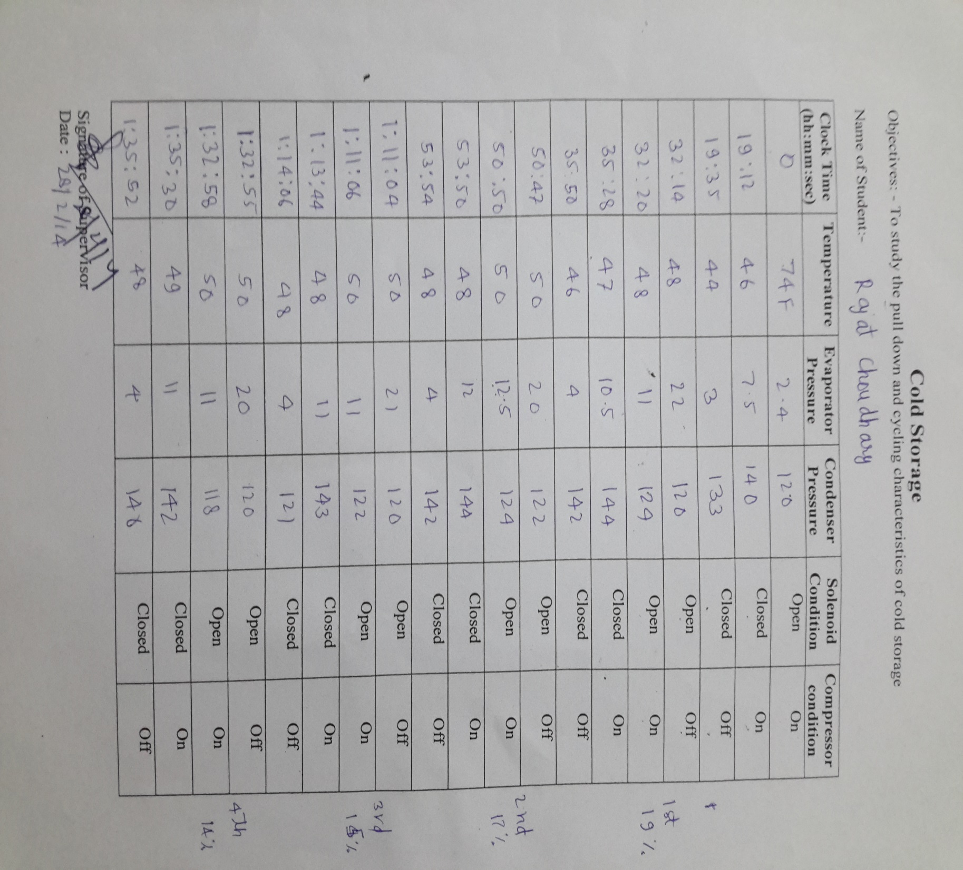

**Temperature vs. Time indicating the solenoid and compressor condition**

Initial temperature: 74oF

Cut out pressure = -8 inch of Hg

Cut on pressure = 20 psi

Pull down time=19min 12sec

Off time= 12min 39sec

On time=3min 36sec, cycle time=16min 15sec

Off time = 14min 57sec

On time=3min 7sec, cycle time=18min 4sec

Off time=17min 10sec

On time = 3min 2sec, cycle time=20min 12sec

Off time = 18min 49sec,

On time = 2min 54sec, cycle time = 21min 43sec

Avg. Cycle time = 19min 3sec

Avg. On time = 3min 9sec

Avg. Off time = 16min 58sec

***Percentage on time = 16.5%***

***Percentage off time = 89%***

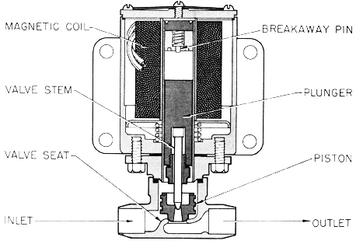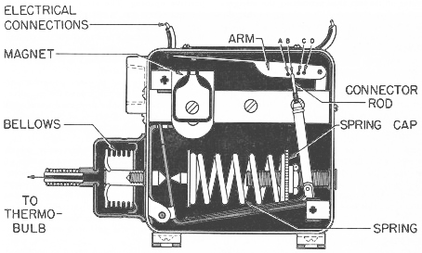

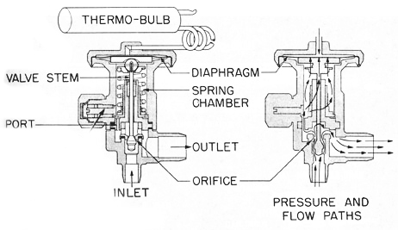 ***Fig: Solenoid Valve Fig: Thermostat***

***Fig: Expansion Valve***

***Discussions:***

**Describe various methods of capacity control of refrigeration systems.**

1. Back pressure regulation throttles the suction gas between the evaporator and the compressor to keep the evaporator pressure and temperature constant when load is decreased. Due to throttling the suction pressure and refrigeration capacity decreases.
2. Bypassing discharge gas from compressor back to suction line or back to the entrance of evaporator.
3. In cycling the compressors starts and stops as per capacity needed.
4. Cylinder unloading in a multi cylinder compressor by automatically holding the suction valve open or diverting the discharge gas from cylinder back to suction line before compression.

**Describe a method for precise control of temperature.**

Temperature control has been found to be the most important factor in maintaining product quality. Keeping products at their lowest safe temperature will increase storage life by lowering respiration rate, decreasing sensitivity to ethylene and reducing water loss. Thermostat and solenoid valve use to control of temperature. When a pre-determined temperature by thermostat is achieved, thermostat close the solenoid valve and refrigerant flow to the evaporator is stopped. Compressor continues to operate and removes the leftover refrigerant in the evaporator to reducing the pressure in the evaporator. When no refrigerant fluid is remaining in the evaporator, compressor is stopped. When settled temperature on thermostat is reached then solenoid valve and compressor start flowing refrigerant, and this process is repeated.

**Describe methods for humidity control**.

To measuring humidity, two temperature sensitive elements may be used to measure the dry and wet bulb temperatures and also hygroscopic nature of some salts (Calcium chloride, lithium chloride etc.) has been used in humidity measurement. Passage over heating and cooling coils exposed to the atmosphere may be used to control humidity.

**Some old types of cold storage have the cooling coil mounted near the ceiling. These are called bunker coils. These do not have any fan for air circulation. How does the air circulate in such a cold storage?**

Air circulate to the cooling coil mounted near the ceiling by *natural convection*.

**In some cold storages the chilled air is injected at high velocity into the cold storage. What are the disadvantages and advantages of this method?**

The high velocity results in high heat transfer coefficient and hence faster cooling.

**What is the advantage of buying a condensing unit rather buying separate components and assembling them?**

The advantage is that in any vapor based assembly, slight mismatches in the components may lead to leakage, besides loss of efficiency.

**Where and why is TEV with external pressure equalizer used?**

A Thermostatic Expansion Valve is used to maintain a constant superheating of the refrigerant. An external pressure equalizer is used when the pressure drop in the evaporator is substantial resulting in superheat of the vapor to be higher than the superheated adjusted with the follow up springs. The equalizer transmits the pressure at the evaporator outlet to the inside of the bellows. Thus the pressure at the inside of the bellows is always equal to the pressure at the exit of the evaporator irrespective extent of drop in evaporator tubing.

**Why are cross charge, liquid charge and vapour charge used in TEV?**

Cross charge uses “power fluids” which have a more flat pressure-Temperature curve than the refrigerant hence helping maintain a constant degree of superheat for different evaporator temperatures.

**Describe pull down characteristics of a compressor and outline the procedure to bypass the power peak while starting a compressor.**

ON pull down compressor is removes the leftover refrigerant in the evaporator to reducing the pressure in the evaporator. Bypass the power peak while starting a compressor the condenser and evaporator should be at the same pressure at the time of starting or the pressure difference should be minimum.

**What decides the cut-in pressure?**

The starting torque of motor and the design temperature of evaporator decides the cut in Pressure.

**What happens if instead of using the LP cut-out/cut-in, the thermostat itself simultaneously closes the solenoid valve and switches off compressor?**

If the compressor is switched off when the solenoid valve closes then some refrigerant will be left in evaporator which will be absorbed by the lubricant present in compressor. It doesn’t happen with the refrigerant present in the condenser because the valve present at the discharge end of compressor doesn’t allow refrigerant to flow back.

So, if the solenoid valve is closed first then the compressor will evacuate the refrigerant present in the evaporator and then it is turned off by LP cut-out switch.

**What differences did you notice between the components of the refrigeration system of the cold storage and the vapour compression refrigeration test rig (Experiment 1)?**

1. In cold storage a thermostatic expansion valve was used, but in Vapor Compression Refrigeration test rig a float valve is use for expansion.
2. An open type compressor is used but in Exp.-1 a closed hermitic compressor is used.
3. IN the VCRS, the system was critically charged, and there was no HP LP cut off used.
4. The refrigerant normally used in cold storage is ammonia, while R22 was used in the VCRS.

**Experiment: 4**

***Studies on a summer air conditioning system***

**Objective:**

* To evaluate the performance of a summer air conditioning system.
* To determine:  

1. the actual COP of an air-conditioning system
2. condensate rate (moisture removal rate)
3. the apparatus dew point and the by-pass factor of the cooling coil

**Components in an air-conditioning system:**

➢ hermetic compressor of 1 TR capacity

➢ air-cooled condenser

➢ finned tube direct expansion coil as an evaporator

➢ capillary tube/thermostatic expansion valve

➢ orifice meter

➢ pre-heat coil

➢ re-heat coil

➢ humidification components

Refrigerant used: R134a

 

**Observations:**

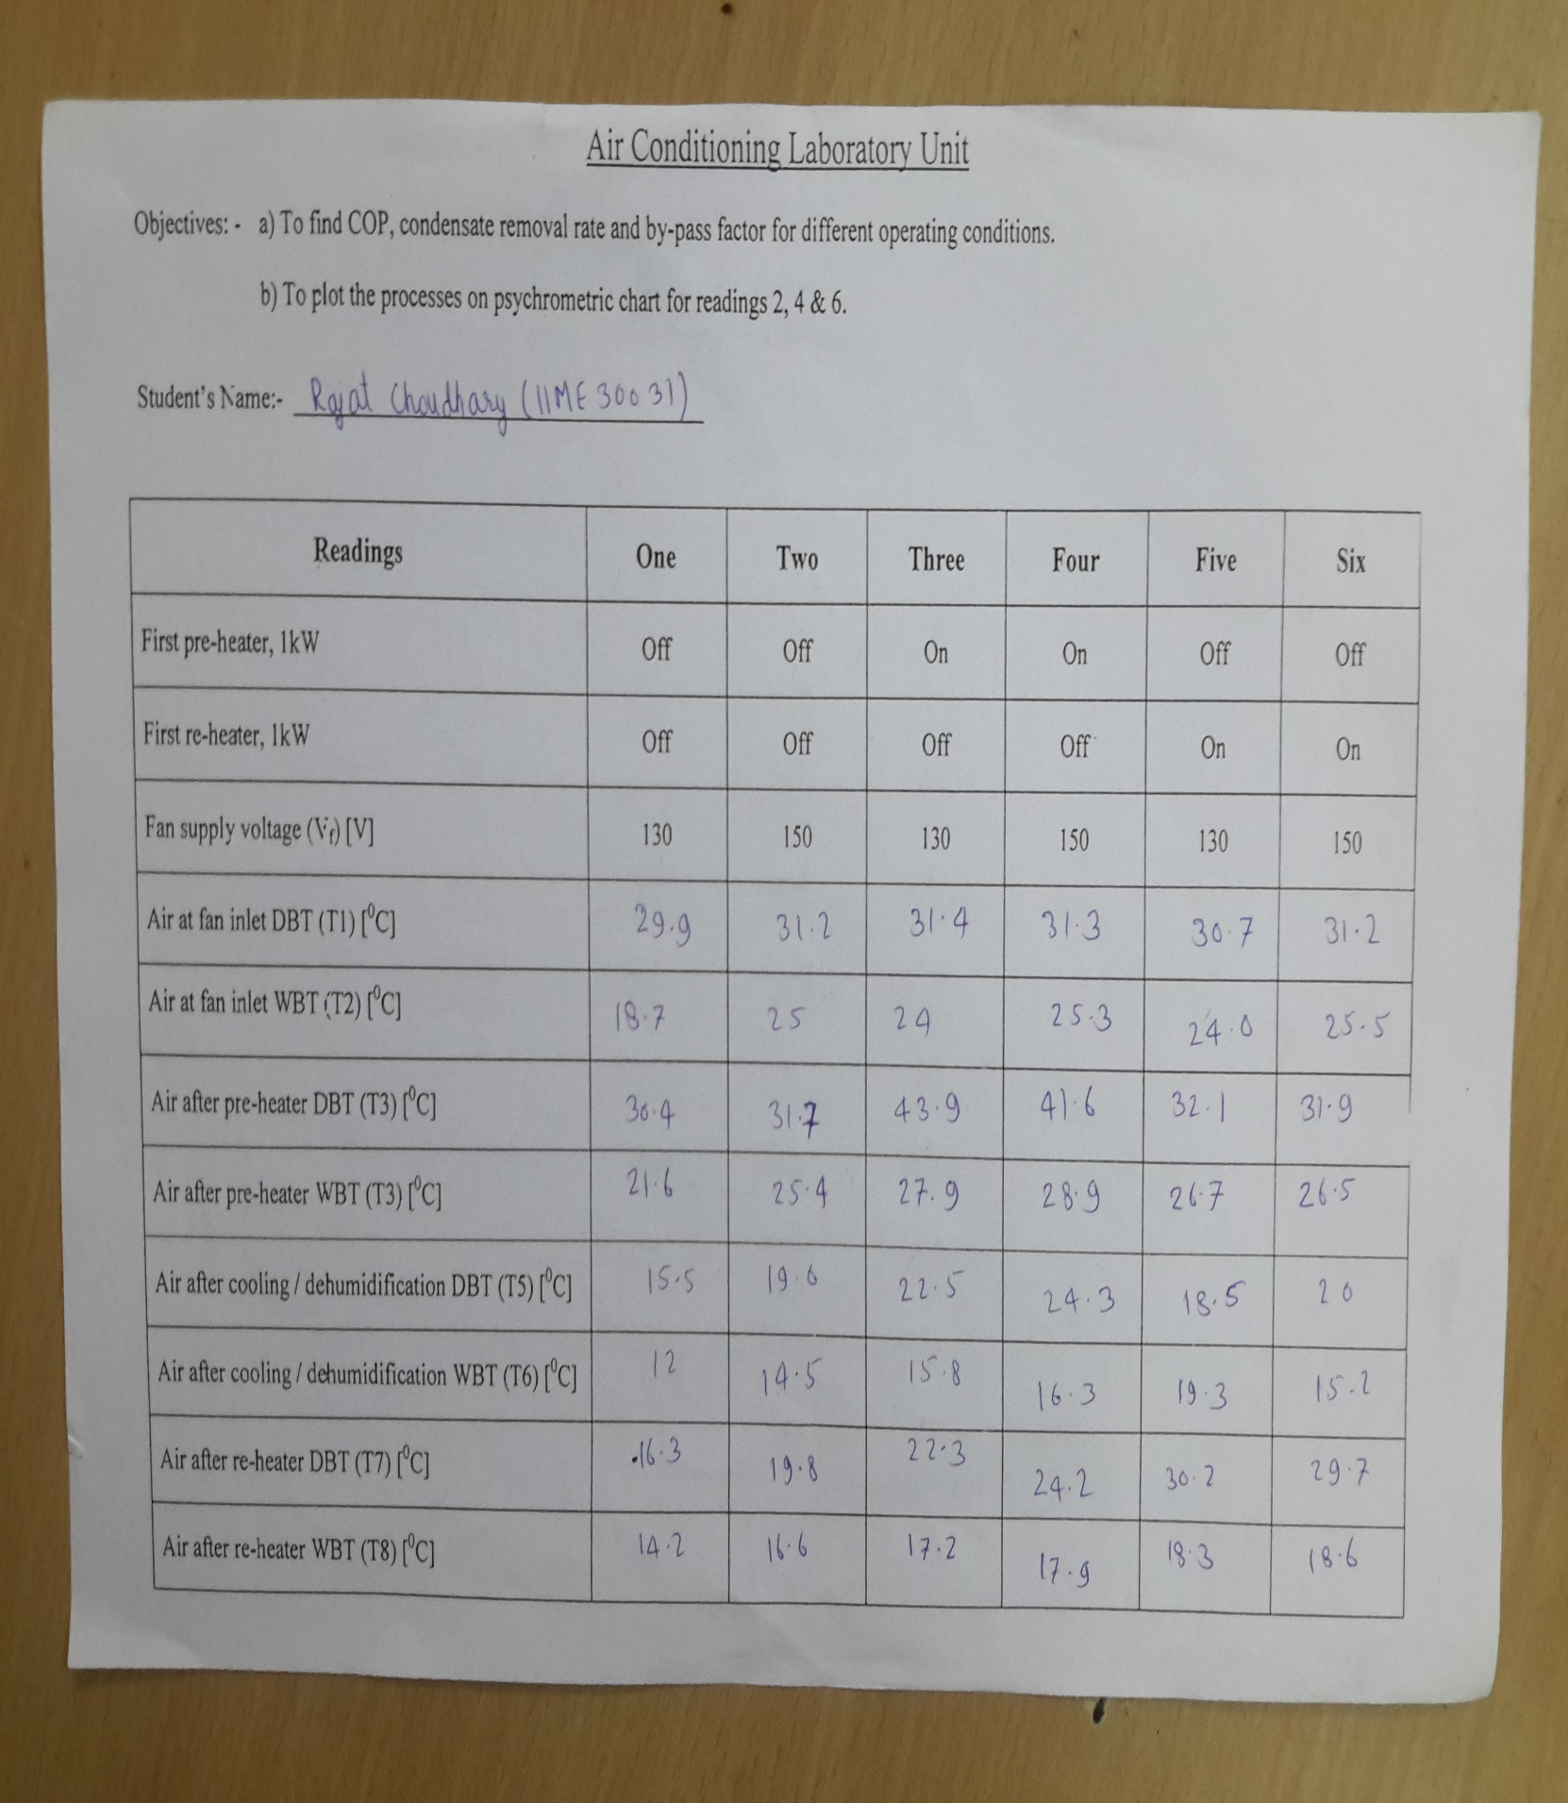

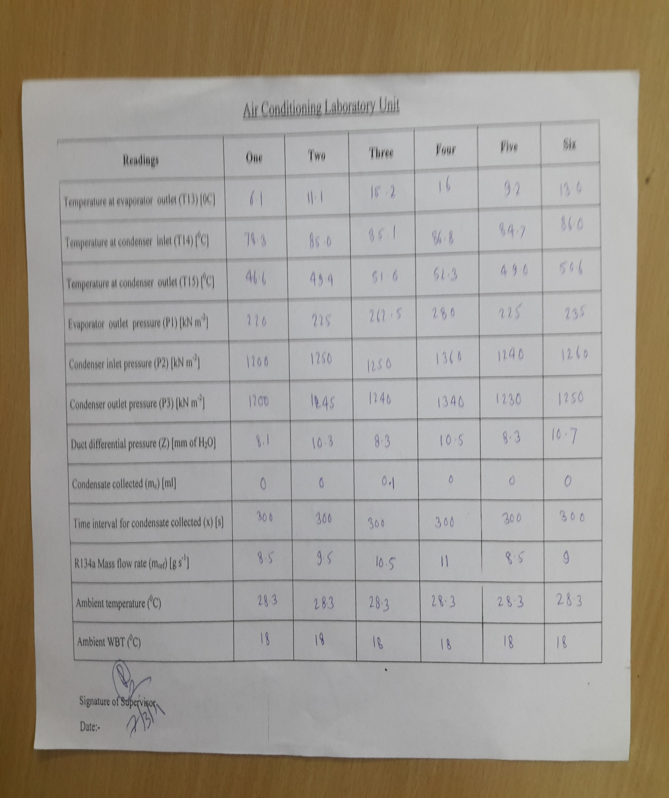

**Calculations:**

**Case: 2(without preheating and reheating)**

Fan Supply Voltage = 150V

Diameter of the orifice (d) = 15.5cm

Actual CoP = actual cooling capacity / power input to compressor

Actual cooling capacity = ma(ha,I – ha,o) - mwhw

ma = Mass flow rate of air

= ρa*Aoutlet*Vavg

ρa = P/RT = 101325/{287.06*301.3}

= 1.171 Kg/m3

Aoutlet = Pi*(d/2)2 = 0.0188 m2

Vavg = ((2*ρwater*g* 10.3)/ ρa)1/2

= 13.13 m/s

Ma = 0.289 Kg/s

ha,I (Specific enthalpy of air before cooling) = 76.2 kJ/kg of dry air

ha,o (Specific enthalpy of air after cooling) = 41kJ/kg of dry air

mw = Condensate removal rate

= ma (Wi -Wo)

= 2.41 g/s

hw (Specific Enthalpy of condensate) = 130.78 kJ/kg

Actual cooling capacity = 9.86 kJ/s

Mass flow rate of refrigerant, mr = 9.5 g/s   
 Specific Enthalpy at evaporator outlet (he,o) = 412.5 kJ/kg   
 Specific Enthalpy at condenser inlet (hi,c) = 478.07 kJ/kg

Power input to compressor = mr*( hi,c- he,o) = 622.915 J/s

**Actual CoP = 15.83**

From the Psychometric chart:-the line is not touching saturation line we cannot determine the By-pass factor

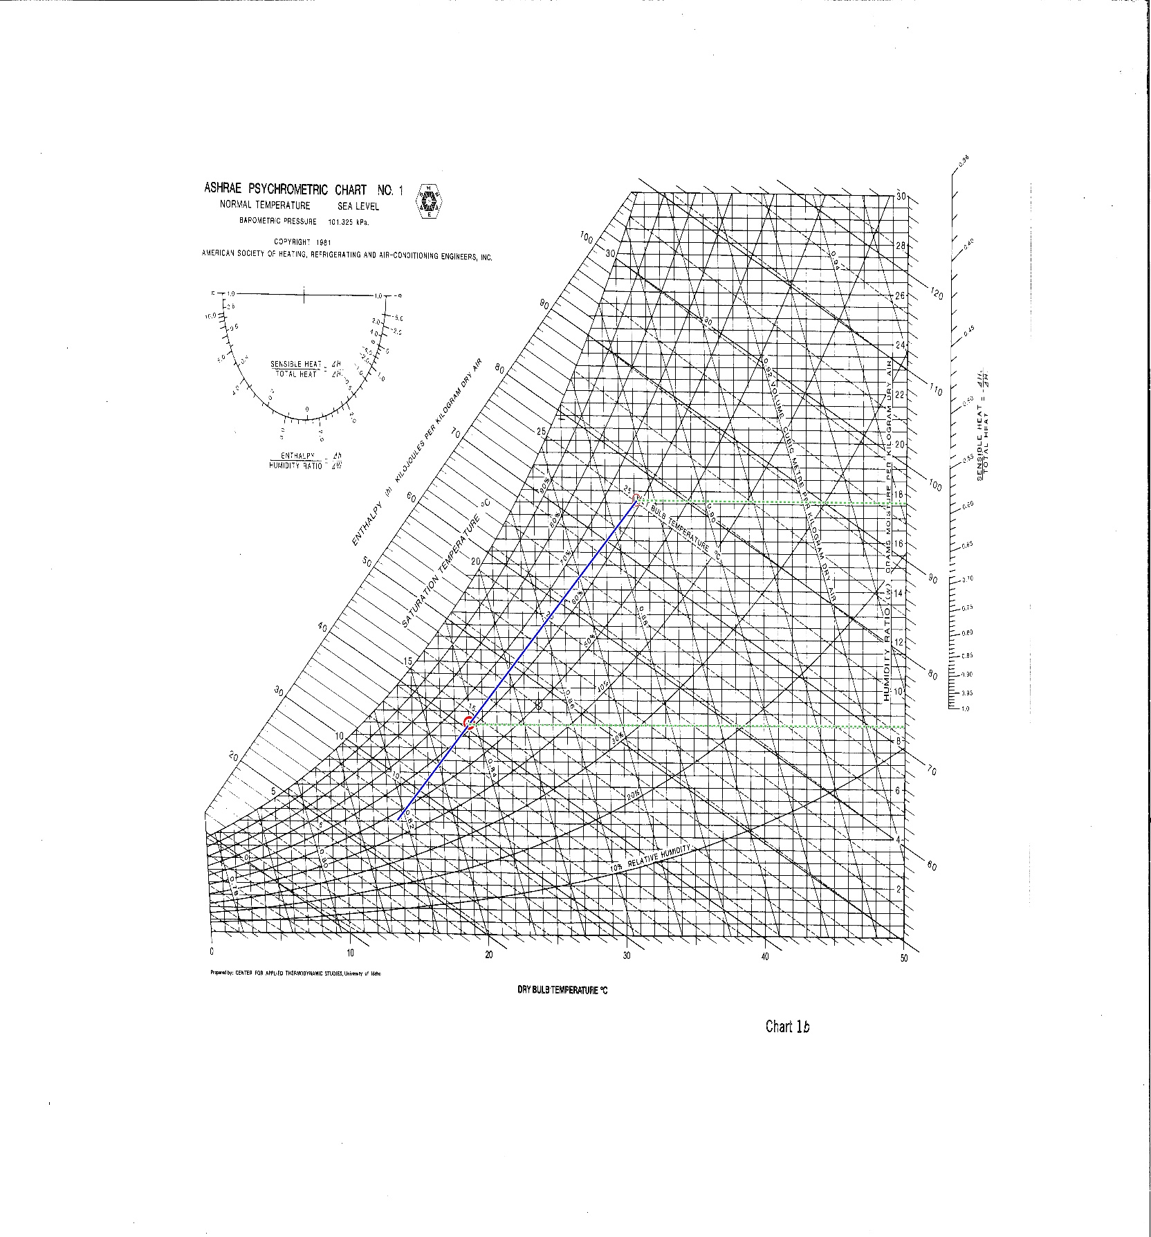

**Discussion:**

**How does the bypass factor vary with air velocity, answer with reason?**

Air velocity increases, the air gets less time to be in contact with the cooling coil and therefore less cooling and dehumidification takes place, difference between air outlet temperature and the cooling coil temperature is less and also bypass factor is less. So, the Bypass factor of the system decrease with increase the air velocity.

**What are the effects of fin spacing and number of rows on bypass factor?**

As the number of rows of fins is increased the contact area with the air increases which leads to increase in bypass factor. Reduction in fin spacing first leads to an increase in bypass factor as contact area increases. However, as fin space is decreased further, the bypass factor increases as flow is restricted.

**What is the relationship between by-pass factor and the performance of the system?**

Bypass factor is a measure of the efficiency of the system. It indicates how well the cooling and dehumidification is taking place. A higher bypass factor means a less efficient system.

**Describe methods for independent control of DBT and RH.**

For controlling DBT and RH independently components such as air washers (RH) and pre-heater and re-heater can be utilized (for DBT).

**What are the errors in the measurements of condensate rate?**

Condensate formation may not take place only at the cooling coil surface. Also, not all the condensate can be collected by the collecting mechanism.

**What precautions should be taken in measurement of WBT?**

Condensate formation may not take place only at the cooling coil surface. Also, not all the condensate can be collected by the collecting mechanism.

**Suggest alternate methods (other than measuring WBT) for finding state points of moist air?**

Other means of finding state points include moisture-absorbing polymer films, Chilled gold mirrors with optical sensors etc.

**How do you design the thermometer wells used for measurement of temperature?**

Condensate formation may not take place only at the cooling coil surface. Also, not all the condensate can be collected by the collecting mechanism.

**How is the relative humidity controlled in A/C systems?**

Refrigeration air conditioning equipment usually reduces the humidity of the air processed by the system. The relatively cold (below the dew point) evaporator coil condenses water vapour from the processed air, (much like an ice-cold drink will condense water on the outside of a glass), sending the water to a drain and removing water vapour from the cooled space and lowering the relative humidity.

**Error Analysis:**

Absolute error in T = 0.1 K

Error in TADP=0.5 K

Error in enthalpy of input=.33 kJ/kg

Error in enthalpy of air after cooling =0.26 kJ/kg

Error in enthalpy of water at evaporator temperature= 0.42 kJ /kg

Error in Qe=ma(Δha,I –Δha,o) - mwΔhw=0.101 KJ/kg

Relative error in Qe=4.2%

Error in enthalpy of refrigerant at compressor outlet=0.11 kJ/kg

Error in enthalpy of refrigerant at compressor inlet=.05 kJ/kg

Error in compressor work=1.6*10-3kJ/kg

Relative error in compressor work=0.3%

Relative Error In COP=4.6%

Relative Error in bypass factor=(0.1+0.5)(1/(To – TADP)+1/(Ti – TADP))=1.54

**Experiment: 1A**

***Studies on refrigerant compressors***

**Objective:**

Study of reciprocating compressors used in refrigeration and air conditioning applications.

**Compressors:**

The compressor is the most critical component of a mechanical vapour compression refrigeration system.

Classification of compressors (Based upon the operating principle):

1. Positive Displacement Type:

* Reciprocating
* Vane
* Screw
* Scroll

2. Rot dynamic Type:

* Centrifugal
* Axial Flow

Compressors are further classified as:

* Open Type compressor.
* Hermetically sealed type compressor.

The Reciprocating type of compressor is the workhorse of the refrigeration and air conditioning industry.

Main parts of a reciprocating compressor are:

* Cylinder Head
* Valve Plate
* Inlet and outlet valves
* Crank case
* Crank shaft
* Connecting rods
* Piston
* Oil return path
* Seals

**Discussion:**

**Define stroke, bore, clearance volume and displacement volume of the compressor.**

The distance travelled by the piston from bottom dead centre (BDC) to top dead centre (TDC) within the cylinder is known as the stroke of the compressor.

The bore is the diameter of the compressor cylinder.

The volume between the piston and the cylinder head when it is at its minimum, i.e. when the piston is at the position of Inner Dead Centre is called the clearance volume.

The volume of the compressor may be defined as the volume swept by the piston in its stroke between the bottom and the top dead centres respectively.

**Do the piston rings have a taper? While mounting the ring the sharp edge should be on the top or the bottom?**

Yes, the piston rings have a taper. While mounting, the sharp edge should be on the bottom.

**In which direction should the piston rings scrap the lubricating oil? If more than one piston ring is used what precautions should be used?**

The lubricating oil should be scrapped towards the crank-case by the piston rings. Care should be taken while mounting of multiple piston rings. The piston-ring which is to be farthest from the cylinder-head should be mounted first and so on.

**What are the methods used for capacity control of compressors?**

“On and Off Control”, “Holding the Valves Open” ,”Hot Gas Bypass” and “Using Multiple Units” are some of the control methods used.

**What are the safety devices used with refrigerant compressors?**

Some of the safety devices used are as follows:

1. Low suction pressure cut-off devices

2. Freeze protectors

3. Proofing switches

4. Exhaust fan interlocks

5. Temperature and pressure pop-off valves

6. Low gas pressure cut-off valves

**What types of motors are normally used with refrigerant compressors?**

1. Small electric motors suitable which are suitable for domestic electrical supplies using

single phase alternating current.

1. Larger electric motors which can be used where an industrial electrical three phase

alternating current supply is available.

**Describe various types of seals used in compressors.**

Open type compressors require seals to minimize leakage. These may be stationary or rotary types. The stationary type is basically a metallic bellow and a hardened shaft. The rotary type employs a synthetic seal tightly fitted to the shaft which prevents leakage using a carbon nose.

**What are the advantages/disadvantages and applications of open type and hermetic compressors?**

Periodic maintenance is required in open type compressors due to the constant slow leakage of refrigerant. These are still preferred in large capacity systems due to higher efficiency compared to hermetic compressors. Open compressors are flexible in terms of speed of the compressor due to use of belt drives and gears. Belt drives also prevent overloading. Open type compressors are unsuitable for small and critically charged systems, particularly domestic systems such as refrigerators and air conditioners, as it is impractical to provide for periodic maintenance for these systems. So hermetic-type compressors are used in these systems. There is almost nil possibility of refrigerant leakage from the hermetic type compressor. In Open type compressors, both compressor and motor normally reject heat to the surrounding air. This is not possible in hermitic compressors since both motor and compressor are enclosed in a shell. The motor winding is in direct contact with the refrigerant; hence only those refrigerants, which have high dielectric strength, can be used in hermetic compressors. The motor insulation in the windings may react with some refrigerants in hermitic compressors, so special cooling provisions must be made for them. Also, hermetically sealed compressors give satisfactory and safe performance only over a very narrow range of design temperature. The COP of the hermetic compressor based systems is lower than that of the open compressor based systems since a part of the refrigeration effect is lost in cooling the motor and the compressor. However, they are ideal for systems which use capillary tubes and are critically charged. Hermetic compressors are normally not serviceable.

**Discuss briefly the advantages, disadvantages and applications of other types of positive displacement (screw, rolling piston, rotary vane and scroll types) and dynamic (centrifugal) compressors.**

Centrifugal compressors are preferred over the reciprocating compressors for higher efficiency over a large range of load and a large volume of the suction vapour and hence have a larger capacity to size ratio. However the capacity of reciprocating machines is not affected much by an increase in the condensing temperature followed by adverse ambient conditions. Rotary compressors have high volumetric efficiencies due to negligible clearance. Screw compressor combines many advantageous features of both centrifugal and reciprocating systems. As it is a positive displacement machine, high pressure refrigerants may be used. And due to high speeds large volumes may be handled. It has no surging problems. It has small pipe dimensions and positive pressures due to the use of high pressure refrigerants. It has high compression efficiency, continuous capacity control, unloaded starting and no balancing problems. It is hence suitable for large capacity installations.

**What are the various performance, material and manufacturing issues involved in the design of refrigerant compressors? In what way the refrigerant compressors are different from air or other industrial gas compressors?**

The major issues that are concerned with the manufacture of the refrigerant compressors are:

* Leakage: Open type compressors are particularly susceptible to leakage of refrigerant. The lubricant leaks through the crankshaft from the cylinder. This requires us to refill the compressor lubricant. Also the valve must be replaced when the leaking starts. Hermetic and semi hermetic type compressors do not face this.
* Cooling: Due to high speeds of operation, cooling of the compressors is very important. The fast moving pistons generate a lot of heat. Various methods are adopted to make sure that the compressor is cooled. Lubrication and Fins are some of them.
* Lubrication: Lubrication of a compressor is very important because of the cooling criteria. There can be active systems which require pumps and forced flow of lubrications, or systems which scoops and throws lubricant from an oil sump to the machine component.
* Slugging of compressor: Compressors, especially fast moving ones, cannot handle fluid inside them. Thus it is imperative to ensure that there are no fluids in the cylinder which could lead to valve damage.
* Noise and Vibrations: Compressors are usually used in domestic refrigerators. To prevent excessive noise is a major design criterion as otherwise it would cause a lot of discomfort.

Hermetically sealed compressors are smaller but less efficient. In this type of compressor the refrigerant also cools the compressor parts which is unnecessary, thus this reduces the efficiency of hermetic compressors. They are usually used in domestic systems because of the smaller size and the lesser maintenance requirements. They also produce lesser vibrations and noise. Industrial compressors do not have to contend with such issues, they can afford to have regular maintenance and deal with noise.

**Experiment: 1B**

***Thermal Comfort***

**Objectives:**

To measure different environmental parameters of human thermal comfort and using them, calculate indices of heat stress and thermal discomfort.

**Observations**:

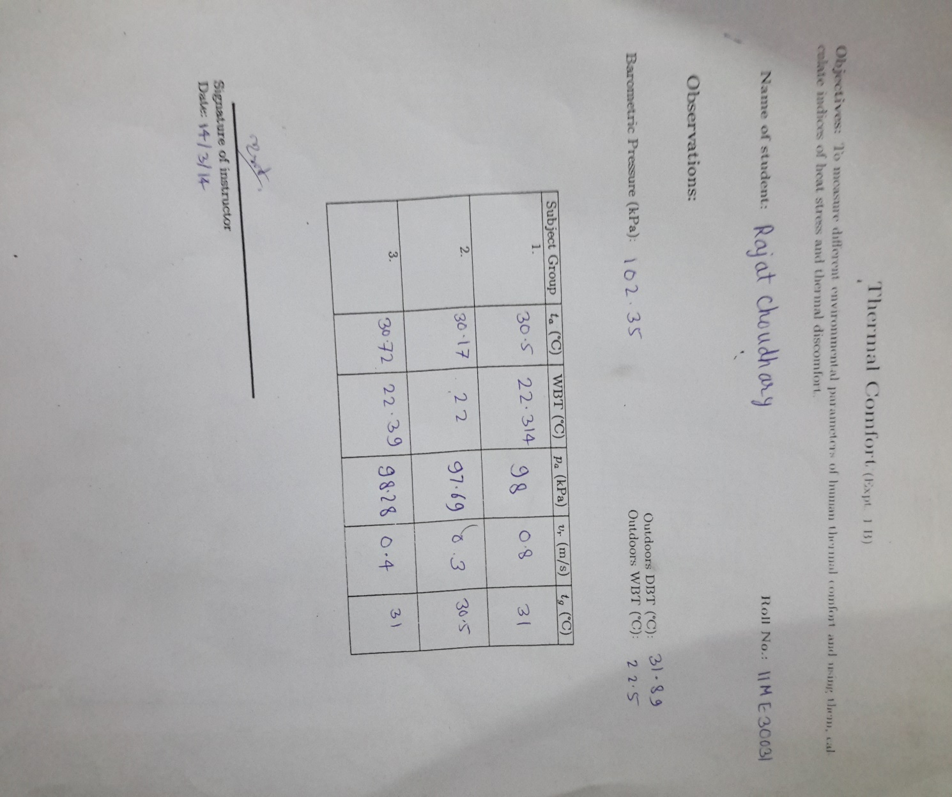

**Calculation:**

First vapour pressure is calculated using psychometric chart.

For Indoors:

WBGT = 0.7*WBT + 0.3*tg = 24.91°C, 24.55°C, 24.97°C (for 3 subject groups)

Emissivity (€) = 0.95

Vr= 0.5 m/s

Wet Bulb temperature WBT = 22.22 °C

D=67mm (Given)

Mean Temperature Gradient

tr = [(tg+ 273)4 + (1.1×108×(Vr)0.60**/**.95×D0.4)× (tg – ta )]1/4 – 273

tr = 30.85°C

For Outdoors:

WBT = 22.5 °C, DBT = 31.89 °C

WBGT = 0.7*WBT + 0.2*tg + 0.1*DBT = 25.34°C

Operating temperature (t0) = (hr*tr + hc*ta)/ (hr + hc) = 30.67°𝐂

Where,

hr = radiative heat transfer coefficient = 4.7 W/m2-K,

hc = consecutive heat transfer coefficient = 3.1 W/m2-K since Vr<0.2

Tropical Summer Index (TSI) = 0.308*WBT + 0.745*tg – 2.06∗√(Vr+0.841)= 27.4°𝐂

So it is slightly hot.

PMV= (.352e−0.042M+0.032)[M−0.35[43−0.061M−pa]−0.42[M−50]−0.0023M(44−pa)−

0.0014M(34−ta)−3.4·10−8 [(tcl+273)4−(tr+273)4]−fclhc(tcl−ta)]

PMV= 0.432

Where M=60 kcal/hr/m^2 = 1.2 met = 22 BTU/h/ft^2, pa= 12.79 mm in Hg, Icl = 1 clo

PPD= 100- 95 x exp(-(-0.03353 x PMV^4 + 0.2179 x PMV^2)) = 8.89

HIS = M+22(tr−95) +2∗(Vr0.5)(DBT−95) 10.3∗(Vr0.4)(42−pa)

= - 0.28

So we will feel mild cold strain.

This is the averaged data for all 3 subject groups.

From surveys,

Group 1: PPD= (1/8)*100=12.5 %

Group 2: PPD= (0/8)*100=0 %

Group 3: PPD= (0/8)*100=0 %

***Average PPD= 4.2%***

**Discussion:**

**How is thermal comfort defined?**

American Society of Heating, Refrigerating and Air-conditioning Engineers (ASHRAE) defines thermal comfort as "*that condition of mind which expresses satisfaction with the thermal environment*".

According to this definition, comfort is a subjective sensation. Since the industrial revolution, human beings have been spending progressively larger proportions of their time indoors. So, here, we are primarily concerned about the sensation of thermal comfort indoors.

**What are the parameters affecting thermal comfort?**

Variables that affect heat dissipation from the body (thus also thermal comfort) can be grouped under environmental and personal factors. Under environmental factors we have air temperature, air movement, humidity, and mean radiant temperature. Under personal factors we have metabolic activity of the person and insulation of the clothing worn.

Air temperature (ta) is the most obvious environmental factor, measured by the dry bulb temperature (DBT), and determines the convective heat dissipation, together with any air movement. In this manual, DBT and ta will be used interchangeably to denote indoor air temperature.

Air movement, (vr) measured in m/s with an anemometer, affects both evaporative and convective heat transfer from the skin. Humidity (RH) of the air also affects evaporation rate as well as non-thermal factors of comfort like feelings of dryness or stuffiness. Humidity can be found from a psychometric chart, after one measures the DBT, wet bulb temperature (WBT), and barometric pressure.

Mean radiant temperature (tr) determines the radiant heat exchange between an occupant and her/his surroundings. The mean radiant temperature is defined as the uniform temperature of an imaginary enclosure in which the radiant heat transfer from the human body is equal to the radiant heat transfer in the actual non-uniform enclosure. Mean radiant temperature cannot be measured directly, but it can be approximated by globe temperature (tg) measurements. The globe thermometer is a mat black sphere with a thermometer located at its centre. Positioned in a room, after equilibrium is reached (in 10-15 minutes), the globe will respond to the net radiation to or from the surrounding surfaces.

**How does the human body regulate its temperature?**

The body has several thermal adjustment mechanisms to survive in drastic temperature environments. To warm conditions (or increased metabolic rates) the body responds by vasodilation: subcutaneous blood vessels expand and increase the skin blood supply, thus the skin temperature, which in turn increases heat dissipation. If this cannot restore thermal equilibrium, the sweat glands are activated to enhance evaporative heat transfer. To cold conditions the response is firstly vasoconstriction: reduced circulation to the skin, lowering of skin temperature, thus reduction of heat dissipation rate. If this is insufficient, shivering takes place, involuntarily forcing the muscles to work and increasing the metabolic heat production. In extreme conditions, shivering can increase the metabolic rate to ten times that of basal values.

**What are the modes of heat transfer from human body?**

Heat transfer from human body is mainly due to radiation from human body to the surroundings. Heat is also transferred through convection though the flow rate comparatively much lower. Convective form of heat transfer is significant in water or when air velocity around the body is high. Heat rejection from the body is also done through sweating where the water droplets on the skin evaporate taking the latent heat of evaporation from the body.

**What scale is used for thermal sensation?**

To determine thermal sensation of occupants, the most popular means is a subjective

Questionnaire using the ASHRAE seven point scale. The scale is represented in Table 2. On this scale, the midpoint i.e. 0 is called the neutral point and anyone recording their thermal sensation at the neutral point are deemed to be comfortable. Since individual differences would make it impossible for a particular thermal environment to be neutral to everyone, a wider comfort band is considered between +1 & -1. Any occupant voting within the comfort band is deemed to be reasonably comfortable and not stressed by her/his thermal environment.

Table 2: ASHRAE thermal sensation scale

Hot warm slightly warm neutral slightly cool cold

3 2 1 0 -1 -2 -3

**What are the different indices used for measuring thermal comfort and heat stress?**

The main indices for measuring thermal comfort are:

1. Wet bulb globe temperature (WBGT)

2. Operative temperature (to)

3. Tropical summer index (TPI)

4. Heat stress index (HSI)

5. Predicted mean vote (PMV)

6. Predicted percentage dissatisfied (PPD)

**How comfort surveys are conducted to evaluate the comfort standards of a building?**

The underlying philosophy of adaptive comfort is: if a change occurs in the surroundings that causes discomfort, then people will react so as to restore their feeling of comfort. In comfort field studies, simultaneously objective data on the thermal environment (DBT, humidity, air velocity, tr) and subjective thermal sensation votes of people are gathered. Normally, some equivalent of the ASHRAE thermal sensation scale is used to collect sensation votes. These subjective data are then statistically analysed to and a regression fit between comfort vote and indoor temperature, of the form CV = αTa – β.

Here CV is the comfort vote, Ta is the indoor air temperature, α is the slope of the line (also referred to as sensitivity of the population), and β is the y-axis intercept. Using these relations, the indoor air temperature where CV is zero is determined. This temperature would be the neutral temperature on the thermal sensation scale and neutrality is assumed to represent comfort conditions.