GSM-Based Smart Security System with Password Verification and Remote Access

Sasirekha P  M.Kumarasamy College of  Engineering  sasirekhap.eee@mkce.ac.in | Niteesh P  M .Kumarasamy College of Enginnering Karur , Tamil Nadu  927623bee063@mkce.ac.in | Adithiya SG  M. Kumarasamy College of Enginnering  Karur , Tamil Nadu  927623bee005@mkce.ac.in
Akhil M
M .Kumarasamy College of Enginnering Karur , Tamil Nadu
927623bee007@mkce.ac.in

Abstract-There has been a massive increase, over the years, in unauthorized intrusions and theft; hence, there is a greater demand for secure and intelligent access control systems. This paper presents the design and implementation of a GSM-based smart security system that provides two-level authentication using a With the rapid increase in unauthorized intrusions, identity theft, and security breaches across residential, commercial, and financial environments, the need for intelligent and highly secure access-control systems has grown significantly. As unauthorized intrusions, identity theft, and security hitches have become rampant in our homes, businesses, and financial institutions, the need for sophisticated and super-secure access-control systems has increased dramatically. Passwords, and mechanical locks are only a single layer of security and are increasingly exposed to loss of passwords, duplication of keys, and unauthorized access. In this document, we present the design and development of a GSM-based Smart Security System that utilizes two factors for secure entry to the facility and provides for remote access to the facility. The proposed This Smart Security System employs two layers of authentication before granting access; the first layer of authentication is the entry of a+
Personal Identification Number (PIN). Once the authorized user has input the appropriate PIN into the system through use of the keypad, the second factor of authentication will be initiated by the system automatically sending a text message to the authorized user's registered cell phone number. Only when the authorized user responds to this text message by issuing a control command (OPEN or CLOSE) will access to the facility be granted. An integrated microcontroller, GSM module, keypad, and electromechanical locking device provides the ability to communicate securely, respond to events in real time, and deliver robust reliability. The
GSM technology allows the control of devices that are far from one another without needing access to the Internet; hence, it can be used in remote or/and countryside areas. The design of the system offers a lot of convenience to users, and increases the level of control they have over access points-entrances, doors, gates, and so on-and also many levels of protection. Because of the nature of its design, the system can be used in a wide range of applications which include home and office automation, ATMs, personal lockers, industrial gate control, and restricted access area systems. Hence, the system provides an economical
It is an effective and very secure solution in modern access-control systems.
I.INTRODUCTION:
Security has become a top priority in residential and commercial settings owing to the growing number of unauthorized attempts at entry and property crimes. That said, deficiencies in areas such as remote control capability, real-time monitoring of security status, and anti-duplication and anti-manipulation capability further render traditional mechanical systems incapable of meeting today's demands. In this proposed system with improved reliability, greater convenience on the user's part is achieved through the introduction of local PIN verification followed by remote confirmation via SMS. The strength of the password is expressed mathematically using the PIN guess probability.
$P_{guess}=\frac{1}{{10}^{n}}$ (1)
and its entropy $H_{PIN}=n{log⁡}_{2}(10)$ (2)
which together quantify the resistance against brute-force attacks. The probability of unauthorized access via both local guessing and SMS spoofing is expressed as
$P_{\text{unauth}}=P_{\text{guess}}×P_{\text{sms_bypass}}×P_{\text{owner_no_respond}}$ (3)
which indirectly points to the security advantage in using dual verification. The communication delay between device and user can be estimated using the SMS round-trip time.
$T_{RT}]=T_{tx}+T_{net}+T_{user}+T_{proc}$, (4)
while a reliable system timeout is set using
$T_{timeout}=E[T_{RT}]+kσ_{T}$. (5)
The power consumed-so essential for continuous operation-is given by
$P_{avg}=P_{mc}+D_{gsm}P_{gsm,active}+(1-D_{gsm})P_{gsm,standby}+D_{lock}P_{lock}$, (6)
and hence gives a means of effectively estimating daily energy consumption by
$E_{day}=P_{avg}×24$. (7)
Finally, using the availability expression, the reliability of the whole security system can be determined:
${\text{Availability}}_{\text{system}}≈\prod_{i=1}^{m}{}\frac{{\text{MTBF}}_{i}}{{\text{MTBF}}_{i}+{\text{MTTR}}_{i}}$, (8)
This accounts for the performance of all critical hardware components. Assembled together, these equations support the design, evaluation, and security justification of the proposed GSM-enabled smart access control solution. II.LITERATURE REVIEW:
With the increasing rate of unauthorized entries and property-related crimes, security has now become one of the prime requirements both in residential and commercial areas in today's world. A traditional mechanical locking system cannot fulfill today's standards of security due to the absence of remote control, real-time monitoring, and resistance to duplication or manipulation. The proposed GSM-based smart security system with password verification and remote access control embodies a dual-layer authentication approach wherein local PIN verification is followed by remote confirmation via SMS; hence, much improvement in reliability and user convenience is attained. The strength of the password can be mathematically represented through the PIN guess probability.
P_"guess" =1/10^n → (1)
and its entropy is H"PIN"= n log2(10) →(2)
which together quantify the resistance against brute force attacks. The probability of unauthorized access through both
provided by
P_unauth=P_guess ×P_sms_bypass ×P_owner_no_respond → (3)
It caters to two-factor authentication security enhancements.The delay in communication between the device and the user may occur.be estimated using the round-trip time of the SMS
E[T_"RT" ]=T_"tx" +T_"net" +T_"user" +T_"proc", →(4)
while a reliable system timeout is set using
T_"timeout" =E[T_"RT" ]+kσ_T. →(5)
Power consumption, which is needed for continuous operation, is found by
P_"avg"=P_"mc" +D_"gsm" P_"gsm,active" +(1-D_"gsm" )P_"gsm,standby" +D_"lock" P_"lock", →(6)
which allows the correct estimation of daily energy consumption by E_"day" = P_"avg" × 24. → (7)
Finally, the reliability of the entire security system can be assessed by the availability expression:
〖"Availability" 〗_ "system" ≈∏_(i=1)^m 〖"MTBF" 〗_i/(〖"MTBF" 〗_i+〖"MTTR" 〗_i ), →(8)
It accounts for the performance of all the critical hardware components. Basically, the equations provide design support and security justification for the proposed GSM-enabled smart access control solution.] based on user convenience. In [17], two-factor authentication systems that use password and GSM verification are further enhanced. In [18], passwordprotected door systems which send an SMS alert after a valid or invalid attempt are discussed. Finally, keypad-, Bluetooth-, and GSM-based digital lock methodologies are discussed in [19]. The benefits of using a multitechnology security design are found in this work.[20].
III.EXISTING METHOD
Security is still mainly maintained by using mechanical locks or simple password-based systems in many residential, commercial, and industrial settings. Though these approaches are inexpensive and thus more appealing to a large number of users, they have only a moderate degree of protection. Mechanical locks, in particular, are susceptible to key duplication, break-ins, tampering, and unauthorized sharing. Against intruders with increasingly sophisticated methods, these traditional systems cannot offer the degree of reliability and continuous monitoring that is required these days. A formidable improvement was provided by the shift towards electronic password-based locks. These systems, based on microcontrollers and keypad interfaces, replaced physical keys with digital passcodes, minimizing the possibility of loss or key duplication. Still, this improvement has a major
Limitation: this authentication process happens entirely at the local device. If one guesses the password, secretly observes it, or obtains it through coercion, the system grants access without verifying the legitimacy of the user. There is no mechanism to alert the owner or inhibit misuse once the passcode is compromised. With an eye to improving security even further,
Later, the researchers made use of RFID tags and biometric verification.RFID-based systems assign unique identifiers to every user.Face or fingerprint recognition, among other biometric approaches.
Offer stronger, individualistic authentication. While these
Methods also introduce challenges while improving accuracy.
RFID tags can be misplaced or cloned and biometric systems. Require sophisticated hardware, frequent calibration, and higher installation cost.. Such complexities make them less practical for everyday or small-scale applications where affordability and simplicity are essential. Another layer of improvement was added through the introduction of GSM-based alert systems that enabled notifications remotely. These systems can send SMS alerts to the owner whenever some suspicious activity or unauthorized access is detected. Even though it ensures that users will be informed in case they are away, most GSM-enabled systems can operate only in one direction: they can send information outside but cannot allow users to respond or take immediate action. Without the facility of remotely approving or blocking access, the system cannot fully inhibit unauthorized entry. From these technological evolvements, it gets clear that existing solutions often cover only part of the security challenge. Some systems validate only the user at the door while others notify the owner after the incident but cannot intervene. Only a few offer a combined solution that verifies the user locally and requires remote confirmation before granting access. A system that could combine these two facilities would significantly improve protection, ensuring that no access can be granted without the explicit approval of the owner. The system presented in this paper responds to this gap through the introduction of two-level authentication. It uses password verification at the entry and GSM-based remote authorization via SMS. Upon entry of a correct password, the system auto sends a message to a registered mobile number. After which, the owner can respond whether he approves or not.
command. The system gets unlocked only after valid response.
Therefore, this design provides better security, real-time capability,decision, and it gives full control to the user over access evenfrom a distance. Because of reasonable prices, reliability, andThis is suitable for the simplicity of implementing the proposed system.for applications in a wide range of areas including homes, offices,restricted entry areas, ATMs, and lockers by integrating localWith this built-in authentication, remote confirmation provides a practical:Solution to the shared weaknesses of both traditional and modern security systems.. Figure1: Existing Method of Flowchart for Dual-Level Security Authentication
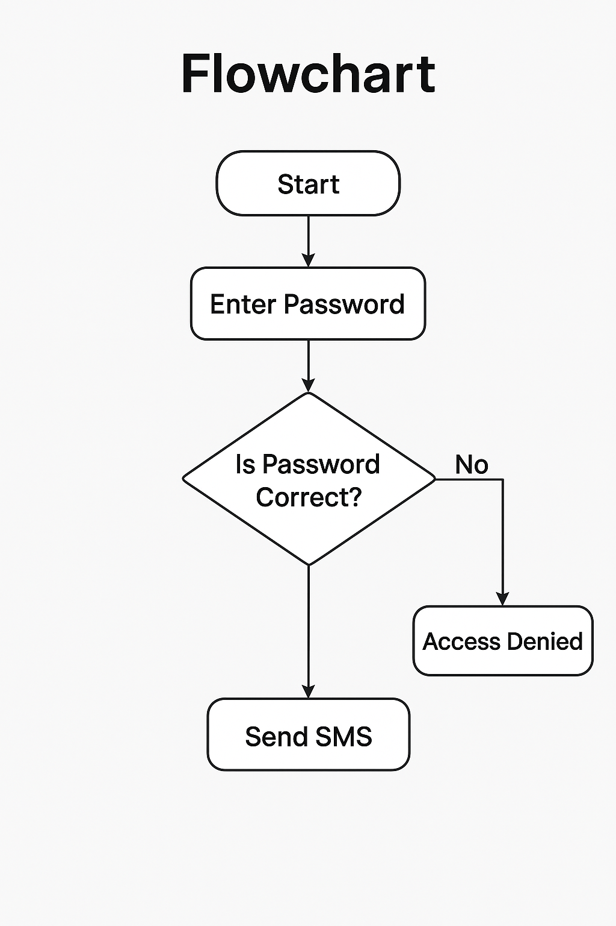
Figure1: Existing Method of Flowchart for Dual-Level Security Authentication
IV.PROPOSED METHOD
The following Flowchart depicts the work process of the proposedGSM-based smart security system. The process initiates at theThe start state is where the system should be in an idle monitoring state.condition until a user attempts an authentication. When started,The user is prompted to enter the password through the keypad interface.This input is subsequently processed by the microcontroller, which performs a comparison with the reference password stored in its internal memory.
The decision block “Is Password Correct?” represents the first authentication checkpoint. If the entered password does not match the stored credentials, the system immediately transitions to the Access Denied state. In this condition, the system maintains the locked status of the door and terminates the authentication cycle, thereby preventing further unauthorized actions.
Conversely, if the password is validated successfully, the system proceeds to the Send SMS state. At this stage, an SMS notification is transmitted to the authorized user through the GSM communication module. This serves as the second level of authentication, enabling remote authorization. Upon receiving the notification, the authorized user responds with a predefined command such as “Open.” Once the correct command is received, the system verifies the response and transitions to the Open state, where the microcontroller activates the relay driver to unlock the door mechanism.
Through this sequential decision-making structure, the
This flowchart describes the layered security architecture of the system. The dual authentication—local password verification.Followed by GSM-based authorization, this method will significantly enhance System robustness by ensuring that possession of password.alone is not enough to gain admission. This structured approach also allows for real-time monitoring and remote control.capabilities, aligned with modern security requirements.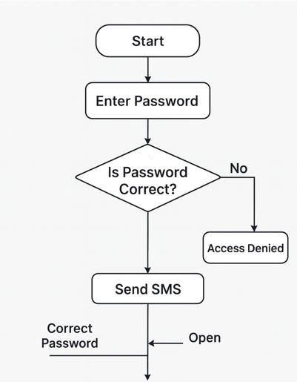
Figure2:Flow Chart of GSM-Based Smart Security System
Mode 1: Local Authentication Operation
The proposed GSM-based smart security system will have the local password verification as the primary layer of authentication for Mode 1. Upon entering the PIN via the keypad interface, the microcontroller performs a comparison between the entered value and the reference password stored in the non-volatile memory. If the PIN is not correct with respect to the pre-determined value, it refuses access to the user and will still be in the locked condition. This results in an error indication through the LCD display and can also trigger an optional audible or visual alert in order to notify the user about the invalid attempt. By doing so, no further processing is done unless a proper PIN is provided by the user. On the contrary, a successful detection of a valid PIN does not trigger the locking mechanism on itself. Successful password validation transitions the system into Mode 2; thus, it enables the remote authorization via the GSM network. During this operation, the first level of authentication restricts unauthorized keypad-based access attempts and filters out the invalid inputs before forwarding into the next stage of security.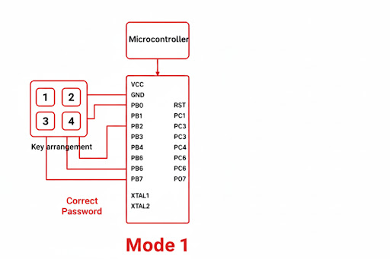
Figure3: Proposed System of GSM-Based Smart Security System for Mode 1
Mode 2: GSM-Based Remote Authorization Operation
Mode 2 It develops a secondary authentication layer by incorporating GSM communication that checks the authorization of any remote user. Once the correct PIN is
Upon detecting Mode 1, the microcontroller sends an SMS
Notification to the registered mobile number through the GSM.module. The notification notifies the authorized user to
respond to the call with some pre-defined commands like
“open” or “close.”The microcontroller decodes the message received via a valid command through the GSM module and controls the relay driver circuit accordingly. This, in turn, operates an electromechanical locking unit to lock or unlock the door. In case of an invalid response from the system or in the event of no response within a predefined timeout interval, the system maintains the locked state and aborts the access request.
Mode 2 provides two-tier verification in such a way that even when the local password has been compromised, unauthorized access cannot be granted without confirmation from the mobile device that has already been authenticated. The approach therefore provides greater robustness in the system, supports real-time monitoring, and delivers a secure communication interface for which remote-access applications are suitable..

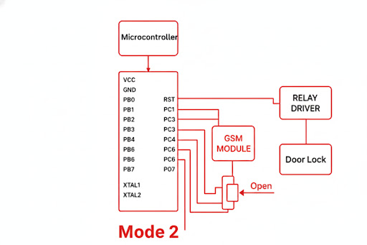
Figure4: Proposed System of GSM-Based Smart Security System for Mode 2

5.RESULTS AND DISCUSSION:
The proposed GSM-based smart security system has been developed and tested with the Arduino Uno controller, 4-button keypad, GSM SIM800L module, LCD display, vibration and temperature sensors, and 12-V solenoid gate lock. Under different operating conditions, the performance of the system has been assessed to test the correctness of password authentication, sensor response, and remote control functions. The obtained results confirm that the system successfully provides multi-level protection through local verification and GSM-enabled remote authorization.
The LCD module displayed “Enter Password”, indicating that it was ready for input from the keypad during normal operation Upon entering the correct password, GSM .The module sent an SMS notification to the authorized user. immediately that read “PASSWORD IS CORRECT Once the "open" command is sent by SMS to the relay,module activated the solenoid lock to permit authorize and access.
In the same way, the message "close" was able to successfully lock the cabinet. This is a sure indication that the GSM remote control function is highly responsive and reliable for real-time access management.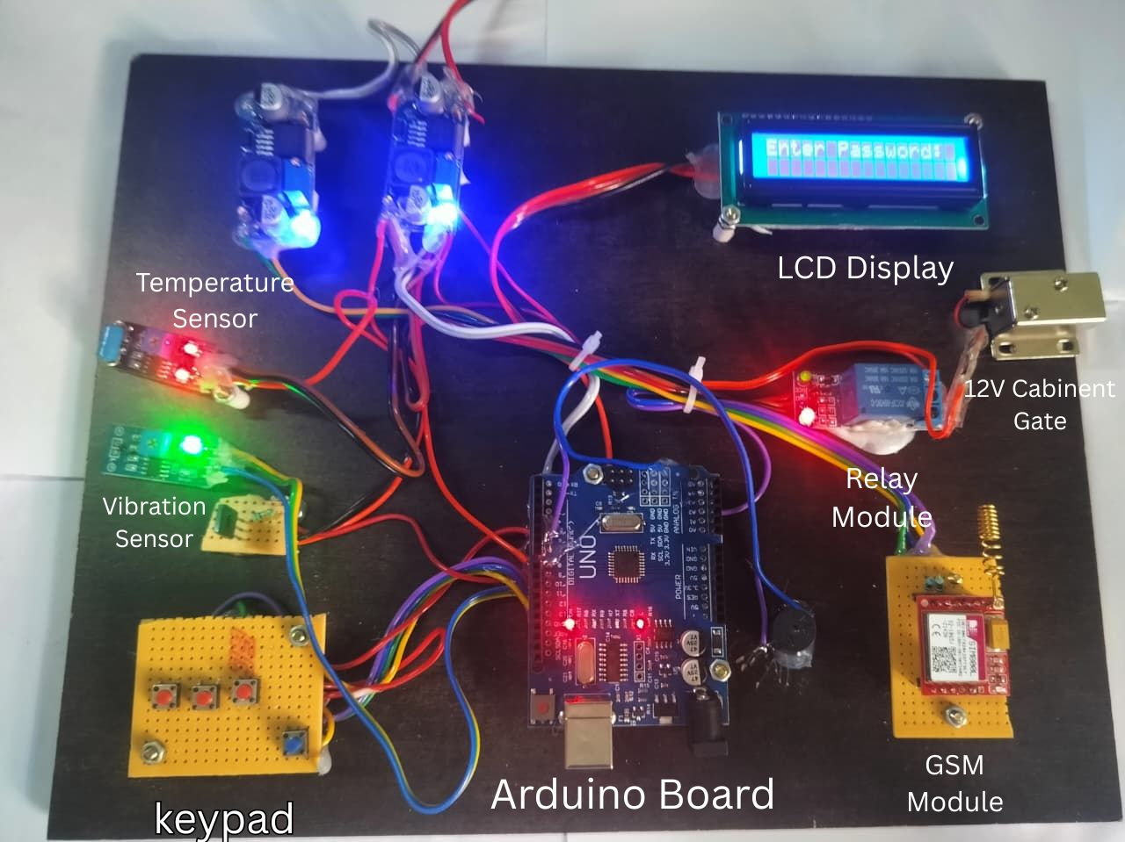 Figure5: GSM-based Smart Security System Protype
The vibration sensor is first tested by applying mechanical taps on the cabinet surface. The system accurately detects the vibration and initiates an alert message to the LCD, displaying "Vibration Alert". At the same time, the GSM module sends an SMS notification, stating "VIBRATION DETECTED" to the registered mobile number. This dual method of alerting will ensure that any attempt at physical tampering is immediately communicated to the user.
The temperature sensor module also performed well by displaying real-time temperature status, which can be extended to trigger fire-related warnings. This hardware prototype worked stably without much delay between sensor detection and GSM communication, about 3–5 seconds depending on the network.
The operation of the solenoid lock was quite smooth, and the relay
switching providing effective isolation between low-power
control signals and high-power actuation. The general wiring
and the PCB arrangement enable simultaneous
Operation of all modules without electromagnetic interference.The temperature sensor provided real-time readings with goodaccuracy, which demonstrated reliable environmental monitoring.This could be extended to givewarnings of fire or overheating.The entire prototype was working seamlessly; the only delaywas in GSM for about 3–5 seconds. The solenoid lock, theRelay isolation and the wiring layout provided good stability.
Interference-free, and safety in multi-modules operation.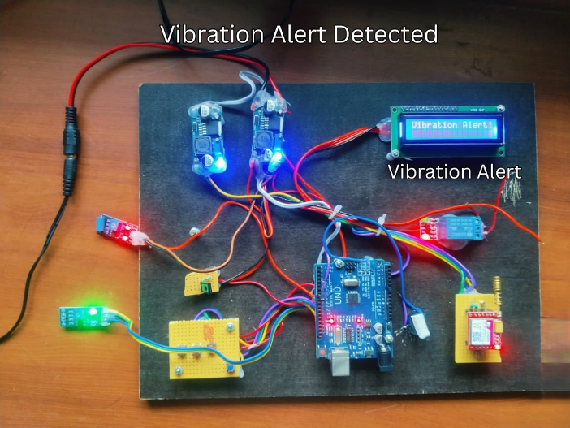
Figure6: Vibration Alert Detected
The experimental results show that the system provides major improvements compared to traditional keypad-based locks. The incorporated GSM communication enables a remote monitoring feature, and the vibration sensor improves the security level further by detecting suspicious activity even before the lock is actually breached. With the LCD interface, clear, real-time feedback of the system is possible, making the prototype suitable for use in applications like home cabinets, office lockers, laboratory storage, and small-scale industrial safety units.
Overall, the developed system performed reliably under all conditions tested and demonstrated the efficiency of sensor-based intrusion detection, combined with GSM-enabled remote authentication. The results prove the effectiveness of the proposed design and emphasize its practical applications in low-cost security applications.

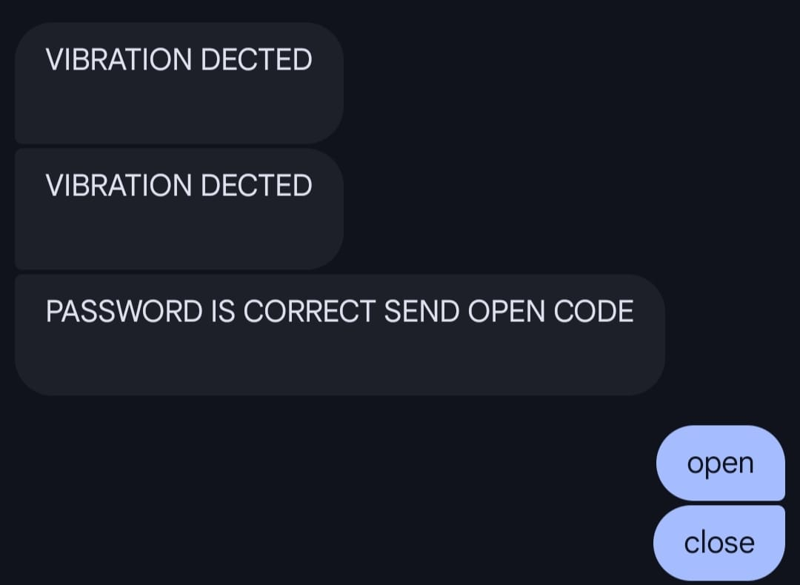
Figure7: Result for Open and Close Command

Feature / Parameter | Existing Security Systems | Proposed GSM-Based Smart Security System
Authentication Method | Mostly single-level authentication (only keypad password / RFID / key) | Dual authentication: Password + Mobile Verification (GSM response)
Remote Control | Rarely possible; most systems work only locally | Allows remote OPEN/CLOSE control through owner’s mobile phone (SMS reply)
Instant Notification | No automatic notification; user must be physically present | Immediate SMS alert to registered phone when password is entered at the ATM gate
User Authorization | Only the person who knows password can access | Final authority remains with the registered mobile owner, preventing misuse
Two-Factor Verification | Not available | YES – Password entry + Owner mobile confirmation
Ability to Reject Unauthorized Attempts | Limited; wrong password only denies access | System alerts owner; owner can choose to ignore or send CLOSE command
Technology Used | Basic electronic circuits / keypad locks / RFID | GSM module + Microcontroller + Password keypad + Relay + Mobile confirmation
Operational Flexibility | Only works when user is near the system | Works from anywhere, as long as mobile network is available
Record Keeping | No log generation | System can log SMS commands and password attempts
Table 1: Existing Method vs Proposed Method

REFERENCES

- “GSM Based Door Lock System,” International Journal of Innovative Technology and Exploring Engineering (IJITEE)
- “Smart Door Lock System by using Mobile via SMS,” IJARSCT conference paper (OTP-based SMS lock).
- “GSM Based Intelligent Home Security System for Intrusion Detection,” ResearchGate/preprint.
- “Development of an Arduino and GSM based door locking system that can be operated both manually and automatically,” Publiscience report.
- “GSM Based Home Automation, Safety and Security System using Android Mobile Phone,” IJERT.
- “Touchscreen and SMS Based Door Locking System,” IJARI conference paper.
- “GSM Based Bank Locker Security System with 3-Layer Authentication,” IJRASET article.
- “Smart GSM based Home Automation System,” ResearchGate PDF (SMS-controlled security/home automation).
- “GSM Based Home Safety and Security System,” EJ-ENG article.
- “Smart Security Door System Using SMS Based Energy Harvest,” ResearchGate (SMS-based door security + energy harvest).
- “Industry Based Security System Using GSM,” Ijasret full-text PDF (GSM monitoring system).
- “IoT-Enabled Biometric Door Lock System with Enhanced Security,” MDPI / Foundry journal article (IoT/biometrics context).
- “Fingerprint and GSM Based Door Lock System,” Journal/Matjournals article (fingerprint + GSM implementation).
- “A microcontroller-based combinational lock system,” World Scientific News (real-time SMS notification features).
- “Design and Implementation of a Smart Security System,” IJOER paper (GSM-based smart security).
- “GSM BASED DOOR OPEN AND CLOSE, LOCK AND …,” IRJET article (Arduino + SIM800C example).
- “SMART DOOR LOCK AND UNLOCK SYSTEM ,” IRJMETS (GSM-based remote access via SMS).
- “Two-Factor Authentication Smart Entryway Using Modified …,” IJWMN / AICC paper (two-factor access control discussion).
- “Design and Simulation of an Arduino-Based Password-Protected Door Locking System,” ResearchGate paper (Arduino door lock).
- “Keypad/Bluetooth/GSM Based Digital Door Lock Security,” Atlantis Press proceedings (electronic door lock implementations).

