Group 11: Ebay Auction

Team members: Hee Kyoung Nam, Nithash Rajendram and Taehyun Ahn

/* A5 */

/*Q1-EXISTS and COUNT and HAVING and GROUP BY: lists number of sales from each seller who is above 19 yr old*/

SELECT COUNT(AUCTIONITEMID), SELLERID

FROM AUCTIONITEM i

WHERE EXISTS

(SELECT SELLERID FROM SELLER s WHERE EXISTS

(SELECT AGE FROM AUCTIONUSER u WHERE s.USERID = u.USERID AND u.AGE > 19)

) group by SELLERID

HAVING COUNT(AUCTIONITEMID) > 1;



/* Q2-EXISTS, UNION, COUNT: count the number of user who is neither seller/buyer: who only created account */

SELECT COUNT(USERNAME)

FROM AUCTIONUSER u

WHERE NOT EXISTS

(SELECT u.USERID

FROM BIDDER b

WHERE b.USERID = u.USERID

UNION

(SELECT u.USERID

FROM SELLER s

WHERE s.USERID = u.USERID));



/*Q3-UNION and EXISTS: lists which sold for over $100 or under 5 days*/

SELECT *

FROM AUCTIONITEM

WHERE (ENDPRICE-STARTPRICE)>100

UNION

SELECT *

FROM AUCTIONITEM

WHERE (ENDTIME-STARTTIME)<5;

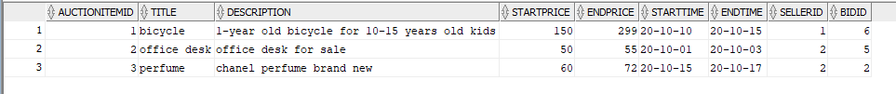

/*Q4-MINUS: show transaction older than 15 days */

SELECT i.title, i.endtime

FROM AUCTIONITEM i, bid b

WHERE status = 'c'

MINUS

(SELECT ai.title, ai.endtime

FROM auctionitem ai

WHERE ai.ENDTIME >= CURRENT_DATE - 15 );



/*Q5-COUNT and GROUP BY: lists the numbder of bids made, based off of bidder id*/

SELECT COUNT(BIDID),BIDDERID

FROM BID

GROUP BY BIDDERID;

