CREATE TABLE BB_Manager ( M_id int NOT NULL, mName varchar(max) NOT NULL, m_phNo bigint -- CONSTRAINT Mid_pk PRIMARY KEY (M_id) );

**2]** CREATE TABLE Blood_Donor ( bd_ID int NOT NULL, bd_name varchar(max) NOT NULL, bd_age varchar(max), bd_sex varchar(max), bd_Bgroup varchar(10), bd_reg_date date, reco_ID int NOT NULL, City_ID int NOT NULL -- CONSTRAINT bdID_pk PRIMARY KEY (bd_ID) );

**3]** CREATE TABLE BloodSpecimen ( specimen_number int NOT NULL, b_group varchar(10) NOT NULL, status int, dfind_ID int NOT NULL, M_id int NOT NULL CONSTRAINT specimenumber_pk PRIMARY KEY (specimen_number) );

**4]** CREATE TABLE DiseaseFinder ( dfind_ID int NOT NULL, dfind_name varchar(max) NOT NULL, dfind_PhNo bigint -- CONSTRAINT dfindID_pk PRIMARY KEY (dfind_ID) );

**5]** CREATE TABLE Hospital_Info_1 ( hosp_ID int NOT NULL, hosp_name varchar(max) NOT NULL, City_ID int NOT NULL, M_id int NOT NULL primary key(hosp_ID) -- CONSTRAINT hospID_pk PRIMARY KEY (hosp_ID) );

**6]** CREATE TABLE Hospital_Info_2 ( hosp_ID int NOT NULL, hosp_name varchar(max) NOT NULL, hosp_needed_Bgrp varchar(10), hosp_needed_qnty int primary key(hosp_ID,hosp_needed_Bgrp) -- CONSTRAINT hospID_pk PRIMARY KEY (hosp_ID) );

**7]** CREATE TABLE Recipient ( reci_ID int NOT NULL, reci_name varchar(max) NOT NULL, reci_age varchar(max), reci_Brgp varchar(max), reci_Bqnty float, reco_ID int NOT NULL, City_ID int NOT NULL, M_id int NOT NULL, reci_sex varchar(max), reci_reg_date date -- CONSTRAINT reciid_pk PRIMARY KEY (reci_id) );

**8]** CREATE TABLE Recording_Staff ( reco_ID int NOT NULL, reco_Name varchar(max) NOT NULL, reco_phNo bigint -- CONSTRAINT recoID_pk PRIMARY KEY (reco_ID) );

**INSERTION OF DATA**

INSERT into BB_Manager VALUES(102,'Jack', 4693959671), (103,'Peter', 4693959601), (104,'Mark', 4693959677), (105,'Jason', 4693957671);

INSERT into BB_Manager VALUES(106,'Steve', 4694959671), (107,'Jason', 4695959671), (108,'Stella', 4663959671), (109,'Monika', 4673959671), (110,'John', 4693859671);

INSERT into Blood_Donor VALUES(150221,'Mark',25,'M','B+','2015-12-17',101212,1100), (160011,'Abdul',35,'F','A+','2016-11-22',101212,1100),(160101,'Smith',22,'M','O+','2016-01-04',101312,1200),(150011,'Pat',29,'M','O+','2015-07-19',101412,1300), (150021,'Shyam',42,'F','A-','2015-12-24',101412,1300),(150121,'Dan',44,'M','AB+','2015-08-28',101212,1200),(160031,'Mike',33,'F','AB-','2016-02-06',101212,1400),(160301,'Elisa',31,'F','AB+','2016-09-10',101312,1200), (160091,'Carrol',24,'M','B-','2016-10-15',101312,1500),(160401,'Mark',29,'M','O-','2016-12-17',101212,1200);

INSERT into BloodSpecimen VALUES(1001, 'B+', 1,11,101), (1002, 'O+', 1,12,102), (1003, 'AB+', 1,11,102), (1004, 'O-', 1,13,103), (1005, 'A+', 0,14,101), (1006, 'A-', 1,13,104), (1007, 'AB-', 1,15,104), (1008, 'AB-', 0,11,105), (1009, 'B+', 1,13,105), (1010, 'O+', 0,12,105), (1011, 'O+', 1,13,103), (1012, 'O-', 1,14,102), (1013, 'B-', 1,14,102), (1014, 'AB+', 0,15,101);

INSERT into City VALUES(1200,'Austin'), (1300,'Irving'), (1400,'Houston'), (1500,'Richardson');

INSERT into City VALUES(1600,'Plano'), (1700,'Frisco'), (1800,'Arlington'), (1900,'San Antonio'), (2000,'Tyler');

INSERT into DiseaseFinder VALUES(11,'Peter',4693804223), (12,'Park',4693804223), (13,'Jerry',4693804223), (14,'Mark',4693804223), (15,'Monika',4693804223);

INSERT into DiseaseFinder VALUES(16,'Ram',4693804123), (17,'Swathi',4693804223), (18,'Gautham',4693804323), (19,'Ashwin',4693804423), (20,'Yash',4693804523);

INSERT into Hospital_Info_1 VALUES(1,'MayoClinic',1100,101), (2,'CleavelandClinic',1200,103), (3,'NYU',1300,103);

INSERT into Hospital_Info_1 VALUES(4,'Baylor',1400,104), (5,'Charlton',1800,103), (6,'Greenoaks',1300,106), (7,'Forestpark',1300,102), (8,'Parkland',1200,106), (9,'Pinecreek',1500,109), (10,'WalnutHill',1700,105);

INSERT into Hospital_Info_2 VALUES(1,'MayoClinic','A+',20), (1,'MayoClinic','AB+',0), (1,'MayoClinic','A-',40), (1,'MayoClinic','B-',10), (1,'MayoClinic','AB-',20);

INSERT into Hospital_Info_2 VALUES(1,'MayoClinic','A+',20), (1,'MayoClinic','AB+',0), (1,'MayoClinic','A-',40), (1,'MayoClinic','B-',10), (1,'MayoClinic','AB-',20);

INSERT into Hospital_Info_2 VALUES(3,'NYU','A+',0), (3,'NYU','AB+',0), (3,'NYU','A-',0), (3,'NYU','B-',20), P a g e | 24 (3,'NYU','B+',10), (3,'NYU','AB-',0);

INSERT into Hospital_Info_2 VALUES(4,'Baylor','A+',10), (5,'Charlton','B+',30), (4,'Baylor','A-',40), (7,'Forestpark','B-',40), (8,'Parkland','B+',10), (9,'Pinecreek','AB-',20);

INSERT into Recipient VALUES(10001,'Mark',25,'B+',1.5,101212,1100,101,'M','2015-12-17'), (10002,'Dan',60,'A+',1,101312,1100,102,'M','2015-12-16'),

(10003,'Steve',35,'AB+',0.5,101312,1200,102,'M','2015-10-17'),(10004,'Parker',66,'B+',1,101212,1300,104,'M','2016-11-17'),(10005,'Jason',53,'B-',1,101412,1400,105,'M','2015-04-17'), (10006,'Preetham',45,'O+',1.5,101512,1500,105,'M','2015-12-17'), (10007,'Swetha',22,'AB-',1,101212,1500,101,'F','2015-05-17');

INSERT into Recipient VALUES(10008,'Swathi',25,'B+',2,101412,1300,103,'F','2015-12-14'), (10009,'Lance',30,'A+',1.5,101312,1100,104,'M','2015-02-16'),

(10010,'Marsh',25,'AB+',3.5,101212,1200,107,'M','2016-10-17');

INSERT into Recording_Staff VALUES(101212,'Walcot',4045806553), (101312,'Henry',4045806553), (101412,'Silva',4045806553), (101512,'Adrian',4045806553), (101612,'Mark',4045806553);

INSERT into Recording_Staff VALUES(101712,'Abdul',4045816553), (101812,'Jerry',4045826553), (101912,'Tim',4045836553), (101012,'Lekha',4044846553), (101112,'Mark',4045856553);

**SAMPLE QUERIES AND OUTPUTS**

**1. Create a View of recipients and donors names having the same blood group registered on the same date.**

QUERY:

CREATEVIEWBlood_Recipient_SameBGrp; AS select Blood_Donor.bd_name,Recipient.reci_name,reco_Name from Recording_Staff inner join Blood_Donor on Recording_Staff.reco_ID = Blood_Donor.reco_ID inner join Recipient on Recording_Staff.reco_ID = Recipient.reco_ID where Blood_Donor.bd_Bgroup = Recipient.reci_Brgp and Blood_Donor.bd_reg_date = Recipient.reci_reg_date

select * from Blood_Recipient_SameBGrp;

OUTPUT:

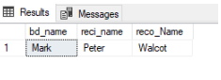

**2. Show the blood specimen verified by disease finder Mark which are pure (status=1).**

**QUERY:**

Select specimen_number,b_group from BloodSpecimen,DiseaseFinder WHERE BloodSpecimen.dfind_ID= DiseaseFinder.dfind_ID AND dfind_name='Mark' AND status=1

OUTPUT:

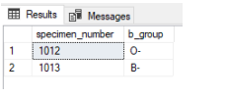

**3.Show the pure blood specimen handled by BB_Manager who also handles a recipient needing the same blood group along with the details of the BB_Manager and Recipient.**

**QUERY:**

SelectBB_Manager.M_id,mName,Recipient.reci_name, Recipient.reci_Brgp,b_group from BB_Manager,Recipient,BloodSpecimen where Recipient.M_id = BloodSpecimen.M_id and Recipient.reci_Brgp = BloodSpecimen.b_group and status = 1

OUTPUT:

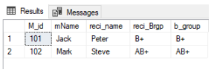

**4. Show the donors having the same blood groups required by the recipient staying in the same city along with recipient details.**

**QUERY:**

Select bd_ID,bd_name,reci_ID,reci_name FROM Blood_Donor,Recipient WHERE bd_Bgroup=reci_Brgp AND Blood_Donor.City_ID= Recipient.City_ID

OUTPUT:

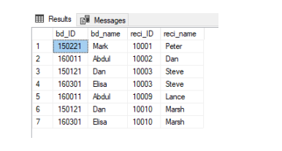

**5. Display the information of Hospital_Info_1 handled by BB_Manager whose ID is 103:**

**QUERY:**

Select hosp_ID,hosp_name , City_ID, HOspital_Info_1.M_id from Hospital_Info_1,BB_Manager where BB_Manager.M_id=Hospital_Info_1.M_id and BB_Manager.M_id=103

OUTPUT:

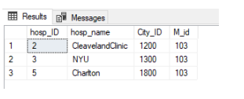

**6.Find all recipients whose age is less than 30 and blood group is 'A+'.**

**QUERY:**

SELECT reci_Name FROM Recipient WHERE reci_age < 30 AND reci_bgrp = 'A+';

**OUTPUT:**

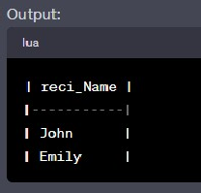

**7. Find the recording staff members who have recorded more than 100 donors.**

**QUERY:**

SELECT reco_name FROM Recording_Staff WHERE reco_id IN ( SELECT reco_id FROM Donor

GROUP BY reco_id HAVING COUNT(*) > 100

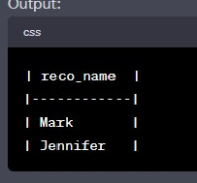);

**8.Count the number of donors in each blood group.**

**QUERY:**

SELECT bd_bgrp, COUNT(*) AS total_donors FROM Donor

GROUP BY bd_bgrp;

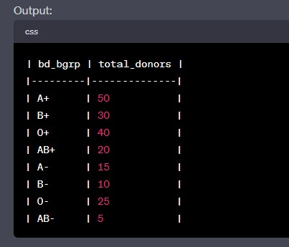

1. **Calculate the average age of recipients.**

**QUERY:**

SELECT AVG(reci_age) AS average_age FROM Recipient;

**OUTPUT:**

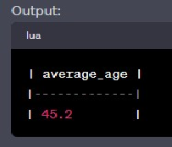

**10. Retrieve the names of recipients along with the city they belong to.**

**QUERY:**

` SELECT r.reci_Name, c.city_name FROM Recipient r

Inner JOIN City c ON r.city_id = c.city_id;

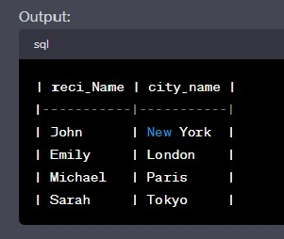

**11.Show the donors having the same blood groups required by the recipient staying in the same city along with recipient details.**

**QUERY:**

Select bd_ID,bd_name,reci_ID,reci_name FROM Blood_Donor,Recipient WHERE bd_Bgroup=reci_Brgp AND Blood_Donor.City_ID= Recipient.City_ID

**OUTPUT:**

