

We are pleased to inform you of AEGEAN’s participation as the “Official Air Carrier” at the Athens Natural Language Processing Summer School 2024 (AthNLP 2024), which will be held from September 19th to 25th, 2024 at the "NCSR Demoktitos" Congress Centre in Athens. Specifically, AEGEAN will generously offer a **40% discount on round trip Economy class tickets, valid on any AEGEAN or Olympic Air domestic or international flights.**

*\*Please note that the 40% discount offer is applicable to the* ***Economy Class – Comfort Flex fare category****. The trip must be scheduled between* ***September 12, 2024 and September 30, 2024****. Reservations can be made through the company’s official website at* [*www.aegeanair.com*](http://www.aegeanair.com)*. However, please be aware that applicable airport taxes and fees are not included in the offer.*

To make a reservation and issue tickets using the discount, please visit AEGEAN’s official website at [www.aegeanair.com](http://www.aegeanair.com) and enter the promo code [**XXXXX]** in the “Promotional Code” field, as shown in the screenshot below:

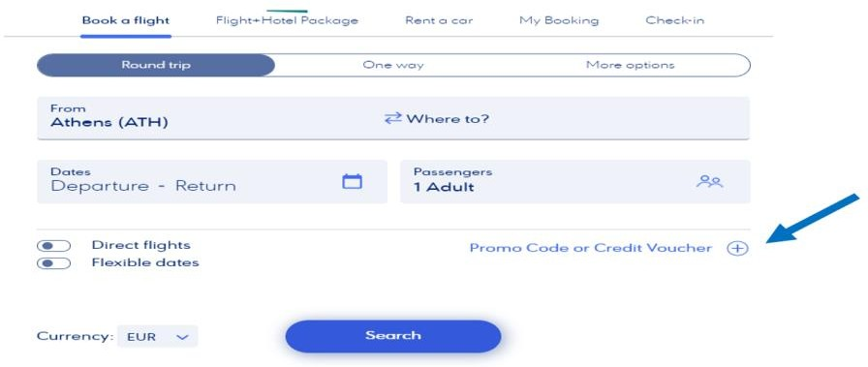

Please note that all bookings are subject to flight availability. For more information about AEGEAN’s flight schedule, you can visit the company's official website at [www.aegeanair.com](http://www.aegeanair.com) or contact the Reservations Department at tel. +30 210 6261000 (Monday – Friday, 07:00-23:00).

|  |
| --- |
| Εικόνα που περιέχει γραμματοσειρά, γραφικά, λογότυπο, Μπελ ηλεκτρίκ  Περιγραφή που δημιουργήθηκε αυτόματα |
| Athens Natural Language  Processing Summer School |