## Logistic Regression – ODDS Ratio

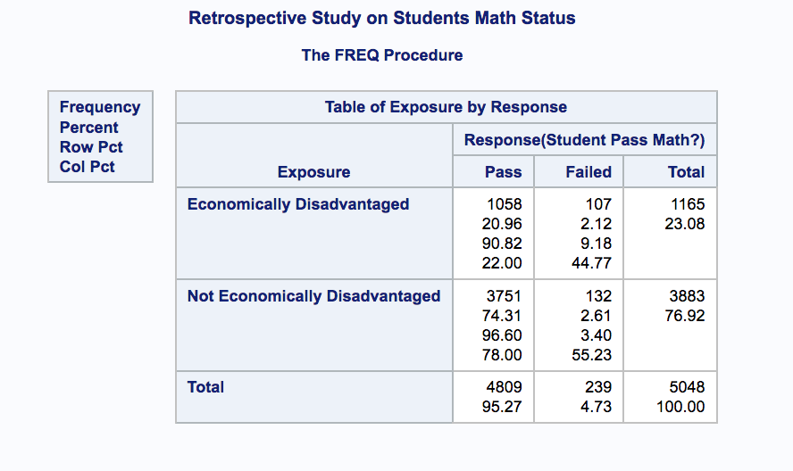

* 5048 test scores were randomly selected from Jodi’s educational database
* Proportion of students passing Math given they are economically disadvantaged is 90.82%.
* Proportion of students passing Math given they were not economically disadvantages is 96.6%.
* Proportion of students economically disadvantaged is 23.08%.

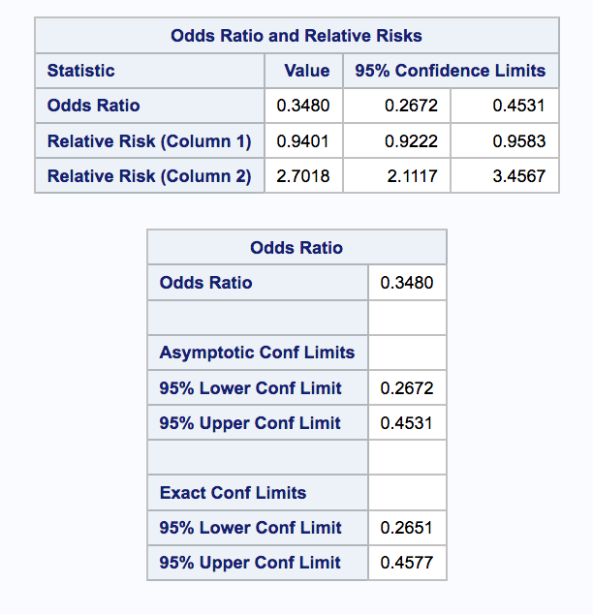

* The ODDS of students not economically disadvantaged of passing Math is 2.87 (1/.348) times the ODDs of students economically disadvantaged.
* The true ODDS ratio of students not economically disadvantages of passing Math is between (2.21 , 3.74).
* Since this is a retrospective study, relative risk does not apply.
* In conclusion, students with economic disadvantage have significantly lower ODDS of passing Math. The schools should look to find ways to help these students more knowing they statistically have much lower ODDs of passing Math.

## SAS Code

*proc format;*

*value ExpFmt 1='Economically Disadvantaged'*

*0='Not Economically Disadvantaged';*

*value RspFmt 1='Pass'*

*0='Failed';*

*run;*

*data education;*

*input Exposure Response Count;*

*label Response='Student Pass Math?';*

*datalines;*

*0 0 132*

*0 1 3751*

*1 0 107*

*1 1 1058*

*;*

*proc sort data=education;*

*by descending Exposure descending Response;*

*run;*

*proc freq data=education order=data;*

*format Exposure ExpFmt. Response RspFmt.;*

*tables Exposure*Response / chisq riskdiff(equal var=null) relrisk;*

*exact pchi or fisher;*

*weight Count;*

*title ' Retrospective Study on Students Math Status ';*

*run;*