## Logistic Regression – Blocking Variable: Disciplined or Not Disciplined

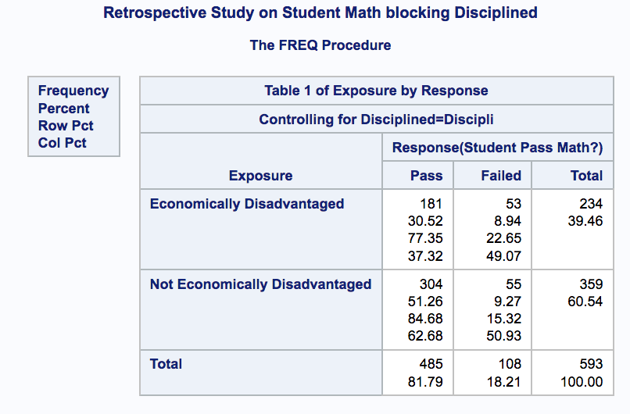 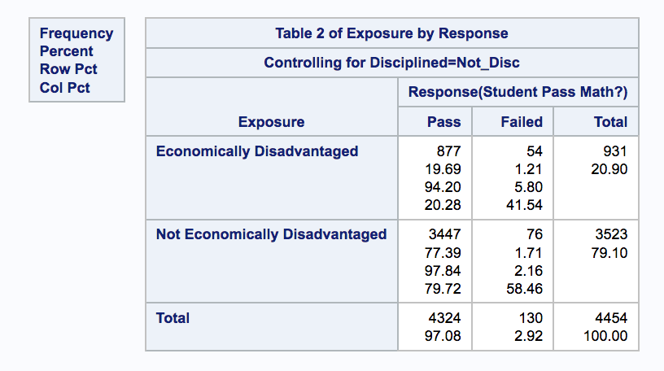

Student Disciplined Student Not Disciplined

* There is a noticeable difference of proportions for both response and explanatory when blocking for variable YN_Discipline. For students who have been disciplined, overall proportions drop when compared to the original model (no blocking). Proportions of students with economic disadvantage 77.35% pass and those with advantage, 84.68% - that is a drop of 13.47% and 11.92% respectively when compared to the original model.
* Furthermore, for the students who have never been disciplined, their overall proportions increased when compared to the original model (no blocking). Proportions of students with economic disadvantage 94.2% pass and those with advantage, 97.64% -- that is an increase of 3.38% and 1.24% respectively when compared to the original model.
* Practical conclusion: When blocking for whether a student has been disciplined or not, it noticeably impacts a student’s ability to pass Math. Since the sample size is 5048, we’ll continue examining the ODDs ratio using Mantel-Haenszel.
* 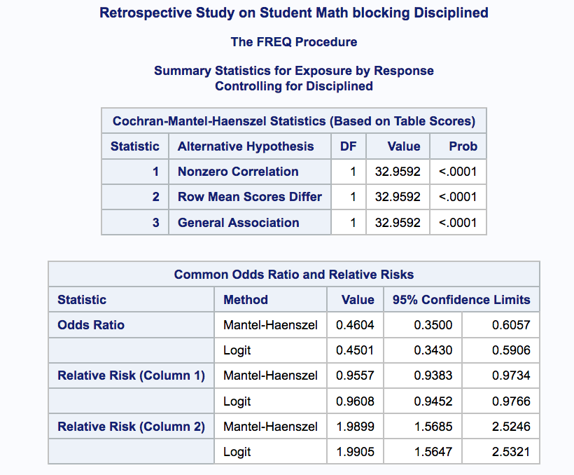The ODDS of students not economically disadvantaged of passing Math is 2.17 (1/0.4604) times the ODDS of students economically disadvantaged after adjusting for disciplined or not.
* Compared to the original model (no blocking), the ODDs difference is 0.70.
* Conclusion: Overall, students with economic advantage will have higher ODDS of passing Math – even after adjusting for disciplinary action. Therefore, it would be statistically more impactful for the schools to focus on how to increase the Math pass proportion for students of economic disadvantage – regardless of disciplined or not.

## SAS Code

*proc format;*

*value ExpFmt 1='Economically Disadvantaged'*

*0='Not Economically Disadvantaged';*

*value RspFmt 1='Pass'*

*0='Failed';*

*run;*

*data education_disciplined;*

*input Exposure Response Count Disciplined $;*

*label Response='Student Pass Math?';*

*datalines;*

*0 0 55 Disciplined*

*0 1 304 Disciplined*

*1 0 53 Disciplined*

*1 1 181 Disciplined*

*0 0 76 Not_Disciplined*

*0 1 3447 Not_Disciplined*

*1 0 54 Not_Disciplined*

*1 1 877 Not_Disciplined*

*;*

*proc sort data=education_disciplined;*

*by descending Exposure descending Response;*

*run;*

*proc freq data=education_disciplined order=data;*

*format Exposure ExpFmt. Response RspFmt.;*

*tables Disciplined*Exposure*Response / CMH chisq riskdiff(equal var=null) relrisk;*

*exact pchi or fisher;*

*weight Count;*

*title ' Retrospective Study on Student Math blocking Disciplined ';*

*run;*