Adam Thoma-Perry

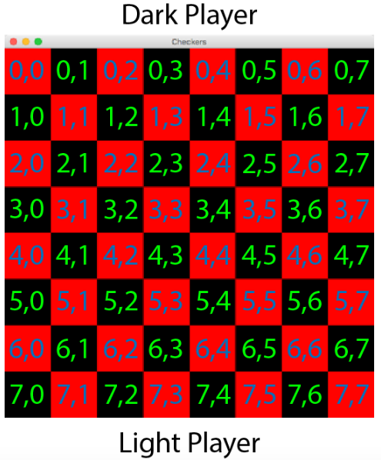

**Objective:** To eliminate all of the opponent’s pieces, to block the opponent from making legal moves, or to return all of your remaining pieces back to their starting line.

A draw occurs when the board state remains the same at the end of three consecutive turns.

**Starting positions:**

Dark: (0,1), (0,3), (0,5), (0,7)

(1,0), (1,2), (1,4), (1,6)

(2,1), (2,3), (2,5), (2,7)

Light: (5,0), (5,2), (5,4), (5,6)

(6,1), (6,3), (6,5), (6,7)

(7,0), (7,2), (7,4), (7,6)

**Movements:**

All Pieces: Can move diagonally (down if dark, up if light) to dark spaces that are unoccupied if X and Y axis’s are greater than or equal to 0 and less than or equal to 7

Capturing: If adjacent diagonal space in appropriate direction (down if dark, up if light) is occupied by an enemy piece AND the space diagonally directly behind is empty, attacking piece will jump to the empty space behind the enemy and look for another enemy to jump.

Ex: Attacking Dark Piece in (5,0) and Light Piece in (4,1)

If (3,2) is unoccupied, Dark Piece will move there and will look for another adjacent enemy piece and will repeat the process until no legal move is found.

**Kings:** If Light piece reaches (Y axis == 0), or if Dark piece reaches (Y axis == 7), that piece will become a king and be able to move up or down to any adjacent dark space if unoccupied and may capture in both the up and down directions.

**Turns:**

Phase 1:

Human: Picks piece to move with.

A.I.: Checks all pieces for legal moves, returns the piece with the highest number of captures available during that turn. If no captures are available, returns a piece whose movement will not result in a capture during the opponent’s next turn. If no safe moves are available, returns a piece whose movement will result in the least amount of captures during opponent’s turn.

Phase 2:

Human and A.I: Picks direction to move in. If piece is moved and no opposing piece is captured, turn ends. If opposing piece is captured, check is made for additional opponents that can be captured. Repeat captures and checks until no more are available. Turn ends.