1. Set project for correct textures pixel rendering ( like 8 bit )
change:
- resolution project to 256x144
- Rendering textures from linear to nearest
- window stretch mode: canvas

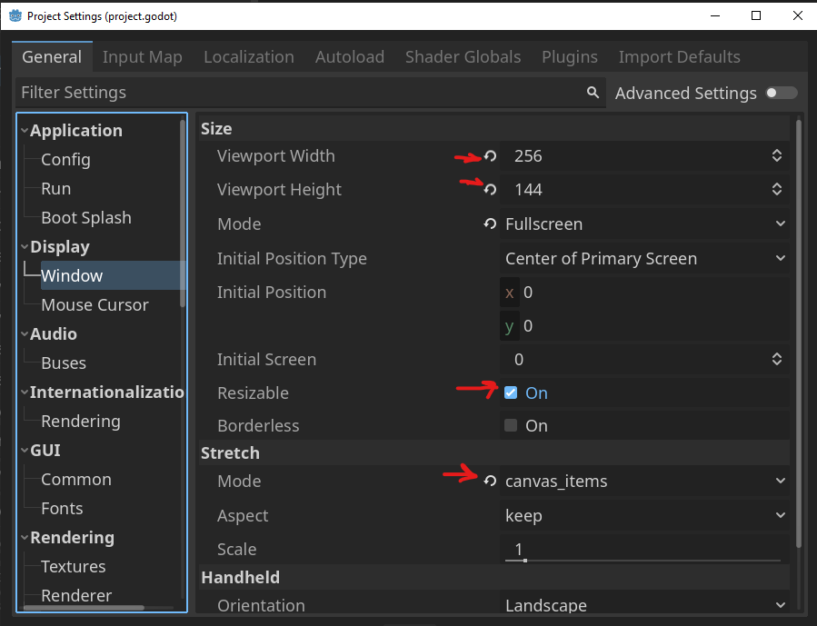
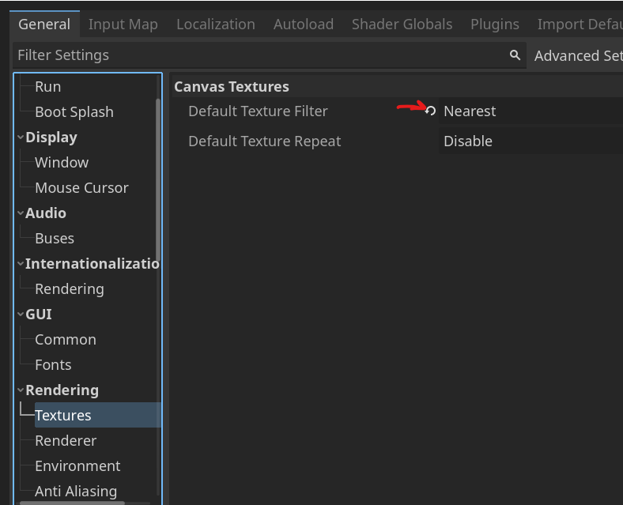

project resolution should be 16x9 divisible by 8:
- 128px x 72px
- 256px x 144px
- 384px x 216px
- 512px x 360px
- 768px x 432px
- 896px x 504px
- 1024px x 576px
- 1152px x 648px
- 1280px x 720px
- 1408px x 792px
- 1536px x 864px
- 1664px x 936px
- 1792px x 1008px
- 1920px x 1080px

We can also override window:

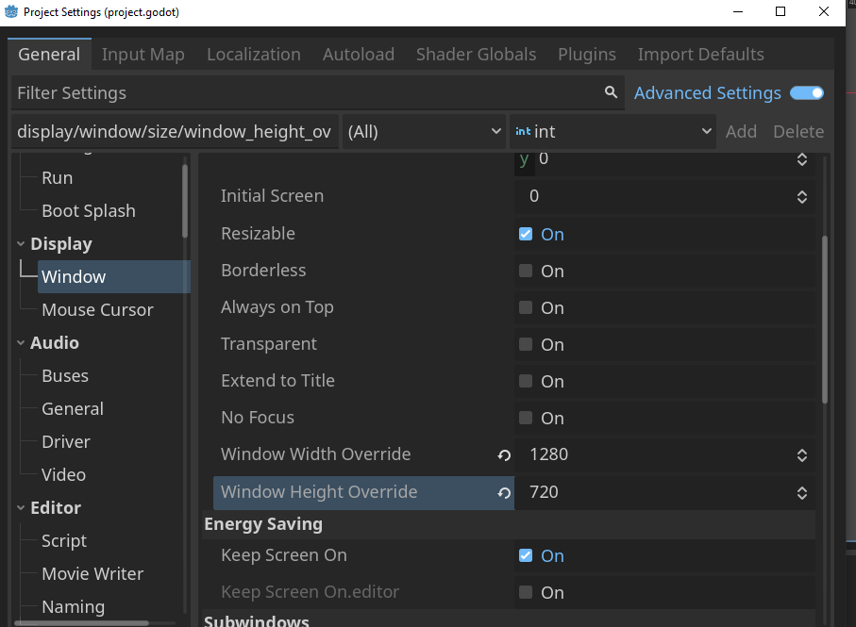

2. Moving Player:

func _process(delta):
process_movement_input()

func _physics_process(delta):
movement()

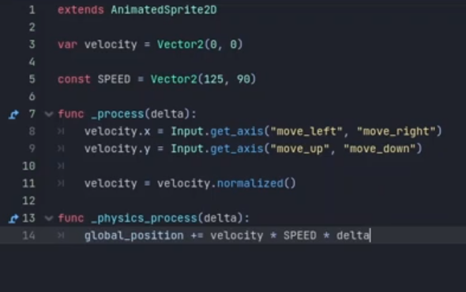
func process_movement_input(): without Physics:
velocity.x = Input.get_axis("move_left","move_right")
velocity.y = Input.get_axis("move_up","move_down")
velocity = velocity.normalized()

func movement():
global_position += velocity * SPEED * get_process_delta_time()

with Physics:
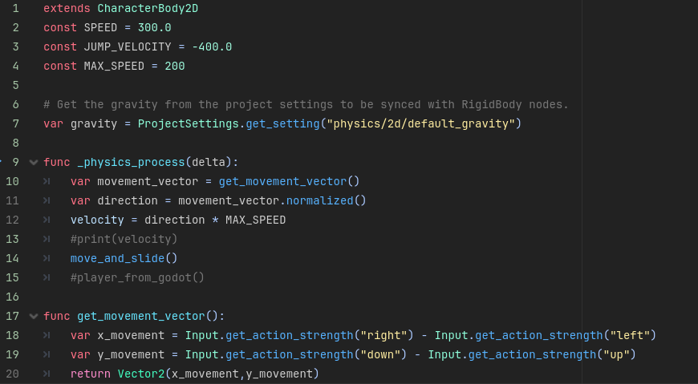
- Additional useful examples:

moving sprite to follow mouse pointer:
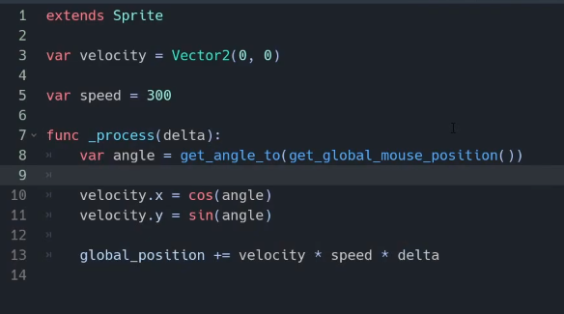

move_and_slide()
move_and_collide()
move_toward() - similar to lerp(), example: velocity.x = move_toward(velocity.x, 0, SPEED /2)

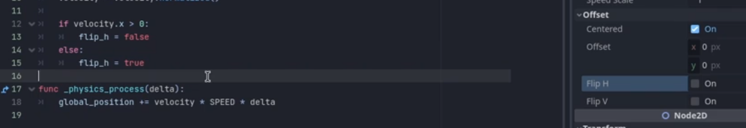
- change player direction Flip H ( Sprite: flip_h = true/ false)

3. Change scene from file:

Global.currentLevel += 1
levelPath = "res://level_" + str(Global.currentLevel) +".tscn"
get_tree().change_scene_to_file(levelPath)

4. Player instantiate bullet:
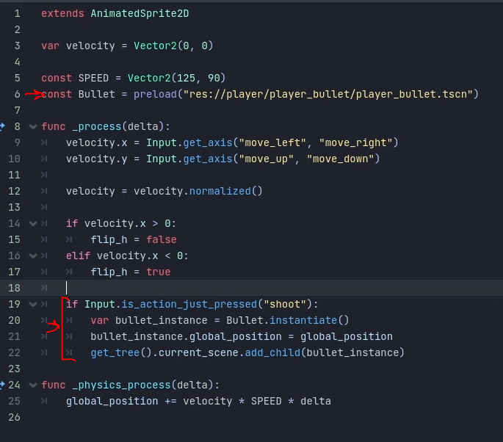

- Changing bullet direction ( in Player script after instantiate):

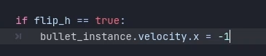

5. !VisibleOnScreenNotifier2D

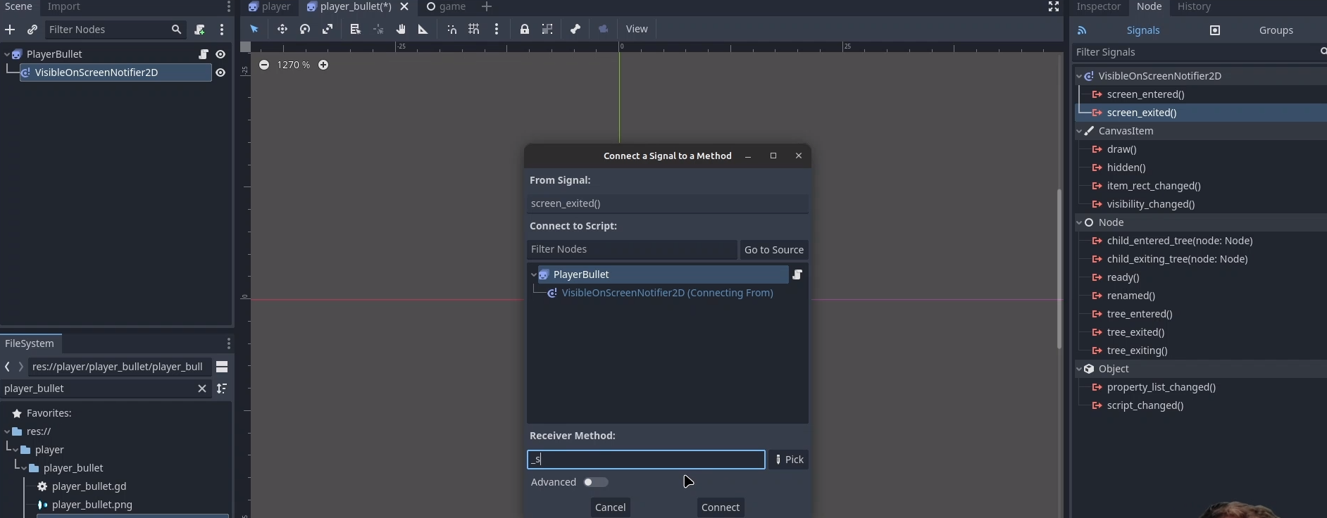
w Signal → screen_exites w in method call queue_free()

6. TextureProgressBar
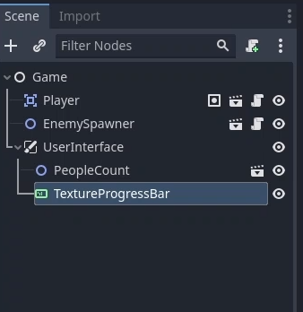

7. Signals (Singleton approach):
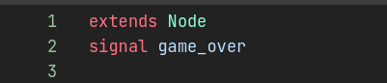
Signal „game_over” created in Singleton file: game_events.gd

In Player script connect Signal game_over to method: _game_over()

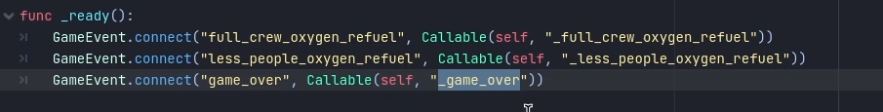
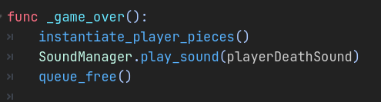

You can emit signal from different object (enemies … )

8. RcEdit changing icon into won icon:

download rcedit github.com/electron/rcedit/ : ( Releases )

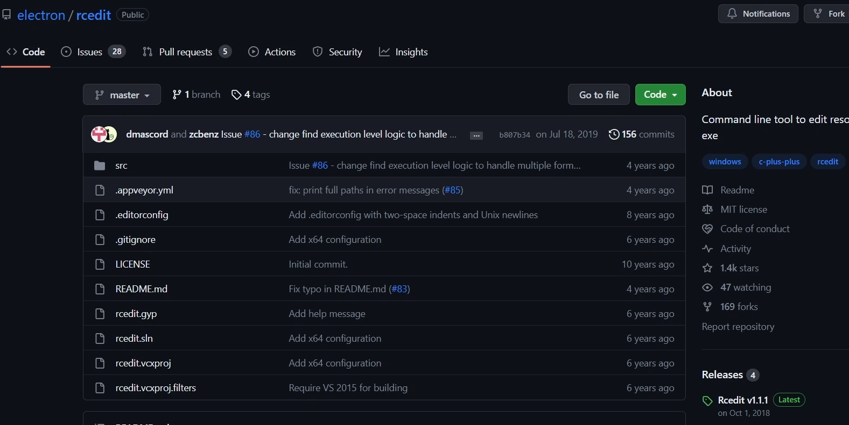
EDITOR → Editor settings:

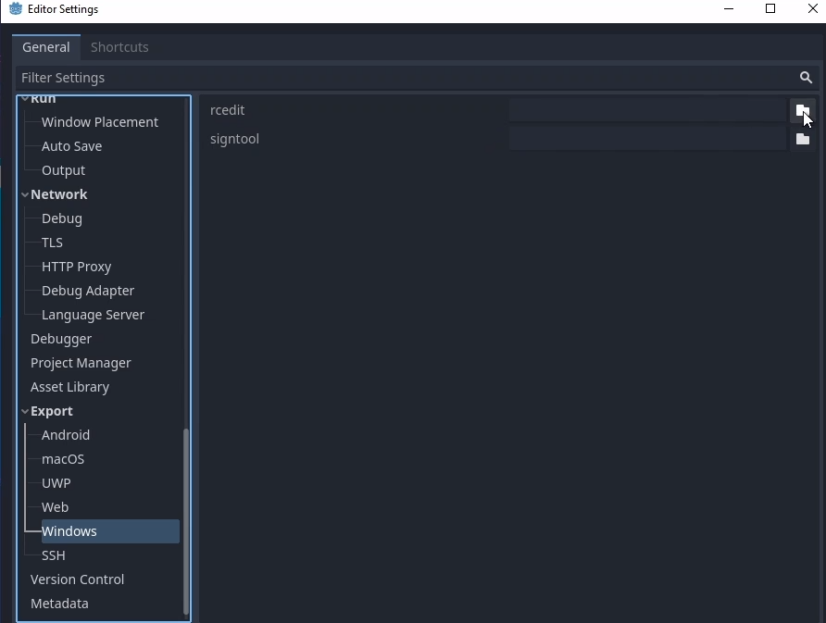
9. Tilemap:
Put Tilemap on the scene
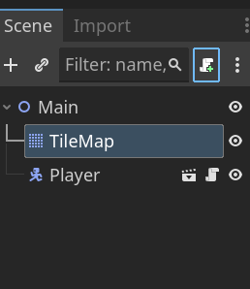

Create new Resource Tilemap:
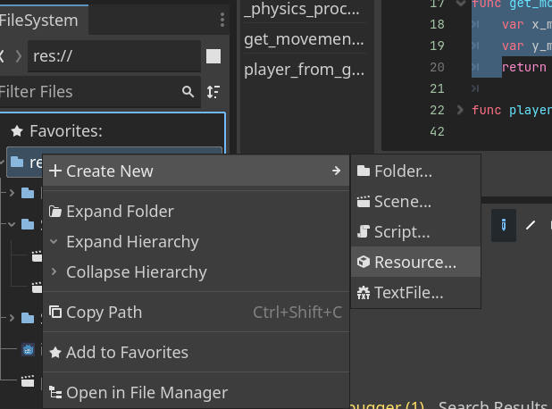
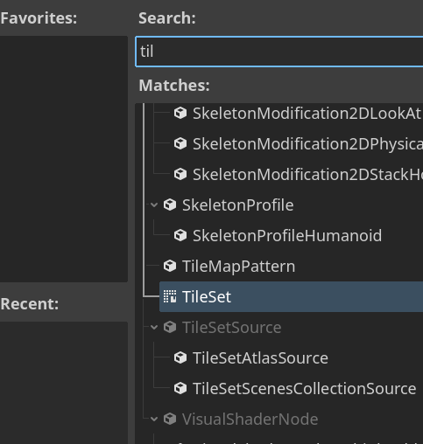

open
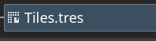

and load packed map ( move it to Tiles Editor window)
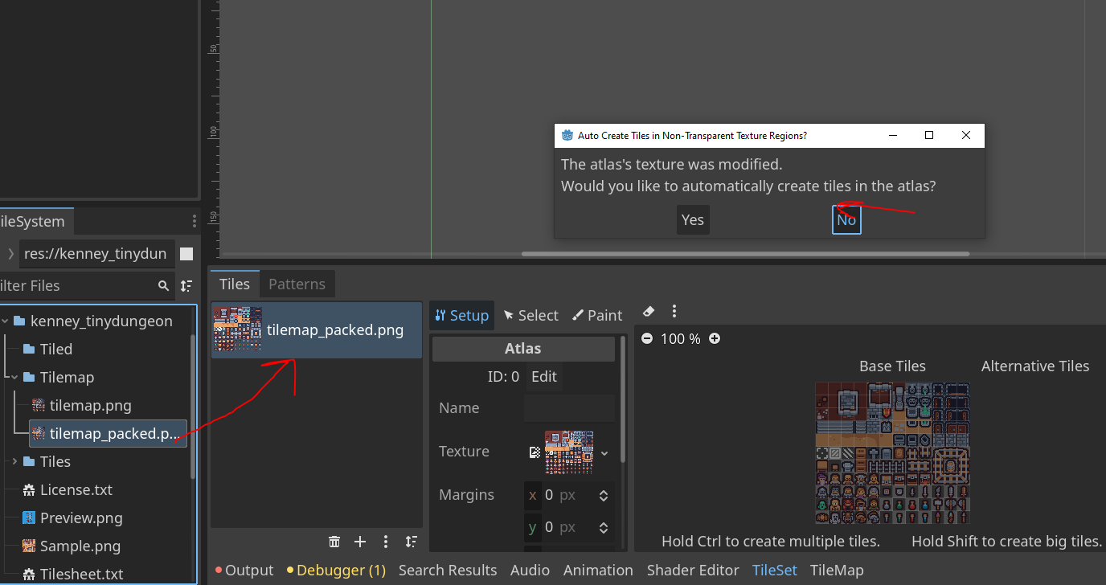

select tiles that you want to use and add Terrain:

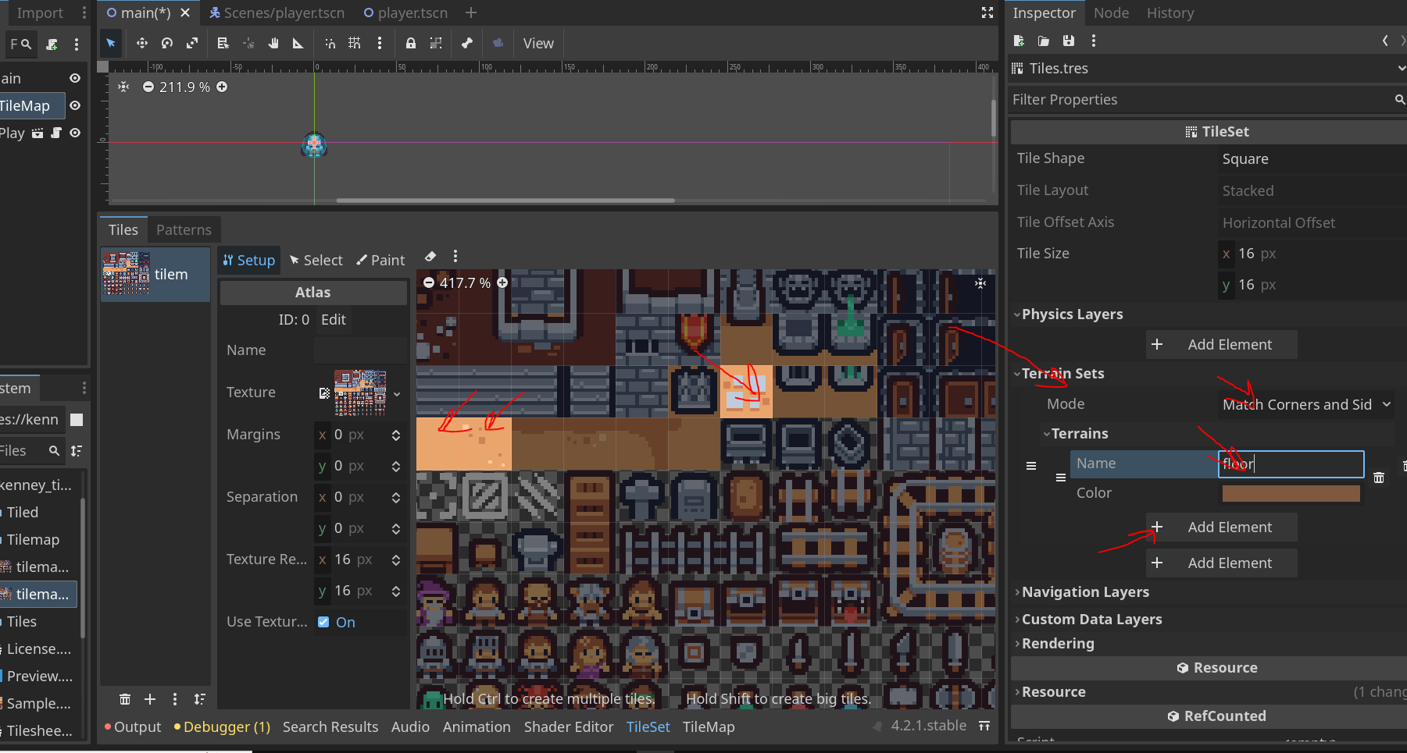

click terraint and Terrain set 0

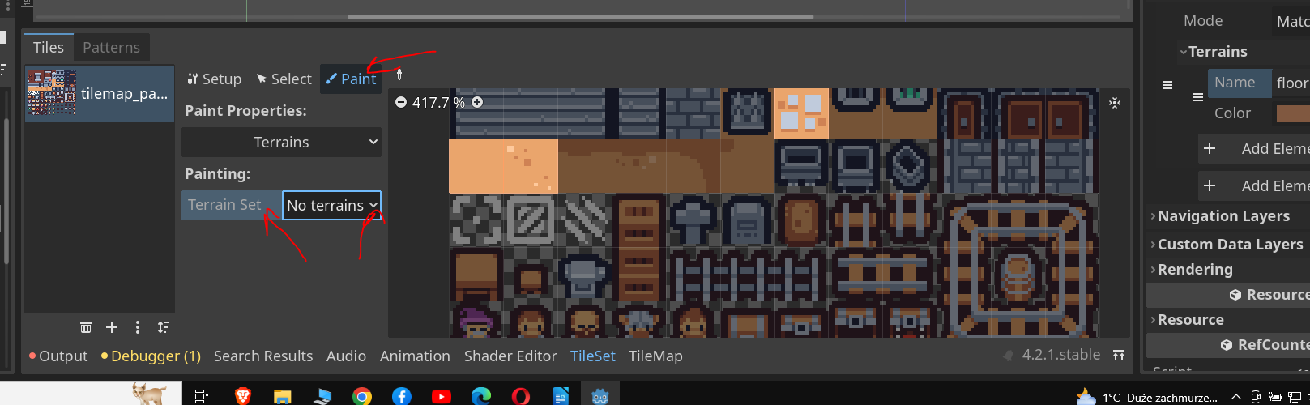

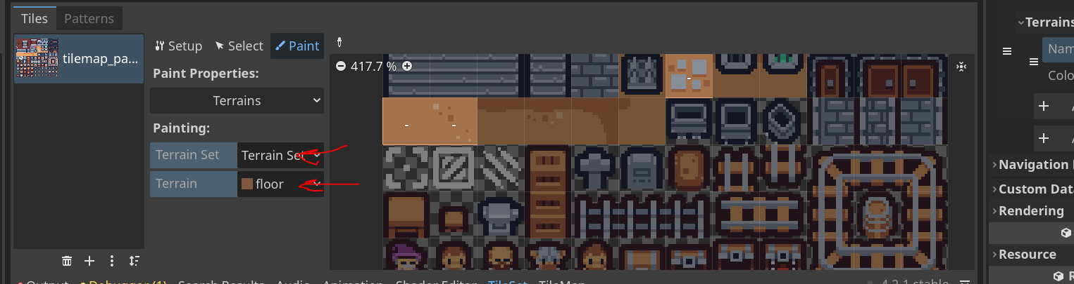

click again in tiles and we need to prepare bit mask:

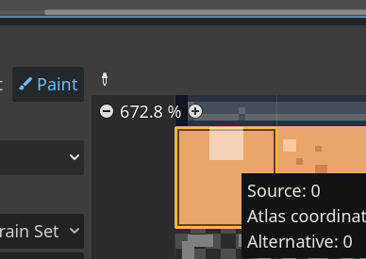

make a bit mask and you can check probability:

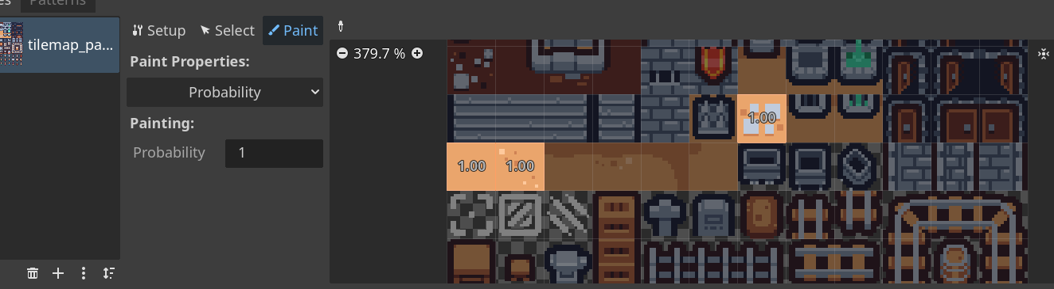
and change a probability:
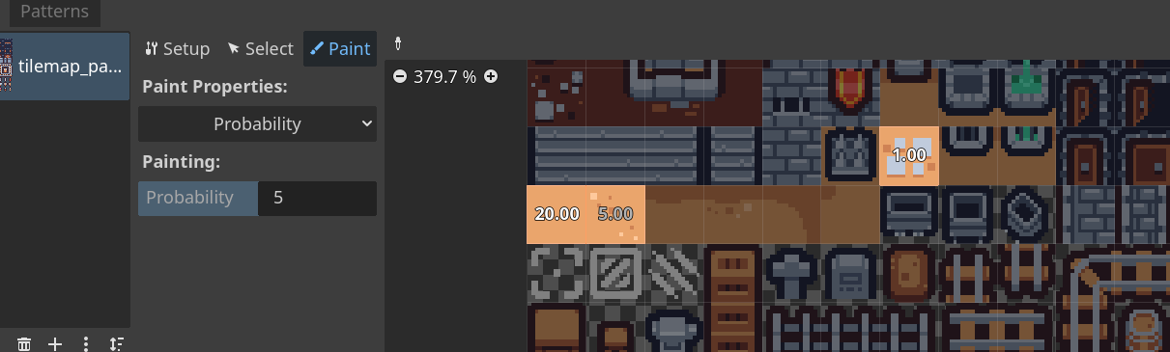

probability that this tiles hapen: 20/26 , 5/26 , 1/26

To paint load Tiles to TileMap->Tile Set:
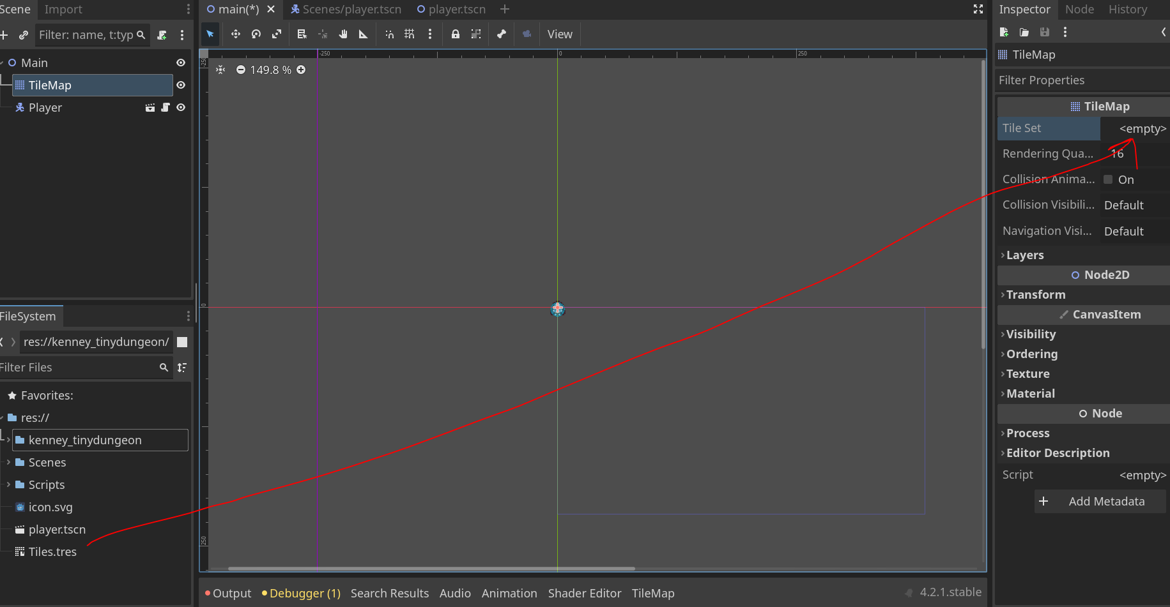

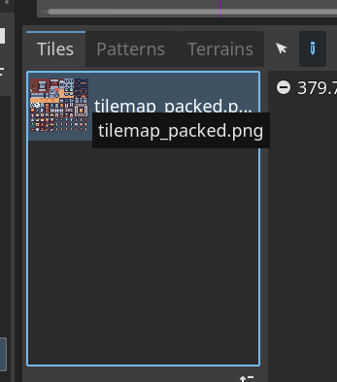
and next

select Tiles→Tilemap, go to
Terrains→ select floor and Paint

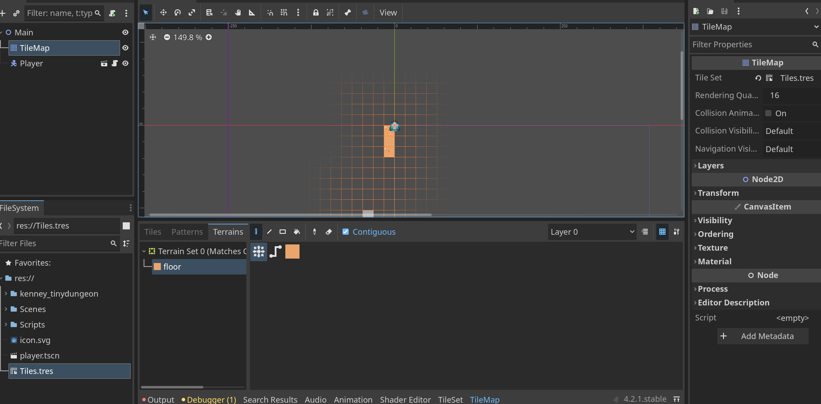

9. LERP FOR Camera:

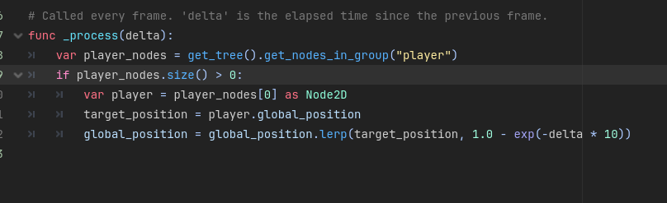

10. FPS in label:
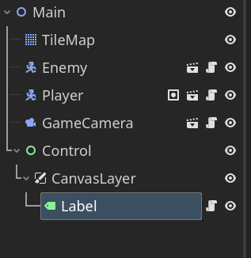
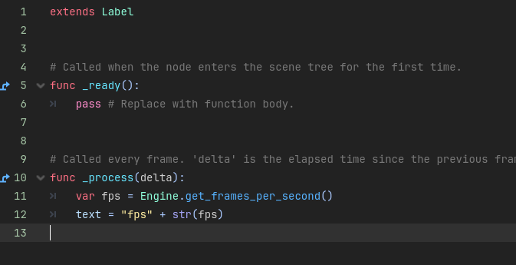

12. Collisions

Layer is the place when object exist ( where objects live)
Mask is checking where objects are colliding (what objects I look for collisions)

below example: player exist on Layer 1 and checking Level 1

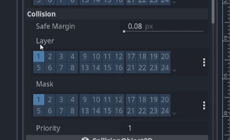

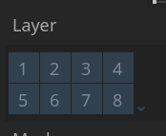

to resolve Enemy and Player will be colliding unclick them from Layer 1:

13. Enemy chase the Player

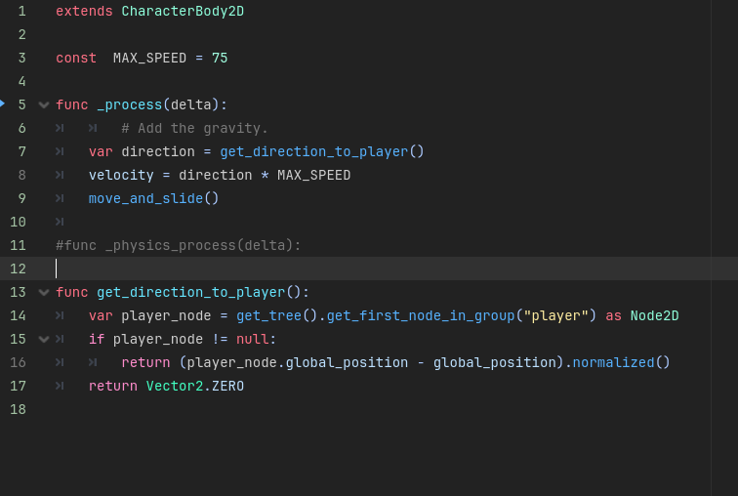

14. Connect to Timer Signal, Instantiate from code or PackedScene from Inspector

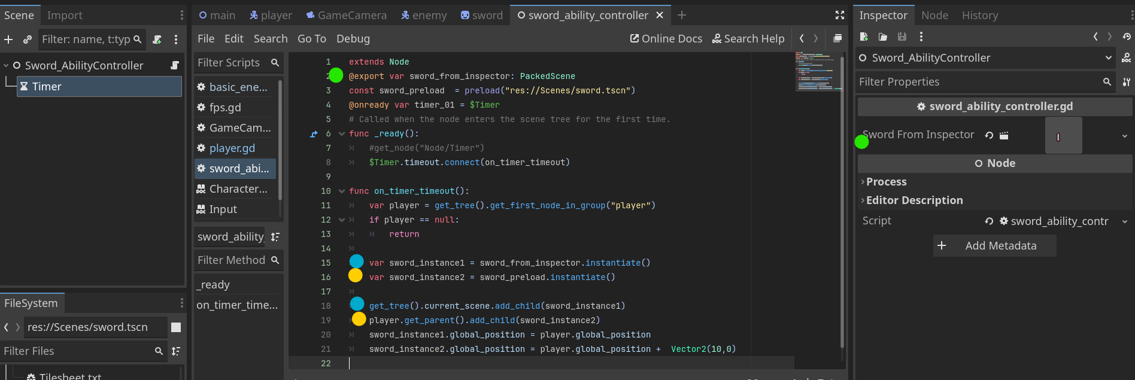
player is searched by GROUP!

15. queue_free() in Animation Player
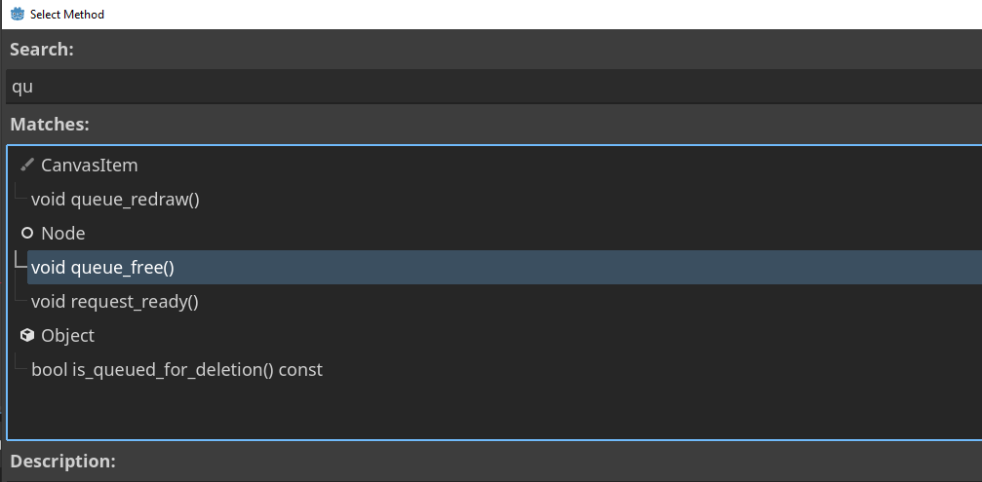
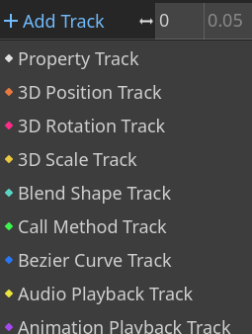
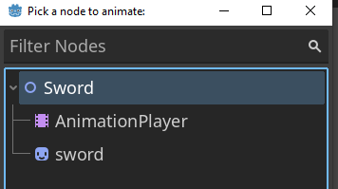

insert a key
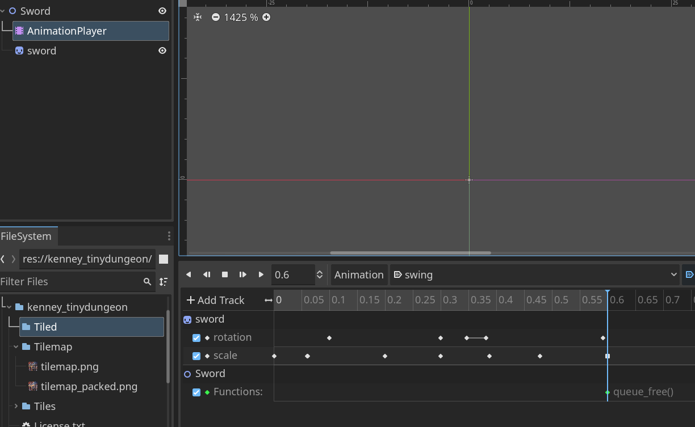
ppm

16. Lambda

In GDScript, it's possible to create lambda functions within a method. Lambda functions are custom callables that are not associated with an Object instance. Optionally, lambda functions can also be named. The name will be displayed in the debugger, or when calling get_method().

func _init():
var my_lambda = func (message):
print(message)

# Prints Hello everyone!
my_lambda.call("Hello everyone!")

# Prints "Attack!", when the button_pressed signal is emitted.
button_pressed.connect(func(): print("Attack!"))

17. Physics Layer names

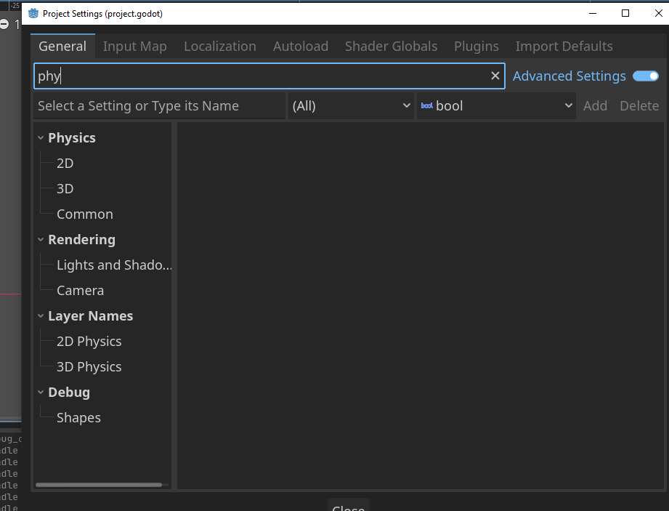

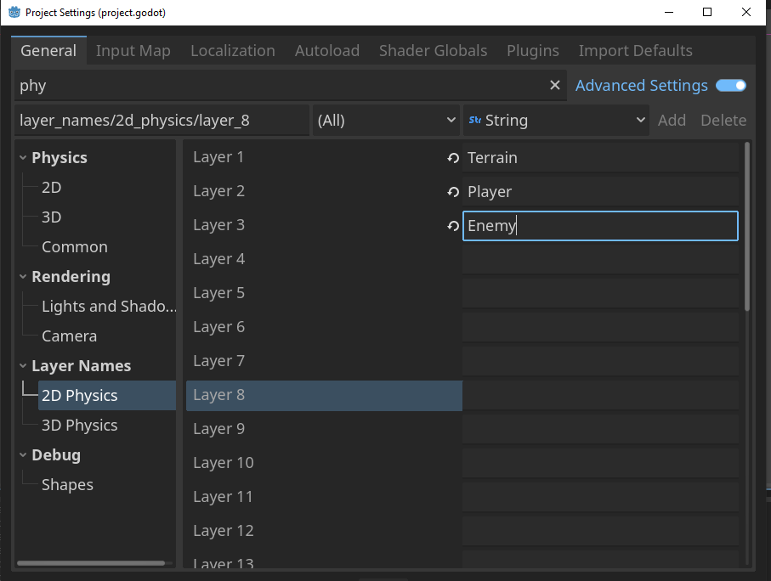

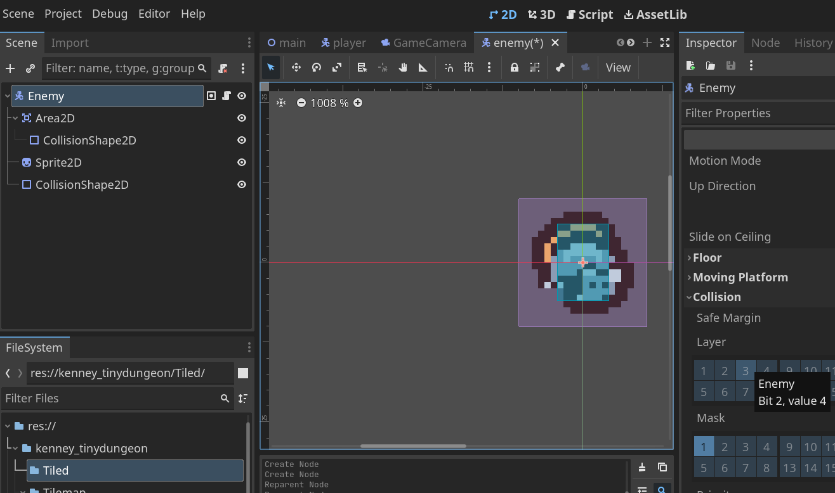

LAYER (just saying): hey other things in the game Im on this Layer so you can collide with me
MASK: hey other things in the game I want to see if I collide with you

so Enemy will be on Enemy Mask and no Layers! But in the AREA2D collision!

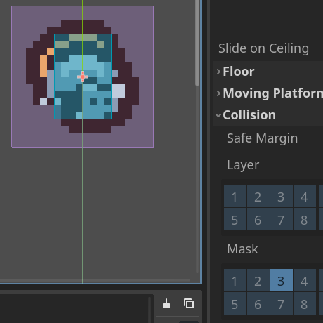

18. Enemy Setup & Sword

Enemy:
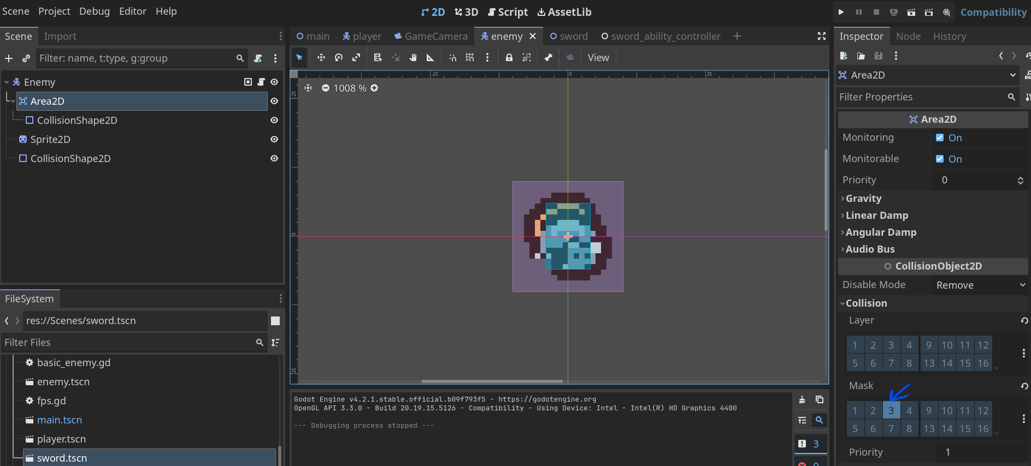
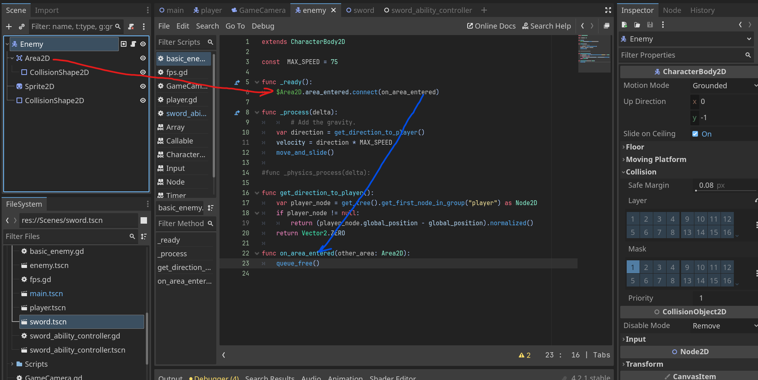

Sword:
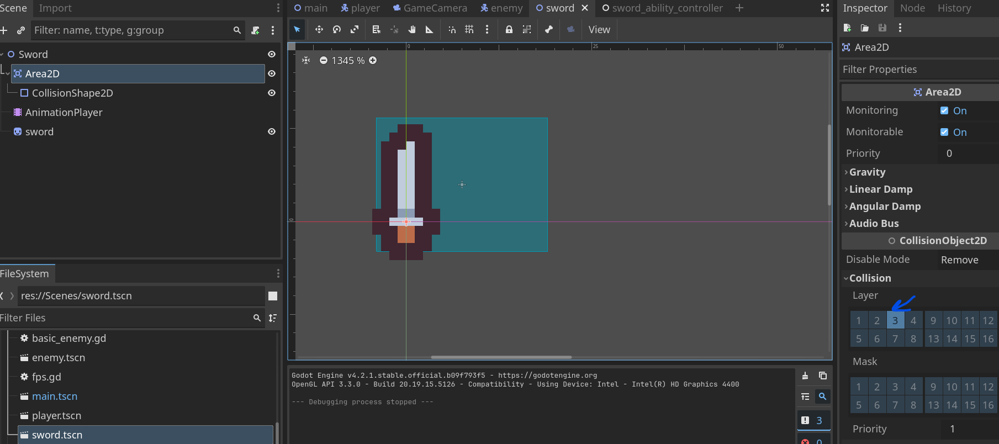

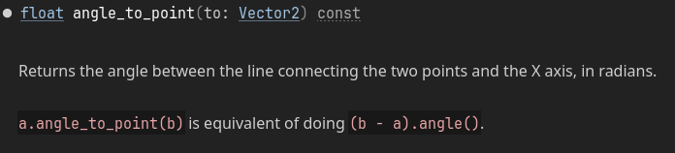

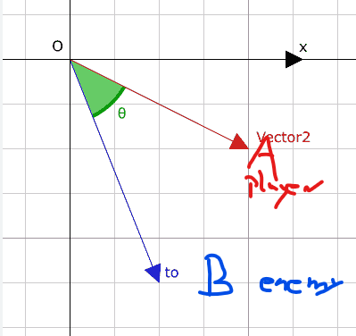
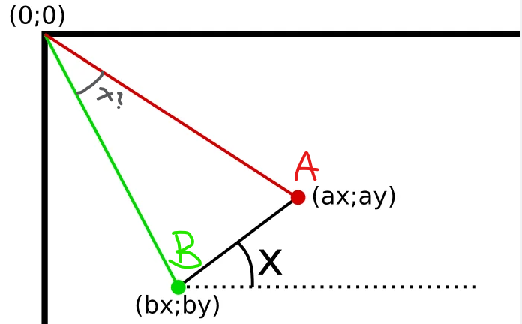

19. Fix Tilemap Gaps and Jittering Problems:

- Snap 2D pixels on / Vertices on ( for me works worst with Transform On!)



