DATA 624 Week 4: KJ 6.3
Andre Thomson
2026-06-28
Table of Contents
Problem 1
Approach 2
Packages 2
Part A: Load and Check the Data 4
Part B: Missing Values and Imputation 5
Part C: Prepare Data, Split, and Pre-process 7
Part D: Model 1 - Linear Regression 10
Part E: Model 2 - Partial Least Squares 11
Part F: Model 3 - Penalized Regression 14
Part G: Model Comparison 15
Part H: Test Set Prediction 16
Part I: Observed vs. Predicted and Residuals 17
Part J: Variable Importance 18
Part K: Top Predictor Relationships 20
Final Answer 21
Takeaway 21
References 21
Reproducibility 21

Problem
KJ 6.3 uses the chemical manufacturing data from the AppliedPredictiveModeling package.
The goal is to predict percent yield from the chemical manufacturing process. This matters because improving product yield by about 1 percent can increase revenue by about $100,000 per batch.
The data has two main types of predictors:
- Biological raw material predictors.
- Manufacturing process predictors.
The biological predictors are useful for checking the starting material before production. The process predictors are more useful for action because they may point to parts of production that can be reviewed or adjusted.
The assignment asks me to:
- Load the chemical manufacturing data.
- Impute missing predictor values.
- Split the data into training and test sets.
- Pre-process the predictor data.
- Tune a Chapter 6 model.
- Report the best performance metric.
- Predict yield for the test set.

Approach
I treated this as a regression problem because yield is numeric.
I used this workflow:
- Load the chemical manufacturing data.
- Check the data size and missing values.
- Impute missing predictor values.
- Split the data into training and test sets.
- Center and scale the predictors.
- Fit Chapter 6 regression models.
- Compare models by cross-validated RMSE.
- Test the best model on the holdout data.
- Review the most important predictors.
RMSE is the main metric. Lower RMSE means smaller prediction errors.
This version does not use caret. The package was causing a blocked prodlim.dll error on the computer. The same work is done with base R, pls, and glmnet.

Packages
Run this install code one time if any package is missing.
install.packages(c(
"AppliedPredictiveModeling",
"glmnet",
"pls",
"dplyr",
"ggplot2",
"tidyr",
"tibble",
"knitr",
"rmarkdown"
))
required_packages <- c(
"AppliedPredictiveModeling",
"glmnet",
"pls",
"dplyr",
"ggplot2",
"tidyr",
"tibble",
"knitr",
"rmarkdown"
)
missing_packages <- required_packages[!required_packages %in% rownames(installed.packages())]
if (length(missing_packages) > 0) {
stop(
paste0(
"Install these packages first: ",
paste(missing_packages, collapse = ", "),
"\nRun: install.packages(c('",
paste(missing_packages, collapse = "', '"),
"'))"
)
)
}
library(AppliedPredictiveModeling)
library(glmnet)
library(pls)
library(dplyr)
library(ggplot2)
library(tidyr)
library(tibble)
library(knitr)

Part A: Load and Check the Data
available_data <- data(package = "AppliedPredictiveModeling")$results[, "Item"]
if ("chemicalManufacturing" %in% available_data) {
data("chemicalManufacturing", package = "AppliedPredictiveModeling")
}
if (exists("processPredictors") && exists("yield")) {
x_raw <- as.data.frame(processPredictors)
y <- as.numeric(yield)
} else if ("ChemicalManufacturingProcess" %in% available_data) {
data("ChemicalManufacturingProcess", package = "AppliedPredictiveModeling")
chem_data <- as.data.frame(ChemicalManufacturingProcess)
x_raw <- chem_data %>% dplyr::select(-Yield)
y <- as.numeric(chem_data$Yield)
} else {
stop("Chemical manufacturing data was not found in the AppliedPredictiveModeling package.")
}
basic_check <- tibble(
item = c(
"Manufacturing runs",
"Predictors",
"Missing predictor cells",
"Missing yield values"
),
value = c(
nrow(x_raw),
ncol(x_raw),
sum(is.na(x_raw)),
sum(is.na(y))
)
)
kable(basic_check, caption = "Basic data check")
Basic data check
item | value
Manufacturing runs | 176
Predictors | 57
Missing predictor cells | 106
Missing yield values | 0
The data has 176 manufacturing runs and 57 predictors. The response variable is percent yield.
bio_cols_raw <- grep("^Biological", names(x_raw), value = TRUE)
process_cols_raw <- grep("^Manufacturing|^Process", names(x_raw), value = TRUE)
predictor_group_table <- tibble(
predictor_group = c(
"Biological raw material",
"Manufacturing process",
"Other predictor names"
),
number_of_predictors = c(
length(bio_cols_raw),
length(process_cols_raw),
ncol(x_raw) - length(bio_cols_raw) - length(process_cols_raw)
)
)
kable(predictor_group_table, caption = "Predictor groups found from column names")
Predictor groups found from column names
predictor_group | number_of_predictors
Biological raw material | 12
Manufacturing process | 45
Other predictor names | 0
The book describes biological predictors and process predictors. The code checks the column names so the report is clear.

Part B: Missing Values and Imputation
missing_table <- x_raw %>%
summarise(across(everything(), ~ sum(is.na(.)))) %>%
pivot_longer(everything(), names_to = "predictor", values_to = "missing_count") %>%
filter(missing_count > 0) %>%
arrange(desc(missing_count))
if (nrow(missing_table) == 0) {
missing_table <- tibble(predictor = "No predictors with missing values", missing_count = 0)
}
kable(missing_table, caption = "Missing values by predictor")
Missing values by predictor
predictor | missing_count
ManufacturingProcess03 | 15
ManufacturingProcess11 | 10
ManufacturingProcess10 | 9
ManufacturingProcess25 | 5
ManufacturingProcess26 | 5
ManufacturingProcess27 | 5
ManufacturingProcess28 | 5
ManufacturingProcess29 | 5
ManufacturingProcess30 | 5
ManufacturingProcess31 | 5
ManufacturingProcess33 | 5
ManufacturingProcess34 | 5
ManufacturingProcess35 | 5
ManufacturingProcess36 | 5
ManufacturingProcess02 | 3
ManufacturingProcess06 | 2
ManufacturingProcess01 | 1
ManufacturingProcess04 | 1
ManufacturingProcess05 | 1
ManufacturingProcess07 | 1
ManufacturingProcess08 | 1
ManufacturingProcess12 | 1
ManufacturingProcess14 | 1
ManufacturingProcess22 | 1
ManufacturingProcess23 | 1
ManufacturingProcess24 | 1
ManufacturingProcess40 | 1
ManufacturingProcess41 | 1
There are missing values in the predictor set. I used median imputation so the full data set can still be used.

Part C: Prepare Data, Split, and Pre-process
rmse_value <- function(obs, pred) {
sqrt(mean((obs - pred)^2, na.rm = TRUE))
}
mae_value <- function(obs, pred) {
mean(abs(obs - pred), na.rm = TRUE)
}
r_squared_value <- function(obs, pred) {
1 - sum((obs - pred)^2, na.rm = TRUE) / sum((obs - mean(obs, na.rm = TRUE))^2, na.rm = TRUE)
}
make_metric_table <- function(obs, pred) {
tibble(
metric = c("RMSE", "Rsquared", "MAE"),
value = c(
rmse_value(obs, pred),
r_squared_value(obs, pred),
mae_value(obs, pred)
)
)
}
make_folds <- function(n, k = 10) {
sample(rep(seq_len(k), length.out = n))
}
# This data is numeric, but this also handles non-numeric predictors if they appear.
x_temp <- x_raw
non_numeric_cols <- names(x_temp)[!sapply(x_temp, is.numeric)]
if (length(non_numeric_cols) > 0) {
for (col_name in non_numeric_cols) {
x_temp[[col_name]] <- as.character(x_temp[[col_name]])
x_temp[[col_name]][is.na(x_temp[[col_name]])] <- "Missing"
x_temp[[col_name]] <- factor(x_temp[[col_name]])
}
x_all <- as.data.frame(model.matrix(~ . - 1, data = x_temp))
} else {
x_all <- as.data.frame(x_temp)
}
near_zero_cols <- names(x_all)[
sapply(x_all, function(z) {
z_no_na <- z[!is.na(z)]
length(unique(z_no_na)) <= 1 || isTRUE(sd(z_no_na) == 0)
})
]
if (length(near_zero_cols) > 0) {
x_all <- x_all[, !names(x_all) %in% near_zero_cols, drop = FALSE]
}
prep_table <- tibble(
item = c(
"Predictors after dummy coding",
"Near-zero variance predictors removed",
"Predictors used for modeling"
),
value = c(
ncol(as.data.frame(x_temp)),
length(near_zero_cols),
ncol(x_all)
)
)
kable(prep_table, caption = "Prepared predictor check")
Prepared predictor check
item | value
Predictors after dummy coding | 57
Near-zero variance predictors removed | 0
Predictors used for modeling | 57
set.seed(624)
train_index <- sort(sample(seq_along(y), size = floor(0.80 * length(y))))
x_train_raw <- x_all[train_index, , drop = FALSE]
x_test_raw <- x_all[-train_index, , drop = FALSE]
y_train <- y[train_index]
y_test <- y[-train_index]
split_table <- tibble(
data_set = c("Training", "Test"),
rows = c(nrow(x_train_raw), nrow(x_test_raw))
)
kable(split_table, caption = "Training and test split")
Training and test split
data_set | rows
Training | 140
Test | 36
fit_preprocess <- function(train_df) {
medians <- sapply(train_df, function(z) median(z, na.rm = TRUE))
medians[is.na(medians)] <- 0
train_imp <- train_df
for (col_name in names(train_imp)) {
train_imp[[col_name]][is.na(train_imp[[col_name]])] <- medians[col_name]
}
centers <- sapply(train_imp, mean)
scales <- sapply(train_imp, sd)
scales[is.na(scales) | scales == 0] <- 1
list(medians = medians, centers = centers, scales = scales)
}
apply_preprocess <- function(new_df, prep) {
out <- new_df
for (col_name in names(out)) {
out[[col_name]][is.na(out[[col_name]])] <- prep$medians[col_name]
out[[col_name]] <- (out[[col_name]] - prep$centers[col_name]) / prep$scales[col_name]
}
as.data.frame(out)
}
preprocess_fit <- fit_preprocess(x_train_raw)
x_train <- apply_preprocess(x_train_raw, preprocess_fit)
x_test <- apply_preprocess(x_test_raw, preprocess_fit)
preprocess_table <- tibble(
step = c("Median imputation", "Centering", "Scaling"),
reason = c(
"Fills missing predictor values without deleting rows.",
"Puts predictors around a mean of zero.",
"Puts predictors on a common scale for PLS and penalized regression."
)
)
kable(preprocess_table, caption = "Pre-processing steps")
Pre-processing steps
step | reason
Median imputation | Fills missing predictor values without deleting rows.
Centering | Puts predictors around a mean of zero.
Scaling | Puts predictors on a common scale for PLS and penalized regression.
The split and pre-processing steps were done before modeling. I fit the pre-processing on the training set and then applied it to the test set. This avoids leaking information from the test set into the model-building process.

Part D: Model 1 - Linear Regression
lm_cv <- function(x, y, k = 10, repeats = 5) {
results <- vector("list", repeats)
for (r in seq_len(repeats)) {
set.seed(624 + r)
folds <- make_folds(nrow(x), k = k)
pred <- rep(NA_real_, length(y))
for (fold in seq_len(k)) {
train_rows <- which(folds != fold)
test_rows <- which(folds == fold)
train_df <- data.frame(y = y[train_rows], x[train_rows, , drop = FALSE])
test_df <- x[test_rows, , drop = FALSE]
fit <- lm(y ~ ., data = train_df)
pred[test_rows] <- as.numeric(predict(fit, newdata = test_df))
}
results[[r]] <- data.frame(
RMSE = rmse_value(y, pred),
Rsquared = r_squared_value(y, pred),
MAE = mae_value(y, pred)
)
}
bind_rows(results) %>%
summarise(
RMSE = mean(RMSE),
Rsquared = mean(Rsquared),
MAE = mean(MAE)
)
}
lm_cv_results <- lm_cv(x_train, y_train)
lm_fit <- lm(
y ~ .,
data = data.frame(y = y_train, x_train)
)
kable(lm_cv_results, digits = 4, caption = "Linear regression cross-validation results")
Linear regression cross-validation results
RMSE | Rsquared | MAE
11.8369 | -39.3149 | 2.5654
Linear regression is the baseline model. It is easy to explain, but it can struggle when predictors are correlated.

Part E: Model 2 - Partial Least Squares
pls_cv <- function(x, y, max_ncomp = 20, k = 10, repeats = 5) {
max_ncomp <- min(max_ncomp, ncol(x), nrow(x) - 2)
all_results <- list()
counter <- 1
for (ncomp_value in seq_len(max_ncomp)) {
for (r in seq_len(repeats)) {
set.seed(700 + r)
folds <- make_folds(nrow(x), k = k)
pred <- rep(NA_real_, length(y))
for (fold in seq_len(k)) {
train_rows <- which(folds != fold)
test_rows <- which(folds == fold)
train_df <- data.frame(y = y[train_rows], x[train_rows, , drop = FALSE])
test_df <- x[test_rows, , drop = FALSE]
fit <- pls::plsr(y ~ ., data = train_df, ncomp = ncomp_value, method = "simpls")
pred[test_rows] <- as.numeric(predict(fit, newdata = test_df, ncomp = ncomp_value))
}
all_results[[counter]] <- data.frame(
ncomp = ncomp_value,
RMSE = rmse_value(y, pred),
Rsquared = r_squared_value(y, pred),
MAE = mae_value(y, pred)
)
counter <- counter + 1
}
}
bind_rows(all_results) %>%
group_by(ncomp) %>%
summarise(
RMSE = mean(RMSE),
Rsquared = mean(Rsquared),
MAE = mean(MAE),
.groups = "drop"
)
}
pls_results <- pls_cv(x_train, y_train, max_ncomp = 20)
pls_best <- pls_results %>% arrange(RMSE) %>% slice(1)
pls_fit <- pls::plsr(
y ~ .,
data = data.frame(y = y_train, x_train),
ncomp = pls_best$ncomp,
method = "simpls"
)
kable(pls_results, digits = 4, caption = "PLS cross-validation results")
PLS cross-validation results
ncomp | RMSE | Rsquared | MAE
1 | 1.4294 | 0.4442 | 1.1543
2 | 1.2604 | 0.5678 | 0.9992
3 | 1.2240 | 0.5924 | 0.9878
4 | 1.2380 | 0.5830 | 1.0098
5 | 1.2646 | 0.5647 | 1.0309
6 | 1.2746 | 0.5576 | 1.0403
7 | 1.2695 | 0.5611 | 1.0355
8 | 1.2914 | 0.5458 | 1.0601
9 | 1.2872 | 0.5488 | 1.0606
10 | 1.3148 | 0.5294 | 1.0812
11 | 1.3418 | 0.5098 | 1.0977
12 | 1.3687 | 0.4899 | 1.1163
13 | 1.3866 | 0.4766 | 1.1283
14 | 1.4075 | 0.4605 | 1.1407
15 | 1.4223 | 0.4488 | 1.1499
16 | 1.4314 | 0.4416 | 1.1532
17 | 1.4407 | 0.4339 | 1.1574
18 | 1.4543 | 0.4229 | 1.1631
19 | 1.4679 | 0.4117 | 1.1713
20 | 1.4798 | 0.4018 | 1.1725
plot(pls_results$ncomp, pls_results$RMSE,
type = "b",
xlab = "Number of Components",
ylab = "Cross-validated RMSE",
main = "PLS Tuning Results")
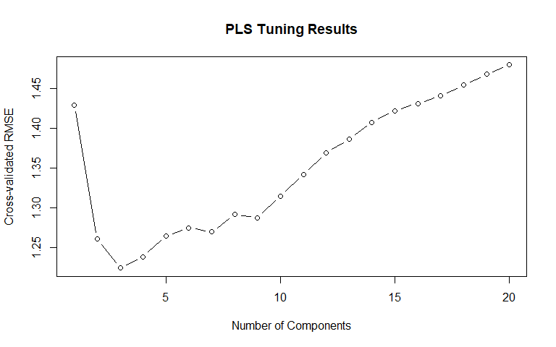
PLS is useful here because manufacturing predictors can be correlated. PLS uses components instead of relying on each predictor by itself.

Part F: Model 3 - Penalized Regression
x_train_matrix <- as.matrix(x_train)
x_test_matrix <- as.matrix(x_test)
set.seed(624)
ridge_fit <- cv.glmnet(
x = x_train_matrix,
y = y_train,
alpha = 0,
nfolds = 10,
standardize = FALSE
)
set.seed(624)
lasso_fit <- cv.glmnet(
x = x_train_matrix,
y = y_train,
alpha = 1,
nfolds = 10,
standardize = FALSE
)
set.seed(624)
elastic_fit <- cv.glmnet(
x = x_train_matrix,
y = y_train,
alpha = 0.5,
nfolds = 10,
standardize = FALSE
)
penalized_summary <- tibble(
model = c("Ridge Regression", "Lasso Regression", "Elastic Net Regression"),
alpha = c(0, 1, 0.5),
lambda_min = c(ridge_fit$lambda.min, lasso_fit$lambda.min, elastic_fit$lambda.min),
cv_rmse = sqrt(c(min(ridge_fit$cvm), min(lasso_fit$cvm), min(elastic_fit$cvm)))
)
kable(penalized_summary, digits = 4, caption = "Penalized regression tuning results")
Penalized regression tuning results
model | alpha | lambda_min | cv_rmse
Ridge Regression | 0.0 | 0.3909 | 1.1941
Lasso Regression | 1.0 | 0.0195 | 1.1658
Elastic Net Regression | 0.5 | 0.0355 | 1.1661
Penalized regression shrinks coefficients so the model does not overfit the training data. Ridge keeps more predictors. Lasso can shrink some predictors to zero. Elastic net is a mix of both.

Part G: Model Comparison
model_summary <- tibble(
model = c(
"Linear Regression",
"Partial Least Squares",
penalized_summary$model
),
tuning = c(
"None",
paste0("ncomp = ", pls_best$ncomp),
paste0("alpha = ", penalized_summary$alpha, ", lambda = ", round(penalized_summary$lambda_min, 5))
),
cv_rmse = c(
lm_cv_results$RMSE,
pls_best$RMSE,
penalized_summary$cv_rmse
),
cv_r_squared = c(
lm_cv_results$Rsquared,
pls_best$Rsquared,
NA_real_, NA_real_, NA_real_
)
) %>%
arrange(cv_rmse)
kable(model_summary, digits = 4, caption = "Cross-validated model comparison")
Cross-validated model comparison
model | tuning | cv_rmse | cv_r_squared
Lasso Regression | alpha = 1, lambda = 0.01945 | 1.1658 | NA
Elastic Net Regression | alpha = 0.5, lambda = 0.03545 | 1.1661 | NA
Ridge Regression | alpha = 0, lambda = 0.39089 | 1.1941 | NA
Partial Least Squares | ncomp = 3 | 1.2240 | 0.5924
Linear Regression | None | 11.8369 | -39.3149
best_model_name <- model_summary$model[1]
best_model_name
## [1] "Lasso Regression"
The selected model is Lasso Regression. The best cross-validated RMSE is 1.1658.

Part H: Test Set Prediction
if (best_model_name == "Linear Regression") {
test_predictions <- as.numeric(predict(lm_fit, newdata = x_test))
} else if (best_model_name == "Partial Least Squares") {
test_predictions <- as.numeric(predict(pls_fit, newdata = x_test, ncomp = pls_best$ncomp))
} else if (best_model_name == "Ridge Regression") {
test_predictions <- as.numeric(predict(ridge_fit, newx = x_test_matrix, s = "lambda.min"))
} else if (best_model_name == "Lasso Regression") {
test_predictions <- as.numeric(predict(lasso_fit, newx = x_test_matrix, s = "lambda.min"))
} else if (best_model_name == "Elastic Net Regression") {
test_predictions <- as.numeric(predict(elastic_fit, newx = x_test_matrix, s = "lambda.min"))
}
test_results <- make_metric_table(y_test, test_predictions)
kable(test_results, digits = 4, caption = "Final test set performance")
Final test set performance
metric | value
RMSE | 1.0361
Rsquared | 0.5199
MAE | 0.8222
The test RMSE is 1.0361. This is the final holdout check.
If the test RMSE is close to the cross-validation RMSE, the model is more stable. If the test RMSE is much higher, the model may not generalize as well.

Part I: Observed vs. Predicted and Residuals
prediction_data <- tibble(
observed = y_test,
predicted = as.numeric(test_predictions),
residual = observed - predicted
)
ggplot(prediction_data, aes(x = predicted, y = observed)) +
geom_point() +
geom_abline(slope = 1, intercept = 0, linetype = "dashed") +
labs(
title = "Observed vs Predicted Yield",
x = "Predicted Yield",
y = "Observed Yield"
)
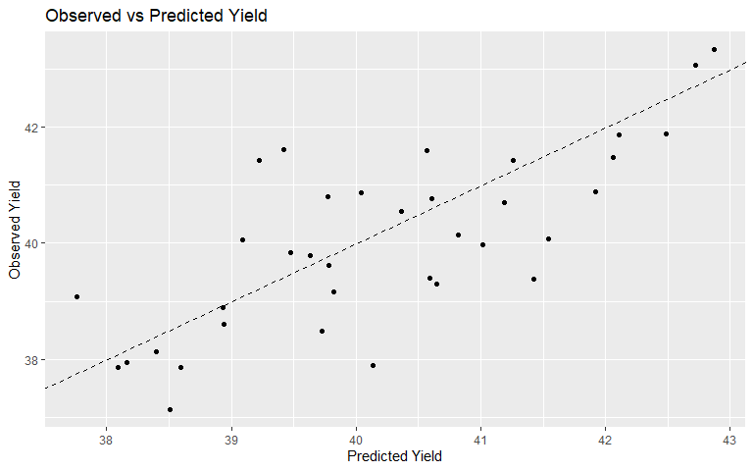
ggplot(prediction_data, aes(x = predicted, y = residual)) +
geom_point() +
geom_hline(yintercept = 0, linetype = "dashed") +
labs(
title = "Residuals vs Predicted Yield",
x = "Predicted Yield",
y = "Residual"
)
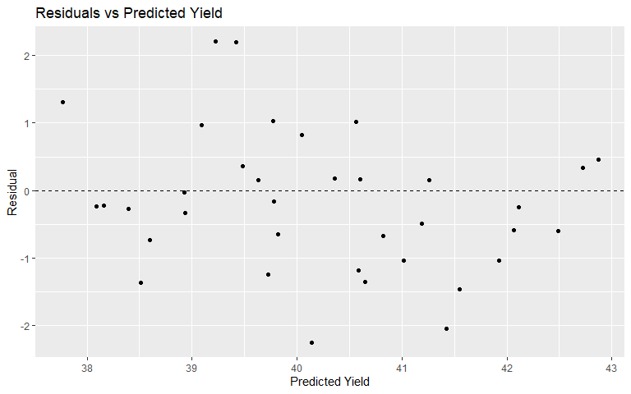
The observed vs. predicted plot shows how close the predictions are to the real yield values. Points closer to the diagonal line mean better predictions.
The residual plot shows the prediction errors. A good residual plot should look random around zero.

Part J: Variable Importance
get_glmnet_importance <- function(fit, model_label) {
coef_table <- as.matrix(coef(fit, s = "lambda.min"))
tibble(
predictor = rownames(coef_table),
Overall = abs(as.numeric(coef_table[, 1])),
model = model_label
) %>%
filter(predictor != "(Intercept)") %>%
arrange(desc(Overall))
}
if (best_model_name == "Linear Regression") {
coef_table <- coef(lm_fit)
vip_table <- tibble(
predictor = names(coef_table),
Overall = abs(as.numeric(coef_table)),
model = best_model_name
) %>%
filter(predictor != "(Intercept)") %>%
arrange(desc(Overall))
} else if (best_model_name == "Partial Least Squares") {
pls_coef <- as.vector(coef(pls_fit, ncomp = pls_best$ncomp))
vip_table <- tibble(
predictor = colnames(x_train),
Overall = abs(pls_coef),
model = best_model_name
) %>%
arrange(desc(Overall))
} else if (best_model_name == "Ridge Regression") {
vip_table <- get_glmnet_importance(ridge_fit, best_model_name)
} else if (best_model_name == "Lasso Regression") {
vip_table <- get_glmnet_importance(lasso_fit, best_model_name)
} else if (best_model_name == "Elastic Net Regression") {
vip_table <- get_glmnet_importance(elastic_fit, best_model_name)
}
top_15 <- vip_table %>%
slice_head(n = 15)
kable(top_15, digits = 4, caption = "Top 15 predictors from the selected model")
Top 15 predictors from the selected model
predictor | Overall | model
ManufacturingProcess32 | 1.2255 | Lasso Regression
ManufacturingProcess09 | 0.8131 | Lasso Regression
ManufacturingProcess04 | 0.3189 | Lasso Regression
ManufacturingProcess13 | 0.2895 | Lasso Regression
BiologicalMaterial05 | 0.2697 | Lasso Regression
ManufacturingProcess33 | 0.2689 | Lasso Regression
ManufacturingProcess37 | 0.2344 | Lasso Regression
ManufacturingProcess28 | 0.2097 | Lasso Regression
ManufacturingProcess15 | 0.2010 | Lasso Regression
BiologicalMaterial10 | 0.1906 | Lasso Regression
ManufacturingProcess39 | 0.1717 | Lasso Regression
ManufacturingProcess43 | 0.1538 | Lasso Regression
ManufacturingProcess03 | 0.1501 | Lasso Regression
BiologicalMaterial01 | 0.1229 | Lasso Regression
ManufacturingProcess34 | 0.1074 | Lasso Regression
Variable importance shows which predictors were most useful to the selected model. This does not prove cause and effect, but it gives the company a place to start its review.

Part K: Top Predictor Relationships
top_predictors <- top_15$predictor[1:min(6, nrow(top_15))]
top_predictors <- top_predictors[top_predictors %in% names(x_train)]
relationship_data <- x_train %>%
dplyr::select(all_of(top_predictors)) %>%
mutate(yield = y_train) %>%
pivot_longer(
cols = all_of(top_predictors),
names_to = "predictor",
values_to = "value"
)
ggplot(relationship_data, aes(x = value, y = yield)) +
geom_point(alpha = 0.65) +
geom_smooth(method = "loess", se = FALSE) +
facet_wrap(~ predictor, scales = "free_x") +
labs(
title = "Top Predictor Relationships with Yield",
x = "Pre-processed Predictor Value",
y = "Yield"
)
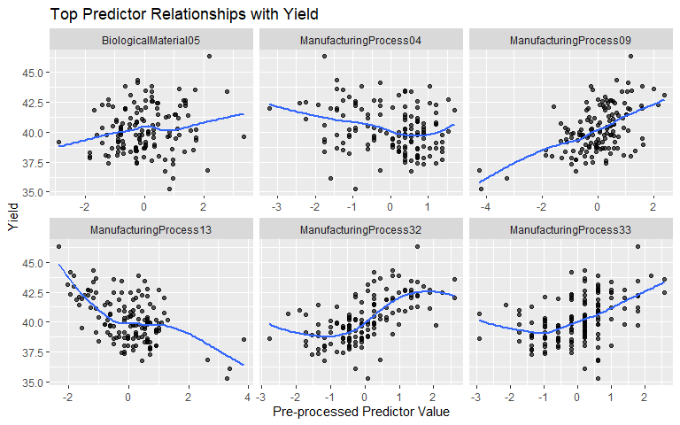
These plots help explain how the top predictors relate to yield. The relationship may be positive, negative, flat, or nonlinear.

Final Answer
The best model from this analysis is Lasso Regression because it had the lowest cross-validated RMSE among the models I tested.
The best cross-validated RMSE is 1.1658. The final test RMSE is 1.0361.
I would use the selected model as a decision-support tool. The model can help flag manufacturing runs that may have lower yield and identify predictors that deserve more review.
I would not change the manufacturing process based only on the model. Any process change should be reviewed by the manufacturing team and tested before being used.
The biological predictors are useful for checking raw material quality before production. The process predictors are more actionable because they may point to steps in the process that can be adjusted or controlled.

Takeaway
Linear regression is a useful baseline.
PLS is useful when predictors are correlated.
Ridge, lasso, and elastic net are useful when the model needs shrinkage to reduce overfitting.
For this assignment, the best model is the one that balances prediction accuracy with a clear explanation of what variables matter.

References
Friedman, J., Hastie, T., & Tibshirani, R. (2010). Regularization paths for generalized linear models via coordinate descent. Journal of Statistical Software, 33(1), 1–22. https://www.jstatsoft.org/article/view/v033i01
Kuhn, M., & Johnson, K. (2013). Applied predictive modeling. Springer.

Reproducibility
sessionInfo()
## R version 4.6.0 (2026-04-24 ucrt)
## Platform: x86_64-w64-mingw32/x64
## Running under: Windows 11 x64 (build 26200)
##
## Matrix products: default
## LAPACK version 3.12.1
##
## locale:
## [1] LC_COLLATE=English_United States.utf8
## [2] LC_CTYPE=English_United States.utf8
## [3] LC_MONETARY=English_United States.utf8
## [4] LC_NUMERIC=C
## [5] LC_TIME=English_United States.utf8
##
## time zone: America/New_York
## tzcode source: internal
##
## attached base packages:
## [1] stats graphics grDevices utils datasets methods base
##
## other attached packages:
## [1] knitr_1.51 tibble_3.3.1
## [3] tidyr_1.3.2 ggplot2_4.0.3
## [5] dplyr_1.2.1 pls_2.9-0
## [7] glmnet_5.0 Matrix_1.7-5
## [9] AppliedPredictiveModeling_1.1-7
##
## loaded via a namespace (and not attached):
## [1] generics_0.1.4 shape_1.4.6.1 stringi_1.8.7 lattice_0.22-9
## [5] digest_0.6.39 magrittr_2.0.5 evaluate_1.0.5 grid_4.6.0
## [9] RColorBrewer_1.1-3 iterators_1.0.14 fastmap_1.2.0 foreach_1.5.2
## [13] plyr_1.8.9 nnet_7.3-20 survival_3.8-6 mgcv_1.9-4
## [17] rpart.plot_3.1.4 purrr_1.2.2 scales_1.4.0 codetools_0.2-20
## [21] cli_3.6.6 rlang_1.2.0 splines_4.6.0 withr_3.0.2
## [25] yaml_2.3.12 ellipse_0.5.0 plotrix_3.8-14 otel_0.2.0
## [29] tools_4.6.0 reshape2_1.4.5 vctrs_0.7.3 R6_2.6.1
## [33] rpart_4.1.27 lifecycle_1.0.5 stringr_1.6.0 MASS_7.3-65
## [37] cluster_2.1.8.2 pkgconfig_2.0.3 pillar_1.11.1 gtable_0.3.6
## [41] glue_1.8.1 Rcpp_1.1.1-1.1 xfun_0.58 tidyselect_1.2.1
## [45] rstudioapi_0.18.0 farver_2.1.2 CORElearn_1.57.3.1 nlme_3.1-169
## [49] htmltools_0.5.9 labeling_0.4.3 rmarkdown_2.31 compiler_4.6.0
## [53] S7_0.2.2

