DATA624_HW.4
Andre Thomson
2026-06-10
Table of Contents
DATA 624 Homework 4 - KJ 3.1 and KJ 3.2 2
KJ 3.1 2
Problem 2
Approach 2
R Code 2
Code Results 12
Interpretation 13
Reference 13
KJ 3.2 14
Problem 14
Approach 14
R Code 14
Code Results 27
Interpretation 29
Reference 29

library(mlbench)
library(caret)
library(tidyverse)
theme_set(theme_minimal())

DATA 624 Homework 4 - KJ 3.1 and KJ 3.2

KJ 3.1

Problem
The Glass data contains 214 glass samples with six class categories in the mlbench version of the data. There are nine predictors: refractive index and the percentages of Na, Mg, Al, Si, K, Ca, Ba, and Fe.
The goal is to explore the predictor distributions, review relationships between predictors, check for skewness and outliers, and decide if transformations may help before building a classification model.

Approach
I first checked the structure of the Glass data. Then I reviewed the class distribution, predictor distributions, boxplots, correlations, skewness, and possible outliers. My goal was to decide what preprocessing steps should be used before fitting a classification model.

R Code
data(Glass)
glass_data <- Glass
str(glass_data)
## 'data.frame': 214 obs. of 10 variables:
## $ RI : num 1.52 1.52 1.52 1.52 1.52 ...
## $ Na : num 13.6 13.9 13.5 13.2 13.3 ...
## $ Mg : num 4.49 3.6 3.55 3.69 3.62 3.61 3.6 3.61 3.58 3.6 ...
## $ Al : num 1.1 1.36 1.54 1.29 1.24 1.62 1.14 1.05 1.37 1.36 ...
## $ Si : num 71.8 72.7 73 72.6 73.1 ...
## $ K : num 0.06 0.48 0.39 0.57 0.55 0.64 0.58 0.57 0.56 0.57 ...
## $ Ca : num 8.75 7.83 7.78 8.22 8.07 8.07 8.17 8.24 8.3 8.4 ...
## $ Ba : num 0 0 0 0 0 0 0 0 0 0 ...
## $ Fe : num 0 0 0 0 0 0.26 0 0 0 0.11 ...
## $ Type: Factor w/ 6 levels "1","2","3","5",..: 1 1 1 1 1 1 1 1 1 1 ...
summary(glass_data)
## RI Na Mg Al
## Min. :1.511 Min. :10.73 Min. :0.000 Min. :0.290
## 1st Qu.:1.517 1st Qu.:12.91 1st Qu.:2.115 1st Qu.:1.190
## Median :1.518 Median :13.30 Median :3.480 Median :1.360
## Mean :1.518 Mean :13.41 Mean :2.685 Mean :1.445
## 3rd Qu.:1.519 3rd Qu.:13.82 3rd Qu.:3.600 3rd Qu.:1.630
## Max. :1.534 Max. :17.38 Max. :4.490 Max. :3.500
## Si K Ca Ba
## Min. :69.81 Min. :0.0000 Min. : 5.430 Min. :0.000
## 1st Qu.:72.28 1st Qu.:0.1225 1st Qu.: 8.240 1st Qu.:0.000
## Median :72.79 Median :0.5550 Median : 8.600 Median :0.000
## Mean :72.65 Mean :0.4971 Mean : 8.957 Mean :0.175
## 3rd Qu.:73.09 3rd Qu.:0.6100 3rd Qu.: 9.172 3rd Qu.:0.000
## Max. :75.41 Max. :6.2100 Max. :16.190 Max. :3.150
## Fe Type
## Min. :0.00000 1:70
## 1st Qu.:0.00000 2:76
## Median :0.00000 3:17
## Mean :0.05701 5:13
## 3rd Qu.:0.10000 6: 9
## Max. :0.51000 7:29
The str() output confirms 214 rows, nine numeric predictors, and a factor class variable Type with six levels in the mlbench version of the data.
glass_class_distribution <- glass_data |>
count(Type) |>
mutate(percent = round(100 * n / sum(n), 1)) |>
arrange(desc(n))
glass_class_distribution
## Type n percent
## 1 2 76 35.5
## 2 1 70 32.7
## 3 7 29 13.6
## 4 3 17 7.9
## 5 5 13 6.1
## 6 6 9 4.2
This table shows how many samples fall into each glass type and what percent of the data each type represents, which helps identify class imbalance before modeling.
glass_data |>
ggplot(aes(x = Type)) +
geom_bar() +
labs(
title = "Glass Type Distribution",
x = "Glass Type",
y = "Count"
)
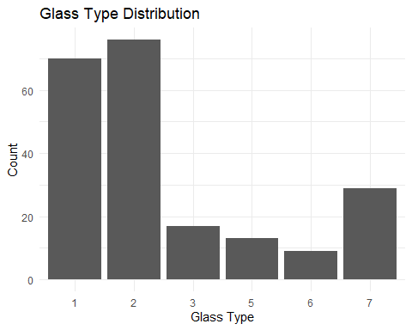
This bar chart shows whether any glass type has many more records than the others, which matters before building a classification model.
glass_long <- glass_data |>
pivot_longer(
cols = -Type,
names_to = "Predictor",
values_to = "Value"
)
glass_long |>
ggplot(aes(x = Value)) +
geom_histogram(bins = 25) +
facet_wrap(~ Predictor, scales = "free") +
labs(
title = "Distribution of Glass Predictors",
x = "Value",
y = "Count"
)
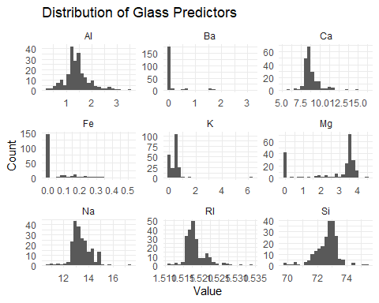
The histograms show the shape of each predictor’s distribution, some are roughly symmetric while others lean heavily to one side, suggesting those predictors may need a transformation before modeling.
glass_long |>
ggplot(aes(x = Predictor, y = Value)) +
geom_boxplot() +
facet_wrap(~ Predictor, scales = "free") +
labs(
title = "Boxplots for Glass Predictors",
x = "Predictor",
y = "Value"
) +
theme(axis.text.x = element_blank())
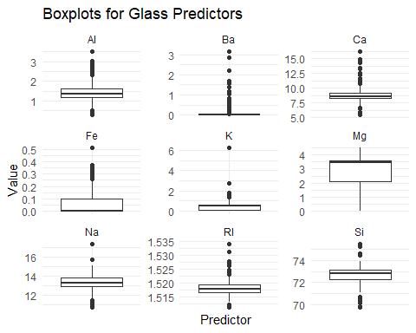
glass_long |>
ggplot(aes(x = Type, y = Value)) +
geom_boxplot() +
facet_wrap(~ Predictor, scales = "free_y") +
labs(
title = "Glass Predictors by Glass Type",
x = "Glass Type",
y = "Value"
)
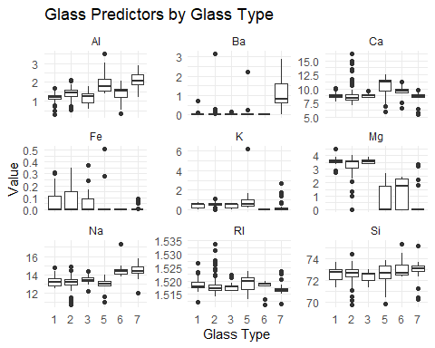
The first set of boxplots shows the overall spread and possible outliers for each predictor. The second set shows how each predictor differs across glass types, which helps see whether any predictor separates the classes well.
glass_predictors <- glass_data |>
select(-Type)
glass_cor <- cor(glass_predictors)
round(glass_cor, 2)
## RI Na Mg Al Si K Ca Ba Fe
## RI 1.00 -0.19 -0.12 -0.41 -0.54 -0.29 0.81 0.00 0.14
## Na -0.19 1.00 -0.27 0.16 -0.07 -0.27 -0.28 0.33 -0.24
## Mg -0.12 -0.27 1.00 -0.48 -0.17 0.01 -0.44 -0.49 0.08
## Al -0.41 0.16 -0.48 1.00 -0.01 0.33 -0.26 0.48 -0.07
## Si -0.54 -0.07 -0.17 -0.01 1.00 -0.19 -0.21 -0.10 -0.09
## K -0.29 -0.27 0.01 0.33 -0.19 1.00 -0.32 -0.04 -0.01
## Ca 0.81 -0.28 -0.44 -0.26 -0.21 -0.32 1.00 -0.11 0.12
## Ba 0.00 0.33 -0.49 0.48 -0.10 -0.04 -0.11 1.00 -0.06
## Fe 0.14 -0.24 0.08 -0.07 -0.09 -0.01 0.12 -0.06 1.00
glass_cor_df <- as.data.frame(as.table(glass_cor))
glass_cor_df |>
ggplot(aes(Var1, Var2, fill = Freq)) +
geom_tile() +
labs(
title = "Correlation Heatmap for Glass Predictors",
x = "Predictor",
y = "Predictor",
fill = "Correlation"
) +
theme(axis.text.x = element_text(angle = 45, hjust = 1))
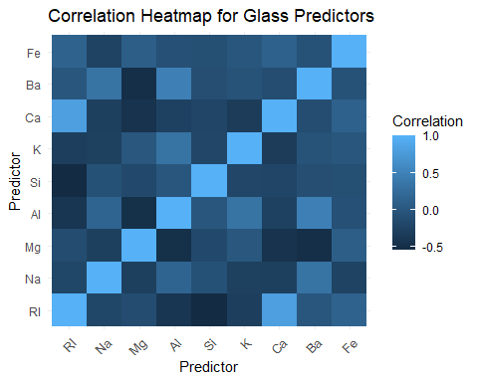
Darker tiles in the heatmap indicate stronger correlations between two predictors, which matters for models that are sensitive to multicollinearity such as linear regression or PCA.
skewness_check <- function(x) {
x <- x[!is.na(x)]
if (sd(x) == 0) {
return(NA_real_)
}
mean((x - mean(x))^3) / sd(x)^3
}
glass_skewness <- glass_predictors |>
summarise(across(everything(), skewness_check)) |>
pivot_longer(
cols = everything(),
names_to = "Predictor",
values_to = "Skewness"
) |>
mutate(abs_skewness = abs(Skewness)) |>
arrange(desc(abs_skewness))
glass_skewness
## # A tibble: 9 × 3
## Predictor Skewness abs_skewness
## <chr> <dbl> <dbl>
## 1 K 6.46 6.46
## 2 Ba 3.37 3.37
## 3 Ca 2.02 2.02
## 4 Fe 1.73 1.73
## 5 RI 1.60 1.60
## 6 Mg -1.14 1.14
## 7 Al 0.895 0.895
## 8 Si -0.720 0.720
## 9 Na 0.448 0.448
This table ranks predictors from most to least skewed, a higher absolute value means the distribution leans further to one side and is more likely to need a transformation.
outlier_count <- function(x) {
q1 <- quantile(x, 0.25, na.rm = TRUE)
q3 <- quantile(x, 0.75, na.rm = TRUE)
iqr_value <- IQR(x, na.rm = TRUE)
lower <- q1 - 1.5 * iqr_value
upper <- q3 + 1.5 * iqr_value
sum(x < lower | x > upper, na.rm = TRUE)
}
glass_outliers <- glass_predictors |>
summarise(across(everything(), outlier_count)) |>
pivot_longer(
cols = everything(),
names_to = "Predictor",
values_to = "Outlier_Count"
) |>
arrange(desc(Outlier_Count))
glass_outliers
## # A tibble: 9 × 2
## Predictor Outlier_Count
## <chr> <int>
## 1 Ba 38
## 2 Ca 26
## 3 Al 18
## 4 RI 17
## 5 Si 12
## 6 Fe 12
## 7 Na 7
## 8 K 7
## 9 Mg 0
This table shows how many values fall outside the IQR fences for each predictor using the standard 1.5 × IQR rule, a higher count means that predictor has more extreme values to investigate.
glass_transformed <- glass_data |>
mutate(
Ba_log = log1p(Ba),
Fe_log = log1p(Fe),
K_log = log1p(K)
)
summary(glass_transformed |> select(Ba, Ba_log, Fe, Fe_log, K, K_log))
## Ba Ba_log Fe Fe_log
## Min. :0.000 Min. :0.0000 Min. :0.00000 Min. :0.00000
## 1st Qu.:0.000 1st Qu.:0.0000 1st Qu.:0.00000 1st Qu.:0.00000
## Median :0.000 Median :0.0000 Median :0.00000 Median :0.00000
## Mean :0.175 Mean :0.1094 Mean :0.05701 Mean :0.05159
## 3rd Qu.:0.000 3rd Qu.:0.0000 3rd Qu.:0.10000 3rd Qu.:0.09531
## Max. :3.150 Max. :1.4231 Max. :0.51000 Max. :0.41211
## K K_log
## Min. :0.0000 Min. :0.0000
## 1st Qu.:0.1225 1st Qu.:0.1156
## Median :0.5550 Median :0.4415
## Mean :0.4971 Mean :0.3567
## 3rd Qu.:0.6100 3rd Qu.:0.4762
## Max. :6.2100 Max. :1.9755
glass_transformed |>
select(Ba, Ba_log, Fe, Fe_log, K, K_log) |>
pivot_longer(
cols = everything(),
names_to = "Predictor",
values_to = "Value"
) |>
ggplot(aes(x = Value)) +
geom_histogram(bins = 25) +
facet_wrap(~ Predictor, scales = "free") +
labs(
title = "Original and Log-Transformed Predictors",
x = "Value",
y = "Count"
)
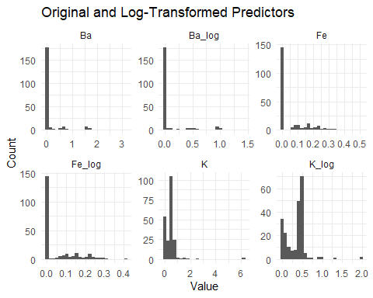
The log-transformed columns show flatter, more spread-out distributions compared to the original heavily skewed predictors, which is what we want before using distance-based or linear models.
# Compare skewness before and after log1p transformation
skew_comparison <- tibble(
Predictor = c("Ba", "Fe", "K"),
Skew_Original = c(
skewness_check(glass_data$Ba),
skewness_check(glass_data$Fe),
skewness_check(glass_data$K)
),
Skew_Log1p = c(
skewness_check(log1p(glass_data$Ba)),
skewness_check(log1p(glass_data$Fe)),
skewness_check(log1p(glass_data$K))
)
) |>
mutate(across(where(is.numeric), ~ round(.x, 3)))
skew_comparison
## # A tibble: 3 × 3
## Predictor Skew_Original Skew_Log1p
## <chr> <dbl> <dbl>
## 1 Ba 3.37 2.69
## 2 Fe 1.73 1.56
## 3 K 6.46 1.95
This table compares the skewness values before and after the log transformation to show how much the transformation actually reduced skewness for the three most skewed predictors.

Code Results
top_skewed <- glass_skewness |>
slice(1:3)
top_outliers <- glass_outliers |>
slice(1:3)
cor_pairs <- glass_cor_df |>
filter(as.character(Var1) < as.character(Var2)) |>
mutate(abs_corr = abs(Freq)) |>
arrange(desc(abs_corr)) |>
slice(1:5)
top_skewed
## # A tibble: 3 × 3
## Predictor Skewness abs_skewness
## <chr> <dbl> <dbl>
## 1 K 6.46 6.46
## 2 Ba 3.37 3.37
## 3 Ca 2.02 2.02
top_outliers
## # A tibble: 3 × 2
## Predictor Outlier_Count
## <chr> <int>
## 1 Ba 38
## 2 Ca 26
## 3 Al 18
cor_pairs
## Var1 Var2 Freq abs_corr
## 1 Ca RI 0.8104027 0.8104027
## 2 RI Si -0.5420522 0.5420522
## 3 Ba Mg -0.4922621 0.4922621
## 4 Al Mg -0.4817985 0.4817985
## 5 Al Ba 0.4794039 0.4794039
cat("Most skewed predictor:", top_skewed$Predictor[1], "\n")
## Most skewed predictor: K
cat("Predictor with most possible outliers:", top_outliers$Predictor[1], "\n")
## Predictor with most possible outliers: Ba
cat("Strongest correlation pair:",
as.character(cor_pairs$Var1[1]), "and",
as.character(cor_pairs$Var2[1]), "\n")
## Strongest correlation pair: Ca and RI
The Glass data has 214 observations, nine numeric predictors, and one class variable called Type with six levels in the mlbench version of the data.
The class distribution shows that Type 2 has the most records and the data is not balanced across all types. The histograms and boxplots confirm that several predictors are right-skewed. The skewness table shows that Ba, Fe, and K are the three most skewed predictors. The skewness comparison table confirms that log1p() noticeably reduced the skewness for all three. The outlier table shows that Ca and Ba have the most values outside the IQR fences.
The correlation heatmap and table show that RI and Ca have the strongest positive correlation. Highly correlated predictors may add extra complexity without adding much new information, depending on which model is used.

Interpretation
I would not remove outliers automatically because they may be real glass measurements. I would first check if they are actual data errors or valid extreme values.
For transformations, the skewness comparison table shows that log1p() reduced the skewness for Ba, Fe, and K. This is useful because log1p() handles zero values and pulls very large values closer to the rest of the distribution.
My preprocessing plan is:
- Keep Type as the outcome variable.
- Check class balance before modeling — Type 2 is the most common class.
- Use log1p() on Ba, Fe, and K based on the skewness results.
- Center and scale all numeric predictors before using distance-based or linear models such as KNN, SVM, or PCA.
- Do not remove outliers unless there is a clear data error.
- Check if removing the correlated predictor pair RI/Ca improves model performance.

Reference
Kuhn, M., & Johnson, K. (2013). Applied predictive modeling (Chapter 3, Exercise 3.1, p. 58). Springer. http://appliedpredictivemodeling.com/

KJ 3.2

Problem
The Soybean data contains 683 observations, 35 mostly categorical predictors, and 19 disease classes. The goal is to check the frequency distributions of the categorical predictors, review missing data, and create a plan for handling missing values.

Approach
I first loaded the Soybean data and checked the class distribution. Since most predictors are categorical, I reviewed the frequency distribution of each predictor. Then I checked near-zero variance predictors, missing values by predictor, and missing values by class. After that, I created a simple imputation strategy.

R Code
data(Soybean)
soybean_data <- Soybean
str(soybean_data)
## 'data.frame': 683 obs. of 36 variables:
## $ Class : Factor w/ 19 levels "2-4-d-injury",..: 11 11 11 11 11 11 11 11 11 11 ...
## $ date : Factor w/ 7 levels "0","1","2","3",..: 7 5 4 4 7 6 6 5 7 5 ...
## $ plant.stand : Ord.factor w/ 2 levels "0"<"1": 1 1 1 1 1 1 1 1 1 1 ...
## $ precip : Ord.factor w/ 3 levels "0"<"1"<"2": 3 3 3 3 3 3 3 3 3 3 ...
## $ temp : Ord.factor w/ 3 levels "0"<"1"<"2": 2 2 2 2 2 2 2 2 2 2 ...
## $ hail : Factor w/ 2 levels "0","1": 1 1 1 1 1 1 1 2 1 1 ...
## $ crop.hist : Factor w/ 4 levels "0","1","2","3": 2 3 2 2 3 4 3 2 4 3 ...
## $ area.dam : Factor w/ 4 levels "0","1","2","3": 2 1 1 1 1 1 1 1 1 1 ...
## $ sever : Factor w/ 3 levels "0","1","2": 2 3 3 3 2 2 2 2 2 3 ...
## $ seed.tmt : Factor w/ 3 levels "0","1","2": 1 2 2 1 1 1 2 1 2 1 ...
## $ germ : Ord.factor w/ 3 levels "0"<"1"<"2": 1 2 3 2 3 2 1 3 2 3 ...
## $ plant.growth : Factor w/ 2 levels "0","1": 2 2 2 2 2 2 2 2 2 2 ...
## $ leaves : Factor w/ 2 levels "0","1": 2 2 2 2 2 2 2 2 2 2 ...
## $ leaf.halo : Factor w/ 3 levels "0","1","2": 1 1 1 1 1 1 1 1 1 1 ...
## $ leaf.marg : Factor w/ 3 levels "0","1","2": 3 3 3 3 3 3 3 3 3 3 ...
## $ leaf.size : Ord.factor w/ 3 levels "0"<"1"<"2": 3 3 3 3 3 3 3 3 3 3 ...
## $ leaf.shread : Factor w/ 2 levels "0","1": 1 1 1 1 1 1 1 1 1 1 ...
## $ leaf.malf : Factor w/ 2 levels "0","1": 1 1 1 1 1 1 1 1 1 1 ...
## $ leaf.mild : Factor w/ 3 levels "0","1","2": 1 1 1 1 1 1 1 1 1 1 ...
## $ stem : Factor w/ 2 levels "0","1": 2 2 2 2 2 2 2 2 2 2 ...
## $ lodging : Factor w/ 2 levels "0","1": 2 1 1 1 1 1 2 1 1 1 ...
## $ stem.cankers : Factor w/ 4 levels "0","1","2","3": 4 4 4 4 4 4 4 4 4 4 ...
## $ canker.lesion : Factor w/ 4 levels "0","1","2","3": 2 2 1 1 2 1 2 2 2 2 ...
## $ fruiting.bodies: Factor w/ 2 levels "0","1": 2 2 2 2 2 2 2 2 2 2 ...
## $ ext.decay : Factor w/ 3 levels "0","1","2": 2 2 2 2 2 2 2 2 2 2 ...
## $ mycelium : Factor w/ 2 levels "0","1": 1 1 1 1 1 1 1 1 1 1 ...
## $ int.discolor : Factor w/ 3 levels "0","1","2": 1 1 1 1 1 1 1 1 1 1 ...
## $ sclerotia : Factor w/ 2 levels "0","1": 1 1 1 1 1 1 1 1 1 1 ...
## $ fruit.pods : Factor w/ 4 levels "0","1","2","3": 1 1 1 1 1 1 1 1 1 1 ...
## $ fruit.spots : Factor w/ 4 levels "0","1","2","4": 4 4 4 4 4 4 4 4 4 4 ...
## $ seed : Factor w/ 2 levels "0","1": 1 1 1 1 1 1 1 1 1 1 ...
## $ mold.growth : Factor w/ 2 levels "0","1": 1 1 1 1 1 1 1 1 1 1 ...
## $ seed.discolor : Factor w/ 2 levels "0","1": 1 1 1 1 1 1 1 1 1 1 ...
## $ seed.size : Factor w/ 2 levels "0","1": 1 1 1 1 1 1 1 1 1 1 ...
## $ shriveling : Factor w/ 2 levels "0","1": 1 1 1 1 1 1 1 1 1 1 ...
## $ roots : Factor w/ 3 levels "0","1","2": 1 1 1 1 1 1 1 1 1 1 ...
summary(soybean_data)
## Class date plant.stand precip temp
## brown-spot : 92 5 :149 0 :354 0 : 74 0 : 80
## alternarialeaf-spot: 91 4 :131 1 :293 1 :112 1 :374
## frog-eye-leaf-spot : 91 3 :118 NAs: 36 2 :459 2 :199
## phytophthora-rot : 88 2 : 93 NAs: 38 NAs: 30
## anthracnose : 44 6 : 90
## brown-stem-rot : 44 (Other):101
## (Other) :233 NAs : 1
## hail crop.hist area.dam sever seed.tmt germ plant.growth
## 0 :435 0 : 65 0 :123 0 :195 0 :305 0 :165 0 :441
## 1 :127 1 :165 1 :227 1 :322 1 :222 1 :213 1 :226
## NAs:121 2 :219 2 :145 2 : 45 2 : 35 2 :193 NAs: 16
## 3 :218 3 :187 NAs:121 NAs:121 NAs:112
## NAs: 16 NAs: 1
##
##
## leaves leaf.halo leaf.marg leaf.size leaf.shread leaf.malf leaf.mild
## 0: 77 0 :221 0 :357 0 : 51 0 :487 0 :554 0 :535
## 1:606 1 : 36 1 : 21 1 :327 1 : 96 1 : 45 1 : 20
## 2 :342 2 :221 2 :221 NAs:100 NAs: 84 2 : 20
## NAs: 84 NAs: 84 NAs: 84 NAs:108
##
##
##
## stem lodging stem.cankers canker.lesion fruiting.bodies ext.decay
## 0 :296 0 :520 0 :379 0 :320 0 :473 0 :497
## 1 :371 1 : 42 1 : 39 1 : 83 1 :104 1 :135
## NAs: 16 NAs:121 2 : 36 2 :177 NAs:106 2 : 13
## 3 :191 3 : 65 NAs: 38
## NAs: 38 NAs: 38
##
##
## mycelium int.discolor sclerotia fruit.pods fruit.spots seed mold.growth
## 0 :639 0 :581 0 :625 0 :407 0 :345 0 :476 0 :524
## 1 : 6 1 : 44 1 : 20 1 :130 1 : 75 1 :115 1 : 67
## NAs: 38 2 : 20 NAs: 38 2 : 14 2 : 57 NAs: 92 NAs: 92
## NAs: 38 3 : 48 4 :100
## NAs: 84 NAs:106
##
##
## seed.discolor seed.size shriveling roots
## 0 :513 0 :532 0 :539 0 :551
## 1 : 64 1 : 59 1 : 38 1 : 86
## NAs:106 NAs: 92 NAs:106 2 : 15
## NAs: 31
##
##
##
The str() output confirms 683 rows, 35 predictors that are mostly ordered factors, and one class variable with 19 disease categories.
soybean_class_distribution <- soybean_data |>
count(Class) |>
mutate(percent = round(100 * n / sum(n), 1)) |>
arrange(desc(n))
soybean_class_distribution
## Class n percent
## 1 brown-spot 92 13.5
## 2 alternarialeaf-spot 91 13.3
## 3 frog-eye-leaf-spot 91 13.3
## 4 phytophthora-rot 88 12.9
## 5 anthracnose 44 6.4
## 6 brown-stem-rot 44 6.4
## 7 bacterial-blight 20 2.9
## 8 bacterial-pustule 20 2.9
## 9 charcoal-rot 20 2.9
## 10 diaporthe-stem-canker 20 2.9
## 11 downy-mildew 20 2.9
## 12 phyllosticta-leaf-spot 20 2.9
## 13 powdery-mildew 20 2.9
## 14 purple-seed-stain 20 2.9
## 15 rhizoctonia-root-rot 20 2.9
## 16 2-4-d-injury 16 2.3
## 17 diaporthe-pod-&-stem-blight 15 2.2
## 18 cyst-nematode 14 2.0
## 19 herbicide-injury 8 1.2
This table shows how many observations belong to each disease class, some classes have many more records than others, so the data is not evenly balanced.
soybean_data |>
ggplot(aes(x = fct_infreq(Class))) +
geom_bar() +
coord_flip() +
labs(
title = "Soybean Class Distribution",
x = "Class",
y = "Count"
)
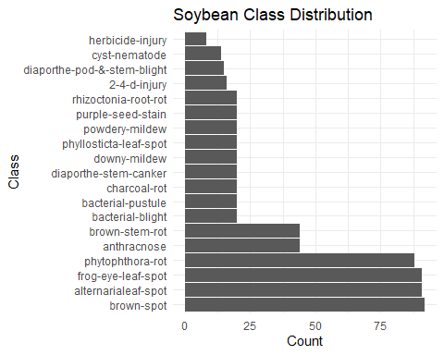
This bar chart makes it easy to see which disease classes are most and least common in the dataset, which is useful before building a classification model.
# Convert all predictors to character before pivot_longer to avoid
# type conflicts across mixed factor levels
soybean_predictors <- soybean_data |>
select(-Class) |>
mutate(across(everything(), as.character))
predictor_frequency <- soybean_predictors |>
pivot_longer(
cols = everything(),
names_to = "Predictor",
values_to = "Value"
) |>
count(Predictor, Value, name = "n") |>
group_by(Predictor) |>
mutate(percent = round(100 * n / sum(n), 1)) |>
arrange(Predictor, desc(n))
predictor_frequency
## # A tibble: 133 × 4
## # Groups: Predictor [35]
## Predictor Value n percent
## <chr> <chr> <int> <dbl>
## 1 area.dam 1 227 33.2
## 2 area.dam 3 187 27.4
## 3 area.dam 2 145 21.2
## 4 area.dam 0 123 18
## 5 area.dam <NA> 1 0.1
## 6 canker.lesion 0 320 46.9
## 7 canker.lesion 2 177 25.9
## 8 canker.lesion 1 83 12.2
## 9 canker.lesion 3 65 9.5
## 10 canker.lesion <NA> 38 5.6
## # ℹ 123 more rows
predictor_frequency |>
ggplot(aes(x = Value, y = n)) +
geom_col() +
facet_wrap(~ Predictor, scales = "free") +
labs(
title = "Frequency Distributions for Soybean Predictors",
x = "Category",
y = "Count"
) +
theme(axis.text.x = element_text(angle = 45, hjust = 1))
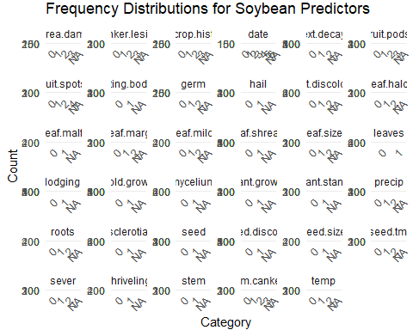
The frequency table and bar charts show how values are distributed for each predictor, predictors with only one visible bar may have near-zero variance and may not help the model.
degenerate_check <- predictor_frequency |>
group_by(Predictor) |>
summarise(
unique_values = n_distinct(Value),
top_category_percent = max(percent, na.rm = TRUE),
.groups = "drop"
) |>
arrange(desc(top_category_percent))
degenerate_check
## # A tibble: 35 × 3
## Predictor unique_values top_category_percent
## <chr> <int> <dbl>
## 1 mycelium 3 93.6
## 2 sclerotia 3 91.5
## 3 leaves 2 88.7
## 4 int.discolor 4 85.1
## 5 leaf.malf 3 81.1
## 6 roots 4 80.7
## 7 shriveling 3 78.9
## 8 leaf.mild 4 78.3
## 9 seed.size 3 77.9
## 10 mold.growth 3 76.7
## # ℹ 25 more rows
This table ranks predictors by the percent of observations in their most common category, predictors at the top with very high percentages are close to degenerate and may not add useful information to the model.
# Use a factor version of the predictors for nearZeroVar()
soybean_predictors_nzv <- soybean_data |>
select(-Class) |>
mutate(across(everything(), as.factor))
nzv_soybean <- nearZeroVar(
soybean_predictors_nzv,
saveMetrics = TRUE
)
nzv_table <- nzv_soybean |>
rownames_to_column("Predictor") |>
arrange(desc(nzv), desc(freqRatio))
nzv_table
## Predictor freqRatio percentUnique zeroVar nzv
## 1 mycelium 106.500000 0.2928258 FALSE TRUE
## 2 sclerotia 31.250000 0.2928258 FALSE TRUE
## 3 leaf.mild 26.750000 0.4392387 FALSE TRUE
## 4 shriveling 14.184211 0.2928258 FALSE FALSE
## 5 int.discolor 13.204545 0.4392387 FALSE FALSE
## 6 lodging 12.380952 0.2928258 FALSE FALSE
## 7 leaf.malf 12.311111 0.2928258 FALSE FALSE
## 8 seed.size 9.016949 0.2928258 FALSE FALSE
## 9 seed.discolor 8.015625 0.2928258 FALSE FALSE
## 10 leaves 7.870130 0.2928258 FALSE FALSE
## 11 mold.growth 7.820896 0.2928258 FALSE FALSE
## 12 roots 6.406977 0.4392387 FALSE FALSE
## 13 leaf.shread 5.072917 0.2928258 FALSE FALSE
## 14 fruiting.bodies 4.548077 0.2928258 FALSE FALSE
## 15 seed 4.139130 0.2928258 FALSE FALSE
## 16 precip 4.098214 0.4392387 FALSE FALSE
## 17 ext.decay 3.681481 0.4392387 FALSE FALSE
## 18 fruit.spots 3.450000 0.5856515 FALSE FALSE
## 19 hail 3.425197 0.2928258 FALSE FALSE
## 20 fruit.pods 3.130769 0.5856515 FALSE FALSE
## 21 stem.cankers 1.984293 0.5856515 FALSE FALSE
## 22 plant.growth 1.951327 0.2928258 FALSE FALSE
## 23 temp 1.879397 0.4392387 FALSE FALSE
## 24 canker.lesion 1.807910 0.5856515 FALSE FALSE
## 25 sever 1.651282 0.4392387 FALSE FALSE
## 26 leaf.marg 1.615385 0.4392387 FALSE FALSE
## 27 leaf.halo 1.547511 0.4392387 FALSE FALSE
## 28 leaf.size 1.479638 0.4392387 FALSE FALSE
## 29 seed.tmt 1.373874 0.4392387 FALSE FALSE
## 30 stem 1.253378 0.2928258 FALSE FALSE
## 31 area.dam 1.213904 0.5856515 FALSE FALSE
## 32 plant.stand 1.208191 0.2928258 FALSE FALSE
## 33 date 1.137405 1.0248902 FALSE FALSE
## 34 germ 1.103627 0.4392387 FALSE FALSE
## 35 crop.hist 1.004587 0.5856515 FALSE FALSE
The nearZeroVar() table flags any predictor where one value dominates the distribution by a wide margin, with nzv = TRUE meaning the predictor has very little useful variation for modeling.
missing_by_predictor <- soybean_data |>
summarise(across(everything(), ~ sum(is.na(.)))) |>
pivot_longer(
cols = everything(),
names_to = "Variable",
values_to = "Missing_Count"
) |>
mutate(Missing_Percent = round(100 * Missing_Count / nrow(soybean_data), 1)) |>
arrange(desc(Missing_Percent))
missing_by_predictor
## # A tibble: 36 × 3
## Variable Missing_Count Missing_Percent
## <chr> <int> <dbl>
## 1 hail 121 17.7
## 2 sever 121 17.7
## 3 seed.tmt 121 17.7
## 4 lodging 121 17.7
## 5 germ 112 16.4
## 6 leaf.mild 108 15.8
## 7 fruiting.bodies 106 15.5
## 8 fruit.spots 106 15.5
## 9 seed.discolor 106 15.5
## 10 shriveling 106 15.5
## # ℹ 26 more rows
missing_by_predictor |>
filter(Missing_Count > 0) |>
ggplot(aes(x = reorder(Variable, Missing_Percent), y = Missing_Percent)) +
geom_col() +
coord_flip() +
labs(
title = "Missing Data Percent by Variable",
x = "Variable",
y = "Missing Percent"
)
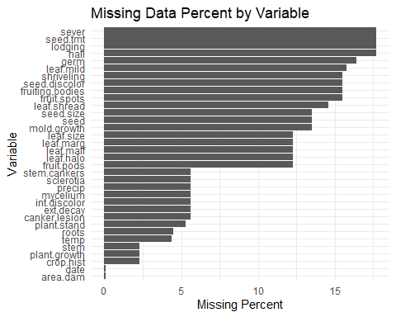
The table and bar chart show which predictors have the most missing values as a percent of total rows, predictors at the top may need to be removed or imputed depending on how much data is missing.
soybean_missing_rows <- soybean_data |>
mutate(row_missing = rowSums(across(-Class, is.na)))
missing_by_class <- soybean_missing_rows |>
group_by(Class) |>
summarise(
rows = n(),
avg_missing = round(mean(row_missing), 2),
max_missing = max(row_missing),
.groups = "drop"
) |>
arrange(desc(avg_missing))
missing_by_class
## # A tibble: 19 × 4
## Class rows avg_missing max_missing
## <fct> <int> <dbl> <dbl>
## 1 2-4-d-injury 16 28.1 30
## 2 cyst-nematode 14 24 24
## 3 herbicide-injury 8 20 20
## 4 phytophthora-rot 88 13.8 19
## 5 diaporthe-pod-&-stem-blight 15 11.8 13
## 6 alternarialeaf-spot 91 0 0
## 7 anthracnose 44 0 0
## 8 bacterial-blight 20 0 0
## 9 bacterial-pustule 20 0 0
## 10 brown-spot 92 0 0
## 11 brown-stem-rot 44 0 0
## 12 charcoal-rot 20 0 0
## 13 diaporthe-stem-canker 20 0 0
## 14 downy-mildew 20 0 0
## 15 frog-eye-leaf-spot 91 0 0
## 16 phyllosticta-leaf-spot 20 0 0
## 17 powdery-mildew 20 0 0
## 18 purple-seed-stain 20 0 0
## 19 rhizoctonia-root-rot 20 0 0
missing_by_class |>
ggplot(aes(x = reorder(Class, avg_missing), y = avg_missing)) +
geom_col() +
coord_flip() +
labs(
title = "Average Missing Values by Soybean Class",
x = "Class",
y = "Average Missing Values Per Row"
)
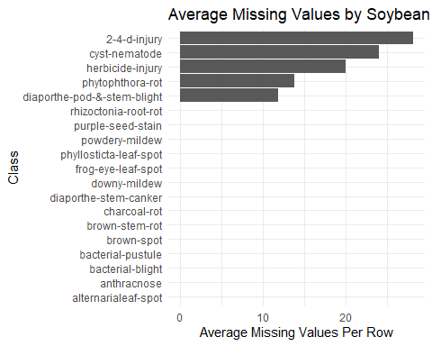
The table and bar chart show which disease classes have the most missing values on average, if only a few classes drive most of the missingness, the missing data is likely not random.
soybean_missing_pattern <- soybean_missing_rows |>
count(Class, row_missing) |>
arrange(Class, row_missing)
soybean_missing_pattern
## Class row_missing n
## 1 2-4-d-injury 28 15
## 2 2-4-d-injury 30 1
## 3 alternarialeaf-spot 0 91
## 4 anthracnose 0 44
## 5 bacterial-blight 0 20
## 6 bacterial-pustule 0 20
## 7 brown-spot 0 92
## 8 brown-stem-rot 0 44
## 9 charcoal-rot 0 20
## 10 cyst-nematode 24 14
## 11 diaporthe-pod-&-stem-blight 11 9
## 12 diaporthe-pod-&-stem-blight 13 6
## 13 diaporthe-stem-canker 0 20
## 14 downy-mildew 0 20
## 15 frog-eye-leaf-spot 0 91
## 16 herbicide-injury 20 8
## 17 phyllosticta-leaf-spot 0 20
## 18 phytophthora-rot 0 20
## 19 phytophthora-rot 13 13
## 20 phytophthora-rot 19 55
## 21 powdery-mildew 0 20
## 22 purple-seed-stain 0 20
## 23 rhizoctonia-root-rot 0 20
This table shows, for each class, how many rows have a given number of missing predictors, making it easier to see which classes contribute most to the missing data problem.
mode_value <- function(x) {
ux <- na.omit(unique(x))
ux[which.max(tabulate(match(x, ux)))]
}
soybean_imputed <- soybean_data
for (nm in names(soybean_imputed)) {
if (nm != "Class" && anyNA(soybean_imputed[[nm]])) {
mv <- mode_value(soybean_imputed[[nm]])
soybean_imputed[[nm]][is.na(soybean_imputed[[nm]])] <- mv
}
}
sum(is.na(soybean_imputed))
## [1] 0
summary(soybean_imputed)
## Class date plant.stand precip temp hail
## brown-spot : 92 0: 26 0:390 0: 74 0: 80 0:556
## alternarialeaf-spot: 91 1: 75 1:293 1:112 1:404 1:127
## frog-eye-leaf-spot : 91 2: 93 2:497 2:199
## phytophthora-rot : 88 3:118
## anthracnose : 44 4:131
## brown-stem-rot : 44 5:150
## (Other) :233 6: 90
## crop.hist area.dam sever seed.tmt germ plant.growth leaves leaf.halo
## 0: 65 0:123 0:195 0:426 0:165 0:457 0: 77 0:221
## 1:165 1:228 1:443 1:222 1:325 1:226 1:606 1: 36
## 2:235 2:145 2: 45 2: 35 2:193 2:426
## 3:218 3:187
##
##
##
## leaf.marg leaf.size leaf.shread leaf.malf leaf.mild stem lodging
## 0:441 0: 51 0:587 0:638 0:643 0:296 0:641
## 1: 21 1:411 1: 96 1: 45 1: 20 1:387 1: 42
## 2:221 2:221 2: 20
##
##
##
##
## stem.cankers canker.lesion fruiting.bodies ext.decay mycelium int.discolor
## 0:417 0:358 0:579 0:535 0:677 0:619
## 1: 39 1: 83 1:104 1:135 1: 6 1: 44
## 2: 36 2:177 2: 13 2: 20
## 3:191 3: 65
##
##
##
## sclerotia fruit.pods fruit.spots seed mold.growth seed.discolor seed.size
## 0:663 0:491 0:451 0:568 0:616 0:619 0:624
## 1: 20 1:130 1: 75 1:115 1: 67 1: 64 1: 59
## 2: 14 2: 57
## 3: 48 4:100
##
##
##
## shriveling roots
## 0:645 0:582
## 1: 38 1: 86
## 2: 15
##
##
##
##
After mode imputation, the missing value count drops to zero, confirming that every NA was replaced with the most common value for that predictor.
high_missing_predictors <- missing_by_predictor |>
filter(Variable != "Class", Missing_Percent > 40) |>
pull(Variable)
high_missing_predictors
## character(0)
soybean_reduced <- soybean_data |>
select(-all_of(high_missing_predictors))
dim(soybean_data)
## [1] 683 36
dim(soybean_reduced)
## [1] 683 36
Removing predictors with more than 40% missing values reduces the number of columns the model has to work with, while keeping the rows and class variable intact.

Code Results
nzv_flagged <- nzv_table |>
filter(nzv == TRUE) |>
pull(Predictor)
top_degenerate <- degenerate_check |>
slice(1:5)
top_missing_predictors <- missing_by_predictor |>
filter(Variable != "Class") |>
slice(1:5)
top_missing_classes <- missing_by_class |>
slice(1:5)
top_degenerate
## # A tibble: 5 × 3
## Predictor unique_values top_category_percent
## <chr> <int> <dbl>
## 1 mycelium 3 93.6
## 2 sclerotia 3 91.5
## 3 leaves 2 88.7
## 4 int.discolor 4 85.1
## 5 leaf.malf 3 81.1
nzv_flagged
## [1] "mycelium" "sclerotia" "leaf.mild"
top_missing_predictors
## # A tibble: 5 × 3
## Variable Missing_Count Missing_Percent
## <chr> <int> <dbl>
## 1 hail 121 17.7
## 2 sever 121 17.7
## 3 seed.tmt 121 17.7
## 4 lodging 121 17.7
## 5 germ 112 16.4
top_missing_classes
## # A tibble: 5 × 4
## Class rows avg_missing max_missing
## <fct> <int> <dbl> <dbl>
## 1 2-4-d-injury 16 28.1 30
## 2 cyst-nematode 14 24 24
## 3 herbicide-injury 8 20 20
## 4 phytophthora-rot 88 13.8 19
## 5 diaporthe-pod-&-stem-blight 15 11.8 13
cat("Number of near-zero variance predictors:", length(nzv_flagged), "\n")
## Number of near-zero variance predictors: 3
cat("Predictor with highest missing percent:", top_missing_predictors$Variable[1], "\n")
## Predictor with highest missing percent: hail
cat("Class with highest average missing values:", as.character(top_missing_classes$Class[1]), "\n")
## Class with highest average missing values: 2-4-d-injury
cat("Missing values after simple mode imputation:", sum(is.na(soybean_imputed)), "\n")
## Missing values after simple mode imputation: 0
The Soybean data has 683 observations, 35 predictors, and 19 disease classes.
The frequency tables and bar charts show how each categorical predictor is distributed. The degenerate check table shows if one category takes up most of a predictor. The nearZeroVar() table flags predictors with very little useful variation.
The missing data table shows which predictors have the most missing values. The missing-by-class table shows that certain disease classes account for most of the missing data, which suggests the missingness is not random, it is connected to specific classes. After the simple mode imputation, the missing value count drops to zero.

Interpretation
A degenerate predictor is one where almost all observations fall into one category. If a predictor has very little variation, it may not help the model learn anything useful.
The missing-by-class table is important. If certain disease classes have nearly all the missing values, then the missingness is informative — it is tied to the class label. In that case, simply deleting those rows would remove too much data from specific classes and would make the class imbalance worse.
I would not delete rows right away. Since most predictors are categorical, mode imputation is a simple and reasonable first approach. I would only remove a predictor if it has very high missingness or almost no variation.
My missing data plan is:
- Remove predictors with very high missingness (above 40%).
- Remove predictors flagged by nearZeroVar() as having almost no variation.
- Use mode imputation for the remaining categorical predictors.
- Keep the class variable separate during all preprocessing steps.
- Check the class distribution again after preprocessing to confirm balance has not changed.
- Use resampling or cross-validation later to see if preprocessing choices improved model performance.

Reference
Kuhn, M., & Johnson, K. (2013). Applied predictive modeling (Chapter 3, Exercise 3.2, p. 59). Springer. http://appliedpredictivemodeling.com/

