DATA 624 Project 1: Forecasting Report
  - Lone Star Appliances and Texas HealthLink
Group 3
June 20, 2026
Table of Contents
Executive Summary 1
Exercise #1: Lone Star Appliances 1
Problem and Approach 1
Board-Level Summary 1
Business Decisions Supported 1
Main Risk 1
Exercise #1 Technical Work 1
Exercise #1 Recommendation 1
Exercise #2: Texas HealthLink 1
Problem and Approach 1
Board-Level Summary 1
Business Decisions Supported 1
Exercise #2 Technical Work 1
Exercise #2 Recommendation 1
Bonus #2: Interview-Ready Time Series Literacy 1
Executive Summary 1
Graph Commentary 1
Mock Interview Q&A 1
Final Conclusion 1
References 1

Executive Summary
This project uses time series forecasting to support planning decisions for two organizations.
For Lone Star Appliances, the main question is how many units the company should expect to ship in the next several quarters. This matters for production, warehouse inventory, staffing, and logistics contracts.
For Texas HealthLink, the main question is how many patient visits each clinic should expect over the next 12 months. This matters for staffing, budgeting, scheduling, and facility planning.
Both datasets show growth over time and seasonal movement. Both also show disruption around the COVID period. Because of that, I would use the forecasts as planning baselines, not as exact promises. The best use of this report is to help leadership plan capacity, prepare for busy periods, and understand where the risk is.

Exercise #1: Lone Star Appliances

Problem and Approach
For Lone Star, the forecast is used as a planning tool for a manufacturer. The main point is not just the model output. The main point is what the forecast means for production, staffing, inventory, and logistics.
The Board should be able to answer three questions after reading this section:
- What is the shipment pattern?
- What should we expect next?
- What should the company do with the forecast?

Board-Level Summary
Lone Star Appliances has a clear upward shipment pattern. Shipments generally increased from 2010 through 2021. The company also has a seasonal pattern. The fourth quarter is usually the strongest quarter, which makes sense for a business that ships appliances to retailers.
The main issue is the 2020 disruption. Shipments dropped in 2020 Q2, then recovered. That tells me the business has a strong base demand, but it is still exposed to outside shocks. A forecast can help the Board plan, but it cannot remove risk.
My recommendation is to use the final forecast as the baseline production plan. I would not plan staffing, inventory, or carrier contracts only around the average forecast. I would also keep a buffer for Q4 and for any quarter where demand moves above the expected range.

Business Decisions Supported
The Lone Star forecast supports these decisions:
- production planning for the next 1 to 3 years
- staffing needs by quarter
- warehouse inventory targets
- logistics contracts with carriers
- risk planning for high-demand quarters

Main Risk
The biggest risk is that future demand may not follow the same pattern as the past. COVID showed that one shock can change shipments quickly. Supply chain issues, retailer orders, labor constraints, or economic changes could also change the forecast.

Exercise #1 Technical Work
lone_star_text <- "year,quarter,shipments
2010,1,60
2010,2,63
2010,3,66
2010,4,70
2011,1,62
2011,2,65
2011,3,69
2011,4,73
2012,1,65
2012,2,69
2012,3,73
2012,4,78
2013,1,68
2013,2,72
2013,3,77
2013,4,82
2014,1,72
2014,2,77
2014,3,82
2014,4,88
2015,1,82
2015,2,88
2015,3,93
2015,4,101
2016,1,86
2016,2,92
2016,3,98
2016,4,107
2017,1,90
2017,2,97
2017,3,104
2017,4,114
2018,1,95
2018,2,103
2018,3,111
2018,4,122
2019,1,100
2019,2,108
2019,3,117
2019,4,129
2020,1,96
2020,2,85
2020,3,110
2020,4,124
2021,1,107
2021,2,116
2021,3,126
2021,4,139"
lone_star <- read.csv(text = lone_star_text)
lone_star$quarter_label <- paste0(lone_star$year, " Q", lone_star$quarter)
lone_star$time_index <- seq_len(nrow(lone_star))
lone_star$quarter_factor <- factor(lone_star$quarter)
head(lone_star)
## year quarter shipments quarter_label time_index quarter_factor
## 1 2010 1 60 2010 Q1 1 1
## 2 2010 2 63 2010 Q2 2 2
## 3 2010 3 66 2010 Q3 3 3
## 4 2010 4 70 2010 Q4 4 4
## 5 2011 1 62 2011 Q1 5 1
## 6 2011 2 65 2011 Q2 6 2
summary(lone_star$shipments)
## Min. 1st Qu. Median Mean 3rd Qu. Max.
## 60.00 72.75 89.00 91.06 107.00 139.00
library(ggplot2)
p_lone_star <- ggplot(lone_star, aes(x = time_index, y = shipments)) +
geom_line() +
geom_point() +
scale_x_continuous(
breaks = seq(1, nrow(lone_star), by = 4),
labels = lone_star$year[seq(1, nrow(lone_star), by = 4)]
) +
labs(
title = "Lone Star Appliances Quarterly Shipments",
x = "Year",
y = "Shipments (thousands of units)"
)
p_lone_star
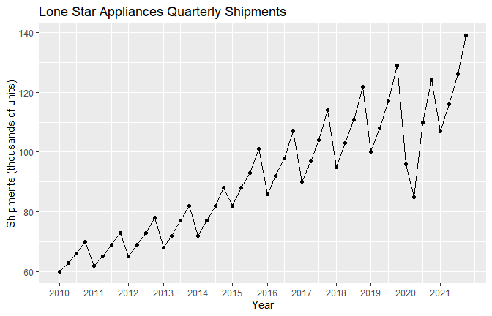
library(forecast)
lone_star_ts <- ts(lone_star$shipments, start = c(2010, 1), frequency = 4)
plot(lone_star_ts,
main = "Lone Star Quarterly Shipments",
ylab = "Shipments (thousands)",
xlab = "Year")
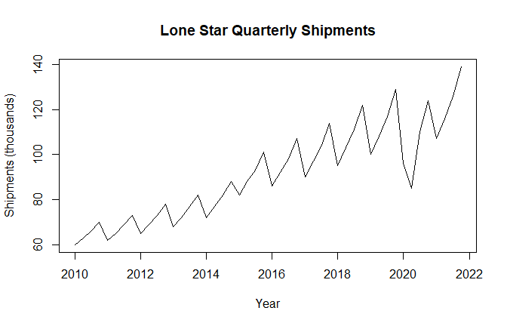
lone_star_decomp <- stl(lone_star_ts, s.window = "periodic")
plot(lone_star_decomp)
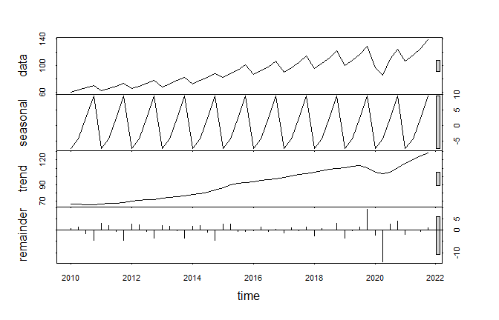
set.seed(624)
ls_snaive <- snaive(lone_star_ts, h = 12)
ls_ets <- ets(lone_star_ts)
ls_ets_fc <- forecast(ls_ets, h = 12)
ls_arima <- auto.arima(lone_star_ts, seasonal = TRUE, stepwise = FALSE, approximation = FALSE)
ls_arima_fc <- forecast(ls_arima, h = 12)
ls_reg <- tslm(lone_star_ts ~ trend + season)
ls_reg_fc <- forecast(ls_reg, h = 12)
ls_models <- list(
Seasonal_Naive = ls_snaive,
ETS = ls_ets_fc,
ARIMA = ls_arima_fc,
Regression = ls_reg_fc
)
ls_ets
## ETS(M,A,M)
##
## Call:
## ets(y = lone_star_ts)
##
## Smoothing parameters:
## alpha = 0.6318
## beta = 1e-04
## gamma = 2e-04
##
## Initial states:
## l = 63.04
## b = 0.9776
## s = 1.0949 1.0245 0.959 0.9216
##
## sigma: 0.0496
##
## AIC AICc BIC
## 336.9289 341.6657 353.7697
ls_arima
## Series: lone_star_ts
## ARIMA(1,0,0)(1,1,0)[4] with drift
##
## Coefficients:
## ar1 sar1 drift
## 0.6121 -0.687 1.1948
## s.e. 0.1195 0.135 0.2676
##
## sigma^2 = 22.97: log likelihood = -131.25
## AIC=270.51 AICc=271.53 BIC=277.64
summary(ls_reg)
##
## Call:
## tslm(formula = lone_star_ts ~ trend + season)
##
## Residuals:
## Min 1Q Median 3Q Max
## -24.666 -2.239 1.213 3.509 8.537
##
## Coefficients:
## Estimate Std. Error t value Pr(>|t|)
## (Intercept) 51.99556 2.16673 23.997 < 2e-16 ***
## trend 1.30092 0.06029 21.578 < 2e-16 ***
## season2 3.03242 2.35534 1.287 0.204820
## season3 9.31483 2.35766 3.951 0.000285 ***
## season4 16.43058 2.36151 6.958 1.48e-08 ***
## ---
## Signif. codes: 0 '***' 0.001 '**' 0.01 '*' 0.05 '.' 0.1 ' ' 1
##
## Residual standard error: 5.768 on 43 degrees of freedom
## Multiple R-squared: 0.9277, Adjusted R-squared: 0.921
## F-statistic: 138 on 4 and 43 DF, p-value: < 2.2e-16
ls_accuracy <- rbind(
Seasonal_Naive = accuracy(ls_snaive)[1, c("RMSE", "MAE", "MAPE")],
ETS = accuracy(ls_ets_fc)[1, c("RMSE", "MAE", "MAPE")],
ARIMA = accuracy(ls_arima_fc)[1, c("RMSE", "MAE", "MAPE")],
Regression = accuracy(ls_reg_fc)[1, c("RMSE", "MAE", "MAPE")]
)
knitr::kable(round(ls_accuracy, 3), caption = "Lone Star model accuracy comparison")
Lone Star model accuracy comparison
 | RMSE | MAE | MAPE
Seasonal_Naive | 8.874 | 6.977 | 7.217
ETS | 4.592 | 2.782 | 2.975
ARIMA | 4.430 | 2.578 | 2.753
Regression | 5.459 | 3.890 | 4.372
ls_accuracy_df <- data.frame(
model = rownames(ls_accuracy),
RMSE = ls_accuracy[, "RMSE"],
MAE = ls_accuracy[, "MAE"],
MAPE = ls_accuracy[, "MAPE"],
row.names = NULL
)
ls_champion_name <- ls_accuracy_df$model[which.min(ls_accuracy_df$RMSE)]
ls_champion_name
## [1] "ARIMA"
ls_forecast <- if (ls_champion_name == "ETS") {
ls_ets_fc
} else if (ls_champion_name == "ARIMA") {
ls_arima_fc
} else if (ls_champion_name == "Regression") {
ls_reg_fc
} else {
ls_snaive
}
ls_fc_table <- data.frame(
period = paste0(rep(2022:2024, each = 4), " Q", rep(1:4, times = 3)),
forecast = as.numeric(ls_forecast$mean),
lower_80 = as.numeric(ls_forecast$lower[, 1]),
upper_80 = as.numeric(ls_forecast$upper[, 1]),
lower_95 = as.numeric(ls_forecast$lower[, 2]),
upper_95 = as.numeric(ls_forecast$upper[, 2])
)
ls_fc_table_print <- ls_fc_table
ls_fc_table_print[, c("forecast", "lower_80", "upper_80", "lower_95", "upper_95")] <-
round(ls_fc_table_print[, c("forecast", "lower_80", "upper_80", "lower_95", "upper_95")], 1)
knitr::kable(ls_fc_table_print, caption = "Lone Star 12-quarter forecast")
Lone Star 12-quarter forecast
period | forecast | lower_80 | upper_80 | lower_95 | upper_95
2022 Q1 | 109.6 | 103.5 | 115.8 | 100.3 | 119.0
2022 Q2 | 104.1 | 96.9 | 111.3 | 93.1 | 115.1
2022 Q3 | 123.9 | 116.3 | 131.4 | 112.3 | 135.4
2022 Q4 | 137.2 | 129.6 | 144.9 | 125.5 | 149.0
2023 Q1 | 116.2 | 108.0 | 124.4 | 103.7 | 128.7
2023 Q2 | 120.5 | 112.2 | 128.9 | 107.7 | 133.3
2023 Q3 | 133.5 | 125.1 | 141.9 | 120.6 | 146.4
2023 Q4 | 146.6 | 138.1 | 155.0 | 133.7 | 159.5
2024 Q1 | 119.8 | 109.9 | 129.7 | 104.6 | 135.0
2024 Q2 | 117.3 | 106.9 | 127.7 | 101.4 | 133.3
2024 Q3 | 135.0 | 124.4 | 145.6 | 118.7 | 151.2
2024 Q4 | 148.2 | 137.6 | 158.9 | 131.9 | 164.6
autoplot(ls_forecast) +
labs(
title = paste("Lone Star Forecast - Champion Model:", ls_champion_name),
x = "Year",
y = "Shipments (thousands)"
)
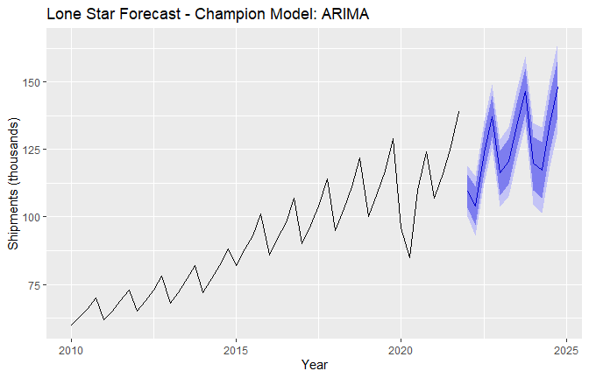
checkresiduals(if (ls_champion_name == "ETS") ls_ets else if (ls_champion_name == "ARIMA") ls_arima else ls_reg)
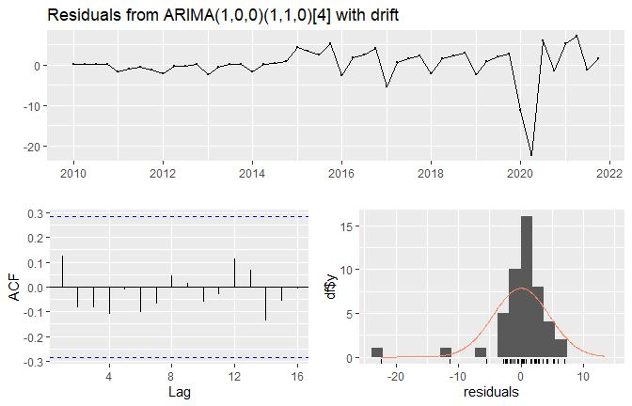
##
## Ljung-Box test
##
## data: Residuals from ARIMA(1,0,0)(1,1,0)[4] with drift
## Q* = 3.1442, df = 6, p-value = 0.7905
##
## Model df: 2. Total lags used: 8

Exercise #1 Recommendation
Lone Star should use the forecast as a baseline for production and logistics planning. The company should plan extra capacity around the fourth quarter because the data shows stronger demand near year-end. The company should also keep a reserve plan because COVID showed that one quarter can move far away from the normal pattern.
The Board should use the forecast as a planning baseline. Based on the historical pattern, demand is expected to keep rising with higher pressure in later quarters. I would not recommend planning only to the point forecast. I would use the forecast range because the company has already seen that shocks can change demand quickly.

Exercise #2: Texas HealthLink

Problem and Approach
For Texas HealthLink, the forecast is used as a staffing and capacity planning tool. This section is more detailed than Exercise #1 because the data has five clinics and a systemwide total.
The Board should be able to answer four questions after reading this section:
- Which clinics have the highest expected demand?
- What is the 12-month outlook for each clinic?
- What is the systemwide patient volume outlook?
- What staffing or facility risks should leadership watch?

Board-Level Summary
Texas HealthLink has five clinics with monthly visit data from 2016 through 2023. The main business need is to forecast patient visits for each clinic and for the total system.
This forecast supports staffing, budget planning, facility planning, and scheduling. Since patient demand can change by clinic, the systemwide forecast alone is not enough. Leadership needs both the total forecast and the clinic-level view.
The early review shows that patient visits generally grow over time. Some clinics are larger than others, so staffing plans should not be spread evenly across all clinics. The COVID period also created volatility, which should be treated as a planning risk.

Business Decisions Supported
The HealthLink forecast supports these decisions:
- monthly staffing plans
- clinic scheduling
- budget planning
- facility expansion decisions
- systemwide resource allocation
- risk planning for peak demand months

Exercise #2 Technical Work
healthlink_text <- "row,clinic,month,visits
1,Temple,2016-01-01,2059
2,Temple,2016-02-01,2028
3,Temple,2016-03-01,1930
4,Temple,2016-04-01,1770
5,Temple,2016-05-01,1797
6,Temple,2016-06-01,1943
7,Temple,2016-07-01,1921
8,Temple,2016-08-01,1923
9,Temple,2016-09-01,1815
10,Temple,2016-10-01,1877
11,Temple,2016-11-01,1841
12,Temple,2016-12-01,1796
13,Temple,2017-01-01,2001
14,Temple,2017-02-01,2087
15,Temple,2017-03-01,2005
16,Temple,2017-04-01,1964
17,Temple,2017-05-01,1839
18,Temple,2017-06-01,2021
19,Temple,2017-07-01,2063
20,Temple,2017-08-01,2058
21,Temple,2017-09-01,1974
22,Temple,2017-10-01,1938
23,Temple,2017-11-01,1933
24,Temple,2017-12-01,1931
25,Temple,2018-01-01,2127
26,Temple,2018-02-01,2071
27,Temple,2018-03-01,2107
28,Temple,2018-04-01,2009
29,Temple,2018-05-01,2143
30,Temple,2018-06-01,2081
31,Temple,2018-07-01,2142
32,Temple,2018-08-01,2141
33,Temple,2018-09-01,2006
34,Temple,2018-10-01,2068
35,Temple,2018-11-01,2167
36,Temple,2018-12-01,2115
37,Temple,2019-01-01,2218
38,Temple,2019-02-01,2199
39,Temple,2019-03-01,2109
40,Temple,2019-04-01,2188
41,Temple,2019-05-01,2040
42,Temple,2019-06-01,2260
43,Temple,2019-07-01,2339
44,Temple,2019-08-01,2145
45,Temple,2019-09-01,2202
46,Temple,2019-10-01,2152
47,Temple,2019-11-01,2082
48,Temple,2019-12-01,2093
49,Temple,2020-01-01,2216
50,Temple,2020-02-01,2288
51,Temple,2020-03-01,2240
52,Temple,2020-04-01,2007
53,Temple,2020-05-01,2100
54,Temple,2020-06-01,1985
55,Temple,2020-07-01,2367
56,Temple,2020-08-01,2374
57,Temple,2020-09-01,2276
58,Temple,2020-10-01,2203
59,Temple,2020-11-01,2265
60,Temple,2020-12-01,2263
61,Temple,2021-01-01,2442
62,Temple,2021-02-01,2394
63,Temple,2021-03-01,2483
64,Temple,2021-04-01,2290
65,Temple,2021-05-01,2383
66,Temple,2021-06-01,2345
67,Temple,2021-07-01,2340
68,Temple,2021-08-01,2618
69,Temple,2021-09-01,2327
70,Temple,2021-10-01,2378
71,Temple,2021-11-01,2406
72,Temple,2021-12-01,2347
73,Temple,2022-01-01,2535
74,Temple,2022-02-01,2534
75,Temple,2022-03-01,2507
76,Temple,2022-04-01,2412
77,Temple,2022-05-01,2414
78,Temple,2022-06-01,2632
79,Temple,2022-07-01,2468
80,Temple,2022-08-01,2454
81,Temple,2022-09-01,2450
82,Temple,2022-10-01,2475
83,Temple,2022-11-01,2490
84,Temple,2022-12-01,2444
85,Temple,2023-01-01,2536
86,Temple,2023-02-01,2684
87,Temple,2023-03-01,2595
88,Temple,2023-04-01,2452
89,Temple,2023-05-01,2498
90,Temple,2023-06-01,2588
91,Temple,2023-07-01,2675
92,Temple,2023-08-01,2621
93,Temple,2023-09-01,2589
94,Temple,2023-10-01,2522
95,Temple,2023-11-01,2573
96,Temple,2023-12-01,2549
97,Belton,2016-01-01,978
98,Belton,2016-02-01,942
99,Belton,2016-03-01,930
100,Belton,2016-04-01,996
101,Belton,2016-05-01,944
102,Belton,2016-06-01,914
103,Belton,2016-07-01,944
104,Belton,2016-08-01,925
105,Belton,2016-09-01,1024
106,Belton,2016-10-01,992
107,Belton,2016-11-01,933
108,Belton,2016-12-01,970
109,Belton,2017-01-01,1005
110,Belton,2017-02-01,1007
111,Belton,2017-03-01,998
112,Belton,2017-04-01,940
113,Belton,2017-05-01,1034
114,Belton,2017-06-01,1010
115,Belton,2017-07-01,1021
116,Belton,2017-08-01,1030
117,Belton,2017-09-01,1033
118,Belton,2017-10-01,967
119,Belton,2017-11-01,952
120,Belton,2017-12-01,1063
121,Belton,2018-01-01,1052
122,Belton,2018-02-01,1045
123,Belton,2018-03-01,1029
124,Belton,2018-04-01,961
125,Belton,2018-05-01,993
126,Belton,2018-06-01,1085
127,Belton,2018-07-01,1108
128,Belton,2018-08-01,1096
129,Belton,2018-09-01,1017
130,Belton,2018-10-01,1038
131,Belton,2018-11-01,1012
132,Belton,2018-12-01,1015
133,Belton,2019-01-01,1153
134,Belton,2019-02-01,1081
135,Belton,2019-03-01,1204
136,Belton,2019-04-01,1056
137,Belton,2019-05-01,1073
138,Belton,2019-06-01,1078
139,Belton,2019-07-01,1089
140,Belton,2019-08-01,1063
141,Belton,2019-09-01,1073
142,Belton,2019-10-01,1101
143,Belton,2019-11-01,1101
144,Belton,2019-12-01,1061
145,Belton,2020-01-01,1134
146,Belton,2020-02-01,1150
147,Belton,2020-03-01,1234
148,Belton,2020-04-01,913
149,Belton,2020-05-01,955
150,Belton,2020-06-01,1082
151,Belton,2020-07-01,1156
152,Belton,2020-08-01,1110
153,Belton,2020-09-01,1101
154,Belton,2020-10-01,1151
155,Belton,2020-11-01,1121
156,Belton,2020-12-01,1118
157,Belton,2021-01-01,1200
158,Belton,2021-02-01,1222
159,Belton,2021-03-01,1286
160,Belton,2021-04-01,1152
161,Belton,2021-05-01,1203
162,Belton,2021-06-01,1229
163,Belton,2021-07-01,1203
164,Belton,2021-08-01,1151
165,Belton,2021-09-01,1155
166,Belton,2021-10-01,1160
167,Belton,2021-11-01,1186
168,Belton,2021-12-01,1240
169,Belton,2022-01-01,1354
170,Belton,2022-02-01,1328
171,Belton,2022-03-01,1265
172,Belton,2022-04-01,1134
173,Belton,2022-05-01,1192
174,Belton,2022-06-01,1256
175,Belton,2022-07-01,1290
176,Belton,2022-08-01,1299
177,Belton,2022-09-01,1251
178,Belton,2022-10-01,1172
179,Belton,2022-11-01,1266
180,Belton,2022-12-01,1218
181,Belton,2023-01-01,1317
182,Belton,2023-02-01,1317
183,Belton,2023-03-01,1335
184,Belton,2023-04-01,1253
185,Belton,2023-05-01,1189
186,Belton,2023-06-01,1329
187,Belton,2023-07-01,1319
188,Belton,2023-08-01,1297
189,Belton,2023-09-01,1277
190,Belton,2023-10-01,1281
191,Belton,2023-11-01,1289
192,Belton,2023-12-01,1350
193,Killeen,2016-01-01,1385
194,Killeen,2016-02-01,1410
195,Killeen,2016-03-01,1466
196,Killeen,2016-04-01,1377
197,Killeen,2016-05-01,1387
198,Killeen,2016-06-01,1367
199,Killeen,2016-07-01,1502
200,Killeen,2016-08-01,1411
201,Killeen,2016-09-01,1447
202,Killeen,2016-10-01,1292
203,Killeen,2016-11-01,1367
204,Killeen,2016-12-01,1434
205,Killeen,2017-01-01,1432
206,Killeen,2017-02-01,1436
207,Killeen,2017-03-01,1433
208,Killeen,2017-04-01,1343
209,Killeen,2017-05-01,1380
210,Killeen,2017-06-01,1485
211,Killeen,2017-07-01,1373
212,Killeen,2017-08-01,1491
213,Killeen,2017-09-01,1488
214,Killeen,2017-10-01,1534
215,Killeen,2017-11-01,1503
216,Killeen,2017-12-01,1482
217,Killeen,2018-01-01,1454
218,Killeen,2018-02-01,1516
219,Killeen,2018-03-01,1534
220,Killeen,2018-04-01,1503
221,Killeen,2018-05-01,1469
222,Killeen,2018-06-01,1477
223,Killeen,2018-07-01,1630
224,Killeen,2018-08-01,1598
225,Killeen,2018-09-01,1510
226,Killeen,2018-10-01,1565
227,Killeen,2018-11-01,1443
228,Killeen,2018-12-01,1549
229,Killeen,2019-01-01,1586
230,Killeen,2019-02-01,1652
231,Killeen,2019-03-01,1621
232,Killeen,2019-04-01,1572
233,Killeen,2019-05-01,1613
234,Killeen,2019-06-01,1612
235,Killeen,2019-07-01,1669
236,Killeen,2019-08-01,1565
237,Killeen,2019-09-01,1534
238,Killeen,2019-10-01,1652
239,Killeen,2019-11-01,1601
240,Killeen,2019-12-01,1485
241,Killeen,2020-01-01,1616
242,Killeen,2020-02-01,1680
243,Killeen,2020-03-01,1739
244,Killeen,2020-04-01,1407
245,Killeen,2020-05-01,1449
246,Killeen,2020-06-01,1532
247,Killeen,2020-07-01,1774
248,Killeen,2020-08-01,1699
249,Killeen,2020-09-01,1639
250,Killeen,2020-10-01,1560
251,Killeen,2020-11-01,1659
252,Killeen,2020-12-01,1631
253,Killeen,2021-01-01,1707
254,Killeen,2021-02-01,1753
255,Killeen,2021-03-01,1819
256,Killeen,2021-04-01,1584
257,Killeen,2021-05-01,1669
258,Killeen,2021-06-01,1762
259,Killeen,2021-07-01,1717
260,Killeen,2021-08-01,1785
261,Killeen,2021-09-01,1735
262,Killeen,2021-10-01,1718
263,Killeen,2021-11-01,1603
264,Killeen,2021-12-01,1861
265,Killeen,2022-01-01,1818
266,Killeen,2022-02-01,1867
267,Killeen,2022-03-01,1854
268,Killeen,2022-04-01,1807
269,Killeen,2022-05-01,1803
270,Killeen,2022-06-01,1818
271,Killeen,2022-07-01,1853
272,Killeen,2022-08-01,1793
273,Killeen,2022-09-01,1829
274,Killeen,2022-10-01,1769
275,Killeen,2022-11-01,1919
276,Killeen,2022-12-01,1721
277,Killeen,2023-01-01,1877
278,Killeen,2023-02-01,1947
279,Killeen,2023-03-01,1938
280,Killeen,2023-04-01,1799
281,Killeen,2023-05-01,1784
282,Killeen,2023-06-01,1907
283,Killeen,2023-07-01,1905
284,Killeen,2023-08-01,1822
285,Killeen,2023-09-01,1860
286,Killeen,2023-10-01,1874
287,Killeen,2023-11-01,1879
288,Killeen,2023-12-01,1823
289,HarkerHeights,2016-01-01,830
290,HarkerHeights,2016-02-01,864
291,HarkerHeights,2016-03-01,835
292,HarkerHeights,2016-04-01,722
293,HarkerHeights,2016-05-01,750
294,HarkerHeights,2016-06-01,815
295,HarkerHeights,2016-07-01,783
296,HarkerHeights,2016-08-01,733
297,HarkerHeights,2016-09-01,808
298,HarkerHeights,2016-10-01,751
299,HarkerHeights,2016-11-01,763
300,HarkerHeights,2016-12-01,839
301,HarkerHeights,2017-01-01,822
302,HarkerHeights,2017-02-01,882
303,HarkerHeights,2017-03-01,811
304,HarkerHeights,2017-04-01,786
305,HarkerHeights,2017-05-01,798
306,HarkerHeights,2017-06-01,798
307,HarkerHeights,2017-07-01,820
308,HarkerHeights,2017-08-01,844
309,HarkerHeights,2017-09-01,836
310,HarkerHeights,2017-10-01,758
311,HarkerHeights,2017-11-01,807
312,HarkerHeights,2017-12-01,848
313,HarkerHeights,2018-01-01,866
314,HarkerHeights,2018-02-01,896
315,HarkerHeights,2018-03-01,908
316,HarkerHeights,2018-04-01,843
317,HarkerHeights,2018-05-01,860
318,HarkerHeights,2018-06-01,871
319,HarkerHeights,2018-07-01,864
320,HarkerHeights,2018-08-01,788
321,HarkerHeights,2018-09-01,846
322,HarkerHeights,2018-10-01,867
323,HarkerHeights,2018-11-01,874
324,HarkerHeights,2018-12-01,839
325,HarkerHeights,2019-01-01,983
326,HarkerHeights,2019-02-01,934
327,HarkerHeights,2019-03-01,931
328,HarkerHeights,2019-04-01,915
329,HarkerHeights,2019-05-01,848
330,HarkerHeights,2019-06-01,895
331,HarkerHeights,2019-07-01,998
332,HarkerHeights,2019-08-01,917
333,HarkerHeights,2019-09-01,942
334,HarkerHeights,2019-10-01,838
335,HarkerHeights,2019-11-01,884
336,HarkerHeights,2019-12-01,907
337,HarkerHeights,2020-01-01,968
338,HarkerHeights,2020-02-01,925
339,HarkerHeights,2020-03-01,964
340,HarkerHeights,2020-04-01,748
341,HarkerHeights,2020-05-01,814
342,HarkerHeights,2020-06-01,865
343,HarkerHeights,2020-07-01,872
344,HarkerHeights,2020-08-01,996
345,HarkerHeights,2020-09-01,878
346,HarkerHeights,2020-10-01,940
347,HarkerHeights,2020-11-01,950
348,HarkerHeights,2020-12-01,923
349,HarkerHeights,2021-01-01,970
350,HarkerHeights,2021-02-01,1002
351,HarkerHeights,2021-03-01,1014
352,HarkerHeights,2021-04-01,973
353,HarkerHeights,2021-05-01,873
354,HarkerHeights,2021-06-01,926
355,HarkerHeights,2021-07-01,1036
356,HarkerHeights,2021-08-01,1026
357,HarkerHeights,2021-09-01,972
358,HarkerHeights,2021-10-01,985
359,HarkerHeights,2021-11-01,995
360,HarkerHeights,2021-12-01,873
361,HarkerHeights,2022-01-01,1068
362,HarkerHeights,2022-02-01,1015
363,HarkerHeights,2022-03-01,1043
364,HarkerHeights,2022-04-01,968
365,HarkerHeights,2022-05-01,1012
366,HarkerHeights,2022-06-01,1007
367,HarkerHeights,2022-07-01,1040
368,HarkerHeights,2022-08-01,1011
369,HarkerHeights,2022-09-01,955
370,HarkerHeights,2022-10-01,1038
371,HarkerHeights,2022-11-01,1025
372,HarkerHeights,2022-12-01,1062
373,HarkerHeights,2023-01-01,1067
374,HarkerHeights,2023-02-01,1107
375,HarkerHeights,2023-03-01,1140
376,HarkerHeights,2023-04-01,1004
377,HarkerHeights,2023-05-01,971
378,HarkerHeights,2023-06-01,1047
379,HarkerHeights,2023-07-01,1051
380,HarkerHeights,2023-08-01,1066
381,HarkerHeights,2023-09-01,1089
382,HarkerHeights,2023-10-01,1021
383,HarkerHeights,2023-11-01,1048
384,HarkerHeights,2023-12-01,1030
385,Waco,2016-01-01,1758
386,Waco,2016-02-01,1781
387,Waco,2016-03-01,1844
388,Waco,2016-04-01,1685
389,Waco,2016-05-01,1724
390,Waco,2016-06-01,1805
391,Waco,2016-07-01,1819
392,Waco,2016-08-01,1744
393,Waco,2016-09-01,1802
394,Waco,2016-10-01,1699
395,Waco,2016-11-01,1721
396,Waco,2016-12-01,1811
397,Waco,2017-01-01,1912
398,Waco,2017-02-01,1788
399,Waco,2017-03-01,1807
400,Waco,2017-04-01,1687
401,Waco,2017-05-01,1779
402,Waco,2017-06-01,1855
403,Waco,2017-07-01,1873
404,Waco,2017-08-01,1890
405,Waco,2017-09-01,1764
406,Waco,2017-10-01,1749
407,Waco,2017-11-01,1867
408,Waco,2017-12-01,1859
409,Waco,2018-01-01,1842
410,Waco,2018-02-01,1927
411,Waco,2018-03-01,1890
412,Waco,2018-04-01,1732
413,Waco,2018-05-01,1861
414,Waco,2018-06-01,1926
415,Waco,2018-07-01,1932
416,Waco,2018-08-01,1956
417,Waco,2018-09-01,1930
418,Waco,2018-10-01,1899
419,Waco,2018-11-01,1861
420,Waco,2018-12-01,1862
421,Waco,2019-01-01,2002
422,Waco,2019-02-01,2033
423,Waco,2019-03-01,1966
424,Waco,2019-04-01,1920
425,Waco,2019-05-01,1990
426,Waco,2019-06-01,2008
427,Waco,2019-07-01,1983
428,Waco,2019-08-01,2013
429,Waco,2019-09-01,2026
430,Waco,2019-10-01,2002
431,Waco,2019-11-01,2047
432,Waco,2019-12-01,1994
433,Waco,2020-01-01,2116
434,Waco,2020-02-01,2069
435,Waco,2020-03-01,2140
436,Waco,2020-04-01,1766
437,Waco,2020-05-01,1723
438,Waco,2020-06-01,1885
439,Waco,2020-07-01,2212
440,Waco,2020-08-01,2156
441,Waco,2020-09-01,2113
442,Waco,2020-10-01,2076
443,Waco,2020-11-01,2030
444,Waco,2020-12-01,2059
445,Waco,2021-01-01,2162
446,Waco,2021-02-01,2158
447,Waco,2021-03-01,2230
448,Waco,2021-04-01,2032
449,Waco,2021-05-01,2153
450,Waco,2021-06-01,2230
451,Waco,2021-07-01,2123
452,Waco,2021-08-01,2231
453,Waco,2021-09-01,2267
454,Waco,2021-10-01,2109
455,Waco,2021-11-01,2193
456,Waco,2021-12-01,2111
457,Waco,2022-01-01,2322
458,Waco,2022-02-01,2282
459,Waco,2022-03-01,2366
460,Waco,2022-04-01,2102
461,Waco,2022-05-01,2186
462,Waco,2022-06-01,2237
463,Waco,2022-07-01,2262
464,Waco,2022-08-01,2245
465,Waco,2022-09-01,2171
466,Waco,2022-10-01,2256
467,Waco,2022-11-01,2171
468,Waco,2022-12-01,2320
469,Waco,2023-01-01,2280
470,Waco,2023-02-01,2358
471,Waco,2023-03-01,2388
472,Waco,2023-04-01,2298
473,Waco,2023-05-01,2256
474,Waco,2023-06-01,2354
475,Waco,2023-07-01,2410
476,Waco,2023-08-01,2284
477,Waco,2023-09-01,2258
478,Waco,2023-10-01,2326
479,Waco,2023-11-01,2291
480,Waco,2023-12-01,2397"
healthlink <- read.csv(text = healthlink_text)
healthlink$month <- as.Date(healthlink$month)
healthlink$month_index <- as.numeric(format(healthlink$month, "%m"))
healthlink$year <- as.numeric(format(healthlink$month, "%Y"))
head(healthlink)
## row clinic month visits month_index year
## 1 1 Temple 2016-01-01 2059 1 2016
## 2 2 Temple 2016-02-01 2028 2 2016
## 3 3 Temple 2016-03-01 1930 3 2016
## 4 4 Temple 2016-04-01 1770 4 2016
## 5 5 Temple 2016-05-01 1797 5 2016
## 6 6 Temple 2016-06-01 1943 6 2016
library(dplyr)
clinic_summary <- healthlink %>%
group_by(clinic) %>%
summarise(
first_month = min(month),
last_month = max(month),
avg_visits = mean(visits),
min_visits = min(visits),
max_visits = max(visits),
.groups = "drop"
)
knitr::kable(clinic_summary, digits = 1, caption = "Texas HealthLink clinic visit summary")
Texas HealthLink clinic visit summary
clinic | first_month | last_month | avg_visits | min_visits | max_visits
Belton | 2016-01-01 | 2023-12-01 | 1118.0 | 913 | 1354
HarkerHeights | 2016-01-01 | 2023-12-01 | 916.6 | 722 | 1140
Killeen | 2016-01-01 | 2023-12-01 | 1625.0 | 1292 | 1947
Temple | 2016-01-01 | 2023-12-01 | 2226.6 | 1770 | 2684
Waco | 2016-01-01 | 2023-12-01 | 2029.1 | 1685 | 2410
ggplot(healthlink, aes(x = month, y = visits)) +
geom_line() +
facet_wrap(~ clinic, scales = "free_y") +
labs(
title = "Monthly Patient Visits by Clinic",
x = "Month",
y = "Visits"
)
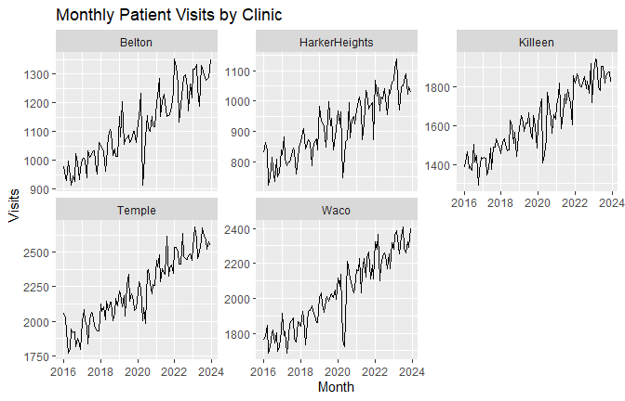
system_monthly <- healthlink %>%
group_by(month) %>%
summarise(visits = sum(visits), .groups = "drop")
system_ts <- ts(system_monthly$visits, start = c(2016, 1), frequency = 12)
plot(system_ts,
main = "Texas HealthLink Systemwide Monthly Visits",
ylab = "Visits",
xlab = "Year")
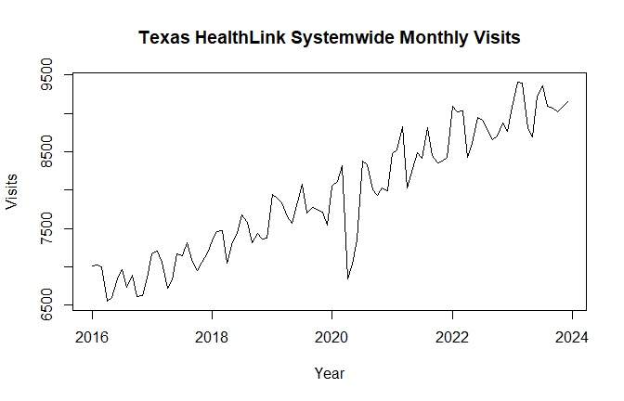
system_decomp <- stl(system_ts, s.window = "periodic")
plot(system_decomp)
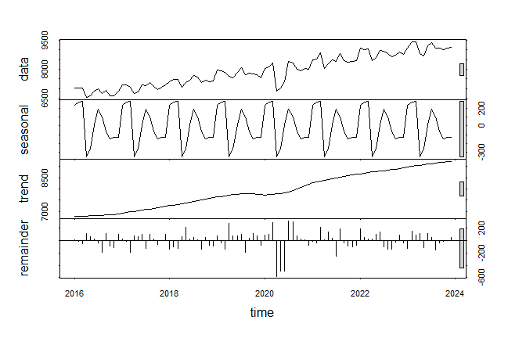
hl_system_snaive <- snaive(system_ts, h = 12)
hl_system_ets <- ets(system_ts)
hl_system_ets_fc <- forecast(hl_system_ets, h = 12)
hl_system_arima <- auto.arima(system_ts, seasonal = TRUE, stepwise = FALSE, approximation = FALSE)
hl_system_arima_fc <- forecast(hl_system_arima, h = 12)
hl_system_reg <- tslm(system_ts ~ trend + season)
hl_system_reg_fc <- forecast(hl_system_reg, h = 12)
hl_system_accuracy <- rbind(
Seasonal_Naive = accuracy(hl_system_snaive)[1, c("RMSE", "MAE", "MAPE")],
ETS = accuracy(hl_system_ets_fc)[1, c("RMSE", "MAE", "MAPE")],
ARIMA = accuracy(hl_system_arima_fc)[1, c("RMSE", "MAE", "MAPE")],
Regression = accuracy(hl_system_reg_fc)[1, c("RMSE", "MAE", "MAPE")]
)
knitr::kable(round(hl_system_accuracy, 3), caption = "Texas HealthLink systemwide model accuracy comparison")
Texas HealthLink systemwide model accuracy comparison
 | RMSE | MAE | MAPE
Seasonal_Naive | 433.273 | 373.810 | 4.645
ETS | 173.238 | 120.470 | 1.552
ARIMA | 194.404 | 127.449 | 1.611
Regression | 178.154 | 117.116 | 1.526
hl_system_accuracy_df <- data.frame(
model = rownames(hl_system_accuracy),
RMSE = hl_system_accuracy[, "RMSE"],
MAE = hl_system_accuracy[, "MAE"],
MAPE = hl_system_accuracy[, "MAPE"],
row.names = NULL
)
hl_system_champion <- hl_system_accuracy_df$model[which.min(hl_system_accuracy_df$RMSE)]
hl_system_champion
## [1] "ETS"
hl_system_forecast <- if (hl_system_champion == "ETS") {
hl_system_ets_fc
} else if (hl_system_champion == "ARIMA") {
hl_system_arima_fc
} else if (hl_system_champion == "Regression") {
hl_system_reg_fc
} else {
hl_system_snaive
}
autoplot(hl_system_forecast) +
labs(
title = paste("Texas HealthLink Systemwide Forecast - Champion Model:", hl_system_champion),
x = "Year",
y = "Visits"
)
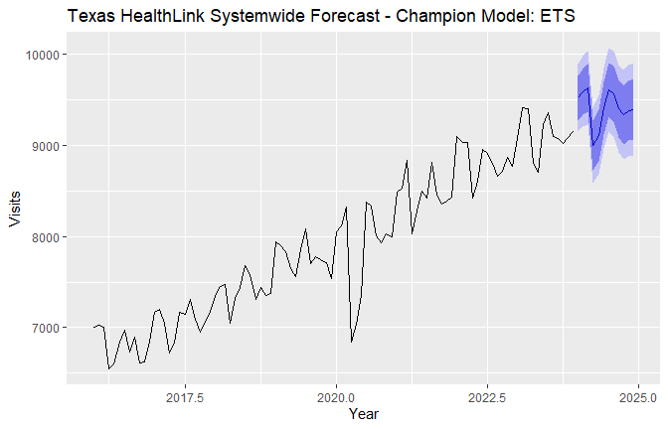
make_clinic_forecast <- function(df, key) {
clinic_name <- as.character(key$clinic[1])
clinic_ts <- ts(df$visits, start = c(2016, 1), frequency = 12)
fit_ets <- ets(clinic_ts)
fit_arima <- auto.arima(clinic_ts, seasonal = TRUE)
fit_reg <- tslm(clinic_ts ~ trend + season)
fc_ets <- forecast(fit_ets, h = 12)
fc_arima <- forecast(fit_arima, h = 12)
fc_reg <- forecast(fit_reg, h = 12)
fc_snaive <- snaive(clinic_ts, h = 12)
acc <- rbind(
Seasonal_Naive = accuracy(fc_snaive)[1, c("RMSE", "MAE", "MAPE")],
ETS = accuracy(fc_ets)[1, c("RMSE", "MAE", "MAPE")],
ARIMA = accuracy(fc_arima)[1, c("RMSE", "MAE", "MAPE")],
Regression = accuracy(fc_reg)[1, c("RMSE", "MAE", "MAPE")]
)
best <- rownames(acc)[which.min(acc[, "RMSE"])]
fc <- if (best == "ETS") {
fc_ets
} else if (best == "ARIMA") {
fc_arima
} else if (best == "Regression") {
fc_reg
} else {
fc_snaive
}
# Do not return the clinic column here.
# group_modify() adds the grouping variable back automatically.
data.frame(
month = seq.Date(as.Date("2024-01-01"), by = "month", length.out = 12),
champion_model = best,
forecast = as.numeric(fc$mean),
lower_80 = as.numeric(fc$lower[, 1]),
upper_80 = as.numeric(fc$upper[, 1]),
lower_95 = as.numeric(fc$lower[, 2]),
upper_95 = as.numeric(fc$upper[, 2])
)
}
clinic_forecasts <- healthlink %>%
group_by(clinic) %>%
group_modify(~ make_clinic_forecast(.x, .y)) %>%
ungroup()
knitr::kable(head(clinic_forecasts, 20), digits = 1, caption = "Clinic-level 12-month forecasts")
Clinic-level 12-month forecasts
clinic | month | champion_model | forecast | lower_80 | upper_80 | lower_95 | upper_95
Belton | 2024-01-01 | Regression | 1368.6 | 1303.9 | 1433.2 | 1269.1 | 1468.0
Belton | 2024-02-01 | Regression | 1355.9 | 1291.3 | 1420.6 | 1256.4 | 1455.4
Belton | 2024-03-01 | Regression | 1379.6 | 1314.9 | 1444.2 | 1280.1 | 1479.0
Belton | 2024-04-01 | Regression | 1270.1 | 1205.4 | 1334.7 | 1170.6 | 1369.5
Belton | 2024-05-01 | Regression | 1292.3 | 1227.7 | 1356.9 | 1192.8 | 1391.8
Belton | 2024-06-01 | Regression | 1342.3 | 1277.7 | 1406.9 | 1242.8 | 1441.8
Belton | 2024-07-01 | Regression | 1360.7 | 1296.1 | 1425.3 | 1261.2 | 1460.2
Belton | 2024-08-01 | Regression | 1340.8 | 1276.2 | 1405.4 | 1241.3 | 1440.3
Belton | 2024-09-01 | Regression | 1335.8 | 1271.2 | 1400.4 | 1236.3 | 1435.3
Belton | 2024-10-01 | Regression | 1327.2 | 1262.6 | 1391.8 | 1227.7 | 1426.7
Belton | 2024-11-01 | Regression | 1326.9 | 1262.3 | 1391.6 | 1227.4 | 1426.4
Belton | 2024-12-01 | Regression | 1348.8 | 1284.2 | 1413.4 | 1249.3 | 1448.3
HarkerHeights | 2024-01-01 | Regression | 1116.5 | 1059.6 | 1173.4 | 1028.9 | 1204.1
HarkerHeights | 2024-02-01 | Regression | 1122.9 | 1066.0 | 1179.8 | 1035.3 | 1210.4
HarkerHeights | 2024-03-01 | Regression | 1125.5 | 1068.6 | 1182.4 | 1037.9 | 1213.1
HarkerHeights | 2024-04-01 | Regression | 1039.6 | 982.8 | 1096.5 | 952.1 | 1127.2
HarkerHeights | 2024-05-01 | Regression | 1035.5 | 978.6 | 1092.4 | 947.9 | 1123.1
HarkerHeights | 2024-06-01 | Regression | 1072.8 | 1015.9 | 1129.6 | 985.2 | 1160.3
HarkerHeights | 2024-07-01 | Regression | 1102.8 | 1045.9 | 1159.6 | 1015.2 | 1190.3
HarkerHeights | 2024-08-01 | Regression | 1092.4 | 1035.5 | 1149.3 | 1004.8 | 1179.9
reconciled_total <- clinic_forecasts %>%
group_by(month) %>%
summarise(
forecast = sum(forecast),
lower_80 = sum(lower_80),
upper_80 = sum(upper_80),
lower_95 = sum(lower_95),
upper_95 = sum(upper_95),
.groups = "drop"
)
knitr::kable(reconciled_total, digits = 1, caption = "Bottom-up reconciled systemwide forecast")
Bottom-up reconciled systemwide forecast
month | forecast | lower_80 | upper_80 | lower_95 | upper_95
2024-01-01 | 9528.4 | 9131.5 | 9925.3 | 8917.3 | 10139.5
2024-02-01 | 9589.6 | 9192.6 | 9986.5 | 8978.5 | 10200.6
2024-03-01 | 9624.4 | 9227.5 | 10021.3 | 9013.3 | 10235.5
2024-04-01 | 9015.9 | 8619.0 | 9412.8 | 8404.8 | 9627.0
2024-05-01 | 9125.8 | 8728.9 | 9522.7 | 8514.7 | 9736.9
2024-06-01 | 9422.4 | 9025.5 | 9819.3 | 8811.3 | 10033.5
2024-07-01 | 9625.4 | 9228.5 | 10022.3 | 9014.3 | 10236.5
2024-08-01 | 9553.3 | 9156.4 | 9950.2 | 8942.2 | 10164.4
2024-09-01 | 9415.8 | 9018.9 | 9812.7 | 8804.7 | 10026.9
2024-10-01 | 9351.3 | 8954.4 | 9748.2 | 8740.2 | 9962.4
2024-11-01 | 9396.9 | 9000.0 | 9793.8 | 8785.8 | 10008.0
2024-12-01 | 9418.8 | 9021.9 | 9815.7 | 8807.7 | 10029.9
ggplot(clinic_forecasts, aes(x = month, y = forecast)) +
geom_line() +
geom_point() +
facet_wrap(~ clinic, scales = "free_y") +
labs(
title = "Texas HealthLink 12-Month Forecast by Clinic",
x = "Month",
y = "Forecasted visits"
)
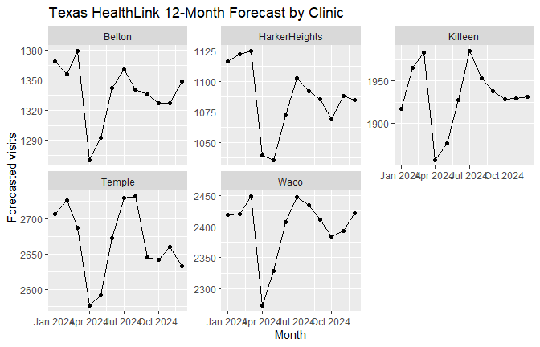

Exercise #2 Recommendation
Texas HealthLink should use both the clinic-level forecasts and the systemwide forecast. The systemwide forecast helps with total budget planning. The clinic forecasts help with staffing and facility decisions. I would not recommend using one staffing rule for all clinics because the clinics have different demand levels.

Bonus #2: Interview-Ready Time Series Literacy

Executive Summary
When I start a forecasting problem, I do not jump straight into the model. I first look at the time series plot because the plot usually tells the first part of the story. I want to see whether the data is moving up or down, whether there is seasonality, and whether there are unusual periods that should not be ignored.
In this project, both datasets had a clear business purpose. Lone Star Appliances needed shipment forecasts to plan production, staffing, inventory, and logistics. Texas HealthLink needed patient visit forecasts to plan staffing, budgeting, scheduling, and clinic capacity.
The main lesson from both exercises is that forecasting is not just a technical task. The forecast has to connect back to a decision. For Lone Star, the 2020 drop showed why leadership should not rely only on the point forecast. For HealthLink, the clinic-level forecasts matter because each clinic has a different demand level. A systemwide forecast helps with budgeting, but the clinic forecasts are better for staffing.
My approach is simple. I check the pattern, test more than one model, compare the errors, review the residuals, and explain the forecast range in plain language. I do not treat the model as perfect. I treat it as a planning tool.

Graph Commentary
The time series plots are the first check. They show whether the data is trending up, moving with a seasonal pattern, or showing unusual shocks. In Lone Star, the plot shows growth over time and stronger end-of-year demand. It also shows the 2020 disruption.
The decomposition plots help separate the series into trend, seasonal movement, and leftover noise. This is useful because leadership may only see one line moving up or down, but the model needs to separate the long-term direction from the repeating seasonal pattern.
The residual plots are the final check. I use them to see what the model missed. A good model should leave residuals that look mostly random. If the residuals still show a pattern, I would not be comfortable using that model without more review.

Mock Interview Q&A
Question: How do you start a forecasting problem?
I start with the plot. Before I choose a model, I want to understand the shape of the data. I look for trend, seasonality, outliers, and shocks. In this project, the Lone Star data showed long-term growth and a clear quarterly pattern. The HealthLink data showed clinic-level differences and systemwide growth.
Question: What did you learn from the Lone Star forecast?
Lone Star shipments were increasing over time, but the 2020 period showed a disruption. That matters because a company can have strong demand and still face short-term shocks. I would use the forecast as a baseline, but I would also keep a buffer for inventory and logistics planning.
Question: What did you learn from the HealthLink forecast?
The HealthLink forecast showed why clinic-level planning matters. The systemwide forecast is useful for the total budget, but staffing has to be planned by clinic. Temple and Waco have higher visit volume than smaller clinics, so one staffing rule would not fit every location.
Question: Why compare ETS, ARIMA, regression, and seasonal naive models?
I do not want to trust one model too quickly. Seasonal naive gives a simple baseline. ETS is useful for trend and seasonality. ARIMA is useful when past values and autocorrelation matter. Regression with seasonality is easy to explain to leadership. Comparing them gives me a better reason for choosing the final model.
Question: What does residual checking tell you?
Residuals show what the model missed. If residuals still have a pattern, that means the model may not be capturing the full story. In a business setting, I would not just show the forecast. I would also check whether the errors look reasonable.
Question: How do you explain forecast uncertainty to leadership?
I explain that the point forecast is not a promise. It is the middle estimate. The interval is the planning range. If leadership only plans around the point forecast, they may be underprepared. For staffing, inventory, and logistics, the range matters.
Question: What makes a forecast useful?
A forecast is useful when it helps someone make a better decision. In this project, the forecast supports production planning, clinic staffing, budgeting, inventory, logistics, and facility planning. The model is only one part of the work. The final step is explaining what leadership should do with it.
Question: What could make the forecast wrong?
The forecast could be wrong if the future does not behave like the past. COVID-type disruptions, supply chain issues, staffing shortages, capacity limits, economic changes, and changes in customer or patient behavior could all affect the forecast.
Question: Which tools would you use in practice?
For this project, R worked well because the forecasting package makes ETS, ARIMA, decomposition, and diagnostics straightforward. I would still use Python when the forecasting work needs to connect with larger machine learning pipelines, dashboards, or production systems. For a time-series class project, R is the cleaner tool.

Final Conclusion
Both exercises point to the same main lesson: forecasting is useful only when it supports a decision. Lone Star should use the shipment forecast for production, staffing, inventory, and logistics planning. Texas HealthLink should use the clinic-level and systemwide forecasts for staffing, budgeting, scheduling, and capacity planning.
The models are not perfect, but they give leadership a better planning baseline than guessing. The safest approach is to review the forecast each period, compare the forecast to actual results, and update the plan when the data changes.

References
CUNY School of Professional Studies. (2026). DATA 624: Predictive Analytics syllabus [Course syllabus].
CUNY School of Professional Studies. (2026). Project #1: Lone Star Appliance [Project instructions].
CUNY School of Professional Studies. (2026). Data: Lone Star Appliance modeling data [Dataset].
CUNY School of Professional Studies. (2026). Project #1: Texas HealthLink [Project instructions].
CUNY School of Professional Studies. (2026). Data: HealthLink modeling data [Dataset].
Hyndman, R. J., & Athanasopoulos, G. (2021). Forecasting: Principles and Practice (3rd ed.). OTexts.
Kuhn, M., & Johnson, K. (2013). Applied predictive modeling. Springer.

