Understanding 802.11 connection process

A basic configuration of a BSS (Basic Service Set) operating in infrastructure mode consists of a station (STA) and an access point (AP) attached to a backbone network.

Wifi network discovering

There are two ways that a STA detects the presence of an AP:
- passive scanning - using beacon frame: the APs broadcast periodically the frames that identify themselves as well as provide information about the networks behind. We call this passive scanning, because the Wireless NIC (WNIC) receives these frames without sending any data. Default beacon broadcasting interval is set to 100TU (1TU = 1,024 ms).

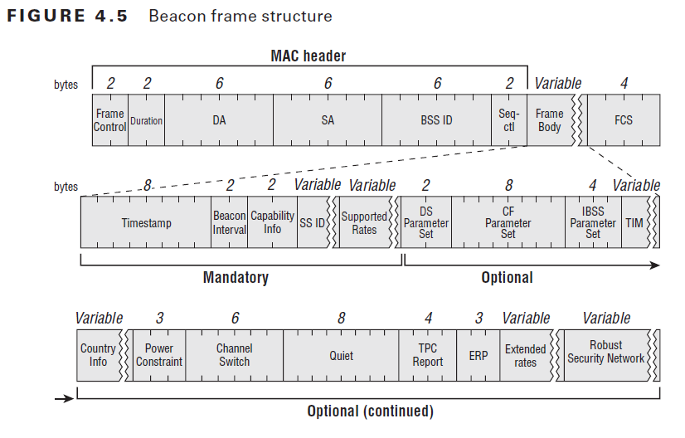
Figure 1 – Structure of a beacon frame

- active scanning - using probe request/response: the STA actively scans for APs by sending probe request on each channel. Probe request is an broadcast Ethernet packet containing STA informations and capabilities (supported data rates, channels). If an AP realizes that it has the same capabilities, an unicast packet is responded to the STA. MinCT is the maximum waiting time of a probe response, and MaxCT is the additional waiting time for other responses if there were any probe response received during MinCT.

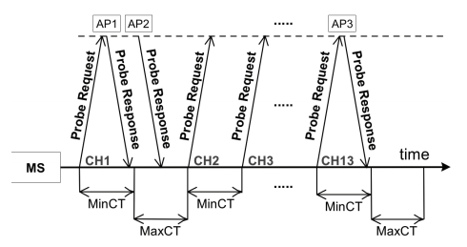
Figure 2 – Active scanning process

Wifi network authenticating and associating

After an active scanning process, the STA has a list of “connectable” access points.
Suppose that our STA wants to connect to an access point AP. This process of two phases then has to be happened:

- authenticating phase: this phase is used to authenticate a STA to an AP. In the past, there were two methods of authenticating:
+ Open System: this method performs no client verification. At the birth of 802.11, this method allows any STA to connect with the AP without providing any password, creating an open network.*
+ Pre-shared key: in this method, the STA and the AP agree on a passphrase that will be used to challenge the STA each time it wants to connect with the AP. This method was then deprecated because of its security vulnerabilities.

In this phase, the STA sends an authentication request, and the AP responds with an authentication response indicating the success of authentication process.
After authenticating itself to the AP, the STA goes into “authenticated, unassociated state”. Both the STA and the AP save this information.

*Nowadays, modern wifi standards use Open System as their default authentication method, along with an Extended Authentication Protocol (EAP) that happens after the association phase.

- association phase: this phase happens when a STA has already been authenticated (aka being in “authenticated, unassociated” state) and decides to connect to the desired AP. This is when the AP and the STA agree on the common parameters that will be used for the communication later on.
In the same way, the STA sends an association request to the AP it wants to connect, and the AP responds with an association response. Depend on the configuration, the AP can either accept or refuse the association request (ex. overloading, weak security policy...).
After successfully associated, the STA is in “authenticated, associated” state. From now on, it is connected to the wifi network.

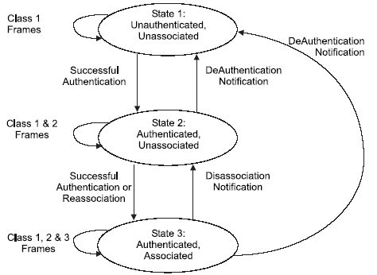
Figure 3 – 802.11 connection state machine
High-level authentication protocol

This is what happens after a STA has successfully connected to a wifi network (authenticated, associated). If the security configuration is set, before that any data frame could be forward between the STA and the network, an other “high-level” authentication phase will take place. Again, it is pre-shared key with 4-way hand shake or key exchanging protocol through EAPoL (Extended Authentication Protocol over LAN).

Dis-authentication, Fast Re-association and Roaming

- Active leaving: when a STA wants to leave an AP, or an AP decides to stop serving the STA, a dis-authentication frame will be sent with info about the reason. After being notified, the status of the STA is set back to “unauthenticated, unassociated”.
- Passive leaving: in case of brutal corruption of AP, the STA must wait for a certain time before notice that the signal has been lost. How?
Remember of beacon frame. The beacon frame is the way the AP confirms its life to the STA. Missing AP beacon frame, the STA will try to scan all the network to find the AP again.

