## CMPEN/EE455:  Digital Image Processing I

## Computer Project # 4

## Image Enhancement: Histogram Modification

## Group 7: Ziheng Fu, Ya Mei, Songmeng Wang

## Date: 11/6/2019

**Objectives**

The objective of this project is to study the method the improve the quality of the image by histogram processing. Histogram is the plot of the bins where each bin represents the number of pixels with the particular intensity value. The distribution of the histogram along the full intensity scale could be a scalar of the equality of the image and the effect of histogram modification such as histogram equalization and histogram specification will be discussed in this project.

**Methods**

1):

To compute the image’s histogram $p_{r}(r)$ (head), we first create a column vector “Histogram” with 256 rows and initiate its values to be zeros. We then use two *for* loops to create a matrix for the image; inside the for loops, we use a variable “temp” to hold a pixel value at pixel (i, j) temporarily. In addition, we need to add 1 to the pixel value because MATLAB index starts at 1 instead of 0. We next can write an algorithm “Histogram(temp) = Histogram(temp) + 1” to compute the number of pixels with respect to each pixel value presented in the image. This algorithm will loop through the image and add 1 to the number of pixels for each pixel value whenever it encounters that pixel value. Finally, we use plotting function bar ($∙$) to plot the Histogram.  
  
To compute the image’s cdf $c_{r}(r)$, we again create a column vector “histogram” with 256 rows and initiate its values to be zeros. We then use a for loop with a value k ranging from 1 to 256 representing the index of Histogram. Since we need to compute the cumulative sum of the number of pixels for each pixel value, we write two if statements inside the for loop. The first if statement is for when k equals to 1, then histogram (1) just equals to Histogram (1) created earlier since there is no value beforehand. The second if statement is for when k is greater than 1, then we can write an algorithm “histogram(k) = Histogram(k) + histogram(k-1)” to compute the cumulative sum of the number of pixels at index k. This algorithm adds the number of pixels at index k and all the number of pixels before it and make it the new number of pixels at index k. We next need to divide each value in histogram by (256*256), the total number of pixels in the image, since we are computing $c_{r}(r)$. Finally, we use plotting function bar ($∙$) to plot the histogram.

2):

Before we apply gamma correction to the image, we first normalize the image using “img = im2double (image)” which normalizes all pixel values to be between 0 and 1. We use two *for* loops to create a matrix for the image; inside the for loops, we implement the gamma correction formula by equation 1:

s =c($r^{ γ}$) (1)

It raises every pixel value to the power of gamma that we specify (gamma = 5.0 and 0.20 in this project) and times the result by a constant factor c, which equals to the maximum possible pixel value of the image, that is, c = 1 in our case. We finally can use imshow($∙$) to display the image after gamma correction. Before we compute the gamma corrected images’ histogram $p_{r}(r)$ (head) and cdf $c_{r}(r)$, we first have to unnormalize the resulted image using “opt=im2uint8(output)”. We can then use the algorithm that we developed in Question 1 to compute the corresponding $p_{r}(r)$ (head) and cdf $c_{r}(r)$.

4):

Histogram equalization is one of the methods in histogram processing, and histogram processing has the form of (2):

$s=T\left(r\right)$ (2)

The r represents the intensities of an image to be processed and s denotes intensities of the result image. The inverse function can be denoted as:

$r=T^{-1}\left(s\right)$ (3)

The intensity of an image can be viewed as a random variable in the interval [0 , L-1], let $p_{r}(r)$ and $p_{s}(s)$ denote the PDFs of intensity values r and s in the two images. The PDF of the mapped s can be obtained as:

$p_{s}\left(s\right)=p_{r}\left(r\right)\left|\frac{dr}{ds}\right|$ (4)

The transformation function from the pdf of r to the mapped image s can be obtained by:

$s=T\left(r\right)=\left(L-1\right)\int_{0}^{r}{p_{r}\left(w\right)}dw=nint\left[\left(L-1\right)c_{r}\left(r\right)\right]$ (5)

To realize the histogram equalization in MATLAB, the distance between s and the upper nearest number and the distance between s and the lower nearest number are compare and the nearest integer can be confirmed accordingly.

**Results**

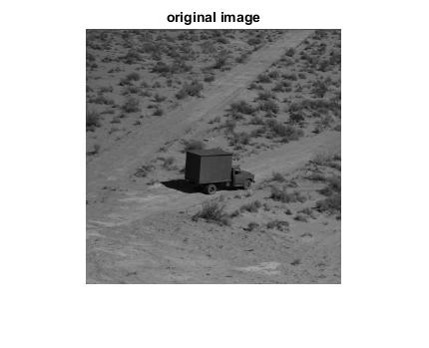

*Figure 1: Original Image*

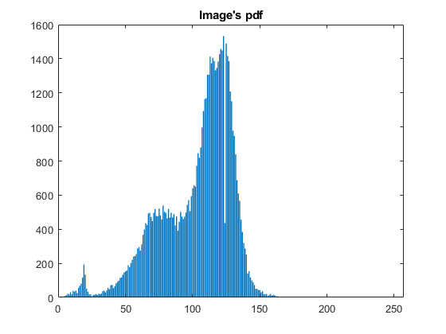

*Figure 2: Image’s histogram $p_{r}\left(r\right)$*

As we see from the image’s histogram $p_{r}\left(r\right)$ (head), there are not many “bright” pixels, nor there are many “black” pixels. The pixel values of the image are mainly grouped between 60 to 140.

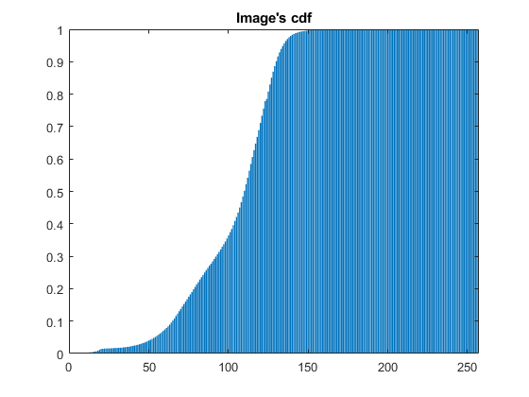

*Figure 3: Image’s cdf $c_{r}(r)$*

As we see from the image’s *cdf $c_{r}(r)$,* the image’s cdf $c_{r}(r)$ is directly proportional to the pixel value. Further, all pixel values are in the range of approximately 15 and 150.

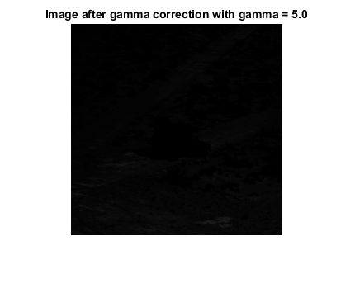

*Figure 4: Image after gamma correction with gamma = 5.0*

As we see from the image, after applying gamma correction with gamma = 5.0, the original image becomes very dark and it is very difficult to see the truck from the image.

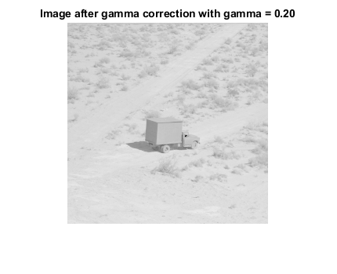

*Figure 5: Image after gamma correction with gamma = 0.20*

As we see from the image, after applying gamma correction with gamma = 0.20, the original image becomes very bright. The truck can be seen easily from the image.

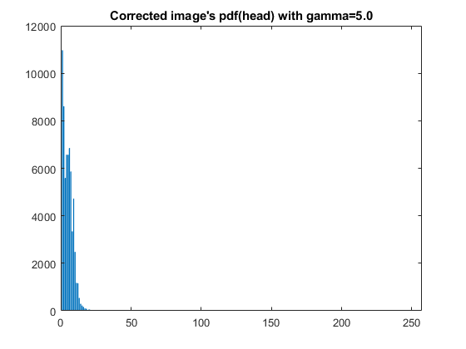

*Figure 6: Corrected image’s histogram $p_{r}\left(r\right)$ with gamma = 5.0*

As we see from the plot, after applying gamma correction with gamma = 5.0, all pixel values fall to the left side of the plot, which are approximately less than 20. The new distribution of the pixel values in the plot, compared to that of the original image, indicates that the image becomes darker after applying gamma correction.

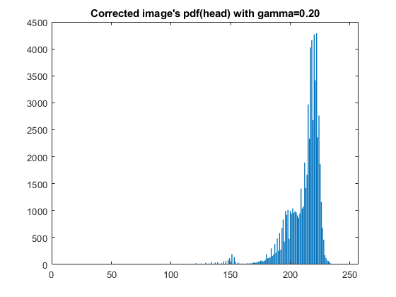

*Figure 7: Corrected image’s histogram $p_{r}\left(r\right)$ with gamma = 0.20*

As we see from the plot, after applying gamma correction with gamma = 0.20, all pixel values fall to the right side of the plot, which are mainly grouped between 180 and 230. The new distribution of the pixel values in the plot, compared to that of the original image, indicates that the image becomes brighter after applying gamma correction.

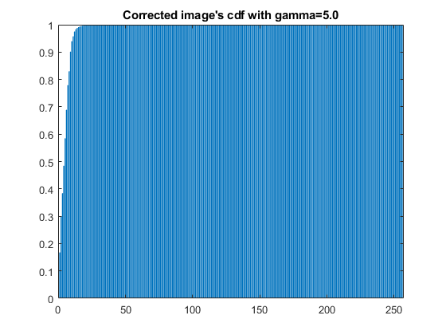

*Figure 8: Corrected image’s cdf $c_{r}(r)$ with gamma = 5.0*

As we see from the plot, all pixel values are less than approximately 20. The plot indicates that all pixels are counted for pixel values less than approximately 20. It again, compared to that of the original image, demonstrates the image becomes darker after applying gamma correction.

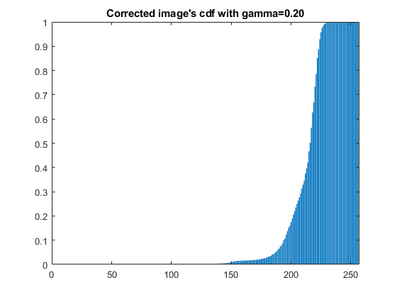

*Figure 9: Corrected image’s cdf $c_{r}(r)$ with gamma = 0.20*

As we see from the plot, the distribution of the pixels values falls to the right side of the plot and all pixel values are greater than approximately 150. It again, compared to that of the original image, demonstrates the image becomes brighter after applying gamma correction.

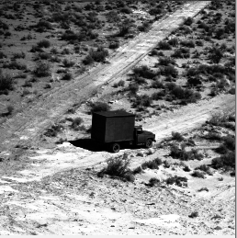

*Figure 10: The comparison of the result image of histogram equalization(left) and the original image(right)*

The result image displays more details compared to the original image, and this shows that the histogram equalization could improve the image equality by spreading the histogram over the full range of the intensities so that the visible detail could be increased. Further details can be studied by its histogram and cdf.

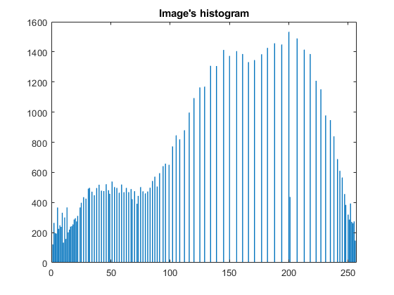

*Figure 11: The histogram of the result*

It’s apparently that the histogram is stretched and spans the full intensity scale as expected, which caused the result as shown in the figure 10.

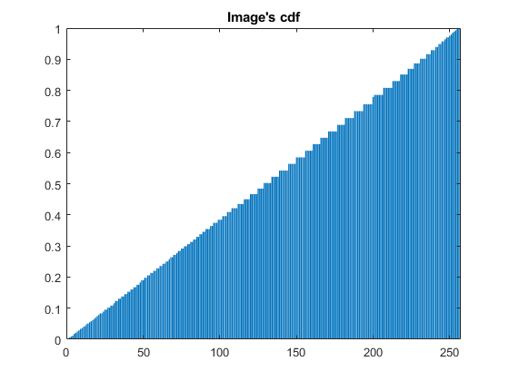

Figure 12: cdf of the result image

As shown in figure 12, the cdf is nearly a linear increasing plot, which means that the pdf of each intensity value is almost same and the histogram equalization works well on this scenario.

**Conclusion**

As discussed in the results, the distribution of the histogram can reflect the quality of the image, to be more specific, the image looks dark as most part of the histogram concentrated at low intensity levels and the histogram for light images are biased toward high intensity levels. Additionally, the image has a low contrast if it has a narrow histogram. Hence, an image with satisfactory quality if its histogram covers a wide range of intensity scale.

Fortunately, the quality of the image could be modified with some methods of histogram processing. The histogram equalization which stretches the histogram to cover the full intensity scale is a significant method to improve the image so that more details of the image could appear as suggested by figure 10.

**Reference**

[1] *Digital Image Processing*, *4th Edition*, Rafael C. Gonzalez, Richard E. Woods