Notes: 07/02/2012. We analyzed the data again and saw that for experiment one there were too few trials for some of the points in the graphs. This was due to the filter that we had applied on trials were the checkerboard appeared before 4 flashes of the mondrians. We took this filter out, plotted the data again and then saw that the statistics were correct and that the accuracy / visibility plots for each contrast condition make much more sense now.

Problem of comparisons: we need a measure of visibility to compare between subjects of experiment 1,2,3 to show the 20% of increase in accuracy in experiment 2

METHODS:

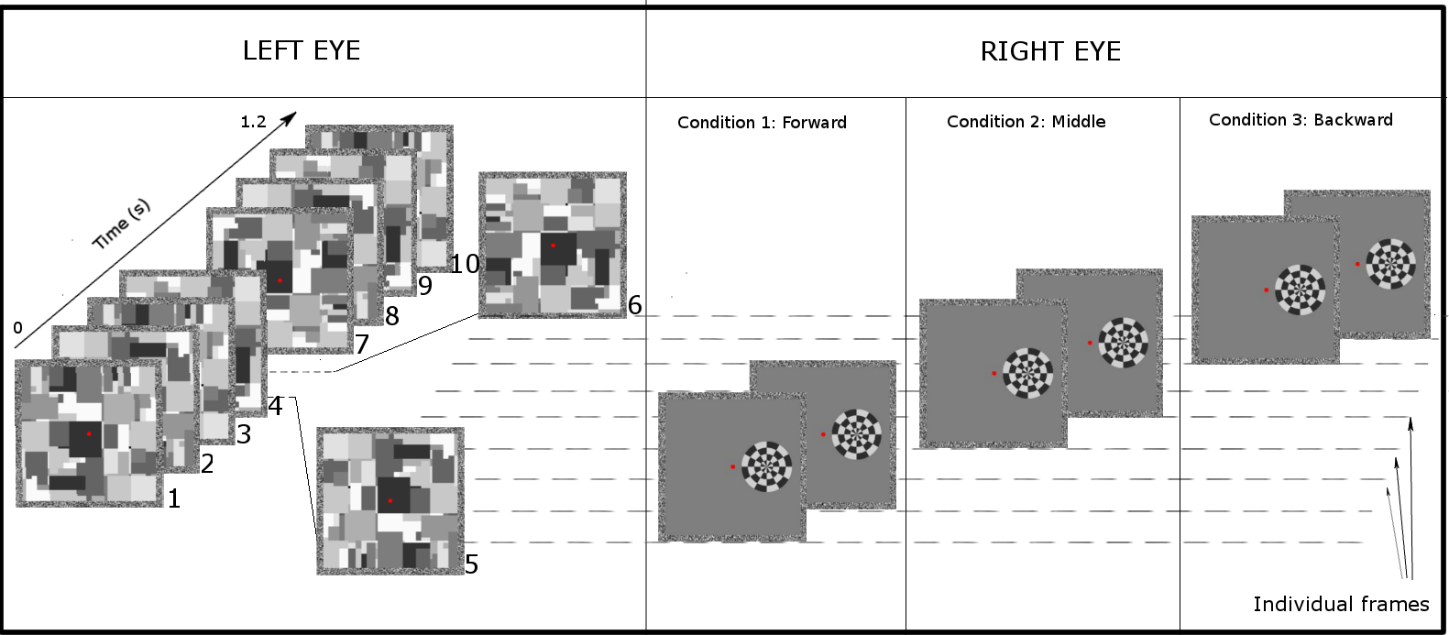
Figure 1. Schematic representation of three trials. Mondrians were presented to left eye (leftmost panel in the figure) with a frequency of 8.5 Hz in experiment 1 and with variable frequencies in experiment 2. Here we show three trials occurring between the 5th and 6th Mondrian. Forward condition: the targets were presented in the two frames immediately after the preceding Mondrian. Middle condition: the targets were presented at an equal temporal distance between the previous and subsequent Mondrian. Backward condition: the targets were presented in the two frames immediately before the following Mondrian. The checkerboard was presented for 2 video frames (24ms), and the color polarity was inverted from the first frame to the second frame (see methods).

Subjects
Three authors and 29 naive subjects (mean age: 28.4 years, range: 23 - 41 years) participated in the experiments. They all had normal or corrected-to-normal visual acuity. Prior to the experiment all participants gave their informed consent according to the guidelines of the University of Trento ethical committee.

Apparatus
Stimuli were generated on a PC running Matlab and Psychtoolbox 3.0. They were presented on a 21” Phillips Brilliance 109P4 CRT monitor with a refresh rate of 85Hz and a screen resolution of 1280 x 1024 pixels. Except for the luminance of the monitor, the room was otherwise dark. Stimuli were viewed through a mirror stereoscope and a headrest was used to maintain a constant viewing distance of 60 cm.

Stimuli
Two square frames were used to help stabilize binocular fusion. Throughout the experiments we used a black and white checkerboard and a series of Mondrian masks. The checkerboard was 3x3 degrees of visual angle in size and was formed by 12 equally sized sectors, each of which was further subdivided into four sections along the radius. The checkerboard was always presented at an eccentricity of 2° from the fixation point against a gray background (CIE coordinates: x = 0.29 y = 0.32 z = 0.39; luminance = 18.2 cd/m^2). Mondrians were created by randomly superimposing black, white and gray squares. They subtended 8° of visual angle and filled the entire inner area of the external frames (Figure 1). Prior to each experimental session 40 Mondrians were created and 10 Mondrians were randomly selected for each trial. Checkerboards were presented to the right eye while Mondrians were always presented to the left eye.

Procedures
In all experiments the task of subjects was to detect the location of the checkerboards. These were presented for 24ms (two video frames) within a time window between 500 and 900ms after trial start. Checkerboards changed color polarity (white areas turning black and black areas turning white) on their second frame of presentation (Figure 1).
Objective measure of detectability. At the end of each trial four blue arrows appeared on the screen and participants had to indicate the location where the checkerboard was presented on the screen. They responded 'up', 'down', 'left' or 'right' (4AFC) using the four arrow keys of the keyboard.
Subjective measure of detectability. Immediately after the first question subjects had to respond whether they had consciously seen the checkerboard on the screen or not. This provided a trial by trial subjective measure of checkerboard visibility.

Experiment 1. The timing of masking brief stimuli with CFS.
Twelve subjects (3 authors) participated in experiment 1. Except for the authors all subjects were naïve with respect to the aims of the experiment. On each trial a series of 10 Mondrians randomly chosen from the set of 40 were presented at a frequency of 8.47Hz. Checkerboards were presented on the screen within a time window of 500 - 900ms after trial start. In order to generate full continuous flash suppression (CITE Tsuchiya 2006 here) at least 5 Mondrians were presented on the screen before the appearance of the checkerboard. Checkerboards were presented at 4, 12, 16, 24 and 64% of Michelson contrast. To study the effect that temporal distance between checkerboard and Mondrian presentation had on detection we presented 3 different timing conditions. Checkerboards were presented on the two frames immediately following the presentation of the Mondrian in the backward condition, on the frames temporarily situated in the middle between two Mondrians (4th and 5th video frames after Mondrian onset) in the middle condition, and on the two frames immediately preceding the presentation of the Mondrian in the forward condition (Figure 1). Each subject performed 64 trials for each contrast x timing condition, in 6 counterbalanced blocks of 160 trials amounting to a total of 960 trials (~1 hour of experiment). 16 checkerboards were presented in each location for each contrast x timing condition. The inter trial interval was randomly chosen among the values: 250, 500, 750 or 1000ms. Prior to the main experiment subjects performed two training blocks.

Experiment 2. The effect of mask frequency on the detection of brief targets.
Twelve subjects (3 authors) participated in experiment 2. Except for the authors all subjects were naïve with respect to the aims of the experiment. The main goal of this experiment was to assess the effect of mask frequency on the detection of brief targets. For this reason we presented the Mondrians with 5 temporal frequencies: 5.3, 8.5, 10.6, 16.6 and 28.5 Hz. The checkerboards were presented at 12%, 16% and 64% of Michelson contrast. In this experiment we presented the checkerboards only in the backward condition. They appeared only after 5 Mondrians had been presented on the screen (to produce full CFS) and in a variable time window (after the 5th, 6th , 7th or 8th Mondrian). Each subject performed 40 trials for each contrast x timing condition, in 5 counterbalanced blocks of 120 trials amounting to a total of 600 trials (~45 minutes of experiment). Each frequency was tested in a block, and the order of block presentation was randomized across subjects to avoid learning effects. 10 checkerboards were presented in each location for each contrast x timing condition. The inter trial interval was randomly chosen among the values: 250, 500, 750 or 1000ms. Prior to the main experiment subjects performed two training blocks.

Control of experiment 2. CFS vs Interocular Visual Masking.
Seven subjects (1 author) participated in this experiment. Except for the author all subjects were naïve with respect to the aims of the experiment. All contrast, timing and frequency parameters were identical to experiment 2, except for the number of Mondrians. For this experiment only 2 Mondrians were presented on each trial: the Mondrians preceding and following the checkerboard presentation. This manipulation transformed the previous CFS experiment into an interocular visual masking experiment. This allowed us to assess the effect of the initial 4 (?) Mondrian presentation during CFS on the detection of brief targets. The aim of this control was also to evaluate the depth of suppression induced by CFS as compared to interocular visual masking for the detection of briefly presented targets. The number of trials, blocks, conditions, and total duration of the experiment were identical to experiment 2

RESULTS:
Experiment 1
A two-way repeated measures ANOVA with timing and contrast as factors revealed main effects for contrast (F(4, 44) = 40.03, p < 0.001), for the timing of presentation of targets (F(2, 22) = 14.89, p < 0.001) and a significant interaction parameter (F(8, 88) = 3.6, p < 0.005). Post-hoc Bonferroni corrected paired t-tests showed a statistically consistent difference between backward masking condition (black squares) and forward and middle masking condition (light gray triangles) at 12 % contrast (corrected p < 0.05). At 16 % contrast levels only middle masking was statistically different from backward masking (corrected p < 0.05). N = 12, error bars represent one s.e.m.

Experiment 2
We ran a two-way repeated measures ANOVA with frequency and contrast as factors. We observed a main effect of frequency (F(4, 44)= 14.23, p < 0.001), a main effect of contrast (F(2, 22)= 49.32, p < 0.001) and an interaction between these main factors (F(8, 88)= 4.25, p < 0.001). Also, for each contrast value we ran one way repeated measures ANOVA with frequency as factor. These analysis showed that there was a main effect of frequency on visibility for targets presented at 12% contrast (F(4,44)= 8.17, p < 0.001), at 16% contrast (F(4,44)= 10.58, p < 0.001) and even at 64% contrast (F(4,44)= 5.12, p < 0.005). Post hoc Bonferroni corrected comparisons showed that for 12 and 16 % contrasts the accuracies for trials with a frequency of 28.5 Hz were statistically lower than for 5, 8.5 and 10.6 Hz (p corrected < 0.005).

Experiment 2. Control
ANOVA revealed a main effect of frequency (F(4, 24)= 6.47, p < 0.001), a main effect of contrast (F(2, 12)= 71.565, p < 0.001) but no interaction between these main factors (F(8, 48)= 0.92, p = 0.5). For each contrast value we ran one way repeated measures ANOVA with frequency as factor. These analysis showed that there was a main effect of frequency on visibility for targets presented at at 16% contrast (F(4,24)= 4.11, p < 0.05) and 64% contrast (F(4,24)= 3.06, p < 0.05). There was no main effect of frequency at 12% contrast (F(4,24)= 0.83, p = 0.51). Post hoc Bonferroni corrected comparisons showed that none of the conditions was statistically different from each other (10 comparisons, p < 0.005):
data: hz_5 and hz_16 ; t = 3.8512, df = 6, p-value = 0.008448
data: hz_5 and hz_28; t = 3.3659, df = 6, p-value = 0.01512
data: hz_8 and hz_28; t = 2.742, df = 6, p-value = 0.03365
# RESULTS EXPERIMENT 1: The timing of target presentation.

Figure 2. Subjects performance for the different time of presentation of targets with respect to the masks. Backward condition: the effect of suppression was maximal when the checkerboard preceded the mask for 2 frames . Forward condition: the checkerboard was presented immediately after the Mondrian. Middle condition: when the checkerboard was presented in the middle of the two successive masks, temporally equidistant to the previous and following mask, subjects were 20% more accurate than in the backward masking conditions for the 12 and 16 % contrast levels. Masks were presented to the left eye at a frequency of 8.47 Hz. The accuracy of subjects at detecting a target linearly correlated with the visibility of the checkerboards (see figure subjective report).

# RESULTS EXPERIMENT 2. The frequency of masking

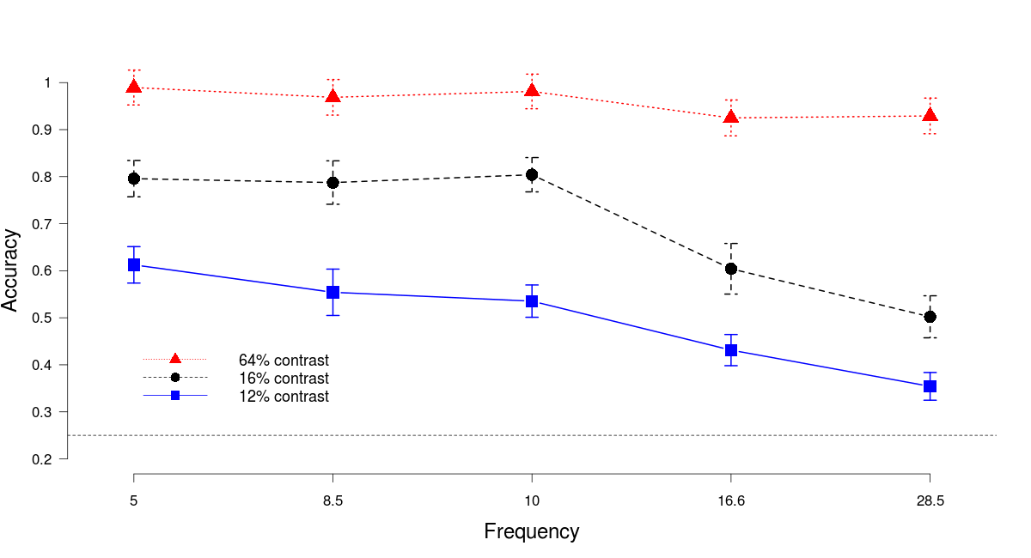Figure 3. Mondrians presented at high frequencies were more effective in suppressing target detection. For the frequencies in the range 5 to 10 Hz there was no difference in the depth of masking of the target checkerboard. However, higher frequencies generated a stronger suppression of targets. We cannot rule out from these data whether the main effect of suppression is due to the frequency of presentation of the masks or to the temporal proximity of the masks. One further control is still needed to solve this question.

Experiment 2 Control: Interocular visual masking

# Notes

# Tsuchiya et al 2006 have shown that continuous flash suppression is most effective after the presentation of 4 Mondrians. Also, they have shown that for the prolonged presentation of pictures the maximal effect of suppression is obtain with a frequency of masks around 10Hz. We have investigated these issues employing brief presentation of checkerboards. Our results suggest that for brief stimuli the effect of frequency on suppression differs from that with prolonged images. Also, they suggest that a key aspect of masking brief stimuli with CFS is the temporal distance of presentation between target and Mondrians.

In previous studies (Tsuchiya) it was shown that for stimuli that are continuously presented on the screen the frequency of presentation of masks that render suppression more efficient was 10Hz. In our study we have investigated the frequencies that were most efficient in masking a briefly presented checkerboard. Our results suggest that higher frequencies mask better than the lower frequencies. This result suggests that the temporal distance between mask and target is of great importance for the suppression of stimuli out of visual awareness.
# Subjective Visibility Assessment

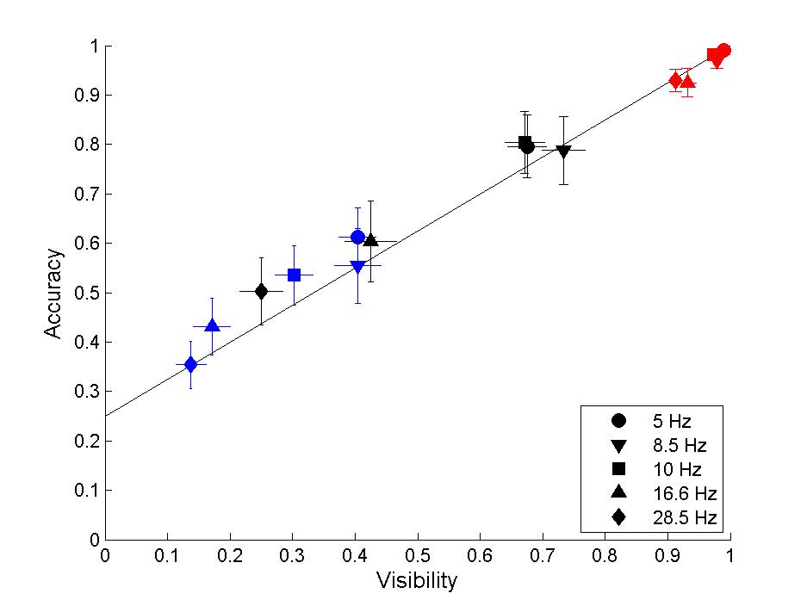Figure 4. Accuracy and subjective report of checkerboards. The proportion of accurate responses increased linearly as a function of the subjective visibility of checkerboards. Colors represent the same contrast conditions as in figure 3. Blue : 12% contrast; Black: 16% contrast; Red: 64% contrast. Shapes represent the different frequencies of presentation of masks. The accuracy at detecting targets presented at 16% contrast for the higher frequencies was similar to the accuracy at detecting targets at 12% contrast for the lower frequencies. Each marker on the figure depicts the average accuracy and proportion of seen checkerboards for 12 subjects. Vertical and horizontal error bars represent one s.e.m.

