# EXPERIMENT DESIGN

here goes the trial figure (figure 1)

# METHODS SECTION

- Subjects (age, inform consent, visual acuity)
- Description of the stimuli: mondrians, checkerboard (size, monitor refresh rate, monitor model), background color, stimuli color, frames to help fusion, streoscope, dim ligth room,
- Description of Procedures: instruction to subjects, practice trials (with and without masks). Description of experiment 1 and of experiment 2.

# EXPERIMENT 1. RESULTS:

Figure 2. Subjects performance for the different time of presentation of targets with respect to the masks. Backward masking: the effect of suppression was maximal when the checkerboard preceded the mask for 2 frames . Forward masking: the checkerboard was presented immediately after the mondrian.Middle condition: when the checkerboard was presented in the middle of the two successive masks, temporally equidistant to the previous and following mask, subjects were 20% more accurate than in the backward masking conditions for the 12 and 16 % contrast levels. The masks were presented to the left eye at a frequency of 8.47 Hz. The accuracy of subjects correlated positively with the visibility of the checkerboards (see figure subjective report).

Statistical analyses:
We ran a two-way repeated measures Anova with timing and contrast as factors. There were main effects for the two factors and a significant interaction parameter. We performed the same analyses on the zscore accuracies and results were very similar to the unnormalized data. Post-hoc Bonferroni corrected paired t-tests showed a consistent difference between backward masking condition (black squares) and the middle masking condition (green circles) for 12 and 16 % contrast levels. N = 12, error bars represent one s.e.m.

NOTE: At the end of the day, we discovered that in Tsuchiya and Blake paper the effect of CFS was fully seen after the presentation of 5 masks. So we filtered our data in order to match their conditions (we took out the trials in which targets were presented before 40 frames) and saw that the results resembled to those of Tsuchiya et al. We decided to run all the analyses again after filtering the trials in which targets were preceded by less than 5 masks (25% of trials for backward masking, forward masking and middle masking conditions ).

- Ran ANOVA again with the filtered data: on the left column we present the results of the two-way ANOVA, on the right we show the ANOVA for the standardized accuracies.

summary(mod.withinAnova)  Error: subject  Df Sum Sq Mean Sq F value Pr(>F)  Residuals 11 3.0152 0.27411  Error: subject:contrast  Df Sum Sq Mean Sq F value Pr(>F)  contrast 4 10.9017 2.72543 49.039 1.156e-15 ***  Residuals 44 2.4454 0.05558  ---  Signif. codes: 0 ‘***’ 0.001 ‘**’ 0.01 ‘*’ 0.05 ‘.’ 0.1 ‘ ’ 1  Error: subject:maskCode  Df Sum Sq Mean Sq F value Pr(>F)  maskCode 2 0.24502 0.122510 14.895 8.128e-05 ***  Residuals 22 0.18095 0.008225  ---  Signif. codes: 0 ‘***’ 0.001 ‘**’ 0.01 ‘*’ 0.05 ‘.’ 0.1 ‘ ’ 1  Error: subject:contrast:maskCode  Df Sum Sq Mean Sq F value Pr(>F)  contrast:maskCode 8 0.37925 0.047406 3.6 0.001165 **  Residuals 88 1.15881 0.013168  ---  Signif. codes: 0 ‘***’ 0.001 ‘**’ 0.01 ‘*’ 0.05 ‘.’ 0.1 ‘ ’ 1 | summary(mod.withinAnovaZscore)  Error: subject  Df Sum Sq Mean Sq F value Pr(>F)  Residuals 11 1.3047e-30 1.1861e-31  Error: subject:contrast  Df Sum Sq Mean Sq F value Pr(>F)  contrast 4 168.441 42.11 56.912 < 2.2e-16 ***  Residuals 44 32.556 0.74  ---  Signif. codes: 0 ‘***’ 0.001 ‘**’ 0.01 ‘*’ 0.05 ‘.’ 0.1 ‘ ’ 1  Error: subject:maskCode  Df Sum Sq Mean Sq F value Pr(>F)  maskCode 3 3.0259 1.0086 7.8862 0.0004210 ***  Residuals 33 4.2206 0.1279  ---  Signif. codes: 0 ‘***’ 0.001 ‘**’ 0.01 ‘*’ 0.05 ‘.’ 0.1 ‘ ’ 1  Error: subject:contrast:maskCode  Df Sum Sq Mean Sq F value Pr(>F)  contrast:maskCode 12 4.251 0.35425 3.0158 0.0009142 ***  Residuals 132 15.505 0.11746  ---  Signif. codes: 0 ‘***’ 0.001 ‘**’ 0.01 ‘*’ 0.05 ‘.’ 0.1 ‘ ’ 1

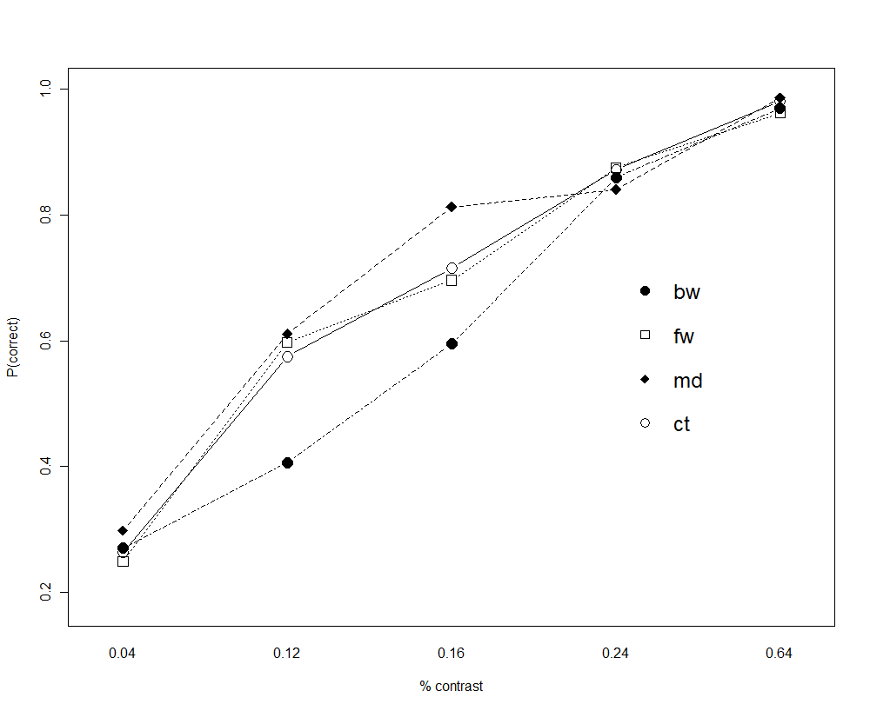
Figure 2. Interaction Plot. Accuracy as a function of contrast level for the 4 conditions of masking. Backward masking condition is lower than all the other conditions, especially when compared to the middle masking condition. Contrast is treated as a factor level and therefore the x-axis looks linearized.

- We plotted accuracies for single subjects again to see the curves: only subjects [1 7 9 10 11 12] seemed good for fitting individual parameters. Observation: many subjects had around 60% accuracy with 4% of contrast only with the middle condition. We should see the p(yes) in these cases.

- Subjective plots: we'll create a scatter plot with p(yes) on the x-axis and accuracy on the y-axis. Two error bars (vertical and horizontal). For each subject we calculated the accuracy and p(yes) for each point in the curve (contrast x masking condition). The final plot is the average of this 20 points across subjects. We want to assess whether accuracy improves linearly as a function of visibility.

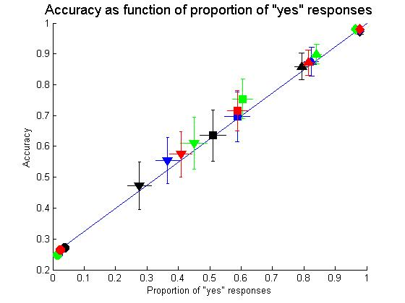
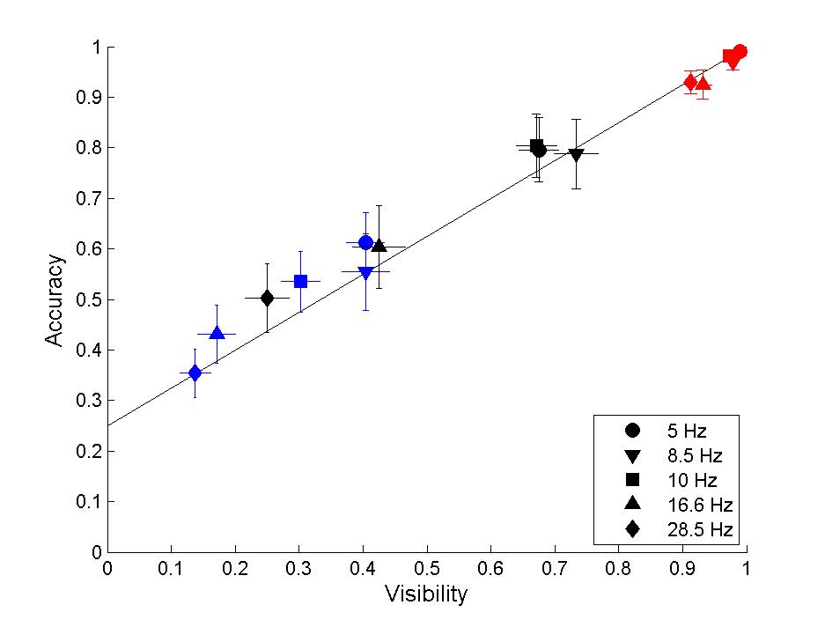
Figure 3. Accuracy and subjective report of checkerboards. The proportion of accurate responses increase linearly as a function of the proportion of visible checkerboards (subjects pressed “yes” when they saw the checkerboard and “no” when they only saw the mondrians). Colors represent the same conditions as in figure 1. Black : backward masking; Blue: forward masking; Red: start condition; Green: middle masking. Shapes represent the different contrast levels. Circles: 4% contrast; Inverted triangles: 12% contrast; Squares: 16% contrast; Triangles; 24% contrast; Diamonds: 64% contrast.
Each marker on the figure represents the average accuracy and proportion of seen checkerboards for 12 subjects. Vertical and horizontal error bars represent one s.e.m.

Next steps:

We'll run the second half of the experiment to test the role of the different frequencies in the accuracy and visibility of the checkerboards. We'll run the experiment with:

- Other 12 subjects
- Presenting at least 5 masks before the presentation of the target (to produce full CFS).
- 2 contrast levels ( 0.12, 0.16)
- 1 masking condition: backward
- 6 frequencies: 5.3 Hz, 8.5 Hz, 10.6 Hz, 16.6 hz, 20.3 Hz, 28.5 Hz.
- 40 trials for each point : 10 trials in each location (on each block 2 trials are presented in each location for each condition, totaling 8 trials per condition per block)
- This amounts to: 2 x 6 x 40 = 480 trials. Half the number of trials of our previous experiment (~ 3/4 hour of experiment). 5 blocks of 96 trials each

At 85 Hz refresh rate, one frame takes 12ms
Presenting mondrians every 6 frames ~ 14.28 Hz (the maximum frequency for the middle masking condition)
Presenting mondrians every 5 frames ~ 16.6 Hz
Presenting mondrians every 3 frames ~ 28.5 Hz

% With 85 Hz refresh rate. Frames rate:
16 frames = 5.3 hz
10 frames = 8.47hz
8 frames = 10.6 hz
5 frames = 16.6 hz
4 frames = 20.3 hz
3 frames = 28.5 hz

Questions:

Should we run a condition with binocular stimulation, both of mondrians and checkerboards?

Should we run a condition with simple backward masking?

How we arrived to the final version:

-5Hz mask seemed to lower accuracy. It turned out the cause of this was the fact that on ~1/3 of the 5hz mask trials the checkerboard was presented relatively late into the trial (flip 111, compared to all the other conditions this was much later). Removing it from the experiment (for the 5Hz mask now we presented the checkerboard either on flip 79 or flip 95) raised the accquarcy and the 5 Hz mask was no longer so much more difficult than the higher frequency masks.

-Learning effect for subjects who had had previous experience with this experiment (piloting frequencies experiment and doing the masking conditions experiment).

-In addition to ourselves (LK, AF, MS), we had 2 pilot subjects with an interleaved design where in each block frequencies from trial to trial changed. Accuracy was lower than expected, meaning, for the 10Hz mask with 12% and 16% contrast it should have been approximately the same as the accuracy under identical conditions (bwd, 12%/16%, 10Hz mask) in the masking experiment. We speculated that the cause of this lower accuracy is the different appearance of mask at different frequencies. Therefore the subjects were having a difficult time learning what to expect in each trial. So we decided to have a blocked design where in each block there is only one mask frequency presented, thus avoiding the problem of having to change the expectation depending on what frequency mask one sees.

Frequency experiment parameters (25.07.2011):

- 12 subjects
- Presenting at least 5 masks before the presentation of the target (to produce full CFS).
- 3 contrast levels ( 0.12, 0.16, 0.64)
- 1 masking condition: backward
- 5 frequencies: 5.3 Hz, 8.5 Hz, 10.6 Hz, 16.6 hz, 28.5 Hz.
- 40 trials for each point : 10 trials in each location (on each block 2 trials are presented in each location for each condition, totaling 8 trials per condition per block)
- This amounts to: 3 x 5 x 40 = 600 trials. Half the number of trials of our previous experiment (~ 1 hour of experiment). 5 blocks of 120 trials each
- We trained subject with 16 trials at 16 and 64% contrast before each block
- The sequence of blocks was randomized for each subject

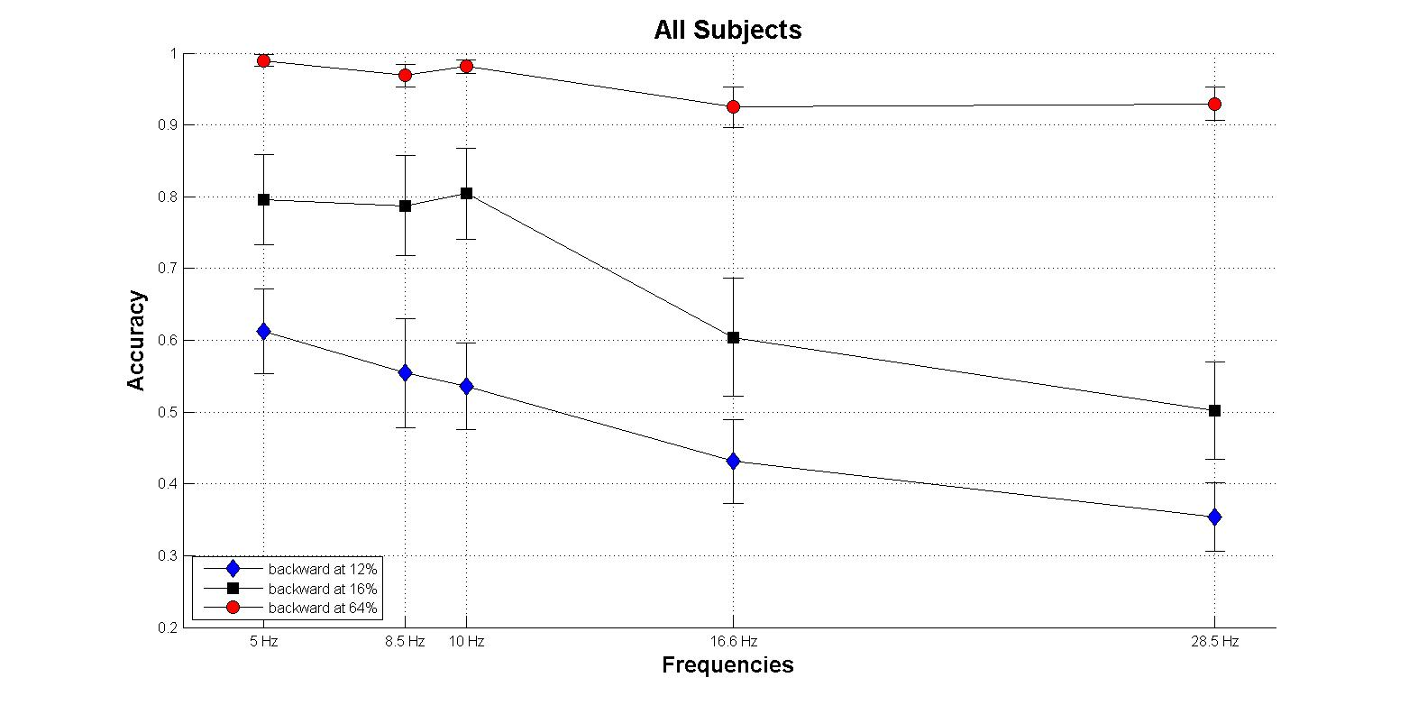
Figure 4. Mondrians presented at high frequencies were more effective in suppressing target detection.

Statistical analyses

- We ran two-way repeated measures ANOVA with frequency and contrast as factors

Error: subject
Df Sum Sq Mean Sq F value Pr(>F)
Residuals 11 2.7084 0.24622

Error: subject:frequency
Df Sum Sq Mean Sq F value Pr(>F)
frequency 4 1.14047 0.285118 14.232 1.566e-07 ***
Residuals 44 0.88144 0.020033
---
Signif. codes: 0 ‘***’ 0.001 ‘**’ 0.01 ‘*’ 0.05 ‘.’ 0.1 ‘ ’ 1

Error: subject:contrast
Df Sum Sq Mean Sq F value Pr(>F)
contrast 2 6.4171 3.2085 49.327 7.408e-09 ***
Residuals 22 1.4310 0.0650
---
Signif. codes: 0 ‘***’ 0.001 ‘**’ 0.01 ‘*’ 0.05 ‘.’ 0.1 ‘ ’ 1

Error: subject:frequency:contrast
Df Sum Sq Mean Sq F value Pr(>F)
frequency:contrast 8 0.32853 0.041066 4.2513 0.0002388 ***
Residuals 88 0.85006 0.009660
---
Signif. codes: 0 ‘***’ 0.001 ‘**’ 0.01 ‘*’ 0.05 ‘.’ 0.1 ‘ ’ 1

- Ran one way repeated measures ANOVA with frequency as factor for each contrast value separately

12 % contrast
Error: subject
Df Sum Sq Mean Sq F value Pr(>F)
Residuals 11 1.7559 0.15962

Error: subject:frequency
Df Sum Sq Mean Sq F value Pr(>F)
frequency 4 0.51369 0.128422 8.1737 5.096e-05 ***
Residuals 44 0.69131 0.015712
---
Signif. codes: 0 ‘***’ 0.001 ‘**’ 0.01 ‘*’ 0.05 ‘.’ 0.1 ‘ ’ 1

16 % contrast
Error: subject
Df Sum Sq Mean Sq F value Pr(>F)
Residuals 11 2.2448 0.20407

Error: subject:frequency
Df Sum Sq Mean Sq F value Pr(>F)
frequency 4 0.91246 0.228115 10.584 4.276e-06 ***
Residuals 44 0.94829 0.021552
---
Signif. codes: 0 ‘***’ 0.001 ‘**’ 0.01 ‘*’ 0.05 ‘.’ 0.1 ‘ ’ 1

64 % contrast
Error: subject
Df Sum Sq Mean Sq F value Pr(>F)
Residuals 11 0.13878 0.012616

Error: subject:frequency
Df Sum Sq Mean Sq F value Pr(>F)
frequency 4 0.042854 0.0107135 5.1297 0.001761 **
Residuals 44 0.091896 0.0020885
---
Signif. codes: 0 ‘***’ 0.001 ‘**’ 0.01 ‘*’ 0.05 ‘.’ 0.1 ‘ ’ 1

- Post hoc bonferroni corrected comparisons showed that for 12 and 16 % contrasts the accuracies for trials with a frequency of 28.5 Hz was statistically lower than for 5, 8.5 and 10.6 Hz (p corrected < 0.005).

Frequency experiment results filtering subjects 1, 3 ( too high visibility) and 2 (too low visibility)

Parameters of the Control for the Frequency Experiment (02.08.2011):

- 12 subjects
- 1 masking condition: “backward masking” (the target immediately before the second mask)
- Presenting only 2 masks
- 3 contrast levels ( 0.12, 0.16, 0.64)
- 5 times of separation between the masks (corresponding to the 5 frequencies): 5.3 Hz, 8.5 Hz, 10.6 Hz, 16.6 Hz, 28.5 Hz.
- 40 trials for each point : 10 trials in each location (on each block 2 trials are presented in each location for each condition, totaling 8 trials per condition per block)
- This amounts to: 3 x 5 x 40 = 600 trials. Half the number of trials of our previous experiment (~ 1 hour of experiment). 5 blocks of 120 trials each
- We trained subjects with 16 trials at 16% and 64% contrast before each block
- The sequence of blocks was randomized for each subject

