**Capability 1: Automatic build in response to a git commit**

1) Making a change to README and pushing it to trigger a build:

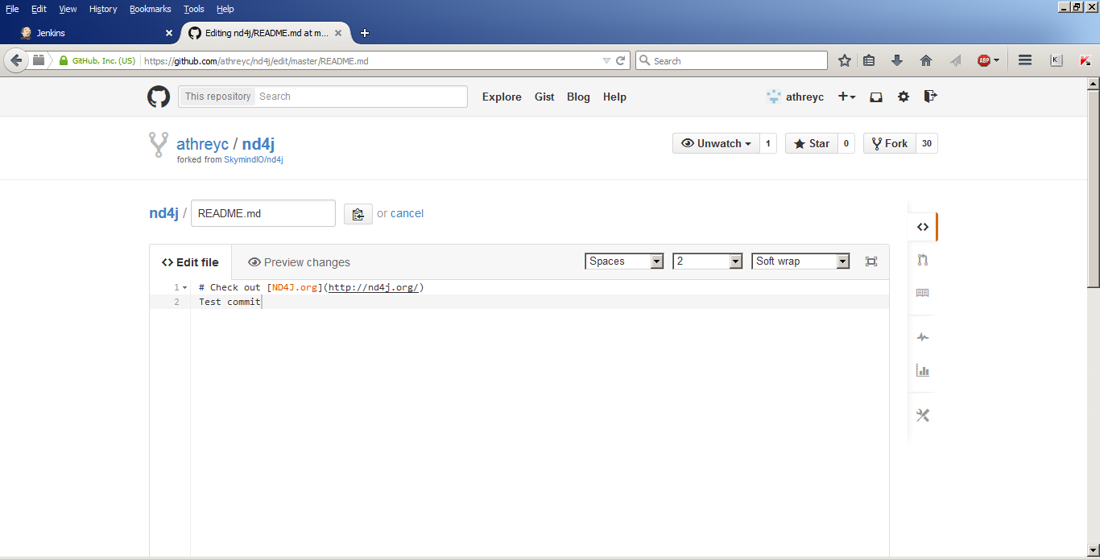

2) Buid trigger cause on Jenkins:

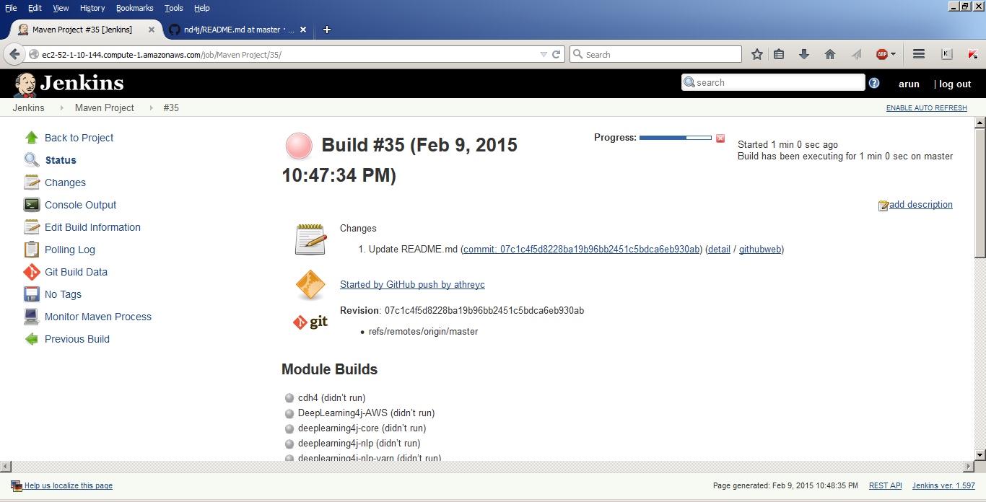

3) Build console output:

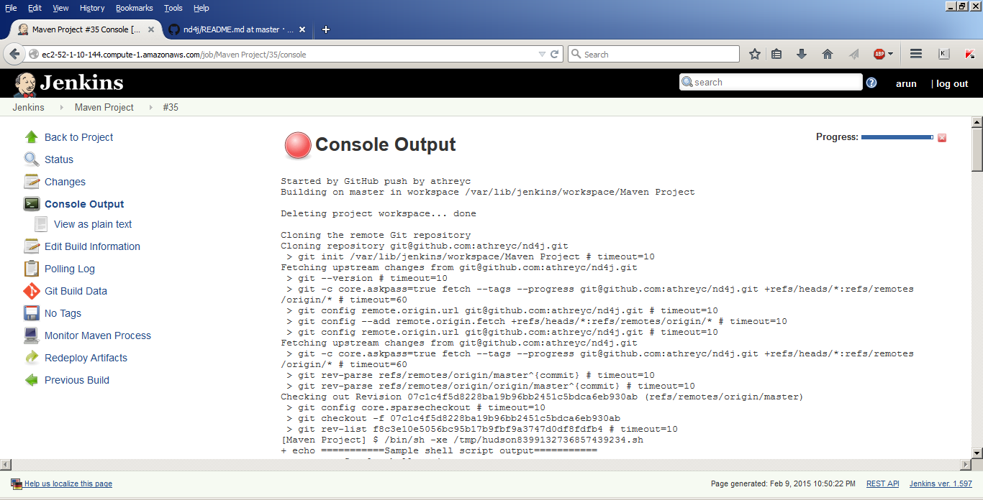

**Capability 2: Setup dependencies for the project**

Note: This is shown by removing the existing dependencies and restoring them

Removing all the dependencies to trigger a build:

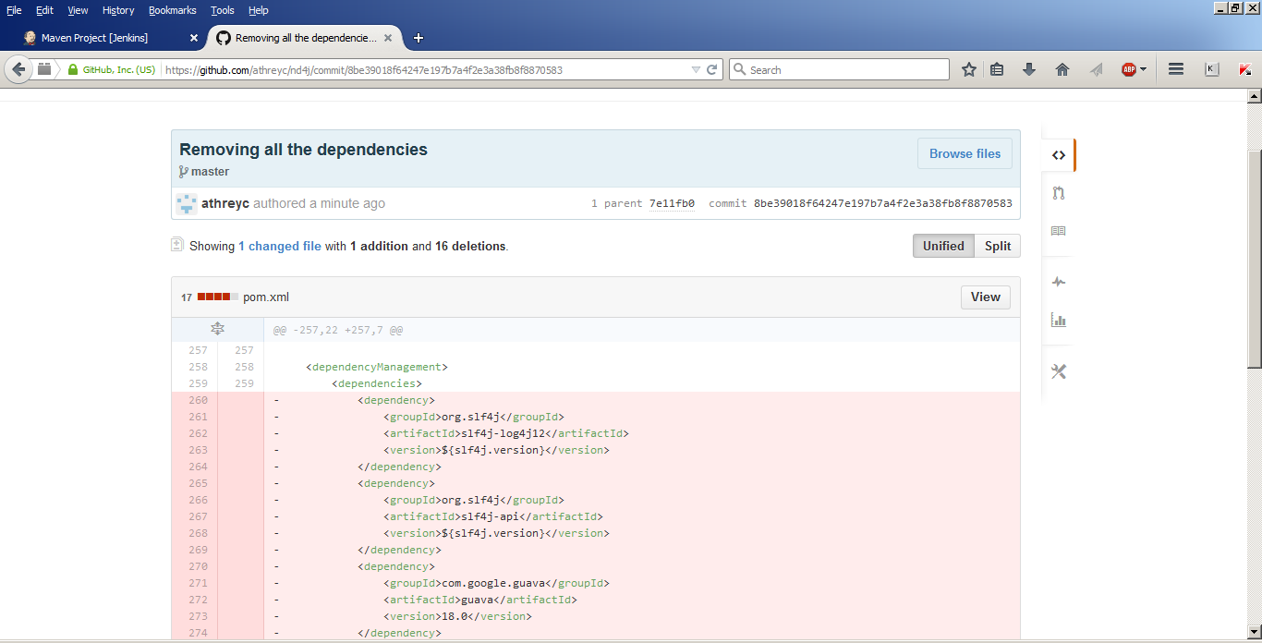

Build triggered on Jenkins on removing the dependencies:

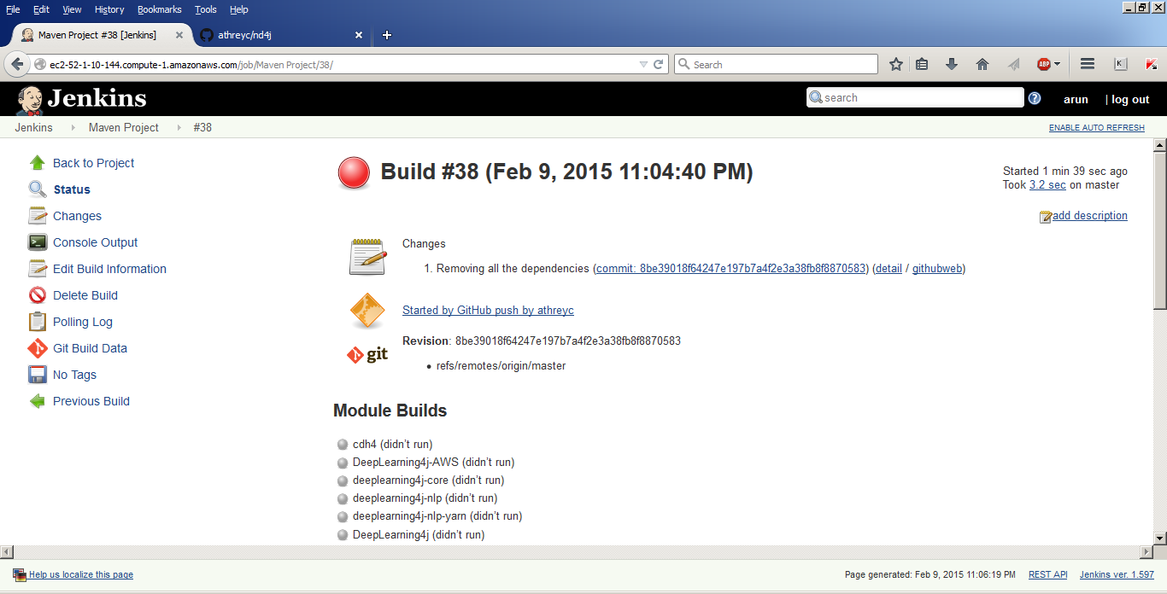

Console output flagging issues due to missing dependencies:

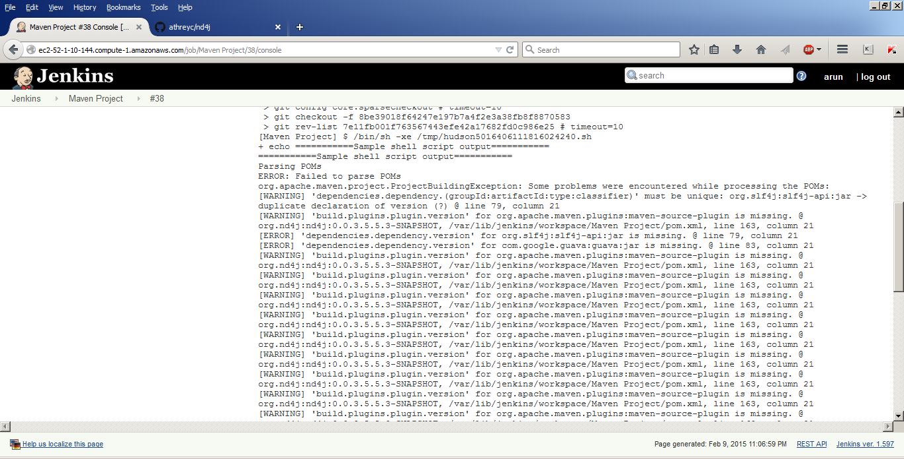

On restoring the dependency information in pom.xml:

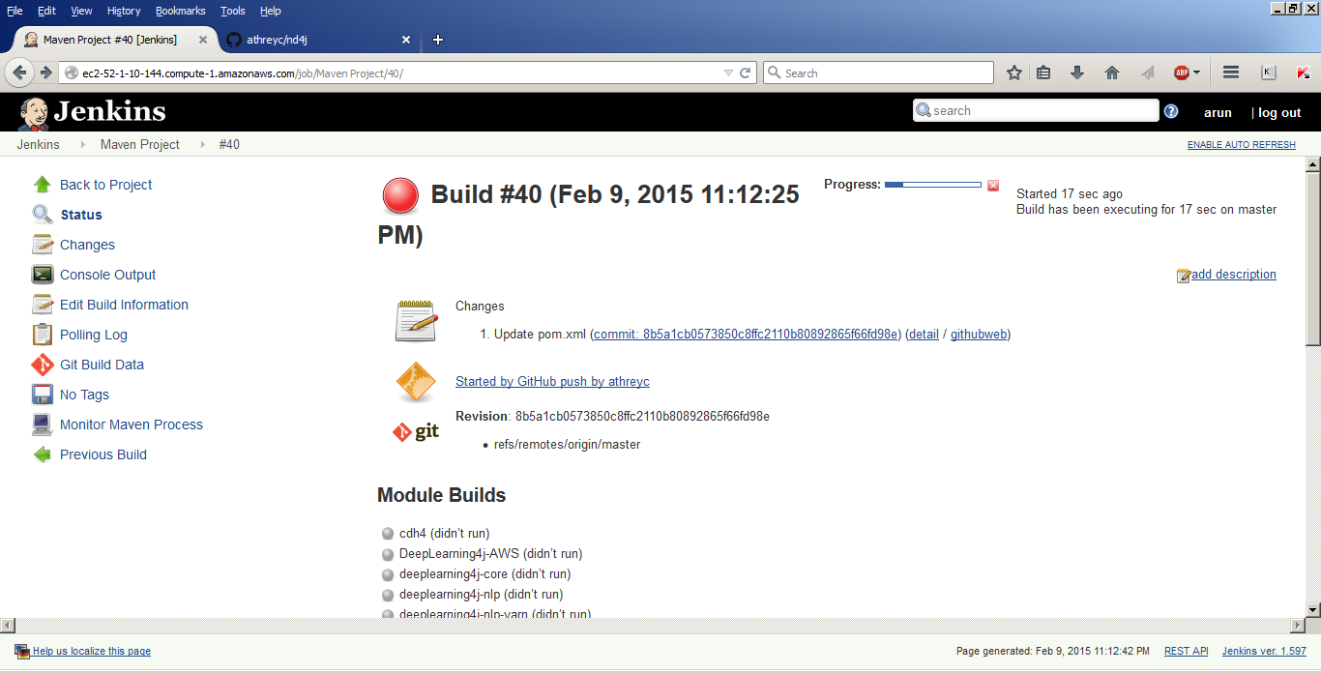

Console o/p when parsing the POM file:

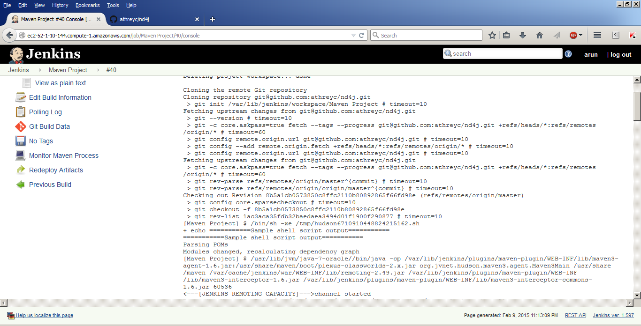

**Capability 2: Restoring to a clean state**

Project Workspace before triggering the build:

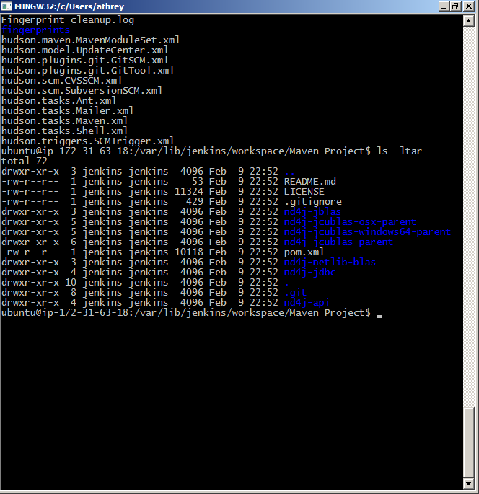

Cleaning the workspace before the new build:

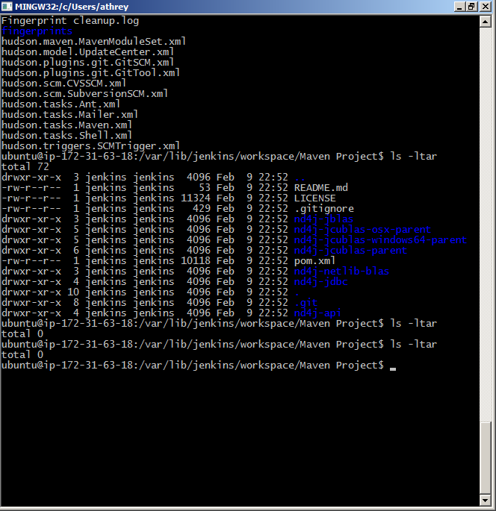

Project workspace on triggering a subsequent build:

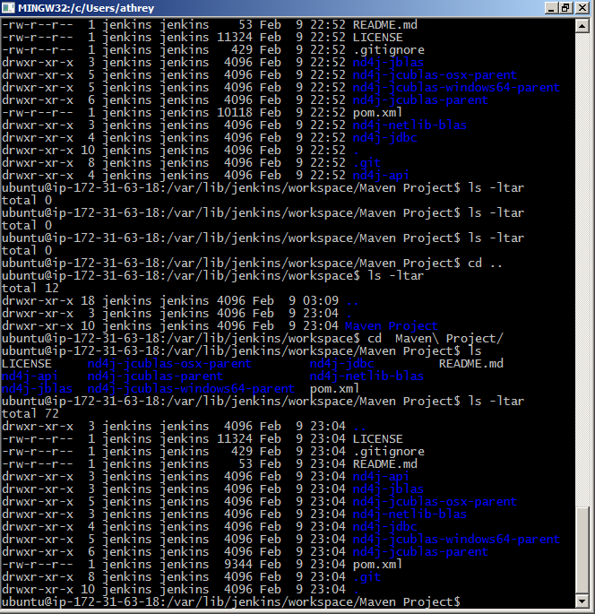

**Capability 3: The ability to execute a build script (Shell, Maven)**

Running a sample shell script as a pre-build step via Jenkins:

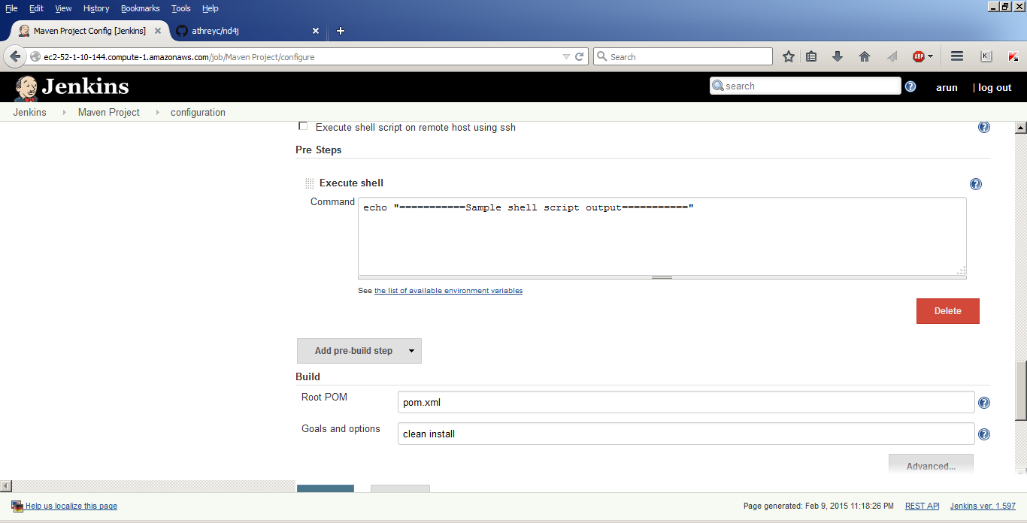

**Shell script o/p on console during build: (Highlighted)**

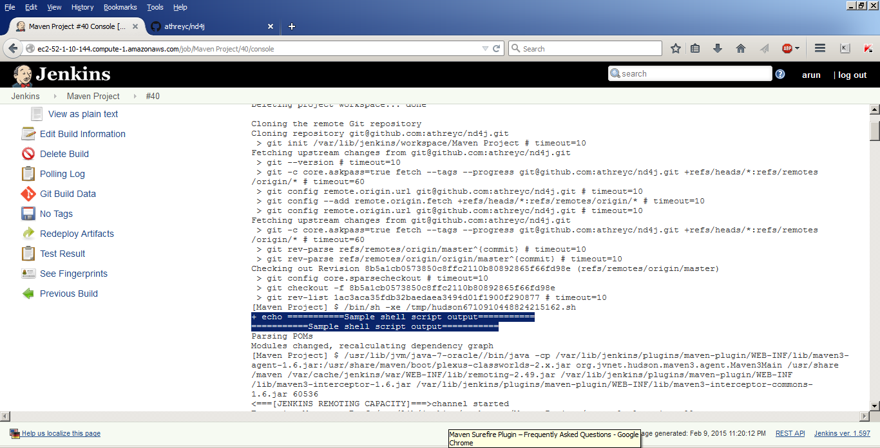

**Capability 4: Running on Multiple nodes**

Using AWS, 2 slaves are spawned from Jenkins and used for the build along with the master

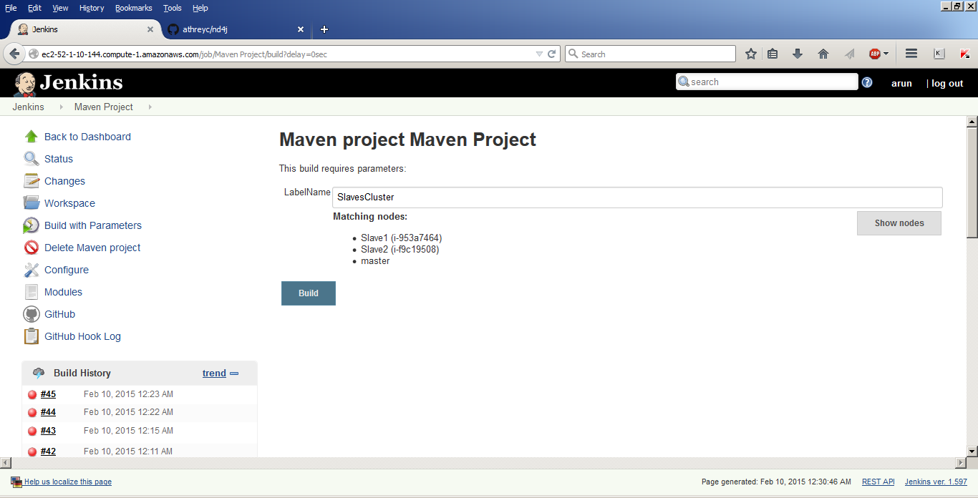

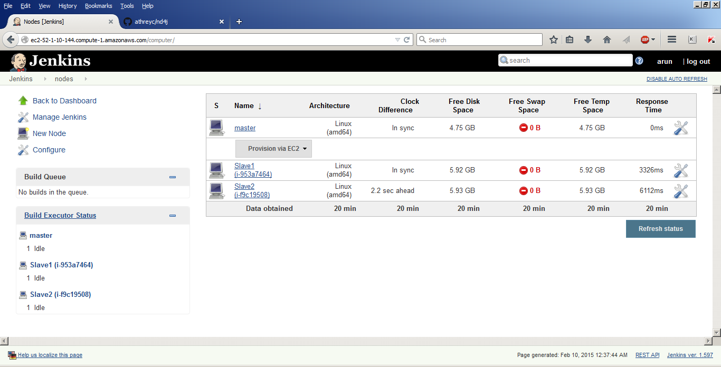

Load on the master and slaves:

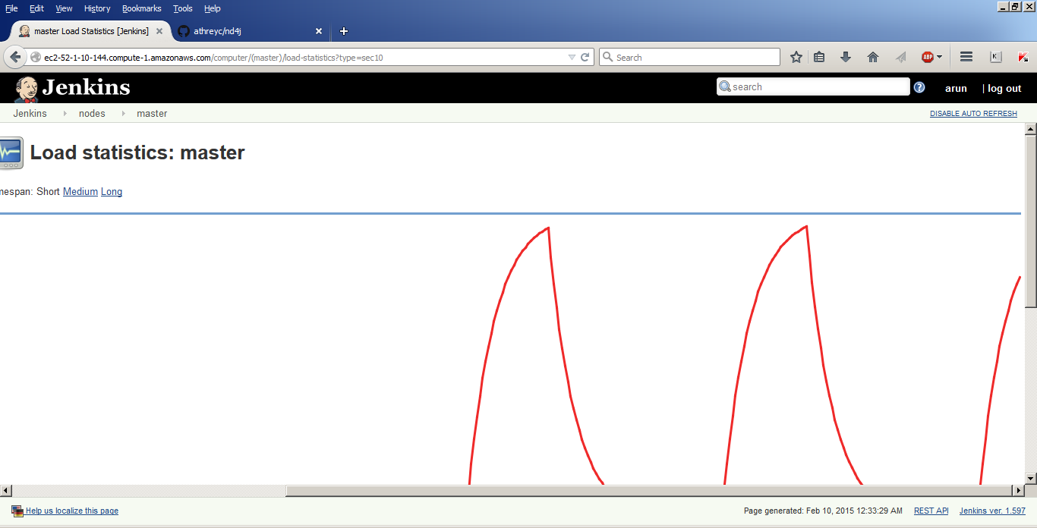

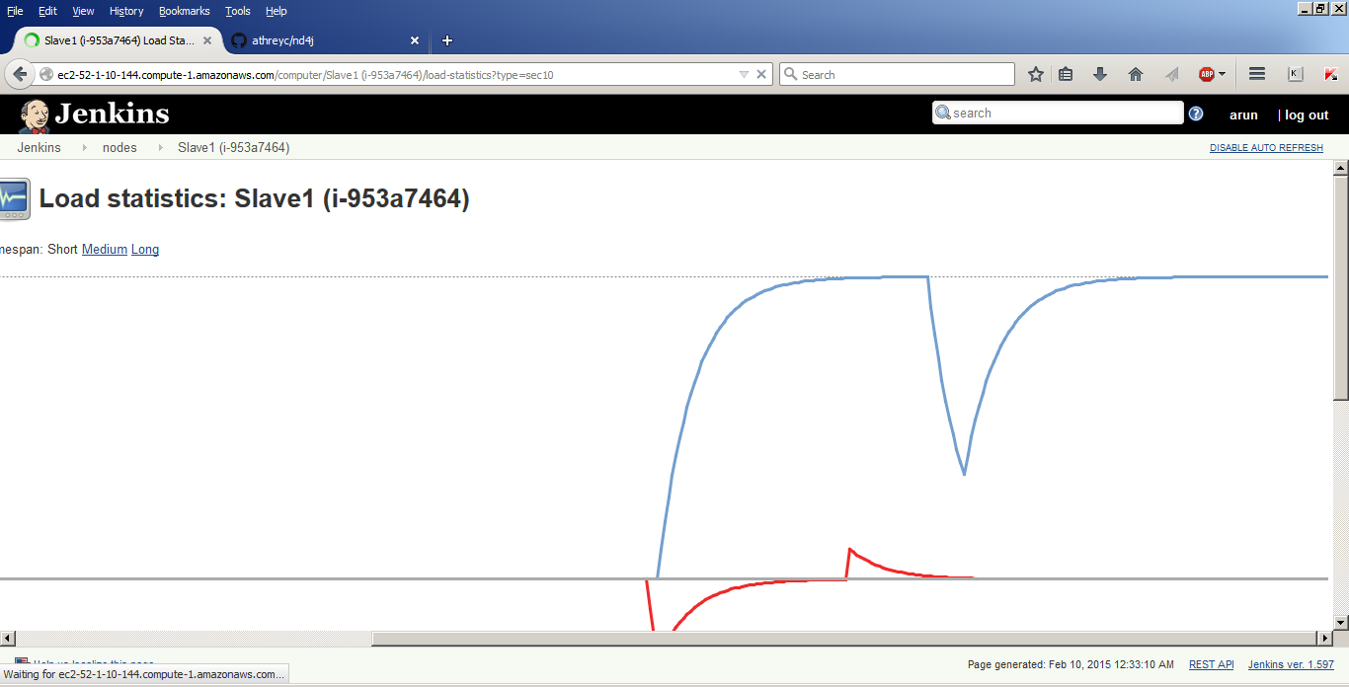

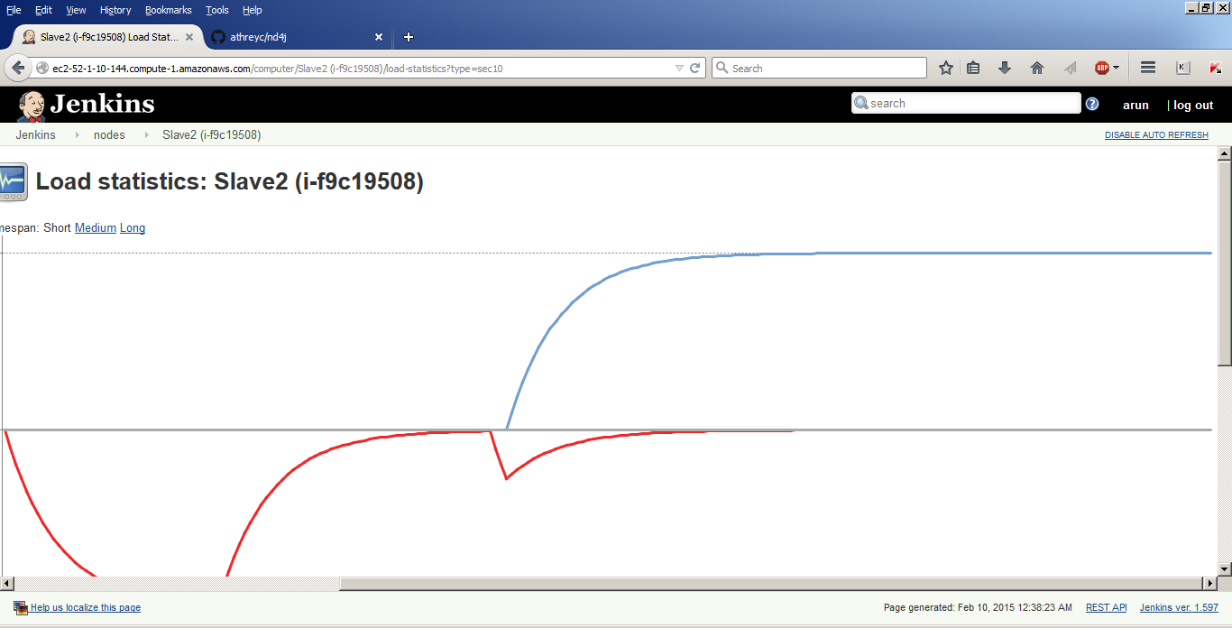

HTTP access via proxy:

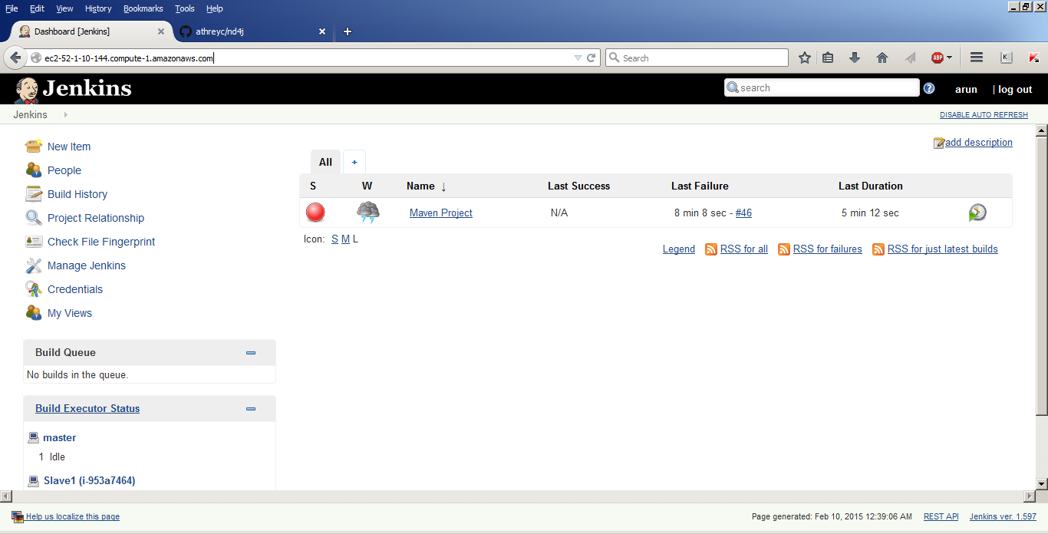

Apache site created (to use port 80 and access the Jenkins server over the web):

