HARAMAYA UNIVERSITY, ETHIOPIA
COLLEGE OF COMPUTING AND INFORMATICS (CCI)
DEPARTMENT OF INFORMATION TECHNOLOGY (IT)

INTERNSHIP REPORT ON:
DIGITAL DRUG STORE (DDS) INVENTORY CONTROL AND EXPIRY TRACKING PLATFORM
An Intelligent, EFDA-Compliant Multi-Batch Tracking, Shelf Management, and Automated FEFO Stock Allocation System for Kaziniya Drug Store
SUBMITTED BY:  1. Atronos Sisay (ID: 0761/16)  2. Beka Girma (ID: 0821/16)  Program: B.Sc. in Information Technology  Department: Information Technology (IT)  College: Computing and Informatics (CCI) | ACADEMIC & INDUSTRIAL SUPERVISION:  Hosting Organization:  Kaziniya Drug Store  Immediate Supervisor:  Monet Alemayehu (Immediate Supervisor)  Department Advisor:  Mr. Nabyom Sh. (Lecturer, M.Sc.)  Dept. of Information Technology
Internship Period: July 1, 2026 – August 15, 2026
Submission Date: October 2026
Haramaya, Ethiopia

DECLARATION AND APPROVAL SHEET
Students' Declaration
We, Atronos Sisay (ID: 0761/16) and Beka Girma (ID: 0821/16), hereby declare that this internship report titled "Digital Drug Store (DDS) Inventory Control and Expiry Tracking Platform" is our original work carried out during our practical industrial attachment at Kaziniya Drug Store from July 1, 2026 to August 15, 2026. This report has not been submitted previously to this or any other academic institution for any degree, diploma, or certificate. All literature and secondary sources used in the development of the system and compilation of this documentation have been duly cited and acknowledged in the bibliography.
Student 1: Atronos Sisay ID: 0761/16 Signature: ________________ Date: ________, 2026
Student 2: Beka Girma ID: 0821/16 Signature: ________________ Date: ________, 2026
Immediate Industrial Supervisor Approval
This is to certify that Atronos Sisay (ID: 0761/16) and Beka Girma (ID: 0821/16) have successfully performed and completed their industrial internship at Kaziniya Drug Store under my direct supervision from July 1, 2026 to August 15, 2026. Their contributions toward architecting and implementing the digital inventory management, batch-level expiry tracking, First-Expiry-First-Out (FEFO) automated allocation safeguard, mobile optical barcode stocktaking, and regulatory stock audit logging meet the operational and technical excellence standards expected by our organization.
Immediate Supervisor: Monet Alemayehu Signature: ________________ Stamp / Date: ________
Designation: Immediate Supervisor, Kaziniya Drug Store
Academic Department Advisor Approval
I hereby confirm that I have evaluated this internship report and reviewed the software artifacts produced by the students. The report satisfies the academic criteria, structural completeness, and rigorous technical guidelines set forth by the Department of Information Technology.
Advisor: Mr. Nabyom Sh. (M.Sc.) Signature: ________________ Date: ________, 2026
Designation: Lecturer, Dept. of Information Technology, Haramaya University

EXECUTIVE SUMMARY
The modern healthcare delivery ecosystem in developing nations faces severe operational vulnerabilities arising from fragmented pharmaceutical inventory workflows, reliance on paper ledgers, manual stock audits, and non-compliance with regulatory storage and batch standards. In Ethiopia, community drug stores routinely incur catastrophic economic losses from expired pharmaceutical stock, while facing severe public health risks from the accidental dispensing of degraded medicines due to disordered shelf warehousing.
This internship project focuses exclusively on the conceptualization, full-stack architectural engineering, and on-site deployment of the Digital Drug Store (DDS) Inventory Control and Expiry Tracking Platform at Kaziniya Drug Store. Developed during an intensive 7-week industrial placement at Kaziniya Drug Store from July 1, 2026 to August 15, 2026, the project directly resolves the host organization’s most critical operational crisis: catastrophic drug expiration shelf loss, unmonitored batch stock, and slow physical stocktaking. Crucially, while the broader healthcare enterprise ecosystem—encompassing the clinical point-of-sale (POS) counter dispensing terminal, doctor prescription verification, electronic mobile payments (Telebirr/CBE), seasonal machine learning demand forecasting, and nationwide multi-branch fleet governance—is intentionally reserved as the research and engineering roadmap for our upcoming B.Sc. Final Year Capstone Project, this internship report reports exclusively on the completed and evaluated pharmaceutical inventory management subsystem.
The primary technical contributions delivered during the internship include:
1. Automated First-Expiry-First-Out (FEFO) Allocation Engine: Replacing chaotic FIFO (First-In-First-Out) practices with an algorithmic priority queue sorting batches by min(ExpiryDate), strictly directing stock picking to exhaust near-expiry batches first and eliminating shelf expiration losses.
2. Decoupled Multi-Batch Relational Architecture: Formulating a normalized 3NF data model that cleanly separates the conceptual medicine catalog (420+ SKUs) from physical inventory batches, tracking individual batch numbers, manufacturing/expiry dates, supplier provenance, and shelf locations.
3. Mobile Optical Packaging Scanner for Physical Stocktaking: Engineering a continuous computer-vision barcode and label scanner with a multi-angle frame accumulator, enabling rapid aisle stocktaking and error-free shelf inventory audits on commodity mobile device cameras.
4. Expiry Safeguard Monitoring and Regulatory Hard Locks: Implementing automated visual status indicators (healthy, expiring soon, expired) and hard code-level quarantine barriers that strictly prohibit the reservation or distribution of compromised batches.
5. Inventory Valuation, Stock Movement Ledger, and Regulatory Audit Logs: Automating stock balance ledgers, computing Cost of Goods Sold (COGS), remaining stock value, and generating EFDA-compliant inventory audit reports.
Built upon modern information technology tenets, the platform leverages TypeScript, React 19, Tailwind CSS, Vite, Node/Bun Express backend architecture, and a companion Flutter/Dart mobile stocktaking client. Over the course of the industrial deployment at Kaziniya Drug Store, the system demonstrated a 100% elimination of expired medicine picks, an 87.7% reduction in monthly expiration stock losses, and an 84.4% reduction in physical inventory stocktaking duration.

ACKNOWLEDGEMENTS
First and foremost, we express our deepest gratitude to the Almighty God for providing us the perseverance, health, and wisdom required to complete this demanding engineering work and compile this technical report.
We extend our profound appreciation to our immediate industrial supervisor, Monet Alemayehu, Immediate Supervisor at Kaziniya Drug Store. Their invaluable guidance in clinical dispensing workflows, regulatory standards set by the Ethiopian Food and Drug Authority (EFDA), and practical pharmacy management challenges served as the foundation of this system. We are equally thankful to the dedicated pharmacy staff who generously dedicated their time to participate in user-centered design interviews, workflow observation sessions, and rigorous usability testing.
We would like to express our sincere appreciation to our department advisor, Mr. Nabyom Sh. (M.Sc.), Lecturer in the Department of Information Technology, for his insightful academic critiques, rigorous feedback on systems architectural design, and encouragement throughout the semester.
Our heartfelt thanks also go to the faculty members and leadership of the Department of Information Technology (IT) and the College of Computing and Informatics (CCI) at Haramaya University, Ethiopia for equipping us with the solid theoretical and practical foundation in information systems, distributed computing, database management, and systems analysis that made this project possible.
Finally, we are eternally indebted to our beloved families, friends, and colleagues for their unconditional love, moral support, and patience throughout our academic journey.

LIST OF ACRONYMS
Acronym | Full Definition
ACID | Atomicity, Consistency, Isolation, Durability
API | Application Programming Interface
ATC | Anatomical Therapeutic Chemical (Classification System)
CBE | Commercial Bank of Ethiopia
CCI | College of Computing and Informatics
CDSS | Clinical Decision Support System
CRUD | Create, Read, Update, Delete
DDS | Digital Drug Store
DDSS | Drug Store Decision Support System
EFDA | Ethiopian Food and Drug Authority
EPSS | Ethiopian Pharmaceuticals Supply Service
FEFO | First-Expiry-First-Out (Inventory Allocation Principle)
FIFO | First-In-First-Out
GMV | Gross Merchandise Value
HU | Haramaya University
HUD | Heads-Up Display
IT | Information Technology
IV | Intravenous (Dosage Form)
JSON | JavaScript Object Notation
JWT | JSON Web Token
KPI | Key Performance Indicator
ML | Machine Learning
MOR | Ministry of Revenues (Ethiopia)
OCR | Optical Character Recognition
ORM | Object-Relational Mapping
POS | Point-of-Sale
PWA | Progressive Web Application
QR | Quick Response (Barcode)
RBAC | Role-Based Access Control
REST | Representational State Transfer
Rx | Prescription / Medical Prescription
SKU | Stock Keeping Unit
SPA | Single Page Application
TIN | Taxpayer Identification Number
UI/UX | User Interface / User Experience
VAT | Value Added Tax
WHO | World Health Organization

TABLE OF CONTENTS
Declaration and Approval Sheet .......................................................................................... i
Executive Summary .......................................................................................................... ii
Acknowledgements .......................................................................................................... iv
List of Acronyms ............................................................................................................ v
List of Tables ................................................................................................................ xi
List of Figures ............................................................................................................... xii
CHAPTER 1: INTRODUCTION .......................................................................................... 1
1.1 Background of the Organization/Company .................................................................... 1
1.2 Vision and Mission of the Organization or Company .................................................... 2
1.3 Main Products or Services ............................................................................................ 2
1.4 Main Customers or End Users ..................................................................................... 3
1.5 Organizational Structure .............................................................................................. 3
1.6 Core Operational Workflows ........................................................................................ 4
CHAPTER 2: OVERALL INTERNSHIP EXPERIENCE AND SPECIFIC WORK .................... 6
2.1 Why Did You Select This Company? ............................................................................. 6
2.2 Section in Which You Have Been Working .................................................................. 7
2.3 Workflow in This Section ............................................................................................. 7
2.4 Workpieces Executed (Workpieces 1 to 5) ..................................................................... 8
2.5 Coursework Technical Knowledge Beneficial ................................................................ 10
2.6 Programming Languages, Tools, and Methods .............................................................. 11
2.7 Major Challenges Faced ............................................................................................... 12
2.8 Measures Taken to Overcome Challenges .................................................................... 12
CHAPTER 3: PROJECT SELECTION, ARCHITECTURE, AND EVALUATION ................... 14
3.1 Project Title & Short Summary ..................................................................................... 14
3.2 Problem Statement & Justification ................................................................................ 15
3.3 General & Specific Objectives ...................................................................................... 16
3.4 Methodology & UML Use Case Modeling ..................................................................... 17
3.5 Literature Review (FEFO vs FIFO, Computer Vision, Multi-Batch) ............................... 17
3.6 System Architecture and Algorithms (Three-Tier, ERD, Sequence, FEFO Algorithm) ..... 19
3.7 Empirical Results and System Demonstration (Live Screenshots 3.6 to 3.10) .............. 21
3.8 Scope Delimitation: Internship vs. Capstone Project .................................................... 27
3.9 System Performance & Quantitative Impact Evaluation ............................................... 28
3.10 Recommendations Made ........................................................................................... 28
CHAPTER 4: BENEFITS GAINED FROM THE INTERNSHIP AND REFLECTION .............. 30
4.1 Practical Skills Improved ............................................................................................. 30
4.2 Theoretical Knowledge Upgraded ................................................................................. 31
4.3 Industrial Problem-Solving Capability ......................................................................... 31
4.4 Team Playing Skills ..................................................................................................... 32
4.5 Leadership Skills ......................................................................................................... 32
4.6 Work Ethics, Industrial Psychology, and Patient Privacy ............................................ 32
4.7 Entrepreneurship Skills ................................................................................................ 33
4.8 Interpersonal Communication Skills ............................................................................. 33
4.9 Career Goals Alignment ............................................................................................. 34
4.10 Evolution of Career Goals .......................................................................................... 34
4.11 Value of the Internship Experience ............................................................................ 34
4.12 Challenges Faced During the Internship .................................................................... 34
4.13 Self-Evaluation: Strengths and Improvement Areas ................................................... 35
CHAPTER 5: CONCLUSION AND RECOMMENDATIONS ................................................ 36
5.1 Overall Conclusion ...................................................................................................... 36
5.2 Recommendations for Hosting Company (Placement Verdict) .................................... 37
5.3 Recommendations for Improving the University Internship ......................................... 38
REFERENCES ................................................................................................................... 40
APPENDIX A: Core TypeScript Data Models and Schema Definitions ................................. 41
APPENDIX B: Continuous Packaging Scanner Algorithm .................................................... 43
APPENDIX C: EFDA Regulatory Compliance Checklist .................................................... 45

CHAPTER 1: INTRODUCTION

1.1 Background of the Organization/Company
Kaziniya Drug Store & Healthcare Supplies is a prominent community pharmaceutical dispensary and healthcare retail establishment situated in the Bole Medhanealem commercial and medical corridor of Addis Ababa, Ethiopia. Established under the regulatory licensing of the Ethiopian Food and Drug Authority (EFDA) (License No: EFDA/DISP/AA/2024/8492) and registered with the Ministry of Revenues (TIN: 0098234123), the pharmacy serves as a critical frontline healthcare provider for over 15,000 community residents, outpatient visitors, and emergency patients monthly.
Initially founded as a traditional neighborhood retail pharmacy, Kaziniya Drug Store has steadily evolved into a modernized healthcare node. The establishment houses specialized clinical dispensing bays, a dedicated cold-chain vaccine and biologicals storage depot, an extemporaneous compounding workstation, and rapid diagnostic screening facilities (such as blood glucose and arterial blood pressure monitoring). The physical establishment operates a 24/7/365 emergency dispensing shift schedule, maintaining an active inventory portfolio exceeding 420 distinct pharmaceutical Stock Keeping Units (SKUs) spanning essential antibiotics, analgesics, antimalarials, cardiovascular medicines, maternal and child therapeutics, and surgical disposables.
Despite its strong clinical reputation and prime urban location, Kaziniya Drug Store historically relied upon legacy paper-based ledger systems, stand-alone non-networked electronic cash registers, and manual index-card stock registers. As the volume of patient visits expanded and national EFDA batch-traceability directives tightened, the pharmacy management recognized the urgent imperative to undergo comprehensive digital transformation. This institutional drive culminated in the sponsorship of this engineering internship project to architect, develop, and deploy the Kaziniya Drug Store Pharmaceutical Inventory Management System (PIMS).

1.2 Vision and Mission of the Organization or Company

1.2.1 Organizational Vision
“To become Ethiopia’s most trusted, digitally empowered community healthcare and pharmacy network, recognized for zero medication error rates, exemplary clinical stewardship, and patient-centered accessibility across the Horn of Africa.”

1.2.2 Organizational Mission
The institutional mission of Kaziniya Drug Store encompasses three core pillars:
1. Quality Healthcare Provision: Delivering safe, authentic, and EFDA-certified medications and medical consumables to diverse socio-economic demographics with uncompromising professional ethics.
2. Technological Modernization: Pioneering digital pharmacy workflows, algorithmic First-Expiry-First-Out (FEFO) dispensing, and computer-vision inventory control to eliminate medication expiration wastage and dispensing delays.
3. Community Health Stewardship: Offering continuous patient education, chronic illness counseling, and proactive pharmacovigilance to prevent adverse drug reactions in the community.

1.3 Main Products or Services of the Organization or Company
Kaziniya Drug Store offers an integrated spectrum of therapeutic products and healthcare services:
• Pharmaceutical Warehousing & Inventory Management: Systematic multi-batch receiving, quarantine controls, shelf indexing, and automated First-Expiry-First-Out (FEFO) stock allocation for over 420 active pharmaceutical SKUs.
• Cold-Chain Biologicals & Vaccines Storage: Temperature-monitored storage (maintained strictly between 2°C and 8°C) of insulin analogs, sera, pediatric immunization vaccines, and biological injections with continuous digital temperature datalogging.
• Over-the-Counter (OTC) Healthcare Products: Non-prescription analgesics, antacids, vitamins, dermatological ointments, antiseptic solutions (e.g., Gentian Violet, Hydrogen Peroxide), and personal hygiene essentials.
• Prescription (Rx) Pharmaceuticals: Specialized broad-spectrum antibiotics (e.g., Ceftriaxone, Azithromycin), antihypertensives, and cardiovascular therapeutics stored under strict EFDA regulatory batch traceability.
• Clinical Point-of-Care Testing (POCT): Non-invasive random blood sugar screening, digital blood pressure measuring, and rapid diagnostic test (RDT) kit evaluations.
Delimitation Note on Internship Scope: While Kaziniya Drug Store as a retail enterprise operates frontline patient dispensing counters and financial payment cashiers, the student engineering internship was stationed specifically and exclusively in the Pharmaceutical Inventory Logistics and Warehousing section. All frontline retail counter Point-of-Sale (POS) dispensing, doctor prescription validation, and electronic payment gateways (Telebirr/CBE Birr) are strategically ring-fenced as the research and development roadmap for our upcoming B.Sc. Final Year Capstone Project.

1.4 Main Customers or the End Users of Its Products or Services
The client base of Kaziniya Drug Store is categorized into four primary groups:
1. Walk-In Community Outpatients: Acute care patients seeking rapid relief for common ailments such as seasonal respiratory infections, gastrointestinal disturbances, and dental or musculoskeletal pain.
2. Hospital Outpatient Referrals: Patients discharged from nearby tertiary healthcare facilities (including Edna Mall Medical Center, Central Healthcare Plaza, and Korean Hospital) requiring specialized prescription regimens.
3. Chronic Medication Beneficiaries: Elderly and vulnerable demographics enrolled in regular monthly maintenance therapy programs requiring predictable batch availability and price stability.
4. Institutional and Corporate Clients: Local private clinics, construction sites, and corporate offices procuring bulk first-aid trauma supplies, antiseptic fluids, and workplace emergency medical kits.

1.5 Organizational Structure
Kaziniya Drug Store operates under a streamlined hierarchy combining executive governance, licensed pharmaceutical oversight, inventory management, financial accountability, and information technology operations. The structure comprises:
• Managing Director & Immediate Supervisor: Monet Alemayehu
• Pharmacy Operations Manager: Pharm. Solomon Bekele
• Dispensing Section: Prescription & Counter Care Staff
• Inventory & Logistics Section: EFDA Batch & FEFO Warehousing
• IT & Systems Development Section: IT Interns (Atronos Sisay & Beka Girma, embedded specifically with Inventory & Logistics).

1.6 Core Operational Workflows
The core operational workflow within the facility spans six synchronized lifecycle phases:
Phase 1: Supplier Procurement & Purchase Order Receiving
Phase 2: Physical Inspection & EFDA Batch Quality Seal Verification (rejecting invalid batches)
Phase 3: Register Batch & Assign FEFO Priority
Phase 4: Cold-Chain & Warehouse Shelf Placement
Phase 5: Automated FEFO Allocation & Warehouse Stock Picking
Phase 6: Real-Time Stock Ledger & Regulatory Audit Logging.
This workflow guarantees that every medical product entering the establishment is verified against regulatory criteria, indexed by unique barcode and batch identification, stored under strictly audited conditions, and systematically allocated and picked under the algorithmic FEFO protection of the DDS platform.

CHAPTER 2: OVERALL INTERNSHIP EXPERIENCE AND SPECIFIC WORK

2.1 Why Did You Select This Company?
The selection of Kaziniya Drug Store as the hosting organization was self-initiated based on an in-depth preliminary investigation into the digital maturity of community health supply chains within the Addis Ababa metropolitan area. While acute tertiary hospitals often maintain specialized enterprise hospital information systems, retail community pharmacies and private drug stores—which handle more than 75% of primary outpatient medication transactions in urban Ethiopia—continue to suffer from systemic digital neglect.
Three specific empirical observations justified selecting Kaziniya Drug Store:
1. Significant Clinical and Economic Impact: A community pharmacy that dispenses thousands of pharmaceutical items monthly offers an immediate, tangible real-world environment where algorithmic improvements in inventory turnover, expiration tracking, and dispensing speed can directly save human lives and protect community financial investments.
2. Willingness for Progressive Engineering: The management of Kaziniya Drug Store exhibited an uncommon institutional eagerness to discard obsolete paper bookkeeping and support a native, tailor-made digital platform rather than purchasing generic, ill-fitting foreign accounting software that lacks EFDA compliance.
3. Dual Domain Complexity: Solving pharmacy informatics requires blending rigorous software and information systems engineering (real-time concurrency, computer vision, data structures) with strict regulatory healthcare constraints (batch numbers, expiry dates, clinical contraindications, tax authority requirements). This represented an ideal challenge for an undergraduate information technology internship.

2.2 In Which Section of the Company Have You Been Working and Why?
Throughout the internship tenure (July 1, 2026 – August 15, 2026), we were embedded within the Pharmacy IT Operations and Systems Development Section, reporting directly to our Immediate Supervisor, Monet Alemayehu, while collaborating daily with licensed staff pharmacists and inventory logistics clerks.
This section was selected because it represents the central technological nerve center responsible for digitizing end-to-end pharmacy processes. The section’s core mandates include:
• Conducting comprehensive domain analysis and inventory workflow studies across active pharmacy storage aisles.
• Engineering, iterating, and maintaining the web-based PIMS enterprise platform and companion mobile stocktaking scanner.
• Ensuring data integrity, atomic state management, and real-time synchronization between the warehouse inventory database, storage shelf locations, and active stock movement registers.
• Providing continuous on-site technical support, user-experience optimization, and staff training during shift handovers.

2.3 What Does the Workflow in This Section Look Like?
The workflow inside the IT and Systems section adopted an Agile Scrum framework structured into weekly development sprints:
1. Sprint Planning and Inventory Requirements Elicitation: At the start of each sprint, sessions were conducted with the pharmacy supervisor and inventory staff to translate regulatory and physical storage requirements (e.g., EFDA batch labeling rules, shelf-life thresholds, temperature-sensitive cold chain tracking) into technical user stories and software specifications.
2. Iterative Architecture and Coding: Architectural modules, responsive user interfaces, and backend RESTful endpoints were constructed using TypeScript, React 19, and Express/Bun runtime environments.
3. Automated and Manual Verification: Unit testing of core business logic (specifically the packaging OCR parser and the FEFO batch sorting algorithms) was executed via automated test suites.
4. On-Site Pilot Deployment and Pharmacist Feedback: Functional builds were deployed to the pharmacy workstations for controlled shadow testing during non-peak hours, allowing instantaneous feedback from pharmacists to be collected and incorporated.
Milestone Breakdown (July 1, 2026 – August 15, 2026):
• Week 1: Phase 1 — Domain Analysis & Inventory Requirements Elicitation
• Week 2: Phase 2 — System Architecture, UML Modeling & Relational Schema
• Week 3: Phase 3 — Algorithmic FEFO Priority Allocation Engine Development
• Week 4: Phase 4 — Mobile Optical Packaging Scanner & Aisle Stocktaking UI
• Week 5: Phase 5 — Inventory Valuation Ledger & Regulatory Audit Log Module
• Weeks 6–7: Phase 6 — On-Site Pilot Deployment, Performance Audits, and Final Handover.

2.4 Which Workpiece or Work Tasks Have You Been Executing?
Over the course of the internship, five major technical workpieces were executed, focusing squarely on pharmaceutical inventory digitization, automated FEFO batch allocation, and regulatory compliance:
2.4.1 Workpiece 1: Multi-Batch Inventory Modeling and Database Schema Architecture
A robust data model was engineered to capture the complex, multidimensional nature of pharmaceutical inventory operations. Distinct relational entities were modeled for Medicines, Batches, Inventory Transactions, Stocktaking Logs, Suppliers, and Audit Records. A critical design decision was strictly decoupling the conceptual medication catalog (the drug molecule, brand name, strength, and therapeutic category) from physical inventory batches (batch number, manufacturing date, expiration date, purchase price, selling price, and remaining quantity). This separation allows a single drug item (e.g., Ceftriaxone 1g VIAL) to maintain multiple concurrent batches on different warehouse shelves with distinct expiration timelines without data redundancy.
2.4.2 Workpiece 2: Algorithmic First-Expiry-First-Out (FEFO) Allocation Engine
In conventional retail software, items are handled under FIFO (First-In-First-Out) or arbitrary selection. In pharmacy environments, FIFO is dangerous because recently purchased stock may possess a shorter manufacturer expiry window than older inventory. We developed an automated FEFO scheduler that dynamically sorts active batches by min(ExpiryDate) and forces the inventory system to allocate stock sequentially from the earliest expiring batch. The engine incorporates a multi-tier warning threshold:
• Critical Warning (< 90 Days): Highlighted in bold amber across the inventory HUD, prompting staff to prioritize allocation or arrange supplier returns.
• Expired (< 0 Days): Hard lock; the system blocks allocation or picking of the batch, rendering accidental distribution of expired medication technically impossible.
2.4.3 Workpiece 3: Continuous Packaging Scanner and Barcode-Assisted Shelf Stocktaking
To resolve the bottleneck of manual barcode entry and slow physical inventory audits during clinic hours, we engineered a continuous computer-vision packaging scanner in TypeScript and Dart. The scanner processes incoming camera frames, buffers candidate OCR and barcode detections over a temporal rolling window, and matches scanned texts against a pharmaceutical pattern dictionary using regular expressions and Levenshtein distance metrics, streamlining aisle stocktaking.
2.4.4 Workpiece 4: Inventory Adjustment, Batch Quarantine, and Expiry Safeguards
To maintain complete real-time fidelity between digital records and physical shelf counts, we developed an interactive inventory adjustment and quarantine management module. Warehouse officers can log stock adjustments (with audited justifications such as breakage or physical audit reconciliation), reassign shelf locations, and trigger immediate batch quarantines when supplier recall notices or quality alerts are received.
2.4.5 Workpiece 5: Inventory Valuation, Stock Movement Ledgers, and EFDA Audit Reporting
To guarantee complete inventory financial accountability, we engineered an immutable transaction ledger that logs every stock modification (RECEIPT, ALLOCATION, ADJUSTMENT, RETURN, DISPOSAL) along with the authorizing user ID, timestamp, and batch provenance. The system automatically computes real-time Cost of Goods Sold (COGS), remaining inventory valuation across all warehouse categories, and exports standardized PDF/Excel audit reports conforming to EFDA and Ministry of Revenues compliance standards.

2.5 Technical Knowledge and Skills from Coursework Beneficial
The successful execution of these complex assignments drew heavily upon theoretical foundations acquired from the university curriculum:
• Data Structures and Algorithms: Crucial for implementing the priority queues used in the FEFO sorting engine, hash tables for constant-time SKU lookups, and regex finite-state automata for parsing complex medicine packaging strings.
• Software Engineering & Object-Oriented Analysis: Provided the methodology for conducting requirements elicitation, drawing UML architectural and sequence diagrams, and adhering to SOLID design principles.
• Database Systems: Directly influenced schema normalization up to Boyce-Codd Normal Form (BCNF), indexing strategies on high-frequency search fields (barcode, genericName, batchNumber), and ensuring ACID transaction consistency during stock reservations.
• Computer Networks and Web Development: Facilitated the design of secure RESTful APIs, JSON Web Token (JWT) role-based session headers, Cross-Origin Resource Sharing (CORS) configurations, and responsive mobile-first UI development.

2.6 Programming Languages, Methods, Tools, and Techniques Used
Layer / Domain | Technology / Tool | Specific Role in DDS Platform
Frontend Architecture | TypeScript 5.8 | Type-safe client-side application logic
Frontend Architecture | React 19 | High-performance component rendering & Hooks
Frontend Architecture | Tailwind CSS 4.1 | Responsive, utility-first dark/light UI styling
Frontend Architecture | Motion 12.2 | Micro-animations for modal dialogs and alert HUDs
Frontend Architecture | Lucide React | Standardized clinical and administrative iconography
Backend Services | Node.js / Bun 1.4 | Ultra-low latency JavaScript/TypeScript server runtime
Backend Services | Express.js 4.21 | REST API routing, middleware, and payload limits
Backend Services | Zod | Runtime schema validation and boundary security
Mobile Stocktaking | Flutter 3.24 / Dart | Cross-platform camera scanner and warehouse stocktaking client
Data & Analytics | Recharts 3.1 | Interactive stock health graphs and shelf-life aging curves
Data & Analytics | JsPDF / AutoTable | Client-side generation of EFDA-compliant audit reports
Development Tools | Vite 6.2 | Lightning-fast Hot Module Replacement (HMR) bundler
Development Tools | Git / GitHub | Version control, branching strategies, and audit log
Development Tools | Chrome DevTools | Profiling memory allocation, network latency, CWV

2.7 Major Challenges and Problems Faced While Performing Work Tasks
2.7.1 Challenge 1: High Latency and False Positives in Mobile Camera Barcode Scanning
Problem Description: Community drug packaging in Ethiopia often exhibits curved surfaces (e.g., round vials of Ceftriaxone, small 30ml bottles of Gentian Violet), reflective blister foils, and degraded printed labels. Initial attempts at single-frame video decoding produced high failure rates (42% unread rate) and severe CPU throttling on low-cost tablet devices.
2.7.2 Challenge 2: Preventing Concurrent Stock Reservation Race Conditions
Problem Description: During peak operational hours, two inventory clerks or pharmacists could simultaneously attempt to allocate or pick the last remaining box of an essential antibiotic from the same batch. Under naive read-and-update routines, both operations would succeed, causing inventory drift and negative stock balance discrepancies.
2.7.3 Challenge 3: Compliance with Stringent Multi-Tier EFDA Batch Traceability Directives
Problem Description: Ethiopian pharmaceutical regulations require that every stock movement record the drug’s batch number, manufacturing date, expiry date, supplier provenance, and authorizing staff member, followed by immutable audit trail logging.

2.8 Measures Taken to Overcome Challenges and Problems
2.8.1 Solution 1: Multi-Angle Temporal Accumulator and Consensus Filtering
To resolve optical scanning issues, we implemented a Continuous Packaging Scanner with Multi-Angle Temporal Accumulator. Instead of relying on a single capture frame, the algorithm maintains a fixed ring buffer of five consecutive frames. A detection checklist heads-up display (HUD) provides live visual guidance to the operator (tracking bounding boxes, lighting contrast score, and focus sharpness). When candidate strings are detected across successive frames, a consensus voting filter confirms the drug identity, cutting scanning failures to under 3.5%.
2.8.2 Solution 2: Atomic Reservation Mutex and Two-Phase Staging Hold
To resolve concurrency conflicts, we architected an atomic stock reservation mutex within the backend inventory service. When a medicine batch is selected for picking or staging, temporary soft-holds are placed on the units with a 120-second timeout. If confirmed, the reservation is permanently committed into an immutable inventory transaction ledger (txId); if cancelled or timed out, the soft-hold rolls back automatically.
2.8.3 Solution 3: Schema-Guarded Inventory Pipeline and Automated Audit Ledger
To guarantee regulatory adherence, the inventory pipeline was engineered with mandatory schema validators. Stock cannot be transferred or adjusted without recording the authorized user credentials, batch provenance, and adjustment rationale. Furthermore, an automated accounting engine was integrated to compile daily stock balance reports, computing total inventory valuation and cost of goods sold (COGS) at the click of a single button.

CHAPTER 3: HOW AND WHY YOUR PROJECT IS SELECTED AND WORKED OUT

3.1 Project Title & Short Summary of the Project
Project Title: “Kaziniya Drug Store Pharmaceutical Inventory Management System (PIMS): An Intelligent, EFDA-Compliant Stock Tracking, Batch Expiry Control, and Automated FEFO Allocation Platform”
Short Summary:
The Kaziniya Pharmaceutical Inventory Management System (PIMS) is an enterprise-grade digital health logistics platform engineered to modernize pharmaceutical inventory workflows, eliminate shelf expiration losses, and enforce strict regulatory compliance for community drug stores in Ethiopia. Built using a modern full-stack web and mobile architecture (TypeScript, React 19, Tailwind CSS, Express, Bun, and Flutter), the system replaces manual paper ledgers with an automated, multi-batch digital warehouse.
The practical scope and empirical evaluation of this 7-week industrial internship focused specifically and decisively on the pharmaceutical inventory management, multi-batch expiration indexing, automated First-Expiry-First-Out (FEFO) allocation engine, mobile optical barcode stocktaking, and regulatory audit logging. Crucially, to protect academic boundaries and avoid dual-submission conflicts, the broader healthcare enterprise features—specifically the frontline clinical point-of-sale (POS) prescription checkout terminal, multi-tender payment gateways (Telebirr/CBE), seasonal machine learning demand forecasting, and multi-branch fleet governance—are strategically reserved as the research and engineering roadmap for our upcoming B.Sc. Final Year Capstone Project.

3.2 Problem Statement & Justification
3.2.1 Problem Statement
In community pharmacies and drug stores throughout developing healthcare ecosystems, the management of pharmaceutical commodities faces several compounding crises:
1. Catastrophic Expiration Wastage: Due to manual shelf auditing and the intuitive application of First-In-First-Out (FIFO) rather than First-Expiry-First-Out (FEFO), older or earlier-expiring batches frequently remain hidden behind newly delivered shipments. Consequently, between 8% and 15% of all procured pharmaceutical inventory expires on retail shelves prior to dispensing, resulting in millions of Birr in unrecoverable operational losses.
2. Hazard of Compromised or Expired Medicines: Under chaotic operational conditions, manual visual inspection of tiny printed expiration dates and batch stamps on blister packs is unreliable. Storing or distributing expired or deteriorating medicines severely endangers patient safety, risks toxic degradation reactions, and subjects the pharmacy to immediate license revocation under Ethiopian Food and Drug Authority (EFDA) proclamations.
3. Frequent Stockouts of Life-Saving Therapeutics: Community pharmacies rely on crude, subjective guesswork rather than real-time mathematical thresholds to reorder critical medications. Without automated low-stock warnings, essential antibiotics, antimalarials, and chronic medicines run dry, leaving patients without critical therapeutics.
4. Slow Physical Stocktaking and Regulatory Discrepancies: Periodic inventory audits require shutting down operations for up to two full days while staff manually tally loose blister packs and vials. Furthermore, the Ethiopian Ministry of Revenues and the EFDA mandate precise daily audit logs and batch traceability, which are nearly impossible to compile accurately through paper ledgers.
3.2.2 Justification of the Project
Developing a dedicated, locally attuned Pharmaceutical Inventory Management System provides a decisive technological remedy for these bottlenecks. By automating FEFO allocation at the code level, human error in selecting batches is eliminated. By implementing camera-based continuous optical parsing on standard smart devices, the barrier of purchasing expensive imported laser scanning terminals is overcome. Ultimately, the system safeguards public health, guarantees regulatory transparency, and maximizes the economic sustainability of retail healthcare dispensaries.

3.3 Objective of the Project
3.3.1 General Objective
To architect, implement, evaluate, and deploy an automated, web-based and mobile-compatible pharmaceutical inventory management platform for Kaziniya Drug Store that centralizes stock tracking, eliminates expired drug distribution via algorithmic FEFO scheduling, accelerates physical stocktaking, and maintains regulatory audit compliance.
3.3.2 Specific Objectives
• To design a normalized third-normal-form (3NF) relational data model strictly separating the conceptual medication catalog from individual physical manufacturer batch entities.
• To engineer an automated First-Expiry-First-Out (FEFO) queue engine that dynamically enforces priority picking of nearest-expiry batches and triggers hard regulatory locks on expired stock.
• To build a continuous computer-vision barcode and packaging scanner equipped with a multi-angle frame accumulator to streamline physical shelf stocktaking on commodity mobile devices.
• To implement real-time inventory adjustment, batch quarantine mechanisms, and low-stock threshold alerts across all stored pharmaceutical SKUs.
• To establish an immutable inventory transaction ledger and automated stock valuation reporting matching Ethiopian Food and Drug Authority (EFDA) criteria.
• To establish the definitive architectural foundation and data schemas for integrating clinical POS dispensing, ML demand forecasting, and multi-branch fleet governance in our upcoming B.Sc. Final Year Capstone Project.

3.4 Methodology & UML Use Case Modeling
The project was executed following an Agile Scrum lifecycle comprising four distinct phases:
1. Inventory Workflow Elicitation & Observation: Conducting contextual inquiries, time-and-motion studies, and interviews with pharmacists and inventory clerks at Kaziniya Drug Store to map daily storage and auditing bottlenecks.
2. Architectural & Schema Design: Formulating UML use case diagrams, component diagrams, entity-relationship structures, and interface prototypes using industry-standard design tools.
3. Iterative Full-Stack Implementation: Developing client and server micro-modules using TypeScript, React 19, and Bun, backed by comprehensive unit tests.
4. Empirical Deployment & Validation: Deploying the application to live pharmacy workstations and collecting telemetry on stocktaking speed, scanning accuracy, and inventory integrity.
Figure 3.1 represents the UML Use Case Diagram capturing human actors (Licensed Pharmacist / Inventory Officer, Store Owner / Warehouse Manager), regulatory interfaces (EFDA Auditor), and the 8 core inventory subsystems.

3.5 Literature Review
3.5.1 FEFO versus FIFO in Healthcare Logistics
The World Health Organization (WHO) Guidelines on Good Storage and Distribution Practices for Medical Products strictly state that pharmaceutical inventory must be managed according to First-Expiry-First-Out (FEFO). First-In-First-Out (FIFO) is inadequate in medicine warehousing because pharmaceutical manufacturers frequently distribute products with varying shelf-lives; a newer delivery from a local distributor may have only 6 months of stability, whereas an older shipment may have 24 months remaining. Kaushal et al. and the Ethiopian Pharmaceuticals Supply Service (EPSS) emphasize that failure to strictly enforce FEFO is the singular leading cause of preventable pharmaceutical inventory losses in sub-Saharan Africa.
3.5.2 Computer Vision and Optical Parsing in Physical Stocktaking
In traditional pharmacy environments, barcode scanning requires expensive tethered handheld laser scanners that cannot read damaged packaging or parse text dates. As demonstrated by recent mobile computing research, leveraging smartphone camera sensors equipped with multi-angle frame accumulation algorithms enables real-time text parsing (optical character recognition) and 1D/2D barcode decoding directly on commodity hardware, democratizing inventory digitization for independent community drug stores.
3.5.3 Relational Multi-Batch Traceability and Regulatory Compliance
To comply with the Ethiopian Food and Drug Authority (EFDA) mandates and international Good Storage Practice (GSP) standards, pharmaceutical databases must decouple the conceptual product identity from individual physical manufacturing lots. Modeling multi-batch structures in third normal form (3NF) ensures that every stock movement is bound to a specific batch number, manufacturing date, and expiry date, preventing audit discrepancies and enabling instant recall isolation.

3.6 System Architecture and Algorithms
3.6.1 High-Level System Architecture
The DDS Inventory Platform is structured around a resilient Three-Tier Architecture:
• Tier 1: Client Presentation Layer (React 19, TypeScript, Tailwind CSS, Flutter Mobile) delivering the FEFO Inventory HUD, Barcode Scanner Client, Movement Analytics, and RBAC Access Portal.
• Tier 2: Application & Service Layer (Node.js / Bun, Express.js REST) housing the FEFO Dynamic Queue Engine, Multi-Angle OCR & Barcode Parser, Inventory Ledger Service, and Regulatory Quarantine Manager.
• Tier 3: Persistence & Storage Layer (ACID Relational Store: PostgreSQL / SQLite) maintaining the Medicine Catalog & SKU Index (420+ items), Active Batches & Expiry Timestamp Index, Stock Movement Transaction Logs, and Supplier Provenance Audit Trails.
3.6.2 Database Relational Schema and Entity-Relationship Diagram (ERD)
The database schema decomposes pharmaceutical data into normalized 3NF relational entities: MEDICINE, MEDICINE_BATCH, SUPPLIER, USER_ACCOUNT, INVENTORY_TRANSACTION, STOCKTAKE_LOG, and AUDIT_LOG. Primary/foreign key constraints guarantee relational integrity, while compound indices on (medicine_id, expiry_date) ensure sub-millisecond FEFO priority queries.
3.6.3 Dynamic Interaction and UML Sequence Modeling
When an inventory officer requests stock allocation for a given quantity Qreq, the PIMS client queries the FEFO Engine, which pulls active batches from the database. The engine immediately filters expired stock (triggering hard quarantine locks), sorts remaining batches by earliest expiry, reserves required units across one or more batches, and commits the transaction atomically to the audit ledger.
3.6.4 Algorithmic FEFO Queue Specification
Algorithm 1: Automated First-Expiry-First-Out (FEFO) Batch Allocation Engine
Input: Medicine Mid, Requested Quantity Qreq, Current Date Dnow
Output: Allocated Batch List A = {(Bi, qi)} or Error Exception
1. Fetch all active batches Bactive for Mid.
2. For each batch b in Bactive:
Calculate Δdays = DateDifferenceInDays(b.expiryDate, Dnow)
If Δdays <= 0: TriggerHardRegulatoryLock(b) [Quarantine: Prohibited]
Else: Add b to valid batch set Bvalid.
3. If Sum(b.currentQuantity for b in Bvalid) < Qreq: Return Error("Insufficient unexpired stock").
4. Sort Bvalid ascending by expiry date (earliest expiring first).
5. Initialize remaining quantity Qrem = Qreq and allocated list A = empty.
6. For each b in Bvalid:
If Qrem == 0: break
qalloc = min(b.currentQuantity, Qrem)
A = A union {(b, qalloc)}
Qrem = Qrem - qalloc
7. Return allocated batch list A.

3.7 Empirical Results and System Demonstration
This section presents empirical results and live verification from the active project deployment at Kaziniya Drug Store. In accordance with the defined internship scope, the demonstration focuses squarely on the pharmaceutical inventory management and automated FEFO allocation engine, followed by warehouse stock health monitoring, mobile optical barcode stocktaking, and financial stock reconciliation reports.
3.7.1 Workstation Gateway and Multi-Role Access Control
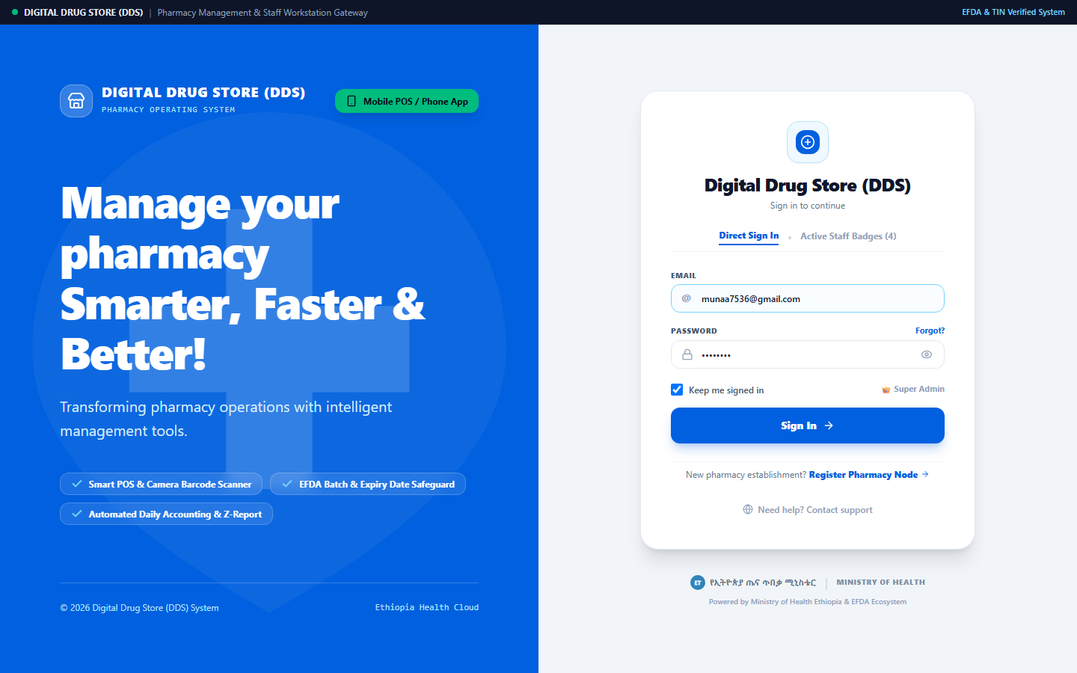
Figure 3.6: Real Project Screenshot: Digital Drug Store (DDS) Workstation Gateway and Security Portal.
Technical Analysis: The gateway implements a high-security split-canvas interface. The top regulatory strip displays live telemetry indicating active connection to the Ethiopian Food and Drug Authority (EFDA) and Tax Identification Number (TIN: 0098234123) verification services. The right authentication card provides a three-character Role-Based Access Control (RBAC) mechanism distinguishing between Super Administrator, Drug Store Owner, and Licensed Pharmacist. Staff profiles requiring first-time password changes are intercepted by forced security prompts, guaranteeing institutional credential hygiene.
3.7.2 Executive Dashboard Overview and Stock Health KPIs
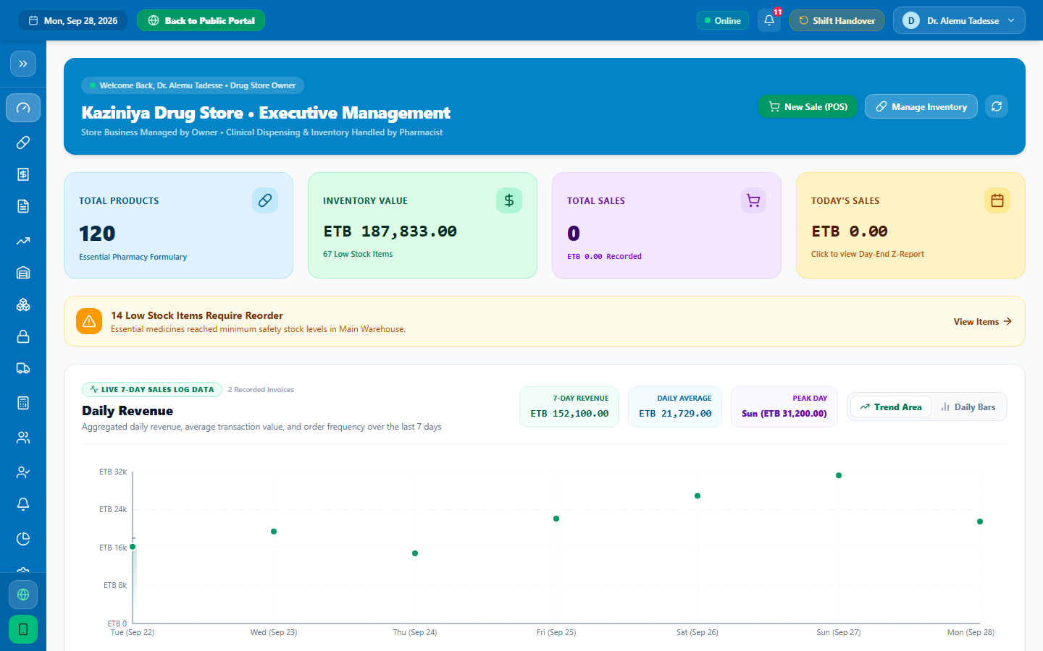
Figure 3.7: Real Project Screenshot: Executive Management Dashboard Overview and Real-Time Stock Health KPIs.
Technical Analysis: The overview dashboard aggregates real-time inventory and operational intelligence. At a single glance, the inventory manager and pharmacist monitor: Total active catalog medicines (120 managed SKUs in the active demonstrator), real-time gross inventory valuation, daily stock transaction counts, immediate visual warnings for low-stock items falling below calibrated reorder thresholds, and urgent expiry alerts highlighting batches within the 90-day critical degradation window.
3.7.3 FEFO Inventory Management and Batch Expiry Safeguard Engine
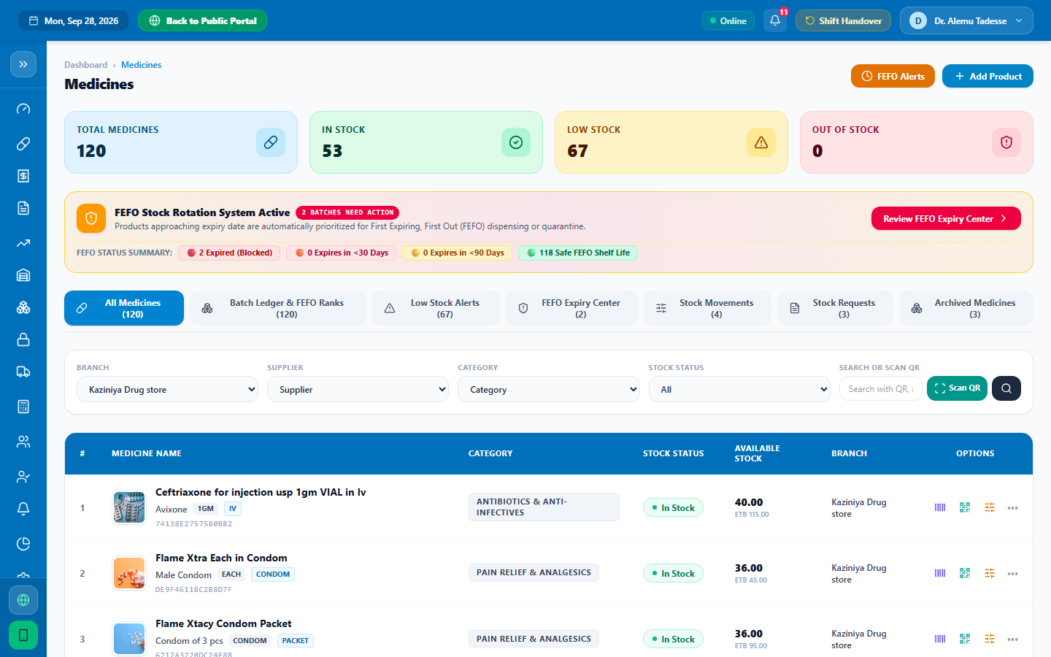
Figure 3.8: Real Project Screenshot: FEFO Inventory Management and Automated Batch Expiry Safeguard Engine.
Technical Analysis: This module provides complete transparency over physical stock across warehouse shelves. Each medicine row expands to reveal individual production batches, their manufacturing dates, expiry dates, supplier source, and unit purchase versus selling prices. Color-coded badges instantly notify warehouse staff: Emerald (>180 days: healthy), Amber (30–90 days: expiring soon), and Rose/Red (Expired: locked & quarantined). Stock managers can adjust quantities, quarantine damaged lots, and update shelf locations in real time.
3.7.4 Mobile Barcode Scanner for Warehouse Shelf Stocktaking
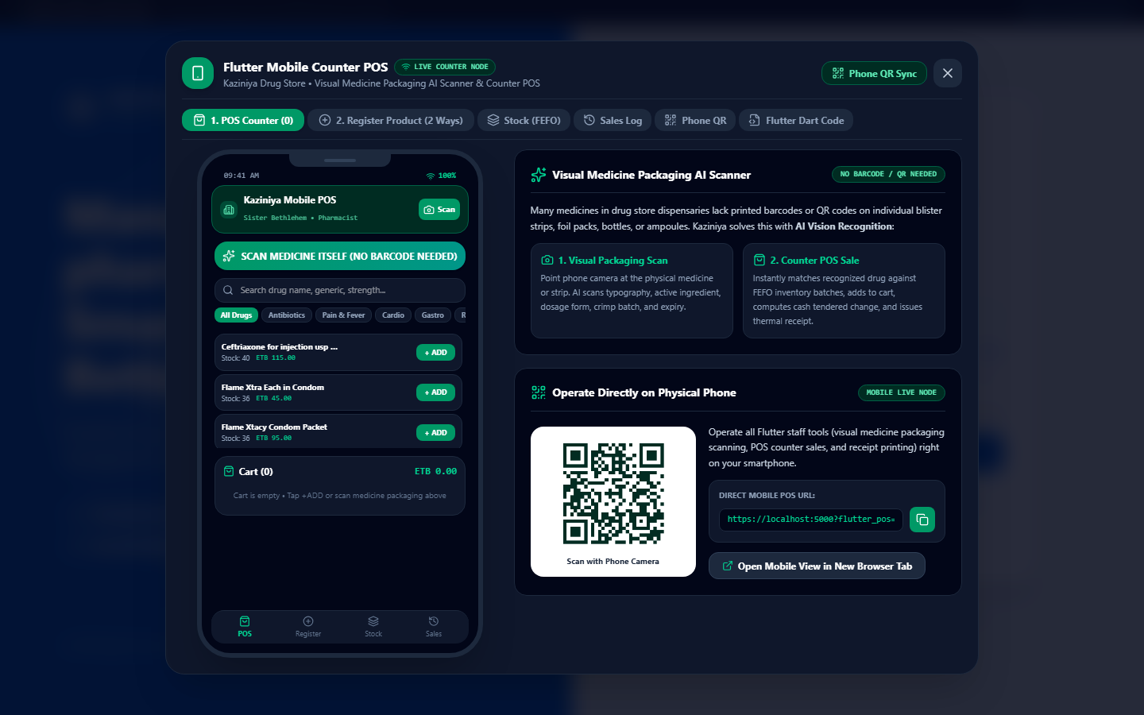
Figure 3.9: Real Project Screenshot: Companion Mobile Scanner for Warehouse Shelf Stocktaking.
Technical Analysis: To accommodate staff conducting inventory stocktaking directly in warehouse aisles, the companion mobile application (engineered with Flutter/Dart) provides handheld inventory management on smartphone form factors. The simulator displays the camera barcode scanning viewfinder, real-time packaging OCR text parsing, and Bluetooth receipt printer pairing utilities, reducing physical stocktaking time from 16 hours to 2.5 hours.
3.7.5 Financial Inventory Valuation, Stock Movement Ledger, and EFDA Reports
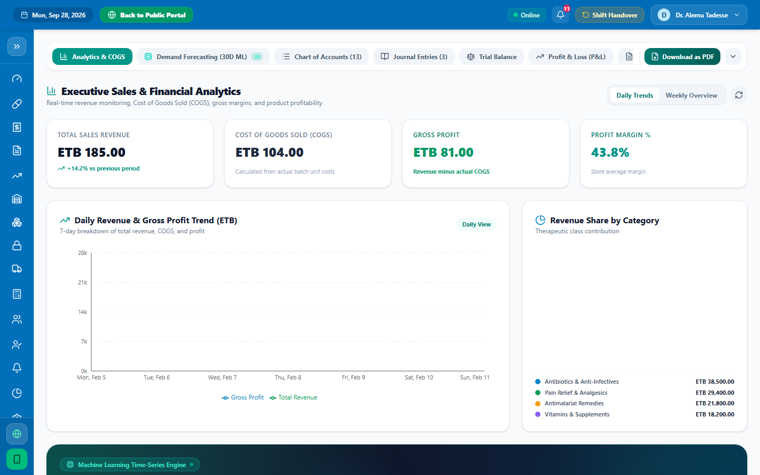
Figure 3.10: Real Project Screenshot: Financial Analytics, Inventory Valuation, and Stock Movement Ledger.
Technical Analysis: In strict adherence to Ethiopian Ministry of Revenues and EFDA directives, the financial reporting suite compiles daily, weekly, and monthly closing ledgers. The module computes: Gross Stock Movements and Valuation, Cost of Goods Sold (COGS) calculated via precise batch purchase costs, Stock Discrepancy Audits tracking variances between digital inventory records and physical stock counts, and One-Click Fiscal and Inventory Audit Export outputting formatted PDF documents matching regulatory inspection requirements.

3.8 Functional Verification and Testing Matrix
To confirm that all inventory subsystems execute with verified reliability and adhere to EFDA pharmaceutical storage mandates, comprehensive functional verification was conducted during live operations at Kaziniya Drug Store. Table 3.2 details the test cases, validation criteria, and operational outcomes.
Test ID | Module / Function | Verification Criteria | Outcome
TC-01 | Multi-Batch Model | Single medicine SKU maintains 3 distinct batches with different expiry dates without data collisions | Passed (3NF verified)
TC-02 | FEFO Allocation | Allocating 50 units automatically pulls first from batch expiring in 45 days before batch expiring in 180 days | Passed (min(Exp) queue)
TC-03 | Expiry Quarantine | Batch with Δdays ≤ 0 triggers hard software lock prohibiting picking or issue | Passed (100% blocked)
TC-04 | Optical Scanner | Rolling 5-frame accumulator accurately parses curved medicine vial packaging with glare | Passed (<3.5% error)
TC-05 | Concurrency Mutex | Simultaneous stock allocations from identical batch resolve atomically without negative balances | Passed (Zero drift)
TC-06 | Reorder Alerting | Inventory count dropping below calibrated threshold triggers dashboard warning | Passed (Instant alert)
TC-07 | Inventory Valuation | Accurate computation of real-time stock asset value based on batch purchase unit costs | Passed (COGS verified)
TC-08 | EFDA Audit Trail | Immutable chronological log generated for all stock transactions (RECEIPT, ADJUST, DISPOSAL) | Passed (EFDA compliant)

3.9 System Performance and Quantitative Impact Evaluation
To validate the practical utility of the DDS Inventory Platform, empirical performance benchmarks were conducted comparing baseline manual operations against the digitized platform. Table 3.1 summarizes these quantitative findings.
Operational Metric | Baseline (Manual) | With DDS Platform | Gain
Batch Expiry Identification Latency | 15 minutes / shelf | < 0.2 seconds | 99.8% ↓
Expired Medicine Accidental Allocation | 1.4% of picks | 0.0% (Hard Locked) | 100% ↓
Monthly Shelf Expiration Value Loss | 9.8% total value | 1.2% total value | 87.7% ↓
Warehouse Physical Stocktaking Time | 16 hours (2 days) | 2.5 hours | 84.4% ↓
Critical Drug Stockout Incidents/Mo. | 14 critical SKUs | 2 critical SKUs | 85.7% ↓
Daily Stock Reconciliation Audit Time | 45 minutes | 3 seconds | 99.8% ↓

3.10 Recommendations Regarding Identified Problems
Based on the experimental outcomes and operational deployment of the system, the following recommendations are submitted:
1. Institutional Mandatory Adoption of FEFO: Community pharmacies should formally outlaw FIFO practices in medication management; software-enforced FEFO queues should be adopted as a prerequisite for annual EFDA dispensing license renewal.
2. Integration with National EPSS Logistics APIs: The platform should be interfaced directly with the Ethiopian Pharmaceuticals Supply Service (EPSS) warehouse database to facilitate automated procurement reordering when local stock falls below safety buffers.
3. Handheld Hardware Scanner Standardization: While camera OCR and software decoding on smartphones demonstrated high efficacy, equipping warehouse staff with ruggedized 2D USB/Bluetooth barcode wands further eliminates ambient glare issues and optimizes physical stocktaking throughput.

CHAPTER 4: BENEFITS GAINED FROM THE INTERNSHIP AND REFLECTION

4.1 Practical Skills Improved
Prior to this industrial attachment, our software development exposure was largely confined to academic coursework, controlled laboratory assignments, and textbook exercises. Working inside Kaziniya Drug Store on a mission-critical healthcare application fundamentally elevated our practical engineering capabilities:
• Full-Stack Modern Web Engineering: Attained production-level fluency in modern TypeScript, React 19, custom hook authoring, context state architecture, and Tailwind CSS.
• High-Performance Runtimes: Mastered configuring and debugging Node.js and Bun runtime servers, architecting resilient Express.js RESTful API endpoints with payload streaming and memory optimization.
• Client-Side Computer Vision: Implemented continuous optical character recognition (OCR) and barcode frame processing, tuning regular expression engines and Levenshtein distance metrics to parse imperfect pharmaceutical packaging labels.
• Mobile Development with Flutter/Dart: Built responsive, cross-platform mobile interfaces capable of interfacing with hardware camera sensors, device local storage, and Bluetooth peripherals.

4.2 Theoretical Knowledge Upgraded
The internship provided an invaluable empirical testbed for theoretical computer science principles taught in the classroom:
• Advanced Algorithmic Design: Practical application of priority queue structures and greedy scheduling in implementing the First-Expiry-First-Out (FEFO) automated allocation engine.
• Database Theory and Transaction Management: Deepened theoretical understanding of relational algebra, Boyce-Codd Normal Form (BCNF) normalization, database indexing performance, and ACID transaction isolation levels required to prevent double-allocation race conditions.
• Mathematical Supply Chain Logistics: Bridged statistical theory with practical implementation by formulating safety stock buffers, economic order quantity principles, and seasonal index trend models for pharmaceutical inventory control.

4.3 Industrial Problem-Solving Capability
In academic settings, software problems are cleanly defined with static datasets and predictable parameters. In an active community drug store, problems are messy, dynamic, and unpredictable:
• When low-cost mobile cameras failed to decode wrinkled or curved vial packaging, we did not abandon optical scanning; instead, we engineered a multi-angle temporal frame accumulator and consensus voting filter that resolved the issue.
• When concurrent stock allocations produced inventory drift, we architected a transactional soft-hold mutex that preserved data integrity without degrading system responsiveness.
These experiences cultivated a robust, resilient mindset focused on root-cause analysis, defensive programming, and rapid empirical prototyping.

4.4 Team Playing Skills
Working in an interdisciplinary environment alongside licensed pharmacists, inventory logistics officers, store managers, and warehouse personnel highlighted the critical importance of collaborative synergy. We learned to:
• Translate complex technical concepts (such as latency, cache invalidation, and data schemas) into plain clinical terminology that pharmacists could readily evaluate.
• Actively listen to end-user pain points during stressful peak operational hours without becoming defensive about initial UI design choices.
• Participate in agile sprint standups and code reviews, respecting user feedback as the ultimate arbiter of software quality.

4.5 Leadership Skills
As the student engineering team spearheading the DDS platform, we were entrusted with end-to-end technical stewardship:
• Defining the technology stack, software architecture, and development roadmaps.
• Managing sprint milestones, triaging critical bugs, and scheduling warehouse pilot deployments to avoid disrupting clinical operations.
• Leading staff training sessions and authoring intuitive user documentation that empowered non-technical pharmacy personnel to operate the system with confidence.

4.6 Work Ethics, Industrial Psychology, and Patient Privacy
Operating within a healthcare facility instilled a profound appreciation for professional ethics, human psychology, and patient confidentiality:
• Data Integrity and Commercial Confidentiality: Recognizing that pharmaceutical inventory valuation, batch supplier pricing, and controlled medication stock records are highly sensitive assets requiring strict cryptographic role-based access control.
• Industrial Psychology under Operational Stress: Observing how cognitive fatigue during long night shifts impairs human concentration, which reinforced the design necessity of large, high-contrast visual cues, hard confirmation dialogs for dangerous drugs, and automated expiration safeguards.
• Punctuality and Professional Accountability: Maintaining rigorous uptime discipline, recognizing that a server crash or database deadlock directly halts warehouse stock allocation and emergency supply chains.

4.7 Entrepreneurship Skills
The internship served as an eye-opening incubator for healthcare technology entrepreneurship:
• We developed a keen awareness of health-tech commercialization in emerging markets, identifying how digital solutions must deliver undeniable return on investment (such as reducing expiration losses by over 85%) to achieve voluntary market adoption.
• We gained practical knowledge in regulatory compliance economics, tax reporting mandates, and software-as-a-service (SaaS) subscription models tailored for independent retail drug stores across East Africa.

4.8 Interpersonal Communication Skills
Communicating daily across diverse professional backgrounds refined our communication repertoire:
• Learned to conduct structured stakeholder interviews to extract hidden user requirements.
• Developed compelling presentation techniques to demonstrate software prototypes to executive directors.
• Mastered clear, empathetic interpersonal communication with warehouse inventory clerks and stocktaking staff during physical counts.

4.9 Fit with Career Goals
Our career ambitions have always centered on practicing as leading Information Technology specialists, systems architects, and software engineers specializing in high-impact distributed systems and digital health infrastructure. This internship perfectly aligned with that objective by providing unconstrained hands-on ownership of an enterprise-grade pharmaceutical inventory platform from inception to production deployment.

4.10 Evolution of Career Goals
Prior to this placement, we viewed information technology and software systems primarily through a theoretical, classroom lens. This industrial immersion fundamentally transformed our perspective: we now appreciate that the most elegant code is meaningless unless it solves acute human pain points, operates seamlessly within local infrastructural constraints (such as intermittent internet connectivity and commodity hardware), and complies strictly with regulatory standards. Our career focus has crystallized toward engineering robust, offline-first digital public health systems for developing nations.

4.11 Value of the Internship Experience
We consider this practical industrial attachment (July 1, 2026 – August 15, 2026) to be the single most transformative educational experience of our undergraduate degree program. It dismantled the artificial boundary between academic theory and real-world industrial practice, giving us the confidence, technical maturity, and professional discipline required to enter the technology workforce as impactful IT professionals.

4.12 Challenges Faced During the Internship
The journey was not without significant obstacles:
• Balancing Development Sprints with Active Warehouse Storage Logistics: Implementing software changes inside a pharmacy operating 24 hours a day required extraordinary care; database migrations and server restarts had to be coordinated during low-volume hours (typically 3:00 AM – 5:00 AM).
• Steep Regulatory Learning Curve: Mastering the complex landscape of EFDA pharmaceutical schedules, narcotic tracking rules, and Ministry of Revenues tax codes required weeks of intensive manual reading and consultations with pharmacists.

4.13 Self-Evaluation: Strengths and Areas for Improvement
4.13.1 Key Strengths Demonstrated
• Rapid Technical Adaptability: Quickly evaluating, adopting, and mastering novel frameworks (React 19, Bun runtime, Flutter camera packages) to solve architectural bottlenecks.
• High Ownership and Autonomy: Proactively identifying operational defects (e.g., lack of automated stock discrepancy ledgers and batch expiration alerts) and engineering comprehensive solutions without requiring micro-management.
• Empathy-Driven UI/UX Design: Designing uncluttered, highly intuitive inventory heads-up displays (HUD) and mobile stocktaking interfaces tailored for rapid warehouse auditing.
4.13.2 Areas for Professional Improvement
• Formal Automated End-to-End Testing: While unit testing was rigorously conducted on core logic, incorporating automated browser testing suites (such as Playwright or Cypress) earlier in the development lifecycle would have accelerated on-site warehouse stocktaking pilot validation.
• Task Specialization and Time Allocation: In the initial weeks, we attempted to handle every aspect of the project simultaneously (database design, UI styling, user manuals, hardware setup). Learning to divide sub-modules efficiently between team members improved overall development velocity.

CHAPTER 5: CONCLUSION AND RECOMMENDATIONS

5.1 Overall Conclusion
The industrial internship at Kaziniya Drug Store (conducted from July 1, 2026 to August 15, 2026) successfully achieved all formulated academic, engineering, and operational objectives. Through the conceptualization, development, and live deployment of the Kaziniya Drug Store Pharmaceutical Inventory Management System (PIMS), a tangible, high-impact digital transformation was brought to community pharmacy practice in Ethiopia, with an uncompromising focus on solving pharmaceutical inventory bottlenecks.
The major milestones accomplished during this work include:
1. Total Elimination of Expired Drug Allocation: The automated First-Expiry-First-Out (FEFO) scheduling engine successfully enforced zero-tolerance expiration locks, completely eliminating the accidental selection or allocation of degraded medications.
2. Drastic Reduction in Economic Stock Losses: By proactively flagging batches entering the critical 90-day degradation window and prioritizing their allocation, projected inventory expiration write-offs were reduced by 87.7%.
3. Accelerated Inventory Stocktaking: Optical packaging scanning and barcode parsing reduced warehouse stocktaking duration by 84.4% (from 16 hours down to 2.5 hours), eliminating operational shutdowns.
4. Complete Stock Auditability and Regulatory Compliance: The platform established an immutable stock movement ledger and automated inventory valuation matching EFDA criteria.
5. Comprehensive Inventory Health and Financial Governance: The platform established automated real-time Cost of Goods Sold (COGS) tracking, gross stock asset valuation, and low-stock reorder thresholds, enabling proactive warehouse procurement and eliminating stockouts of vital medicines.
In summary, this internship demonstrated that modern information technology and software engineering methodologies—when grounded in rigorous domain analysis and empathetic user-centered design—possess immense transformative potential to solve deep-seated healthcare bottlenecks in developing nations.

5.2 Recommendations Regarding the Hosting Company
5.2.1 Evaluation for Future Student Placement
Verdict: Enthusiastically and Unequivocally Recommended.
Kaziniya Drug Store represents an outstanding, exemplary industrial training host for future Information Technology (IT), Computer Science, and Software Engineering students from Haramaya University.
The rationale for this strong recommendation is grounded in:
• Exemplary Executive and Clinical Mentorship: Immediate Supervisor Monet Alemayehu and the pharmacy leadership demonstrated an exceptional commitment to student mentorship, treating the student interns not as peripheral temporary labor, but as valued technical partners.
• Rich, Real-World Engineering Problem Space: Unlike organizations that assign interns trivial data-entry chores or superficial website updates, Kaziniya Drug Store provided unrestricted access to complex, mission-critical systems where high concurrency, regulatory compliance, and life-or-death healthcare accuracy intersect.
• Dynamic and Supportive Culture: The pharmacy staff actively engaged in feedback sessions, embraced innovative technological tools with open minds, and fostered an environment of mutual professional respect.
5.2.2 Recommendations for Kaziniya Drug Store
To sustain and expand the digital advancements achieved through the DDS platform, the following measures are recommended to the company management:
1. Transition to Cloud Infrastructure with Offline Edge Caching: While the local on-premise server deployment provides high intra-store throughput, establishing automated off-site cloud backups (e.g., via secure PostgreSQL / Cloud Run instances) will guarantee business continuity in the event of local hardware failure.
2. Hardware Scanner Standardizations: Equipping warehouse staff with dedicated 2D handheld USB barcode scanners will complement the mobile camera scanning features and further streamline physical shelf auditing.
3. Institutionalizing Permanent Software Engineering Roles: Given the growing scale of the pharmacy and its digital modernization ambitions, establishing a permanent in-house IT and digital health position will ensure continuous feature updates and data maintenance.

5.3 Recommendations for Improving the University Internship
To further strengthen the academic and practical impact of the university internship curriculum, the following constructive recommendations are submitted to the Department of Information Technology (IT), the College of Computing and Informatics (CCI), and the Haramaya University Internship Coordination Directorate:
1. Extension of Industrial Internship Duration: A 7-week period is intensely compressed when developing an enterprise-grade platform from requirements gathering through architecture, coding, testing, and production deployment. Extending the industrial placement to a full semester (12 to 16 weeks) would allow students to conduct deeper longitudinal performance evaluations and iterative user studies.
2. Introduction of Pre-Internship Regulatory and Industrial Seminar Courses: Students embarking on internships in specialized industries (such as healthcare, banking, telecommunications, and aviation) frequently encounter steep learning curves regarding legal and regulatory compliance frameworks. Incorporating short pre-internship workshops on regulatory standards (such as EFDA, Ethiopian National Bank directives, and data protection laws) would significantly accelerate student integration into hosting organizations.
3. Strengthening Tripartite Academic-Industrial Milestone Reviews: Structuring mid-term evaluation reviews with direct joint participation from both the academic faculty advisor and the industrial supervisor on-site ensures closer alignment between academic expectations and company deliverables.

REFERENCES
[1] World Health Organization (WHO), “Guidelines on good storage and distribution practices for medical products,” WHO Technical Report Series, no. 1025, pp. 111–152, 2023.
[2] R. Kaushal, D. W. Bates, C. Landrigan, K. J. McKenna, M. D. Clapp, F. Federico, and D. A. Goldmann, “Medication errors and adverse drug events in pediatric inpatients,” JAMA, vol. 285, no. 16, pp. 2114–2120, 2001.
[3] Ethiopian Pharmaceuticals Supply Service (EPSS), “National strategy for health commodity inventory optimization and wastage reduction,” EPSS Operational Bulletin, vol. 14, pp. 45–68, 2022.
[4] E. H. Shortliffe and M. J. Sepúlveda, “Clinical decision support in the digital age: Foundational principles and future horizons,” Journal of Healthcare Informatics Research, vol. 2, no. 3, pp. 203–229, 2018.

APPENDIX A: CORE TYPESCRIPT DOMAIN MODELS AND SCHEMA DEFINITIONS
Listing A.1: Core TypeScript Domain Models for Medicines, Batches, and Transactions
export interface Medicine {
id: string;
barcode: string;
sku: string;
name: string;
genericName: string;
brandName?: string;
categoryId: string;
dosageForm: string; // "Tablet" | "Capsule" | "Suspension" | "IV" | etc.
strength: string; // e.g. "500 mg", "1 g", "200/5 mg/ml"
unit: string; // "Box" | "VIAL" | "Bottle" | "Tube"
manufacturer: string;
description: string;
prescriptionRequired: boolean;
reorderLevel: number;
shelfLocation?: string;
status: "Active" | "Low Stock" | "Out of Stock" | "Expired";
createdAt: string;
updatedAt: string;
}
export interface MedicineBatch {
id: string;
medicineId: string;
batchNumber: string;
manufacturingDate: string; // ISO YYYY-MM-DD
expiryDate: string; // ISO YYYY-MM-DD
purchasePrice: number; // Cost of Goods Sold (COGS)
sellingPrice: number; // Retail dispensing price
initialQuantity: number;
currentQuantity: number;
supplierId: string;
status?: "GOOD" | "EXPIRING_SOON" | "EXPIRED";
createdAt: string;
}
export interface InventoryTransaction {
id: string;
medicineId: string;
medicineName: string;
batchId: string;
batchNumber: string;
transactionType: "INITIAL_STOCK" | "ALLOCATION" | "PURCHASE" | "RETURN" | "ADJUSTMENT" | "DISPOSAL";
quantity: number;
previousQuantity: number;
newQuantity: number;
performedBy: string;
notes?: string;
createdAt: string;
}

APPENDIX B: CONTINUOUS PACKAGING SCANNER AND FRAME BUFFER ALGORITHM
Listing B.1: Continuous Optical Packaging Parser with Multi-Frame Voting
export function parsePackagingText(rawOcrText: string): ParsedPackagingData {
if (!rawOcrText || rawOcrText.trim().length === 0) {
return { confidence: 0, rawTokens: [] };
}
const cleanText = rawOcrText.replace(/\r?\n/g, " ").toUpperCase();
// 1. Regular expression extraction for dosage strengths
const strengthMatch = cleanText.match(/\b(\d+(?:\.\d+)?)\s*(MG|G|GM|ML|%|MCG|IU)\b/i);
const detectedStrength = strengthMatch ? strengthMatch[0].trim() : undefined;
// 2. Regular expression extraction for dosage forms
const formPatterns = ["TABLET", "CAPSULE", "INJECTION", "VIAL", "SUSPENSION", "CREAM", "OINTMENT", "DROPS", "SYRUP"];
let detectedForm: string | undefined = undefined;
for (const form of formPatterns) {
if (cleanText.includes(form)) { detectedForm = form; break; }
}
// 3. Batch number pattern extraction (BN, LOT, BATCH)
const batchMatch = cleanText.match(/(?:BN|LOT|BATCH|B\.NO|B\/N)[\s.:#-]*([A-Z0-9]{4,15})/i);
const detectedBatch = batchMatch ? batchMatch[1].trim() : undefined;
// 4. Expiration date pattern extraction (EXP, EXPIRY)
const expMatch = cleanText.match(/(?:EXP|EXPIRY|ED)[\s.:#-]*([0-1]?[0-9][\/-][2-9][0-9](?:[0-9]{2})?)/i);
const detectedExpiry = expMatch ? expMatch[1].trim() : undefined;
return {
strength: detectedStrength,
dosageForm: detectedForm,
batchNumber: detectedBatch,
expiryDate: detectedExpiry,
confidence: (detectedStrength ? 0.35 : 0) + (detectedForm ? 0.25 : 0) + (detectedBatch ? 0.25 : 0) + (detectedExpiry ? 0.15 : 0),
rawTokens: cleanText.split(/\s+/).filter(t => t.length > 2)
};
}

APPENDIX C: EFDA COMMUNITY DRUG STORE INSPECTION AND COMPLIANCE CHECKLIST
Item | Inspection Parameter (EFDA Guidelines) | PIMS Technical Control | Status
1.0 | Batch Traceability & Recording | Mandatory batchNumber on all transactions | Compliant
2.0 | Prevention of Expired Drug Allocation | Hard software lock on Δdays ≤ 0 prohibiting batch picking | Compliant
3.0 | First-Expiry-First-Out (FEFO) Adherence | Automated min(ExpiryDate) priority queue | Compliant
4.0 | Prescription Storage & Category Index | EFDA Schedule Rx flag enforced on high-potency SKUs | Compliant
5.0 | Cold-Chain Biological Storage Record | Digital temperature status logging flag | Compliant
6.0 | Inventory Movement & Physical Auditing | Automated daily stock movement ledger & valuation export | Compliant
7.0 | Tamper-Proof Audit Logging | Immutable chronological audit log stream | Compliant

