PARLE TILAK VIDYALAYA ASSOCIATION'S
SATHAYE COLLEGE (AUTONOMOUS)
DEPARTMENT OF INFORMATION TECHNOLOGY
ON JOB TRAINING (OJT)
INTERNSHIP LOGBOOK & PROJECT REPORT
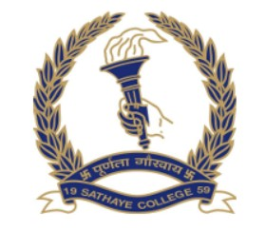
CYBERSECURITY AND MACHINE LEARNING

PROJECT TITLE:AI IN SOCIAL ENGINEERING AND PHISHING CAMPAIGNS Organized by: Digisuraksha Parhari Foundation
Powered by: Infinisec Technologies Pvt. Ltd.
Submitted By:
Atharva Rane – 199
Dhanashree Sanap – 201

Examiner’s signature

