ACME ENGINEERING LTD
Global Infrastructure Division
Technical Design Specification for Offshore Platform
Document No.

CEP210090ER

Document Number CEP210090ER
Document Title Technical Design Specification for Offshore Platform
Revision 03
Security Classification CONFIDENTIAL
Reason for Issue Approved for Construction
Date 15 March 2026
Author J. Smith
Checker A. Brown
Approver M. Davis



Document Information

Field | Value
Document Number | CEP210090ER
Document Title | Technical Design Specification for Offshore Platform
Revision No. | 03
Security Classification | CONFIDENTIAL
Reason for Issue | IFU
Project | Offshore Platform Alpha
Client | Energy Corp International

Revision History

Rev | Date | Description | Author | Checker
01 | 10 Jan 2025 | Initial issue for review | J. Smith | A. Brown
02 | 22 Aug 2025 | Updated per client comments | J. Smith | A. Brown
03 | 15 Mar 2026 | Approved for Construction | J. Smith | M. Davis

Distribution List

Copy No. | Recipient | Organisation | Doc Ref
1 | Project Manager | Energy Corp | CEP210090ER
2 | Lead Engineer | ACME Engineering | CEP210090ER
3 | Safety Review | HSE Authority | CEP210090ER

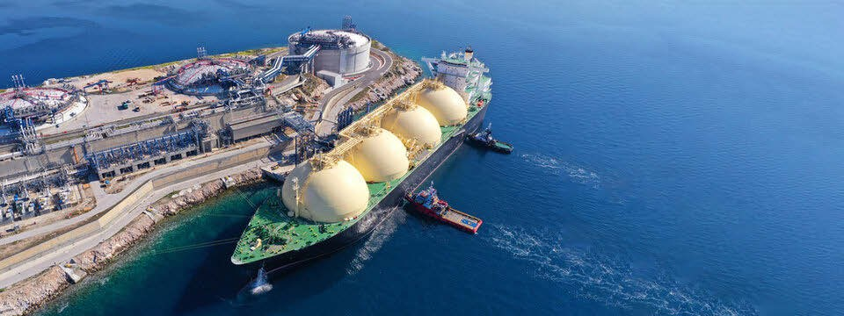

DOCUMENT TRANSMITTAL FORM

DOCUMENT NUMBER
REV
DATE

CEP210090ER

03

15/03/2026

DOCUMENT TITLE

Technical Design Specification for Offshore Platform

SECURITY CLASSIFICATION
REASON FOR ISSUE
ORIGINATOR

CONFIDENTIAL
IFU

J. Smith

Transmittal Reference: TR-CEP210090ER-03

Associated Drawing No: CEP210090ER

APPROVAL SIGNATURES

Role | Name | Signature | Date
Prepared by | J. Smith | [Signed] | 10/03/2026
Checked by | A. Brown | [Signed] | 12/03/2026
Approved by | M. Davis | [Signed] | 15/03/2026

NOTICE: This document (CEP210090ER, Revision 03) is classified as CONFIDENTIAL. Unauthorized reproduction or distribution is strictly prohibited. This document has been issued for the purpose of 'Approved for Construction' and supersedes all previous revisions.

Ref: CEP210091ER Issue: 04

This technical summary is issued under document reference CEP210091ER at revision 04. The design presented herein covers the structural analysis of the topsides module for the offshore platform.

CONFIDENTIAL
Document: CEP210091ER

Key Parameters

Parameter | Value | Reference
Document Ref | CEP210091ER | Cover sheet
Revision | 04 | Rev history
Classification | CONFIDENTIAL | Security policy
Design Life | 25 years | Client spec
Water Depth | 120m | Metocean report

