Visual Testing Tool - Comprehensive Documentation

Table of Contents
1. Overview
2. Problem Statement
3. Solution Architecture
4. Key Features
5. Technical Flow
6. System Architecture
7. Baseline Manager
8. Authentication System
9. API Documentation
10. Future Scope
──────────────────────────────────────────────────

Overview
The Visual Testing Tool is an automated pixel-perfect UI regression testing solution that captures and compares website screenshots across multiple resolutions (Desktop, Tablet, Mobile). It detects even single-pixel differences between baseline and current versions, ensuring UI consistency and catching visual bugs before production deployment.

Key Statistics
• 3 Resolutions: Desktop (1920x1080), Tablet (768x1024), Mobile (375x667)
• Pixel-Perfect Accuracy: Detects 1-pixel differences
• Flexible Routes: Test any combination of public and authenticated routes
• Automated Testing: Powered by Playwright for reliable browser automation
──────────────────────────────────────────────────

Problem Statement

Challenges in Modern Web Development
1. Undetected UI Changes

• Minor visual regressions often slip through manual testing
• Affects user experience and brand consistency
• Difficult to track across multiple pages
2. Multi-Device Complexity

• Testing across desktop, tablet, and mobile resolutions manually is time-consuming
• Inconsistent rendering across different viewports
• Error-prone manual verification
3. Continuous Deployment Risks

• Fast-paced development cycles increase risk of visual bugs
• Lack of automated visual regression testing
• No historical tracking of UI changes
4. Pixel-Level Precision

• Human eyes can miss subtle changes
• Need for automated, objective comparison
• Requirement for detailed diff reports
──────────────────────────────────────────────────

Solution Architecture

Technology Stack

Backend
• Node.js + Express: RESTful API server
• Playwright: Browser automation and screenshot capture
• Python (OpenCV): Pixel-perfect image comparison
• Multer: File upload handling for baseline images

Frontend
• React + Vite: Modern, fast UI development
• TailwindCSS: Responsive styling
• Axios: API communication

Storage
• File System: Screenshots, baselines, and reports stored locally
• JSON Files: Configuration for routes, authentication, and reports
──────────────────────────────────────────────────

Key Features

1. Multi-Resolution Testing
Tests are automatically executed across three viewport sizes:
• Desktop: 1920x1080 (Full HD)
• Tablet: 768x1024 (iPad Portrait)
• Mobile: 375x667 (iPhone SE)

2. Baseline Manager
Complete control over baseline images:
• Add: Upload custom baseline images for any route/resolution
• Delete: Remove outdated baselines
• Replace: Update baselines when UI changes are intentional
• View: Browse all baseline images per domain

3. Route Management
Flexible route configuration:
• Add/remove routes dynamically
• Test any combination of routes
• Support for authenticated routes
• Per-domain route storage

4. Authentication Support
Automatic login for protected pages:
• Mobile number and password-based authentication
• Session storage capture and restoration
• Cookie management
• Reusable authentication across routes

5. Pixel-Perfect Comparison
Advanced image comparison:
• Pixel-by-pixel analysis using OpenCV
• Diff image generation with highlighted changes
• Accuracy percentage calculation
• Detailed pixel difference metrics

6. Component-Level Testing
Intelligent component detection:
• Header, Footer, Navigation
• Forms and Input Fields
• Buttons and Interactive Elements
• Cards, Articles, Sections
• Modals and Menus

7. Comprehensive Reports
Detailed test results:
• JSON reports with full test metadata
• Visual diff images
• Accuracy percentages
• Downloadable ZIP archives
• Historical report tracking
──────────────────────────────────────────────────

Technical Flow

High-Level Testing Flow
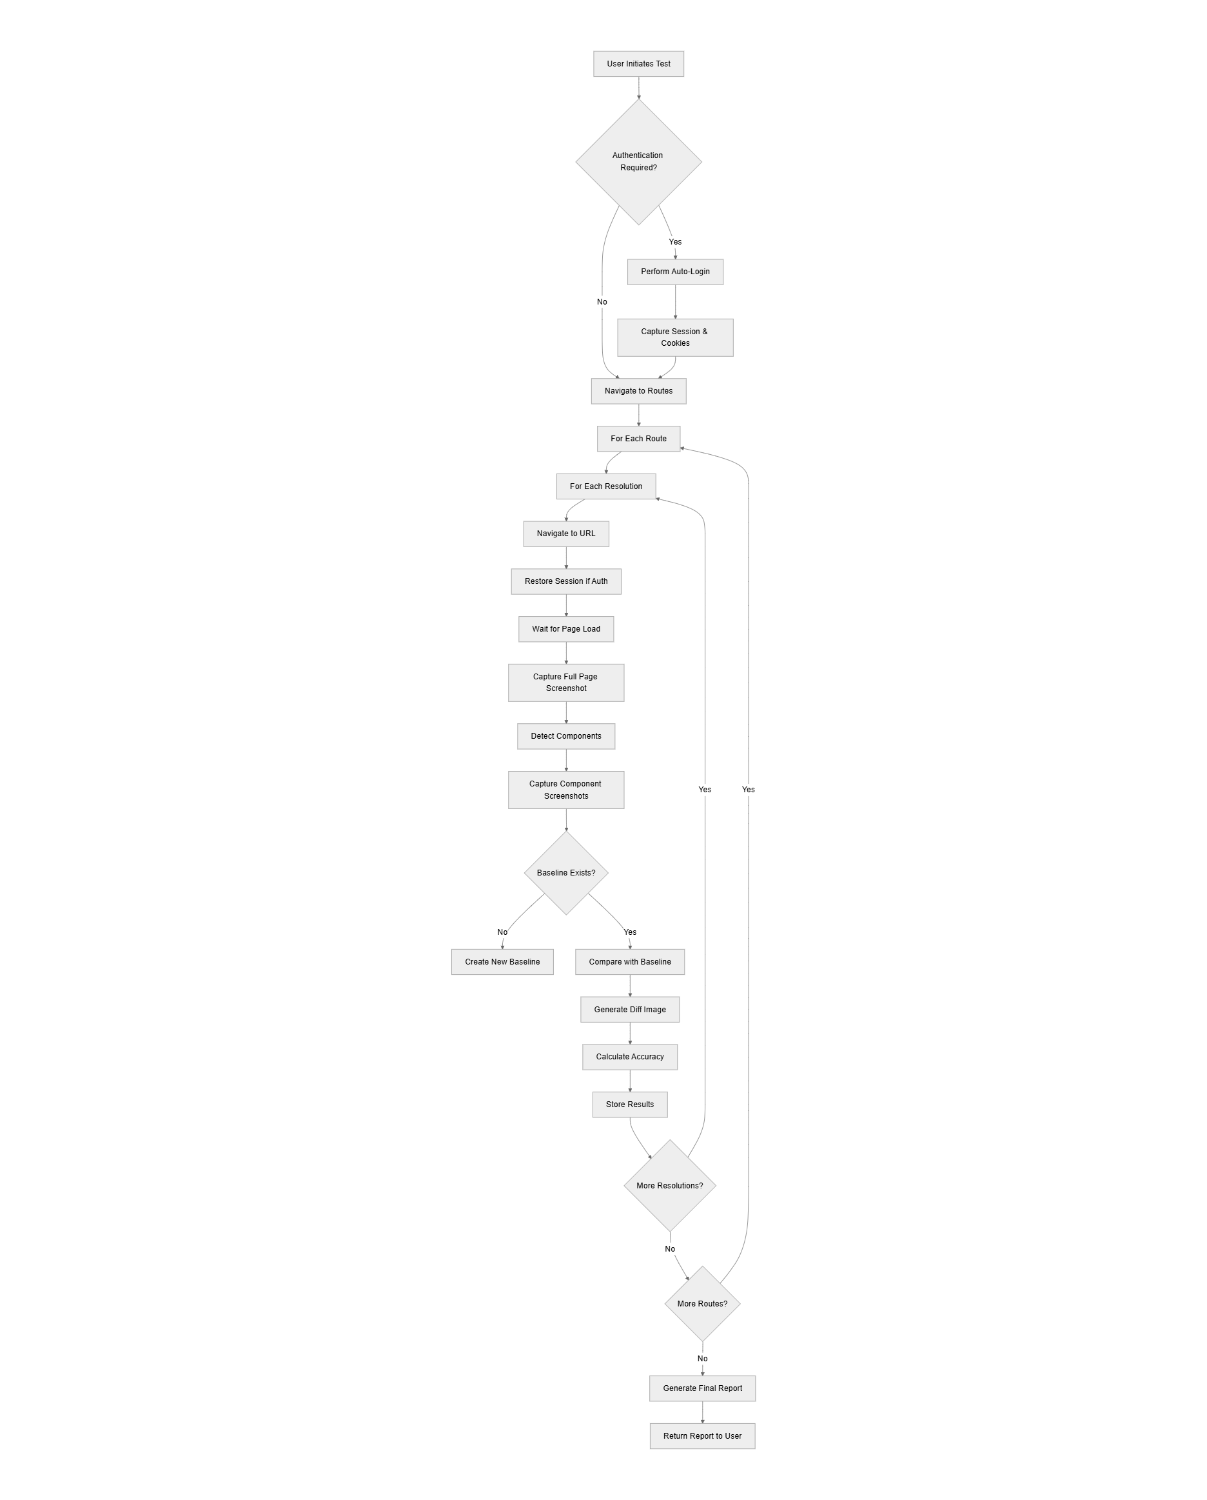

Authentication Flow
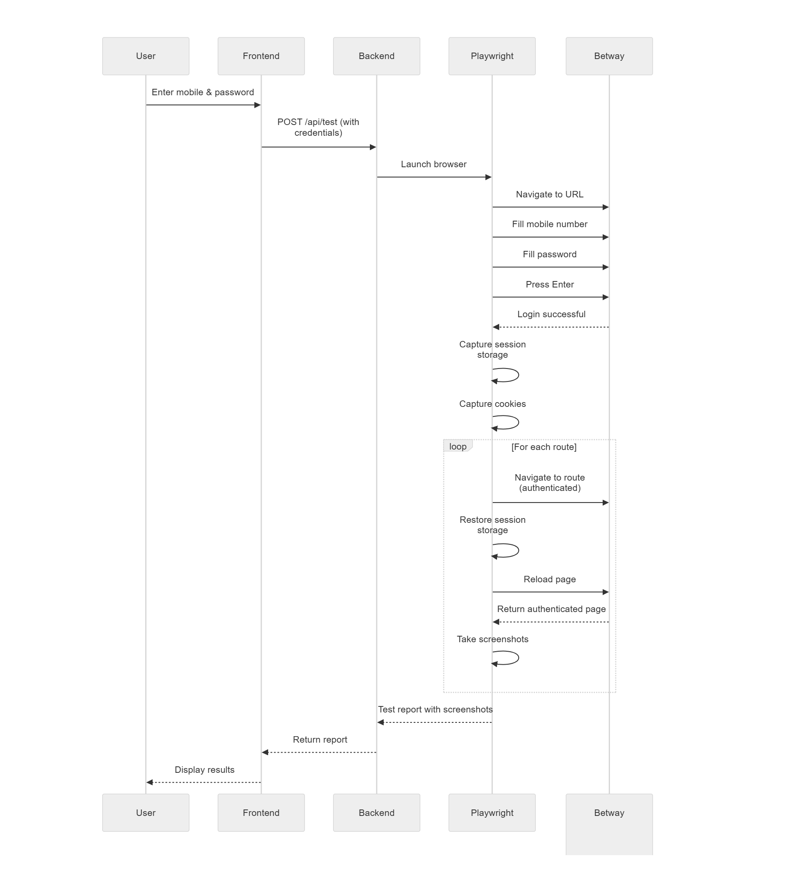

Image Comparison Flow
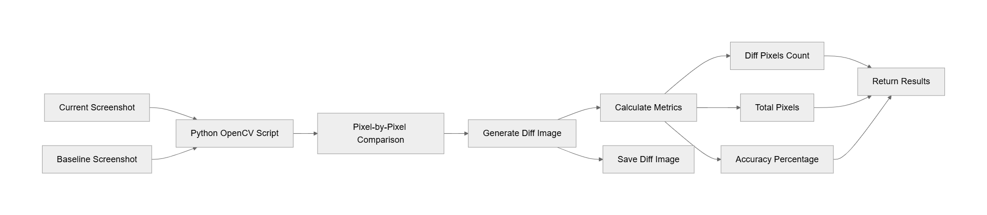

──────────────────────────────────────────────────

System Architecture

Directory Structure

visual-testing-app/

├── backend/

│ ├── services/

│ │ └── tester.js # Core testing logic

│ ├── public/

│ │ ├── baselines/ # Baseline images per domain

│ │ ├── runs/ # Test run screenshots

│ │ ├── results/ # JSON reports

│ │ ├── routes.json # Route configuration

│ │ └── auth.json # Authentication config

│ ├── uploads/ # Temporary upload storage

│ ├── compare_images.py # Python comparison script

│ ├── server.js # Express API server

│ └── package.json

├── frontend/

│ ├── src/

│ │ ├── components/

│ │ │ ├── TestForm.jsx # Main test form

│ │ │ ├── ReportList.jsx # Report listing

│ │ │ ├── ReportDetail.jsx # Detailed report view

│ │ │ └── BaselineManager.jsx # Baseline management

│ │ ├── App.jsx

│ │ ├── api.js # API client

│ │ └── main.jsx

│ ├── index.html

│ └── package.json

└── README.md

Component Architecture
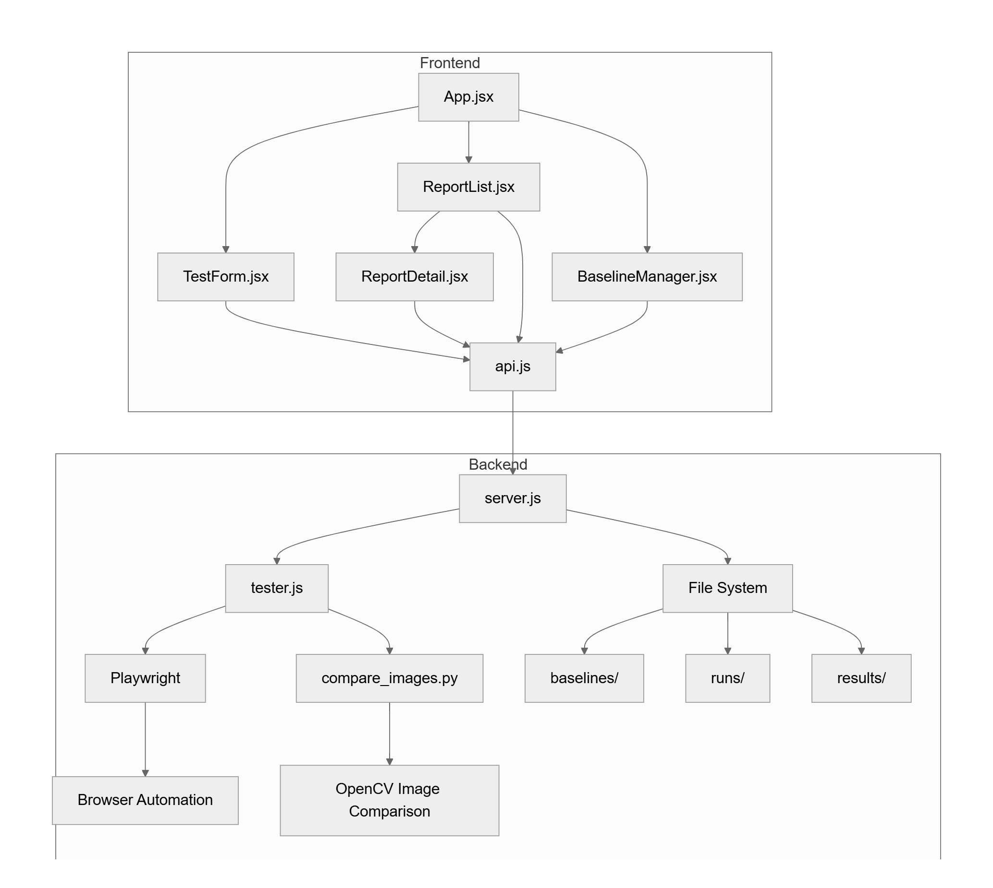

──────────────────────────────────────────────────

Baseline Manager
The Baseline Manager provides complete control over baseline images used for visual comparison testing.

Features
1. View Baselines

• Display all baseline images for a domain
• Organized by route and resolution
• Preview images directly in the UI
2. Upload Baselines

• Upload custom baseline images
• Specify route name and resolution
• Supports Desktop, Tablet, Mobile resolutions
• Automatic file naming: {route}-{resolution}-fullpage.png
3. Delete Baselines

• Remove outdated or incorrect baselines
• Confirmation before deletion
• Automatic cleanup
4. Replace Baselines

• Upload new baseline to replace existing
• Useful when UI changes are intentional
• Maintains consistent naming

Baseline File Naming Convention
{routeName}-{resolution}-fullpage.png
Examples:
• home-desktop-fullpage.png
• about-tablet-fullpage.png
• contact-mobile-fullpage.png
• my-bets-desktop-fullpage.png

API Endpoints
Method | Endpoint | Description
GET | /api/baselines/:domain | Get all baselines for a domain
POST | /api/baselines/upload | Upload a new baseline image
DELETE | /api/baselines/:domain/:filename | Delete a specific baseline
──────────────────────────────────────────────────

Authentication System

Automatic Login Flow
The tool supports automatic authentication for testing protected routes:
1. User Provides Credentials

• Mobile number
• Password
• Toggle "Requires Authentication"
2. Backend Performs Login

• Navigate to base URL
• Fill mobile number field
• Fill password field
• Submit form (Enter key)
• Wait for login completion
3. Session Capture

• Capture all session storage items
• Capture all cookies
• Store for reuse across routes
4. Session Restoration

• For each authenticated route:
• Navigate to route
• Restore session storage
• Reload page
• Page loads in authenticated state

Authentication Configuration Storage
Stored in backend/public/auth.json:

{

"betway.co.za": {

"requiresAuth": true,

"bearerToken": "",

"customHeaders": {}

}

}

Supported Authentication Methods
• ✅ Form-based login (mobile + password)
• 🔄 Bearer token (planned)
• 🔄 Custom headers (planned)
• 🔄 OAuth (future scope)
──────────────────────────────────────────────────

API Documentation

Test Execution
POST /api/test
Execute a visual test for a website.
Request Body:

{

"url": "https://betway.co.za",

"routes": ["/", "/my-bets", "/sports"],

"requiresAuth": true,

"mobile": "0123456789",

"password": "password123",

"customHeaders": {}

}

Response:

{

"id": "1735812345678",

"url": "https://betway.co.za",

"site": "betway.co.za",

"timestamp": "2026-01-02T08:30:00.000Z",

"duration": "45.32s",

"results": [

{

"route": "/",

"viewports": [

{

"viewport": "Desktop",

"width": 1920,

"height": 1080,

"fullPage": {

"name": "Full Page",

"filename": "home-desktop-fullpage.png",

"status": "pass",

"diffPixels": 0,

"accuracy": "100.00",

"baseline": "baselines/betway.co.za/home-desktop-fullpage.png",

"current": "runs/1735812345678/home-desktop-fullpage.png",

"diff": "runs/1735812345678/home-desktop-fullpage-diff.png"

},

"components": [...]

}

]

}

]

}

Report Management
Method | Endpoint | Description
GET | /api/reports | Get all test reports
GET | /api/reports/:id | Get specific report by ID
GET | /api/reports/:id/download | Download report as ZIP
DELETE | /api/reports/:id | Delete a report

Route Management
Method | Endpoint | Description
GET | /api/routes/:domain | Get routes for a domain
POST | /api/routes/:domain | Add a route to a domain
POST Request Body:

{

"route": "/my-bets"

}

Authentication Management
Method | Endpoint | Description
GET | /api/auth/:domain | Get auth config for domain
POST | /api/auth/:domain | Save auth config
DELETE | /api/auth/:domain | Remove auth config
──────────────────────────────────────────────────

Future Scope

1. AI-Powered Authentication 🤖
Goal: Eliminate manual credential management with intelligent authentication.
Features:
• Automatic form field detection
• Multi-step login flow handling
• CAPTCHA solving integration
• OAuth/SSO support
• Credential vault with encryption
• Support for any website without configuration
Benefits:
• Zero manual configuration
• Works with any authentication system
• Secure credential storage
• Automatic session management

2. Unified Dashboard Integration 📊
Goal: Make the visual testing tool part of a comprehensive QA dashboard.
Features:
• Centralized test management
• Integration with other testing tools
• Real-time test execution monitoring
• Historical trend analysis
• Team collaboration features
• Role-based access control
Benefits:
• One-stop solution for all testing needs
• Better visibility across teams
• Streamlined workflows
• Consolidated reporting

3. Smart Diff Analysis 🧠
Goal: Use AI to distinguish between intentional changes and actual bugs.
Features:
• ML-based change classification
• Ignore dynamic content (ads, timestamps)
• Smart threshold adjustment
• Pattern recognition for common UI changes
• Auto-approve minor changes
• Anomaly detection
Benefits:
• Reduced false positives
• Faster review process
• Intelligent baseline updates
• Better signal-to-noise ratio

4. Performance Optimization ⚡
Goal: Faster test execution and scalability.
Features:
• Parallel test execution
• Cloud-based infrastructure
• Distributed testing across multiple machines
• Screenshot caching
• Incremental testing (only changed routes)
• GPU-accelerated image comparison
Benefits:
• 10x faster test execution
• Handle large-scale applications
• Cost-effective scaling
• Reduced CI/CD pipeline time

5. Real-time Notifications 🔔
Goal: Instant alerts when visual regressions are detected.
Features:
• Slack integration
• Microsoft Teams integration
• Email notifications
• Webhook support
• Custom notification rules
• Severity-based alerting
Benefits:
• Immediate awareness of issues
• Faster response time
• Better team coordination
• Configurable alert preferences

6. Historical Trend Analysis 📈
Goal: Track UI stability and changes over time.
Features:
• Visual change timeline
• Stability metrics dashboard
• Component-level change tracking
• Regression frequency analysis
• Automated reports
• Predictive analytics
Benefits:
• Identify problematic areas
• Data-driven decision making
• Quality metrics for stakeholders
• Continuous improvement insights

7. CI/CD Integration
Goal: Seamless integration with existing development workflows.
Features:
• GitHub Actions integration
• GitLab CI/CD support
• Jenkins plugin
• Azure DevOps integration
• Automatic PR comments with visual diffs
• Blocking deployments on failures
Benefits:
• Automated testing in pipeline
• Prevent visual bugs from merging
• Developer-friendly workflow
• Continuous visual testing

8. Advanced Reporting
Goal: Rich, interactive reports with better insights.
Features:
• Interactive diff viewer
• Side-by-side comparison
• Slider to compare baseline vs current
• Heatmap of changes
• PDF report generation
• Shareable report links
Benefits:
• Better visualization
• Easier stakeholder communication
• Professional documentation
• Collaborative review
──────────────────────────────────────────────────

Getting Started

Prerequisites
• Node.js (v16+)
• Python 3.x (for image comparison)
• pip (Python package manager)

Installation
1. Install Python Dependencies

pip install opencv-python numpy
2. Install Backend Dependencies

cd backend
npm install
3. Install Frontend Dependencies

cd frontend
npm install

Running the Application
1. Start Backend Server

cd backend
npm start

Server runs on: http://localhost:3000
2. Start Frontend Development Server

cd frontend
npm run dev

App runs on: http://localhost:5173

Running Your First Test
1. Open http://localhost:5173
2. Enter a URL (e.g., https://example.com)
3. Add routes (optional)
4. Configure authentication (if needed)
5. Click "Run Test"
6. Wait for completion
7. View detailed results with diff images
──────────────────────────────────────────────────

Advantages Summary
Advantage | Description
Pixel-Perfect Detection | Catches even 1-pixel differences that humans miss
Multi-Resolution | Ensures consistency across Desktop, Tablet, Mobile
Automated Testing | Saves hours of manual QA effort
Early Bug Detection | Catch visual regressions before production
Baseline Management | Full control over what to compare against
Authentication Support | Test protected pages automatically
Component-Level Testing | Granular testing of individual UI components
Comprehensive Reports | Detailed insights with visual diffs
Flexible Route Testing | Test any combination of pages
CI/CD Ready | Can be integrated into deployment pipelines
──────────────────────────────────────────────────

Conclusion
The Visual Testing Tool provides a robust, automated solution for pixel-perfect UI regression testing. With support for multiple resolutions, authentication, baseline management, and comprehensive reporting, it ensures your web applications maintain visual consistency across all updates and deployments.
The planned future enhancements, particularly AI-powered authentication and dashboard integration, will transform this tool into a comprehensive, one-stop solution for all visual testing needs.
──────────────────────────────────────────────────
Version: 2.0
Last Updated: January 2, 2026
Maintained By: Development Team

