**Manarat International University**

Course: Software Development

Course_Code: CSE 312

**Project Proposal**

Team Name: GameBagh

**Project Title: Android Gaming App**

**Project Category: Mobile App**

Github Repository: [GameBagh](https://github.com/mhapu46/GameBagh)

tEAMMATES-

1.Abdullah Ath Tawfiq

1846CSE00687

2.Mehorab Hossain

1846CSE00679

Project Description

Programming Language: Java, XML

IDE: Android Studio

Platform: Android

Libraries:

**Features:**

This is a two player game, where each player will get a chance one after the other. This game will be having a coart with two part and 13 points. In start the role of one player will be a tiger and other players role will be goat.Tiger duty is to hunt the goats and Goat duty is to save owns life and to stuck the tiger in one place.Our application will have the following things in its interface:

1. It will have total 13 options and two parts grid.
2. There will be 1 tiger and 7 goats in the game.
3. It will display who’s turn it is.
4. Then it’ll have the Restart button. This button can help the player to restart the game at any time they like.
5. 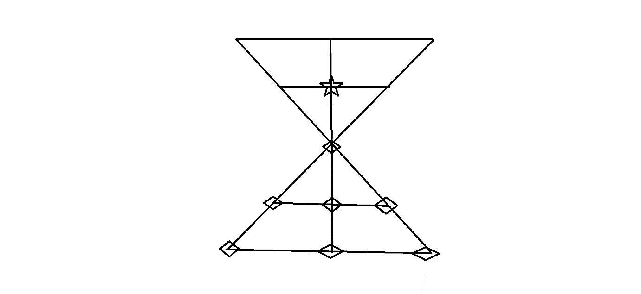Once the game is over the app will declare who lost/win the game.

**Contribution:**

1. Abdullah Ath Towfiq: Write the code and XML text.

2.Mehorab Hossain: Design the game, Create idea and help about code.