

SPENDWISE – SMART EXPENSE MANAGER
A Command Line Based Expense Tracking System

Project Report
Submitted as part of the requirements for
VITyarthi’s Evaluated Course Project (BYOP)

Submitted by:
Aviraj Singh Thakur
25BCE10894
Date: 31 March 2026
Slot: A11+A12+A13

TABLE OF CONTENTS

S.No. | Topic | Page no.
1. | Introduction | 03
2. | Objectives | 03
3. | Problem Statement | 04
4. | Methodology | 04
5. | Features of the Project | 05
6. | System Architecture/Flow | 06
7. | Technologies used | 08
8. | Output Screenshots | 09
9. | Challenges Faced | 11
10. | Limitations | 11
11. | Future Scope | 12
12. | Conclusion | 12

1. Introduction
In today’s time, managing personal finances has become very important, especially for students and young individuals. Most people spend money daily but do not keep a proper track of where it is going. Because of this, they often end up overspending or failing to save.
SpendWise is a simple command-line based expense manager that helps users record and analyze their daily expenses. The main idea behind this project was to create something practical and actually usable instead of just making a basic project for submission.
This project focuses on helping users become more aware of their spending habits and take better financial decisions over time.

2. Objective
The main objectives of this project are:
- To create a simple tool for tracking daily expenses
- To help users manage their monthly budget
- To provide basic insights into spending habits
- To improve financial awareness among users
- To implement real programming concepts in a practical way
3. Problem Statement
Many people do not track their expenses properly, especially students. They spend money on small things regularly but do not realize how much it adds up over time.
There are existing applications for expense tracking, but many of them are either too complex or not convenient for quick usage. Also, most users do not need very advanced features, they just need something simple and effective.
So, the problem is to design a lightweight and easy-to-use system that allows users to track expenses and understand their spending patterns without much complexity.

4. Methodology / Approach
The project is developed using Python and follows a modular approach. Different functionalities are divided into separate files to keep the code organized.
The application runs in a command-line interface where users interact through menu options. The main components of the project include:
- Authentication system for login and signup
- Expense manager for handling all operations
- Data handler for reading and writing files
User data and expenses are stored in JSON format. Each user has their own separate data file, which helps in managing multiple users.
For analysis, logic-based methods are used instead of machine learning. The program calculates patterns and gives suggestions based on available data.

5. Features of the Project
SpendWise includes several useful features:
- User signup and login system with password hashing
- Add, update, and delete expense records
- View all expenses in a structured format
- Search expenses by category
- Monthly budget setting and warning system
- Category-wise expense analysis
- Graphical representation of expenses using charts
- Basic smart analysis and predictions
- Detection of recurring expenses
These features make the project more than just a basic expense tracker.

6. System Architecture / Flow
The overall flow of the system is simple:
User starts the program and logs in or signs up. After authentication, the user is presented with a menu containing different options.
Based on the selected option, the program performs operations like adding expenses, viewing data, or generating analysis.
All the data is stored in JSON files and updated in real time. The output is then displayed back to the user through the terminal.

Flow can be summarized as:

USER

LOGIN/SIGN-UP

MAIN-MENU

EXPENSE MANAGER
VIEW ANALYTICS

DATA HANDLER

JSON STORAGE

7. Technologies Used
The following technologies were used in this project:
- Python for core development
- JSON for data storage
- Matplotlib for graphs and visualization
- Hashlib for password security
The focus was more on logic building rather than using complex frameworks.

8. Output Screenshots
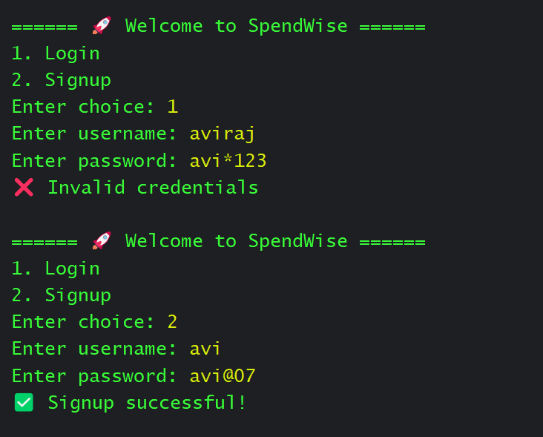
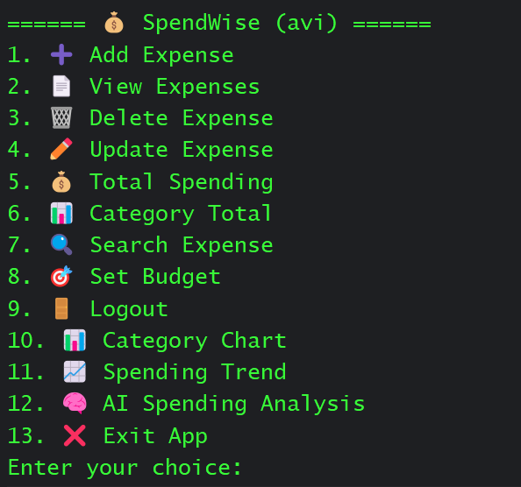
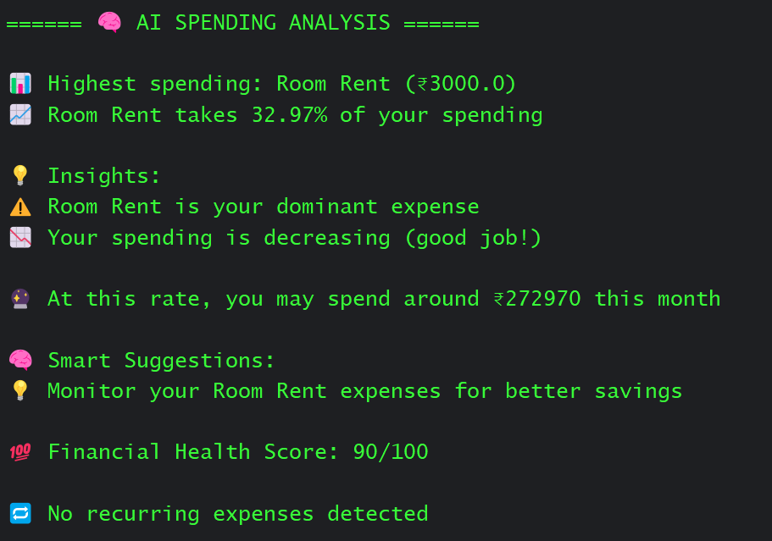

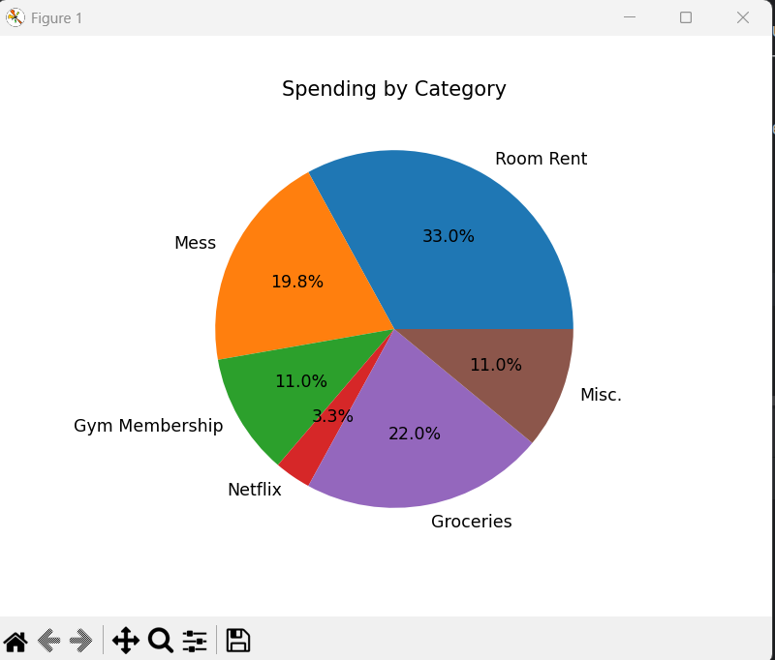
9. Challenges Faced
While building this project, some challenges I faced were:
- Managing separate data for different users
- Implementing a proper login system
- Handling file read/write operations without errors
- Designing logic for analysis and predictions
- Keeping the program simple while adding features
Some of these took time to figure out and required debugging multiple times.

10. Limitations
The project also has some limitations:
- It is command-line based, so no graphical interface
- Data is stored locally and not online
- Analysis is basic and not very advanced
- Not suitable for large-scale usage
These can be improved in future versions.

11. Future Scope
There are several improvements that can be made:
- Develop a graphical user interface (GUI)
- Convert it into a web application
- Use a proper database instead of JSON
- Implement real machine learning for better analysis
- Add features like data export and reports
This project can be expanded into a much more advanced system.

12. Conclusion
SpendWise started as a simple idea but gradually developed into a more feature-rich application. It helped in understanding important programming concepts like file handling, modular coding, and user authentication.
The project also shows how basic logic can be used to create useful tools without relying on complex technologies.
Overall, it was a good learning experience and gave practical exposure to building real-world applications. Some parts can still be improved, but the current version works well for its purpose.

