REVIEW 1: PROBLEM AND DESIGN

Design and Implementation of a Secure Online Examination System
with Multimodal AI Proctoring, Cryptographic Data Protection,
and Real-Time WebSocket Telemetry

Academic Level: B.Tech Pre-Final / Final Year Capstone Project
Domain: Artificial Intelligence, Computer Vision, Cybersecurity, Distributed Web Systems
Date: September 2026

1. Problem Statement
The rapid adoption of online education and remote assessment has introduced critical vulnerabilities in digital examination systems that compromise academic integrity, data confidentiality, and proctor efficiency. Current online examination platforms suffer from the following fundamental problems:
Academic Dishonesty in Unsupervised Environments: Students taking remote exams can collaborate with peers, consult unauthorized materials, use secondary devices (smartphones, tablets), glance at off-screen physical notes, or have unauthorized persons take the exam on their behalf. Conventional proctoring relies on post-exam manual video review, which is labor-intensive, expensive, and incapable of real-time intervention.
Plaintext Data Exposure and Insider Threats: Most Learning Management Systems (LMS) such as Moodle and Canvas store examination question papers, correct answer keys, and student submissions in plaintext within relational databases. A single SQL injection attack, misconfigured database backup, or unauthorized database administrator access can compromise the entire examination integrity.
Heavy Client-Side Computational Burden: Existing commercial AI proctoring solutions (e.g., Proctorio, Respondus LockDown Browser) mandate intrusive desktop agents or resource-heavy local deep learning inference that causes thermal throttling, crashes on low-specification student hardware, and raises privacy concerns.
Absence of Real-Time Alerting: Most proctoring tools only record raw video for post-exam forensic review. Faculty/examiners cannot intervene during the examination to warn or disqualify suspicious candidates in real time.
Weak Identity and Access Management: Basic password-based authentication without multi-factor verification and without strict server-side role-based access control leaves the system vulnerable to credential stuffing, brute-force attacks, and privilege escalation.
This project addresses the problem of designing and implementing a unified, enterprise-grade online examination platform that simultaneously provides real-time multimodal AI-driven behavioral proctoring, zero-plaintext cryptographic data protection at rest, and defense-in-depth identity assurance — all while maintaining minimal client-side computational overhead.

2. Objectives
# | Objective | Measurable Target
O1 | Design a multimodal AI proctoring engine analyzing webcam frames across five behavioral modules | 37-D feature vector with ≥ 85% accuracy on held-out data
O2 | Implement zero-plaintext cryptographic data protection at rest | AES-256 Fernet encryption; SQL inspection reveals zero plaintext
O3 | Build real-time WebSocket telemetry for suspicious event notification | Sub-200ms alert delivery latency
O4 | Enforce strict server-side RBAC with three roles: Admin, Faculty, Student | HTTP 403 on all cross-role access attempts
O5 | Integrate RFC 6238 TOTP Multi-Factor Authentication | TOTP enrollment, QR generation, 6-digit code validation
O6 | Implement resilient exam state management with periodic autosave | 10-second interval delta autosave
O7 | Maintain lightweight client-edge sampling for low-spec hardware | 320×240 @ 0.25 Hz; AI inference offloaded to server

3. Scope

3.1 In Scope
- Full-stack web application with React (Vite) frontend and FastAPI backend
- Role-tailored portals for Admin, Faculty/Examiner, and Student
- AI proctoring engine with 5 behavioral analysis modules and Random Forest classifier
- AES-256 Fernet authenticated encryption for questions, answers, and submissions
- Bidirectional WebSocket channels for real-time proctoring alert broadcasting
- RFC 6238 TOTP MFA with QR code provisioning
- Server-side RBAC via FastAPI dependency injection
- Automated objective exam grading with encrypted answer comparison
- Comprehensive audit logging of all administrative actions
- In-memory sliding-window rate limiting for brute-force protection
- Docker multi-container deployment (PostgreSQL, FastAPI, React)

3.2 Out of Scope
- Biometric face-recognition-based identity verification
- Subjective/essay-type answer evaluation using NLP
- Audio-based spatial triangulation for off-screen voice detection
- WebAssembly edge inference acceleration
- Dynamic question shuffling and parameterized question templates
- Mobile native application (iOS/Android)
- Integration with third-party LMS platforms (Moodle, Canvas)

4. Literature Survey
A comprehensive survey of 15 research papers was conducted across the domains of AI-based online proctoring, examination security, cryptographic data protection, and access control in e-assessment systems.

4.1 Comparison Table of 15 Surveyed Papers

# | Authors & Year | Method / Approach | Dataset | Key Results | Identified Gap
1 | Atoum et al. (2017) | Dual-camera hardware + wearable sensor with SVM anomaly classification | Self-collected (47 students, 2 cameras/student) | 87% detection accuracy | Requires multi-camera/wearable hardware; impractical for mass education
2 | Nigam et al. (2021) | Systematic taxonomy of 50+ DL/CV approaches for exam monitoring | Meta-analysis of 50+ papers | Single-task CNNs: 70-92% acc, 15-30% false positives | Client-side compute bloat; high false-positive rates with single-modality models
3 | Li et al. (2021) | Multimodal video analytics (face + gaze + audio) for MOOCs | 1,200 exam sessions, HD video | 91% suspicious behavior detection at 720p | Bandwidth bottleneck from continuous HD streaming; prohibitive for limited connectivity
4 | Garg & Sharma (2022) | Cryptographic protocols (TLS, AES) + RBAC in cloud assessments | Simulated environment, 500 users | Secure transit with <2% latency overhead | Only transit security; DB storage remains plaintext
5 | Hu et al. (2020) | 3D head pose (yaw/pitch/roll) + eye gaze tracking with MediaPipe | Self-collected (60 participants, lab) | 84% off-screen gaze detection | Gaze in isolation; no hand/device/multi-person analysis
6 | Prathish et al. (2016) | Rule-based face detection with Haar cascades | 30 students, single session | 78% face detection accuracy | No probabilistic scoring; high false-negatives in poor lighting
7 | Cote et al. (2016) | Video summarization via temporal segmentation + keyframe extraction | 50 recorded exam sessions | 65% reduction in review time | Post-exam only; no real-time alerting
8 | Hasan et al. (2021) | YOLOv3 object detection for phones, books, unauthorized persons | 3,000 annotated images, 5 categories | 89% mAP; 12 FPS on GPU | Requires GPU; no behavioral integration; client-side only
9 | Tiong & Lee (2021) | Multi-task CNN for face verification + behavior classification | CelebA + custom (2,500 samples) | 86% verification; 83% behavior detection | Heavy model (~200MB); thermal issues on low-spec devices; no encryption
10 | Indi et al. (2021) | Ensemble MTCNN + PnP head pose + audio anomaly detection | 150 students, ~4 hrs each | 88% combined detection accuracy | No crypto protection; frontend-only RBAC; no MFA
11 | Kasliwal et al. (2021) | OpenCV face/eye tracking with rule-based thresholds | 80 students, scripted scenarios | 82% detection accuracy | Rigid thresholds; no ML generalization for unseen patterns
12 | Pandey et al. (2022) | Blockchain tamper-proof storage + smart contract grading | Ethereum testnet, 200 records | Tamper-proof grade storage | High blockchain overhead; impractical latency; no AI proctoring
13 | Thomas & Raorane (2020) | Fingerprint + face recognition for identity verification | FERET + fingerprints (100 users) | 94% identity verification | Requires biometric hardware; privacy concerns; no behavioral analysis
14 | Masud et al. (2022) | IoT sensor fusion (mic, IR, webcam) + Random Forest | 500 sessions with labeled events | 90% cheating detection | Requires physical IoT sensors; not for remote/home exams
15 | Jia & He (2021) | FACS Action Unit analysis + temporal LSTM networks | BP4D dataset (41 participants) | 85% micro-expression detection | Expensive LSTM inference; facial modality only; no device/hand cues

4.2 Summary of Identified Gaps
Gap Category | Description | Papers
Single-modality limitation | Systems analyze only 1-2 behavioral channels, missing comprehensive contextual cues | [1],[5],[6],[7],[11],[13],[15]
Heavy client-side computation | Deep learning models run locally, causing overheating on low-spec hardware | [2],[3],[8],[9],[15]
No real-time alerting | Post-exam forensic review only; no intervention during examination | [1],[6],[7],[9],[11]
No cryptographic data protection | Questions, answers, and submissions stored in plaintext in database | [1],[2],[5],[6],[8],[9],[10],[11],[14],[15]
Weak access control | Missing or frontend-only RBAC; no MFA; privilege escalation risk | [6],[8],[10],[11],[14]
Specialized hardware | Requires dedicated cameras, GPUs, IoT sensors, or biometric scanners | [1],[8],[12],[13],[14]

5. Proposed Methodology
The proposed system employs a 5-Tier Zero-Trust Architecture that integrates multimodal AI proctoring, cryptographic data protection, and real-time telemetry into a unified platform.
Step 1 — Lightweight Edge Frame Acquisition: The student's browser captures webcam frames at low resolution (320×240 pixels) at 0.25 Hz using the HTML5 Canvas API and WebRTC MediaStream, ensuring negligible CPU/bandwidth usage.
Step 2 — Server-Side Multimodal Feature Extraction: Each captured frame is transmitted as a base64-encoded payload to the FastAPI backend, where a 5-module feature extractor produces a 37-dimensional behavioral feature vector.
Step 3 — Ensemble Random Forest Classification: The 37-D feature vector is fed into a 100-tree Random Forest classifier that outputs a cheating probability score P(Cheating | X) ∈ [0.0, 1.0]. Threshold τ = 0.50.
Step 4 — Real-Time WebSocket Broadcasting: Flagged events are broadcast via bidirectional WebSocket channels to the faculty dashboard with sub-200ms latency.
Step 5 — Cryptographic Data Protection: All sensitive data passes through Fernet-based AES-256 authenticated encryption before database persistence.
Step 6 — Defense-in-Depth Identity Assurance: Authentication layers: bcrypt hashing, JWT tokens, server-side RBAC, RFC 6238 TOTP MFA, rate limiting, and comprehensive audit logging.

5.1 Feature Extraction Modules
Module | Features Extracted | Count
Module 1: Face Detection | Face detected, count, confidence, bbox area, center (x, y) | 6
Module 2: 3D Head Pose | Yaw, pitch, roll angles and normalized deviations | 6
Module 3: Eye Gaze Tracking | Horizontal/vertical gaze, screen focus, blink count, eye openness, gaze deviation, saccade rate | 8
Module 4: Hand Movement | Hand detected, count, near-face/ear/pocket, speed, mouth obstruction, both-hands visible, typing heuristic | 9
Module 5: Device Detection | Phone detected, confidence, screen glow, reflective surface, whisper score, secondary person, tab switch, mouth talking | 8
TOTAL |  | 37

5.2 Methodology Flowchart
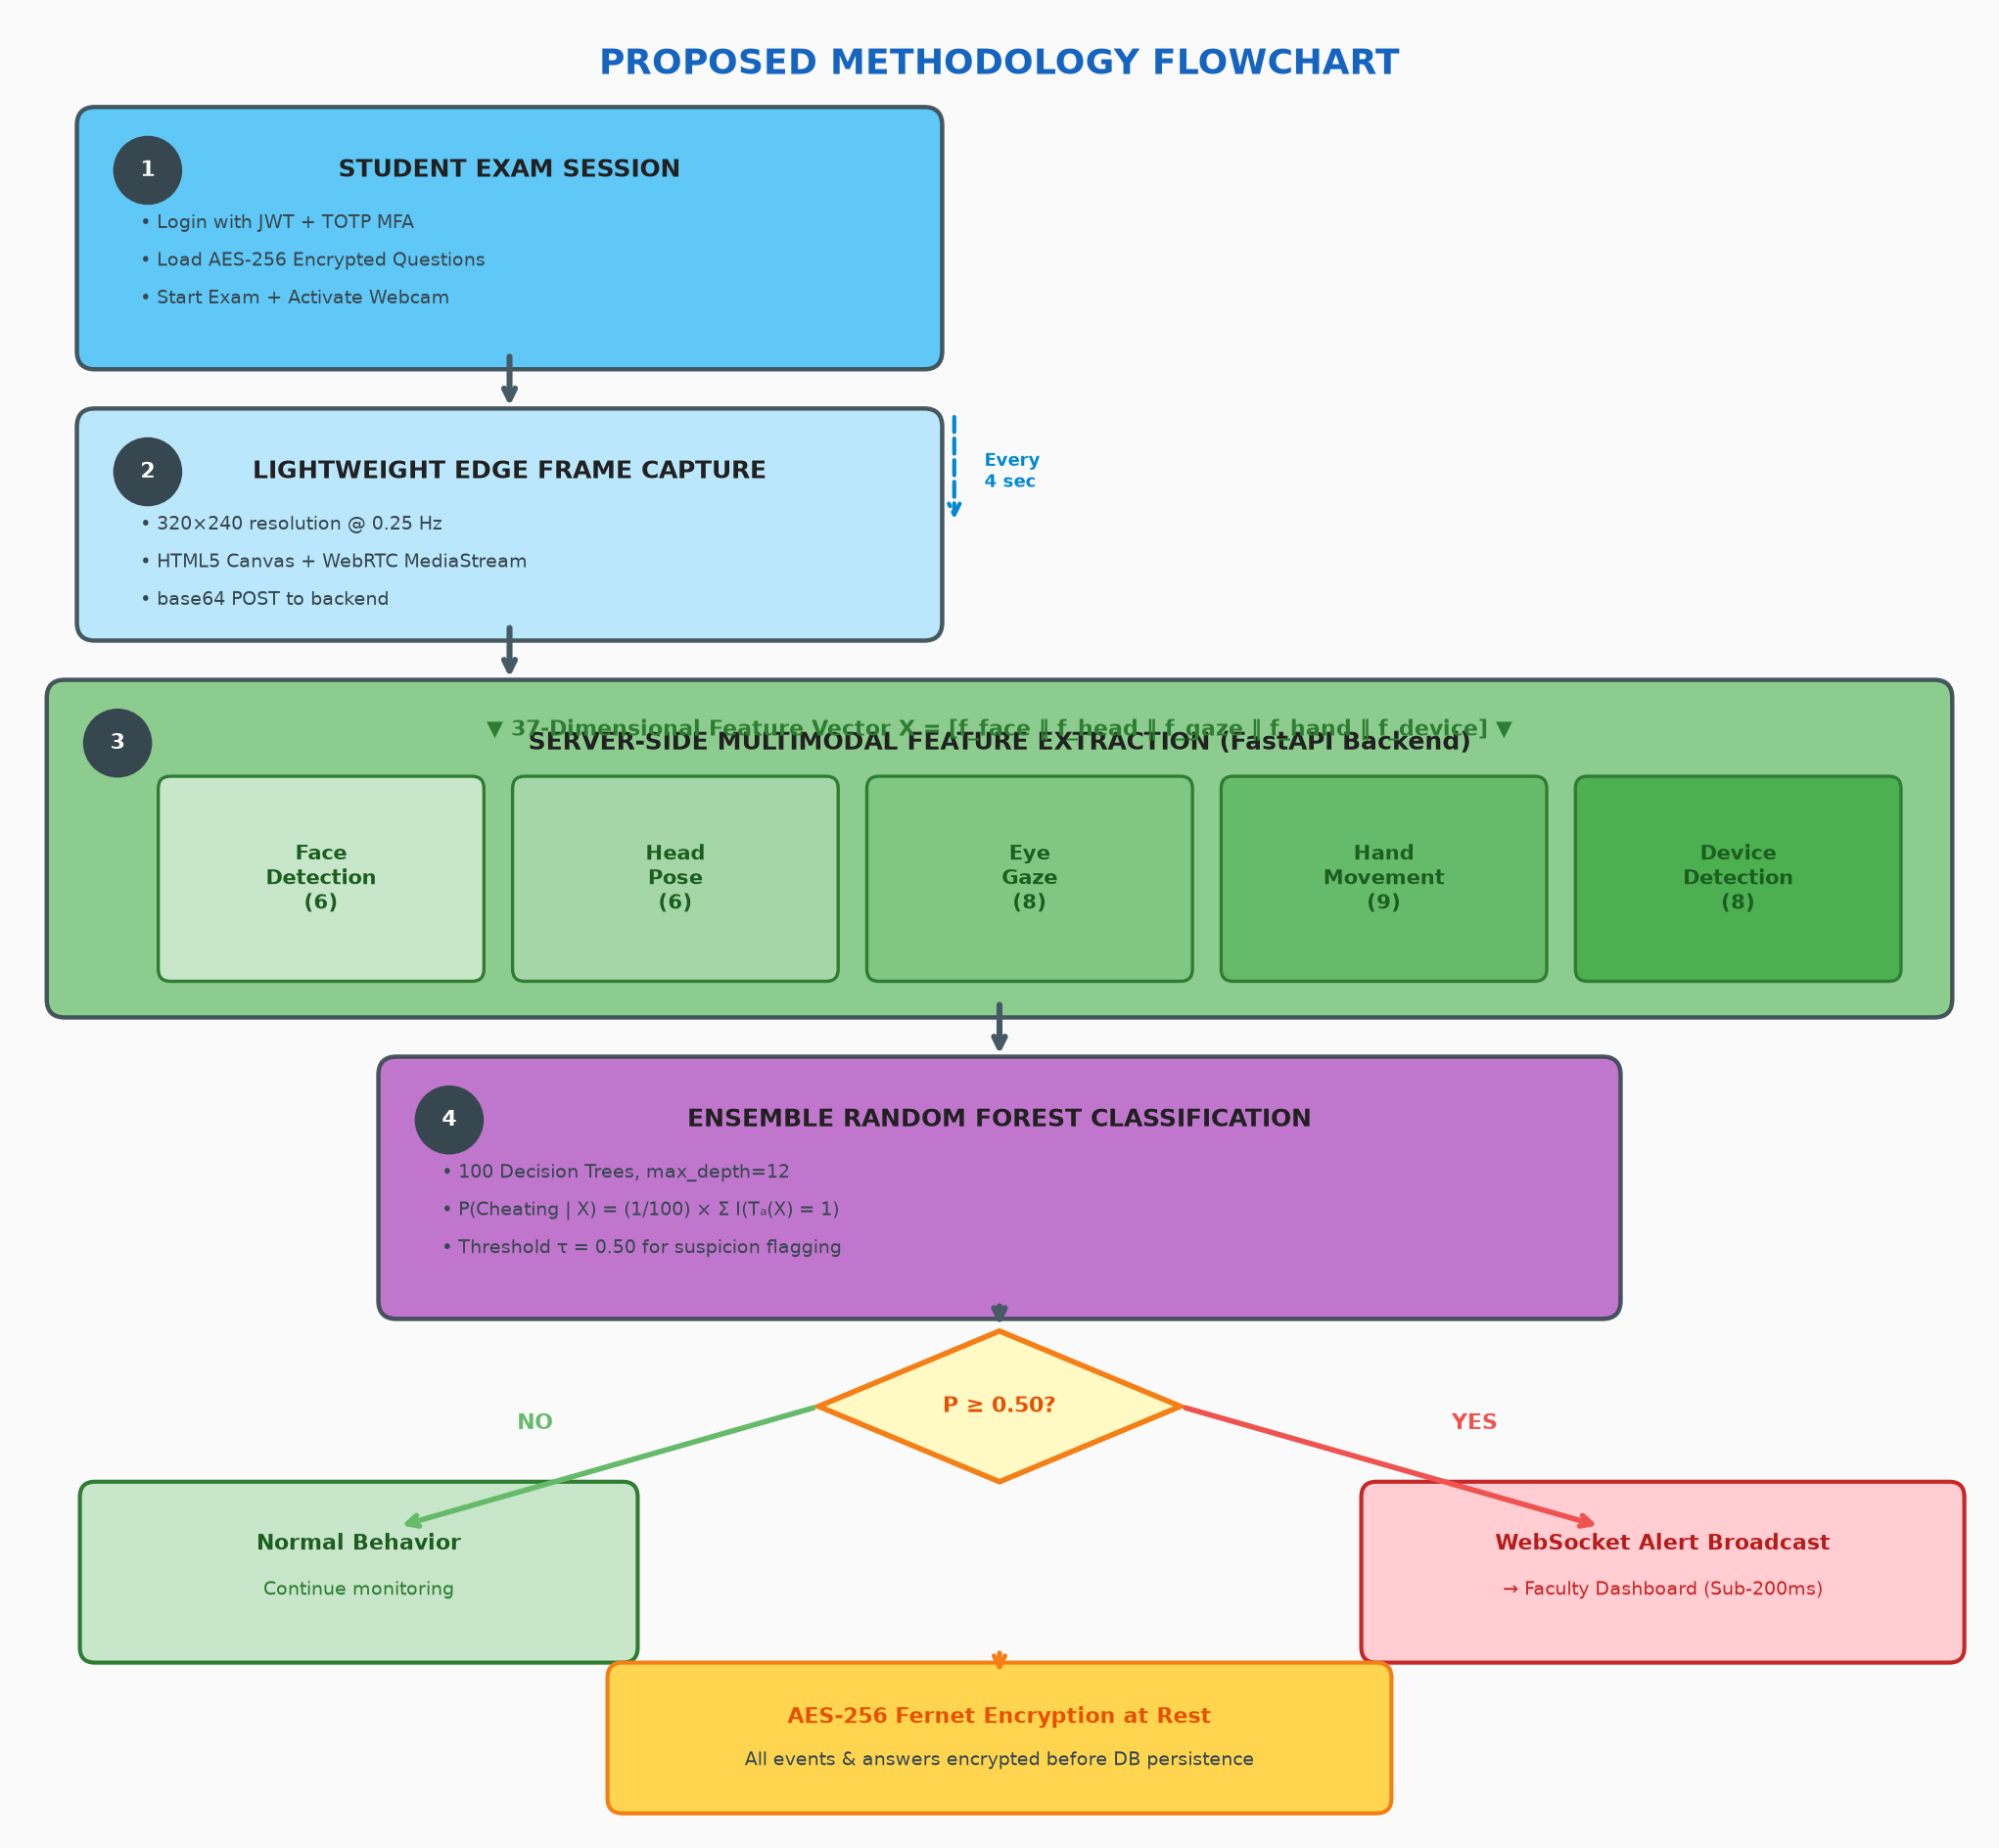

6. Dataset Details

6.1 Primary Dataset
Property | Detail
Dataset Name | Mendeley Exam Proctoring Suspicious Behaviours Dataset
DOI | 10.17632/39xs8th543.1
Source | Mendeley Data (Open Access Research Data Repository)
Total Samples | 5,500 validated records
Number of Features | 37 behavioral features
Number of Classes | 2 (Normal/Honest: 0, Suspicious/Cheating: 1)
Class Distribution | Approximately balanced — 52% Normal, 48% Suspicious
Feature Modules | 5 modules: Face (6), Head Pose (6), Eye Gaze (8), Hand (9), Device (8)

6.2 Feature Description by Module
Module | Feature Name | Data Type | Range / Domain
Face Detection | face_detected | Binary | {0, 1}
Face Detection | face_count | Integer | ℕ₀
Face Detection | face_confidence | Float | [0.0, 1.0]
Face Detection | face_bbox_area | Float | [0.0, 1.0] (normalized)
Face Detection | face_center_x | Float | [0.0, 1.0] (normalized)
Face Detection | face_center_y | Float | [0.0, 1.0] (normalized)
Head Pose | head_yaw | Float | [-90°, +90°]
Head Pose | head_pitch | Float | [-90°, +90°]
Head Pose | head_roll | Float | [-90°, +90°]
Head Pose | yaw_deviation | Float | [0.0, 1.0]
Head Pose | pitch_deviation | Float | [0.0, 1.0]
Head Pose | roll_deviation | Float | [0.0, 1.0]
Eye Gaze | gaze_horizontal | Float | [-1.0, +1.0]
Eye Gaze | gaze_vertical | Float | [-1.0, +1.0]
Eye Gaze | gaze_screen_focus | Float | [0.0, 1.0]
Eye Gaze | blink_count | Float | Blinks/minute
Eye Gaze | left_eye_openness | Float | [0.0, 1.0]
Eye Gaze | right_eye_openness | Float | [0.0, 1.0]
Eye Gaze | gaze_deviation | Float | [0.0, ∞)
Eye Gaze | saccade_rate | Float | [0.0, ∞)
Hand Movement | hand_detected | Binary | {0, 1}
Hand Movement | hand_count | Integer | {0, 1, 2}
Hand Movement | hand_near_face | Float | [0.0, 1.0]
Hand Movement | hand_near_ear | Float | [0.0, 1.0]
Hand Movement | hand_near_pocket | Float | [0.0, 1.0]
Hand Movement | hand_movement_speed | Float | [0.0, 1.0]
Hand Movement | hand_obscuring_mouth | Float | [0.0, 1.0]
Hand Movement | both_hands_visible | Binary | {0, 1}
Hand Movement | keyboard_typing_heuristic | Float | [0.0, 1.0]
Device Detection | phone_detected | Binary | {0, 1}
Device Detection | phone_confidence | Float | [0.0, 1.0]
Device Detection | device_screen_glow | Float | [0.0, 1.0]
Device Detection | reflective_surface_score | Float | [0.0, 1.0]
Device Detection | audio_whisper_score | Float | [0.0, 1.0]
Device Detection | secondary_person_presence | Binary | {0, 1}
Device Detection | tab_switch_flag | Binary | {0, 1}
Device Detection | mouth_movement_talking | Float | [0.0, 1.0]

6.3 Preprocessing Plan
Step | Operation | Details
1 | Data Loading | Load CSV from Mendeley; verify 5,500 rows × 37 features + 1 label
2 | Missing Values | Median imputation (continuous); mode imputation (binary)
3 | Normalization | Min-Max scaling for angular features; standard scaling for rates
4 | Class Balance | Verify 52:48 split; apply SMOTE if imbalanced
5 | Train-Test Split | Stratified 80:20 preserving class distribution
6 | Cross-Validation | Stratified 5-Fold CV for hyperparameter tuning
7 | Feature Importance | Random Forest importance ranking for discriminative features

7. System Architecture Diagram
The system is architected around a 5-Tier Decoupled Zero-Trust Model as depicted below:
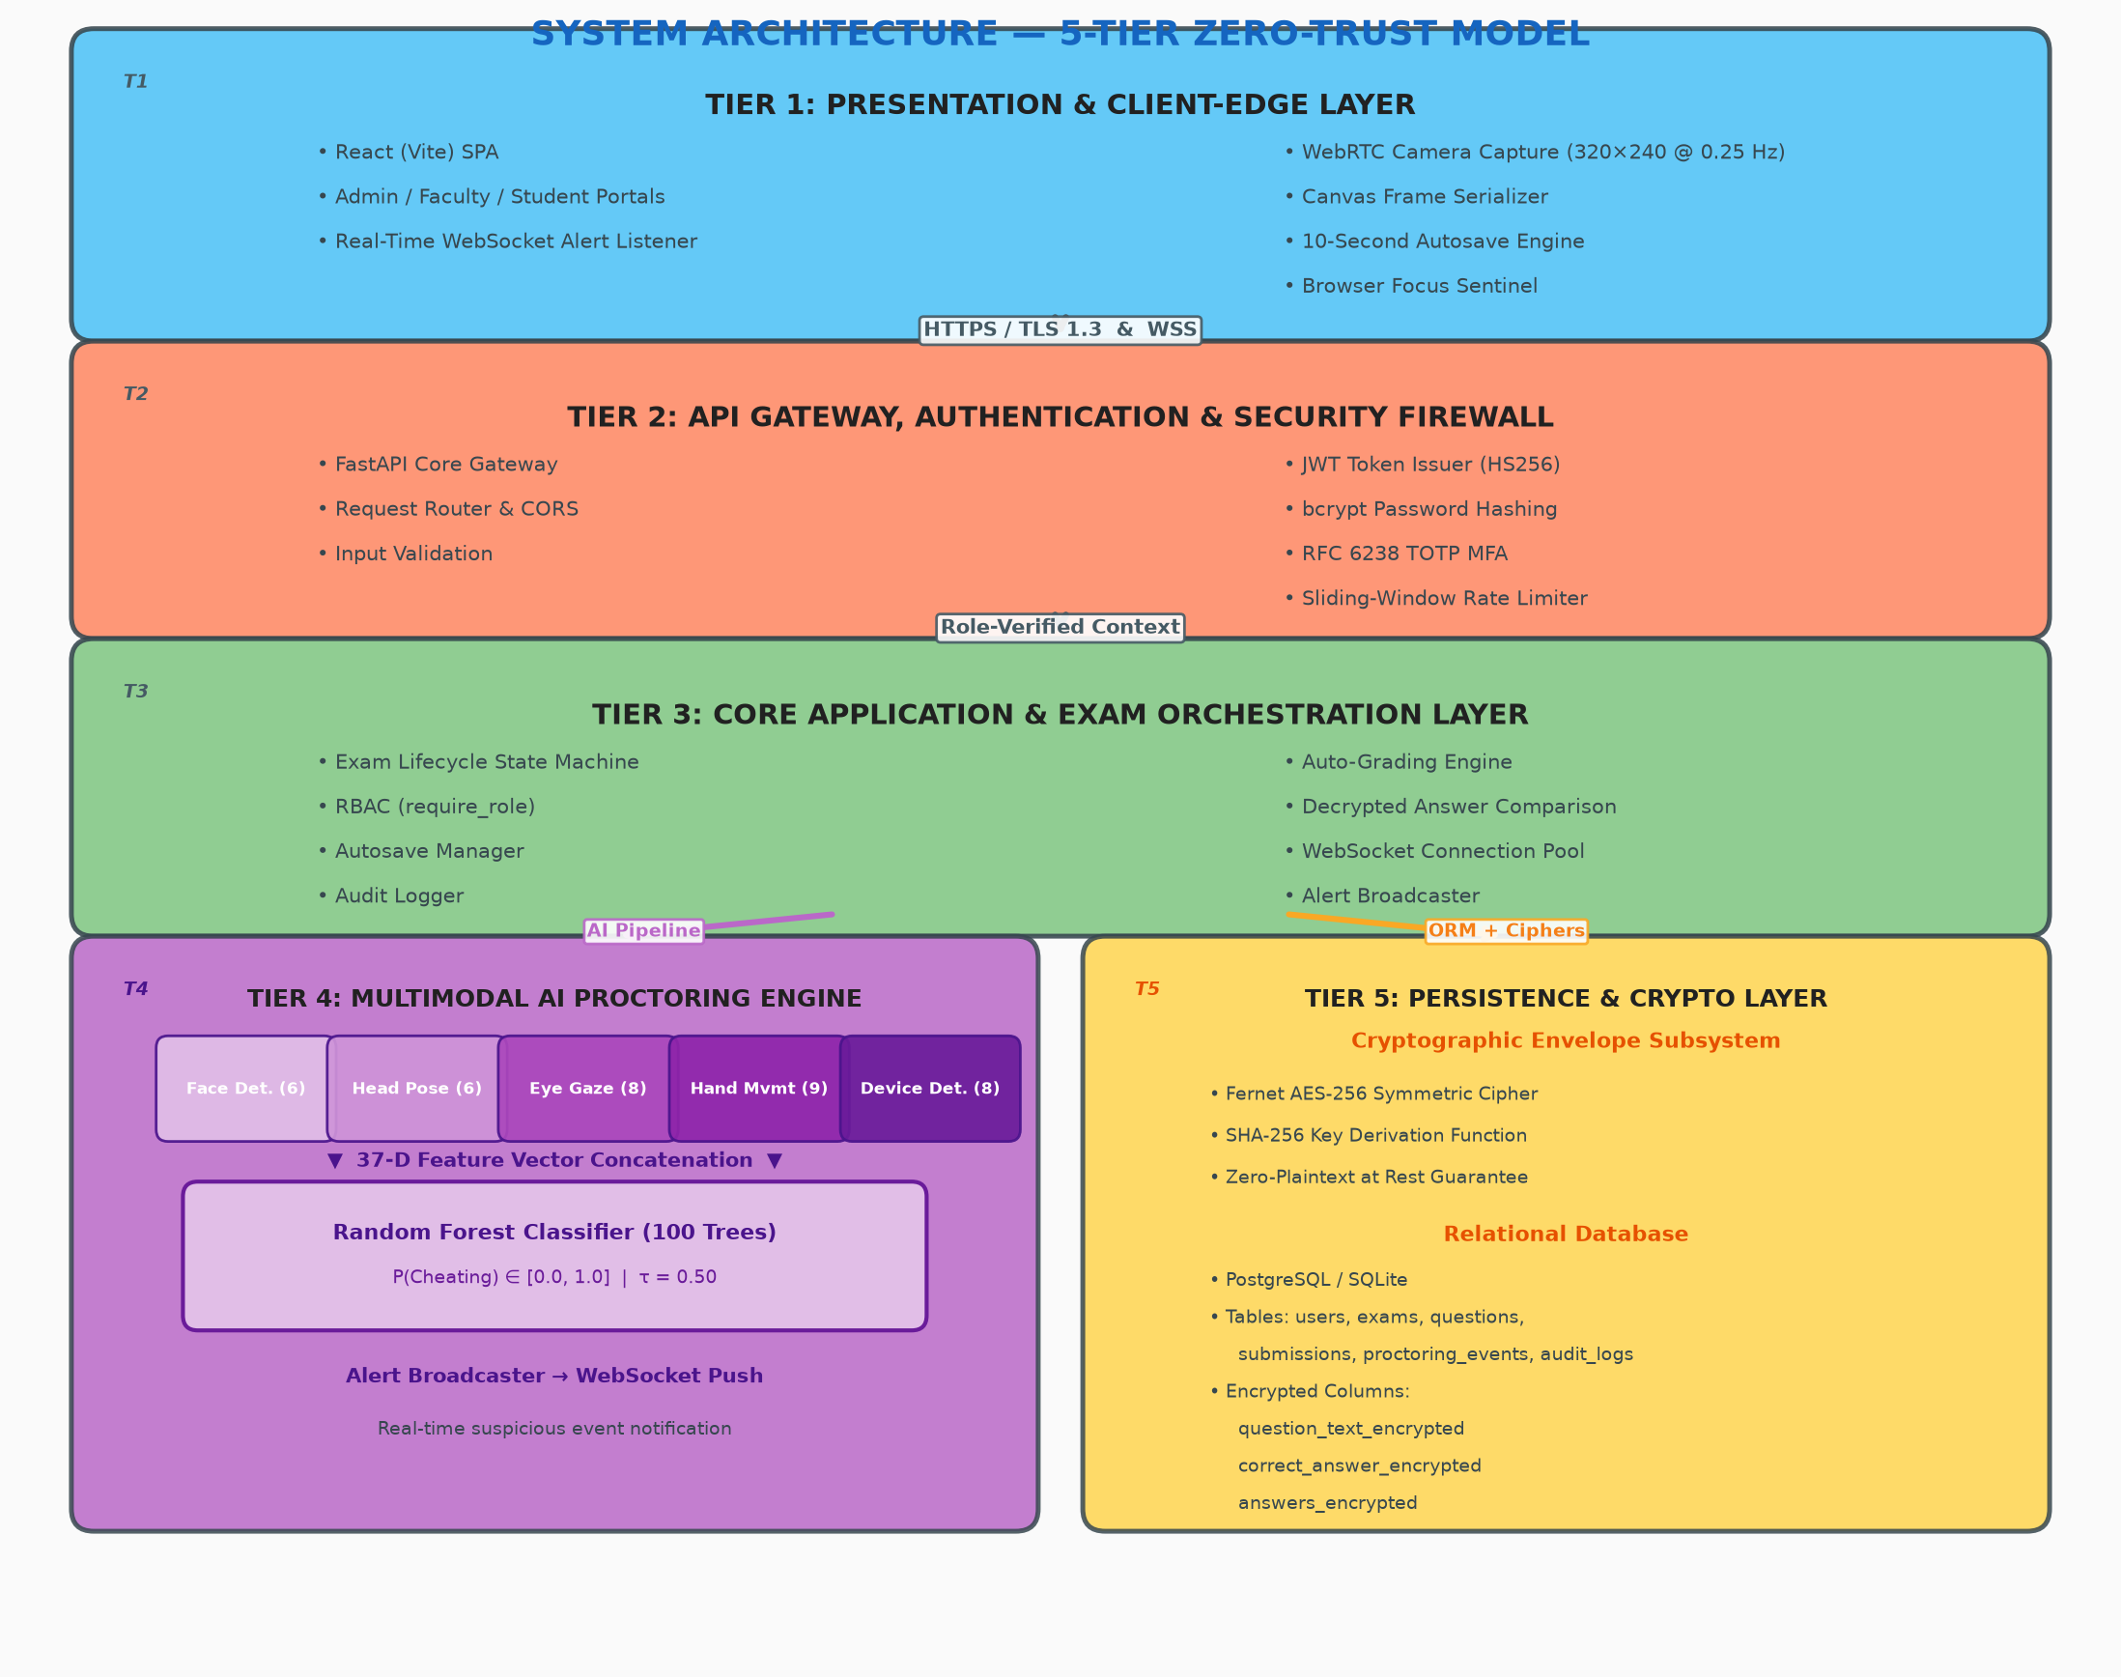
Figure 1: 5-Tier Zero-Trust System Architecture

7.1 Layer Responsibilities
Tier 1 (Client-Edge Layer): Manages user interactions, renders responsive dashboards, captures webcam frames every 4 seconds via HTML5 Canvas, and listens for live proctoring events over WebSockets.
Tier 2 (Security & Gateway Layer): Enforces TLS transport security, terminates brute-force attempts via sliding-window rate limiting, issues cryptographically signed JWT tokens, and validates RFC 6238 TOTP codes.
Tier 3 (Application Orchestration Layer): Implements exam lifecycle state machines (Draft → Published → Completed), orchestrates autosaves, evaluates submissions against decrypted answer keys, and manages active WebSocket channels.
Tier 4 (AI Proctoring Engine): Receives base64 frame payloads, decodes to OpenCV BGR matrices, extracts 37 features, evaluates cheating probability via Random Forest, and dispatches flags upon anomaly detection.
Tier 5 (Cryptographic & Persistence Layer): Executes AES-256 encryption on sensitive columns, maintains relational integrity, and logs all administrative actions into an append-only audit trail.

8. Threat Model

8.1 What is Protected (Assets)
Asset | Description | Protection Mechanism
Examination Questions | Question text stored in DB | AES-256 Fernet encryption (question_text_encrypted)
Correct Answer Keys | Answer keys stored in DB | AES-256 Fernet encryption (correct_answer_encrypted)
Student Submissions | Student answers stored in DB | AES-256 Fernet encryption (answers_encrypted)
User Credentials | Passwords and auth tokens | bcrypt hashing; JWT HMAC-SHA256 signing
Academic Integrity | No cheating during exams | Multimodal AI proctoring with real-time analysis
System Access Control | No unauthorized access | Server-side RBAC with require_role()
User Accounts | Against unauthorized access | RFC 6238 TOTP MFA; sliding-window rate limiting
Audit Trail | Forensic record of actions | Append-only audit_logs table

8.2 Attacker Capabilities (Threat Actors)
Threat Actor | Capabilities | Motivation
Malicious Student | Laptop, secondary devices, peer collaboration, physical notes, tab switching | Cheat for higher grades
Credential Attacker | Brute-force tools, stolen credential databases, credential stuffing | Unauthorized account access
Insider (Rogue DBA) | Direct DB access via SQL client, backup file access | Leak questions, alter grades
Network Eavesdropper | Passive MITM interception, packet sniffing | Intercept exam data in transit
Privilege Escalation | Valid student account, knowledge of API endpoints | Access admin/faculty APIs
Impersonator | Student credentials, willing proxy test-taker | Take exam for someone else

8.3 Attack Types and Countermeasures
Attack Type | Description | Countermeasure
Behavioral Cheating | Phone use, looking away, consulting secondary person | 5-module AI proctoring (37 features); real-time alert at P≥0.50
Tab Switching | Alt-Tab to search for answers | Page Visibility API; tab_switch_flag in proctoring vector
Multiple Person | Unauthorized person in frame | face_count module; secondary_person_presence detection
Phone/Device Usage | Using phone to look up answers | YOLOv8 phone detection; phone_detected, device_screen_glow
SQL Injection | Extract plaintext from DB | SQLAlchemy ORM parameterized queries; AES-256 encrypted data
DB Dump / Backup Leak | Obtain raw database file | Zero-plaintext at rest; all sensitive data encrypted
Brute-Force Login | Repeated login attempts | Sliding-window rate limiter; bcrypt slow hash
Credential Stuffing | Reuse leaked credentials | RFC 6238 TOTP MFA second factor required
JWT Token Forgery | Forge/modify JWT tokens | HMAC-SHA256 signing; expiration enforcement
Privilege Escalation | Student hits admin API | require_role() server-side; HTTP 403 rejection
MITM Attack | Intercept client-server comms | TLS 1.3 HTTPS + WSS encrypted transport
Session Hijacking | Steal valid JWT token | Short-lived tokens; refresh rotation; TLS-only

8.4 Threat Model Diagram
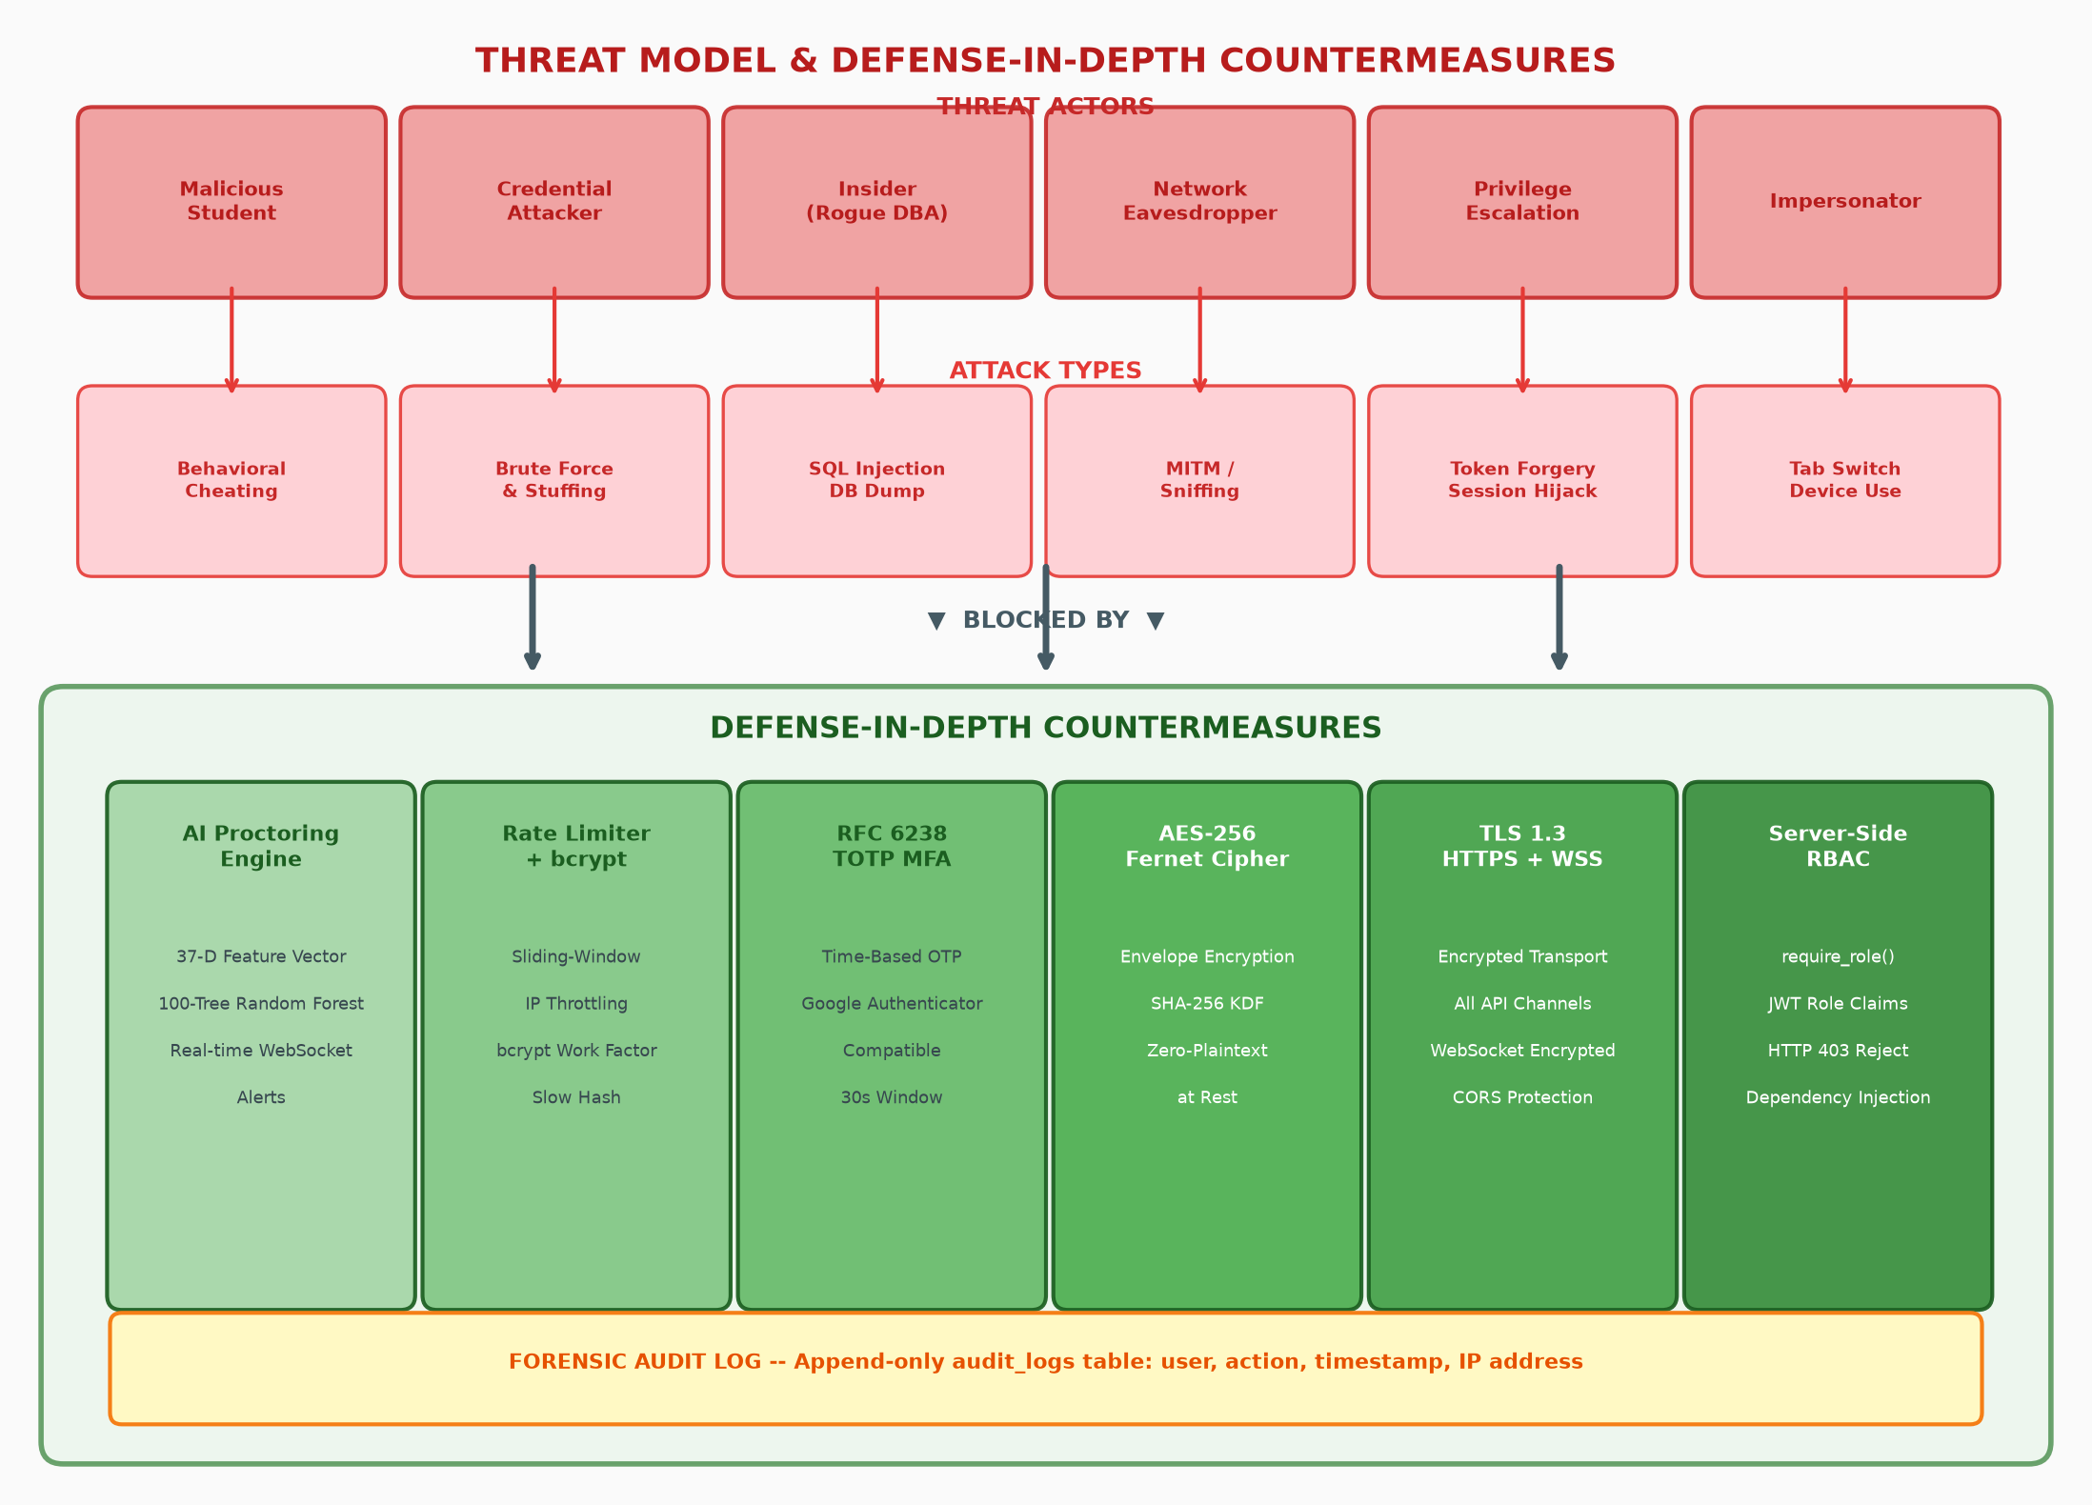
Figure 3: Threat Landscape and Defense-in-Depth Countermeasures

9. References
[1] Y. Atoum, L. Chen, A. X. Liu, S. D. H. Hsu, and X. Liu, "Automated Online Exam Proctoring," IEEE Transactions on Multimedia, vol. 19, no. 7, pp. 1609-1624, Jul. 2017.
[2] A. Nigam, R. Pasricha, T. Singh, and P. Churi, "A Systematic Review on AI-Based Online Exam Proctoring Systems," IEEE Access, vol. 9, pp. 64227-64240, 2021.
[3] H. Li, M. Xu, J. Wang, and Y. Kang, "A Multimodal AI Proctoring System for Massive Open Online Courses," IEEE Transactions on Learning Technologies, vol. 14, no. 3, pp. 364-375, Jun. 2021.
[4] S. Garg and V. Sharma, "Role-Based Access Control and Cryptographic Security in Cloud-Based E-Assessment Systems," IEEE Access, vol. 10, pp. 58312-58326, 2022.
[5] S. Hu, Y. Liu, and Z. Zhang, "Real-Time Gaze and Head Pose Tracking for Cheating Detection in Online Tests," IEEE Transactions on Human-Machine Systems, vol. 50, no. 4, pp. 312-323, Aug. 2020.
[6] D. A. Prathish, P. Athul, and P. R. Sreeraj, "An Intelligent System for Online Exam Monitoring," in Proc. IEEE ICSTM, 2016, pp. 138-142.
[7] M. Cote, F. Jean, A. B. Albu, and D. Capson, "Video Summarization for Remote Invigilation of Online Exams," in Proc. IEEE WACV, 2016, pp. 1-9.
[8] M. A. Hasan, S. Ahmed, and K. Wahid, "CNN-Based Object Detection for Online Exam Proctoring," in Proc. IEEE ECCE, 2021, pp. 1-6.
[9] L. C. O. Tiong and H. J. Lee, "E-Cheating Prevention Measures: Detection of Cheating at Online Examinations Using Deep Learning Approach," IEEE Access, vol. 9, pp. 149185-149198, 2021.
[10] T. S. Indi, S. Gunge, M. Indi, and A. Biradar, "AI-Based Proctoring for Virtual Assessments," IEEE Transactions on Education, vol. 64, no. 4, pp. 432-441, Nov. 2021.
[11] C. Kasliwal, S. Patil, D. Puri, and M. K. Bhanarkar, "Cheating Detection in Online Exams Using Computer Vision," in Proc. IEEE ICCUBEA, 2021, pp. 1-6.
[12] P. Pandey, R. Kumar, and S. Singh, "Secure Online Examination System Using Blockchain Technology," in Proc. IEEE ICCCIS, 2022, pp. 278-283.
[13] A. Thomas and A. A. Raorane, "Biometric Authentication for Secure E-Learning Examination Systems," in Proc. IEEE RTEICT, 2020, pp. 115-119.
[14] M. Masud, G. Muhammad, and H. Alhumyani, "Smart Anti-Cheating Exam System Using IoT and Machine Learning," IEEE Internet of Things Journal, vol. 9, no. 16, pp. 14584-14593, Aug. 2022.
[15] J. Jia and J. He, "Facial Action Unit Analysis for Remote Exam Monitoring," in Proc. IEEE FG, 2021, pp. 1-8.

Document prepared for Review 1: Problem and Design • B.Tech Capstone Project • September 2026

