
Sri Lanka Institute of Advanced Technological Education (SLIATE)
Advanced Technological Institute – Kurunegala Higher National Diploma in
Information Technology Batch – 2324(FT)
HNDIT4052- Programming Individual Project
A Full-Stack Food Delivery Platform
Supervisor: Ms.K.G.D.De.A.Wijesinghe
A.A.A.U.Athukorala
KUR/IT/2324/F/0078

Table of Contents
1. Introduction 4
1.1 Purpose of this Document 4
1.2 Scope of the System 4
2. General Description 5
2.1 Product Perspective and Importance 5
2.2 User Objectives and Benefits 5
2.3 User Characteristics and Community Features 5
3. Functional Requirements 6
3.1 User Management and Authentication 6
3.2 Food Discovery and Menu Exploration 6
3.3 Transaction Flow and Cart Management 7
3.4 Payment Processing 7
3.5 Order Tracking and History 7
3.6 Rating and Review System 7
3.7 Admin and Restaurant Dashboard 7
4. Interface Requirements 8
4.1 User Interfaces (UI/UX) 8
4.2 Software Interfaces 8
5. Design Constraints 10
5.1 Technology Stack Selection (The MERN Blueprint) 10
5.2 Exclusion of Real-Time Logistics Engines 10
5.3 Hardware Thresholds and Development Environments 10
6. Non-Functional Attributes 11
6.1 Performance and Latency Optimization 11
6.2 Data Integrity and Security Standards 11
6.3 Reliability and Graceful Fault Recovery 11
7. ER Diagram 12
8. Use Case 13
9. References 14

SOFTWARE REQUIREMENT SPECIFICATION (SRS)
- Project Title: A Full-Stack Food Delivery Platform
- Course Code: HNDIT4052 - Programming Individual Project
- Institute: Sri Lanka Institute of Advanced Technological Education (SLIATE)
- ATI Location: Advanced Technological Institute – Kurunegala
- Batch: 2324 (FT)
- Student Name: A.A.A.U.Athukorala
- Student ID: KUR/IT/2324/F/0078
- Supervisor: Ms.K.G.D.De.A.Wijesinghe

1. Introduction

1.1 Purpose of this Document
The primary purpose of this Software Requirement Specification (SRS) document is to provide a complete, detailed, and comprehensive overview of the Full-Stack Food Delivery Platform. It outlines both the functional and non-functional requirements, design constraints, system interfaces, and overall architecture of the application. This document serves as a definitive blueprint and reference guide for developers, quality assurance testers, and the project supervisor to verify that the final software implementation fulfills the intended business and technical objectives

1.2 Scope of the System
The proposed system is an independent, specialized digital ecosystem tailored to optimize localized, low-overhead food commerce. Unlike dominant food delivery applications that function as congested, high-commission aggregators, this application operates as a lean, direct-to-consumer software-as-a-service model designed to champion micro-merchant sustainability.
The software encapsulates two major subsystems managed via an unified technical architecture:
- The Client-Side Portal (Customer Web App): An asynchronous Single Page Application (SPA) designed to minimize consumer search fatigue and maximize conversion rates via an ultra-fast "three-click" checkout pipeline.
- The Merchant Control Panel (Vendor/Admin Dashboard): A data-driven administrative center enabling non-technical restaurant operators to manage digital menus, execute immediate pricing adjustments, and monitor incoming order fulfillment pipelines without requiring prior operational training.
By restricting the initial operational scope to close-proximity commercial ranges, the platform purposely isolates itself from complex geo-routing dependencies. This strategic constraint ensures that the core codebase remains lightweight, secure, highly maintainable, and thoroughly optimized for deployment on standard public cloud infrastructure (such as MongoDB Atlas and Render/Vercel platforms).

2. General Description

2.1 Product Perspective and Importance
The modern food delivery industry relies heavily on complex software architectures that often impose heavy financial and cognitive taxes on small-scale operations. This product is an independent, specialized MERN-stack web application developed as a Single Page Application (SPA). It provides an affordable, lightweight alternative that eliminates the 20% to 30% predatory commission fees and hidden surcharges tied to mainstream global delivery giants. It shifts the focus entirely to local proximity, lowering economic barriers for small businesses and building a personalized, community-centric digital ecosystem.

2.2 User Objectives and Benefits
- Customers (Consumers): The primary objective is to streamline the online food ordering experience. Customers benefit from a highly optimized, minimalist "three-click" ordering path that eliminates unnecessary checkout friction. The benefit is instant access to localized digital menus with transparent pricing and rapid transaction completion.

- Vendors / Admin Owners: The objective is to grant small business owners absolute sovereignty over their digital storefronts. Vendors benefit from a centralized, secure control panel allowing them to effortlessly list food items, modify menus dynamically, execute real-time inventory adjustments, and track orders independently. The platform eliminates steep software learning curves, giving local merchants enterprise-grade tools without enterprise-level complexity.

2.3 User Characteristics and Community Features
The system is tailored to accommodate two primary user segments, each possessing distinct technical literacies and operational environments:
- The Consumer Community: This demographic spans a broad spectrum of the general public—from digital natives who expect instantaneous interactions to non-technical users who may feel overwhelmed by complex layouts. To serve both, the platform utilizes a mobile-first, responsive web layout engineered specifically to prevent cognitive overload. UI elements are highly intuitive, accessible, and designed with micro-interactions that guide users effortlessly through the app.
- The Merchant/Vendor Community: This segment consists of local, small-scale restaurant owners, kitchen managers, and counter staff. Given the fast-paced, high-stress nature of kitchen environments, these users require a "Zero-Learning-Curve" administration dashboard.

3. Functional Requirements
The functional requirements detail the operational capabilities that the software system must execute.

3.1 User Management and Authentication
• FR-1.1 (User Registration): The system shall allow new users to create a secure account by providing a valid email address, a unique username, and a strong password. A verification email shall be sent to complete the registration.
• FR-1.2 (Secure Login & Session Management): The system shall authenticate users securely by validating inputs against encrypted credentials stored in the database. Upon successful authentication, the system shall issue a secure JSON Web Token (JWT) to manage the user session.
• FR-1.3 (Password Privacy & Hashing): The system must hash all raw user passwords using the Bcrypt encryption library before committing them to the database. Raw passwords must never be stored or logged.
• FR-1.4 (Profile Management): The system shall allow authenticated users to update their profile information, including delivery addresses, contact numbers, and profile pictures.

3.2 Food Discovery and Menu Exploration
- FR-2.1 (Advanced Search & Filter): The system shall allow consumers to search for food items or restaurants using keywords. Users must be able to filter results based on cuisine type, price range, dietary restrictions (e.g., vegetarian, gluten-free), and ratings.

- FR-2.2 (Dynamic Menu Rendering): The system shall instantly display food item details, descriptions, prices, availability status, and high-quality images using reusable Frontend (React) components.

- FR-2.3 (Real-time Availability): The system shall dynamically gray out or mark food items as "Unavailable" if the restaurant updates the item status in real-time.

3.3 Transaction Flow and Cart Management
- FR-3.1 (Cart Modification): The system shall permit users to add items to an active shopping cart, modify item quantities, and delete items with instant, client-side state updates without requiring a full page reload.
- FR-3.2 (Persistent Cart): The system shall persist the user's cart items across sessions (e.g., using local storage or database syncing) so that the cart is retained when the user logs back in.
- FR-3.3 (Order Placement & Validation): The system shall process checkout requests by validating cart data (prices and availability) against the live database before safely generating a new order profile linked to the logged-in user.

3.4 Payment Processing
- FR-4.1 (Payment Gateway Integration): The system shall integrate with a secure third-party payment gateway (e.g., Stripe, PayPal) to process credit/debit card transactions safely.
- FR-4.2 (Payment Status Feedback): The system shall display immediate success or failure notifications to the user post-transaction and update the order status accordingly in the database.

3.5 Order Tracking and History
- FR-5.1 (Real-time Order Tracking): The system shall provide users with real-time updates on their order status (e.g., Ordered, Preparing, Out for Delivery, Delivered).
- FR-5.2 (Order History): The system shall allow users to view a detailed history of their past orders, including receipts, item lists, and dates, with an option to "Re-order" easily.

3.6 Rating and Review System
- FR-6.1 (User Reviews): The system shall allow customers to rate (1-5 stars) and write text reviews for restaurants and specific food items after a successful delivery.
- FR-6.2 (Review Moderation): The system shall display aggregated ratings on the restaurant and food item pages for all users to see.

3.7 Admin and Restaurant Dashboard
- FR-7.1 (Menu Management): The system shall provide an interface for restaurant administrators to add, update, or delete food items, descriptions, prices, and images.
- FR-7.2 (Order Management): The system shall allow restaurant staff to view incoming orders, accept/reject orders, and update the preparation status in real-time.

4. Interface Requirements

4.1 User Interfaces (UI/UX)
- Design & Presentation Style: The web application shall feature a minimalist, modern, and uncluttered user interface. The entire presentation layer must be styled using Tailwind CSS, adhering to a consistent color palette, typography hierarchy, and component-based design system to ensure visual harmony.

- Responsiveness & Cross-Browser Compatibility: The UI must be fully fluid, adaptive, and mobile-responsive. It must deliver an optimal viewing and interactive experience across a wide range of devices, including desktops, laptops, tablets, and smartphones. Additionally, it must maintain compatibility with all major modern web browsers (e.g., Google Chrome, Mozilla Firefox, Safari, and Microsoft Edge).

- Dynamic User Interactions (SPA Architecture): To provide a seamless, Single Page Application (SPA) experience, the user interface must eliminate full-page browser reloads. All data modifications, form submissions, and state updates must be handled asynchronously using the Fetch API or Axios, ensuring near-instantaneous visual feedback for user actions.

4.2 Software Interfaces
- Frontend-Backend Communication (API Architecture): The frontend presentation layer, developed using React.js, must communicate with the backend application logic exclusively through a secure, stateless RESTful API. All data exchange between the client and the server must be strictly encapsulated within JSON (JavaScript Object Notation) formatted message payloads.

- Database Connectivity (ODM Interface): The Node.js / Express.js backend runtime environment must establish and maintain a secure connection with the remote MongoDB Atlas cloud database cluster. This interface must be managed utilizing the Mongoose ODM (Object Data Modeling) library, enforcing schema validation, data integrity, and efficient query execution.

- Authentication & Session Management Interface: The software interface must support secure token-based authentication. The frontend and backend must interact via JSON Web Tokens (JWT) included in the HTTP headers to validate user sessions and enforce role-based access control (RBAC) across protected API endpoints.

- Cross-Origin Resource Sharing (CORS) & Security Protocols: Since the frontend and backend may reside on different domains or subdomains, a strict CORS configuration must be implemented on the Express.js backend. The server must only accept incoming requests from whitelisted origins (the frontend domain). Additionally, the communication interface must be strictly bound over HTTPS (Hypertext Transfer Protocol Secure) to encrypt data-in-transit and protect against Man-in-the-Middle (MitM) attacks.

5. Design Constraints
The architecture of the application is explicitly bound by hard structural constraints, physical computing environments, and scope limitations that must be maintained throughout development.

5.1 Technology Stack Selection (The MERN Blueprint)
The system must be built exclusively using the open-source components of the MERN stack. Substituting core technologies with alternative systems (such as replacing the Express web engine with alternative backends like Django or Laravel, or moving to SQL relational database architectures) is strictly prohibited.

5.2 Exclusion of Real-Time Logistics Engines
To ensure the project can be completed within the academic semester timeframe, advanced third-party map integrations and tracking algorithms are explicitly excluded from the development scope. The system will not include:
- Real-time interactive driver tracking via Google Maps or OpenStreetMap components.
- AI-powered route optimization models or multi-point automated dispatch logic.
- Live WebSockets-driven geospatial coordinate rendering for moving delivery drivers.

5.3 Hardware Thresholds and Development Environments
The code architecture must remain lightweight and performant. It must be optimized to compile and run efficiently on modest developer systems and standard local infrastructure setups. The application must not require high-performance, enterprise-grade cloud server instances to develop or run.
The target baseline hardware specification includes:
- Processor: Intel Core i3 (or equivalent multi-core processor architectures).
- Memory: Minimum 8GB of system Random Access Memory (RAM).
- Storage Environment: 256GB Solid State Drive (SSD) with at least 15GB of free space for local node dependency tracking.
- Software Runtimes: LTS (Long Term Support) configurations of Node.js accompanied by clean installations of standard modern web browsers.

6. Non-Functional Attributes

6.1 Performance and Latency Optimization
As a Single Page Application (SPA), the system must maintain low latency to keep the user experience feeling responsive and application-like. The application must load quickly, and page view shifts must resolve smoothly without heavy rendering lag.
- Asset Footprint Management: Code bundles must be minified and optimized using modern build tools (such as Vite) to remove redundant logic pathways before deployment.
- Database Query Optimization: The backend must fetch data using selective query parameters to avoid pulling unnecessary document fields over the network.
- Client State Optimization: The front-end must maintain local component states efficiently to avoid unnecessary React re-render loops during UI changes.

6.2 Data Integrity and Security Standards
The system must handle data securely to protect sensitive user profiles and maintain transaction records across the document collections.
- Authorization Guardrails: All protected API operational paths (such as reading merchant records or placing orders) must be guarded by JWT validation middleware. Incoming tokens must be checked for validity before any resource data is exposed.
- NoSQL Injection Prevention: Input parameters sent via API payloads must be systematically validated to prevent NoSQL database query manipulation attempts.
- Strict Database Validations: The system must use Mongoose validation rules to ensure data consistency, blocking any incomplete or corrupted document changes.

6.3 Reliability and Graceful Fault Recovery
The system must handle technical faults gracefully, ensuring it can recover without completely locking up the user interface.
- Centralized Error Handling: All unhandled route exceptions must be caught by global Express.js error-handling middleware to prevent system server crashes.
- UI Fault Protection: If an external network timeout or a cloud database connection loss occurs, the front-end must catch the error status and display an informative, user-friendly notification screen instead of freezing the interface.

7. ER Diagram

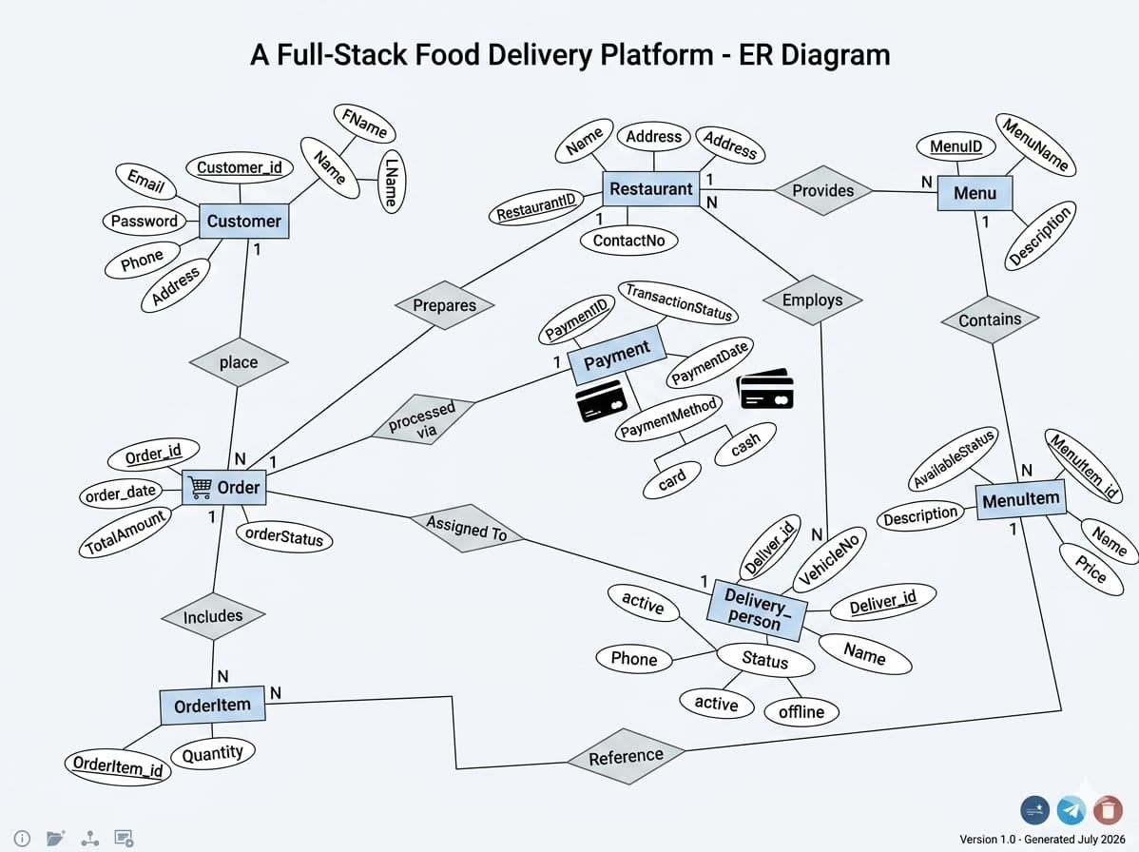

8. Use Case

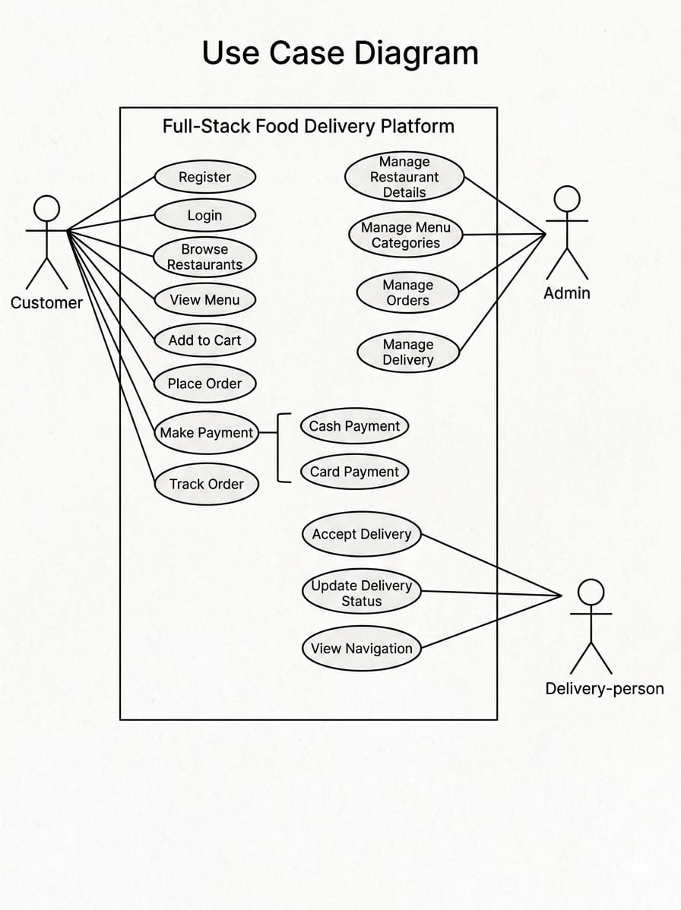

9. References
Acronyms and Abbreviations
- SRS: Software Requirement Specification
- MERN: MongoDB, Express.js, React.js, Node.js
- SPA: Single Page Application
- API: Application Programming Interface
- JWT: JSON Web Token
- UI/UX: User Interface / User Experience
- SLIATE: Sri Lanka Institute of Advanced Technological Education
- HNDIT: Higher National Diploma in Information Technology
References
- Shama, H. (2018). Full-Stack React Projects: Learn MERN stack development by building modern web applications using MongoDB, Express, React, and Node.js. Packt Publishing.
- Wilson, K. (2020). MERN Quick Start Guide: Build web applications with MongoDB, Express.js, React, and Node. Packt Publishing.
- MongoDB. (n.d.). What is the MERN Stack? Introduction and Examples. Available at: https://www.mongodb.com/mern-stack (Accessed: 06 April 2026).
- React Documentation. (n.d.). Getting Started with React and Vite. Available at: https://react.dev (Accessed: 06 April 2026).
- Sri Lanka Institute of Advanced Technological Education (SLIATE). (2026). ICT Project Guidelines for HNDIT.

