SMART INDIA HACKATHON 2026 · PROBLEM STATEMENT SIH26251
DRONA-LOG

Predictive Logistics and Terrain-Aware Resupply
for High-Altitude Formations
DETAILED PROJECT REPORT
A working, end-to-end decision-support prototype
for the Ladakh sector

A forecast → route → optimise → replan loop for forward supply, with an offline, hash-chained edge ledger. The prototype combines LightGBM demand models, terrain-aware A*, an OR-Tools/SCIP mixed-integer allocator, automatic pass-closure replanning and operator-visible evidence.
TEAM | Subterra Mesh
TEAM ID | 185972
PROBLEM STATEMENT | SIH26251 — Predictive Logistics and Forward Supply Chain
TECHNOLOGY BUCKET | Software
PROTOTYPE STATUS | Working end-to-end software; Docker Compose deployment
REPOSITORY | github.com/athul-dev-sys/DRONA-LOG
DOCUMENT | Version 1.0 · 20 October 2026 · Final for submission
DATA | Synthetic; every operational figure is labelled SIMULATED
Prepared for Smart India Hackathon 2026. This is a prototype on synthetic data and is not an operational deployment.

SUBMISSION RECORD
Document control
This report documents the design, implementation, evidence and limitations of the DRONA-LOG prototype submitted against problem statement SIH26251. It is written to be read alongside the running repository, the six-page idea template and the recorded demonstration.
Field | Value
Document title | DRONA-LOG — Detailed Project Report
Version / status | 1.0 · Final for submission
Date | 20 October 2026
Prepared by | Team Subterra Mesh, Team ID 185972
Problem statement | SIH26251 — Predictive Logistics and Forward Supply Chain for the Indian Army in the Ladakh Sector
Technology bucket | Software
Primary artefact | Working backend, frontend, optimisation and edge-ledger prototype
Companion artefacts | 6-page idea template (PDF), recorded demo (MP4), submission answers (MD)
Repository | github.com/athul-dev-sys/DRONA-LOG
Data basis | Synthetic seed 26251; no live, personal or classified data

Revision history
Version | Date | Author | Change
1.0 | 20 Oct 2026 | Team Subterra Mesh | Initial detailed report for SIH submission

Evidence basis
The report is based on the repository at the submitted revision, a seeded SQLite database, the completed 30-day evaluation run, the recorded closure events, and screenshots captured from the running prototype. The backend and frontend test suites were executed on 20 October 2026. The key measured artefacts are:
- 24 backend tests passed with python -m pytest tests/ -q (6.84 s in the recorded run).
- 6 frontend ledger tests passed with npx vitest run (528 ms in the recorded run).
- Production frontend bundle built successfully with npm run build.
- Closure events recorded on 20 October 2026: 28.5 ms reroute and 688.5 ms re-solve on closure; 20.7 ms and 517.0 ms on reopen.
- 30-day simulation counters: 755 units of demand, Zoji La closed on days 10–16, naive and DRONA policies evaluated on the same seed.
A note on numbers
SIMULATED — recomputed, not baked in
Every operational number in this report is produced by the seeded simulation or by a live solve at runtime. Solve times are wall-clock measurements from the development machine and will differ across hardware. The 30-day counters are deterministic for the fixed seed and configuration, but a time-limited SCIP solve can change the last decimal of a plan objective on another machine. Where a value is a trade-off rather than a benefit, it is labelled as such.

NAVIGATION
Contents
Table of contents will be generated when the document is opened in Word.
Page numbers and the table of contents are updated in Microsoft Word and are regenerated in the exported PDF. Chapter numbering is manual so that the document remains readable even if fields are not refreshed.

Executive Summary
Forward supply in high-altitude sectors is a constrained decision problem disguised as a transport problem. A small number of passes carry most of the tonnage; weather and road conditions can remove one for days; demand moves with troop strength, season and exercises; and the fleet at each depot is finite. A plan that ignores terrain, corridor capacity or fleet limits is not a plan — it is a wish list. DRONA-LOG is a working prototype that makes the decision loop explicit and fast: forecast demand, route over the terrain, allocate under capacity, and replan when a pass closes. It also keeps requisitions working at the edge when the network does not.
The prototype is deliberately end-to-end rather than a collection of notebooks. A FastAPI backend exposes a seeded synthetic theatre, a LightGBM forecast per supply class, an elevation-penalised A* router, an OR-Tools/SCIP mixed-integer allocator, a closure-event pipeline and a server-verified edge ledger. A React command view presents the map, the 7-day plan, stock versus buffer and the 30-day impact comparison; a separate edge client records offline requisitions in IndexedDB. Docker Compose brings the whole stack up with one command, and the first boot trains the three models and seeds the database.

What the prototype demonstrates
Capability | Observed result in the seeded run
7-day baseline plan | OPTIMAL; 15 truck dispatches; 0 stockout units; 0 buffer-deficit units; objective ₹23.14 lakh
Pass closure | Zoji La removed; west gateway route unreachable; south route via Manali active; 28.5 ms reroute and 688.5 ms re-solve in the recorded event
Plan change | 6 deliveries cancelled, 5 added, 4 modified, 5 unchanged; closure objective ₹27.94 lakh
Offline edge ledger | Entries recorded with the backend stopped, accepted after restart; hand-edited entry rejected as HASH MISMATCH
30-day comparison | Stockouts 4.15 → 0.25 units; below-buffer unit-days 983.9 → 493.3; cost per unit ₹30,242 → ₹25,619
Test suites | 24 backend tests and 6 frontend ledger tests passing; production frontend build succeeds

The 30-day comparison is presented with its trade-offs. DRONA-LOG uses the longer southern corridor during the closure, so truck-kilometres per unit of demand rise by 22.1%. That is an operating cost, not a saving, and the interface presents it as a warning. The held-requisition counter of 258 for the naive policy and 0 for DRONA is also annotated: the DRONA simulation has no hold path, so the zero is structural and is not claimed as a measured queue reduction. This discipline matters more than a flattering slide: a planner needs to know what a plan costs, not only what it saves.

Submission position
The prototype meets every acceptance criterion set for the build: a feasible baseline with zero modelled stockouts, a valid alternate route and new plan after closure, displayed solve times, offline sync after restart, rejection of a hand-edited ledger entry, one-command bring-up, computed rather than hardcoded metrics, and complete run/demo documentation. It is not a production system: the data is synthetic, the network is schematic, authentication and device signing are absent, and the evaluation is a single 30-day scenario. Section 16 states those limits directly and sets out what a pilot would require.

1. Context and Problem Definition

1.1 Operational setting
The prototype models a high-altitude theatre inspired by Ladakh. Supply enters through two gateways, west and south, and reaches a base depot before moving to staging depots and forward operating bases (FOBs). The synthetic network contains 49 nodes and 53 road edges: 2 gateways, 22 transit nodes, 12 named passes, 2 staging depots, 1 base depot and 10 FOBs. The road topology is deliberately sparse, because that sparsity is the operational problem. When a pass is removed, an entire corridor can disappear and the remaining route can be hundreds of kilometres longer.
Demand is not uniform. Supply class I covers rations and fresh items, class III covers petroleum, oils and lubricants, and class V covers ammunition. Consumption responds to troop strength, season, temperature and snowfall, and can spike during exercises. Stocks at FOBs are bounded by storage and by the need to keep a safety buffer; depots also hold a war reserve. The fleet is finite and shared across destinations, so a plan that sends too many trucks to one FOB can starve another. These are the ingredients of a capacitated, time-phased, terrain-dependent allocation problem.

1.2 Why the conventional process fails
A spreadsheet-and-experience process is not irrational; it is a reasonable response to missing tools. Its failure modes are predictable:
- Trailing demand. Reordering from a trailing mean reacts to the last crisis rather than the next one. A forecast that uses weather and troop strength can move supply before consumption rises.
- Nearest-depot rules. The nearest depot is not always the cheapest or the most feasible source once gradient, corridor capacity and stock are considered. A slightly longer route can be cheaper in cost-km and less exposed to a single pass.
- Fixed lead times. A three-day lead with no lead-time demand compensation systematically under-orders when consumption is rising and over-orders when it falls.
- Corridor blindness. When a pass closes, a static plan becomes invalid instantly. Holding convoys at the closure is safe in the short term but converts a transport problem into a stockout problem.
- Depot hoarding. Without visibility of FOB buffers and depot reserves in one model, each echelon protects itself. Total inventory rises while availability at the edge does not.
- Unverifiable edge data. Paper or local records captured during an outage are hard to reconcile later. Without a tamper-evident chain, the server cannot distinguish a legitimate late entry from an altered one.

1.3 Problem statement
Decision problem addressed by DRONA-LOG
Given a road network with pass closures, a multi-day demand forecast, depot and FOB stocks, safety buffers, a finite fleet at each depot, corridor inflow caps and a cost model, produce a feasible dispatch plan that meets demand, maintains buffers where possible and minimises total cost — and recompute that plan within seconds when a pass closes. At the edge, capture requisitions while disconnected and later prove to the server that each entry is intact and belongs to a valid chain.

The problem has two outputs that must agree: a plan a human can act on, and evidence that the plan and its exceptions are internally consistent. A map that disagrees with the plan table, or a sync that accepts an altered entry, fails the operational test even if the optimiser is sophisticated.

1.4 Objectives and success criteria
ID | Objective | Success criterion | Where verified
O1 | Produce a feasible 7-day plan | OPTIMAL or FEASIBLE; zero modelled stockouts and zero buffer deficit on the seeded baseline | Planner tests; baseline plan payload
O2 | Respond to a pass closure | Severed corridor returns no route; alternate route is valid; new plan solves and is diffed | Zoji La and Khardung La tests; closure event
O3 | Expose solve performance | Router and solve times returned and rendered; no hardcoded timing | Closure payload; UI panel
O4 | Operate offline | Entries recorded with backend stopped; accepted after restart; stock applied for receipts | Sync-after-restart test; live edge demo
O5 | Detect tampering | Hand-edited, replayed, gapped or broken-chain entries rejected with a reason | Eight sync tests; UI tamper demo
O6 | Measure honestly | Naive and DRONA policies simulated on the same seed; all cards labelled SIMULATED | Metrics tests; 30-day report
O7 | Make it reproducible | One command brings up the stack; tests and seed are deterministic | Docker Compose; test suites

1.5 Scope, assumptions and non-goals
In scope | Out of scope (prototype)
Synthetic Ladakh-inspired theatre with 49 nodes, 53 edges, 10 FOBs and 12 passes | Live weather, road reports, service records or classified feeds
Three supply classes (I, III, V), three depots, two gateways | Unit-level inventory, lot tracking, shelf-life or hazardous-materials rules
7-day operational MILP and 30-day policy comparison | Multi-theatre campaign planning or strategic force flow
Single-pass closure and reopen workflow, with a persisted set of closed passes | Simultaneous multi-pass stress testing and recovery playbooks
Offline requisitions with a per-device hash chain | Device registration, signing, PKI, conflict resolution between devices
Two operator views and OpenAPI documentation | Authentication, roles, audit administration, mobile field app

The prototype is a decision-support system. It does not fire weapons, task real vehicles or transmit classified information. All operational figures are synthetic and labelled SIMULATED; all recommendations are subject to human review.

2. Solution Overview

2.1 Concept of operations
DRONA-LOG is organised around a daily planning cycle and an exception path. The cycle is intentionally short enough to run before a morning briefing; the exception path is short enough to run while a closure is being confirmed.
Step | Operator / system action | Output
1. Sense | Load the seeded theatre, stock, weather forecast and troop strength | Current state snapshot
2. Forecast | Run one LightGBM model per class over the 7-day horizon | Daily demand by FOB and class
3. Route | Build the closure-aware graph and compute depot→FOB cost-km | Route matrix with gradient penalties
4. Allocate | Solve the capacitated MILP for trucks, loads and gateway inflow | 7-day dispatch plan and stock projection
5. Publish | Return plan, routes, KPIs, timings and SIMULATED comparison in one payload | Command view
6. Except | On a pass closure, remove the pass, reroute, re-solve, diff and record | New plan, timings, diff, event
7. Reconcile | Sync edge entries; verify hash, sequence and previous link; apply receipts | Accepted/rejected ledger response

2.2 Capability map
Capability | Mechanism | Operator-visible output
Anticipate demand | LightGBM per supply class; temperature, snowfall, troops, day-of-week | 7-day forecast per FOB and class
Choose realistic routes | A* on distance + 6 × gradient%; pass nodes removed on closure | Route, distance, cost-km, gradient penalty, max elevation
Allocate scarce capacity | OR-Tools/SCIP MILP with trucks, fleet caps, stock, buffers and inflow caps | Dispatch table, stock projection, objective, solve time
React to a closure | Persist closure, rebuild graph, remap routes, re-solve, diff plans | Red corridor, alternate route, timings, cancelled/added/changed counts
Operate at the edge | IndexedDB append-only ledger with SHA-256 chain | Offline status, local entries, sync result
Reconcile safely | Server recomputes hashes and checks chain continuity | Accepted/rejected entries with explicit reasons
Measure honestly | Naive vs DRONA on the same seeded 30-day scenario | SIMULATED impact cards and trade-off warnings

2.3 Design principles
Compute, do not hardcode. Every operational number is derived at runtime: plans from the MILP, routes from the graph, metrics from the simulation, timings from the solver. The UI labels data SIMULATED rather than presenting decorative numbers as facts.
One payload, one truth. The closure response contains the new routes, the new plan, the diff and the timings. The map, plan table, inventory chart and event log all read from that response or from the persisted plan, so they cannot tell different stories.
Degrade, do not stop. The edge client keeps recording when the backend is unreachable. On reconnect it syncs rather than discarding local work, and it never silently accepts an entry the server rejects.
Expose the trade-off. A longer corridor can preserve availability while increasing truck-kilometres. The interface reports the increase instead of hiding it. A zero hold counter that is structural is annotated as structural.
Be reproducible. Seed 26251, deterministic model parameters, one-thread SCIP and a fixed scenario make the demonstration repeatable. The stack needs no external API key, tile server or GPU.

2.4 Users and workflows
User | Primary questions | View and workflow
Commander / staff officer | Is the theatre covered? What does a closure do to cost and availability? | Command view: map, 7-day plan, impact panel, closure controls
Logistics planner | Which trucks, from where, with what load, on which day? What changed? | Command view: dispatch table, stock vs buffer, closure diff and timings
Edge quartermaster | Can I record a requisition without connectivity? Did it sync? Was anything rejected? | Edge client: requisition form, local chain, sync result, tamper simulation

There are two operator views, not three: the command view at / combines the commander and planner workflows because they read the same plan; the edge client at /edge serves the disconnected quartermaster. FastAPI's interactive OpenAPI documentation at /docs is a developer surface, not a third operational screen.

3. System Architecture

3.1 Component view
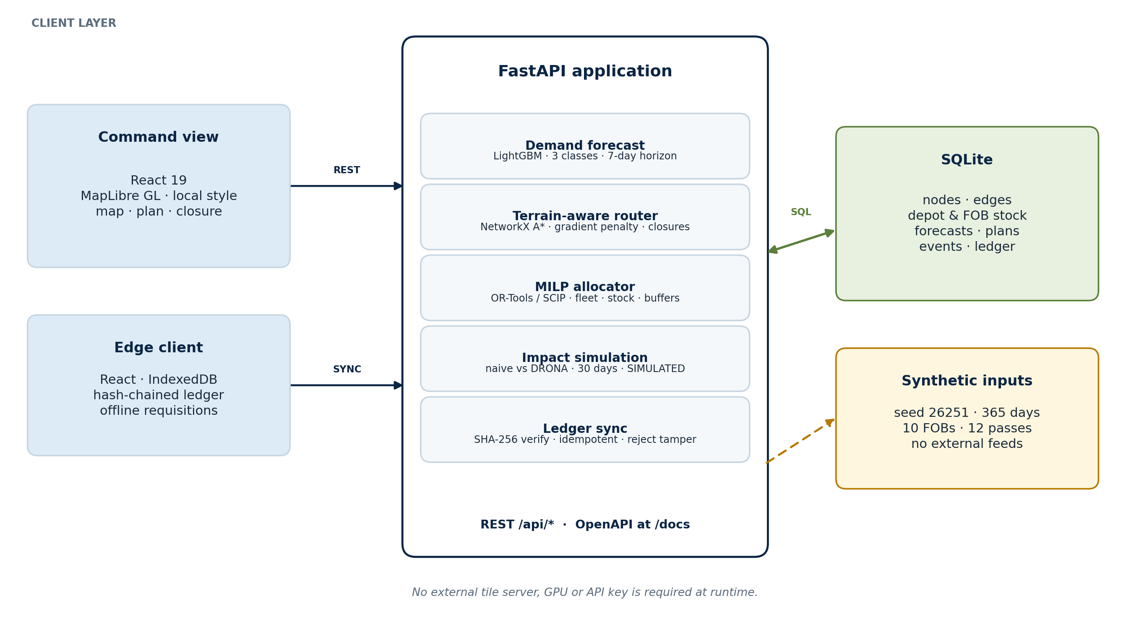
Figure 3.1 — Component architecture. Two React clients call one FastAPI application; SQLite is the single persistent store; synthetic inputs are generated locally.
The architecture separates decision engines from transport concerns. The React clients never compute a route or a plan; they render server responses. The FastAPI application owns the forecast, graph, MILP, simulation and ledger verification. SQLite stores the seeded theatre, models' inputs, plans, events and ledger records. No runtime component calls an external service.

3.2 Backend services
Module | Responsibility | Key output
seed.py | Builds the synthetic theatre, weather, history, stock and actual-future demand | Deterministic SQLite database
graph.py | Builds the NetworkX graph; removes closed pass nodes and incident edges | Closure-aware graph
router.py | A* over cost-km; route matrix; gateway routes; per-leg gradient detail | Routes with distance, cost-km and penalty
forecast.py | Trains one LightGBM model per class; predicts from weather forecast | Per-FOB, per-class daily demand
allocator.py | Builds and solves the MILP with OR-Tools/SCIP; returns plan and KPIs | Trucks, loads, inflow, stock projection
scenario.py | Assembles demand, stock, buffers, route costs and corridor caps for a closure state | Solver-ready inputs
simulate.py | Runs naive and DRONA policies over the same 30-day seeded scenario | SIMULATED comparison counters
main.py | FastAPI endpoints, closure flow, metrics cache and ledger sync verification | REST API

3.3 Operator frontend
The frontend is a React 19 single-page application built with Vite 8 and styled with Tailwind CSS 4. It has two routes: the command view and the edge client. MapLibre GL 6 renders the theatre over a locally vendored satellite mosaic and hillshade (Esri/Maxar imagery, Mapzen/AWS SRTM terrain); there is no external tile request, so the demonstration works without internet access. The raster basemap is added only after the operational layers load, so a slow or failed image fetch cannot blank the map. The production container uses nginx to serve the built assets, provide SPA fallback and proxy /api to the backend. The development server proxies /api to port 8000 in the same way.
The command view is desktop-first and intentionally dense. The map occupies the flexible left pane; a 420 px right pane holds the closure impact panel, the 30-day comparison, the 7-day allocation table and FOB stock bars. The edge client uses a form-and-table layout with a 340 px sync panel. The visual language is a light Indian Army field-dossier surface: an olive header with a tricolour stripe, parchment panels and khaki borders, with army green for healthy/open, teal for the southern corridor, brass/amber for warnings and planned convoys, and maroon for closures or rejection.

3.4 Data layer
SQLite is sufficient for the prototype because the workload is read-mostly and single-node. The schema separates reference data, time series, plans and audit records:
Table group | Examples | Purpose
Theatre | nodes, edges, stock | Topology, elevations, corridors, FOB/depot stock and buffers
Time series | history, weather_forecast, actual_future | 365-day training history, 7-day weather inputs, 30-day evaluation demand
Decisions | plans, events | Persisted plan payloads and closure/reopen events with timings and diffs
Edge trust | ledger, chain_heads, sync_log | Accepted entries, per-device chain head, sync audit
Metadata | kv | Seed flags and the persisted set of closed passes

The database file is mounted on the drona-data Docker volume, so plans and ledger entries survive container restarts. Rebuilding the volume returns the demonstration to a clean seeded state.

3.5 Deployment topology
Service | Image / build | Port | Role and health
backend | backend/Dockerfile | 8000 | FastAPI + seed + models; healthcheck calls /api/health; 12 retries over a 10 s interval
frontend | frontend/Dockerfile | 8080 → 80 | nginx serving the SPA and proxying /api; starts only after backend is healthy
volume | drona-data | — | Persistent SQLite database and trained model artefacts

The stack has no external runtime dependency. The base images, Python packages and npm packages are the only downloads, and they are fetched at build time. Runtime API keys, tile servers, CDNs and GPUs are not required.

3.6 Request lifecycles
Plan request. GET /api/plan checks that the database is seeded and the models exist; on first use it seeds and trains. It assembles the current scenario, computes the route matrix, solves the MILP, persists the plan and returns the plan payload with routes, gateway routes, stock projection and KPIs. The command view calls it on load and exposes a refresh action.
Closure request. POST /api/events/pass-closure accepts a pass id, an action and a duration. It validates the pass, updates the persisted closed-pass set, rebuilds the graph, remaps the route matrix, re-solves the plan, diffs the old and new deliveries, stores the event with both plans and timings, and returns the closure payload used by the UI.
Sync request. POST /api/sync accepts a device id and a batch of entries. It reads the per-device chain head, sorts by sequence, recomputes each hash, validates continuity and idempotency, inserts accepted entries, updates the chain head, applies accepted receipt quantities to stock and records a sync audit row.

4. Synthetic Theatre and Data

4.1 Why synthetic data
A hackathon prototype cannot use classified movement records, live road reports or personal data. Synthetic data is therefore a design choice, not a shortcut: it lets the team publish the scenario, reproduce every number and avoid implying access to operational information. The trade-off is external validity. The relationships in the data are plausible but constructed, so the measured improvements demonstrate that the decision loop works on a controlled problem; they do not predict performance on a real road network.
Data honesty rule
Every operational surface is labelled SIMULATED. No figure in the UI is a claimed real-world measurement. The README, this report and the demo state that the theatre, weather, demand and costs are synthetic.

4.2 Network and formations
Entity | Count | Detail
Nodes | 49 | 2 gateways, 22 transit, 12 passes, 2 staging depots, 1 base depot, 10 FOBs
Road edges | 53 | Undirected; distance, simulated gradient, elevation gain, corridor
Gateways | 2 | Srinagar (west) and Manali (south)
Depots | 3 | Leh (base), Karu and Upshi (staging)
FOBs | 10 | DBO, Turtuk, Sasoma, Diskit, Durbuk, Spangmik, Chushul, Nyoma, Hanle, Demchok
Passes | 12 | Zoji La, Namika La, Fotu La, Rohtang, Baralacha, Tanglang La, Khardung La, Wari La, Saser La, Chang La, Kaksang La, Umling La

FOB names and pass names are drawn from Ladakh for recognisability. Coordinates and elevations are a simplified synthetic model, not an authoritative operational map. The network is sparse by design: the western gateway passes through Zoji La, Namika La and Fotu La; the southern gateway passes through Rohtang, Baralacha and Tanglang La. Removing Zoji La therefore severs the western corridor rather than merely lengthening it.

4.3 Demand, weather and history
The seed generates 365 days of daily history for each of 10 FOBs and 3 supply classes: 10,950 rows. Daily temperature and snowfall follow a seeded seasonal pattern; troop strength includes periodic exercise surges and small monthly drift. Consumption is driven by troop strength and weather with day-of-week variation and noise. A separate 30-day actual_future series (900 rows) is used only for evaluation, so the forecast and the evaluation target are not the same series. A 7-day weather forecast table supplies inference features.
Data set | Rows | Use
history | 10,950 | Train one LightGBM model per class (365 days × 10 FOBs × 3 classes)
actual_future | 900 | 30-day evaluation demand (30 × 10 × 3); never used for training
weather_forecast | 370 | Inference features for the forecast horizon
stock | 39 | Initial on-hand and buffer for 10 FOBs + 3 depots × 3 classes

The evaluation closure is fixed: Zoji La is closed from day 10 to day 16 inclusive, seven days. Both policies see the same closure and the same actual demand. This is what makes the naive-versus-DRONA comparison meaningful even though the underlying data is synthetic.

4.4 Data dictionary
Field | Type / unit | Meaning
nodes.kind | enum | gateway, transit, pass, base depot, staging, FOB
nodes.elev_m | metres | Synthetic node elevation used by the gradient penalty
edges.distance_km | km | Road distance (1.25 × haversine, minimum 3 km)
edges.gradient_pct | percent | |Δelevation| / (distance_km × 10)
history.qty | units/day | Synthetic consumption for a FOB, class and date
stock.on_hand / buffer | units | Current stock and safety buffer / war reserve
plans.payload_json | JSON | Persisted plan, routes, projection and KPIs
ledger.payload_json | JSON | Canonical edge payload: FOB, class, qty, note, timestamp

4.5 Determinism and reproducibility
The seed is 26251. Per-FOB random streams are derived from a CRC32 of the FOB id, so adding a FOB does not reshuffle the whole theatre. LightGBM is configured with random_state=26251, deterministic=True, force_col_wise=True and one thread. SCIP runs with one thread. These choices make a rerun on the same machine reproduce the same data and the same model. They do not make solve time a constant: SCIP is time-limited, and wall-clock time depends on the host. The report therefore quotes timings as recorded samples and the UI displays live values.

5. Demand Forecasting

5.1 Formulation
For each FOB f, supply class c and day t in the horizon, the system estimates daily consumption ŷ(f,c,t). One model is trained per class on the pooled daily history across FOBs. The forecast horizon in the command view is seven days; the allocator consumes the same daily vector. The model is a point forecast: it produces a single expected quantity, not a distribution.
ŷ(f, c, t) = f_c( temp_c(t), snowfall_cm(t), troops(t), dow(t) )
c ∈ {I, III, V} t ∈ {0, …, 6} ŷ ≥ 0

5.2 Features
Feature | Unit | Operational rationale
temp_c | °C | Cold-weather demand and storage conditions
snowfall_cm | cm | Access difficulty, heating and clothing consumption
troops | persons | Scale of demand at the FOB
dow | 0–6 | Day-of-week pattern in issuing and consumption

The model is deliberately compact. A larger feature set would require data the prototype does not have, and would make the forecast harder to explain to a planner. The features are all present in both the historical table and the weather forecast table, which keeps training and inference consistent.

5.3 Model configuration
Parameter | Value | Reason
Algorithm | LightGBM LGBMRegressor | Fast, strong on tabular data, no GPU required
Objective | regression (L2) | Daily quantities are continuous and roughly symmetric
Trees | 300 | Enough capacity for 365 days × 10 FOBs per class
Learning rate | 0.05 | Stable fit with 300 trees
Leaves | 31 | Moderate non-linearity without overfitting
Min child samples | 20 | Regularisation on small daily counts
Random state | 26251 | Reproducible
Threads | 1 | Determinism over speed for a small data set

5.4 Training and inference pipeline
At first boot the backend checks for three persisted model files. If any is missing it trains all three from history, writes them to the model directory and continues. The health endpoint reports readiness. Inference reads the weather_forecast rows for the requested dates, builds the same four features, predicts per class and clamps negative outputs to zero. The result is shaped into a per-FOB, per-class payload with daily values and a total.
Stage | Input | Output
Train | history rows for one class | Fitted LightGBM model
Persist | Fitted model | data/models/model_<class>.pkl
Infer | weather_forecast for horizon | Daily demand per FOB and class
Clamp / round | Raw prediction | Non-negative value, 4 decimal places
Shape | Predictions | {fob: {class: {daily, total}}} payload

5.5 Output contract
The forecast endpoint returns dates, FOB metadata and per-class daily values. The allocator consumes the same daily vectors. A shortened example:
{
"start_date": "2026-10-01",
"dates": ["2026-10-01", "..."],
"fobs": {
"DBO": {
"name": "Daulat Beg Oldi",
"troops": 420,
"forecast": {
"I": {"daily": [2.31, 2.28, "..."], "total": 16.1},
"III": {"daily": [5.02, 5.11, "..."], "total": 35.4},
"V": {"daily": [0.74, 0.70, "..."], "total": 5.1}
}
}
}
}
The numbers above are illustrative of the shape, not a claimed sample from a particular run. The live payload is the source of truth.

5.6 Limitations
- Point forecast. There is no prediction interval, so the MILP cannot optimise against a demand distribution or a service level. Buffers and penalties are the current risk mechanism.
- Pooled model. One model per class is trained across all FOBs; FOB identity is not a feature. Distinct local patterns must be explained by troops and weather, which is a simplification.
- Synthetic relationships. The data generator encodes plausible effects, not observed ones. Forecast accuracy on this data is not evidence of accuracy on service records.
- No retraining schedule. Models train at first boot or when files are missing. A production system would need drift monitoring and scheduled retraining.
- Uncertainty in weather. The weather forecast is treated as exact. A real system would carry forecast error into the demand model or the optimisation.

6. Terrain-Aware Routing

6.1 Graph model
The road network is an undirected NetworkX graph. Each node carries a kind, coordinates and elevation. Each edge carries distance, elevation gain, gradient percentage and corridor. The graph is rebuilt for every scenario so that closures cannot leak between requests. A closed pass is removed as a node, which removes every incident edge at once; this is more robust than marking edges closed, because it prevents a route from transiting the pass under any combination of incoming and outgoing edges.

6.2 Elevation-penalised cost
Edge cost is expressed in cost-kilometres, not minutes or rupees. The conversion factor is deliberately simple and explainable:
gradient_pct = |Δelev_m| / (distance_km × 10)
cost_km = distance_km + 6.0 × gradient_pct
A 10 km edge with a 5% gradient costs 40 cost-km: 10 km of distance plus 30 km of climb penalty. A flat 12 km edge costs 12 cost-km and wins. The multiplier 6.0 is a policy parameter, not a measured fuel model; it makes the router prefer lower-gradient routes without pretending to be a physics simulation. The route response reports both distance_km and gradient_penalty_km, so a planner can see why a longer route was chosen.

6.3 A* and the route matrix
A* uses a great-circle heuristic to the destination. The heuristic is admissible because the true cost of a path is at least its great-circle distance; the gradient penalty only adds cost. The router computes a matrix from each of the three depots to every FOB and the two staging depots. Unreachable pairs are returned as None and excluded from the MILP, so the optimiser cannot dispatch to a severed destination. The API also exposes the two gateway routes — Srinagar to Leh and Manali to Leh — for the map and the closure panel.

6.4 Closure handling
build_graph(conn, closed_passes) skips closed pass nodes and any edge whose endpoint is missing. The route matrix is recomputed from scratch. For a Zoji La closure, the western gateway route becomes None; the southern route remains and avoids Zoji La. For a Khardung La closure, Nubra traffic is routed via Wari La, which is verified by a dedicated test. The allocator receives only the reachable pairs and the corridor caps for the current state.

6.5 Worked corridor example
Gateway route | Distance | Cost-km | Gradient penalty | Max elevation | Status
Srinagar → Leh (west) | 377.06 km | 517.51 | 140.45 km | 4,108 m | Open baseline; None when Zoji La is closed
Manali → Leh (south) | 331.36 km | 519.59 | — | — | Open baseline and closure alternate

The southern route is 45.7 km shorter but slightly more expensive in cost-km because its climbs attract a larger gradient penalty. It also has lower daily inflow caps and a 33% higher procurement cost. Those differences are why a closure changes the plan rather than merely replacing one road with another.

6.6 Limitations
- Schematic geometry. Path geometry is a sequence of node coordinates, not a surveyed road alignment. Distance is 1.25 × haversine with a 3 km minimum, not a routing-engine result.
- Static gradients. Each edge has one gradient value. Seasonal road quality, surface, switchbacks and direction-dependent ascent are not modelled.
- No traffic or weather delays. Travel time is not modelled; the lead time is a fixed one day for every route.
- One penalty weight. The gradient multiplier is a single policy parameter. A production model would calibrate it against fuel, time and maintenance data.

7. Allocation Optimisation

7.1 Decision variables
Variable | Domain | Meaning
x[d,j,c,t] | continuous ≥ 0 | Units of class c dispatched from depot d to destination j on day t; arrives t+1
n[d,j,t] | integer ≥ 0 | Trucks dispatched from d to j on day t
s[f,c,t] | continuous ≥ 0 | FOB stock at start of day t
short[f,c,t] | continuous ≥ 0 | Unmet demand (stockout) at FOB f, class c, day t
bdef[f,c,t] | continuous ≥ 0 | Units below the FOB safety buffer on day t
sd[d,c,t] | continuous ≥ 0 | Depot stock at start of day t
in_w[c,t], in_s[c,t] | continuous, capped | Gateway inflow from west and south on day t
bdef_d[d,c] | continuous ≥ 0 | End-of-horizon war-reserve shortfall at depot d

7.2 Objective function
The objective is a sum of transport, procurement and soft-penalty terms. It is denominated in rupees, so a stockout penalty of ₹500,000 per unit dominates ordinary transport cost and makes stockouts a last resort rather than an equal trade.
Term | Coefficient / formula | Purpose
Transport variable | ₹42 × cost-km × units | Distance and gradient cost of moving each class
Transport fixed | ₹4,000 × trucks | Dispatch overhead per truck
Procurement west | ₹18,000 × west inflow | Gateway supply cost via Zoji La corridor
Procurement south | ₹24,000 × south inflow | 33% premium for the longer Manali corridor
Stockout | ₹500,000 × unmet units | Strongly discourage unmet demand
FOB buffer deficit | ₹60,000 × unit-days below buffer | Protect safety stock
Depot reserve deficit | ₹60,000 × end-horizon shortfall | Discourage consuming the war reserve
Day tie-break | ₹40 × day × inflow | Break procurement-timing symmetry

7.3 Constraints
Constraint | Formulation / effect
Truck capacity | Load on a route ≤ 10 × trucks, with classes sharing the truck
Fleet per depot per day | Sum of trucks from Leh/Karu/Upshi ≤ 24 / 8 / 8
Delivery lead | Dispatch on day t arrives at the destination on day t+1
FOB stock balance | Start stock + arrivals − demand + stockout = next start stock
FOB buffer | Start stock + buffer deficit ≥ 7-day buffer (soft)
Depot stock balance | Start stock + inflow − outflow = next start stock; inflow only at Leh
War reserve | End-of-horizon depot stock + shortfall ≥ reserve (soft)
Corridor caps | West: I/III/V ≤ 6/26/2.5 per day; South: ≤ 2.5/11/1.2 per day; zero on closure days
Reachability | Variables exist only for pairs with a route in the current graph
Non-negativity | All stock, load, inflow and deficit variables ≥ 0

7.4 Solver configuration
Setting | Value
Solver | OR-Tools pywraplp with SCIP
Threads | 1
Time limit | 10,000 ms
Relative gap | 1%
Objective sense | Minimise
Statuses surfaced | OPTIMAL, FEASIBLE, INFEASIBLE, ABNORMAL

A one-thread, 10-second configuration is deliberate for a demonstration: it keeps the model deterministic and prevents a pathological instance from hanging the UI. The recorded baseline and closure solves completed in 517–689 ms, well below the limit, but a larger network or a tighter gap could hit it. In that case the UI would show FEASIBLE and the objective would be the best incumbent, not a proof of optimality.

7.5 Plan outputs
A successful solve returns the status, objective, wall time, solver time, deliveries, gateway inflow, FOB and depot stock projections, FOB buffers and KPIs. A delivery row contains the day, source, destination, truck count, per-class loads, cost in rupees and route cost-km. The UI renders this as a dispatch table and uses the stock projection for the inventory chart. The closure endpoint embeds both the old and new plan payloads in the event so the diff can be audited later.

7.6 Baseline plan behaviour
Seeded 7-day baseline (recorded run)
Status OPTIMAL · 15 truck dispatches · 0 stockout units · 0 buffer-deficit units · objective ₹23.14 lakh. The plan uses both staging depots and the base depot, respects the daily fleet caps and keeps every FOB at or above its safety buffer across the horizon. The objective is dominated by procurement, not by the ₹4,000 dispatch fee.

The baseline is a plan for the 7-day operational horizon, not a 30-day guarantee. The 30-day evaluation is a separate simulation with its own rolling replans; its DRONA result is 0.25 stockout units, not zero. The report keeps those two claims separate on purpose.

7.7 Limitations
- Deterministic demand. The MILP uses the point forecast. It does not hedge against forecast error or weather uncertainty.
- Unit aggregation. A unit represents tonnes for classes I and V and kilolitres for class III. The model does not mix commodity-specific volume, weight or handling constraints.
- No route scheduling. A truck is available per day, but there is no vehicle routing, driver hours, convoy escort or road-window schedule.
- Soft constraints. Stockouts and buffer deficits are penalised, not forbidden. Extremely tight instances could choose a small stockout over a very expensive delivery; the penalty makes that rare but not impossible.
- Time-limited optimality. The 1% gap and 10-second limit mean the last decimal of the objective may vary across machines or instances.

8. Closure Response

8.1 Event pipeline
The closure endpoint is the most important integration path in the prototype. It must change the road network, the plan, the UI and the audit trail without allowing them to drift. The sequence is:
Step | Action | Failure handling
1 | Validate the pass id and action | Unknown pass returns 404; invalid action is rejected by schema
2 | Persist the closed-pass set | Survives subsequent plan requests
3 | Rebuild the graph with the pass removed | West gateway becomes None if severed
4 | Remap every depot→FOB and gateway route | Unreachable pairs are excluded from the MILP
5 | Recompute corridor caps for the closure state | West inflow is zero while closed
6 | Re-solve the 7-day MILP | Status and wall time recorded
7 | Diff old and new deliveries | Cancelled, added, changed, unchanged counts
8 | Persist the event with both plans and timings | Returned to the UI as one payload

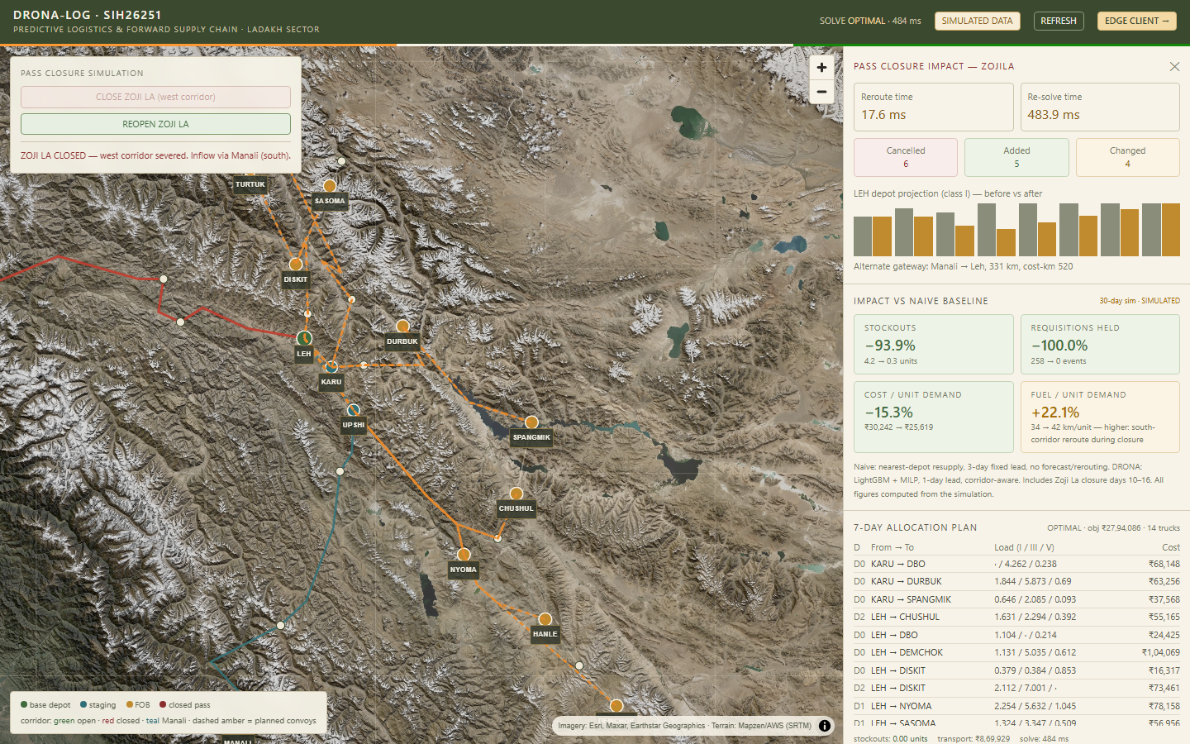
Figure 8.1 — Closure response in the command view. The west corridor is red, the alternate southern corridor is active, and the panel shows measured reroute/re-solve times, the plan diff and the depot inventory projection.
The screenshot is from the running prototype. The numbers on screen are live values from that run; they are not the same sample quoted in the event table below, because each solve measures its own wall time.

8.2 Recorded closure run
Item | Recorded value (20 Oct 2026)
Event | ZOJILA closed
Old plan → new plan | Plan 2 → Plan 3
Router time | 28.5 ms
Re-solve time | 688.5 ms
Solver status | OPTIMAL
Objective | ₹23,13,860.73 → ₹27,94,086.02 (+20.8%)
Trucks | 15 → 14
West gateway route | None (severed)
South gateway route | MANALI → ROHTANG → KEYLONG → BARALACHA → SARCHU → DEBRING → TANGLANGLA → RUMTSE → UPSHI → LEH
South route distance / cost | 331.36 km / 519.59 cost-km

The timings are wall-clock samples from one development machine. A second closure run produced 20.7 ms and 517.0 ms on reopen. The UI displays whatever the current solve returns; the report quotes samples to avoid implying a guaranteed latency.

8.3 Plan differences
Diff category | Count | Interpretation
Cancelled | 6 | Deliveries that existed before the closure and are no longer in the new plan
Added | 5 | New deliveries introduced by the new plan
Changed | 4 | Same day/source/destination but a different truck or class load
Unchanged | 5 | Deliveries that remain identical

A changed row is not a cosmetic edit. For example, a KARU→DBO day-0 delivery moved from 1.03 units of class III to 4.262 units of class III plus 0.238 units of class V. The new plan is re-optimised as a whole, not patched delivery by delivery, so quantities can move between classes and days to protect buffers under the reduced southern inflow.

8.4 Why the objective rises
The closure objective is 20.8% higher even though the new plan uses one fewer truck. Three forces dominate. First, procurement via the south corridor costs ₹24,000 per unit instead of ₹18,000, a 33% premium. Second, southern daily inflow caps are materially lower, so the plan cannot simply replace western tonnage one-for-one. Third, the longer southern route has a higher gradient penalty and reduces the set of feasible depot→FOB pairs. The optimiser is not failing to find a cheaper plan; it is finding the cheapest plan under a worse network and a more expensive supply source. Showing that increase is the honest outcome.

8.5 Operator experience
The command view deliberately couples the map and the numbers. The west corridor turns red, the southern corridor becomes the active route, planned convoys are redrawn from the new plan, and the impact panel shows both timings, the diff counts and the depot inventory projection. The panel is populated from the same response that produced the new plan, so there is no second fetch that could show a stale route. A 'REOPEN ZOJI LA' action restores the west corridor and re-solves again.

8.6 Reopening and multiple closures
The API persists a set of closed passes rather than a single boolean. Reopening removes the pass from that set and re-solves; closing another pass adds it. The demo exercises one pass at a time because that is the clearest operational story, and the tests verify the two named closure scenarios (Zoji La and Khardung La). A production deployment would need stress testing of simultaneous closures, partial reopenings and closure duration uncertainty; those are not claimed here.

9. Edge Operations and Ledger Integrity

9.1 Offline-first design
The edge client is a React view backed by IndexedDB. It does not depend on a service worker or a cached API response for its core function: requisitions are written directly to a local object store. Each entry records a device id, sequence number, previous hash, canonical payload, FOB, class, quantity, entry type, client timestamp and hash. The UI shows backend online/offline state, the local chain, pending versus synced entries, and the last sync result.
The ledger is append-only in normal operation. There is a deliberate 'clear local ledger' action for demonstrations; it is a reset, not a production feature. The local chain can be verified in the browser before sync, but the server verification is authoritative because the server recomputes the hash from the submitted fields and compares it with the submitted hash and its own chain head.

9.2 Hash-chained ledger
The hash covers both the chain fields and the semantic transaction fields, so changing a quantity, FOB, class or entry type by hand breaks the digest even if the JSON payload is left untouched:
body = seq | prev_hash | payload_json | fob_id | class_id | entry_type | qty.toFixed(4)
hash = SHA-256(body)
genesis: prev_hash = "0" × 64
canonical payload: {"fob": ..., "class": ..., "qty": ..., "note": ..., "ts": ...}
The browser uses WebCrypto crypto.subtle.digest; the server uses Python hashlib.sha256. A frontend test asserts byte-identical digests for the same input. The canonical payload is produced by a single function, so field order is stable and the two implementations hash the same string.

9.3 Sync verification
On POST /api/sync the server reads the per-device chain head from chain_heads (falling back to the latest accepted ledger row, or the genesis value for a new device). It sorts the batch by sequence and processes entries in order. For each entry it:
- recomputes the hash from the submitted chain and semantic fields;
- checks whether the entry id already exists, and if so, verifies that the stored copy and the submitted copy agree;
- requires seq = previous + 1;
- requires prev_hash to equal the stored chain head;
- rejects negative quantities;
- stops accepting later entries in the batch once the chain is broken;
- inserts accepted entries, advances the chain head and applies accepted receipts to stock.
The response reports accepted and rejected counts, a primary reason, the new chain-head sequence and per-entry results. The client marks only accepted entries as synced.

9.4 Rejection taxonomy
Condition | Server result | Why it matters
Hand-edited qty / FOB / class / type | HASH MISMATCH | The digest covers semantic fields, not only the JSON blob
Altered replayed entry with same id | HASH MISMATCH | Idempotency does not mean accepting a different payload
True duplicate with identical content | Accepted as duplicate, already synced | A retry after a timeout is safe
Sequence gap | Sequence gap error | A deleted or missing entry cannot be hidden
Broken previous link | prev_hash does not match preceding entry | Reordering or splicing is detected
Entry id owned by another device | Rejected | Prevents cross-device replay
Negative quantity | Rejected | Basic domain validation
Chain broken earlier in batch | Later entries rejected | One bad entry cannot be followed by silent acceptance

9.5 Demonstrated tamper rejection
The edge client includes a demonstration action that edits the last local entry's quantity without recomputing its hash. On the next sync the server returns '0 accepted · 1 rejected — HASH MISMATCH'. Entries already accepted on the server remain valid; the local chain is flagged as broken. The same behaviour is covered by tests for a tampered entry, a tampered payload, an altered replay, a sequence gap and a broken previous hash.
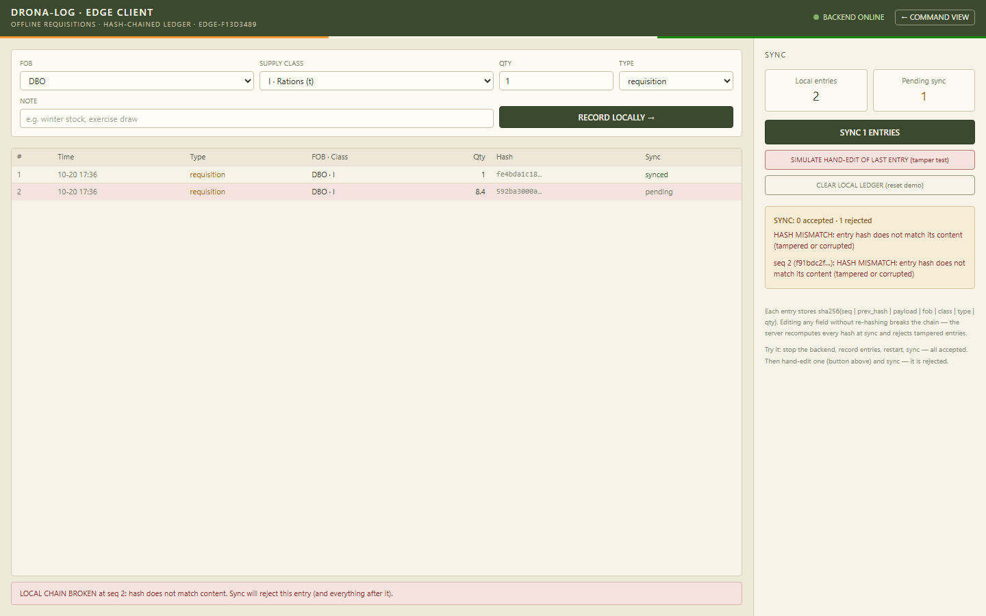
Figure 9.1 — Edge client after a hand edit and sync. The modified entry is rejected; the server reports zero accepted and one rejected with a hash mismatch.

9.6 Stock semantics and limitations
Only accepted receipt entries advance server stock. Requisitions are recorded and verified but do not silently change on-hand inventory; a requisition is a request, not a receipt. This distinction is visible in the code and is important for auditability: accepting a requisition as stock would create inventory that never physically arrived.
- No device signing. Possession of the device id and the ability to compute a hash is sufficient to submit a well-formed chain. Production needs registered device keys and signatures.
- Fixed genesis. Every device starts from 64 zeros. Production needs a device registration record bound to the genesis.
- No conflict resolution. Two devices can create independent chains; the server accepts each per-device chain but does not reconcile competing requisitions for the same stock.
- Local reset. The demo can clear the local ledger. This is not a tamper-proof hardware root of trust.
- Browser storage. IndexedDB can be cleared by the user or the browser under storage pressure. A production edge app needs durable storage and backup.

10. User Experience and Interface

10.1 Command view
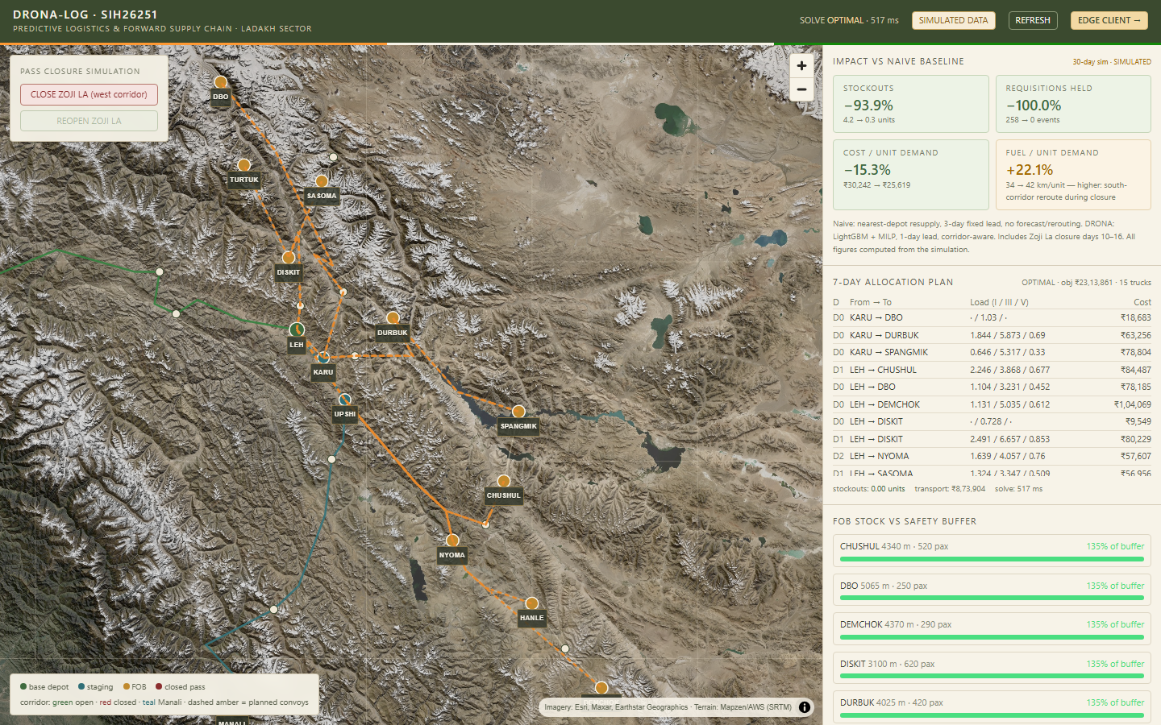
Figure 10.1 — Command view. The offline satellite basemap, 7-day allocation table, stock-versus-buffer panel, closure controls and SIMULATED impact comparison share one screen.
The command view is built around a single question: what is the plan, and what happens if the road changes? The map answers the spatial part; the right pane answers the quantitative part. The closure control sits over the map where the corridor is visible, not buried in a settings menu. The SIMULATED impact panel is always present, so a planner sees the policy comparison without leaving the operational plan. The edge-client link is in the header, making the offline workflow discoverable.

10.2 Visual system
Element | Choice | Reason
Surface | Olive header, parchment panels | Light field-dossier palette with a tricolour stripe; keeps the map and dense data legible in daylight and operations-room lighting
Basemap | Local satellite + hillshade | Terrain context without any tile request; imagery failure cannot blank the operational layers
Open corridor | Green | Conventional 'go' signal
Southern corridor | Teal | Distinguishes the alternate from the primary without implying warning
Planned convoy | Dashed amber | Visible over both corridors without competing with status colours
Closure / rejection | Maroon | Unambiguous exception state
Data provenance | Amber 'SIMULATED DATA' tag | Prevents synthetic figures being mistaken for live data
Typography | Compact sans-serif, uppercase micro-labels | High information density with clear grouping

The interface uses text labels in addition to colour: 'open', 'closed', 'synced', 'pending', 'accepted', 'rejected'. Colour is a fast cue, not the only carrier of meaning. The map legend spells out corridor and convoy states. This matters for both accessibility and for screenshots reproduced in black and white.

10.3 States and feedback
State | Interface behaviour
Loading | Plan panel shows a solving state; the closure button is disabled while a request is in flight
Backend offline | Edge client shows a red BACKEND OFFLINE indicator; requisitions still record locally
Sync pending | Pending entries are counted separately and marked 'pending'
Sync rejected | A red panel lists the rejected entry and the server reason
Plan infeasible | Status is surfaced from the solver rather than masked as success
Closure applied | West corridor turns red, alternate route is drawn, impact panel opens
Empty ledger | A short instruction replaces the table rather than showing an empty grid

10.4 Accessibility and usability notes
The UI has not been through a formal WCAG audit. Known gaps are the small 10–11 px micro-labels, a map that carries some information only spatially, limited keyboard navigation for map interactions and no screen-reader annotations for the canvas map. The design mitigates the most important issues with text labels, explicit status words and a plan table that repeats the map's operational content. A production pilot would need a contrast audit, larger type options and a keyboard-accessible alternative to the map.

11. Evaluation

11.1 Methodology and fairness controls
The evaluation compares two policies over the same 30-day seeded scenario. The naive policy is a constructed legacy baseline: nearest-depot resupply, a fixed three-day lead, a trailing seven-day mean for ordering, reorder points at the safety buffer, no forecasting and no rerouting. Convoys whose route crosses the closed pass are held, and gateway procurement waits for the west corridor. The DRONA policy uses the LightGBM forecast, a three-day rolling MILP replan, a one-day lead and corridor-aware rerouting; it replans on cadence, on a closure-state change and when a FOB falls below half its buffer.
Both policies start from the same stock and buffers, face the same 755 units of actual demand, the same weather and troop series, and the same seven-day Zoji La closure. Cost is divided by total demand rather than delivered units, so a policy cannot improve its cost per unit by failing to deliver. Truck-kilometres are divided by the same denominator. The comparison is recomputed by POST /api/metrics/recompute and cached; every card is labelled SIMULATED.
What is and is not comparable
The policies intentionally differ in lead time and replanning behaviour; that is the intervention being tested. They share the same cost constants, route distances, demand and starting stock. The naive baseline is a reasonable representation of a legacy reorder process, not a strawman with deliberately sabotaged parameters. Even so, it is a constructed baseline, not an observed unit's historical performance.

11.2 Results
Metric (30-day simulation) | Naive | DRONA-LOG | Change
Stockout units | 4.15 | 0.25 | −93.9%
Stockout rate (% of demand) | 0.55% | 0.034% | −93.9%
Below-buffer unit-days | 983.9 | 493.3 | −49.9%
Cost per unit demand | ₹30,242 | ₹25,619 | −15.3%
Total cost | ₹2.28 crore | ₹1.93 crore | −15.3%
Trucks dispatched | 207 | 160 | −22.7%
Truck-km per unit demand | 34.46 | 42.06 | +22.1%
Mean days of cover | 8.6 | 8.2 | −4.7%
Held-requisition counter | 258 | 0 | structural (see text)

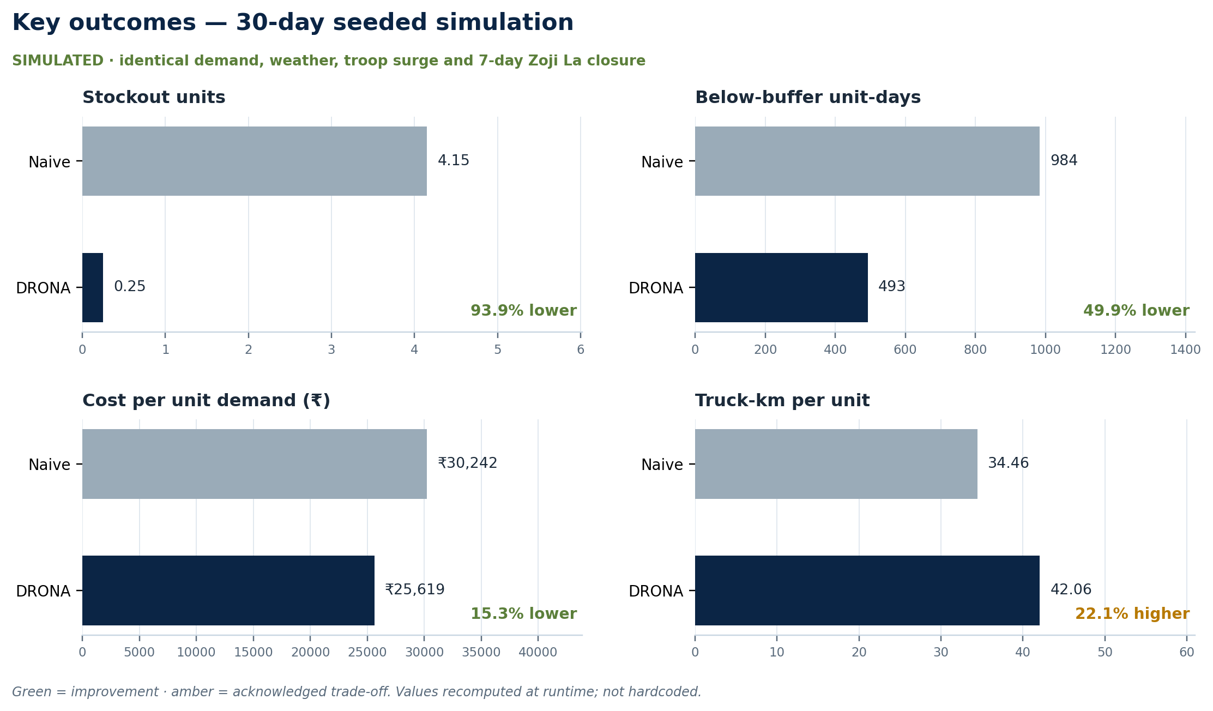
Figure 11.1 — Key 30-day outcomes. Green marks an improvement; amber marks the truck-km trade-off that DRONA-LOG accepts to maintain availability during the closure.
The total cost is the sum of transport and procurement. Naive transport is ₹76.06 lakh and procurement ₹1.52 crore; DRONA transport is ₹61.83 lakh and procurement ₹1.32 crore. The DRONA plan spends more per unit on southern procurement during the closure but buys and moves less overall, so total cost falls.

11.3 Interpretation and trade-offs
The headline is a 93.9% reduction in stockout units, from 4.15 to 0.25 units over 30 days. The absolute numbers are small because the scenario starts with meaningful safety stock, so the result should be read as a reduction in residual shortages under a closure, not as evidence that the theatre was on the brink of failure. The below-buffer metric is a broader measure of resilience: FOB-days below the safety buffer fall by 49.9%, which means the plan is not merely avoiding the visible stockout but keeping more formations inside their intended posture.
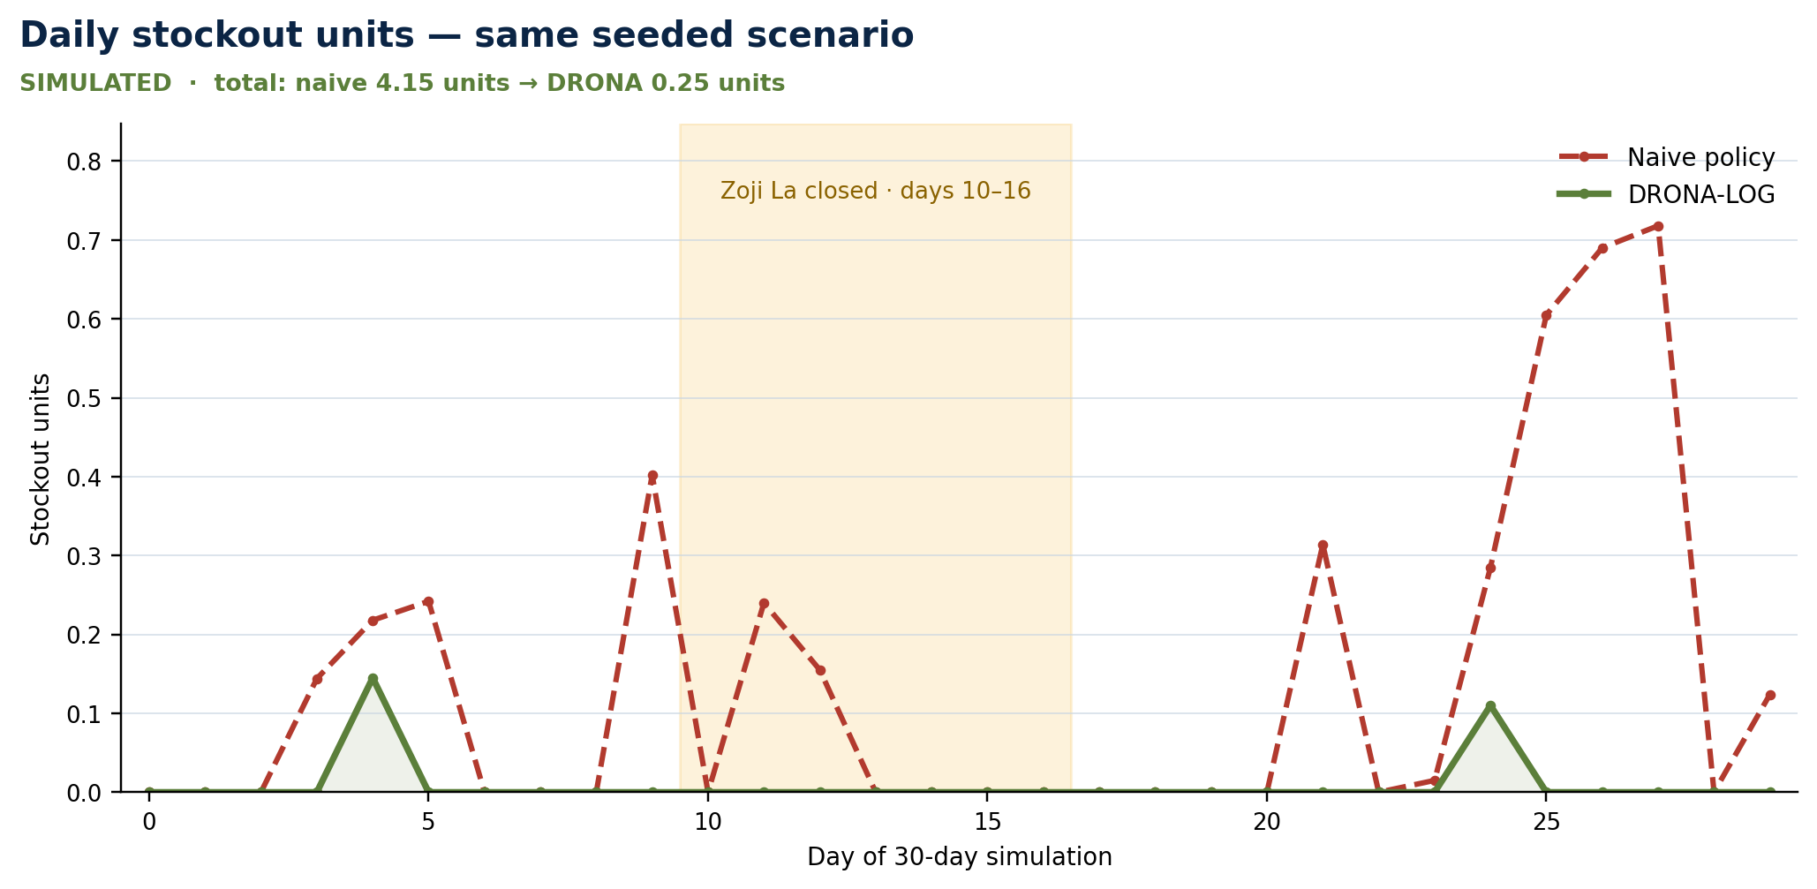
Figure 11.2 — Daily stockout units for both policies. The shaded band is the seven-day Zoji La closure. The DRONA policy absorbs the closure with two small residual events; the naive policy accumulates stockouts before, during and after it.
Cost per unit falls 15.3% because the DRONA policy carries less excess inventory and dispatches 47 fewer trucks, even though it pays a southern procurement premium during the closure. The truck-km result goes the other way: delivering through the longer southern corridor raises truck-km per unit by 22.1%. If truck-kilometres are used as a diesel proxy, DRONA-LOG consumes more fuel per unit of demand in this scenario. The system reports that as a warning, not a benefit. A planner can decide whether availability during a closure is worth the fuel; the tool does not make that value judgement for them.
The held-requisition counter requires a separate caveat. The naive policy increments the counter whenever a reorder is triggered but no load is available or a convoy is held at a closed pass. The DRONA simulation has no equivalent hold path, so its counter is zero by construction. The 258 → 0 row therefore illustrates the absence of the naive behaviour; it is not an independently measured 100% reduction in real held requisitions. The report and the UI both say so.

11.4 Variability
The seeded data and model training are deterministic, so the demand and forecast inputs reproduce on the same machine. The MILP is time-limited and the simulation performs many solves, so the last decimal of an objective or a delivery quantity can vary with solver version, host speed and thread scheduling. The metric cards are recomputed from the simulation at runtime rather than baked into the frontend. The values in this report are from the recorded run on 20 October 2026 and may differ slightly on another machine; the direction and approximate magnitude are the claim, not the last digit.

11.5 Threats to validity
- Synthetic data. The demand generator encodes assumed relationships. The measured improvement is evidence that the decision loop responds correctly to a controlled scenario, not a forecast of field performance.
- Single scenario. One 30-day window, one closure, one seed. There is no Monte Carlo distribution or sensitivity sweep across closure durations.
- Constructed baseline. The naive policy is a plausible legacy process, but it is not calibrated to a specific unit's historical behaviour.
- Model mismatch. The DRONA simulation uses a three-day rolling MILP replan, while the command view exposes a seven-day plan. This is intentional for compute cost, but it means the 30-day result is not a direct replay of the displayed plan.
- Cost model. Transport is linear in cost-km and procurement is a flat per-unit price. Real contracts, fuel surcharges, maintenance and crew costs are not modelled.
- No stochastic optimisation. Forecast error and weather uncertainty are not explicitly hedged; safety buffers and penalties are the only risk controls.

12. Acceptance Criteria and Evidence

12.1 Criterion-by-criterion evidence
Criterion | Implementation | Evidence and observed result
Feasible baseline with zero stockouts | MILP with 7-day horizon, fleet and stock constraints, soft stockout/buffer penalties | test_baseline_plan_feasible_zero_stockouts, test_plan_zero_stockouts; seeded plan OPTIMAL, 0 stockout units, 15 deliveries
Closure produces a valid alternate and a new plan | Closed pass removed from graph; A* remaps every depot→FOB route; MILP re-solves; diff and timings returned | test_zojila_closure_severs_west_corridor, test_pass_closure_flow; west route None, south route valid, objective rises
Solve time displayed | Wall-clock solve time stored in every plan and closure event | solve_time_ms and re_solve; UI shows 28.5 ms / 688.5 ms in the recorded closure
Offline entries sync after restart | IndexedDB append-only ledger; server idempotent sync; receipts applied | test_sync_after_backend_restart, test_sync_receipt_updates_stock; live demo 2 entries recorded offline and accepted after restart
Hand-edited entry rejected | Server recomputes SHA-256 over canonical fields and checks sequence and previous link | test_tampered_entry_rejected, test_tampered_payload_rejected, test_tampered_replay_rejected; UI 0 accepted, 1 rejected
One-command bring-up | Docker Compose with backend healthcheck, nginx SPA and /api proxy, persistent volume | docker compose up --build; health verified from 8080 and 8000
Metrics computed, not hardcoded | Naive and DRONA simulated on the same seed; cards labelled SIMULATED | test_metrics_computed_not_hardcoded, test_drona_beats_naive_on_stockouts_and_holds; live cards match counters
Run steps and demo documented | README, this report, ideas template, recorded demo, submission answers | Repository docs; 2:33 demo; 6-page PDF

12.2 Test and demonstration inventory
The acceptance evidence comes from three sources: automated tests, the running UI, and recorded events in the database. Each source covers a different risk. Tests prove invariants and rejection paths; the UI demonstrates that the integrated screen behaves as described; events prove that timings, plans and diffs were persisted in a real run.
Evidence source | Scope | Location
Backend tests | 24 tests across API, planning, metrics and sync | backend/tests/
Frontend tests | 6 hash/chain tests | frontend/src/edge/ledger.test.js
Recorded events | 3 closure/reopen events with plans and timings | GET /api/events; submission/events.json
Screenshots | Command view, closure panel, tamper result | docs/*.png
Demo video | 2:33 narrated walkthrough | docs/drona-log-demo.mp4
Idea template | 6-page submission deck | docs/Subterra_Mesh_SIH26251_Idea_Template.pdf

13. Testing and Quality Assurance

13.1 Strategy
The test suite is organised around the failure modes that would invalidate the demonstration: an infeasible plan, a closure that leaves a severed route usable, a metric that is hardcoded, a sync that accepts a tampered entry, and a chain that tolerates a gap. Backend tests use FastAPI's test client against a seeded temporary database, so they exercise the real database and solver paths rather than mocks. Frontend tests exercise the ledger hash and chain functions in isolation; a parity test compares the JavaScript digest with a known Python digest.

13.2 Backend suite
File | Tests | Focus
test_api.py | 7 | Health, network shape, zero-stockout plan, forecast endpoint, closure flow, unknown pass, SIMULATED label
test_planner.py | 6 | Baseline feasibility, forecast shape, gradient penalty, Zoji La severance, Khardung La alternate, all-FOB reachability
test_metrics.py | 3 | Computed metrics, DRONA vs naive behaviour, series shapes
test_sync.py | 8 | Restart sync, receipt stock, tampering, payload tampering, idempotent replay, altered replay, sequence gap, broken link

The recorded run on 20 October 2026 completed 24 tests in 6.84 s, all passing. The exact wall time is machine-dependent; the pass count is the invariant.

13.3 Frontend suite
Test | What it checks
Same digest as backend | Byte-identical SHA-256 for identical canonical input
Hash changes when qty is edited | Quantity is covered by the digest
Well-formed chain verifies | Local chain walk accepts a valid sequence
Hand-edited entry detected | Qty changed without re-hashing is flagged
Swapped hash link detected | A broken previous link is flagged
Sequence gap detected | A missing sequence number is flagged

The recorded run completed 6 tests in 528 ms. The production bundle also builds successfully with npm run build.

13.4 Determinism and reproducibility
The seed, model parameters and one-thread solver configuration are fixed. The backend test database is seeded fresh for the suite. The frontend hash tests use fixed inputs. The reproduction checklist in Appendix D lists the exact commands and expected counts. A clean demonstration can be restored with docker compose down -v followed by docker compose up -d; this removes the volume, reseeds and retrains.

13.5 Coverage gaps
- No browser end-to-end test. The UI flows are verified by screenshots and manual demonstration, not by Playwright or Cypress.
- No load or concurrency testing. The prototype is single-user and single-node.
- No solver stress suite. Infeasible and time-limit paths are surfaced in code but not exercised by an automated test.
- No security testing. There has been no penetration test, dependency audit or threat-model review.
- No accessibility audit. The known gaps are listed in Section 10.4.
- No multi-device conflict test. The server supports per-device chains but does not reconcile competing requisitions.

14. Deployment and Operations

14.1 Container topology
The stack is defined in docker-compose.yml and runs as two services plus a named volume. The backend healthcheck is the gate for the frontend, which avoids the common failure where nginx serves the SPA before the API is ready and the first request fails.
Service | Port | Depends on | Notes
backend | 8000 | — | FastAPI, seed, LightGBM models, SQLite; healthcheck /api/health
frontend | 8080 | backend healthy | nginx SPA, /api proxy, static assets
drona-data | — | — | SQLite database and model artefacts

14.2 First boot
On first boot the backend seeds the database with 49 nodes, 53 edges, 365 days of history and 10 FOBs, then trains three LightGBM models. This takes roughly 30 seconds on a development laptop. The frontend waits for the healthcheck, so the first page load may show a short wait rather than a connection error. Subsequent starts reuse the persisted database and models.
docker compose up --build
# command view http://localhost:8080
# edge client http://localhost:8080/edge
# API documentation http://localhost:8000/docs

14.3 Local development
The backend and frontend can also run outside Docker. The backend uses a Python virtual environment, seeds explicitly and starts uvicorn on port 8000. The frontend uses Vite on 5173 and proxies /api to 8000. The seed command is idempotent and accepts --force to rebuild.
cd backend
python -m venv .venv
# Windows: .venv\Scripts\activate
# macOS/Linux: source .venv/bin/activate
pip install -r requirements.txt
python -m app.seed --force
python -m uvicorn app.main:app --port 8000
cd frontend
npm install
npm run dev # http://localhost:5173

14.4 Reset and troubleshooting
Symptom | Likely cause | Resolution
Frontend shows connection error | Backend still seeding or training | Wait for healthcheck; check docker compose ps and backend logs
Plan is infeasible | Tight instance or corrupted stock | Recompute; reset volume and reseed if the demo state is corrupted
Models missing | Volume cleared or model files removed | Restart backend; it retrains if any model file is missing
Edge entries will not sync | Sequence gap, broken chain or backend offline | Read the sync reason; clear the local ledger only for a demo reset
Port already in use | Another process on 8000 or 8080 | Stop the process or change the host port mapping

A clean demonstration state is docker compose down -v && docker compose up -d. The -v flag deletes the named volume, including ledger and plans; this is a demo reset, not a production operation.

14.5 Runtime dependencies
The runtime needs Docker with Compose, or Python 3.12+ and Node.js for a local run. There is no runtime API key, external tile server, CDN, database server or GPU. The build downloads base images and packages, but the demonstration itself is offline-capable. The backend exposes port 8000 for API inspection; the frontend exposes 8080.

15. Security, Ethics and Data Handling

15.1 Current security posture
Control | Status in prototype
Input validation | Pydantic models for sync and closure payloads; pass existence checked; negative quantities rejected
SQL injection | Parameterised SQLite queries throughout the backend
Transport | Local HTTP only; TLS terminates nowhere in the prototype
Authentication / roles | Not implemented
Device identity | Device id is client-supplied; no registration or signature
Secrets | No runtime API keys or credentials are used
Data at rest | SQLite file in a Docker volume; no encryption
Audit | Plans, closure events and sync results are persisted; no administrator audit UI

The prototype should be treated as a controlled demonstration, not a system for operational data. It is not hardened for a contested network, multi-user access or classified information.

15.2 Gaps before production
- Authentication and role-based access. A commander, planner and edge quartermaster need distinct permissions and an auditable identity.
- Device registration and signing. A hash chain proves internal consistency, not authorship. Entries should be signed by a registered device key.
- TLS and network segmentation. The API should not be exposed over plain HTTP outside a trusted host.
- Secrets and key management. Model artefacts, device keys and signing keys need a managed lifecycle.
- Data classification. The system must be accredited for the classification of the data it handles, with appropriate storage and logging controls.
- Rate limiting and DoS protection. Sync and solve endpoints are expensive and currently unthrottled.
- Dependency and container scanning. No SBOM, image scan or patch process is in place.

15.3 Data ethics and responsible claims
All data is synthetic. No personal data is collected, no classified movement record is used and no live unit is represented. The map is schematic and must not be treated as an operational map. The forecast is a decision-support output, not an order; a human planner remains responsible for the plan. The evaluation is presented with its trade-offs and its structural artefacts (the hold counter) rather than as a marketing claim.
The team has deliberately avoided claims that the prototype cannot support: it does not claim fuel savings, real-world forecast accuracy, production security, or a measured reduction in actual held requisitions. Those distinctions are part of the submission's honesty requirement, not an afterthought.

16. Limitations and Roadmap

16.1 Current limitations
Area | Limitation | Consequence
Data | Synthetic weather, demand and network; schematic geometry | External validity is unproven
Forecast | Point estimate; pooled per class; no drift monitoring | No service-level or uncertainty-aware planning
Routing | Static gradients; no traffic, surface or seasonal road state | Travel time and risk are approximated
Optimisation | Deterministic demand; unit aggregation; no vehicle scheduling | Plan is a capacity plan, not a dispatch schedule
Evaluation | One seed, one 30-day window, one closure; constructed baseline | No statistical confidence interval
Edge | No device signatures, conflict resolution or durable hardware root | Trust is server-side consistency, not authorship
Security | No auth, TLS, roles or accreditation | Demonstration only
UI | Desktop-first; no formal accessibility audit; canvas map | Limited field usability

16.2 Production roadmap
Phase | Focus | Exit criterion
0–3 months | Real data adapters (weather, road status, stock), configurable theatre, signed device identities | A pilot theatre can be loaded and a signed edge entry verified end to end
3–6 months | Stochastic or robust demand, multi-pass stress tests, browser E2E tests, authentication and roles | Closure scenarios pass an automated end-to-end suite with authenticated users
6–12 months | Pilot with logistics users, calibration of cost and gradient weights, monitoring and retraining | Measured pilot metrics against the legacy process, with a documented rollback

The roadmap is intentionally staged. Adding real data and authentication before the decision loop is validated would obscure whether the improvement comes from the model or from the data. The prototype's role is to prove the loop, the evidence trail and the operator experience; the pilot's role is to test them against reality.

16.3 What would make the evaluation stronger
- A Monte Carlo sweep over seeds, closure durations and demand shocks, reporting distributions rather than one run.
- A calibrated naive baseline derived from historical unit behaviour rather than a constructed policy.
- Forecast backtests with rolling origins and error metrics by class and FOB.
- Solver sensitivity to the 1% gap, time limit and penalty weights.
- Usability testing with logistics staff, including a map-free fallback and larger type.

17. Conclusion
DRONA-LOG demonstrates a complete, inspectable decision loop for forward supply in a mountain theatre. It forecasts demand per supply class, routes over terrain with an explicit gradient penalty, allocates a capacitated 7-day plan with a mixed-integer optimiser, and replans in under a second of solve time when a pass closes. It keeps requisitions working offline and gives the server a way to verify that they were not altered. The same API payload drives the map, the plan, the diff and the timings, so the operator sees one coherent story.
The measured result is meaningful but bounded: on a seeded 30-day scenario with a seven-day closure, stockouts fall by 93.9%, below-buffer unit-days by 49.9% and cost per unit of demand by 15.3%. Truck-kilometres per unit rise by 22.1% because availability is maintained through a longer corridor. The report keeps that trade-off visible, along with the structural nature of the zero hold counter. The prototype also passes 24 backend and 6 frontend tests, builds a production bundle and comes up with one command.
The next step is not a larger slide deck; it is a pilot with real weather and road data, signed device identities, authenticated users and a calibrated baseline. DRONA-LOG is ready to be tested in that setting because its assumptions, costs, failure modes and evidence are explicit. That is the standard the submission sets for itself.

References
[1] Team Subterra Mesh. DRONA-LOG repository, SIH26251 prototype. github.com/athul-dev-sys/DRONA-LOG (accessed 20 October 2026).
[2] FastAPI. Documentation. https://fastapi.tiangolo.com (accessed 20 October 2026).
[3] LightGBM. Documentation. https://lightgbm.readthedocs.io (accessed 20 October 2026).
[4] Google OR-Tools. Documentation and SCIP solver. https://developers.google.com/optimization (accessed 20 October 2026).
[5] NetworkX. Documentation. https://networkx.org (accessed 20 October 2026).
[6] MapLibre GL JS. Documentation. https://maplibre.org (accessed 20 October 2026).
[7] MDN Web Docs. IndexedDB API and Web Crypto API. https://developer.mozilla.org (accessed 20 October 2026).
[8] Smart India Hackathon. Official portal. https://www.sih.gov.in (accessed 20 October 2026).

Appendix A — API Reference
Method | Endpoint | Purpose
GET | /api/health | Seed, model and metrics readiness
GET | /api/network | Nodes, edges, stock, gateway routes and corridor state
GET | /api/fobs | FOB list with stock and demand context
GET | /api/forecast?days=7 | Per-FOB, per-class LightGBM forecast
GET | /api/plan | Latest 7-day MILP plan; solves on first request
POST | /api/plan/recompute | Force a fresh solve
POST | /api/events/pass-closure | Close or reopen a pass; reroute, re-solve, diff, time
GET | /api/events | Closure and reopen audit log
GET | /api/metrics | SIMULATED naive-vs-DRONA comparison
POST | /api/metrics/recompute | Recompute the 30-day comparison
POST | /api/sync | Verify and ingest edge ledger entries
GET | /api/ledger | Server ledger rows in sequence order

The closure payload is { "pass_id": "ZOJILA", "action": "closed" | "reopened", "days": 7 }. Interactive schemas are available at /docs when the backend is running.

Appendix B — Configuration Parameters
Parameter | Value | Meaning
SIM_TODAY | 2026-10-01 | Simulation start date
EVAL_DAYS | 30 | Evaluation horizon
FORECAST_DAYS / PLAN_HORIZON_DAYS | 7 / 7 | Operational forecast and MILP horizons
GRADIENT_K | 6.0 | Cost-km added per 1% gradient
ROAD_FACTOR | 1.25 | Road distance vs great-circle
TRUCK_CAPACITY | 10.0 | Units per truck
RATE_PER_UNIT_KM | ₹42 | Variable transport cost
TRUCK_FIXED_COST | ₹4,000 | Fixed dispatch cost per truck
FLEET | 24 / 8 / 8 | Trucks per day at Leh / Karu / Upshi
STOCKOUT_PENALTY | ₹500,000 | Penalty per unmet unit
BUFFER_PENALTY | ₹60,000 | Penalty per unit-day below buffer
INFLOW_WEST_CAP | 6 / 26 / 2.5 | West units/day for classes I / III / V
INFLOW_SOUTH_CAP | 2.5 / 11 / 1.2 | South units/day for classes I / III / V
PROC_COST_WEST / SOUTH | ₹18,000 / ₹24,000 | Procurement cost per unit
DELIVERY_LEAD_DAYS | 1 | Dispatch-to-arrival lead
SOLVE_TIME_LIMIT_MS | 10,000 | SCIP time limit
SOLVE_GAP_REL | 0.01 | SCIP relative gap

Appendix C — Test Inventory

C.1 Backend (24 tests)
Test | Invariant
test_health | Health endpoint reports seeded/ready state
test_network_shape | 49 nodes and 53 edges, required FOBs and passes
test_plan_zero_stockouts | Baseline plan has zero stockout units
test_forecast_endpoint | Forecast shape and non-negative daily values
test_pass_closure_flow | Closure returns new plan, diff and timings
test_unknown_pass_404 | Unknown pass is rejected
test_metrics_simulated_label | Metrics payload carries SIMULATED
test_metrics_computed_not_hardcoded | Metrics match simulation counters
test_drona_beats_naive_on_stockouts_and_holds | Directional policy comparison
test_series_shapes | Daily series lengths match the 30-day horizon
test_baseline_plan_feasible_zero_stockouts | MILP feasibility and zero stockout
test_forecast_shape | Per-FOB per-class forecast shape
test_router_gradient_penalty | Gradient penalty is applied to edge cost
test_zojila_closure_severs_west_corridor | West route is None after Zoji La closure
test_khardungla_closure_alternate_route | Nubra traffic routes via Wari La
test_all_fobs_reachable_baseline_and_closure | Every FOB reachable in both states
test_sync_after_backend_restart | Offline entries accepted after restart
test_sync_receipt_updates_stock | Accepted receipt advances stock
test_tampered_entry_rejected | Hand-edited quantity rejected
test_tampered_payload_rejected | Altered payload rejected
test_replay_is_idempotent | True duplicate accepted idempotently
test_tampered_replay_rejected | Altered replay rejected
test_sequence_gap_rejected | Sequence gap rejected
test_broken_prev_hash_rejected | Broken previous link rejected

C.2 Frontend (6 tests)
Test | Invariant
Same digest as backend | JavaScript and Python hashes match byte-for-byte
Hash changes when qty is edited | Quantity is bound to the digest
Well-formed chain verifies | A valid local chain passes
Hand-edited entry detected | Qty change without re-hash fails
Swapped hash link detected | Broken previous link fails
Sequence gap detected | Missing sequence number fails

Appendix D — Reproducibility Checklist
Step | Action
1 | Clone the repository at the submitted revision.
2 | Run docker compose up --build from the repository root.
3 | Wait for the backend healthcheck and the first-boot seed/training to complete.
4 | Open http://localhost:8080 and confirm the SIMULATED banner and the 7-day plan.
5 | Open http://localhost:8080/edge and record two requisitions.
6 | Stop the backend with docker compose stop backend; confirm BACKEND OFFLINE and record another entry.
7 | Start the backend with docker compose start backend; wait for BACKEND ONLINE and press SYNC.
8 | Press SIMULATE HAND-EDIT OF LAST ENTRY, then SYNC; confirm one rejection with HASH MISMATCH.
9 | Return to the command view and close Zoji La; confirm the red west corridor and the new timings/diff.
10 | Reopen Zoji La; confirm the west corridor is restored.
11 | Run cd backend && python -m pytest tests/ -q; expect 24 passed.
12 | Run cd frontend && npx vitest run; expect 6 passed.
13 | Run cd frontend && npm run build; expect a successful production build.
14 | Optional reset: docker compose down -v && docker compose up -d.

Appendix E — Submission Artefacts
Artefact | File | Detail
Detailed report | docs/DRONA-LOG_Detailed_Report.pdf | This document; PDF and editable DOCX
Idea template | docs/Subterra_Mesh_SIH26251_Idea_Template.pdf | 6 pages; under the 10 MB limit
Editable deck | submission/final/Subterra_Mesh_SIH26251.pptx | Final 6-slide source used for the template PDF
Demo video | docs/drona-log-demo.mp4 | 2:33 narrated walkthrough; 5.6 MB
Submission answers | docs/SUBMISSION_ANSWERS.md | Title, abstract, description and technology bucket
Repository | github.com/athul-dev-sys/DRONA-LOG | Source, tests, Docker Compose, README

Portal field summary: Idea Title 87 characters; Abstract 2,687 characters; Idea Description 11,515 characters; Technology Bucket Software; Idea Template PDF under 10 MB. The full copy-paste text is in docs/SUBMISSION_ANSWERS.md.
— End of report —

