ASSIGNMENT

Novel milling technologies in cereals

Submit By:

Ajmi S

RollNo: 10

Cereal grains are hygroscopic and would gain or lose moisture initially until they are in equilibrium with air. Food grains include cereals like rice, wheat, maize, sorghum and millets; pulses like pigeon pea, chick pea, black gram and oilseeds like groundnut, mustard, coconut, sesame. Storage is done to meet the food, feed and seed requirements of the people between two harvests and during natural calamities like draught, famine, war etc.

Milling of food grains and oil seeds is done to convert them into suitable products. All these operations could be performed with best possible efficiency if crop location specific appropriate processing technology and equipments are used. In general processing of products is done in three ways i.e., primary processing, secondary processing and tertiary processing. By products are processed for economic utilization. At every stage of processing, value is added to the product. Primary processing refers to those operations which convert raw food materials into a form fit for eating or to be used in subsequent processing. Some examples are: milling of paddy into rice, that of wheat into flour. Secondary processing c333onverts primary processed food materials into form fit for use at home or canteen or hotels. Some examples are milling of chick pea, splits into Besan.

* The milling process for cereals involves several steps, including:
* Cleaning: The outer hull is removed, which contains tough fibrous material.
* Tempering: The grains are conditioned by adding water and/or heat.
* Breaking: The grains are placed between large metal rollers to separate the bran.
* Sifting: The grains are separated into different streams based on particle size
* Grinding: The grains are ground into flour or other milled grain products.
* Blending: Different flours are blended to create specific products, such as wholemeal flour.

The milling process can vary depending on the cereal and the consumer's eating habits. For example, corn is often milled using wet processes, but dry milling is also used. Most other cereals are ground dry. The milling process makes cereals easier to cook and more attractive as food. Ground grain was one of the first foods eaten by humans, with ancient grinding methods dating back to the Far East, Egypt, and Rome

**Rice Milling**

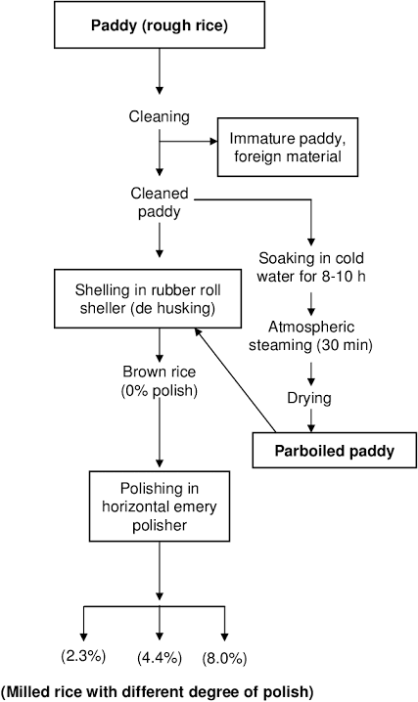

* 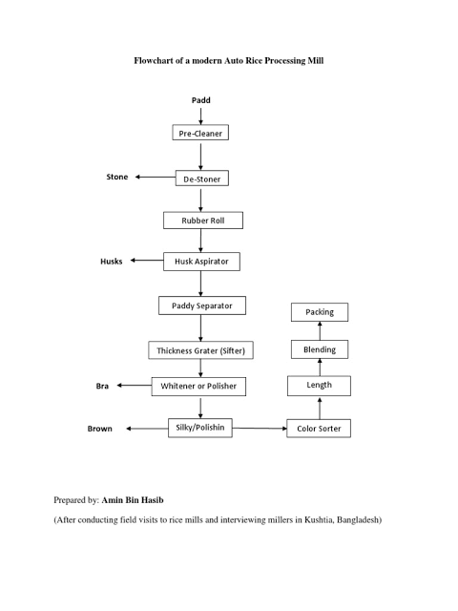**Modern Auto Rice Processing** **Mill**
* **Rubber roller**

The latest technology has adopting Rubber roller technology for husking and paddy separators in a 2 stage whitening process, replacing old equipment with emery-coated cylinders, friction-type whitener polisher and dry & wet mist polishers.

Modernisation is necessary and it has improved the milling yield and quality. This latest technology lead to better yields and lesser losses. The productivity and efficiency also increases with this technology. This is the latest computer-aided design which enables us to get higher quality rice and earn profit. These machines are based upon the ultra-modern energy saving technologies

* **Two stage whitening**

Two-stage whitening in rice milling technology is a process that involves separating the hulling and polishing processes of rice into two stages. This can be done using a compact two-stage rice mill or with two separate machines.

**Advantages**

Reduces overheating: Two-stage whitening helps reduce grain overheating.

Improves milling and head rice recovery: Two-stage whitening helps ensure higher milling and head rice recovery.

**The two-stage whitening process typically involves:**

Hulling: Rubber rollers remove the husk from the rice.

Polishing: A steel friction whitener polishes the brown rice.

* **KOOL MILL**

Koolmill machinery provides a simplified, cold process, working gently with rice to deliver more food from existing harvests. Koolmill uses up to 90% less power than a traditional machine, typically consuming only 5kWh/to. This improves high quality food output by 20% and delivers a step change reduction in economic, social and environmental impact.The Koolmill F1 Machine installed at NCEFE is a ‘living lab’ approach to research and innovation. The machine has digitised the milling process, including the development of a remote monitoring and augmented reality toolkit to remotely support machines globally.  NCEFE Academics created a highly accurate ‘digital twin’ of the milling chamber, enabling the  creation of forecasting simulations. Koollmill and NCEFE are also working to auto-classify broken rice. This will enable closed loop feedback to reconfigure machines in real time, minimising broken grains which maximises both the return of food and economic value.Koolmill’s chamber flexibility can be adapted to process other grains, such as barley, legumes and pulses.Through collaborative research and innovation, the machinery has been repeatedly enhanced to optimise the rice milling process, improve capacity, reduce breakage and enable the development of waste by-products.

**MAIZE MILLING**

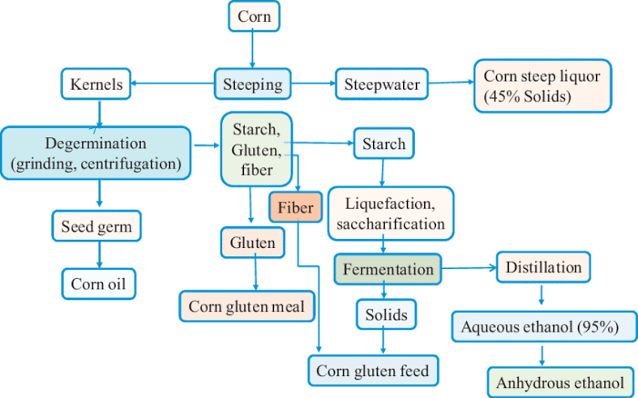

* CORN WET MILLING PROCESS
* DRY MILLING PROCESS

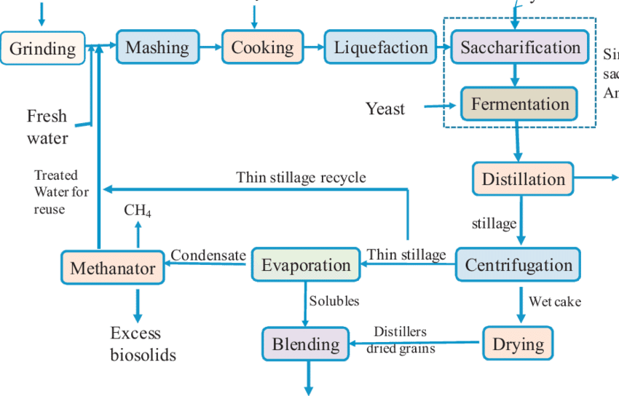

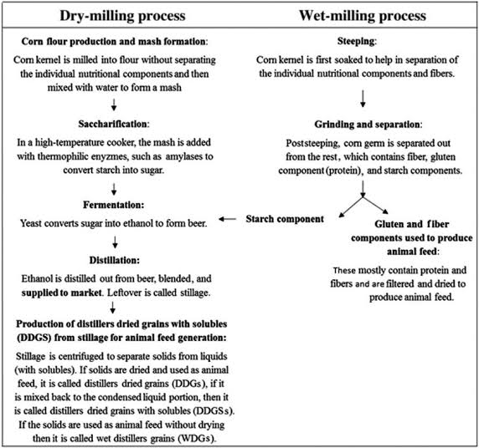

**WHEAT MILLING**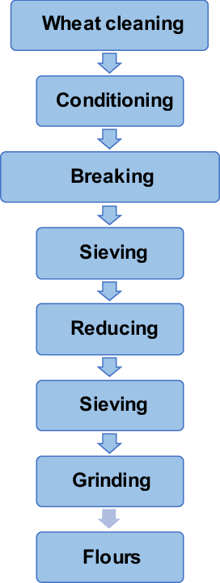

**Automated and modern wheat flour milling production:**

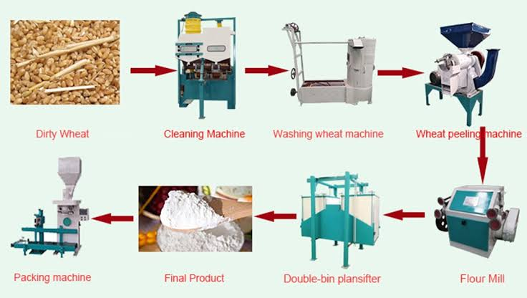

**Some of the new technologies introduced are as follows:**

* **AUTOMATIC LEVELLING SYSTEM (ROBOT)**

Metalmont Robots are one of the most efficient systems for handling cereals in flat storage warehouses, with the maximum exploitation of the entire surface area by utilizing the volume of the storage facility and representing a great, and sometimes even necessary, alternative to the silos storage system. In designing its Robot, Metalmont has duly applied the latest and most stringent international standards regarding: • People safety • System reliability • Product preservation • Working flexibility • Construction quality • Operation cost optimization

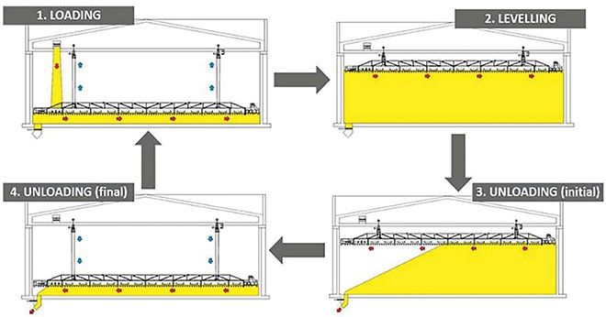

The Robot is basically a reclaimer, used mainly for the automatic filling, levelling, and emptying of flat warehouses, assuring continuous high flow rates. It is perfectly adapted to work with bulk materials such as cereals, seeds, legumes, compound feed but it can also deal with hard flowing materials such as soybean or rapeseed meals. In nutshell, the main features are: • Efficiency: Operating workflow in automated 24/7 program. • Safety: No need to have people inside the warehouse. • Effectiveness: Complete filling of the available volume. • Customization: Operating logic based on user needs. • Unique solution: For management of non-free flowing bulk materials. • Versatility: Shed divided in sections for multiple product storage. The Robot works perfectly with different products stored in the same warehouse, moving automatically from one section of the shed to another. • A structure designed to meet the specific needs of the user in compliance with international standards and requirements. • Specific software developed for full automation of the working modes. • Thermometry is a crucial and sometimes legal requirement in the storage of cereals and other agricultural bulk materials. Measure and monitor temperature automatically of the product in any point of the warehouse. • Reports temperature continuously to react quickly in case of any potential degradation. • It is available in several models and, with combined solutions, can reach a capacity flow rate of up to 500 t/h.

* **GRAIN IMPROVES SMART**

Grain Improvers is a completely new type of processing aid based on 100% natural Enzymes developed by IZU GLOBAL. Grain Improvers is a patented complex of Enzymes. It is used in flour millsto improve the quality while preparing wheat for grinding and is applied directly to Grain prior to grinding at Tempering stage and helps in providing unprecedented benefits during Flour production. It is designed for lower quality wheat processing to improve Flour quality. The Cellulose of grain kernel is the substrate for Enzymes’ action. It is applied in dry form by a simple in-line dispenser on wet grain at the stage of Tempering. Grain Improvers soften and disintegrate Grain kernels making them much more flexible than with standard way of Grain preparation for grinding with only water.It improves the hydration of grain at the stage of tempering to achieve significant softening of grain kernels to increase the efficiency while milling. Functional benefits of the improver are: • Tempering efficiency increases 7 times compared to standard tempering. • Grain shells separation from Endosperm efficiency increases. • Sifting effectiveness increases by 30%. • Rheological properties of Flour improves. • Starch deformation rate optimization. • Taste and aroma of bakery products improves. • Increased amount of premium flour. • Improving the baking properties of flour: water absorption, shape stability, bread volume, and crumb whiteness. • Improving the stability and elasticity of the dough, reducing stickiness. • Optimizing granulation of flour and degree of damaged starch. • Increases machine maintenance interval. • Saving electricity at the roller mill. • Lower roll temperature and product temperature.

* **AlPesa Milling System**

Bühler recently introduced AlPesa, a compact and complete milling system for whole wheat atta flour and flour from sorghum. The system has a throughput of up to 18 tons per day, offers a high level of food safety, and produces a wide range of flour qualities. The AlPesa combines different modules — for feeding, grinding, sifting, bagging, pneumatic conveying, and automation. The switch cabinet of the AlPesa contains the power electronics and an integrated touchscreen to operate the system. The AlPesa can be operated and monitored from various devices, including smartphones, tablets, and personal computers. It is a compact version of Bühler’s PesaMill milling system, which has been operating worldwide since 2017. The AlPesa replaces traditional chakki stone mills, producing authentic whole wheat atta flour for flatbreads commonly consumed in Asian sub-continent.

* **Dante Wheat Scrubbing Technology**

Omas’ new Dante wheat scrubbing technology decreases microbial count, toxin levels, chemical residue and tempering time. The system utilizes unique flow placement along with upgrades to traditional scouring / de-branning technologies to increase flour safety, reduce wheat ash, and improve overall performance of the mill while maintaining or improving flour performance. Technical features include: • Internal rotor with eight abrasive elements • Internal body with perforated plate with adjustable reinforces. • Inspection doors • Outlet with electrical control by ammeter • Cooling fan on the machine • Body of welded steel and painted with epoxy for food equipment. • Electric motor with ammeter • Control panel to adjust the parameters of abrasion. • Omas said a decade’s experience has led to the development of “Dante,” with eight machining wheels and an electro-mechanical actuator managed by PLC that allows you to decide how long the product remains in the machine.

* **Summit Sieve**

Great Western’s new Summit Sieve frame and tray combine strength and simplicity with a larger net screen area per stack than previous sieves. The new design features a minimal number of fasteners, each of which has strategically been positioned to eliminate risks of contamination. Removal of gaskets results in interlocking trays and sieves, while retaining stability and preventing leaks. Summit Sieves feature food grade plastic and stainless-steel pan; increased net sieve area; a stronger design with fewer parts; aluminum trays that interlock with sieve below and above to prevent outward bowing; columns that create strength throughout the stack and prevent downward deflections; increased sanitation, and more.

* **SightTrap**

Insects Limited has introduced SightTrap, a pheromone monitoring device that puts cameras on insect traps and provides essential information and data on your computer or smart phone. The device provides detailed reporting in which you can monitor traps, view pre-identified insects, and see trending data. The device automatically records a daily image of the pheromone trap. The ForesightIPM app shows and counts the insects in your trap. This pest management method involves less time and fewer steps, according to Insects Limited. Each kit includes: • A SightTrap camera • Two lithium batteries • A battery charger • A glueboard and pheromone lure • SightTrap hangers • All access to ForesightIPM with unlimited users.

* **Differential Dosing Scale**

As a mass flow controller, the Grano differential dosing scale manufactured by Swisca precisely doses a pre-selected quantity of product and registers the total weight in grams. The differential dosing scale precisely serves as a mass flow meter for the accurate measuring of a given product flow. For a constant and exact measure of grain mixtures, the differential dosing scale is used below silos, raw production bins and tempering bins. For grain processing in a continuously operating setting, accurate measurement and exact regulation are made possible by innovative drive and measurement technology. The differential dosing scale GRANO is suitable for weight-oriented measurement of quantity, performance-oriented process control and recipe-oriented mixtures. The flow quantity of a free-flowing product is precisely determined, the capacity is precisely regulated, and the total weight is accurately recorded. An extraordinarily robust control system with touchscreen along the precise measuring cells used in Swisca dosing scales guarantee the highest quality and reliability.

* **Roll Measuring Device**

Yenar’s latest innovation at its research and development center is the rollCare Profile Measurement Device, which utilizes laser technology to check fluted roll profiles while fluting and also on the roller mills. After measurement, millers can compare stats by automatically overlapping the measured profile and the theoretical one to see if there are deviations. The device measures the sharp angle, dull angle, land, depth, bottom radius and grinding surface area. With rollCare, you can easily and quickly determine the optimal time to change the rolls. The device features a wireless connection, user-friendly interface and there is no limit for the diameter range.

* **Top Innovative Technologies in Grain Milling Solutions**
* Grain milling solutions have seen a significant transformation with the introduction of innovative technologies. One such technology making waves in the industry is AI-powered grain sorting systems. These advanced systems can efficiently separate impurities from grains, ensuring higher quality end products.
* Another cutting-edge technology is remote monitoring and control systems. By enabling operators to oversee milling processes from anywhere, these systems enhance efficiency and productivity while reducing downtime significantly.
* Furthermore, precision milling equipment equipped with IoT sensors allows for real-time data collection and analysis. This ensures optimal performance and maintenance scheduling, ultimately leading to cost savings for mill operators.
* Additionally, advances in automation through robotics have revolutionized the grain milling process by streamlining operations and improving consistency in flour quality.
* The integration of these top innovative technologies is reshaping the landscape of grain milling solutions, paving the way for more sustainable and efficient practices in the industry.