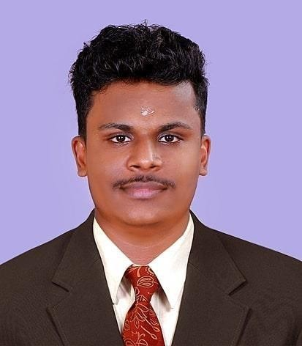

**YADHU KRISHNAN**

**Mechanical Engineer I Year Experience**

**UAE Visiting Visa**

**Email ID:** [**99yadhukrishnan@gmail.com**](mailto:arimbramansoor@gmail.com)

**Mobile No: +971563774157, +917034452469**

**CAREER OBJECTIVE**

Seeking a c hallenging role where I c an utilize my skills and give sat isfactory service to the organization where I work and exceed the expectation of superiors.

# PROJECTS HANDLED

1. PIPING CONSTRUCTION FOR BERGER PAINTS INDIA LIMITED

# ACADAMIC CAREER

* **B TECH IN MECHANICAL ENGINEERING [2017-2021]**

APJ ABDUL KALAM TECHNOLOGICAL UNIVERSITY, KERALA, INDIA. CGPA : 7.6

* **HIGHER SECONDARY SCHOOL LEAVING CERTIFICATE[2015-2017]**

CENTRAL BOARD OF SECONDARY EDUCATION, INDIA

PERCENTAGE : 63.8

* **SECONDARY SCHOOL LEAVING CERTIFICATE[2015]** CENTRAL BOARD OF SECONDARY EDUCATION, INDIA CGPA : 9.2
* **DIPLOMA IN OIL AND GAS**
* **DILOMA IN QA/QC**
* **MEP ENGINEERING( MECHANICAL- ELECTRICAL –PLUMBING)**

# PROFESSIONALCAREER

Name Client

Job Title

Period Employed

: Smart Zero Facility Management Service, Kochi, Kerala (India)

: Technician

: 01/07/2021-31/08/2022

# Job Responsibilities

* + Analyzing project progress
  + Submitting reports to client
  + Controlling work force to deliver quality work
  + Control to minimize operation cost and risk

# Computer / Software Skills

* Auto CAD [**CAD**]
* Proficient in using **MS Office applications**

# Personal Details

* + Passport Number : RO551707
  + Da te o f Birth : 19/03/1999
  + Ge nde r : Ma le
  + Father Name : Krishna Kumar
  + Na tio na lity : India n
  + Re ligio n : Hindu/Nair
  + Ma rita l Sta tus : Single
  + Language fluency : English, Hindi, Malayalam & Tamil

# Reference Available on Request

Yours Faithfully YADHU KRISHNAN