MySQL Assignment 1
DDL Commands & Constraints
Short Documentation with SQL Code
1. Database and Table Creation
Create the employee database and three tables: Departments, Location, and Employees.
CREATE DATABASE employee;
USE employee;
CREATE TABLE Departments (
department_id INT PRIMARY KEY,
department_name VARCHAR(100)
);
CREATE TABLE Location (
location_id INT,
location_name VARCHAR(100)
);
CREATE TABLE Employees (
employee_id INT,
employee_name VARCHAR(100),
age INT,
gender CHAR(1),
designation VARCHAR(100),
hire_date DATE,
department_id INT,
location_id INT
);
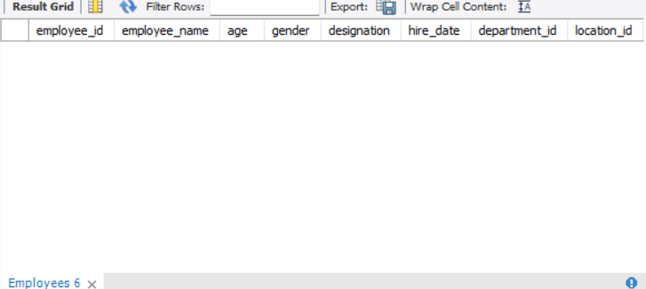

Employees table

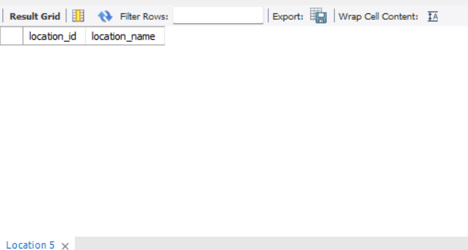

Location Table

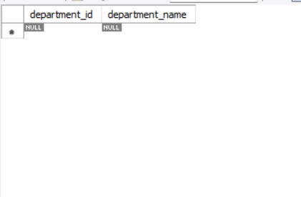

Department Table

2. Table Alteration
ALTER TABLE changes the structure of an existing table. The assignment requires adding email, widening designation, removing age, and renaming hire_date.
ALTER TABLE Employees ADD email VARCHAR(150);
ALTER TABLE Employees
MODIFY designation VARCHAR(200);
ALTER TABLE Employees
DROP COLUMN age;
ALTER TABLE Employees
RENAME COLUMN hire_date TO date_of_joining;
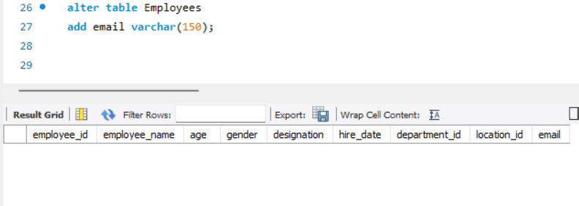

Add Email

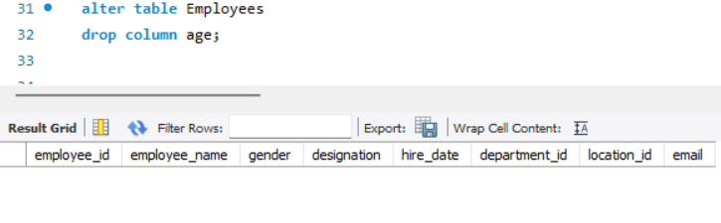

Drop Age
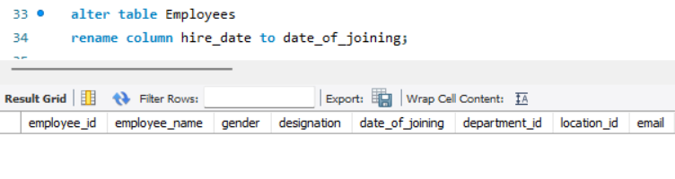

3. Table Renaming
RENAME TABLE changes an existing table name.
RENAME TABLE Departments TO Departments_Info;
RENAME TABLE Location TO Locations;
4. Table Truncation
TRUNCATE removes all records from Employees while keeping the table structure.
TRUNCATE TABLE Employees;
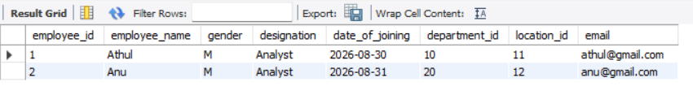

Before

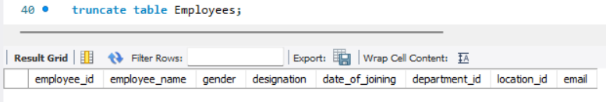

After

5. Dropping Table and Database
DROP permanently removes the specified table or database.
DROP TABLE Employees;
DROP DATABASE employee;
6. Recreate Database with Constraints
The constraints section requires recreating the database and applying rules to Departments, Location, and Employees.
DROP DATABASE IF EXISTS employee;
CREATE DATABASE employee;
USE employee;
7. Departments Table
department_id uniquely identifies each department. department_name cannot be NULL and cannot be duplicated.
CREATE TABLE Departments (
department_id INT PRIMARY KEY,
department_name VARCHAR(100) NOT NULL UNIQUE
);
8. Location Table
AUTO_INCREMENT generates sequential location IDs. NOT NULL prevents missing locations and UNIQUE prevents duplicates.
CREATE TABLE Location (
location_id INT AUTO_INCREMENT PRIMARY KEY,
location_name VARCHAR(100) NOT NULL UNIQUE
);
9. Employees Table
Employees uses PRIMARY KEY for unique IDs, NOT NULL for the employee name, CHECK for gender and age, a default current date for hire_date, and foreign keys to Departments and Location.
CREATE TABLE Employees (
employee_id INT PRIMARY KEY,
employee_name VARCHAR(100) NOT NULL,
gender CHAR(1) CHECK (gender IN ('M', 'F')),
age INT CHECK (age >= 18),
hire_date DATE DEFAULT (CURRENT_DATE),
department_id INT,
location_id INT,
FOREIGN KEY (department_id)
REFERENCES Departments(department_id),
FOREIGN KEY (location_id)
REFERENCES Location(location_id)
);
10. Test Data
Insert sample records to verify that the tables and relationships work correctly.
INSERT INTO Departments
(department_id, department_name)
VALUES
(1, 'IT'),
(2, 'HR'),
(3, 'Finance');
INSERT INTO Location (location_name)
VALUES
('Kochi'),
('Calicut'),
('Trivandrum');
INSERT INTO Employees
(employee_id, employee_name, gender, age,
department_id, location_id)
VALUES
(101, 'Athul', 'M', 25, 1, 1);
SELECT * FROM Departments;
SELECT * FROM Location;
SELECT * FROM Employees;
11. Constraint Summary
Constraint | Purpose
PRIMARY KEY | Uniquely identifies each record.
NOT NULL | Prevents missing values.
UNIQUE | Prevents duplicate values.
CHECK | Restricts values to a condition.
DEFAULT | Automatically provides a value when omitted.
AUTO_INCREMENT | Generates sequential numeric IDs.
FOREIGN KEY | Links related tables and maintains referential integrity.
Conclusion
This assignment demonstrates the main MySQL DDL commands and constraints used to create, modify, control, and relate database tables. The SQL statements can be executed in MySQL Workbench and the screenshot spaces can be used to document the results.

