QUERY
Table Bank
create table BANK(bankcode varchar(3),
bankname varchar(30) not null,
headoffice varchar(30),
branches int not null check(branches>0),
primary key(bankcode));

insert into BANK values('SBI','State Bank','Delhi',30);
insert into BANK values('CNB','Canara Bank','Ernakulam',20);
insert into BANK values('SlB','South Indian Bank','Madras',30);
insert into BANK values('AXB','Axis Bank','Kottayam',15);
insert into BANK values('FDB','Federal Bank','Ernakulam',25);

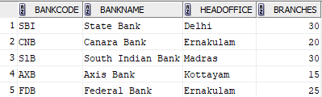

1.COMMIT
insert into BANK values('IFB','Indian Federal Bank','Ernakulam',25);
commit;


select *from BANK;

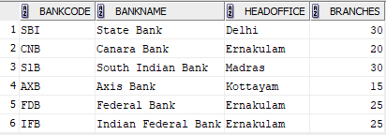
2.SAVEPOINT
insert into BANK values('ICL','ICL Fincorp','Ernakulam',5);
savepoint A;

select *from BANK;
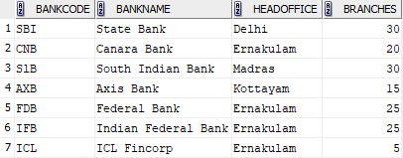

insert into BANK values('GMB','Grameen Bank','Pune',15);
savepoint B;


select *from BANK;
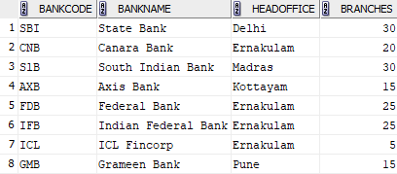

3.ROLLBACK
rollback to B;
select *from BANK;
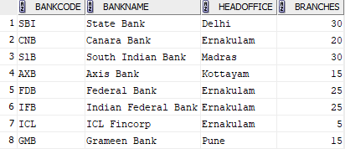
rollback to A;
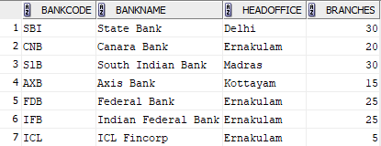
(Couldn’t rollback to B anymore… coz it lose permanently.. if needed add new)
insert into BANK values('GMB','Grameen Bank','Pune',15);
savepoint B;

rollback to B;
select *from BANK;


GRANT &REVOKE

grant select on BANK to c24csa27;
revoke select on BANK from c24csa27;

select * from C24CSA27.bank;(after they grant)
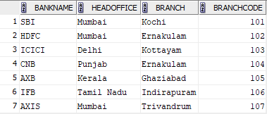
select * from C24CSA27.bank;(after they revoke)
