STUDENT
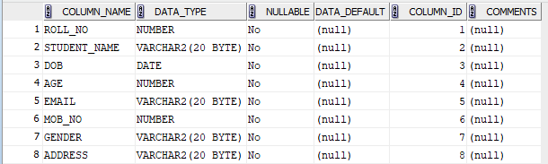
DEPARTMENT
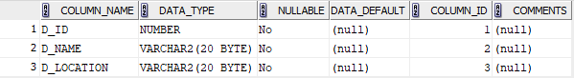
INSTRUCTOR
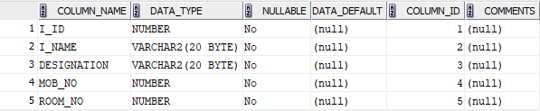
COURSE
