INSTRUCTOR
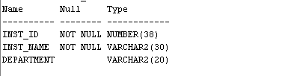
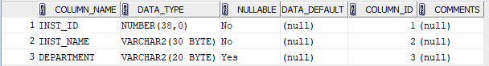
COURSE
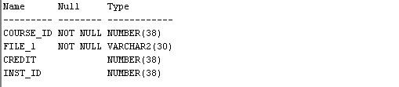
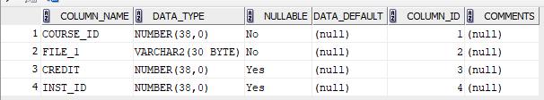
STUDENT
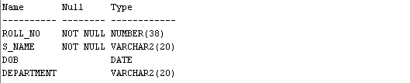
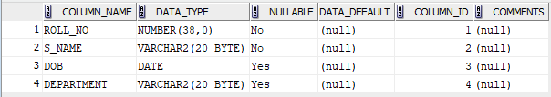
ENROLLMENT
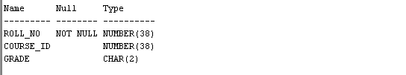
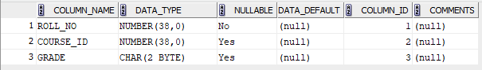
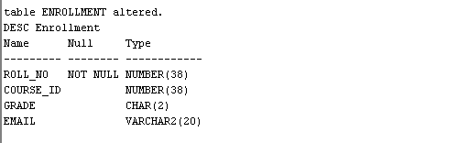
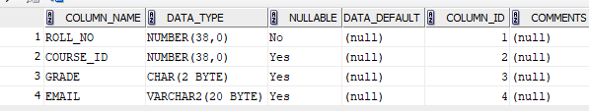
Truncate table

